Supplementary Information for

Pulsed Electrosynthesis of Glycolic Acid through Polyethylene Terephthalate Upcycling over a Lamellar Mesoporous PdCu Catalyst
Shu Han,¹ Lizhi Sun,^{1,}* Dongping Fan,¹ and Ben Liu^{1,}*
¹Key Laboratory of Green Chemistry and Technology of Ministry of Education, College of Chemistry, Sichuan University, Chengdu 610064, China. E-mails: lizhisun@scu.edu.cn; ben.liu@scu.edu.cn

Materials and Methods
Materials and Chemicals
Ammonium terachloropalladate ((NH₄)₂PdCl₄) and 1,3,5-trimethylbenzene (TMB) were purchased from Adamas-beta. Hexadecyl trimethyl ammonium bromide (CTAB) was purchased from Macklin. Copper nitrate (Cu(NO₃)₂∙3H₂O) was purchased from Aladdin. Nafion solution was obtained from Alfa Aesar. Hydrochloric acid (HCl), cobalt nitrate (Co(NO₃)₂∙6H₂O), ferric nitrate(Fe(NO₃)₃∙9H₂O), nickel nitrate (Ni(NO₃)₂∙6H₂O), silver nitrate(AgNO₃), ethanol, ethylene glycol, and potassium hydroxide (KOH) were obtained from Sinopharm Chemical Reagent Co. Ltd. (Shanghai). All the reagents were utilized as received without further purification.

Hydrolysis of PET plastics into PETH
PETH was made by immersing 16 g of PET powder in 200 mL of 4.0 M KOH and reacted for 48 h at 90 ºC. Similarly, bottle-based PETH was prepared by soaking 6.0 g of PET bottle powder in 100 mL of 10 M KOH and further reacted for 48 h at 90 ºC.

Synthesis methods
LM-PdCu was synthesized by a simple solution-phase route with NH₄PdCl₄ and Cu(NO₃)₂ as metal precursors, cetrimonium bromide (CTAB) as mesopore-forming template, 1,3,5-trimethylbenzene (TMB) as structure-controlled agent, and NaBH₄ as reducing agent. Typically, 200 mg of CTAB was dissolved in 40 mL of water at room temperature. Then, 200 μL of TMB was added into above solution. After the mixture was stirred for 20 min, 500 μL of aqueous solution containing 12.5 mg of (NH₄)₂PdCl₄ and 250 μL of aqueous solution containing 6.7 mg of Cu(NO₃)₂ were added. After being further stirred for 30 min, 1.5 mL of fresh solution containing 12.6 mg of NaBH₄ was injected to above solution. After being reacted for 1.5 h, the products (LM-PdCu) were cleaned with H₂O and ethanol for several times. Similarly, LM-Pd was prepared with the same procedures but with NH₄PdCl₄ as sole metal precursor. Besides, other LM-PdM were prepared with the same procedures but with NH₄PdCl₄ and corresponding metal salts as metal precursors.

Preparation of electrocatalyst ink
The electrocatalyst ink were prepared by mixing 5.0 mg of electrocatalyst and 2.5 mg of Vulcan XC-72 carbon with a mixed solution of 0.20 mL of water, 0.70 mL of ethanol, and 0.10 mL of Nafion. After being sonicated thoroughly, 100 mL of electrocatalyst ink was dropped onto 0.50 cm⁻² of carbon paper, followed by natural drying within a culture dish with a cover. A compact film was finally formed and used as the working electrode in the following electrocatalysis process.

Electrocatalytic measurement
All electrochemical measurements were carried out using a CHI 660E electrochemical workstation (Chenhua, Shanghai) in a single electrolytic cell with a test temperature of 25 ºC. A standard three-electrode system, in which Ag/AgCl (with saturated KCl as the filling solution) and carbon rod were used as the reference and counter electrodes. All potentials were recorded against the reversible hydrogen electrode (RHE) by the following equation: E_{RHE} = E_{Ag/AgCl} + (0.197 + 0.0591 × pH). Before electrocatalytic tests, linear sweep voltammetry (LSV) curves were performed until that the polarization curves achieved the steady-state ones at a rate of 10 mV s⁻¹ from 0.3 V to 1.4 V. The PE was conducted by using muti-potential steps technique. Cyclic voltammetry (CV) curves in electrochemical double-layer capacitance (C_{dl}) determinations were measured in a potential window nearly without the Faradaic process at different scan rates of 20, 40, 60, 80, 100, and 120 mV s⁻¹.

Product Analysis
Liquid products were analyzed by nuclear magnetic resonance (NMR) spectrometer. ¹H NMR spectra were recorded on a 400 MHz/AVANCE 400 (Bruker), in which 500 μL of electrolyte was added 100 μL of D₂O (contains maleic acid (MA) at a concentration of 4.0 mg mL⁻¹) used as an internal standard.
Yield rate (mmol h⁻¹ cm⁻¹) of GA can be calculated using the following equation:
$$Yield rate=\frac{{2N}_{GA}}{t}$$
Faraday efficiency (%) of GA can be determined by the following equation:
$$FE (\%)=\frac{N_{GA}× n × F}{Q}=\frac{N_{GA}× n × F}{\int_{0}^{t}{I dt}}$$
Selectivity (%) of GA formed can be determined by the following equation:
$$Selectivity(\%)=\frac{N_{GA}}{N_{consumed EG}}$$
where N is the amount of substance; t is the electrocatalytic time in high potential (1 h); F is the Faraday constant (96485 C mol⁻¹), n is the number of transferred electrons; Q is obtained from the integral of i-t curve and is the total charge passed through the electrode.

In situ Raman spectroscopy
In situ Raman measurements were carried out on a Renishaw (inVia-Qontor) reflex Raman microscope under an excitation of 532 nm laser light with 50 mW. A homemade cell and CHI660E electrochemical workstation were used. The cell was made of Teflon and equipped with a quartz glass plate to protect the objective. The WE (carbon paper coated with catalyst) was submerged in the electrolyte and kept perpendicular to the laser. Ag/AgCl was acted as the RE. A platinum wire embraced around the cell wall was served as the CE.

Characterization
TEM and STEM studies were carried out using a field emission TEM (JEM-F200, JEOL Ltd., Japan) with an accelerating voltage of 200 kV. TEM and STEM samples were prepared by dropcasting a diluted suspension of the sample powder onto a carbon coated copper grid (300 mesh). Powder X-ray Diffraction (XRD) patterns were recorded using a D/max 2500 VL/PC diffractometer (Japan) equipped with graphite-monochromatized Cu Kα radiation in 2θ ranging from 30º to 90º. The working voltage and current were 40 kV and 100 mA, respectively. Inductively coupled plasma-mass spectrometry HAADF-STEM images were obtained on probe aberration-corrected JEM ARM200F (S) TEM operated at 200 kV.

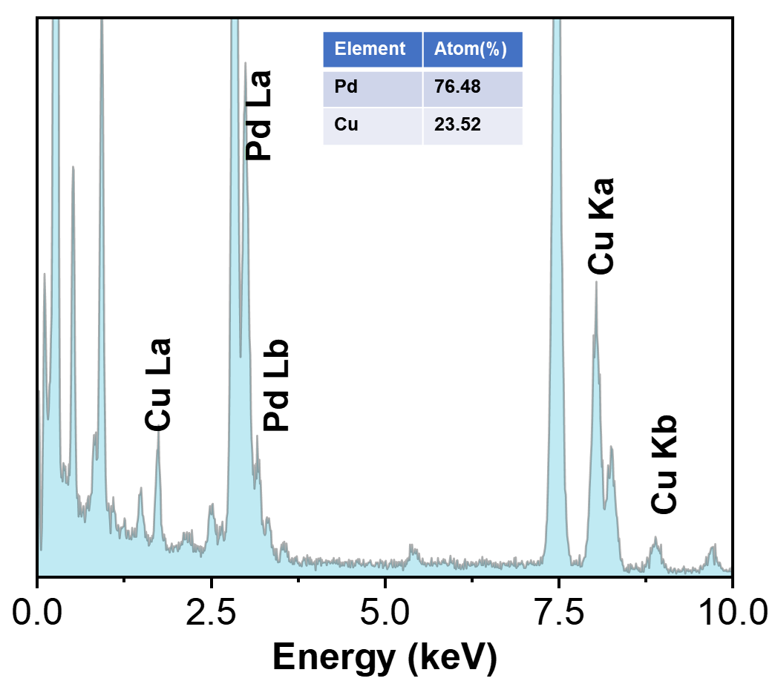
Figure S1. HAADF-STEM EDS spectra and (inset) corresponding atomic ratios of LM-PdCu.

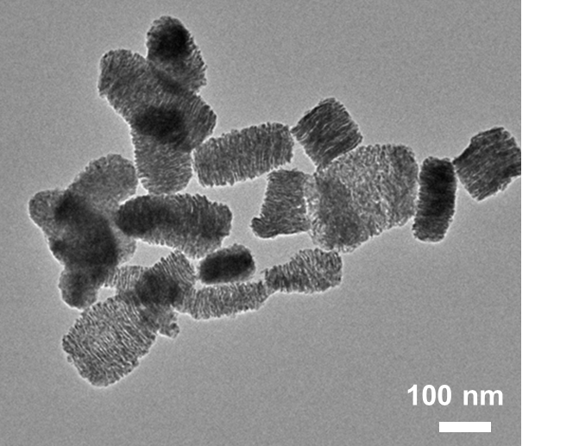
Figure S2. Low-magnification TEM image of monometallic LM-Pd.

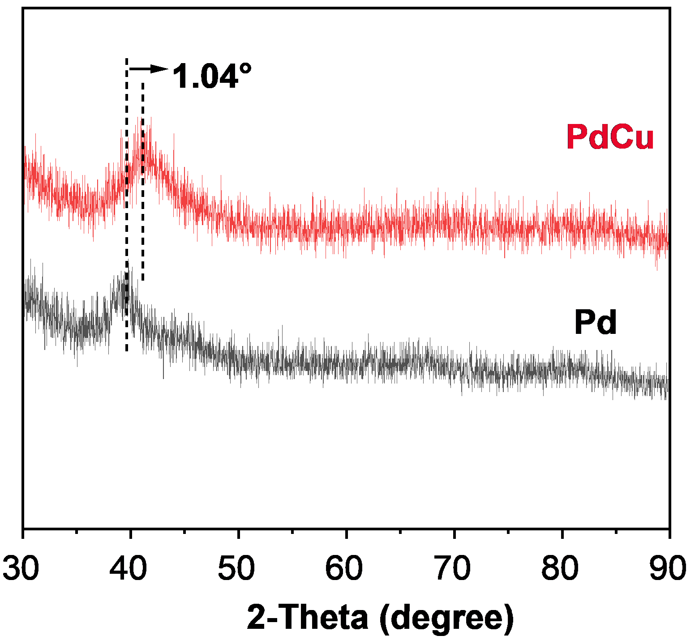
Figure S3. PXRD patterns of LM-PdCu and LM-Pd.

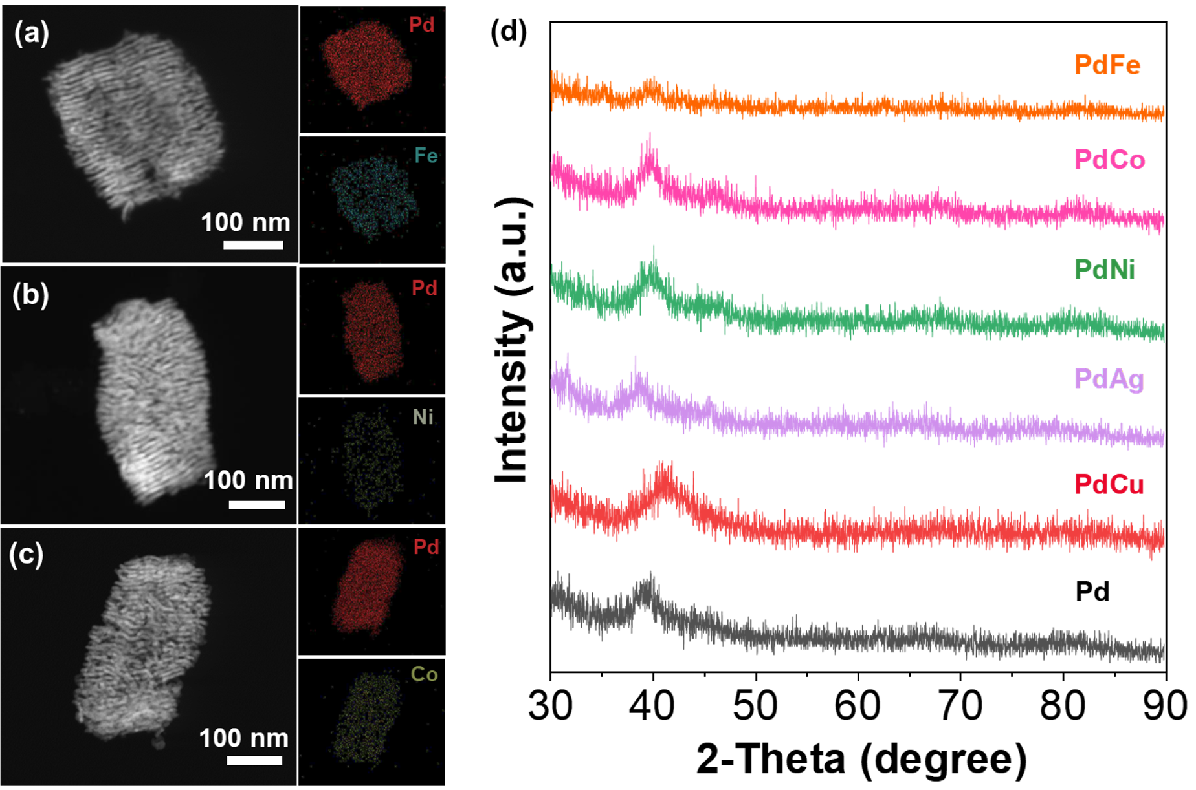
Figure S4. HAADF-STEM images and corresponding EDS mapping images of (a) LM-PdFe, (b) LM-PdNi, and (c) LM-PdCo. (d) PXRD patterns of LM-PdFe, LM-PdCo, LM-PdNi, LM-PdAg, LM-PdCu, and LM-Pd.

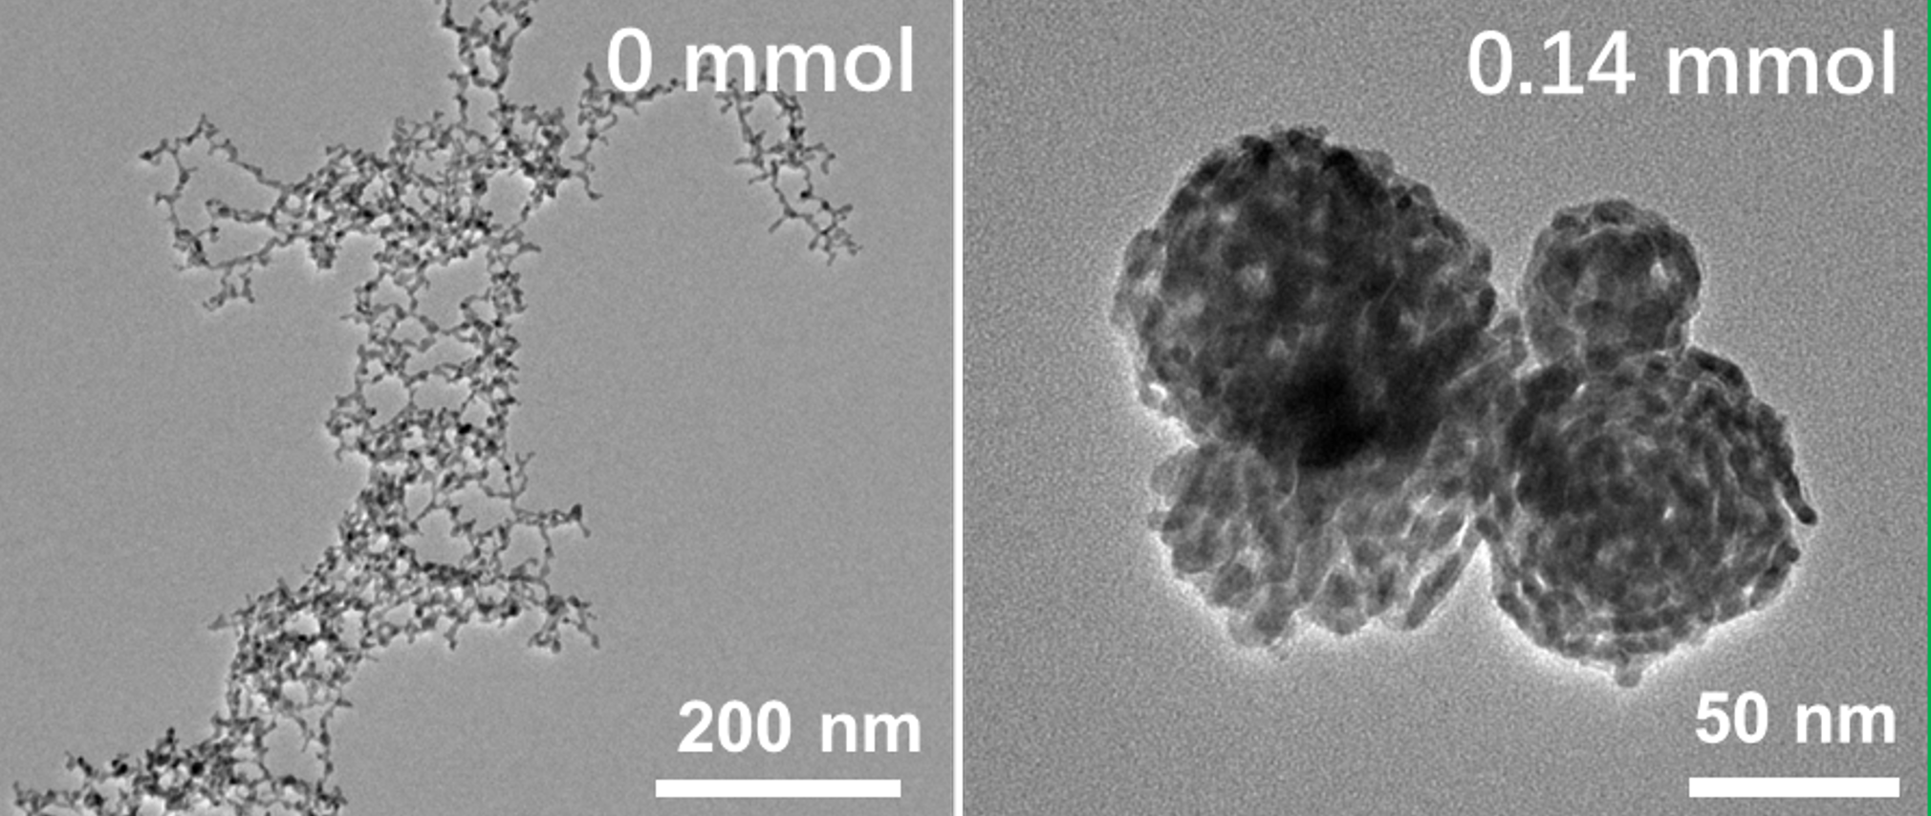
Figure S5. TEM images of PdCu nanostructures synthesized with different CTAB dosages of 0 mmol and 0.14 mmol.

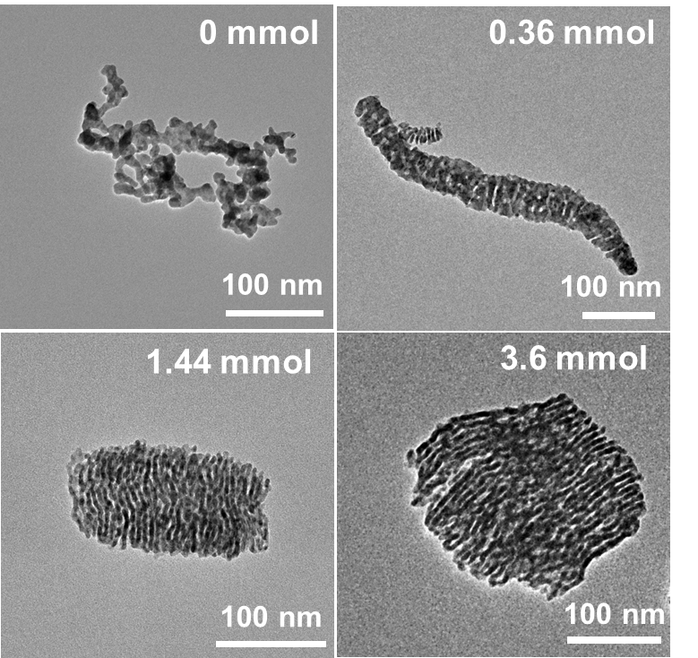
Figure S6. TEM images of PdCu nanostructures synthesized with different TMB dosages of 0 mmol, 0.36 mmol, 1.44 mmol, and 3.6 mmol.

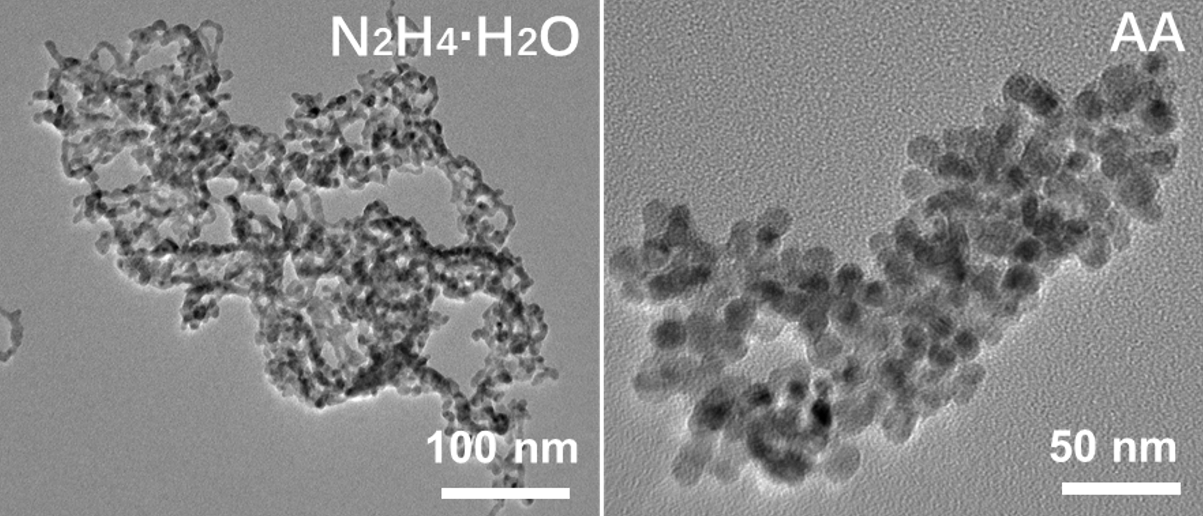
Figure S7. TEM images of PdCu nanostructures synthesized with different reducing agents of N₂H₄ and AA.

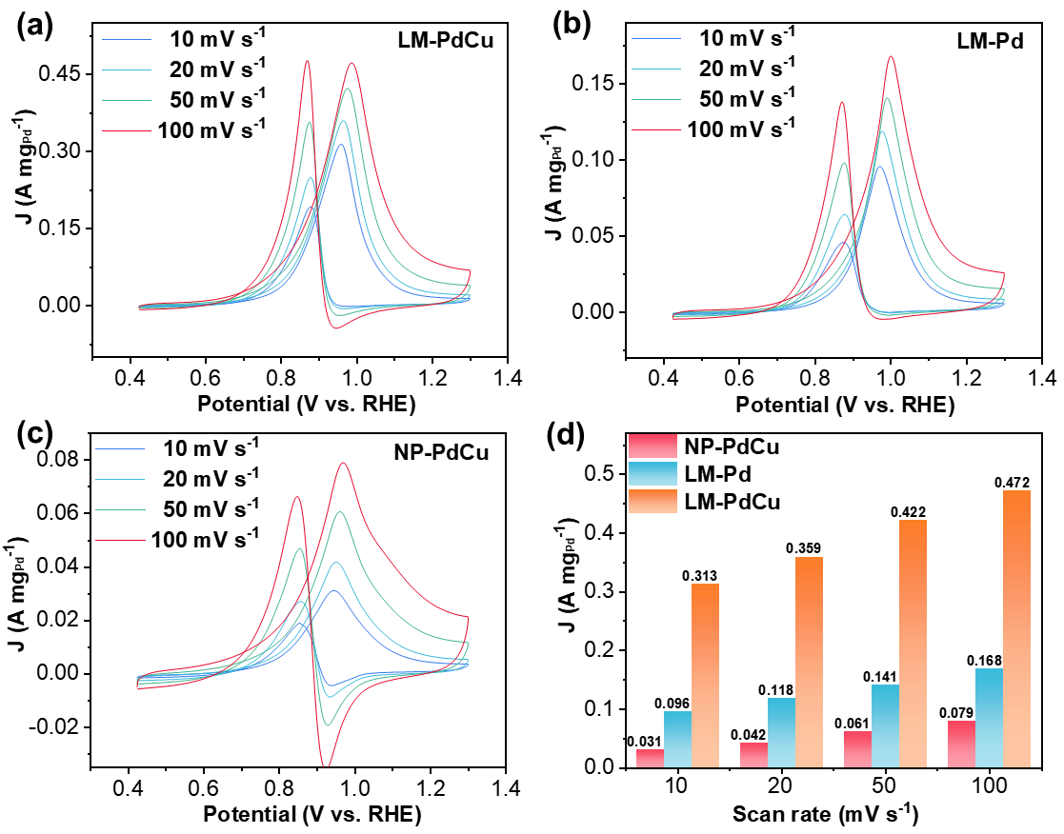
Figure S8. CV curves of (a) LM-PdCu, (b) LM-Pd, and (c) NP-PdCu collected at different sweep speeds. (d) Mass activities of LM-PdCu, LM-Pd, and NP-PdCu obtained at different sweep speeds.

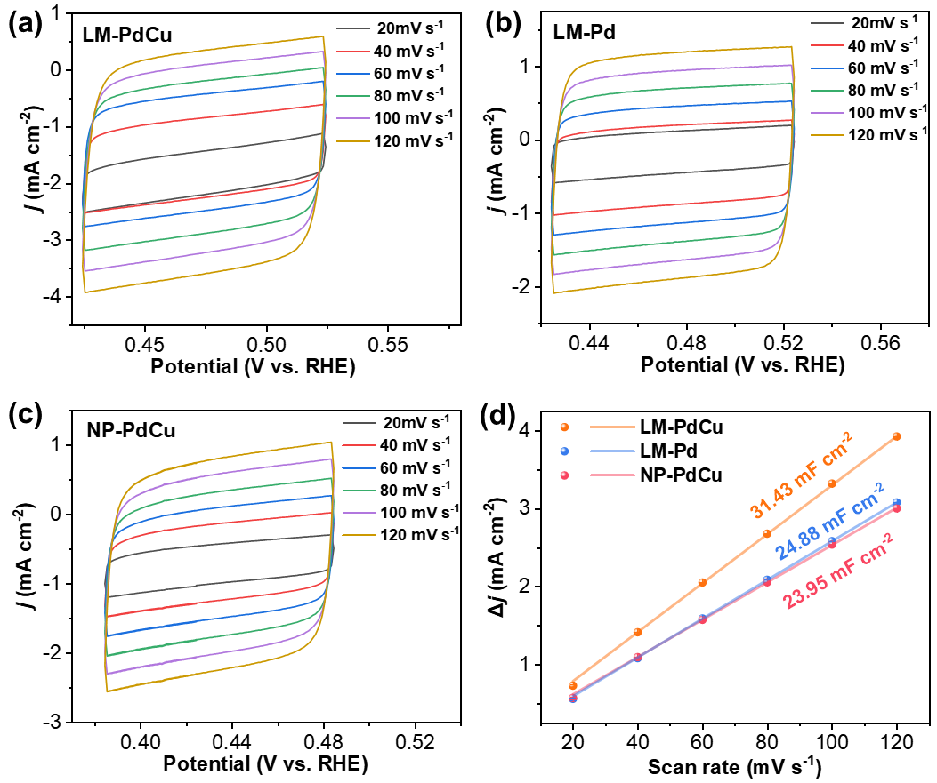
Figure S9. CV curves of (a) LM-PdCu, (b) LM-Pd, and (c) NP-PdCu collected at different sweep rates. (d) Summarized double–layer capacitance of LM-PdCu, LM-Pd, and NP-PdCu.

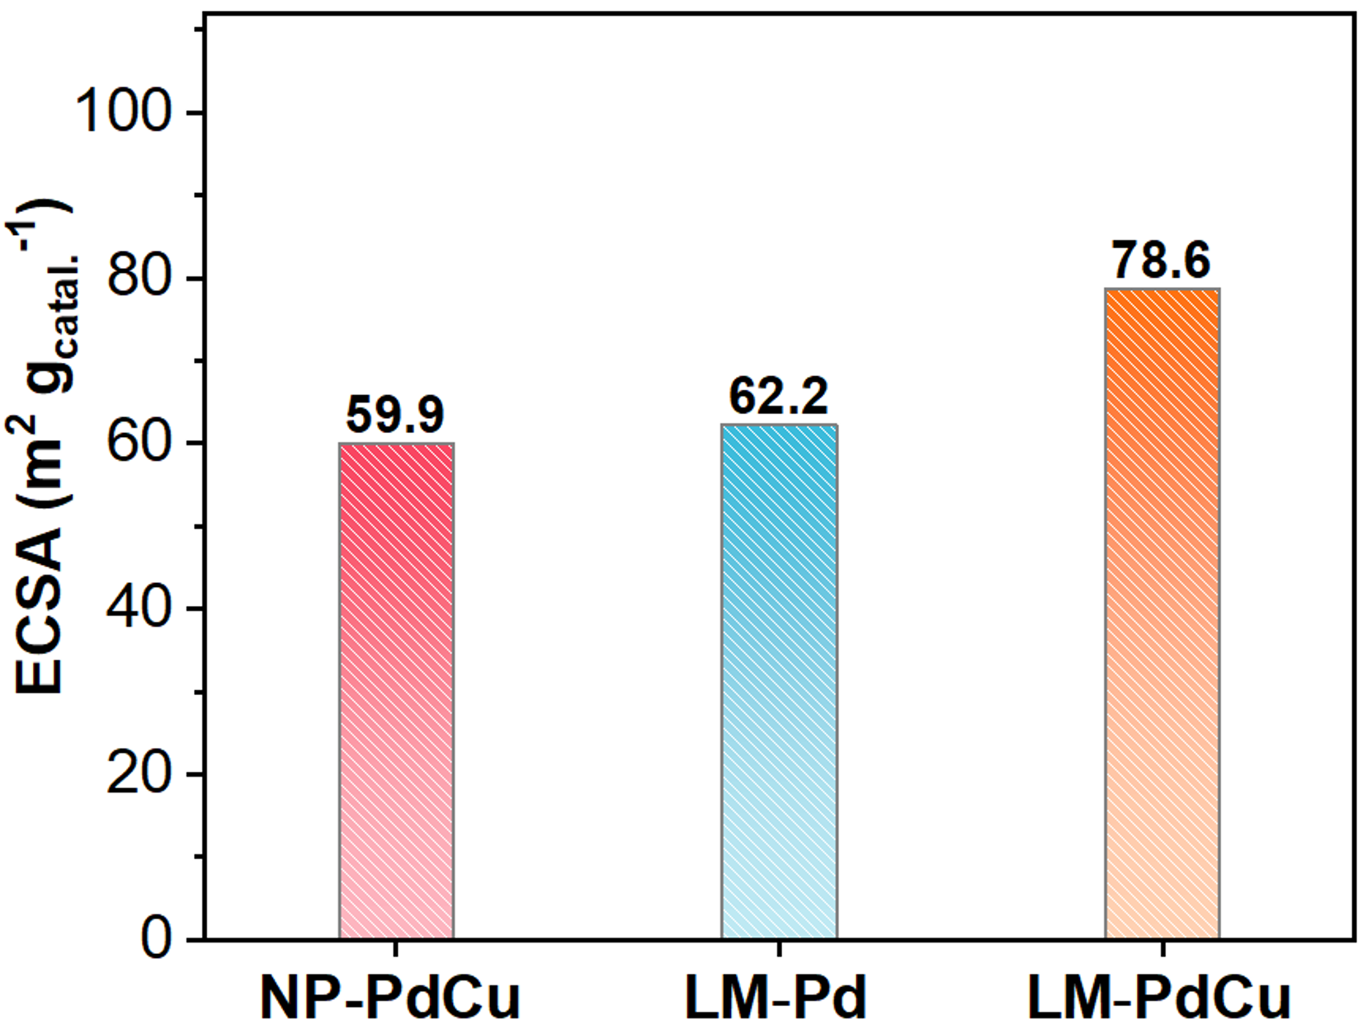
Figure S10. ECSA values of LM-PdCu, LM-Pd, and NP-PdCu.

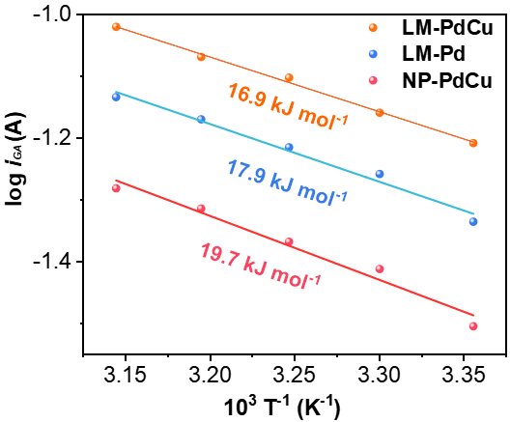
Figure S11. Apparent activation energy values of LM-PdCu, LM-Pd, and NP-PdCu.

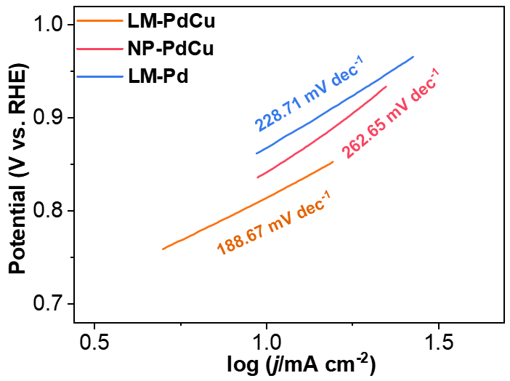
Figure S12. Tafel slope plots of LM-PdCu, LM-Pd, and NP-PdCu.

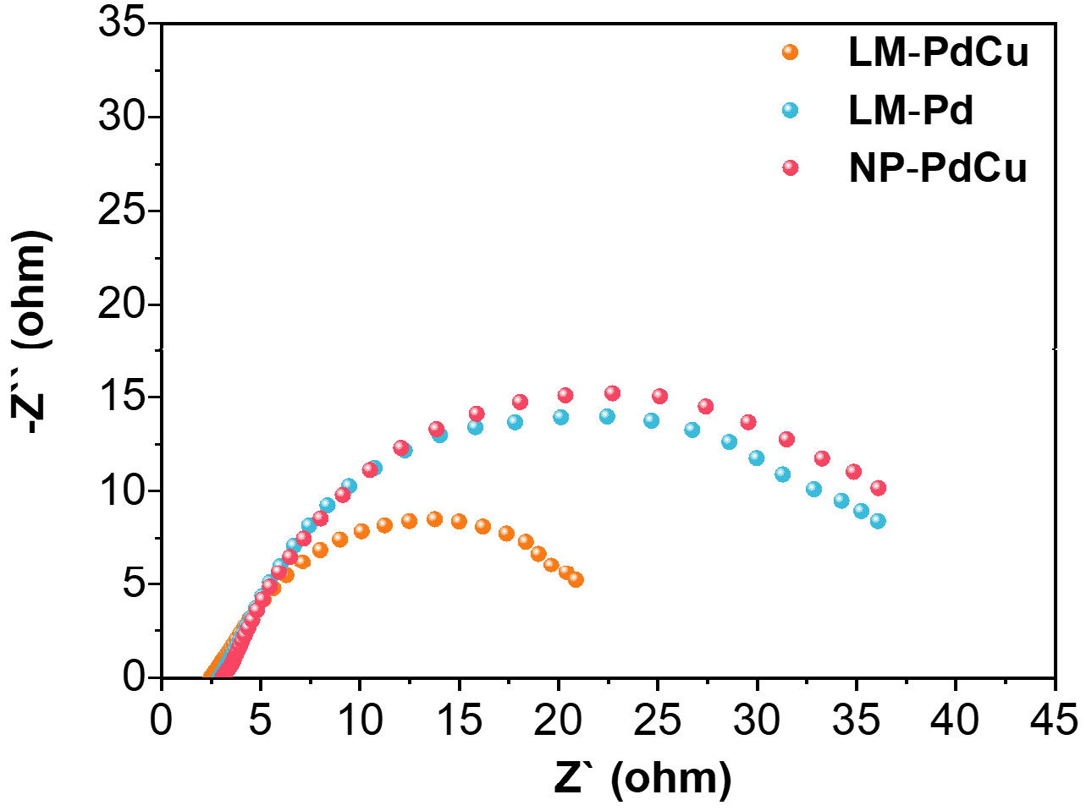
Figure S13. Electrochemical impedance spectra of LM-PdCu, LM-Pd, and NP-PdCu.

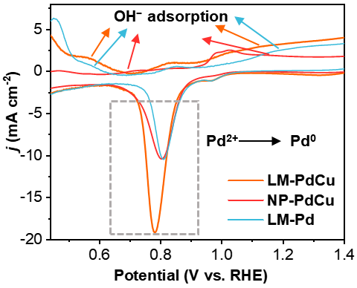
Figure S14. CV curves of LM-PdCu, LM-Pd, and NP-PdCu collected in 1.0 M.

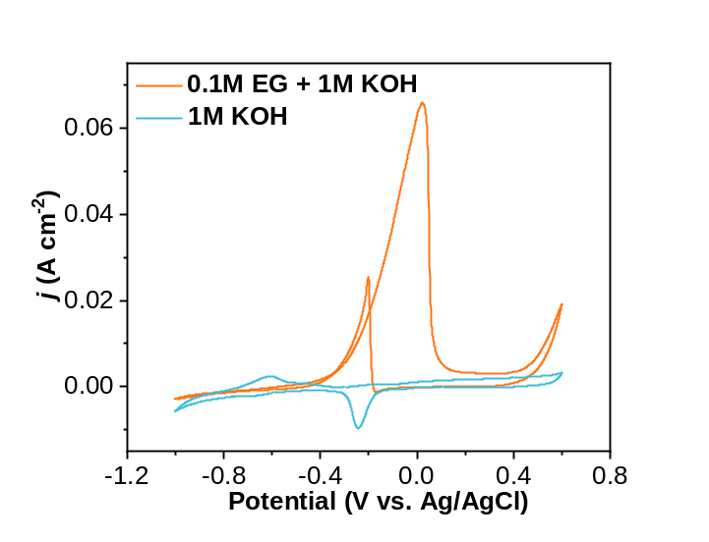
Figure S15. CV curves for the second lap in KOH and EG solutions at a scan rate of 5.0 mV s⁻¹.

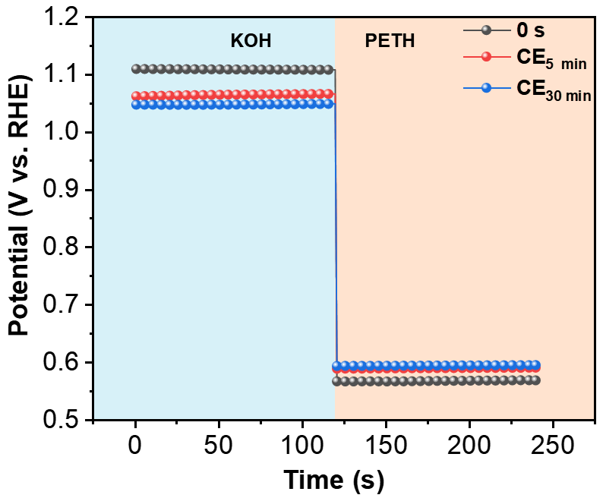
Figure S16. OCP tests after different electrocatalysis at CE mode.

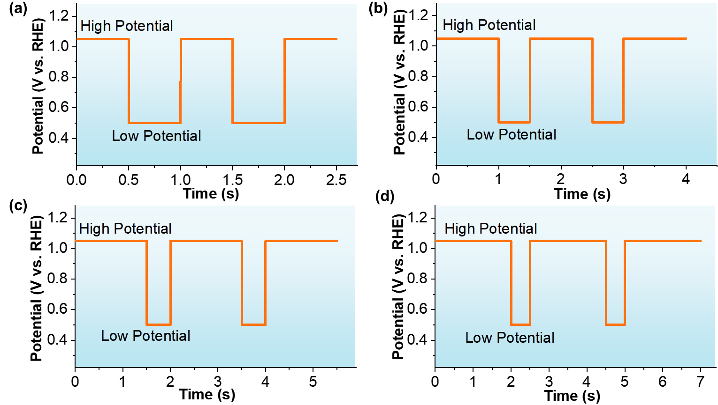
Figure S17. Output potentials of a pulsed square wave with different high potential duration times of (a) 0.5 s, (b) 1 s, (c) 1.5 s, and (d) 2 s.

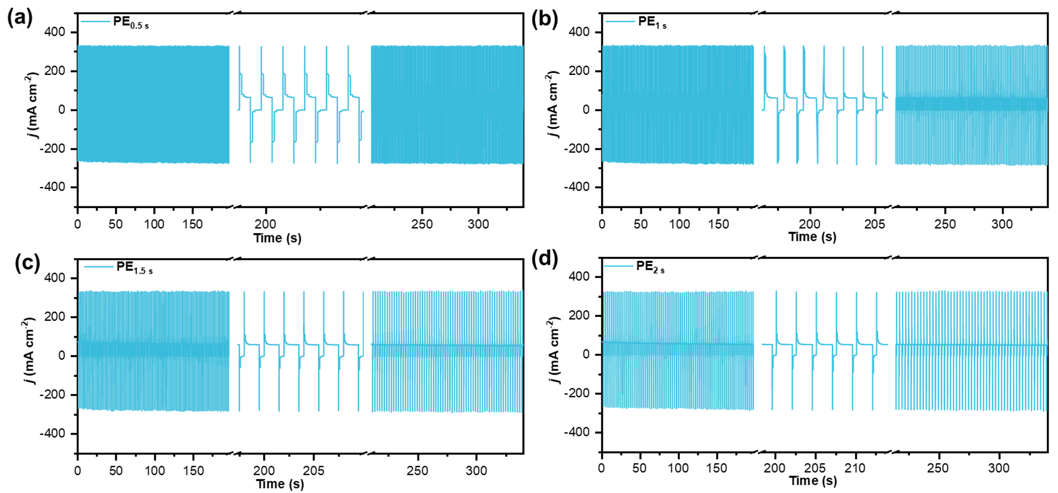
Figure S18. chronoamperometric curves at PE mode with high potential pulse duration times of (a) 0.5 s, (b) 1 s, (c) 1.5 s, and (d) 2 s.

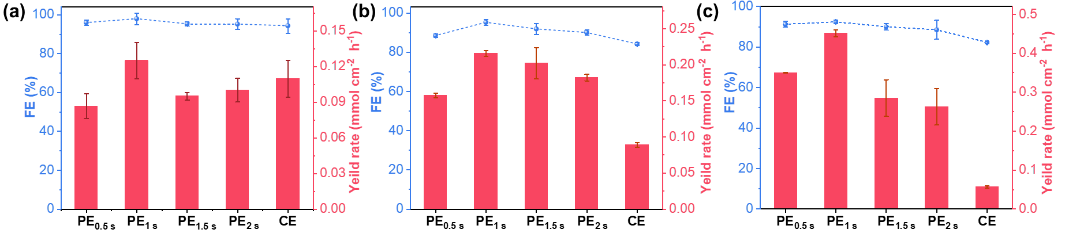
Figure S19. Electrocatalytic performance for GA electrosynthesis from PETH at (a) 0.85 V, (b) 0.95 V, and (c) 1.05 V.

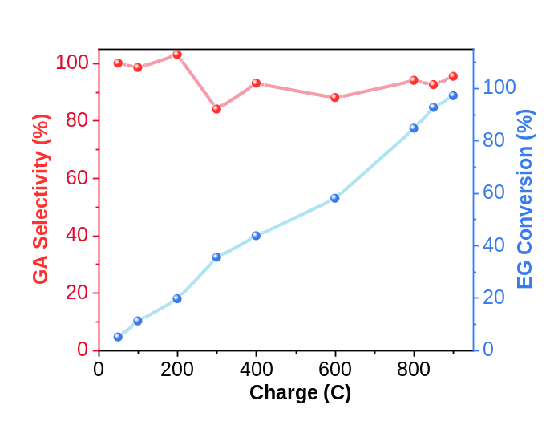
Figure S20. GA selectivity and EG conversion during electrocatalysis collected with different input charges.

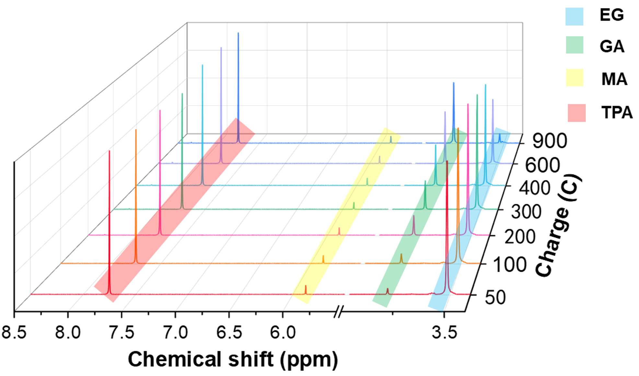
Figure S21. ¹H NMR spectra of changes in each substance during electrocatalysis collected with different input charges.

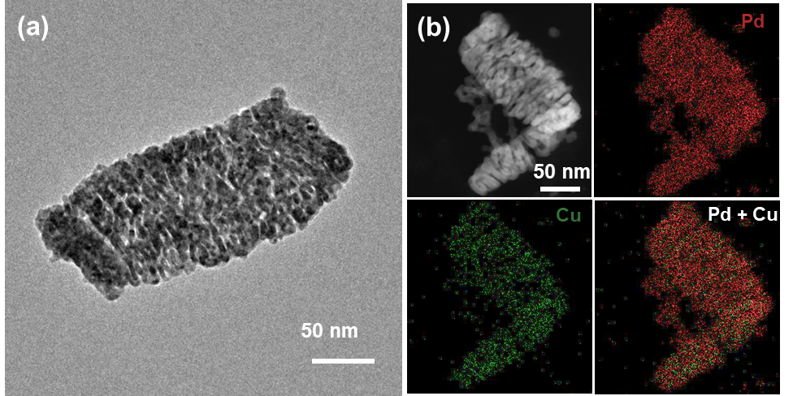
Figure S22. (a) TEM image and (b) HAADF-STEM EDS mapping images of LM-PdCu after cyclic stability test.

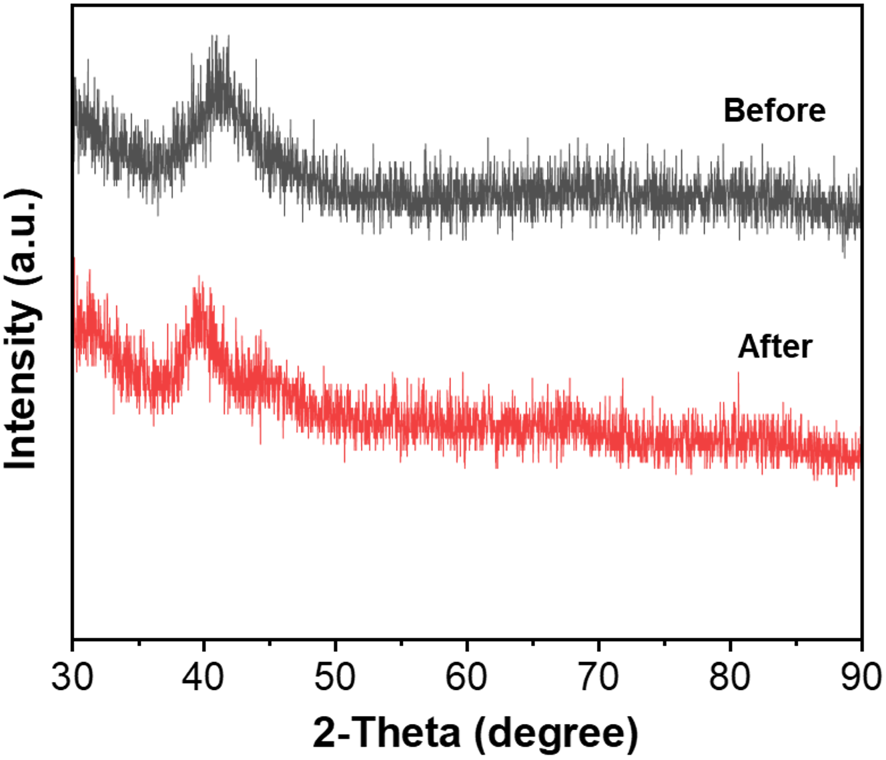
Figure S23. PXRD patterns of LM-PdCu before and after cyclic stability test.
Table S1. Performance comparisons of LM-PdCu with previously reported electrocatalysts for selective EG-to-GA electrocatalysis.
Catalysts | Electrolytes | Potential  (V vs. RHE) | Yield Rate  (mmol cm^{–2} h^{–1}) |  | Faraday  efficiency  (%) | Ref.
LM-PdCu | PET  hydrolysate  (1 M KOH) | 1.05 | 0.451 | 92.4 |  | This Work
Pd-Ni(OH)₂/NF | 1 M KOH +  1 M EG | 1.15 | – | 86 |  | Angew. Chem. Int. Ed. 62, e202300094 (2023)
PdCu MCs | PET  hydrolysate  (1 M KOH) | 0.8268 | 0.291 | 93.6 |  | Adv. Mater. 36, 2402767 (2024)
Pt/γ-NiOOH/NF | 1 M KOH +  1 M EG | 0.55 | 0.14 | 97.2 |  | Small 19, 2303693 (2023)
PdAg/NF | 1 M KOH +  1 M EG | 0.91 | 0.15 | 92 |  | Chem. Catal. 1, 941 (2021)
Pd NTs/NF | PET  hydrolysate  (1 M KOH) | 0.57 | – | 87.9 |  | ACS Catal. 13, 10394 (2023)
Au/Ni(OH)₂ | 3 M KOH +  0.3 M EG | 1.15 | 2.24 | 91 |  | J. Am. Chem. Soc. 145, 6144 (2023)

Table S2. Comparison of current retention rate of LM-PdCu in EGOR electrocatalysis with noble metal-based catalysts reported in the literature.
Catalysts | Electrolytes | Current  retention rate | Ref.
LM-PdCu | PETH  (1 M KOH) | 42.8% | This Work
PdCu | 1 M KOH + 1 M EG | 5% | Chem. Eng. J. 438, 135666 (2022)
Pd-PdSe | 1 M KOH + 1 M EG | 40.8% | Angew. Chem. Int. Ed. 61, e202200899 (2022)
Pd₉Ru₁ | 1 M KOH + 1 M EG | 16.3% | J. Colloid Interface Sci. 601, 42 (2021)
Pt_{53.1}Bi_{43.4}Au_{3.5} | 1 M KOH + 0.5 M EG | 25% | Adv. Funct. Mater. 31, 2103671 (2021)
Au@PdPt | 1 M KOH + 1 M EG | 36% | Adv. Energy Mater. 11, 2100812 (2021)
Pd₇Ag NSs | 0.5 M KOH + 1 M EG | 37% | Adv. Funct. Mater. 30, 2000255 (2020)
Pd₆₂Au₂₁Ni₁₇ | 0.5 M KOH + 0.5 M EG | 10% | Energy Environ. Sci. 9, 3097 (2016)
PdCu | 1 M KOH + 1 M EG | 23% | Electrochim. Acta  245, 227-236 (2017)
Pd₂Ag₁ | 1 M KOH + 1 M EG | 4.9% | J. Power Sources 418, 186 (2019)
Pd₁Au₁Ag₁ | 1 M KOH + 1 M EG | 18.2% | Nanoscale 9, 17004 (2017)
Pd₅₂-Ni₄₈/ NSCNT/CA | 0.5 M KOH + 0.5 M EG | 12.5% | Adv. Energy Mater. 9, 1800684 (2019)
Pd₂Cu | 1 M KOH + 1 M EG | 15.5% | Appl. Surf. Sci. 481, 1532 (2019)

