Supplementary material

Article title: Prenatal octamethylcyclotetrasiloxane exposure impairs brain development and subsequent motor, cognition, social and behavioral functions.

Dinh Nam Tran¹, Seon-Mi Park¹, Eui-Man Jung² and Eui-Bae Jeung^{*1}.

¹Laboratory of Veterinary Biochemistry and Molecular Biology, Veterinary Medical Center and College of Veterinary Medicine, Chungbuk National University, Cheongju, Chungbuk 28644 Republic of Korea.
²Laboratory of Molecular Developmental Biology, Department of Molecular Biology, College of Natural Sciences, Pusan National University, Busandaehang-ro, 63beon-gil 2, Geumjeong-gu, Busan 46241, Republic of Korea

*Correspondence: Prof. Eui-Bae Jeung, D.V.M., Ph. D. Laboratory of Veterinary Biochemistry and Molecular Biology, Veterinary Medical Center and College of Veterinary Medicine, Chungbuk National University, Cheongju, Chungbuk 28644 Republic of Korea
Phone: +82-43-261-2397; Fax: +82-43-267-3150; Email: ebjeung@chungbuk.ac.kr

Contents:
Supplemental Methods
Supplementary Figures 1 to 2 and Legends

Supplemental Methods

Behavioral Analysis

All experiments were performed between 8:00 AM and 2:00 PM in an empty testing room within the animal vivarium. On testing days, mice were habituated in the test room for at least 1 h before the start of testing and the testing was performed by laboratory technicians blinded to the mouse group information. A test-free period of 2 days to 1 week was used between two consecutive tests. All experimental areas were cleaned with 70% ethanol before the tests and between subjects. The animal number is reported in Figure legends and Supplementary Table 1.
Open field test. Open field consisted of a large acrylic cube measuring 50 cm tall, 60 cm wide with a white bottom and mice were automatically video-tracked using EthoVision XT14 software (Noldus, Leesburg, VA, USA). Mice were individually placed near the wall-side and locomotor behavior was recorded for 5 min. Time spent in the center zone (15x 15 cm), velocity and distance traveled was evaluated.
Morris water maze test. Spatial learning and memory were measured using a circular pool (90 cm diameter, 40 cm high), filled with water (25±1ºC) and the water was made opaque by adding skim milk. The tank was and divided into four equal quadrants (Q1-4) by lines drawn on the floor. Mice were trained to locate a platform (10 cm diameter, 20 cm high) made of plexiglass was placed in the middle of a Q3 (12 cm from the pool’s edge and 1 cm below the surface of the water) with visual cues on the pool walls as spatial references. Over a period of 9 days (cue training (4 days) and followed by spatial training (5 days), mice received four training trials with an intertrial interval of 3 to 5 min. Each trial ended when the mice had reached the submerged platform within 60 s. If the mice failed to reach the platform within 60 s, the experimenter gently guided the mice to the platform allowed to rest on it for 30 s. The mean of escape latencies (second) for 4 trials is represented for the learning result for each mouse. Following the completion of spatial learning, spatial memory was measured using a 60 s probe trial (with the platform was removed from the pool) 24 h following completion of the last training session. Video recordings of the probe trial were analyzed using EthoVision XT14 and spatial memory was scored as the time spent in the target platform where the platform was positioned during training.
Novel object recognition test. A test mouse was placed into an empty open field arena and allowed to explore freely during a 5-minute habituation period. The following day, in the familiarization session, the subject mice were placed into the open field arena in the presence of two identical objects (2 cm width× 5cm length× 9 cm tall in opposite corners of the arena, 7cm from the side walls) and freely explored for 10 min. The mouse was returned to its home cage, and after 6 hours, one of the objects was replaced by a novel object (different shape and color compared to the old object). The subject mice were again introduced in the arena and allowed to explore for another 10 min. The duration of time mice spent exploring with familiar object vs novel object (sniffing or exploring at distance within 2 cm of the object) were recorded. Videos were analyzed using EthoVision XT14.
Rotarod test. Motor coordination was assessed in an accelerating rotarod test (4–40 r.p.m.) using a Rota Rod (Panlab, Sydney, Australia). Mice were introduced in a rotarod apparatus rotating drums (3cm in diameter) and measuring retention time on the rod. Mice were given a 3-day training period with the speed of the rotarod accelerating from 4 to 40 rpm over 10 minutes. The following a 7-day testing period was conducted (day: 4, 6, 8, 10, 14, 16, and 20) with the speed of the rotarod accelerating from 4 to 40 rpm over 5 minutes. Three trials per day were conducted. At least 20min recovery time was allowed between trials.
Hanging-wire grip test. A hanging-wire grip test apparatus was performed to assess balance and grip strength. The apparatus consists of a box (42 × 42 × 42 cm) with a wire-mesh grid (20 × 20 cm) on top that can be inverted. Mice were placed on the wire mesh, which was then inverted, causing the animal to grip the wire. The latency to the mouse falling was recorded, with a 90 s cutoff time and scored as follows: 1, falls off within 10 s; 2, falls off within 11 - 25 s; 3, falls off within 26 - 60 s; 4, falls off within 61 - 90 s; 5, falls off after 90 s. Mice were individually assessed and the mean score of each group was determined.
Three-chamber social test. The three-chambered apparatus consisted of three Plexiglas chambers, each chamber was 20 cm width× 40 cm length× 22 cm tall and the dividing walls were made from clear Plexiglas, with small rectangular openings (5 × 3 cm) allowing access into each chamber. Both side chambers contained a cylindrical plastic cage (17 cm in height, a bottom diameter of 8 cm with the bars spaced 1 cm apart) in the corner that used to hold the stranger mice. First, the subject mouse was placed in the middle chamber and allowed to freely explore all three chambers with an empty plastic cage in each side chamber for the 5 min habituation period. For sociability testing, an unfamiliar same age, sex, and weight-matched (within 5 g) mouse was placed in a cylindrical plastic cage in one of the side chambers (Stranger 1- ‘S1’), and an empty cylindrical plastic cage (Empty - ‘E’) on the other side-chamber. Then, the subject mouse was placed in the center chamber and allowed to freely explore all three chambers for 10 min while being video recorded. For the social novelty test, a wild-type stimulus mouse (Stranger 2- ‘S2’) was placed in the empty plastic cage and the subject mouse again freely explored all three chambers for 10 min. The time spent in each chamber was video-tracked using Ethovision XT14 software. The preference index for each animal was calculated as: Preference index = $\frac{(S1-E)}{(S1+E)}$ or as $\frac{(S2-S1)}{(S2+S1}$: where ‘E’, ‘S1’ and ‘S2’ are the time spent in close proximity with empty cage, the stranger animal 1 and 2, respectively.
Forced swimming test. A mouse was gently placed into a glass cylinder (20 cm height, 17 cm diameter) filled with water to a depth of 12 cm at 25°C. All mice were forced to swim for 5 min and then were removed from the water, dried, and returned to their home cages. 24 h later, the mice were again placed in the cylinder, and acclimatized for 1 minute, followed by a testing period of 5 minutes in which the duration of immobility was measured. Videos were analyzed using EthoVision XT14.
Marble burying test. Mice were individually placed in a Plexiglas cage (25 cm width × 40 cm length × 18 height cm) containing 5 cm-deep fresh, unscented mouse bedding material (corn cob bedding) for 10 min before the test. Then the mouse was removed from the testing cage and 20 glass marbles (15 mm diameter) were carefully overlaid equidistantly from each other in a 4 × 5 arrangement on the surface of the bedding. The mouse was placed into a corner of the cage and allowed to bury marbles for 30 min. The mouse was removed from the cage and the marbles were imaged and scored by a scorer blinded to the conditions. A marble was considered buried if more than 75% marble was covered by the bedding.
Grooming test. Mice were placed in a separate clear plastic cage (17×32×14cm). Self-grooming behavior was recorded for 10 min. Self-grooming was defined as scratching of face, head, or body with the two forelimbs, or licking body parts. Cumulative time spent grooming was scored for each mouse.
Nesting test. Mice were individually placed in its one clean cage with a nestlet of tissue cotton (5× 5 cm, mean weight 2.5 g) at 7:00 AM and recorded 12 h later. Nest quality produced by each mouse was assessed according to a 5-point rating scale from 1 to 5 as follows (Deacon, 2006). All mice were assessed together and the mean score of each group was determined.

Supplemental references
Deacon RM (2006) Assessing nest building in mice. Nature protocols 1:1117-1119.

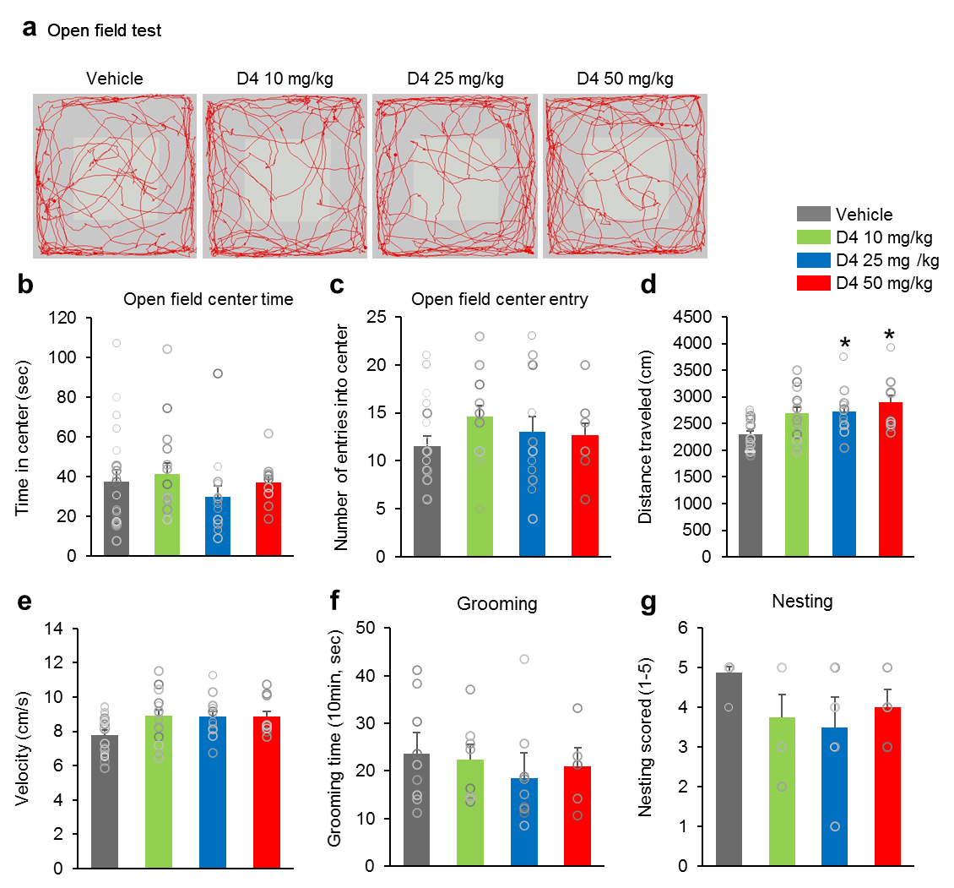
Fig. S1 Prenatal D4 did no elevates anxiety-like behavior. (a) Representative tracing of mouse travel in the open field test. (b, c, d, e) Quantification of (a). D4-treated groups displayed no difference in both open field center time (F_{3,50} = 0.5989, p = 0.6185), open field center entry (F_{3,50} = 1.149, p = 0.3379) and velocity (F_{3,50} = 2.434, p = 0.0755) compared to vehicle group. However, D4 25 mg/kg and D4 50 mg/kg groups showed increased in the moving distances (F_{3,50} = 7.702, p = 0.0002). n = 13 mice (8 male, 5 female) for vehicle, 15 mice (8 male, 7 female) for D4 10 mg/kg, 13 mice (7 male, 6 female) for D4 25 mg/kg,10 mice (5 male, 5 female) for D4 50 mg/kg. In grooming test. (F, G) In grooming and nesting test, D4-treated groups also showed no significant difference (grooming; F_{3,32} = 0.4932, p = 0.6904; nesting; F_{3,32} = 2.506, p = 0.0787). n = 8-10 per group. Data represent mean ± SEM. Statistical significance was determined by one-way ANOVA with Bonferroni correction. *p < 0.05 vs. vehicle

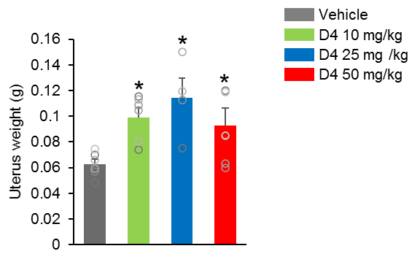
Fig. S2 D4 increased uterine weight. D4-treated groups exhibited slightly higher in the uterine weight than in those of Vehicle group (F_{3,21} = 6.731, p = 0.0019). n = 6 mice for vehicle, 6 mice for D4 10 mg/kg, 4 mice for D4 25 mg/kg, 7 mice for D4 50 mg/kg. Data represent mean ± SEM. Statistical significance was determined by one-way ANOVA with Bonferroni correction. *p < 0.05 vs. vehicle

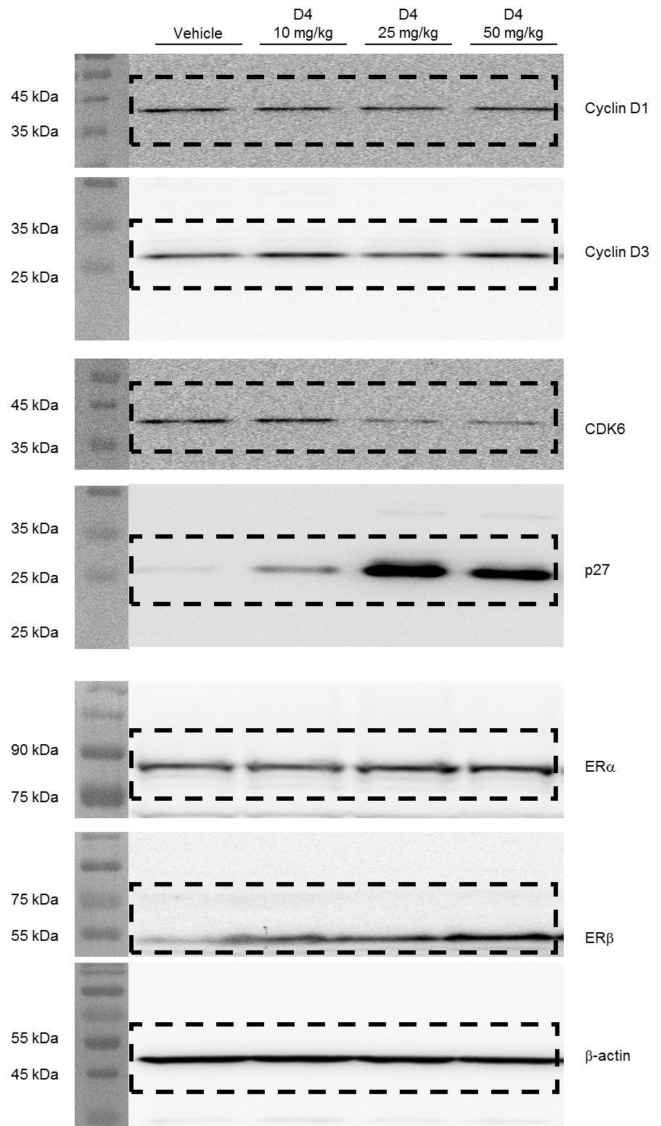
Fig. S3. Full length Western blots.
Full length Western blots for cropped images in Fig. 7a

Table S1 Behavior statistic data
Test | Duration | Measurement | Number of animals | Values |  | Statistical test
 |  |  |  | Day1 | VE = 51.16 ± 2.52 | One-way ANOVA with Bonferroni correction test
 |  |  |  | Day1 | D4 10 = 56.43 ± 1.81 | One-way ANOVA with Bonferroni correction test
 |  |  |  | Day1 | D4 25 = 52.84 ± 2.44  D4 50 = 54.04 ± 1.49 | One-way ANOVA with Bonferroni correction test
 |  |  |  | Day2 | VE = 28.67 ± 2.82 | One-way ANOVA with Bonferroni correction test
 |  |  |  | Day2 | D4 10 = 32.94 ± 3.21 | One-way ANOVA with Bonferroni correction test
 |  |  |  | Day2 | D4 25 = 33.21 ± 3.57  D4 50 = 46.05 ± 2.81 | One-way ANOVA with Bonferroni correction test
 |  |  |  | Day3 | VE = 19.59 ± 1.99 | One-way ANOVA with Bonferroni correction test
 |  |  |  | Day3 | D4 10 = 25.69 ± 2.98 | One-way ANOVA with Bonferroni correction test
 |  |  |  | Day3 | D4 25 = 30.34 ± 3.54  D4 50 = 37.04 ± 7.39 | One-way ANOVA with Bonferroni correction test
 |  |  |  | Day4 | VE = 15.61 ± 1.54 | One-way ANOVA with Bonferroni correction test
 |  |  |  | Day4 | D4 10 = 19.36 ± 2.67 | One-way ANOVA with Bonferroni correction test
 |  |  |  | Day4 | D4 25 = 25.83 ± 3.45  D4 50 = 30.25 ± 3.56 | One-way ANOVA with Bonferroni correction test
 |  |  |  | Day5 | VE = 9.00 ± 0.58 | One-way ANOVA with Bonferroni correction test
 |  |  |  | Day5 | D4 10 = 11.55 ± 1.53 | One-way ANOVA with Bonferroni correction test
 |  |  |  | Day5 | D4 25 = 17.56 ± 2.48  D4 50 = 28.36 ± 3.84 | One-way ANOVA with Bonferroni correction test
 |  |  |  | Day6 | VE = 9.44 ± 0.62 | One-way ANOVA with Bonferroni correction test
Morris water maze | 1 min | Escape latency (sec) | VE = 10  D4 10 = 11  D4 25 = 11  D4 50 = 10 | Day6 | D4 10 = 10.64 ± 0.99 | One-way ANOVA with Bonferroni correction test
 |  |  |  |  | D4 25 = 16.77 ± 2.56  D4 50 = 26.23 ± 3.15 | One-way ANOVA with Bonferroni correction test
 |  |  |  | Day7 | VE = 6.27 ± 0.90 | One-way ANOVA with Bonferroni correction test
 |  |  |  |  | D4 10 = 7.42 ± 1.13 | One-way ANOVA with Bonferroni correction test
 |  |  |  | Day7 | D4 25 = 10.45 ± 1.96  D4 50 = 22.04 ± 3.62 | One-way ANOVA with Bonferroni correction test
 |  |  |  | Day8 | VE = 4.25 ± 0.42 | One-way ANOVA with Bonferroni correction test
 |  |  |  | Day8 | D4 10 = 5.59 ± 0.71 | One-way ANOVA with Bonferroni correction test
 |  |  |  | Day8 | D4 25 = 6.68 ± 0.86  D4 50 = 16.33 ± 3.12 | One-way ANOVA with Bonferroni correction test
 |  |  |  | Day9 | VE = 5.14 ± 0.64 | One-way ANOVA with Bonferroni correction test
 |  |  |  | Day9 | D4 10 = 5.48 ± 0.67 | One-way ANOVA with Bonferroni correction test
 |  |  |  | Day9 | D4 25 = 5.45 ± 0.78  D4 50 = 18.33 ± 3.54 | One-way ANOVA with Bonferroni correction test
 |  | Platform crossing |  |  | VE = 5.86 ± 0.70 | One-way ANOVA with Bonferroni correction test
 |  | Platform crossing |  |  | D4 10 = 4.94 ± 0.52 | One-way ANOVA with Bonferroni correction test
 |  | Platform crossing |  |  | D4 25 = 4.28 ± 0.54  D4 50 = 2.60 ± 0.56 | One-way ANOVA with Bonferroni correction test
 |  | Distance move (cm) |  |  | VE = 562.80 ± 41.05 | One-way ANOVA with Bonferroni correction test
 |  | Distance move (cm) |  |  | D4 10 = 660.67 ± 42.30 | One-way ANOVA with Bonferroni correction test
 |  | Distance move (cm) |  |  | D4 25 = 521.44 ± 41.70  D4 50 = 506.72 ± 68.67 | One-way ANOVA with Bonferroni correction test
 |  | Velocity (cm/s) |  |  | VE = 9.17 ± 0.67 | One-way ANOVA with Bonferroni correction test
 |  | Velocity (cm/s) |  |  | D4 10 = 10.84 ± 0.69 | One-way ANOVA with Bonferroni correction test
 |  | Velocity (cm/s) |  |  | D4 25 = 8.28 ± 0.71  D4 50 = 7.02 ± 1.23 | One-way ANOVA with Bonferroni correction test
 |  |  |  | Day1 | VE = 76.95 ± 13.13 | One-way ANOVA with Bonferroni correction test
 |  |  |  | Day1 | D4 10 = 36.29 ± 5.04 | One-way ANOVA with Bonferroni correction test
 |  |  |  | Day1 | D4 25 = 38.08 ± 6.47  D4 50 = 21.38 ± 3.56 | One-way ANOVA with Bonferroni correction test
 |  |  |  | Day2 | VE = 113.21 ± 7.67 | One-way ANOVA with Bonferroni correction test
 |  |  |  | Day2 | D4 10 = 68.17 ± 10.00 | One-way ANOVA with Bonferroni correction test
 |  |  |  | Day2 | D4 25 = 74.58 ± 6.88  D4 50 = 49.76 ± 6.42 | One-way ANOVA with Bonferroni correction test
 |  |  |  | Day3 | VE = 120.67 ± 7.13 | One-way ANOVA with Bonferroni correction test
 |  |  |  | Day3 | D4 10 = 107.58 ± 11.34 | One-way ANOVA with Bonferroni correction test
 |  |  |  | Day3 | D4 25 = 112.63 ± 11.62  D4 50 = 70.81 ± 6.79 | One-way ANOVA with Bonferroni correction test
 |  |  |  | Day4 | VE = 93.26 ± 5.16 | One-way ANOVA with Bonferroni correction test
 |  |  |  | Day4 | D4 10 = 91.33 ± 7.55 | One-way ANOVA with Bonferroni correction test
 |  |  |  | Day4 | D4 25 = 63.20 ± 5.66  D4 50 = 59.86 ± 5.01 | One-way ANOVA with Bonferroni correction test
 |  |  |  | Day6 | VE = 103.74 ± 5.11 | One-way ANOVA with Bonferroni correction test
 |  |  |  | Day6 | D4 10 = 97.42 ± 5.52 | One-way ANOVA with Bonferroni correction test
 |  |  |  | Day6 | D4 25 = 72.08 ± 6.42  D4 50 = 64.95 ± 6.30 | One-way ANOVA with Bonferroni correction test
 |  |  |  | Day8 | VE = 110.74 ± 6.04 | One-way ANOVA with Bonferroni correction test
Rotarod | 5 min | Latency to fall (sec) | VE = 10  D4 10 = 10  D4 25 = 10  D4 50 = 10 | Day8 | D4 10 = 98.56 ± 3.72 | One-way ANOVA with Bonferroni correction test
 |  |  |  |  | D4 25 = 85.58 ± 6.83  D4 50 = 76.42 ± 5.11 | One-way ANOVA with Bonferroni correction test
 |  |  |  | Day10 | VE = 116.39 ± 6.70 | One-way ANOVA with Bonferroni correction test
 |  |  |  |  | D4 10 = 103.71 ± 8.72 | One-way ANOVA with Bonferroni correction test
 |  |  |  | Day10 | D4 25 = 88.00 ± 5.40  D4 50 = 77.66 ± 4.62 | One-way ANOVA with Bonferroni correction test
 |  |  |  | Day14 | VE = 111.63 ± 5.04 | One-way ANOVA with Bonferroni correction test
 |  |  |  | Day14 | D4 10 = 108.63 ± 8.75 | One-way ANOVA with Bonferroni correction test
 |  |  |  | Day14 | D4 25 = 82.35 ± 6.03  D4 50 = 76.75 ± 5.07 | One-way ANOVA with Bonferroni correction test
 |  |  |  | Day16 | VE = 108.28 ± 5.35 | One-way ANOVA with Bonferroni correction test
 |  |  |  | Day16 | D4 10 = 106.04 ± 8.54 | One-way ANOVA with Bonferroni correction test
 |  |  |  | Day16 | D4 25 = 82.00 ± 7.08  D4 50 = 76.05 ± 3.74 | One-way ANOVA with Bonferroni correction test
 |  |  |  | Day20 | VE = 106.62 ± 3.08 | One-way ANOVA with Bonferroni correction test
 |  |  |  |  | D4 10 = 110.95 ± 6.16 | One-way ANOVA with Bonferroni correction test
 |  |  |  |  | D4 25 = 83.60 ± 7.54 | One-way ANOVA with Bonferroni correction test
 |  |  |  |  | D4 50 = 76.76 ± 3.78 | One-way ANOVA with Bonferroni correction test
Novel object recognition | 10 min | Recognition index (%) | VE = 14  D4 10 = 12  D4 25 = 12  D4 50 = 10 |  | VE; Familiar = 41.67 ± 6.80 | Two-tailed Student’s t test
 |  |  |  |  | VE; Novel = 58.33 ± 6.80 | Two-tailed Student’s t test
 |  |  |  |  | D4 10; Familiar = 44.61 ± 4.58 | Two-tailed Student’s t test
 |  |  |  |  | D4 10; Novel = 55.39 ± 4.58 | Two-tailed Student’s t test
 |  |  |  |  | D4 25; Familiar = 55.28 ± 2.72 | Two-tailed Student’s t test
 |  |  |  |  | D4 25; Novel = 44.72 ± 2.72 | Two-tailed Student’s t test
 |  |  |  |  | D4 50; Familiar = 48.28 ± 3.47 | Two-tailed Student’s t test
 |  |  |  |  | D4 50; Novel = 51.72 ± 3.47 | Two-tailed Student’s t test
Grip strength | 1 min 30 second | Scoring | VE = 14  D4 10 = 14  D4 25 = 14  D4 50 = 14 |  | VE = 4.86 ± 0.22  D4 10 = 4.86 ± 0.22  D4 25 = 4.79 ± 0.29  D4 50 = 4.93 ± 0.13 | One-way ANOVA with Bonferroni correction test
Social behavior | 10 min | Latency to fall (sec) | VE = 10  D4 10 = 10  D4 25 = 10  D4 50 = 10 | Sociability | VE; Empty = 175.07 ± 12.16 | Two-tailed Student’s t test
 |  |  |  |  | VE; Stranger I = 242.52 ± 10.65 | Two-tailed Student’s t test
 |  |  |  |  | D4 10; Empty = 208.73 ± 12.90 | Two-tailed Student’s t test
 |  |  |  |  | D4 10; Stranger I = 254.93 ± 14.16 | Two-tailed Student’s t test
 |  |  |  |  | D4 25; Empty = 167.94 ± 7.11 | Two-tailed Student’s t test
 |  |  |  |  | D4 25; Stranger I = 242.99 ± 6.46 | Two-tailed Student’s t test
 |  |  |  |  | D4 50; Empty = 170.23 ± 9.65 | Two-tailed Student’s t test
 |  |  |  |  | D4 50; Stranger I = 284.01 ± 13.64 | Two-tailed Student’s t test
 |  |  |  | Social novelty | VE; Stranger I = 150.70 ± 17.66 | Two-tailed Student’s t test
 |  |  |  |  | VE; Stranger II = 241.37 ± 22.69 | Two-tailed Student’s t test
 |  |  |  |  | D4 10; Stranger I = 184.64 ± 13.02 | Two-tailed Student’s t test
 |  |  |  |  | D4 10; Stranger II = 256.62 ± 11.19 | Two-tailed Student’s t test
 |  |  |  |  | D4 25; Stranger I = 182.85 ± 8.97 | Two-tailed Student’s t test
 |  |  |  |  | D4 25; Stranger II = 224.90 ± 18.74 | Two-tailed Student’s t test
 |  |  |  |  | D4 50; Stranger I = 194.75 ± 9.39 | Two-tailed Student’s t test
 |  |  |  |  | D4 50; Stranger II = 230.04 ± 23.08 | Two-tailed Student’s t test
Open field | 5 min | Time in center (sec) | VE = 13  D4 10 = 15  D4 25 = 13  D4 50 = 10 |  | VE = 37.51 ± 2.02 | One-way ANOVA with Bonferroni correction test
 |  |  |  |  | D4 10 = 41.17 ± 1.08 | One-way ANOVA with Bonferroni correction test
 |  |  |  |  | D4 25 = 29.83 ± 1.03 | One-way ANOVA with Bonferroni correction test
 |  |  |  |  | D4 50 = 37.21 ± 1.03 | One-way ANOVA with Bonferroni correction test
Open field | 5 min | Number of entries into center | VE = 13  D4 10 = 15  D4 25 = 13  D4 50 = 10 |  | VE = 11.57 ± 0.75 | One-way ANOVA with Bonferroni correction test
 |  |  |  |  | D4 10 = 14.60 ± 1.08 | One-way ANOVA with Bonferroni correction test
 |  |  |  |  | D4 25 = 13.00 ± 0.60 | One-way ANOVA with Bonferroni correction test
 |  |  |  |  | D4 50 = 12.38 ± 1.03 | One-way ANOVA with Bonferroni correction test
Forced swim | 5 min | Immobility time (sec) | VE = 20  D4 10 = 15  D4 25 = 11  D4 50 = 10 |  | VE = 218.35 ± 9.76  D4 10 = 229.94 ± 7.40  D4 25 = 267.38 ± 9.63  D4 50 = 252.42 ± 9.63 | One-way ANOVA with Bonferroni correction test
Marble burying | 30 min | Number of marbles buried (n) | VE = 7  D4 10 = 8  D4 25 = 7  D4 50 = 7 |  | VE = 5.28 ± 1.02  D4 10 = 9.88 ± 1.18  D4 25 = 10.14 ± 1.52  D4 50 = 11.40 ± 2.20 | One-way ANOVA Bonferroni correction test
Spontaneous self-grooming | 10 min | Immobility time (sec) | VE = 10  D4 10 = 9  D4 25 = 9  D4 50 = 8 |  | VE = 23.71 ± 4.40  D4 10 = 22.30 ± 2.39  D4 25 = 18.42 ± 5.35  D4 50 = 20.92 ± 3.97 | One-way ANOVA with Bonferroni correction test
Nesting | 12h | Nesting score | VE = 10  D4 10 = 10  D4 25 = 10  D4 50 = 10 |  | VE = 4.89 ± 0.13  D4 10 = 3.75 ± 0.57  D4 25 = 3.50 ± 0.75  D4 50 = 4.00 ± 0.45 | One-way ANOVA with Bonferroni correction test
VE: Vehicle; D4 10: D4 10 mg/kg/day; D4 25: D4 25 mg/kg/day; D4 50: D4 50 mg/kg/day.

