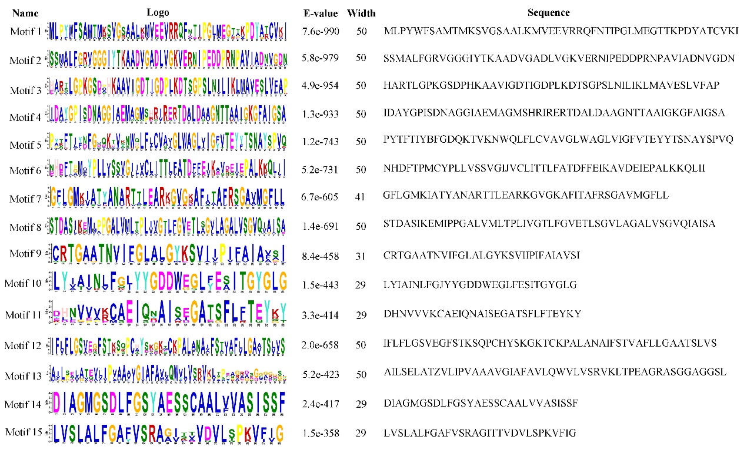
Fig. S1. Motif analysis of VPP members in S. spontaneum.
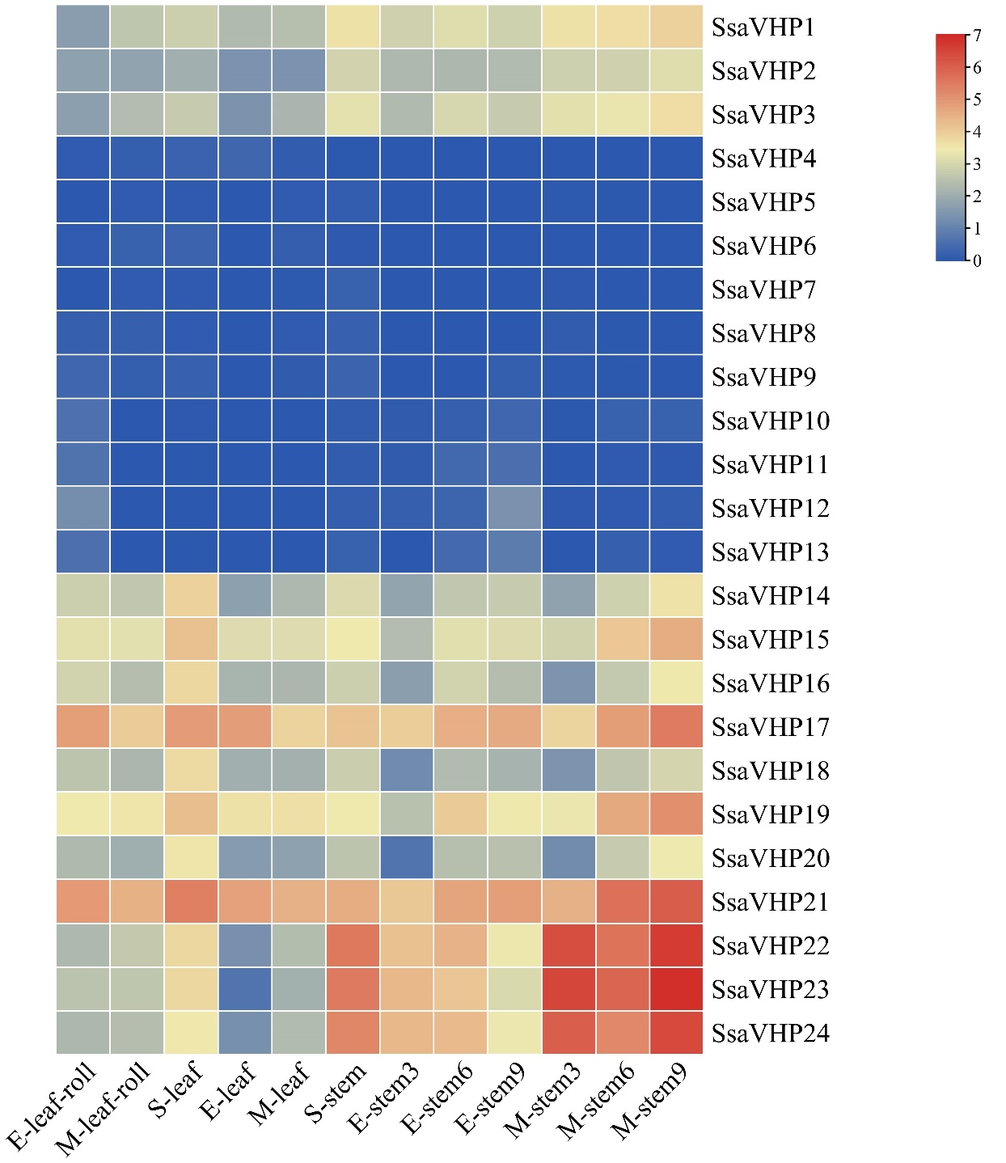
Fig. S2. Expression pattern of the SsaVPP genes in different tissues from S. spontaneum. E represents elongation stage; M represents mature stage; S represents seedling stage; 3, 6, and 9 represent the third, sixth, and ninth stem nodes of sugarcane in S. spontaneum.
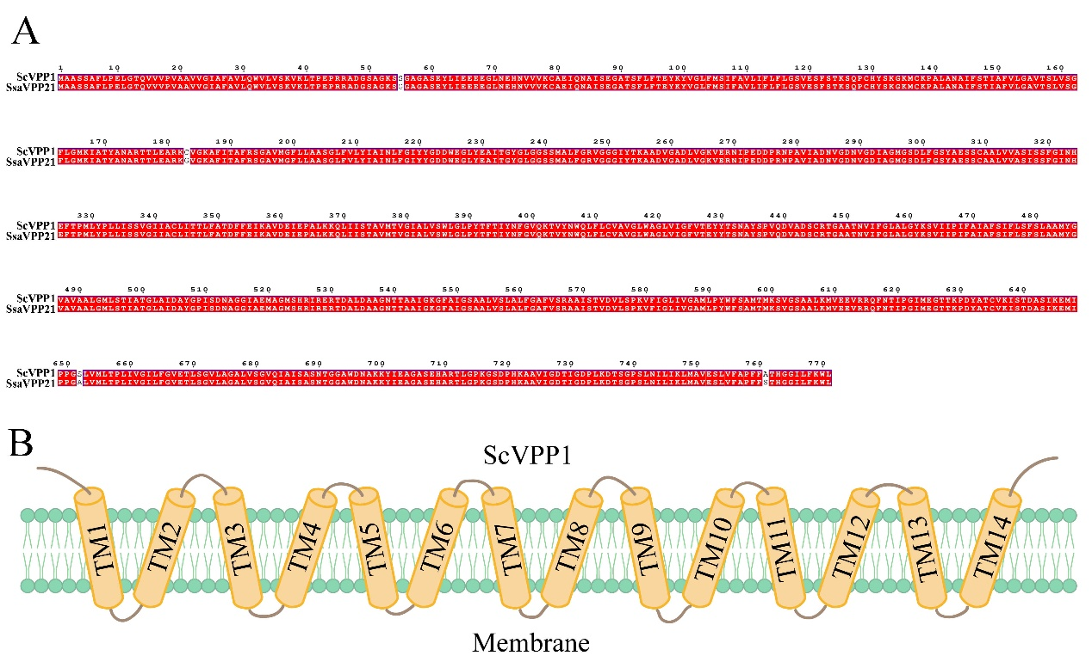
Fig. S3. The sequence characteristics of ScVPP1. Sequence alignment between ScVPP1 and SsaVHP21 in S. spontaneum (A) and protein structure of ScVPP1 (B).
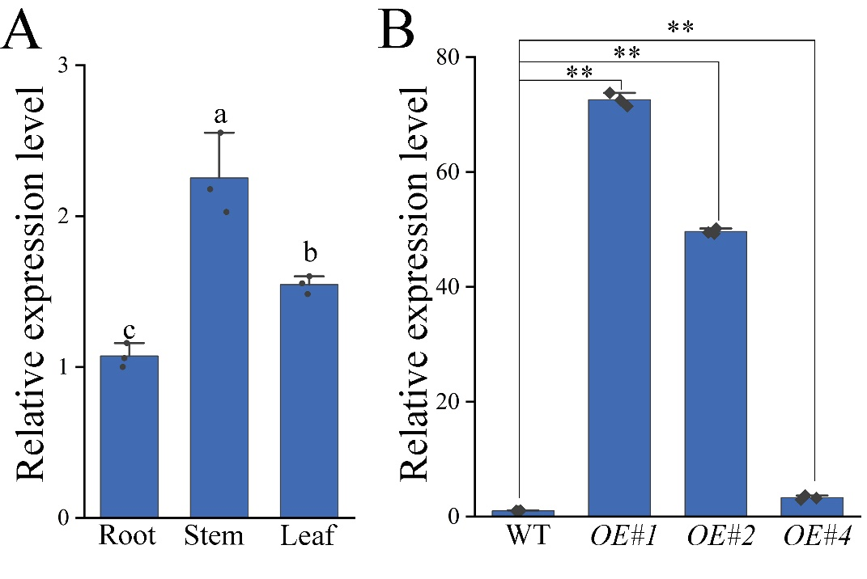
Fig. S4. Expression profiles of ScVPP1 gene in sugarcane and Arabidopsis. Tissue specific expression profile of ScVPP1 gene in the root, stem, and leaf of sugarcane seedlings (A). Relative expression of ScVPP1 gene in three overexpression (OE) lines. Values are the mean of three replicates ± SE. Different minuscules indicate significant differences (P ＜ 0.05) between each other. **P < 0.01 compared with the control using Student's t‐test.

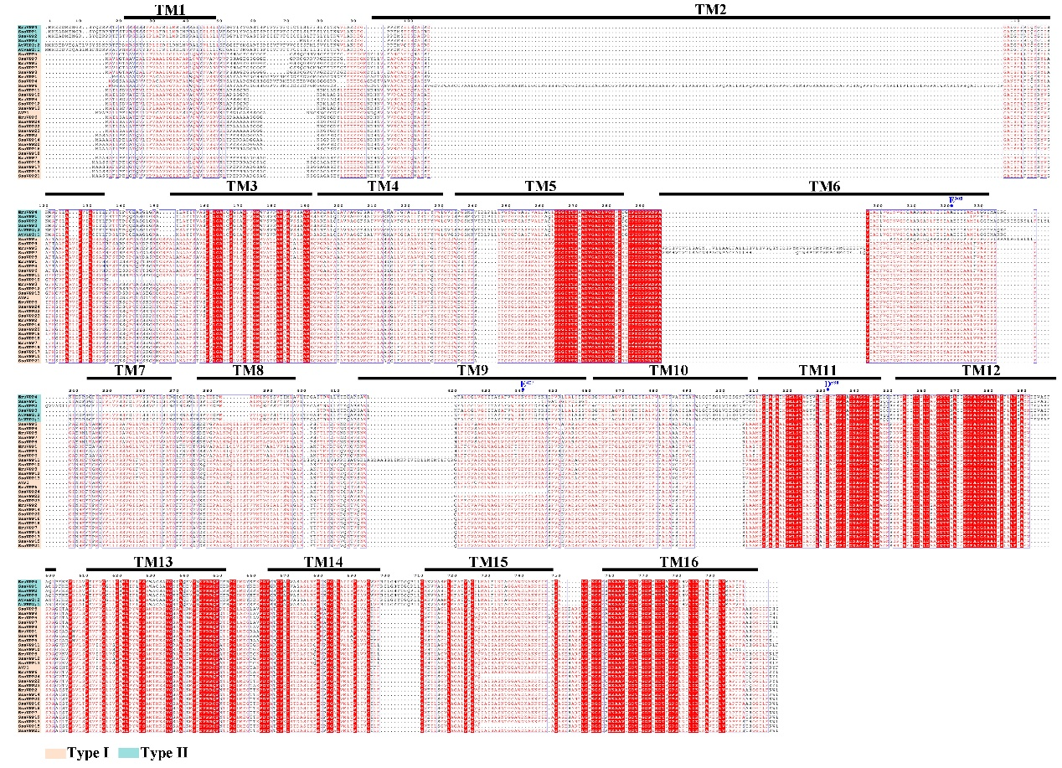
Fig. S5. Sequence alignment of VPP protein sequences in sugarcane.

