SUPPLEMENTAL MATERIAL
Supplementary Methods
PRONIA cohort
PRONIA (Personalized Prognostic Tools for Early Psychosis Management, https://www.pronia.eu/) is a multisite study where participants were recruited across nine sites in Finland, Germany, Italy, Switzerland, and the United Kingdom following the standardized recruitment and ascertainment protocol of the study. The observational part of the protocol involved follow-up examinations every three months after the index ascertainment which was further implemented by the nine PRONIA sites. The participants were pseudonymized twice after recruitment locally at each site and centrally in the PRONIA portal. This portal has a multi-user database which hosts the clinical and neurocognitive information, and defaced MR images of the study participants which are organized into digital questionnaires, visits, and cases. The portal also provided the case managers with the control of a web-based interface for entering and uploading the different acquired data into the respective questionnaires. Furthermore, there was an implemented PRONIA@home mobile device interface allowing study participants to securely log into the portal and fill out the self-rating questionnaires of a given visit. The data is checked by an automatic quality control procedure on completion of data entry across all questionnaires of a given visit which executes approximately 1600 data integrity and dependency rules: (i) basic checks on missing data and data ranges, (ii) checks on dependency within one questionnaire, (iii) dependencies between two questionnaires within one visit, (iv) dependencies between two consecutive visits (such as consistency of dates). The errors found are reported back to the case managers, thus allowing for a manual correction of the respective issues. The process is reiterated until the given visit’s quality of clinical questionnaires is sufficient for the visit to be locked.
Participant inclusion
In the current study, we included: (i) Information eXtraction from Images (IXI; https://brain-development.org/ixi-dataset/), Personalized Prognostic Tools for Early Psychosis Management (PRONIA; www.pronia.eu), Norwegian Centre for Mental Disorders Research (NORMENT; https://www.med.uio.no/norment/ (1)) and Munich Brain Imaging Database (MUC, (2)) healthy individuals who had received a structural MRI scan and further were successfully processed by the VBM8 pipeline, (ii) healthy subjects which had the information about height, weight, age and sex (participants within 18.5 - 35 kg/m² of body mass index (BMI) and 15-75 years of age were included), (iii) Schizophrenia (SCZ) patients which had 70% of the clinical items and complying to (i) and (ii).
The patients with SCZ were evaluated with the Structured Clinical Interview for Diagnostic (SCID) and Statistical Manual of Mental Disorders, Fourth Edition, for Axis I Disorders. The criteria for recent onset-depression (ROD) were a first major depressive episode within the past three months, as determined by the Structured Clinical Interview for DSM-IV-TR (SCID) (29). The clinical high-risk states (CHR) for psychosis state were defined by: (i) cognitive disturbances as evaluated with the Schizophrenia Proneness Instrument (30), and/or (ii) ultra-high-risk criteria for psychosis, as outlined by the Structured Interview for Psychosis-Risk Syndromes (31). Inclusion criteria for ROD and CHR individuals only allowed minimal antipsychotic medication. Additional general exclusion criteria for PRONIA subjects are described in Table S2 and in Koutsouleris et al. 2018 (3).
MRI preprocessing pipeline
Using the VBM8 toolbox (http://dbm.neuro.uni-jena.de/vbm), the structural images were first bias-corrected, tissue classified, and normalized to MNI-space. The normalization used linear (12-parameter affine) and non-linear transformations, within a unified model including high-dimensional DARTEL-normalization. Next, the grey matter segments were modulated only by the non-linear components to retain the actual grey matter values locally, thereby, there is no need to correct for total intracranial volume. An absolute threshold masking with a threshold value of 0.1 was further used, as recommended in VBM8 analyses.
Creating gray matter volume-specific brain mask
To generate the binarized gray matter volume (GMV) brain mask, we employed the ImCalc function within the Statistical Parametric Mapping (SPM) toolbox. The first image comprised preprocessed data from a single subject, utilizing the desired voxel size. The second image corresponded to the Tissue Probability Mask (TPM) specific to GMV within the SPM toolbox, previously utilized in tissue segmentation. Specifically, for GMV, we retained only voxels with values >0.2 in the second image (TPM). Subsequently, the ImCalc function resliced the TPM GMV-specific mask according to the specifications of our input image, resulting in a binarized mask that retained GMV voxels >0.2 (4).
Machine Learning Analysis
To prevent information leakage between train and test data and enhance model generalizability, we implemented a repeated nested cross-validation (CV) cycle with 5 folds at inner (CV1) and outer CV cycles (CV2) each, and 5 permutations of both cycles (which produced 625 CV1 training and test partitions in total). The hyperparameter optimization was confined to the inner folds, effectively preventing overfitting while optimizing the model.
Data pre-processing involved the following pre-processing steps: (i) Gaussian smoothing with 0, 3, 6 and 9 mm full-width-at-half maximum (FWHM) kernel widths, (ii) regressing out age effects using partial correlation analysis, (iii) mean offset correction to remove site effects, (iv) principal component analysis (PCA) with different PCA energy levels (0.25, 0.50, 0.75) to reduce the dimensionality of the image space, and (v) voxel-wise scaling from 0 to 1. All the pre-processing steps were fully wrapped within each training cycle. Further, the model used a linear kernel type nu-support vector machine regression algorithm with a regularization parameter of 1. We measured the precision of the model’s BMI estimates in the CV1 test and CV2 validation data, using the mean absolute error (MAE), Pearson’s correlation coefficient (r) and the coefficient of determination (R²) between individual observed BMI and predicted BMI. The MAE was selected as the optimization criterion. Optimization consisted of finding the hyperparameter combination amongst 4 (smoothing) × 3 (PCA) × 1 (nu) = 12 hyperparameter combinations that maximized the average MAE computed across the CV1 test data partition (detailed in Figure S2 and Supplementary results). Models were retrained using the CV1 training and test data at the optimal hyperparameter combination before being applied to the CV2 validation data. The final BMI prediction of a CV2 individual was computed by averaging the predictions of those models, which did not use the given person for training of hyperparameter optimization. The BMI prediction model’s statistical significance was evaluated using 1000 random BMI label permutations and determined at α=0.05.
Predictive brain patterns were visualized using the grand-mean of cross-validation ratio (CVR) as a measure of feature stability (3) and a sign-based consistency metric assessing feature importance (5). To retain only significant voxels, we thresholded the CVR map based on the false-discovery rate (FDR)-corrected sign-based consistency map (α=0.05). The open-source 3-dimensional rendering software MRIcroGL (McCausland Center for Brain Imaging, University of South Carolina; https://www.nitrc.org /projects/mricrogl/) was used to overlay the thresholded map on the Montreal Neurological Institute (MNI) template to produce 3-dimensional renderings and axial mosaic slices. Additionally, the Automated Anatomical Labelling (AAL3) atlas was overlaid to visualize predictive regions-of-interest (ROIs) (6) in a spider-plot. Then, we applied the discovery model to the independent validation sample to assess the model’s generalizability. Further, the discovery model was applied to the SCZ, ROD and CHR patients to obtain brain-based BMI predictions. The HC individuals’ and patients’ BMIgap was calculated by subtracting the original from the predicted BMI scores.
Site-correction
Previous studies have shown that structural magnetic resonance imaging (sMRI) data is susceptible to site or scanner effects (7,8). We used the data from four cohorts and two of which are multi-site studies. Considering this, we applied a global mean correction procedure within the nested cross-validation settings to remove the site effects. This involves subtracting the mean value of each site from the overall mean and then subtracting this mean difference from each feature of the other sites.
Post-hoc BMIgap correction for true BMI
To remove the effects of BMI from BMIgap for discovery, validation, and clinical groups we followed the stepwise calibration strategy: (i) We implemented the conceptual idea of k-fold cross validation. We split the discovery sample into five smaller groups. In each iteration, one-fold was a hold-out set (equivalent to the test-set) and the remaining samples (equivalent to the training group) were considered for calculating the beta values using partial correlation. (ii) the calculated beta coefficient was applied to the hold-out fold of the discovery sample, the whole validation sample, and the clinical groups to obtain the corrected BMIgap values. This was repeated until all folds have been used as the hold-out test-set once. Finally, we calculated the mean BMIgap across all folds to find a corrected BMIgap score for each individual.
Classification model for HC/SCZ
We created an sMRI-based classification model within NeuroMiner that distinguished individuals with SCZ from HC to extract SCZ-specific brain patterns. We used the following pre-processing steps: (i) Gaussian smoothing with 0, 3, 6 and 9 mm full-width-at-half maximum (FWHM) kernel widths, (ii) regressing out age effects using partial correlation analysis, (iii) principal component analysis (PCA) with different PCA energy levels (0.25, 0.50, 0.75) to reduce the dimensionality of the image space, and (iv) voxel-wise scaling from 0 to 1 similar to the model parameters used in the BMI prediction model within a repeated nested CV cycle with 5 folds at inner and outer cycles each, and 5 permutations for both cycles, like for the BMI regression model. Additionally, we used a GMV specific brain mask to retain only voxels specific to the GMV regions. Further, the model used a linear class-weighted support vector machine (SVM) as classification algorithm with optimization performed for the regularization parameter C_{SVM} over the range of 2^{[−4→ +4]} (11 parameters). We used sensitivity, specificity, accuracy, and balanced accuracy (BAC) as metrics to evaluate the performance of this model at the CV1 test and CV2 validation datasets. BAC was selected as optimization criterion.
BAC=(Sensitivity+Specificity)/2
Optimization consisted of finding the hyperparameter combination amongst 4 (smoothing) × 3 (PCA) × 11 (C_{SVM}) = 132 hyperparameter combinations maximizing the BAC across CV1 test data partition. We visualized the predictive voxels using the sign-based consistency metric as described earlier.
Model Visualization
We evaluated the statistical significance of classification/regression model performances by comparing the observed respective optimization criterion BAC/r with an empirical null-distribution of the respective out-of-training BAC/r obtained by permuting the group labels 1000 times and retraining the models within the cross-validation scheme. Afterwards, we computed the probability of the observed BAC/r as the number of cases in which the permuted BAC/r was equal or higher than the observed BAC/r divided by 1000 and evaluated statistical significance at α=0.05, using FDR correction to control for multiple comparisons. For the visualization of the predictive features, we primarily employed a measure of feature stability termed grand mean CVR (described in detail in Koutsouleris et al., 2021 (9) and adapted from Krishnan et al., 2011 (10)). This is calculated as the sum of the selected CV1 median weights across all the CV2 folds divided by the standard error of the selected CV1 weights for each feature, similar to the bootstrap ratio (BSR) approach in partial least squares (PLS) studies (10,11). The BSRs show how reliably each source is contributing to the observed pattern. A BSR thresholded at ±2 is considered stable. Additionally, we computed a metric of feature importance called sign-based consistency, which assigns feature relevance based on the times that a specific feature has the same sign (positive/negative) across the ensemble, adapted from the method of Gómez-Verdejo et al., 2019 (5) and detailed in Koutsouleris et al., 2021 (9). For visualizing the predictive brain voxels in the BMI-predicting model for the discovery sample: (i) we binarized the sign-based consistency maps to retain the significant voxels thresolded at α=0.05, and (ii) we multiplied the CVR with the binarized sign-based consistency maps. The resulting map showed the significant stable CVR with the warm and cool colored regions differentiating regions with positive and negative correlation of GMV and estimated BMI, respectively.
Overlapping brain regions
To identify shared brain regions predictive of both BMI and SCZ, we followed the following steps: (i) we binarized the FDR-corrected (α=0.05) sign-based consistency maps which were generated during the model visualization step for the regression and classification models and retained only the significant voxels (P>0.001), and (ii) created the overlap between the two binarized maps, resulting in a brain-mask that specifically represents the overlapping regions predictive of BMI and SCZ.
Investigation of phenotypic BMIgap associations
To investigate the phenotypic associations between obesity, SCZ and clinically relevant variables we employed multivariate Sparse Partial Least Squares Analysis (SPLS) as implemented in the SPLS Toolbox by Popovic et al. 2020 (12) in which this algorithm is embedded in a nested CV framework with five folds each on the outer CV2 and the inner CV1 cycle. The SCZ subjects who had less than 30% missing values in the clinical variables (N=139) were included in the SPLS analysis to detect the associations between two data domains: (i) the brain data matrix consisting of the overlapping GMV regions between the significant voxels produced from the BMI-prediction model and the classification model, and (ii) five feature matrix including clinical dimensions such as BMIgap values, SCZ expression-score and clinical items such as PANSS total score, age of disease onset, illness duration and the number of hospitalizations. The SPLS algorithm uses singular value decomposition to generate latent variables (LV), which represent distinct, multivariate associative effects between the two data matrices. A LV consists of a weight vector pair (u, v), which places weights on individual features in the respective brain and clinical data matrix. Here, u represents the brain pattern and v the clinical-dimension pattern of the LV with the feature weights varying between -1 to 1, indicating the direction and strength of covariance between the respective features. Furthermore, two feature weights (u, v) having the same signum (i.e., both positive or both negative) for the respective features covary positively with each other, two feature weights with opposite signum for their feature weights have a negative covariation with each other and, finally zero weighting is indicative of non-significant contribution of the feature to the respective covariance signature. Additionally, the two weight vectors form a new latent space, in which individuals are represented by their respective latent scores as calculated by multiplying individualized clinical and brain data with the respective clinical and brain vectors of the LV, thereby obtaining two numerical values, representing participant’s individual loadings onto these weight vectors. The correlation between the latent scores for all individuals indicates the effectiveness of the weight vector pair of the LV to maximize the covariance. The significance of the associative effects from the SPLS analysis were determined using 5000 random permutations of the brain-clinical design matrix, followed by bootstrap resampling to identify stable brain-clinical features in the significant LVs. Finally, significant patterns were mapped to the 17-network parcellation solution of Yeo-Buckner atlas for visualization (13). The network names and the cerebral cortical regions that compose the 17 networks are from the supplementary video in Baker et al. (2014) (14). The BSRs are plotted separately for clinical and brain-based findings. The significance of the associative effects was determined using 5000 random permutations of the brain-behavioral design matrix, followed by bootstrap resampling (N=500) to identify the most stable features within the respective LVs. Specifically, we used BSR, calculated as the ratio between each variable’s bootstrap-estimated mean weight to its standard error, to quantify the reliability of each variable within the overall brain-behavioral pattern of the LV (15). Only feature weights with a BSR>|2| were considered as reliably contributing to the respective LV.
Machine learning analysis to predict future weight-change
We conducted a multivariate classification to categorize subjects with 3%, 5%, and 7% weight-changes, using BMIgap and selected clinical variables. The ROD and CHR subjects who had less than 30% missing values as well as the clinical items which had less than 30% of missing values were included in this analysis. The final clinical variables were BMIgap, age, sex, study group (ROD, CHR), exercise (strenuous exercise or mindfulness activities such as yoga and meditation), and history of somatic comorbidities (i.e. whether the individual suffered from somatic illness) as features. These items were used as features to classify whether subjects underwent future weight gain. The pre-processing steps included imputing missing values, regressing out study group information, and standardizing the data. Further, the model used a linear class-weighted SVM as classification algorithm with optimization performed for the regularization parameter C_{SVM} over the range of 2^{[−4→ +4]} (11 parameters). We used sensitivity, specificity, accuracy, and BAC as metrics to evaluate the performance of this model at the CV1 test and CV2 validation datasets. The analysis was performed within a nested CV framework with 5 folds for CV1, 5 folds for CV2 with 5 permutations for each cycle.
Supplementary Results
Hyperparameter optimization
The BMI-predictor opted for a 3 mm FWHM Gaussian smoothing kernel with the highest selection frequency across the folds in the support vector subspace. Moreover, the discovery model optimized for 0.75 PCA energy level.
The classification model also opted for the 3 mm FWHM Gaussian smoothing kernel with the highest selection frequency across the folds in the support vector subspace and optimized for 0.75 PCA energy level.
Clinical associations in brain regions predictive of BMI and SCZ
The SPLS analysis yielded five significant LVs, representing distinct levels of association between the neuroanatomic overlap regions of the BMI and SCZ models and the clinical disease features (Figure 2, Figure S8). LV1 and LV4 extracted covariate patterns of age and sex (Supplement Results).
In LV1 (r=0.87, P<0.001), lower BMIgap scores and higher SCZ expression-scores were related to decreased GMV in the ventral attention network and increased GMV in the default mode network (DMN) (auditory), somatomotor-B, control-B/C, and central visual networks (Figure S8a).
In LV4 (r=0.44, P=0.025), higher SCZ expression-scores, illness duration, age of onset, and number of hospitalizations and lower BMIgap and PANSS total scores were related to decreased GMV in the limbic as well as Control-A/B , DMN-A/B, somatomotor-A/B, salience, dorsal and ventral attention, and peripheral visual networks and increased GMV in non-overlapping subcomponents DMN-C and control-C networks (Figure S8b).
Supplementary Figures
Figure S1. Sample for discovery/validation data. Histogram for the BMI distribution for A) discovery and C) validation sample showing the uniform-like distribution for the discovery sample with the different colors representing the four cohorts. Age distribution per BMI bin of 0.5 BMI units for B) discovery and D) validation sample.

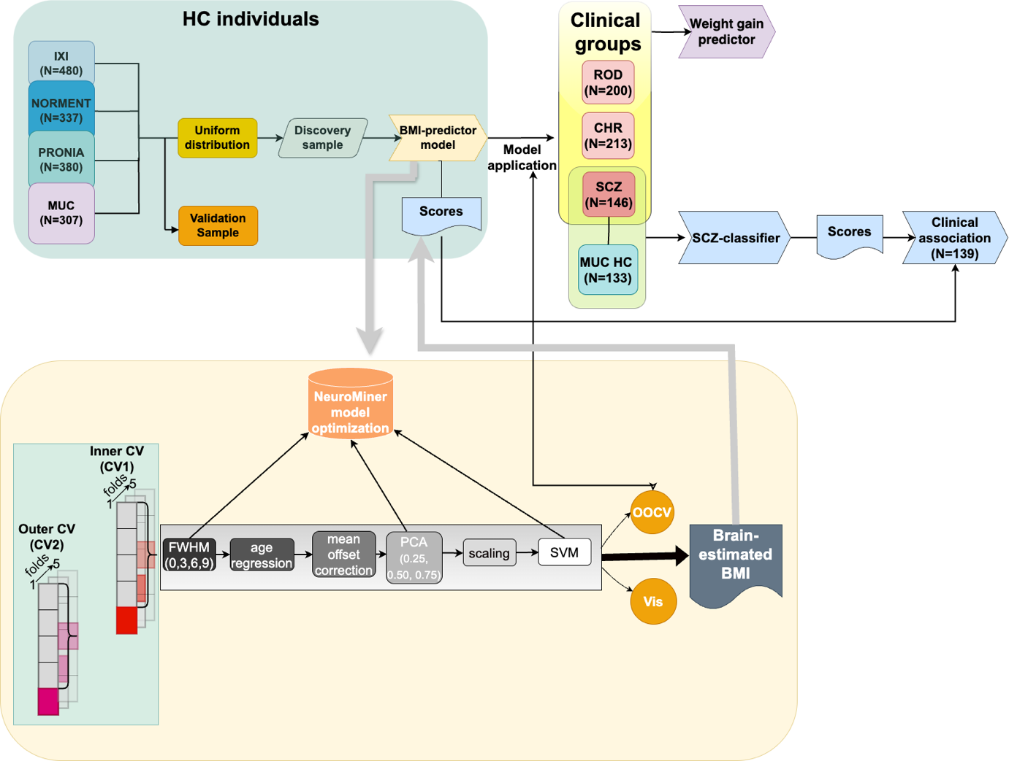
Figure S2. Schematic representation of analysis flow conducted in the study. Abbreviations: HC= healthy controls, MUC= Munich database, BMI= Body mass index, ROD= Recent onset depression, CHR= Clinical high risk, SCZ= Schizophrenia, SPLS= Sparse partial least squares, CV= Cross validation, PCA= Principal component analysis, SVM= Support vector machine, Vis= Model visualization, OOCV= Out-of-sample cross-validation

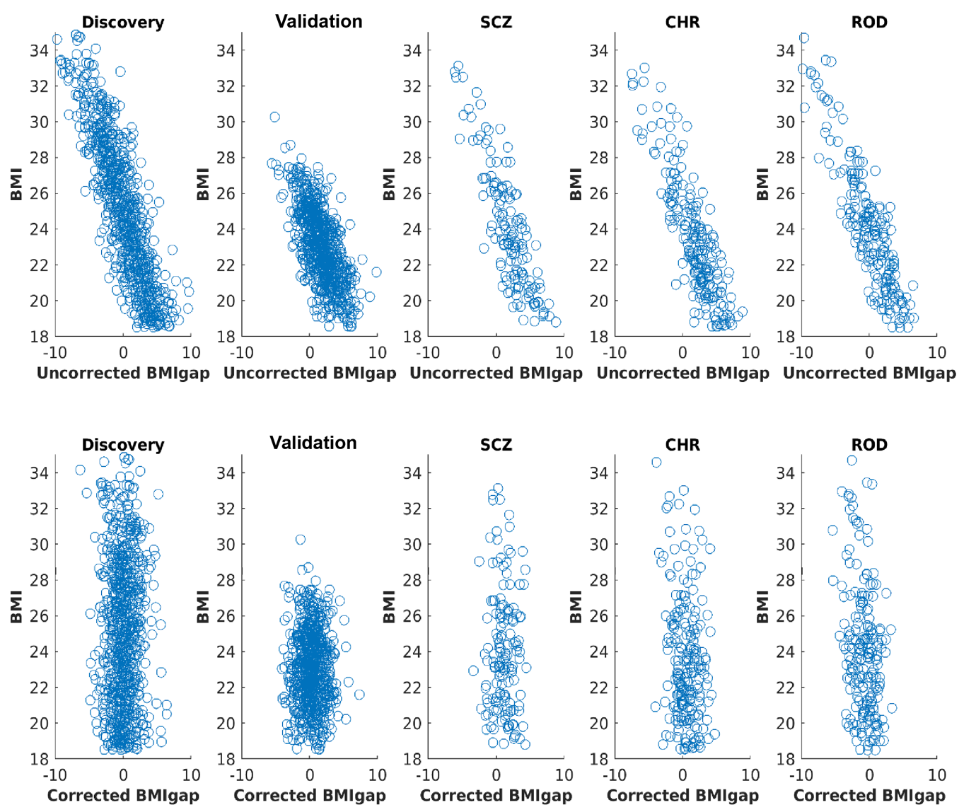Figure S3: Scatter plots for BMIgap before and after the BMIgap correction for BMI for the discovery, validation, and clinical groups. Abbreviations: BMI= Body mass index, ROD= Recent onset depression, CHR= Clinical high risk, SCZ= Schizophrenia

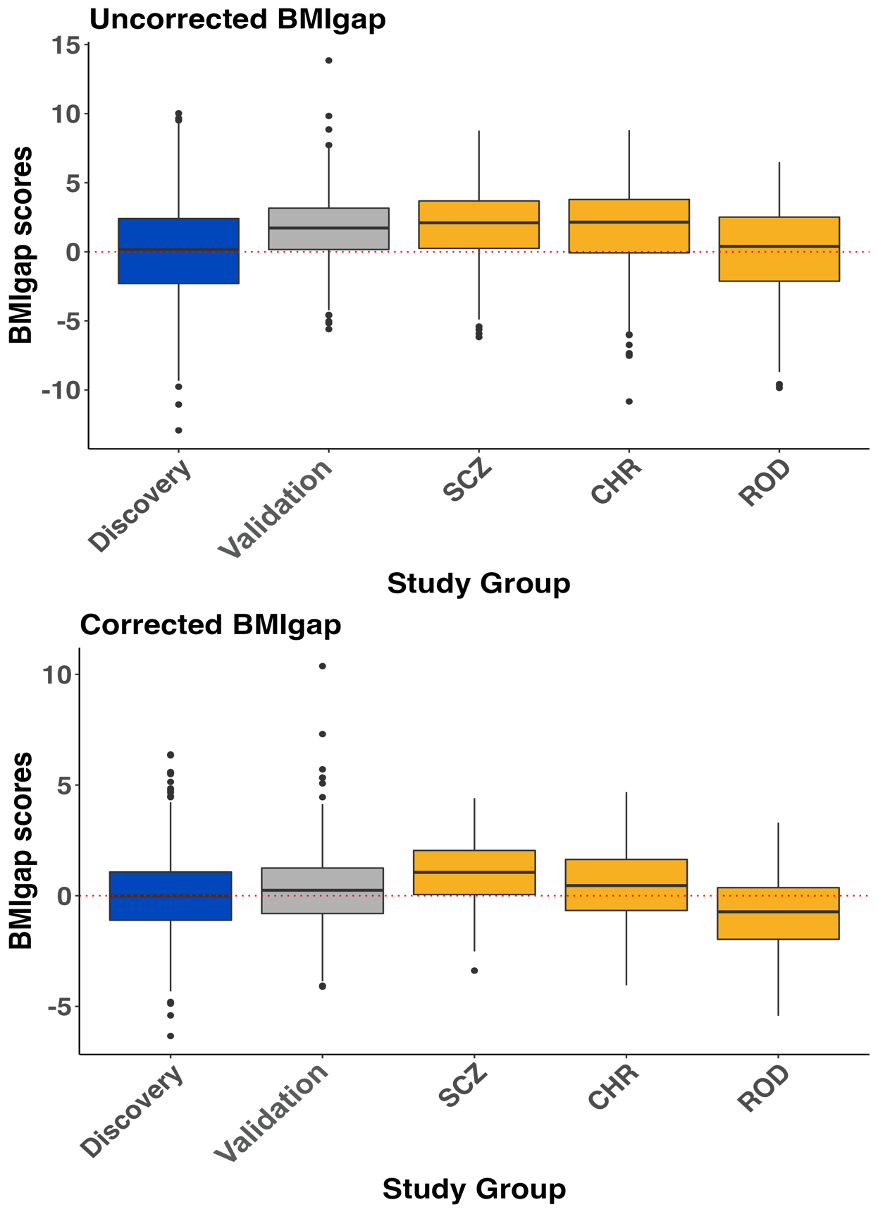
Figure S4: Group-level BMIgap analysis. BMIgap distributions across clinical groups are visualized as box plots. BMIgap are visualized before and after the correction of BMIgap for BMI. Abbreviations: BMI= Body mass index, ROD= Recent onset depression, CHR= Clinical high risk, SCZ= Schizophrenia

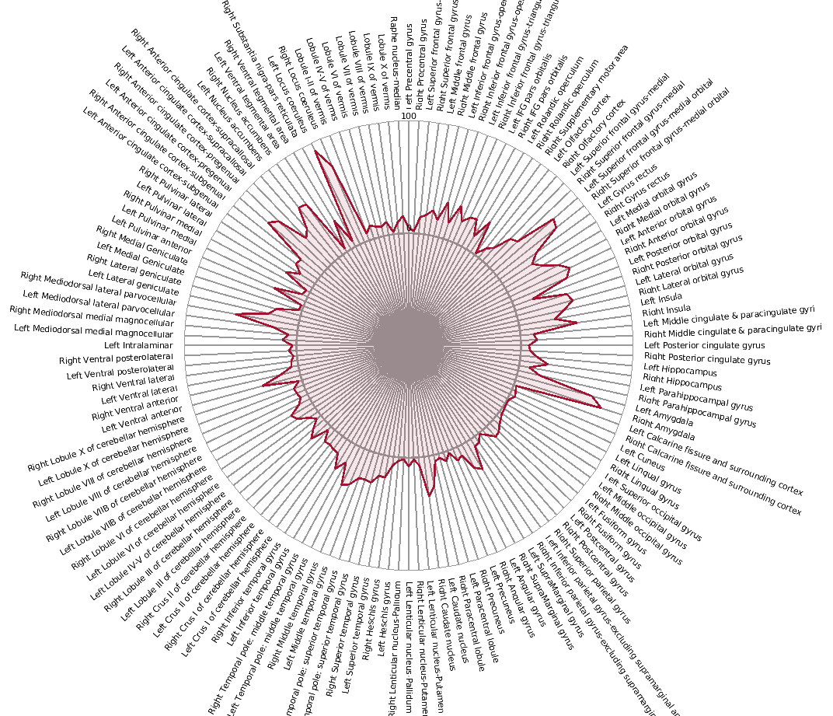
Figure S5: Regional distribution of predictive brain-based BMI patterns of the discovery model. The percentage of voxels occupied by the predictive patterns was quantified based on the AAL3 atlas (6).

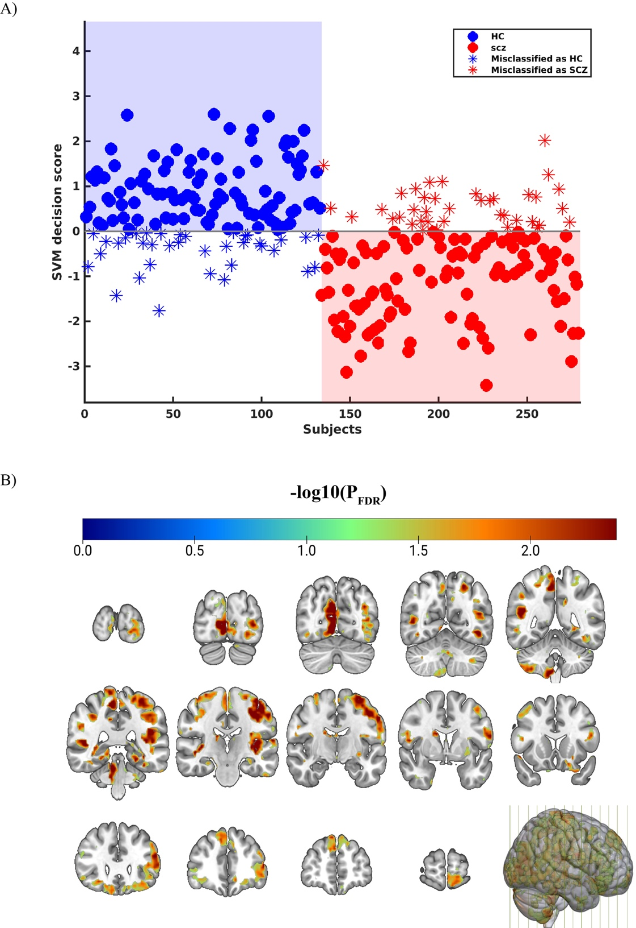
Figure S6: Classification model for classifying SCZ from HC. A) Classification performance. B) The reliability of the predictive voxels visualized using FDR-corrected sign-based consistency map thresholded at α=0.05. Abbreviations: FDR= False discovery rate

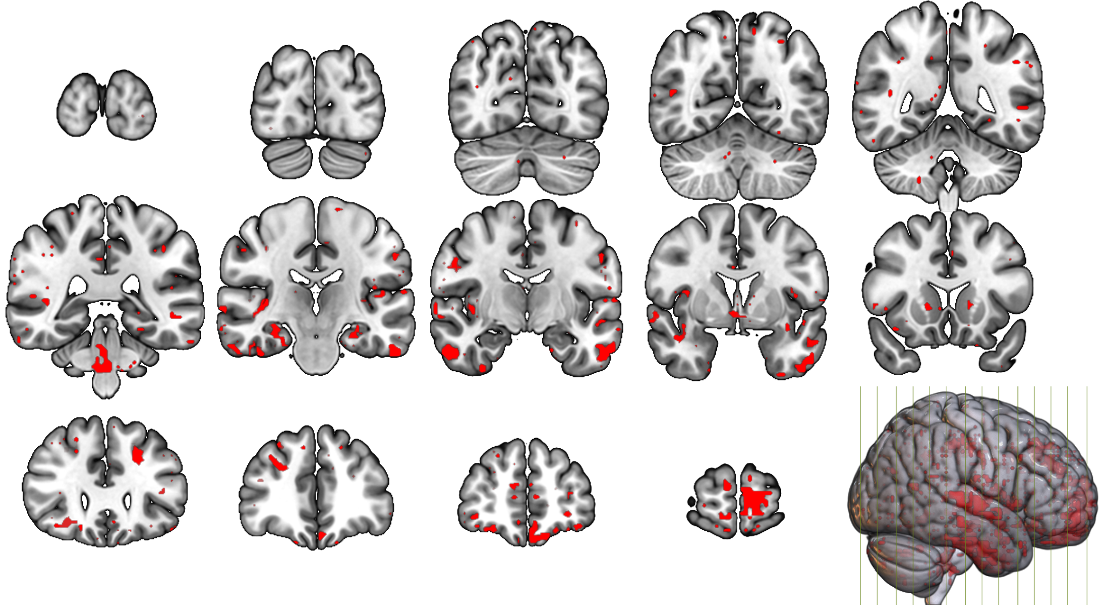
Figure S7: Overlapping brain regions. Overlapping regions across schizophrenia and obesity obtained by binarizing and multiplying the sign-based consistency maps from the regression and classification models (α=0.05).

Figure S8: Signature for SCZ and BMIgap effects. SPLS analysis results for A) LV1 and B) LV4. Bar plots visualize the correlation of each variable with the LV, blue identifies variables significantly contributing to the LV. The x-axis denotes bootstrap ratios (BSR) (interpretable as z-scores) and the y-axis denotes BMIgap, SCZ expression-score and other clinical items. The red dotted line in the graph represents a BSR of 1.96 (equivalent to a 95% confidence interval). The contribution of individual voxels is shown using BSR in MNI space. Cool colors indicate voxels with a negative correlation of GMV and clinical items, whereas warm colors represent a positive correlation. The spider-plot represents the voxel contribution within the 17-network parcellation solution of the Yeo-Buckner atlas (13). The network names and the cerebral cortical regions that compose the 17 networks are from the supplementary video in Baker et al. (2014) (14). Abbreviations: LV= Latent variable, SCZ= Schizophrenia, BMIgap= body mass index gap score, PANSS= Positive and Negative Symptom Scale total score

Figure S9: Correlation between BMIgap and weight change at 1- and 2-year follow-up. The correlations across different age windows including A), C) 15-40, 20-40, 25-40, 30-40 years and as well as within 5-year bins B), D) 15–20, 20–25, 25–30, 30–35, and 35–40 years. Abbreviations: ΔW₁= weight at T1 – Weight at T0, ΔW₂= Weight at T2 – Weight at T0, BMIgap= body mass index gap score, HC=Healthy controls, CHR= Clinical high-risk, ROD= Recent-onset depression, Net= any weight change without defining a threshold.

Supplementary Tables
Table S1: MRI scanner systems and structural MRI sequence parameters used in the respective cohorts. Abbreviations: TR = repetition time, TE = echo time, FOV = field of view.
Site | Model | Field Strength | Coil Channels | Flip Angle | TR [ms] | TE [ms] | Voxel Size [mm] | FOV | Slice Number
IXI database
Hammersmith Hospital | Philips Intera | 3.0T | - | 8 | 9.6 | 4.6 | - | 208 x 208 | -
Institute of Psychiatry | Philips Gyroscan Intera | 1.5T | - | - | - | - | - | - | -
Guy’s Hospital | General Electric | 1.5T | - | 8 | 9.8 | 4.6 | - | 208 x 208 | -
NORMENT
Oslo | SIEMENS Magnetom | 3T | 32 | 7 | 2730 | 3.93 | 1.33 × 0.94 × 1.0 | 240 x 240 | 160
Munich database
LMU Hospital | SIEMENS Magnetom | 1.5T | 8 | 12 | 11.6 | 4.9 | 0.45 x 0.45 x 1.5 | 230 x 230 | 126
PRONIA
Munich | Philips Ingenia | 3T | 32 | 8 | 9.5 | 5.5 | 0.97 x 0.97 x 1.0 | 250 x 250 | 190
Milan Niguarda | Philips Achieva Intera | 1.5T | 8 | 12 | Shortest (8.1) | Shortest (3.7) | 0.93 x 0.93 x 1.0 | 240 x 240 | 170
Basel | SIEMENS Verio | 3T | 12 | 8 | 2000 | 3.4 | 1.0 x 1.0 x 1.0 | 256 x 256 | 176
Cologne | Philips Achieva | 3T | 8 | 8 | 9.5 | 5.5 | 0.97 x 0.97 x 1.0 | 250 x 250 | 190
Birmingham | Philips Achieva | 3T | 32 | 8 | 8.4 | 3.8 | 1.0 x 1.0 x 1.0 | 288 x 288 | 175
Turku | Philips Ingenuity | 3T | 32 | 7 | 8.1 | 3.7 | 1.0 x 1.0 x 1.0 | 256 x 256 | 176
Udine | Philips Achieva | 3T | 8 | 12 | Shortest (8.1) | Shortest (3.7) | 0.93 x 0.93 x 1.0 | 240 x 240 | 170
Muenster | Siemens Magnetom  PRISMA-FIT | 3T | 20 | 8 | 2130 | 2,28 | 1x1x1 | 256 | 192
Duesseldorf | Siemens Prisma | 3T | 32 | 8 | 2000 | 3.37 | 1.0x1.0x1.0 | 256x256 | 176
Bari | Philips Ingenia | 3T | 32 | 8 | 8.1 | 3.7 | 1.0 x 1.0 x 1.0 | 256 x 256 | 180

Table S2: Inclusion and exclusion criteria for the PRONIA HC. Adapted from Koutsouleris et al. 2018 (3)

Group | Inclusion Criteria | Exclusion Criteria
Healthy Controls |  | 1. Any current or past DSM-IV axis disorder  2. A positive familial history (1st degree relatives) of affective or non-affective psychoses or major affective disorders;  3. Intake of psychotropic medication or drugs more than 5 times/year or in the month before study inclusion.
General | 1. Age between 15 and 40 years  2. Sufficient language abilities for participation  3. Ability to provide consent / assent | 1. IQ below 70  2. Hearing is not sufficient for neuro-cognitive testing  3. Current or past head trauma with loss of consciousness (> 5 min)  4. Current or past known neurological disorder of the brain  5. Current or past known somatic disorder potentially affecting the structure or functioning of the brain  6. Current or past alcohol dependence  7. Current poly-substance dependence or within the past six months  8. Any contra-indication for MRI

Table S3: BMI-predictive voxels. The voxels occupied by the BMI-predictive patterns were quantified based on the AAL3 atlas (6).
Volume (mm³) | Peak  Intensity value | Peak  (x, y, z) | Peak Structure | Structure (according to the AAL3 atlas)
10007 | 4.8 | 0.2×-36.3×-36.4 |  | -(87) Cerebelum_8_L(7) Cerebelum_9_L(2) Cerebelum_10_L(2) Cerebelum_10_R(1) Vermis_10 (1)
6087 | 4.2 | 33.4×-3.1×35.9 |  | -(97) Precentral_R(2) Putamen_R(1)
322 | 4.1 | 14.9×-48.1×24.1 | Precuneus_R | -(51) Precuneus_R(36) Cingulum_Post_R(13)
7016 | 3.7 | -24.1×-11.9×35.9 |  | -(91) Thalamus_L(5) Insula_L(2) Rolandic_Oper_L(1)
441 | 3.7 | 42.2×-23.7×30.0 |  | -(95) Rolandic_Oper_R(5)
360 | 3.7 | 39.3×-39.2×21.2 |  | -(97) Temporal_Mid_R(3)
937 | 3.6 | -33.0×-29.6×0.5 |  | -(79) Thalamus_L(13) Hippocampus_L(8)
244 | 3.6 | -11.6×-48.1×21.2 | Cingulum_Post_L | Precuneus_L(53) Cingulum_Post_L(26) -(21)
630 | 3.5 | 14.9×-9.0×-5.4 |  | -(77) Thalamus_R(19) Pallidum_R(4)
117 | 3.5 | -47.7×-29.6×-17.9 | Temporal_Inf_L | Temporal_Inf_L(47) Temporal_Mid_L(37) -(15)
779 | 3.4 | 26.7×-26.7×-0.2 |  | -(94) Thalamus_R(5) Pallidum_R(1)
62 | 3.3 | 48.1×-0.1×18.2 | Rolandic_Oper_R | Rolandic_Oper_R(59) -(41)
1312 | 3.3 | 14.9×-59.9×-39.3 | Cerebelum_8_R | -(52) Cerebelum_8_R(40) Vermis_9(5) Cerebelum_9_R(3)
115 | 3.3 | -41.8×-45.1×15.3 |  | -(99) Temporal_Mid_L(1)
138 | 3.3 | 29.7×-93.1×-6.1 | Occipital_Inf_R | Occipital_Inf_R(100)
140 | 3.2 | -38.9×-23.7×-9.1 |  | -(87) Hippocampus_L(13)
33 | 2.9 | 42.2×-18.6×-12.0 |  | -(67) Hippocampus_R(33)
89 | 2.8 | -8.7×-3.1×59.5 | Supp_Motor_Area_L | Supp_Motor_Area_L(60) -(38) Frontal_Sup_L(2)
57 | 2.7 | 0.2×-36.3×15.3 |  | -(99) Cingulum_Post_R(1)
80 | 2.6 | -9.4×-9.0×27.1 |  | -(100)
45 | 2.5 | -3.5×-41.4×14.5 |  | -(67) Cingulum_Post_L(31) Precuneus_L(2)
49 | 2.4 | -38.9×-32.6×-36.4 | Cerebelum_6_L | Cerebelum_Crus1_L(36) -(35) Cerebelum_7b_L(23) Cerebelum_6_L(7)
38 | -2.3 | -18.2×-14.9×-32.7 |  | -(82) ParaHippocampal_L(18)
115 | -2.4 | 6.1×-90.1×-32.7 | Cerebelum_Crus2_R | Cerebelum_Crus2_R(76) -(24)
44 | -2.4 | -11.6×-26.7×0.5 | Thalamus_L | Thalamus_L(95) -(5)
108 | -2.4 | -66.2×-11.9×14.5 | Postcentral_L | -(72) Postcentral_L(21) Rolandic_Oper_L(3) Temporal_Sup_L(3) Heschl_L(1)
72 | -2.4 | 57.0×-51.0×-20.9 | Temporal_Inf_R | Temporal_Inf_R(100)
68 | -2.5 | 45.2×-56.9×56.6 | Parietal_Inf_R | Parietal_Inf_R(82) Angular_R(18)
35 | -2.5 | 35.6×-45.1×-51.1 | Cerebelum_8_R | Cerebelum_8_R(100)
183 | -2.5 | 17.9×-51.0×-54.1 | Cerebelum_8_R | Cerebelum_8_R(78) Cerebelum_9_R(22)
257 | -2.5 | 17.9×-65.8×66.1 | Parietal_Sup_R | Parietal_Sup_R(100)
44 | -2.5 | -27.1×-68.7×-17.9 | Cerebelum_6_L | Cerebelum_6_L(100)
51 | -2.6 | 9.0×-24.5×47.7 | Cingulum_Mid_R | Cingulum_Mid_R(95) Paracentral_Lobule_R(5)
49 | -2.6 | -48.5×15.3×33.0 | Frontal_Inf_Oper_L | Frontal_Inf_Tri_L(47) Precentral_L(27) Frontal_Inf_Oper_L(26)
61 | -2.6 | 38.5×-20.8×45.5 | Postcentral_R | Postcentral_R(75) -(19) Precentral_R(6)
71 | -2.6 | -47.7×-45.1×-36.4 | Cerebelum_Crus1_L | Cerebelum_Crus1_L(100)
186 | -2.6 | -26.4×-86.4×44.8 |  | Occipital_Sup_L(40) -(34) Parietal_Sup_L(16) Parietal_Inf_L(10)
35 | -2.6 | -9.4×15.3×-12.0 | Olfactory_L | Rectus_L(59) Olfactory_L(26) Caudate_L(15)
35 | -2.6 | -18.2×-27.4×-20.9 | ParaHippocampal_L | ParaHippocampal_L(50) Cerebelum_4_5_L(45) Fusiform_L(5)
78 | -2.7 | 0.2×3.5×5.7 |  | -(100)
71 | -2.7 | -8.7×-75.4×47.7 | Precuneus_L | Precuneus_L(91) Parietal_Sup_L(9)
101 | -2.7 | 20.8×21.2×0.5 | Putamen_R | Putamen_R(75) -(18) Caudate_R(7)
51 | -2.8 | 20.8×30.1×35.9 | Frontal_Sup_R | Frontal_Sup_R(87) Frontal_Mid_R(13)
454 | -2.8 | 9.0×-14.9×6.4 | Thalamus_R | Thalamus_R(92) -(8)
147 | -2.8 | 42.2×-59.9×-54.1 | Cerebelum_7b_R | Cerebelum_8_R(74) Cerebelum_7b_R(26)
105 | -2.8 | 3.1×-6.0×41.8 | Cingulum_Mid_R | Cingulum_Mid_R(100)
74 | -2.9 | -41.8×-72.4×27.1 | Occipital_Mid_L | Occipital_Mid_L(93) Angular_L(7)
322 | -2.9 | -24.1×-57.7×69.1 | Parietal_Sup_L | Parietal_Sup_L(100)
835 | -3.0 | -51.4×-0.1×35.9 | Precentral_L | Precentral_L(74) Postcentral_L(21) Frontal_Inf_Oper_L(5)
69 | -3.0 | -0.5×-77.6×44.8 | Precuneus_L | Precuneus_L(92) -(8)
788 | -3.0 | -35.9×-83.5×38.9 | Occipital_Mid_L | Occipital_Mid_L(60) -(30) Parietal_Inf_L(10)
982 | -3.0 | -53.6×-56.9×50.7 |  | Parietal_Inf_L(79) -(10) Angular_L(7) SupraMarginal_L(4)
705 | -3.1 | -44.8×-32.6×41.8 | Parietal_Inf_L | Parietal_Inf_L(85) Postcentral_L(15)
973 | -3.2 | -41.8×-17.8×-30.5 | Temporal_Inf_L | Temporal_Inf_L(54) -(42) Fusiform_L(4)
231 | -3.2 | -21.2×-36.3×-6.1 | ParaHippocampal_L | ParaHippocampal_L(77) -(14) Lingual_L(6) Hippocampus_L(2) Precuneus_L(1)
1049 | -3.3 | 54.0×-9.0×30.0 | Postcentral_R | Postcentral_R(85) Precentral_R(11) -(3)
1510 | -3.3 | -27.1×-54.0×-6.1 | Lingual_L | Fusiform_L(84) Lingual_L(14) Cerebelum_4_5_L(2)
1689 | -3.3 | 54.0×-3.1×-36.4 | Temporal_Inf_R | Temporal_Inf_R(94) -(5)
283 | -3.3 | 14.9×-48.1×-45.2 | Cerebelum_9_R | Cerebelum_9_R(99)
2347 | -3.3 | -8.7×-77.6×-45.2 |  | -(68) Cerebelum_8_L(16) Cerebelum_7b_L(11) Cerebelum_Crus2_L(5)
2605 | -3.3 | -5.7×-62.8×57.3 | Precuneus_L | Precuneus_R(46) Precuneus_L(38) Postcentral_R(10) -(4) Parietal_Sup_R(1)
3152 | -3.4 | -2.8×-20.8×41.8 | Cingulum_Mid_L | Cingulum_Mid_L(48) Cingulum_Mid_R(31) Cingulum_Post_L(16) Precuneus_L(4) -(1)
2126 | -3.5 | -30.0×-56.9×44.8 | Parietal_Inf_L | Parietal_Inf_L(48) Angular_L(24) Parietal_Sup_L(20) -(7) Occipital_Mid_L(2)
2616 | -3.6 | -24.1×-68.7×-32.7 | Cerebelum_Crus1_L | Cerebelum_Crus1_L(92) Cerebelum_6_L(6) Cerebelum_Crus2_L(1) -(1)
209360 | -5.1 | -2.8×54.4×-12.0 | Frontal_Mid_Orb_L | -(9) Frontal_Sup_Medial_L(4) Temporal_Mid_L(4) Frontal_Inf_Orb_R(4) Insula_R(4) Temporal_Mid_R(4) Frontal_Inf_Orb_L(4) Frontal_Mid_R(4) Temporal_Sup_R(3) Frontal_Mid_L(3) Cingulum_Ant_R(3) Frontal_Sup_Medial_R(3) Insula_L(3) Cingulum_Ant_L(3) Front

Table S6: Sensitivity analysis for predicting weight-change. Abbreviations: SEN= Sensitivity, SPE= Specificity, BAC= Balanced accuracy, AUC= Area under the curve at 95% confidence interval.

Threshold | SEN | SPE | BAC | AUC
T1
3% | 20.7 | 77.8 | 49.2 | 0.49
5% | 32.9 | 64.6 | 48.7 | 0.50
7% | 66.0 | 35.3 | 50.6 | 0.48
T2
3% | 52.5 | 51.9 | 52.2 | 0.47
5% | 37.0 | 53.4 | 45.2 | 0.40
7% | 64.9 | 53.5 | 59.2 | 0.59

References

1. Wolfers T, Doan NT, Kaufmann T, Alnæs D, Moberget T, Agartz I, et al. (2018): Mapping the Heterogeneous Phenotype of Schizophrenia and Bipolar Disorder Using Normative Models. JAMA Psychiatry 75: 1146–1155.
2. Koutsouleris N, Meisenzahl EM, Borgwardt S, Riecher-Rössler A, Frodl T, Kambeitz J, et al. (2015): Individualized differential diagnosis of schizophrenia and mood disorders using neuroanatomical biomarkers. Brain J Neurol 138: 2059–2073.
3. Koutsouleris N, Kambeitz-Ilankovic L, Ruhrmann S, Rosen M, Ruef A, Dwyer DB, et al. (2018): Prediction Models of Functional Outcomes for Individuals in the Clinical High-Risk State for Psychosis or With Recent-Onset Depression: A Multimodal, Multisite Machine Learning Analysis. JAMA Psychiatry 75: 1156–1172.
4. Correll CU, Lencz T, Malhotra AK (2011): Antipsychotic drugs and obesity. Trends Mol Med 17: 97–107.
5. Gómez-Verdejo V, Parrado-Hernández E, Tohka J, Alzheimer’s Disease Neuroimaging Initiative (2019): Sign-Consistency Based Variable Importance for Machine Learning in Brain Imaging. Neuroinformatics 17: 593–609.
6. Rolls ET, Huang C-C, Lin C-P, Feng J, Joliot M (2020): Automated anatomical labelling atlas 3. NeuroImage 206: 116189.
7. Bayer J, Thompson P, Ching C, Liu M, Chen A, Panzenhagen A, et al. (2022): Site effects how-to and when: An overview of retrospective techniques to accommodate site effects in multi-site neuroimaging analyses. Front Neurol 13: 923988.
8. Jovicich J, Czanner S, Greve D, Haley E, van der Kouwe A, Gollub R, et al. (2006): Reliability in multi-site structural MRI studies: effects of gradient non-linearity correction on phantom and human data. NeuroImage 30: 436–443.
9. Koutsouleris N, Dwyer DB, Degenhardt F, Maj C, Urquijo-Castro MF, Sanfelici R, et al. (2021): Multimodal Machine Learning Workflows for Prediction of Psychosis in Patients With Clinical High-Risk Syndromes and Recent-Onset Depression. JAMA Psychiatry 78: 195–209.
10. Krishnan A, Williams LJ, McIntosh AR, Abdi H (2011): Partial Least Squares (PLS) methods for neuroimaging: a tutorial and review. NeuroImage 56: 455–475.
11. McIntosh AR, Lobaugh NJ (2004): Partial least squares analysis of neuroimaging data: applications and advances. NeuroImage 23 Suppl 1: S250-263.
12. Popovic D, Ruef A, Dwyer DB, Antonucci LA, Eder J, Sanfelici R, et al. (2020): Traces of Trauma: A Multivariate Pattern Analysis of Childhood Trauma, Brain Structure, and Clinical Phenotypes. Biol Psychiatry 88: 829–842.
13. Thomas Yeo BT, Krienen FM, Sepulcre J, Sabuncu MR, Lashkari D, Hollinshead M, et al. (2011): The organization of the human cerebral cortex estimated by intrinsic functional connectivity. J Neurophysiol 106: 1125–1165.
14. Baker JT, Holmes AJ, Masters GA, Yeo BTT, Krienen F, Buckner RL, Öngür D (2014): Disruption of cortical association networks in schizophrenia and psychotic bipolar disorder. JAMA Psychiatry 71: 109–118.
15. Efron B, Tibshirani R (1986): Bootstrap Methods for Standard Errors, Confidence Intervals, and Other Measures of Statistical Accuracy. Stat Sci 1: 54–75.

