SUPPLEMENTARY INFORMATION

Electrochemical immunosensing of Crohn´s disease biomarkers using diazonium salt grafted crystalline nanocellulose / carbon nanotubes modified electrodes
Lorena García-Rodrigo¹, Claudia Ramos-López¹, Esther Sánchez-Tirado, Lourdes Agüí, Araceli González-Cortés*, Paloma Yáñez-Sedeño*, José M. Pingarrón
Department of Analytical Chemistry, Faculty of Chemistry, University Complutense of Madrid, 28040 Madrid, Spain.
* Corresponding authors
E-mail addresses: yseo@quim.ucm.es (P. Yáñez-Sedeño); aracelig@ucm.es (A. González-Cortés)
¹These authors contributed equally to this study.

CONTENT
Figure S1. Chemical structure of crystalline nanocellulose with hydroxyl and sulfonic groups.
1. Optimization of variables involved in the preparation of the immunoplatforms for the individual determination of IL-23. Figures S2 - S4
2. Stability study Figure S5
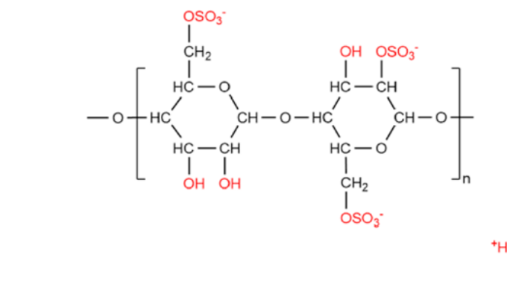

Figure S1. Chemical structure of crystalline nanocellulose with hydroxyl and sulfonic groups [1].

1. Optimization of variables involved in the preparation of the immunoplatforms for the individual determination of IL-23
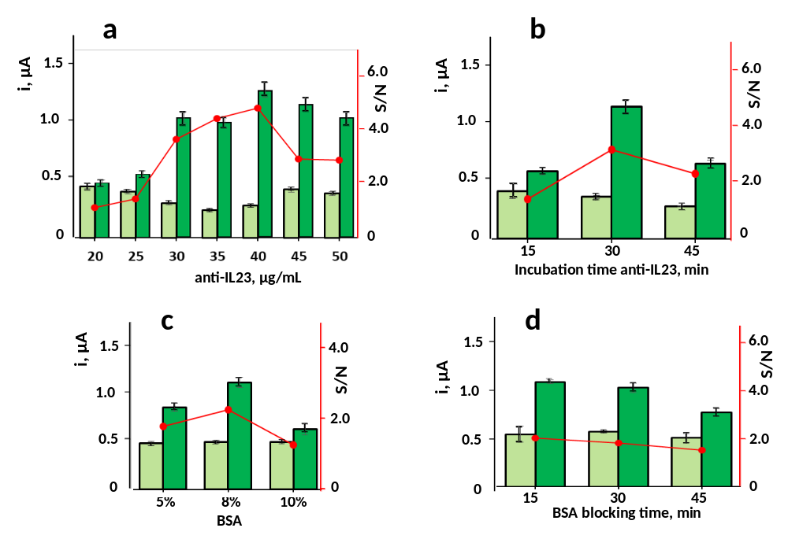
The effect of the capture antibody loading (anti-IL23) over the 20 to 50 μg mL⁻¹ range, and of its incubation time for immobilization onto grafted MWCNTs/CNC/SPCEs, between15 to 45 min, on the measured amperometric responses was tested in the absence (N) and in the presence (S) of 10 ng mL⁻¹ IL-23. Figure S2a shows as a better S/N ratio was reached for 40 μg mL⁻¹ antibody. Smaller concentrations gave rise to lower specific amperometric currents because of the insufficient antibody loading with practically constant nonspecific currents thus providing lower S/N ratios. Furthermore, antibody loadings larger than 40 μg mL⁻¹ provoked also a decrease in the S/N ratio probably due to the hindered recognition of the target biomarker. Regarding the incubation time, the results of Figure S2b led us to select 30 min for further work. Bovine serum albumin (BSA) was used as the blocking agent to minimize unspecific adsorptions onto the modified anti-IL23-MWCNTs/CNC/SPCEs electrode. The effect of the blocker concentration over the 5 to 10 % range (Figure S2c) showed that an 8% BSA provided a larger S/N ratio. Furthermore, since there is no significative difference between 15 and 30 min, the last blocking time was chosen for further work because it coincides with that required for IL-12, facilitating the preparation of the dual immunosensor.

Figure S2. Effect on the amperometric responses obtained with the developed immunosensor of: a) loading and b) incubation time of anti-IL23; c) BSA concentration and effect of BB blocker; d) BSA blocking time. Amperometric responses measured in the absence (N; light bars) and in the presence of 10 ng mL⁻¹ IL23 standard solutions (S; dark bars) as well as the resulting S/N ratio values (circles and red lines).
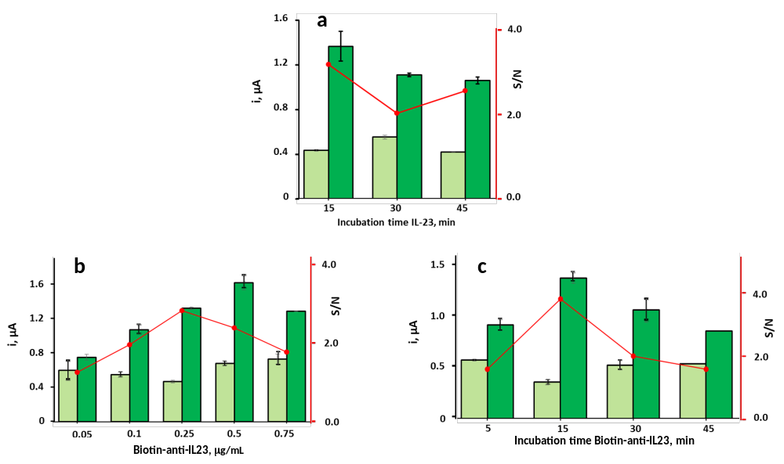
The effect of the incubation time of IL-23 antigen on the amperometric responses was evaluated over the 15 to 45 min with the results shown in Figure S3a. As it can be seen, 15 min were sufficient to reach a better S/N ratio. On the other hand, Figure S3b shows as the specific responses increased with the loading of biotinylated antibody up to 0.5 μg mL⁻¹, probably due to the higher amount of biotin to form the affinity link with the poly-HRP-Strep conjugate for detection. However, a larger Biotin-anti-IL23 concentration gave rise to a decrease in the S/N ratio. Therefore, 0.5 μg mL⁻¹ was chosen to prepare the immunosensor. Regarding the incubation time for Biotin-anti-IL23 (Figure S3c) 15 min were selected according to the used criterion.

Figure S3. Effect on the amperometric responses obtained with the developed immunosensor of a) incubation time of IL-23 antigen; b) concentration and c) incubation time of Biotin-anti-IL23. Amperometric responses measured in the absence (N; light bars) and in the presence of 10 ng mL⁻¹ IL 23 standard solutions (S; dark bars) as well as the resulting S/N ratio values (circles and red lines).
An amplification strategy involving poly-HRP-Strept instead of the usual HRP-Strept conjugate was implemented. The effect of the polymer dilution on the immunosensor responses was studied over the 1/250 to 1/1000 range and the results were compared with that obtained by using an 1/1000 HRP-Strept conjugate (Figure S4a). Both specific and non-specific currents gradually decreased as the dilution of poly-HRP-Strept increased, probably due to the lower number of detector labels on the biotinylated antibodies. However, a better S/N ratio was obtained for a 1/500 dilution, so that this value was chosen for subsequent studies. It should be noted that in all cases, the S/N ratio was better than that obtained using the HRP-Strept conjugate, which demonstrates the signal amplification ability of the polymeric conjugate. In order to reinforce the electrode blocking to further reduce remaining active sites and nonspecific responses, an optimized amount of BSA was added to the aqueous solutions of poly-HRP-Strept. As Figure S4b shows, better results were obtained with 8% BSA. Finally, the effect of the incubation time of poly-HRP-Strept prepared under the previous conditions (Figure 3Sc), led us to choose 20 min to prepare the immunosensor.
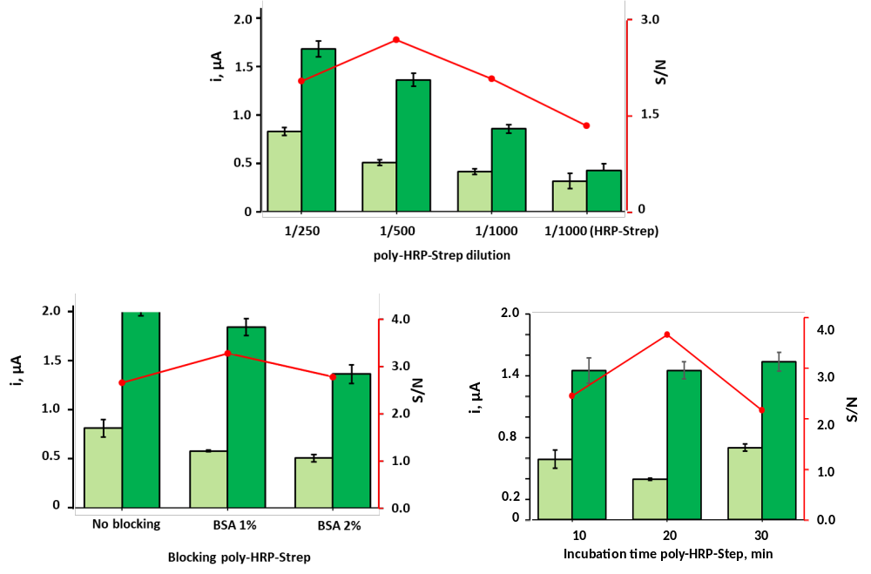

Figure S4. Effect on the amperometric responses obtained with the developed immunosensor of a) dilution of poly-HRP-Strept; b) BSA concentration in the poly-HRP-Strept solutions, and c) incubation time of poly-HRP-Strept. Amperometric responses measured in the absence (N; light bars) and in the presence of 10 ng mL⁻¹ IL-23 standard solutions (S; dark bars) as well as the resulting S/N ratio values (circles and red lines).

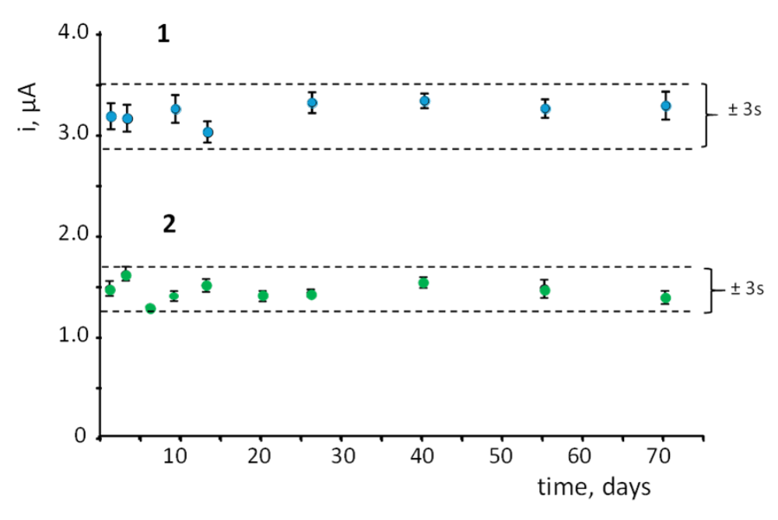
2. Storage stability

Figure S5. Control chart constructed to check the storage stability of anti-IL12-MWCNTs/CNC/SPCE and anti-IL-23-MWCNTs/CNC/SPCE bioelectrodes at 4 ºC in humid ambient. The central value was set as the average amperometric current for ten measurements of different 10 ng/mL IL-12 and IL-23 carried out on the first day.

REFERENCES
1. V. Durairaj et al., ACS Appl. Nano Mater 4 (2021) 5842-5853

