Enhancing Early Diabetes Prediction: A Hybrid Optimization Framework Using Adaptive Heterogeneous Differential Evolution (AHDE)
Lin Chen¹, Ben Niu ^{1*}
¹College of Management, Shenzhen University, Shenzhen, China
*Corresponding author address: drniuben@gmail.com

Supplementary Material (SM)
Table S1. Description and raw range of attributes used for Dataset 1 (PIDD) and Dataset 3 (ESDRPD).
Table S2. Statistical summary of dataset 1(PIDD) and dataset 2(LMCH).
Table S3. Statistical Significance of Scaled P-Values for Predictor and Outcome Variables in Dataset1 (PIDD).

Table S4. Configuration space for the hyperparameters of tested ML models.

Model | Hyperparameter | GA | PSO | DE | AHDE
SVM | C | 6.83 | 0.1 | 0.66 | 1.12
SVM | Kernel | poly | poly | poly | linear
SVM | gamma | 0.77 | 10 | 6.25 | /
KNN | n_neighbors | 19 | 20 | 20 | 1
 | weights | uniform | distance | distance | distance
 | p | 1 | 2 | 2 | 1
XGBoost | n_estimators | 52 | 50 | 95 | 51
XGBoost | max_depth | 3 | 3 | 4 | 3
XGBoost | learning_rate | 0.10 | 0.01 | 0.02 | 0.01
RF | n_estimators | 14 | 100 | 83 | 63
RF | max_depth | 10 | 50 | 5 | 5
RF | min_samples_split | 21 | 2 | 13 | 4
RF | min_samples_leaf | 8 | 20 | 8 | 1
RF | max_features | 3 | 8 | 1 | 1
Table S5 . Best hyperparameters obtained with different optimization algorithm for machine learning for Dataset 1(PIDD).

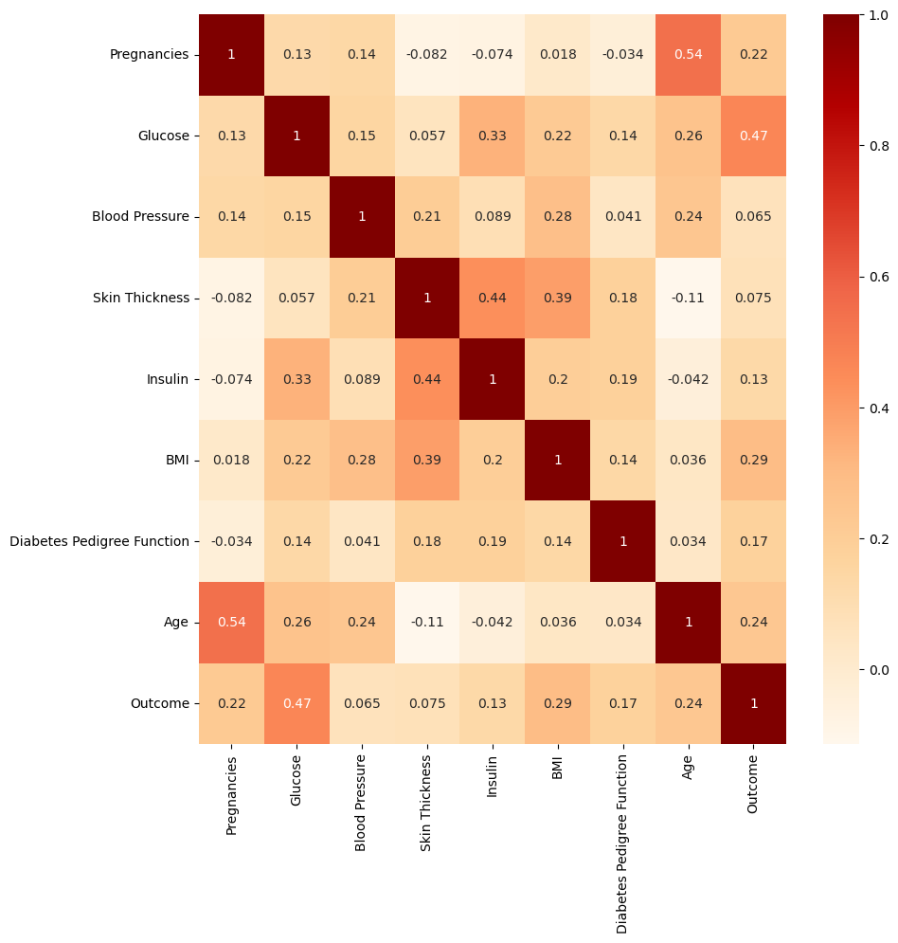
Figure S1. Correlation Matrix Heatmap of Features in Dataset 1(PIDD).

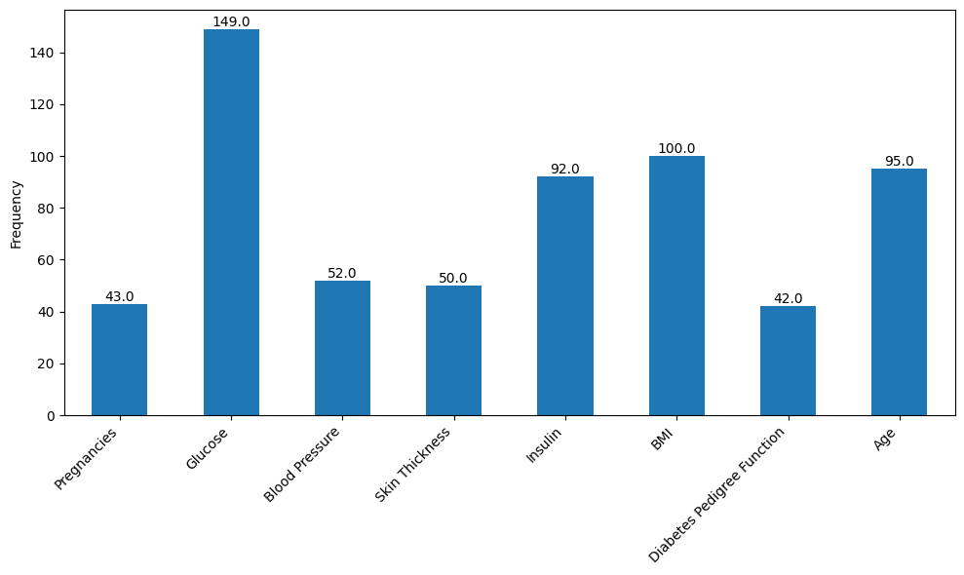
Figure S2. Frequency of Selected Features by Optimization Models on Dataset 1(PIDD).
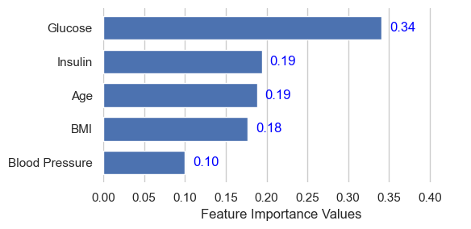
Figure S3. Feature Importance Ranking for Dataset 1(PIDD).
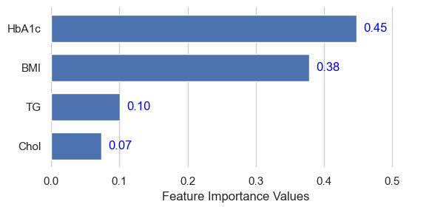
Figure S4. Feature Importance Ranking for Dataset 2(LMCH).

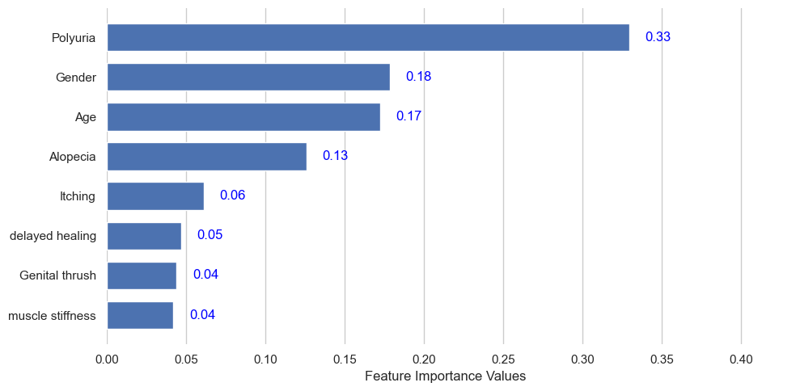
Figure S5. Feature Importance Ranking for Dataset 3(ESDRPD).

Theoretical overview
In this study, we selected four widely used machine learning algorithms in the medical field:Support Vector Machine (SVM), K-Nearest Neighbors (KNN), Extreme Gradient Boosting (XGBoost), and Random Forest (RF) for the task of early diabetes diagnosis and prediction. To further improve the predictive performance, we introduced three heuristic algorithms: Genetic Algorithm (GA), Particle Swarm Optimization (PSO), and Differential Evolution (DE), to optimize the hyperparameters of the machine learning models and select the most predictive feature subsets.

Machine learning model

SVM
SVM is a generalized linear classifier used for binary classification within supervised learning. It determines the decision boundary, which is the maximum-margin hyperplane, based on the learning sample. Initially developed for linear models, SVM was extended to accommodate non-linear training data in 1995.M involves identifying key data points, known as support vectors, on the edge of the dataset. These points are utilized to establish a decision plane, to maximize the distance between the support vectors and this plane.The SVM provides predictive solutions based on a specific functional form equation below³ :
 | $$y(x)=\sum_{n=1}^{N}{ω_{n}K(x,x_{n})+ω_{0}}$$ | (1)
Where $ω_{n}$ represents the model's 'weights', and $K(x,x_{n})$ is a kernel function. The kernel functions commonly employed in SVM include the polynomial kernel, radial basis function kernel, and Gaussian kernel.

KNN
KNN is a supervised learning algorithm that falls under the category of instance-based and lazy learning. It is extensively utilized for both classification and regression tasks. In the context of classification, KNN operates by analyzing a given training dataset and, upon encountering a new input instance, calculates the distance between this instance and those in the training set. It then identifies the k-nearest instances based on these distances. The classification of the new instance is determined by majority voting among these k-nearest neighbors. The fundamental principle of KNN is rooted in measuring the similarity between instances, with the understanding that shorter distances indicate more remarkable similarity. Consequently, instances sharing similar features are more likely to be categorized together or have comparable output values.

XGBoost
XGBoost, an advanced machine learning algorithm developed, has gained considerable acclaim in various domains. It represents an innovative implementation of gradient boosting machines, primarily focusing on classification and regression trees. Rooted in the foundational concept of 'boosting,' XGBoost employs an additive training strategy. This approach involves sequentially combining the predictions of weak learners to construct a powerful and efficient predictive model.
This approach helps to mitigate the risk of overfitting and optimizes computational efficiency. The core strength of XGBoost lies in its ability to minimize objective functions, which facilitates the integration of prediction and regularization terms while maintaining high processing speeds. Furthermore, XGBoost automatically performs cross-validation during the training process. The algorithm employs an additive learning approach, starting with the initial learner fitted to the entire dataset. Subsequent models are then fitted to the residuals of the previous model. This iterative process continues until a predefined stopping criterion is met. The final model prediction is the cumulative result of each learner's predictions.

RF
The RF algorithm, an advanced and parallel machine learning method, was proposed initially by Breiman in 2001. It synergizes the bagging method with the Classification and Regression Tree (CART) algorithm. This process involves extracting multiple samples from the original dataset using the Bootstrap resampling. Decision trees are constructed for each of these Bootstrap samples, and their predictions are aggregated through a voting mechanism to determine the final prediction result. Belgiu and Dragut provide a detailed explanation of the final decision-making process of the RF model as follows:
 | $$H(X)= arg max\sum_{i=1}^{K}{I(h_{i}(X))=Y}$$ | (2)
Where, $X$denotes the input vector, and$Y$represents the vector of correct classifications. $H(X)$ symbolizes the RF model, which is composed of DTs. Here,${ h}_{i}$ refers to individual DTs within the model. $K$ indicates the number of DTs incorporated in this RF model.

Heuristic Optimization Algorithm

GA
GAs are computational search algorithms used for solving optimization problems and fall under the category of evolutionary algorithms. These algorithms draw inspiration from various phenomena observed in evolutionary biology, such as genetics, mutations, natural selection, and hybridization. The process of a GA typically unfolds in three distinct phases:
Initialization Phase: This phase involves setting up key optimization parameters such as the crossover rate, mutation rate, and population size. The initial population can be selected randomly or based on pre-existing knowledge of potential solutions, laying the foundation for the algorithm's search process.
Evolution Phase: During this phase, the algorithm generates the next generation of solutions from the existing population. This is achieved through selection, crossover, and mutation operations. Selection is driven by the fitness of individuals, with those exhibiting higher fitness having a greater likelihood of being chosen. Crossover involves combining the genetic information of parent individuals, while mutation introduces an element of randomness, enhancing diversity in the population.
Termination Phase: The algorithm concludes when a predefined termination condition is met. This could be the achievement of a maximum number of iterations or the identification of a solution that meets the desired criteria. At this point, the algorithm returns the best solution it has discovered.

PSO
PSO is an evolutionary computing technique. PSO is a collective search algorithm, that draws inspiration from the social behaviors observed in animal groups, such as fish and birds, which exhibit coordinated movement patterns in small and large swarms.
In PSO, each 'particle' represents a potential solution to the problem. Within a D-dimensional search space, the $i$th particle at the $t$th iteration is characterized by two vectors that guide its search: the position vector $X_{i}^{t}=[X_{i1}^{t},X_{i2,}^{t}...,X_{iD}^{t}]$ and the velocity vector $V_{i}^{t}=[V_{i1}^{t},V_{i2,}^{t}...,V_{iD}^{t}]$. As the particles move through the search space, their positions and velocities are updated based on two key solutions: the personal best position (${pbest}_{i}=[{pbest}_{i1}{,pbest}_{i2},...,{pbest}_{iD}])$ achieved by the particle itself, and the global best position ($gbest=[{gbest}_{1}{,gbest}_{2},...,{gbest}_{D}]$) found by the entire swarm. The updating of the $i$th particle's velocity and position for the $(t+1)$th iteration is governed by specific formulas that consider both $pbest$ and $gbest$. These formulas are presented in following equations:
 | $$V_{id}^{t+1}=ω{∙V}_{id}^{t}+c_{1}∙r_{1}∙{(pbest}_{id}−X_{id}^{t})+c_{2}∙r_{2}∙({gbest}_{d}^{t}−X_{id}^{t})$$ | (3)
 | $$X_{id}^{t+1}=X_{id}^{t}+V_{id}^{t+1}$$ | (4)
Where $t$ denotes the current iteration number; $ω$ represents the inertia weight. The constants $c_{1}$and $c_{2}$ are known as the cognitive and social parameters, respectively. These acceleration constants guide the particle's movement toward its personal best position and the global best position. Additionally, $r_{1}$ and $r_{2}$ are random values uniformly distributed over the interval [0, 1]

DE
DE,similar to GA, is a population-based metaheuristic optimization algorithm inspired by Darwin's theory of evolution. DE was introduced to solve global optimization problems in continuous spaces. The method is straightforward and easy to implement, requiring only a few control parameters. Due to these characteristics, DE has attracted significant attention from researchers across various fields .
The basic framework of the DE algorithm consists of four stages: initialization, mutation, crossover, and selection. Initialization is a one-time process, while the other three mechanisms are repeated during DE's search process in the $D$-dimensional solution space until the termination condition is met.
The core concept of the DE algorithm lies in generating new candidate solutions by leveraging the mutual learning and random perturbations among individuals within the population. More specifically, for each individual $X_{i}^{t}=[X_{i1}^{t},X_{i2,}^{t}...,X_{iD}^{t}]$ in the population, DE generates a trial vector $Y_{i}^{t}=[Y_{i1}^{t},Y_{i2,}^{t}...,Y_{iD}^{t}]$by selecting other individuals from the population. Upon generating the trial vector SSS, DE compares the fitness values of the target vector and the trial vector to determine whether to replace the target vector with the trial vector. If the trial vector exhibits a superior fitness value, it replaces the target vector in the subsequent generation; otherwise, the original target vector is retained.
The performance of the DE algorithm is influenced by several key parameters, including the population size $N$, the scaling factor $F$, and the crossover probability $CR$, By judiciously adjusting these parameters, the DE algorithm can achieve favorable results across a wide range of optimization problems.

Evaluation metrics
The experimental setup for assessing the proposed diabetes prediction framework includes key aspects. First, we evaluate the effectiveness of our imputation method for missing values in data preprocessing. Second, we assess its performance in diabetes prediction across various machine learning classifiers. Third, we examine optimizing RF hyperparameters and feature subsets using various heuristic algorithms. The framework's performance is evaluated using accuracy, precision, recall, and F1 score, calculated from true positives (TP), false positives (FP), true negatives (TN), and false negatives (FN).
Given a dataset with (TP + TN + FP + FN) data points, accuracy is the ratio of correctly predicted points (TP + TN) to the total. It's a crucial metric for assessing model performance. It is calculated using the following formula:
 | $$Accuracy=\frac{TP+TN}{TP+TN+FP+FN}$$ | (5)
Precision is the ratio of true positives (TP) to the total instances classified as positive, including both TP and false positives (FP). It's essential for correctly identifying instances in imbalanced datasets. The formula is as follows:
 | $$Precison=\frac{TP}{TP+FP}$$ | (6)
Recall, also known as sensitivity, is the proportion of true positives (TP) out of all actual positive instances, including both TP and false negatives (FN). It's crucial for measuring the model's ability to identify positive instances in imbalanced datasets. The formula is:
 | $$Recall=\frac{TP}{TP+FN}$$ | (7)
The F1 score is the harmonic mean of Precision and Recall, providing a balanced evaluation of the model's performance in classifying diabetes patients. It's the most critical metric for assessing the model's effectiveness. The formula is:
 | $$F_{1 }score=2∗\frac{Precison∗Recall}{Precison+Recall}$$ | (8)
The Receiver Operating Characteristic (ROC) curve graphically represents a diagnostic test's performance by plotting the true positive rate (TPR) against the false positive rate (FPR). The area under the ROC curve (AUC) quantifies a model's overall diagnostic accuracy .This performance metric ranges from 0 to 1, evaluating a classifier's ability to distinguish between positive and negative outcomes. The ROC AUC can be calculated using the following formula:
 | $$ROC AUC=\int_{0}^{1}{TPR(FPR)dFPR=\int_{0}^{1}{TPR({FPR}^{−1}(x))dx}}$$ | (9)
An AUC of 0 indicates a completely inaccurate classifier with all predictions incorrect. An AUC of 0.5 suggests the classifier performs no better than random guessing, failing to differentiate between classes. When the AUC is between 0.7 and 0.8, the classifier's performance is considered acceptable, indicating moderate discrimination. An AUC from 0.8 to 0.9 is regarded as excellent, showing strong discrimination. An AUC above 0.9 is outstanding, signifying exceptional performance in identifying class outcomes. These AUC thresholds are valuable benchmarks for assessing and comparing the effectiveness of classifiers across various domains.

