Appendix
Appendix A. Operating mileage of China's high-speed rail and its proportion to the total operating mileage of railways from 2008 to 2022.

Appendix B. China's high-speed rail passenger volume and its proportion to the total railway passenger volume from 2008 to 2022.

Note: between 2020 and 2022, passenger volume fluctuated due to COVID-19.
Appendix C. mobile phone base stations, length of optical cable lines, and capacity of mobile phone exchanges from 2008 to 2022.

Appendix D. Top Eight Countries in the 2024 Tourism Development Index.

Appendix E. Map of China's four major regions.
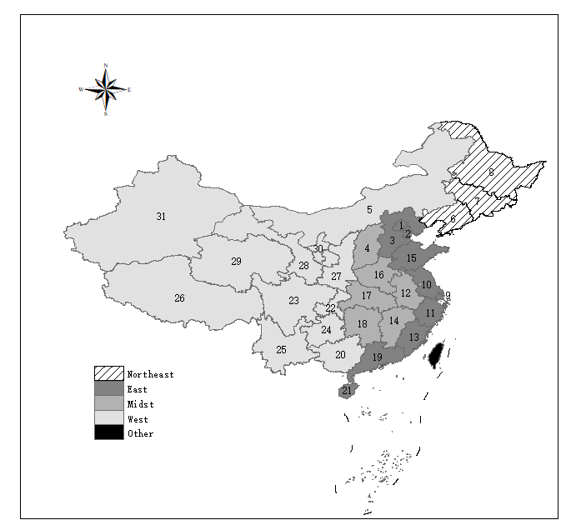
Note: The administrative units on the map are ranked in numerical order as follows: Beijing, Tianjin, Hebei, Shanxi, Inner Mongolia, Liaoning, Jilin, Heilongjiang, Shanghai, Jiangsu, Zhejiang, Anhui, Fujian, Jiangxi, Shandong, Henan, Hubei, Hunan, Guangdong, Guangxi, Hainan, Chongqing, Sichuan, Guizhou, Yunnan, Xizang, Shaanxi, Gansu, Qinghai, Ningxia, and Xinjiang. Other administrative units in China include Hong Kong, Macao, and Taiwan.

