Supplementary information

Reaction-induced regioselective reconstruction of Ni-doped Ce(OH)₃/CeO₂ enables exceptional activity and selectivity for reverse water-shift reaction
Wenbin Li^{1,#}, Bing Liu^{2,#}, Qing Guo¹, Wenjie Guo¹, Sai Zhang^{1,3,}* and Yongquan Qu^{1,}*
¹ School of Chemistry and Chemical Engineering, Northwestern Polytechnical University, Xi’an, 710072, China
² Department of Chemical Engineering, School of Chemical and Material Engineering, Jiangnan University, Wuxi 214122, China
³ Research & Development Institute of Northwestern Polytechnical University in Shenzhen, Shenzhen 518057, China

Correspondence and requests for materials should be addressed to Zhang S. and Qu Y. Q. (Email: zhangsai1112@nwpu.edu.cn and yongquan@nwpu.edu.cn)

Experimental Section
Synthesis of the Ce(OH)₃/CeO₂ nanorods
Initially, 5 mL of aqueous Ce(NO₃)₃ solution (0.8 mmol mL⁻¹) was added into 75 mL of aqueous NaOH solution (6.4 mmol mL⁻¹) with continuous stirring at room temperature. After 30 min, the mixture was transferred to a Pyrex bottle (100 mL) for a hydrothermal process at 100 °C for 24 h. Finally, the Ce(OH)₃/CeO₂ pre-catalysts were washed alternatively with H₂O and ethanol for three times and dried overnight at 60 ℃.
Synthesis of the Ni-CeO₂ catalysts
The Ni-CeO₂ catalysts were prepared by hydrothermal of the Ni-Ce(OH)₃/CeO₂ catalysts at 180 °C for 12 h. Then, the solids were collected by centrifugation and washed with copious of H₂O. Finally, the catalysts were dried overnight at 60 ℃.
Synthesis of the reconstructed Ni-Ce(OH)₃/CeO₂ and H₂-treated Ni-Ce(OH)₃/CeO₂ catalysts
The Ni-Ce(OH)₃/CeO₂ per-catalysts were treated by a flow of H₂:CO₂ (a ratio of 3:1, 50 mL min⁻¹) at 600 ℃ for 2 h, resulting in the reconstructed Ni-Ce(OH)₃/CeO₂ catalysts.
The Ni-Ce(OH)₃/CeO₂ per-catalysts were treated by H₂/Ar (10 vol.%, 50 mL min⁻¹) at 600 ℃ for 2 h, giving the H₂-treated Ni-Ce(OH)₃/CeO₂ catalysts.
Characterizations
Transmission electron microscope (TEM) characterizations were conducted using a JEOL2100F instrument operating an accelerating voltage of 200 kV. The high angle annular dark-field scanning transmission electron microscopy (HAADF-STEM) and element mapping analyses were performed on a FEI Tecnai F30 microscope operated at 300 kV. X-ray photoelectron spectroscopy (XPS) profiles were acquired from a Thermo Electron Model K-Alpha with Al Ka as the excitation source. The Ni contents in various catalysts were determined by inductively coupled plasma optical emission spectrometer (ICP-OES). Alpha300R micro confocal Raman spectrometer (Raman) produced by German WITec Company was used to analyze the surface defects.
Experimental details of hydrogen temperature programmed reduction (H₂-TPR)
H₂-TPR measurements were performed on the Auto Chem 2920 chemisorbent. Initially, 100 mg of catalyst was loaded into the sample tube, and then pretreated at 350 ℃ in an Ar atmosphere for 1 h (50 mL min⁻¹). Once the temperature was lowered to 50 ℃, the gas was switched to a mixture of 10 vol.% H₂/Ar (50 mL min⁻¹). Subsequently, the temperature was gradually increased from 50 ℃ to 800 ℃ with a ramping rate of 10 ℃ min⁻¹. Thermal conductivity detection (TCD) was used to monitor the consumption of hydrogen during the reduction process.
Experimental details of CO₂ and CO temperature programmed reduction (TPD)
The CO₂-TPD experiments were conducted on the Auto Chem 2920 Chemisorbent. Typically, 100 mg of sample was pretreated at 200 ℃ in an Ar atmosphere for 0.5 h (50 mL min⁻¹). After cooling down to 50 ℃, the gas was switched to CO₂ (50 mL min⁻¹) for adsorption of 0.5 h, and then purged with He (50 mL min⁻¹) for 1 h. Under the He atmosphere, the temperature was raised from 50 ℃ to 800 °C with a heating rate of 10 °C min⁻¹.
The CO-TPD experiments were also performed using the Auto Chem 2920 Chemisorbent. Initially, 100 mg of sample was pre-treated at 200 ℃ in Ar atmosphere for 0.5 h (50 mL min⁻¹). After cooling down to 50 ℃, the gas was switched to CO (50 mL min⁻¹) for a 0.5 h adsorption period, and then purged with (50 mL min⁻¹) He for 1 h. Under the He atmosphere, the temperature was gradually increased from 50 ℃ to 800 °C with a ramping rate of 10 °C min⁻¹.
Calculations of reaction equilibrium
The gas-phase thermochemical data of reactants at various temperatures are obtained from the NIST Chemistry WebBook. According to the equation of the RWGS reaction, H and S of reactants and products at different temperatures are used to calculate ΔH and ΔS. Then, the thermodynamic state function ΔG is calculated using the formula of ΔG=ΔH–T×ΔS. Afterwards, the reaction equilibrium constant (K) is derived from the following formula.
Where R is the gas constant and T is the absolute temperature.
The chemical equilibrium at each temperature is calculated according to the ratio of hydrogen and carbon dioxide (H₂: CO₂ =3:1) in the reaction conditions. The specific equation used for the calculations is as follows:
Here, CO, H₂O, H₂ and CO₂ represent the concentrations of CO, H₂O, H₂ and CO₂ at the specific temperature, respectively.
Reaction order calculations
The reaction orders of different reactants are determined by the reaction rate equation of RWGS, as follows:
In the formula, r_{CO} represents the rate of the CO generation, k is the reaction rate constant, P_{CO2} represents the partial pressure of CO₂ under the reaction conditions, P_{H2} represents the partial pressure of H₂ under the reaction conditions, α represents the reaction order of CO₂, β represents the reaction order of H₂.
Computational Methods
All the spin-polarized density functional theory (DFT) calculations were performed by using the Vienna ab initio simulation package (VASP).^{1,2} To accurately treat the Ce 4f orbital, a correction for Coulomb and exchange interactions (DFT+U) was employed by setting U_{eff} = 5.0 eV (U_{eff} = coulomb U – exchange J) applied to the Ce 4f state, according to previous studiy.³ The D3 correction method (DFT-D3) was employed in order to include van der Waals (vdW) interations.⁴ The projector-augmented wave (PAW) method was used to represent core-valence interations.⁵ Valence electrons were described by a plane wave basis with an energy cutoff of 400 eV. The generalized gradient approximation with the Perdew-Burke-Ernzerhof (GGA-PBE) functional was used to model electronic exchange and correlation.⁶ Electron smearing was employed via Gaussian smearing method with a smearing width consistent to 0.05 eV. The conjugate gradient algorithm was used in geometry optimization calculations. The force convergence criteria and energy convergence criteria were set to 0.03 eV/Å and 10⁻⁵ eV, respectively. The Brillouin zone was sampled at the Γ-point. A fluorite face-centered cubic Ce₄O₈ cell with Fm$\overline{3}$m space group was used to model the CeO₂ unit cell. The calculated lattice parameter for CeO₂ was 5.437 Å, which well matches the experimental value (5.412 Å).⁷

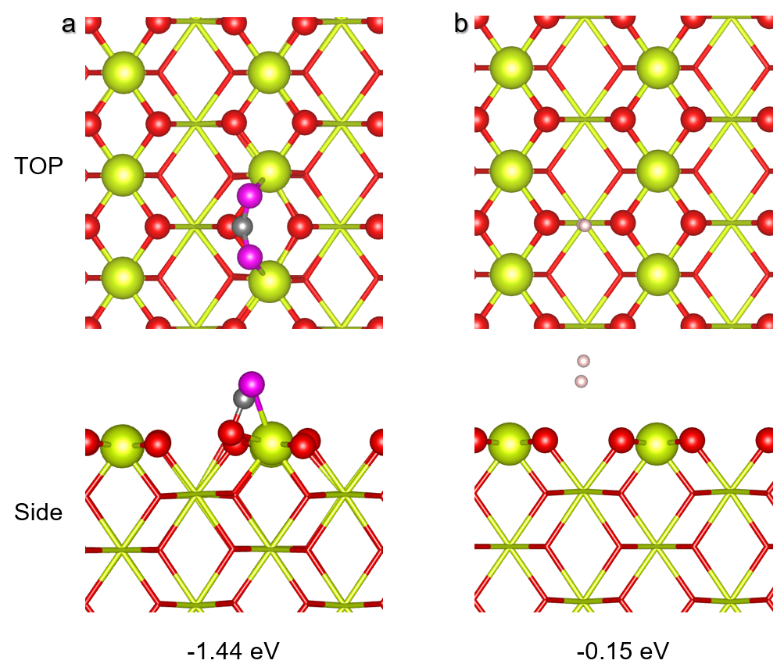
Figure S1. Adsorption behaviors of reactants on the ideal CeO₂(110) surface. The optimized adsorption configurations of (a) CO₂ and (b) H₂ on the ideal CeO₂(110) surface.
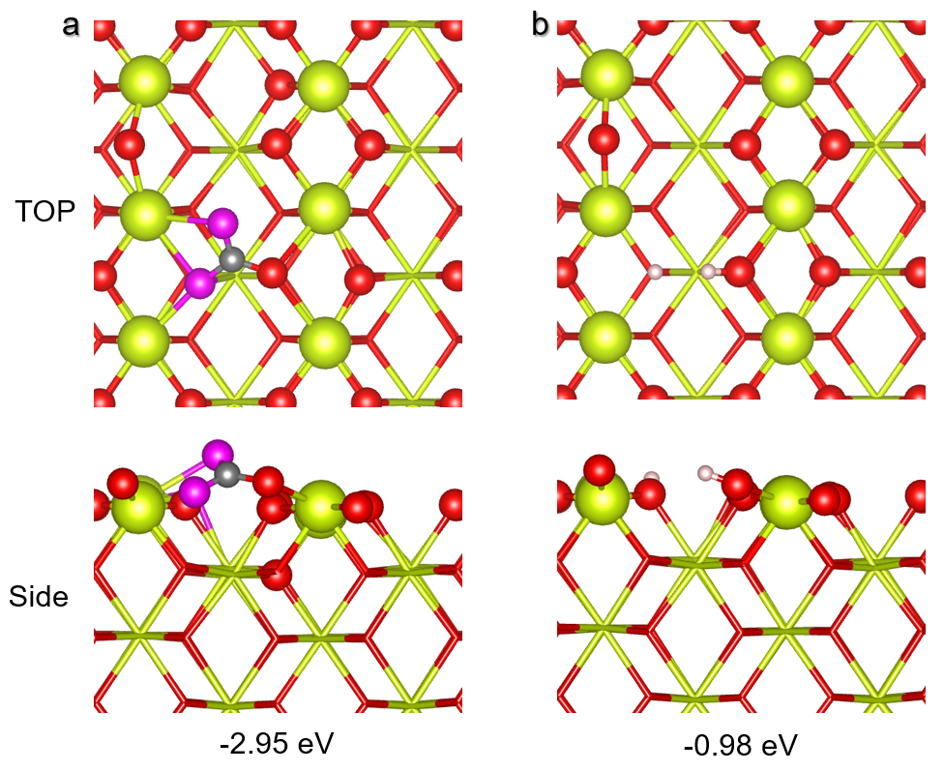
Figure S2. Adsorption behaviors of reactants on the FLP sites of CeO₂(110) surface. The optimized adsorption configurations of (a) CO₂ and (b) H₂ on the FLP sites of CeO₂(110) surface.
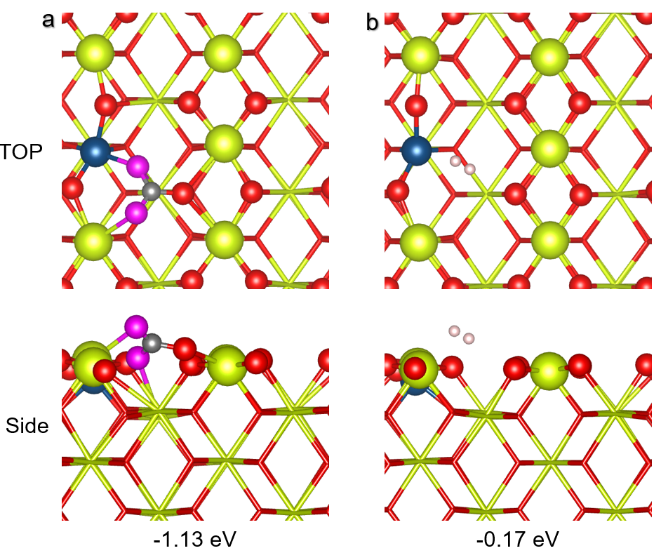
Figure S3. Adsorption behaviors of reactants on the FLP sites of CeO₂(110)-Ni_{surf} surface. The optimized adsorption configurations of (a) CO₂ and (b) H₂ on the FLP sites of CeO₂(110)-Ni_{surf} surface.
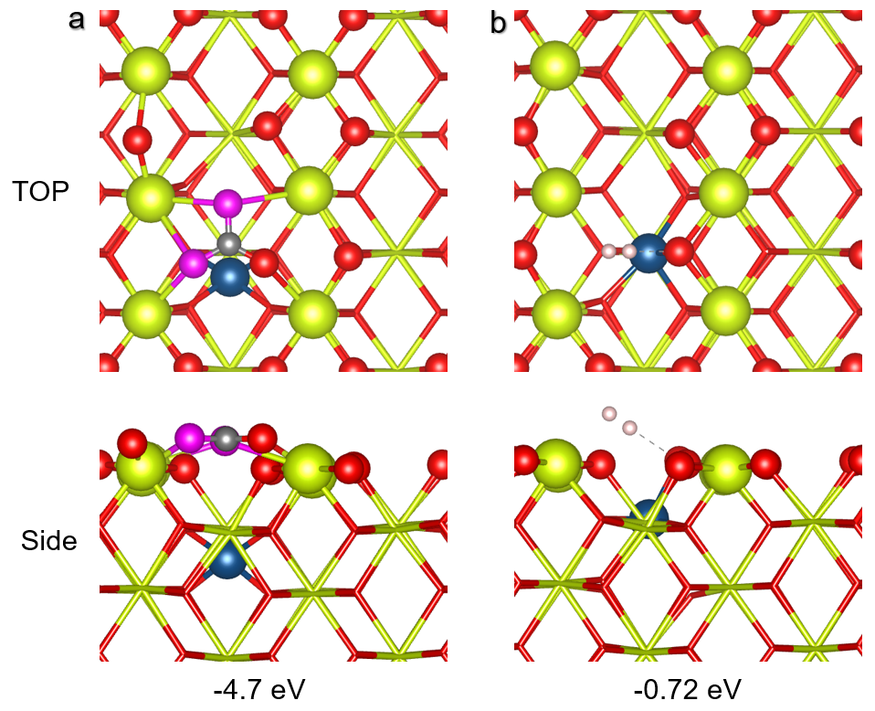
Figure S4. Adsorption behaviors of reactants on the FLP sites of CeO₂(110)-Ni_{sub} surface. The optimized adsorption configurations of (a) CO₂ and (b) H₂ on the FLP sites of CeO₂(110)-Ni_{sub} surface.
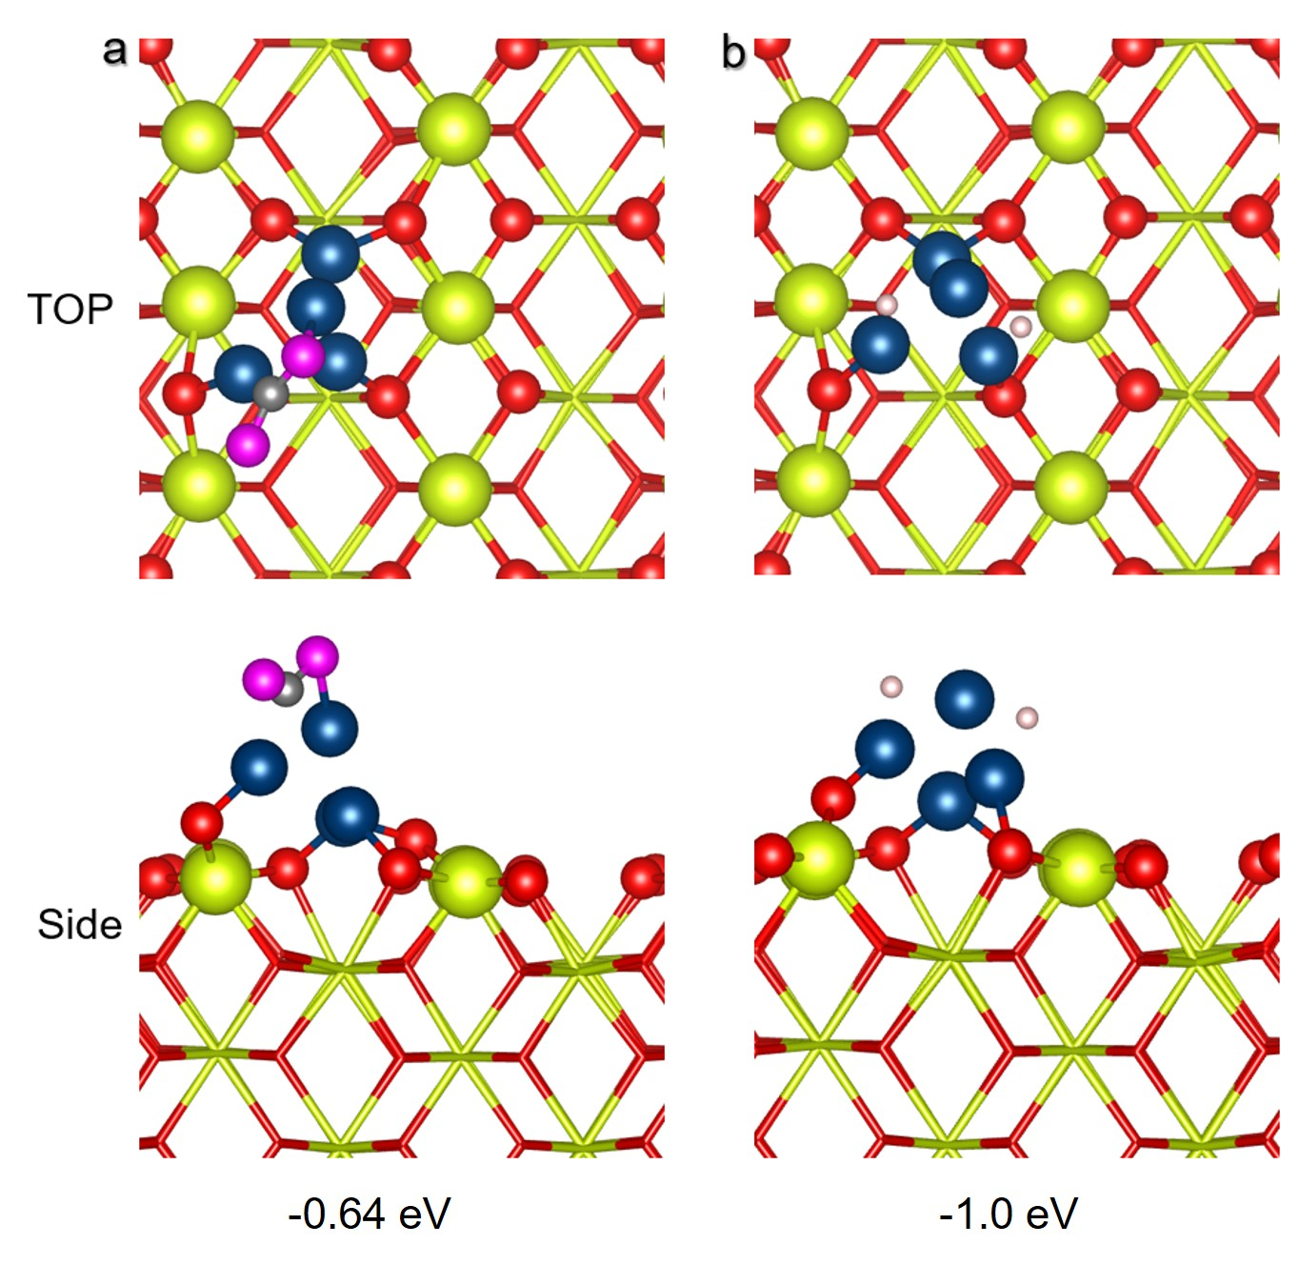
Figure S5. Adsorption behaviors of reactants on Ni₄ cluster of Ni₄/CeO₂(110) surface. The optimized adsorption configurations of (a) CO₂ and (b) H₂ on Ni₄ cluster of Ni₄/CeO₂(110) surface.

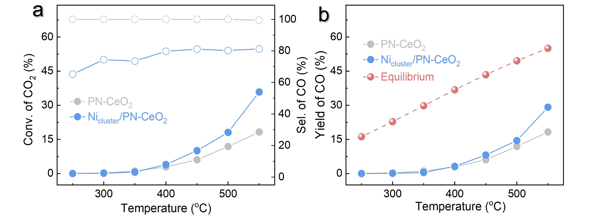
Figure S6. Catalytic performance of PN-CeO₂ and Ni_{cluster}/PN-CeO₂ for RWGS reaction. (a) CO₂ conversions and CO selectivity. (b) CO yields. Note: The PN-CeO₂ catalysts have been demonstrated with the abundant FLP sites in our previous reports^{8,9}. The Ni_{cluster}/PN-CeO₂ catalysts exhibited the dual-active sites of Ni clusters and FLP sites. Reaction conditions: catalysts (50 mg), WHSV (72,000 mL g_{cat}⁻¹ h⁻¹), H₂:CO₂:N₂ of 3:1:8.
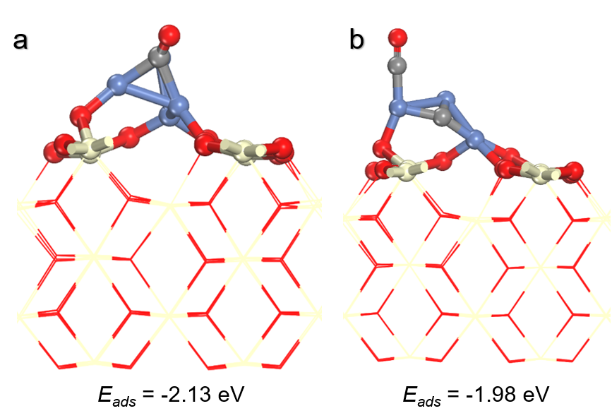
Figure S7. Adsorption behaviors of CO on various catalysts. The optimized adsorption configurations of CO on the (a) Ni₄/CeO₂(110)-2O_{V} and (b) carburized Ni₄/CeO₂(110)-2O_{V} surfaces.

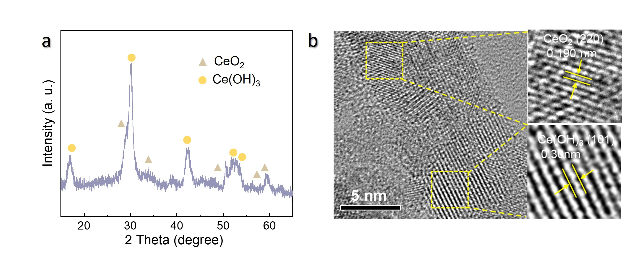
Figure S8. Characterizations of the Ce(OH)₃/CeO₂ pre-catalysts. (a) XRD pattern and (b) HR-TEM image.

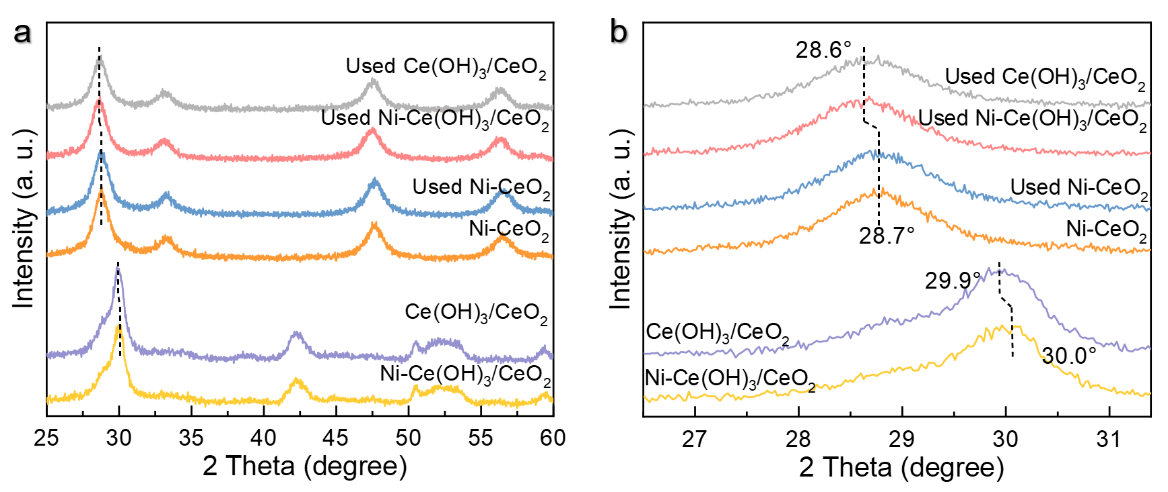
Figure S9. XRD analysis. (a) XRD and (b) locally magnified XRD patterns of the Ce(OH)₃/CeO₂, Ni-CeO₂ and Ni-Ce(OH)₃/CeO₂ catalysts before and after the RWGS reaction.

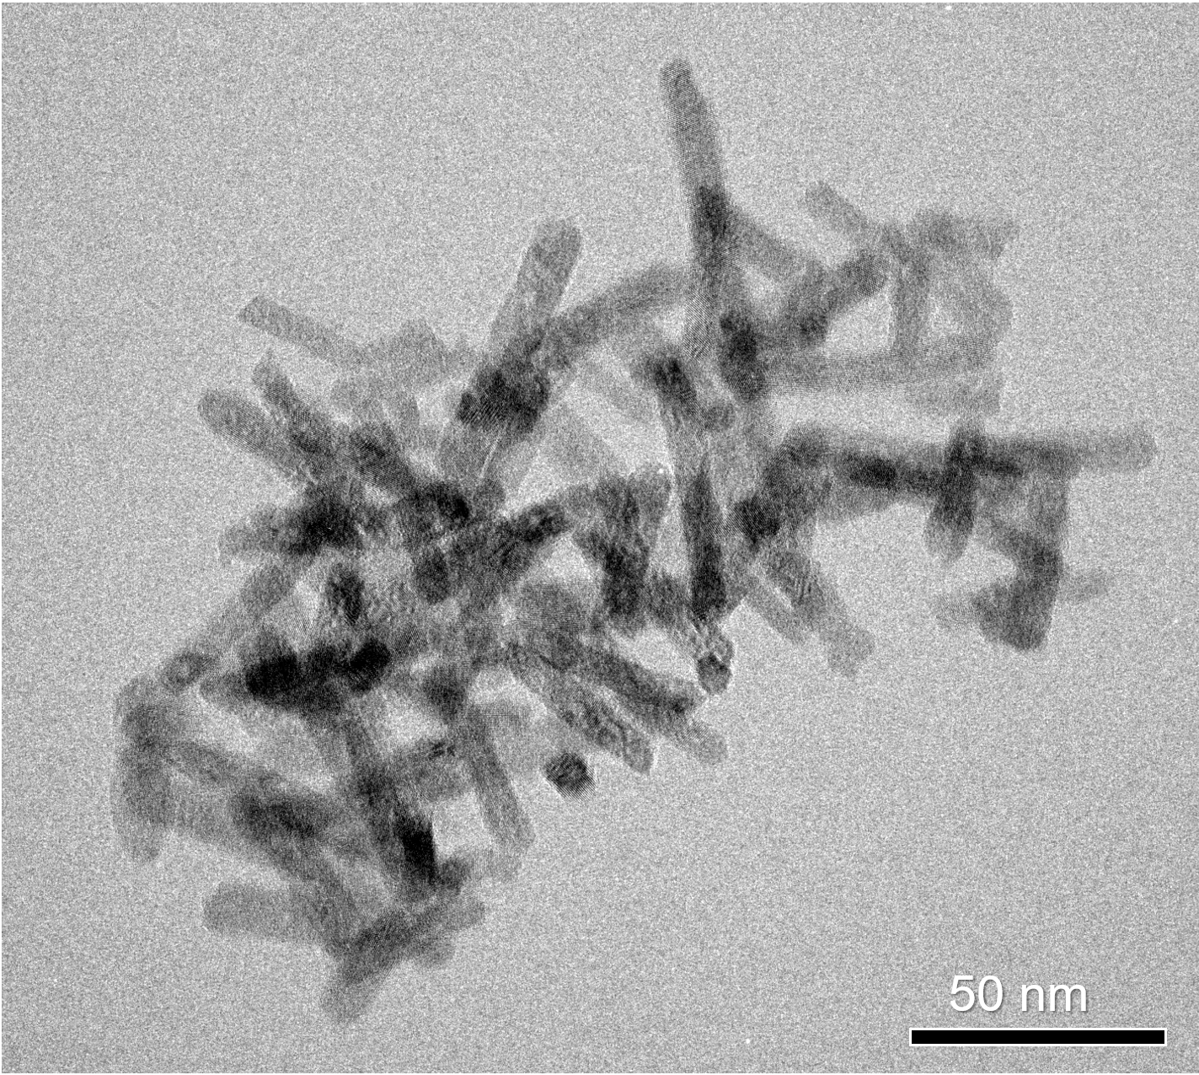
Figure S10. TEM image of the Ni-Ce(OH)₃/CeO₂ pre-catalysts.

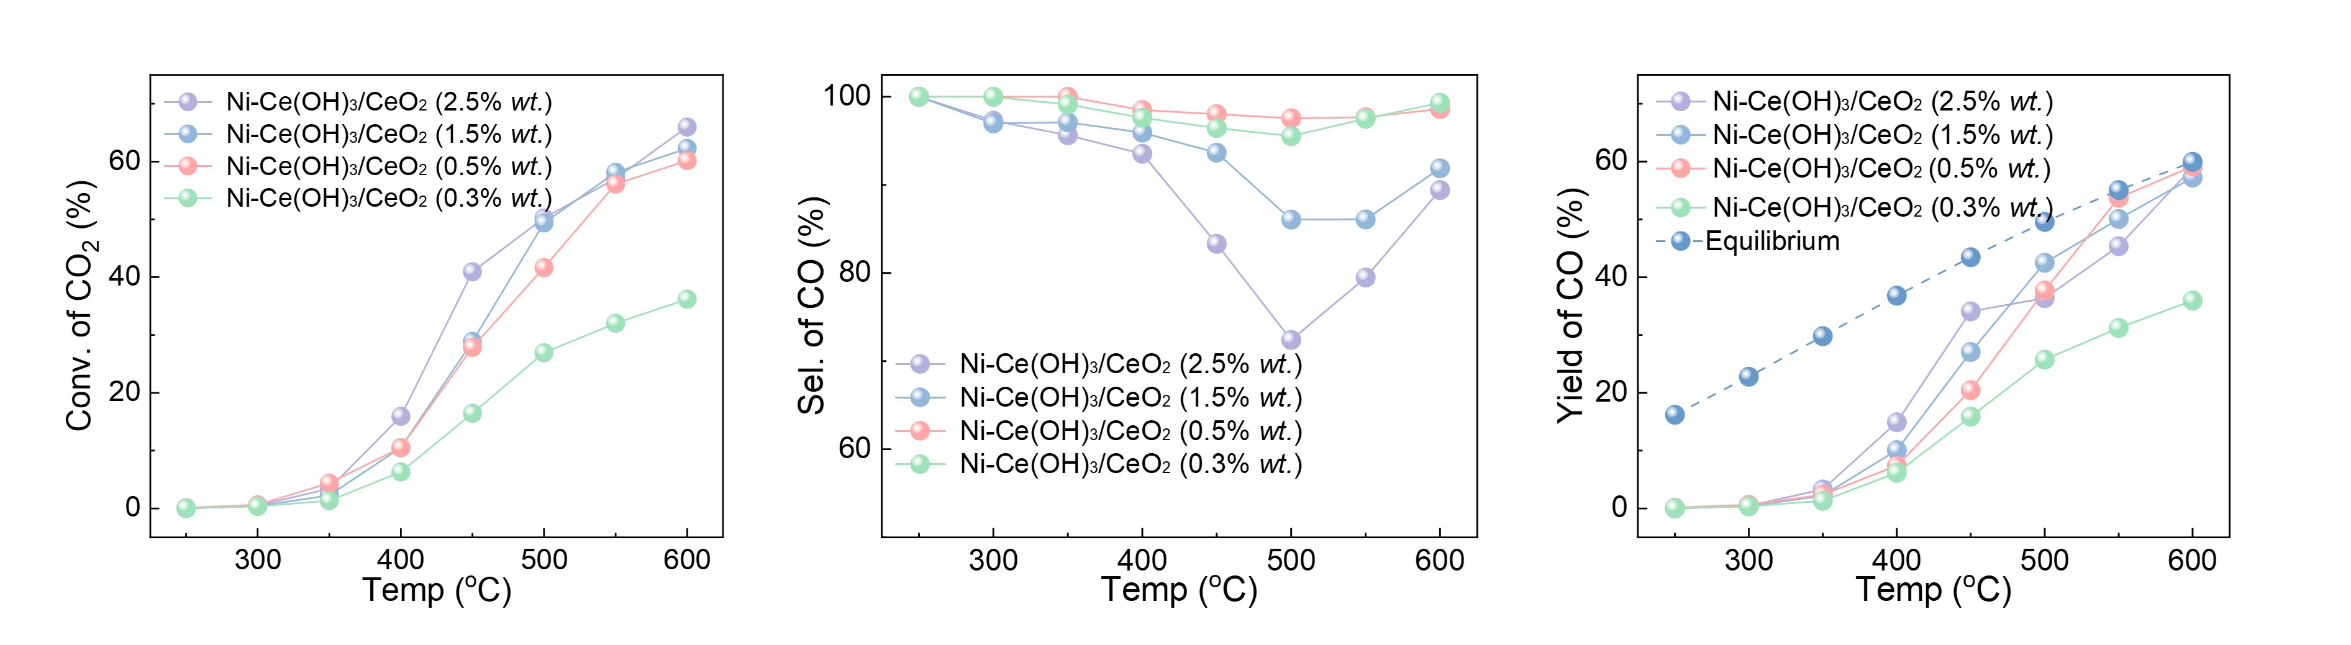
Figure S11. Catalytic performance of Ni-Ce(OH)₃/CeO₂ with various Ni loading for RWGS. (a) CO₂ conversions, (b) CO selectivity and (c) CO yields of various Ni-Ce(OH)₃/CeO₂ catalysts for the RWGS reaction. Reaction conditions: catalysts (50 mg), WHSV (72,000 mL g_{cat}⁻¹ h⁻¹), H₂:CO₂:N₂ of 3:1:8.

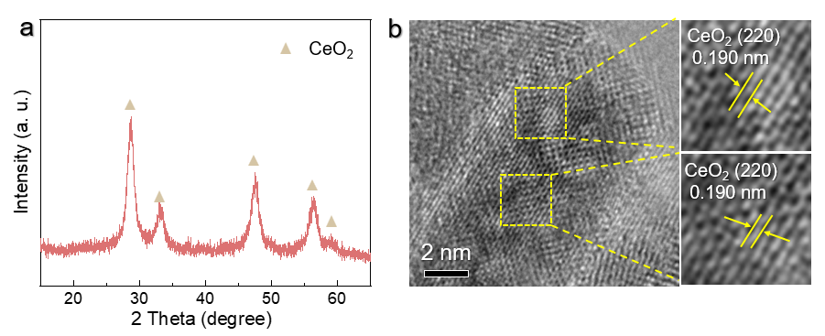
Figure S12. Characterizations of the Ni-CeO₂ catalysts. (a) XRD pattern and (b) HR-TEM image.

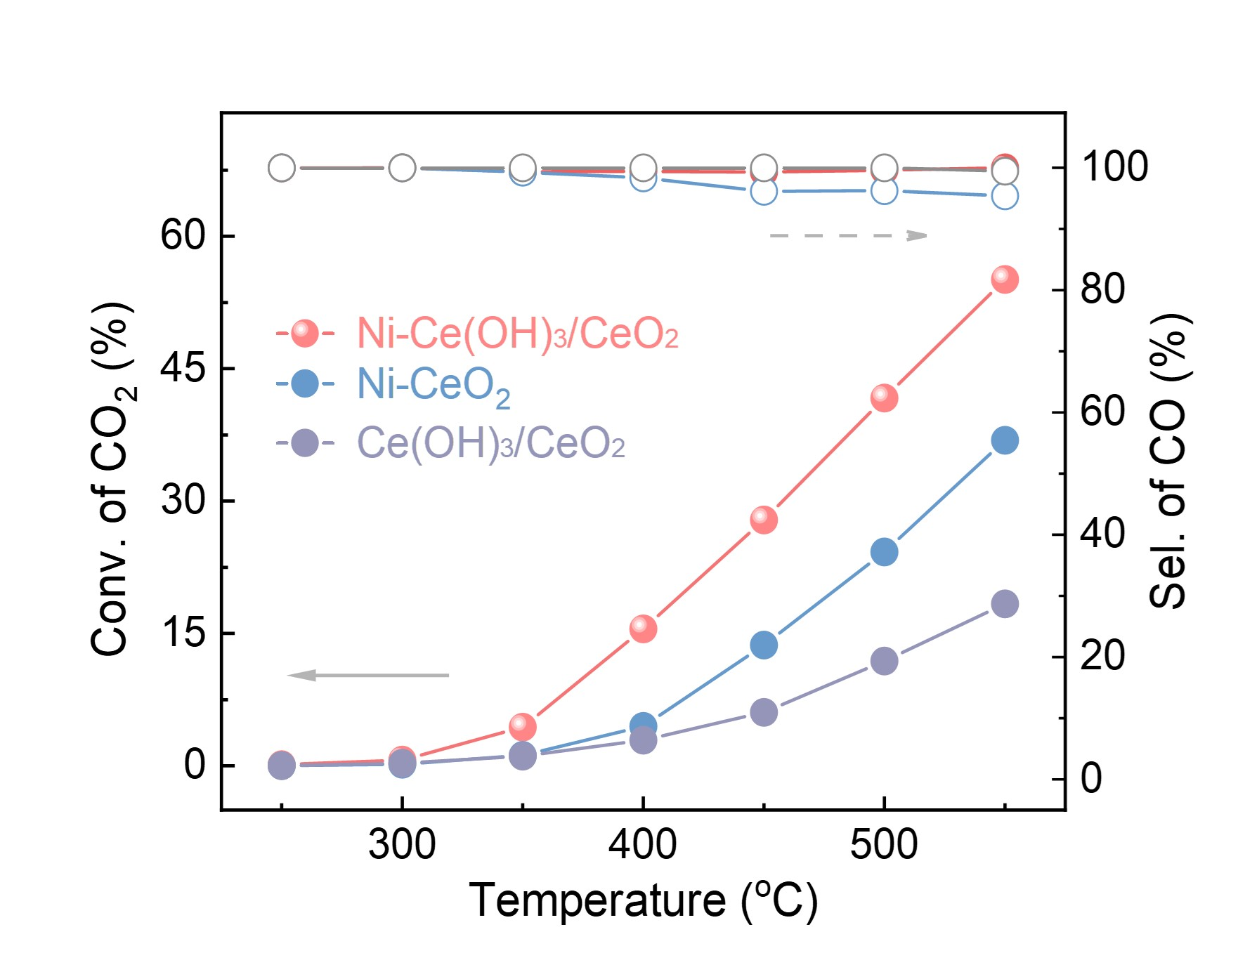
Figure S13. Catalytic performance of the Ni-Ce(OH)₃/CeO₂, Ni-CeO₂ and Ce(OH)₃/CeO₂ catalysts for RWGS reaction. Reaction conditions: catalysts (50 mg), WHSV (72,000 mL g_{cat}⁻¹ h⁻¹), H₂:CO₂:N₂ of 3:1:8.

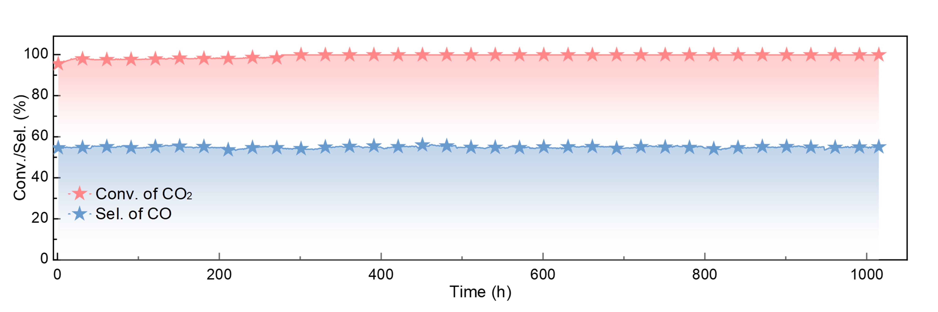
Figure S14. Catalytic stability of Ni-Ce(OH)₃/CeO₂ for the RWGS reaction at 550 ℃ temperatures. Reaction conditions: Ni-Ce(OH)₃/CeO₂ (50 mg), WHSV (72,000 mL g_{cat}⁻¹ h⁻¹), H₂:CO₂:N₂ of 3:1:8, 550 °C.
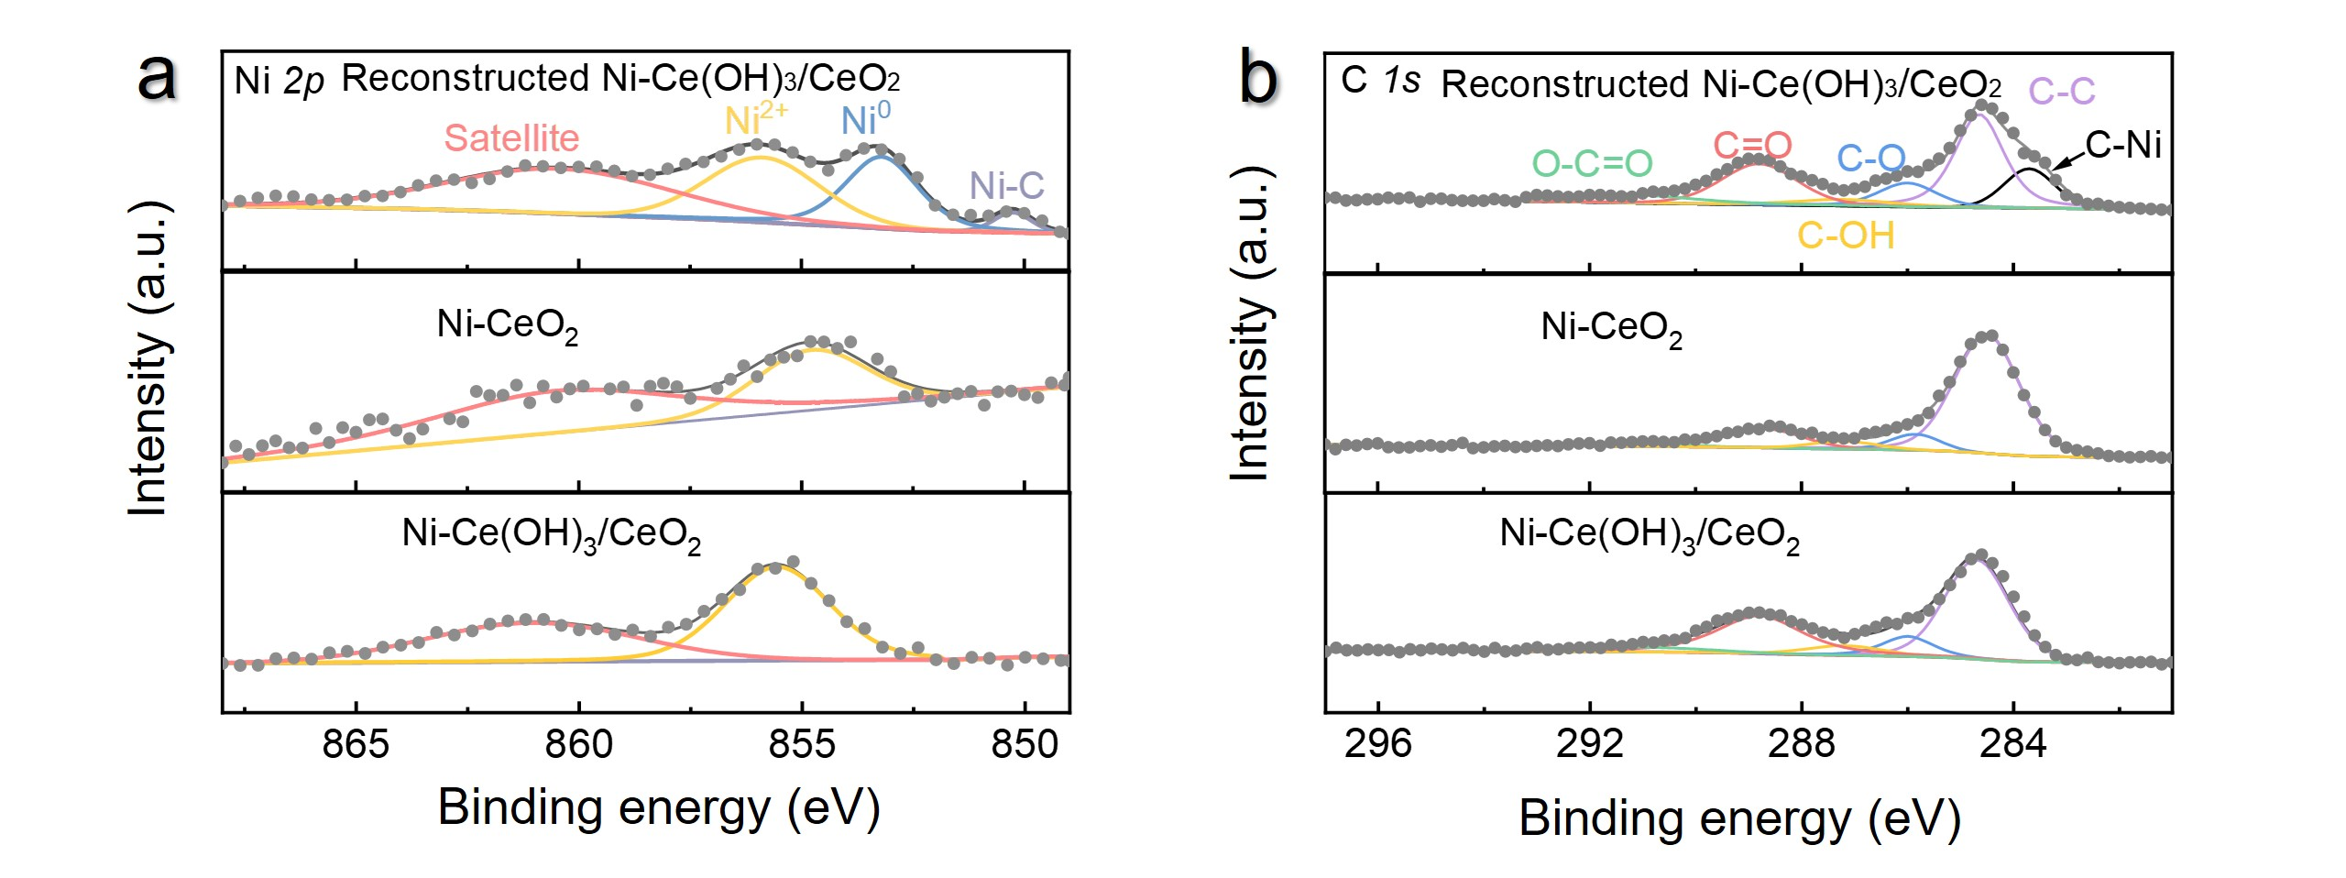
Figure S15. XPS analysis. XPS analysis of (a) Ni 3d and (b) C 1s peaks for the Ni-Ce(OH)₃/CeO₂, reconstructed Ni-Ce(OH)₃/CeO₂ and Ni-CeO₂ catalysts.

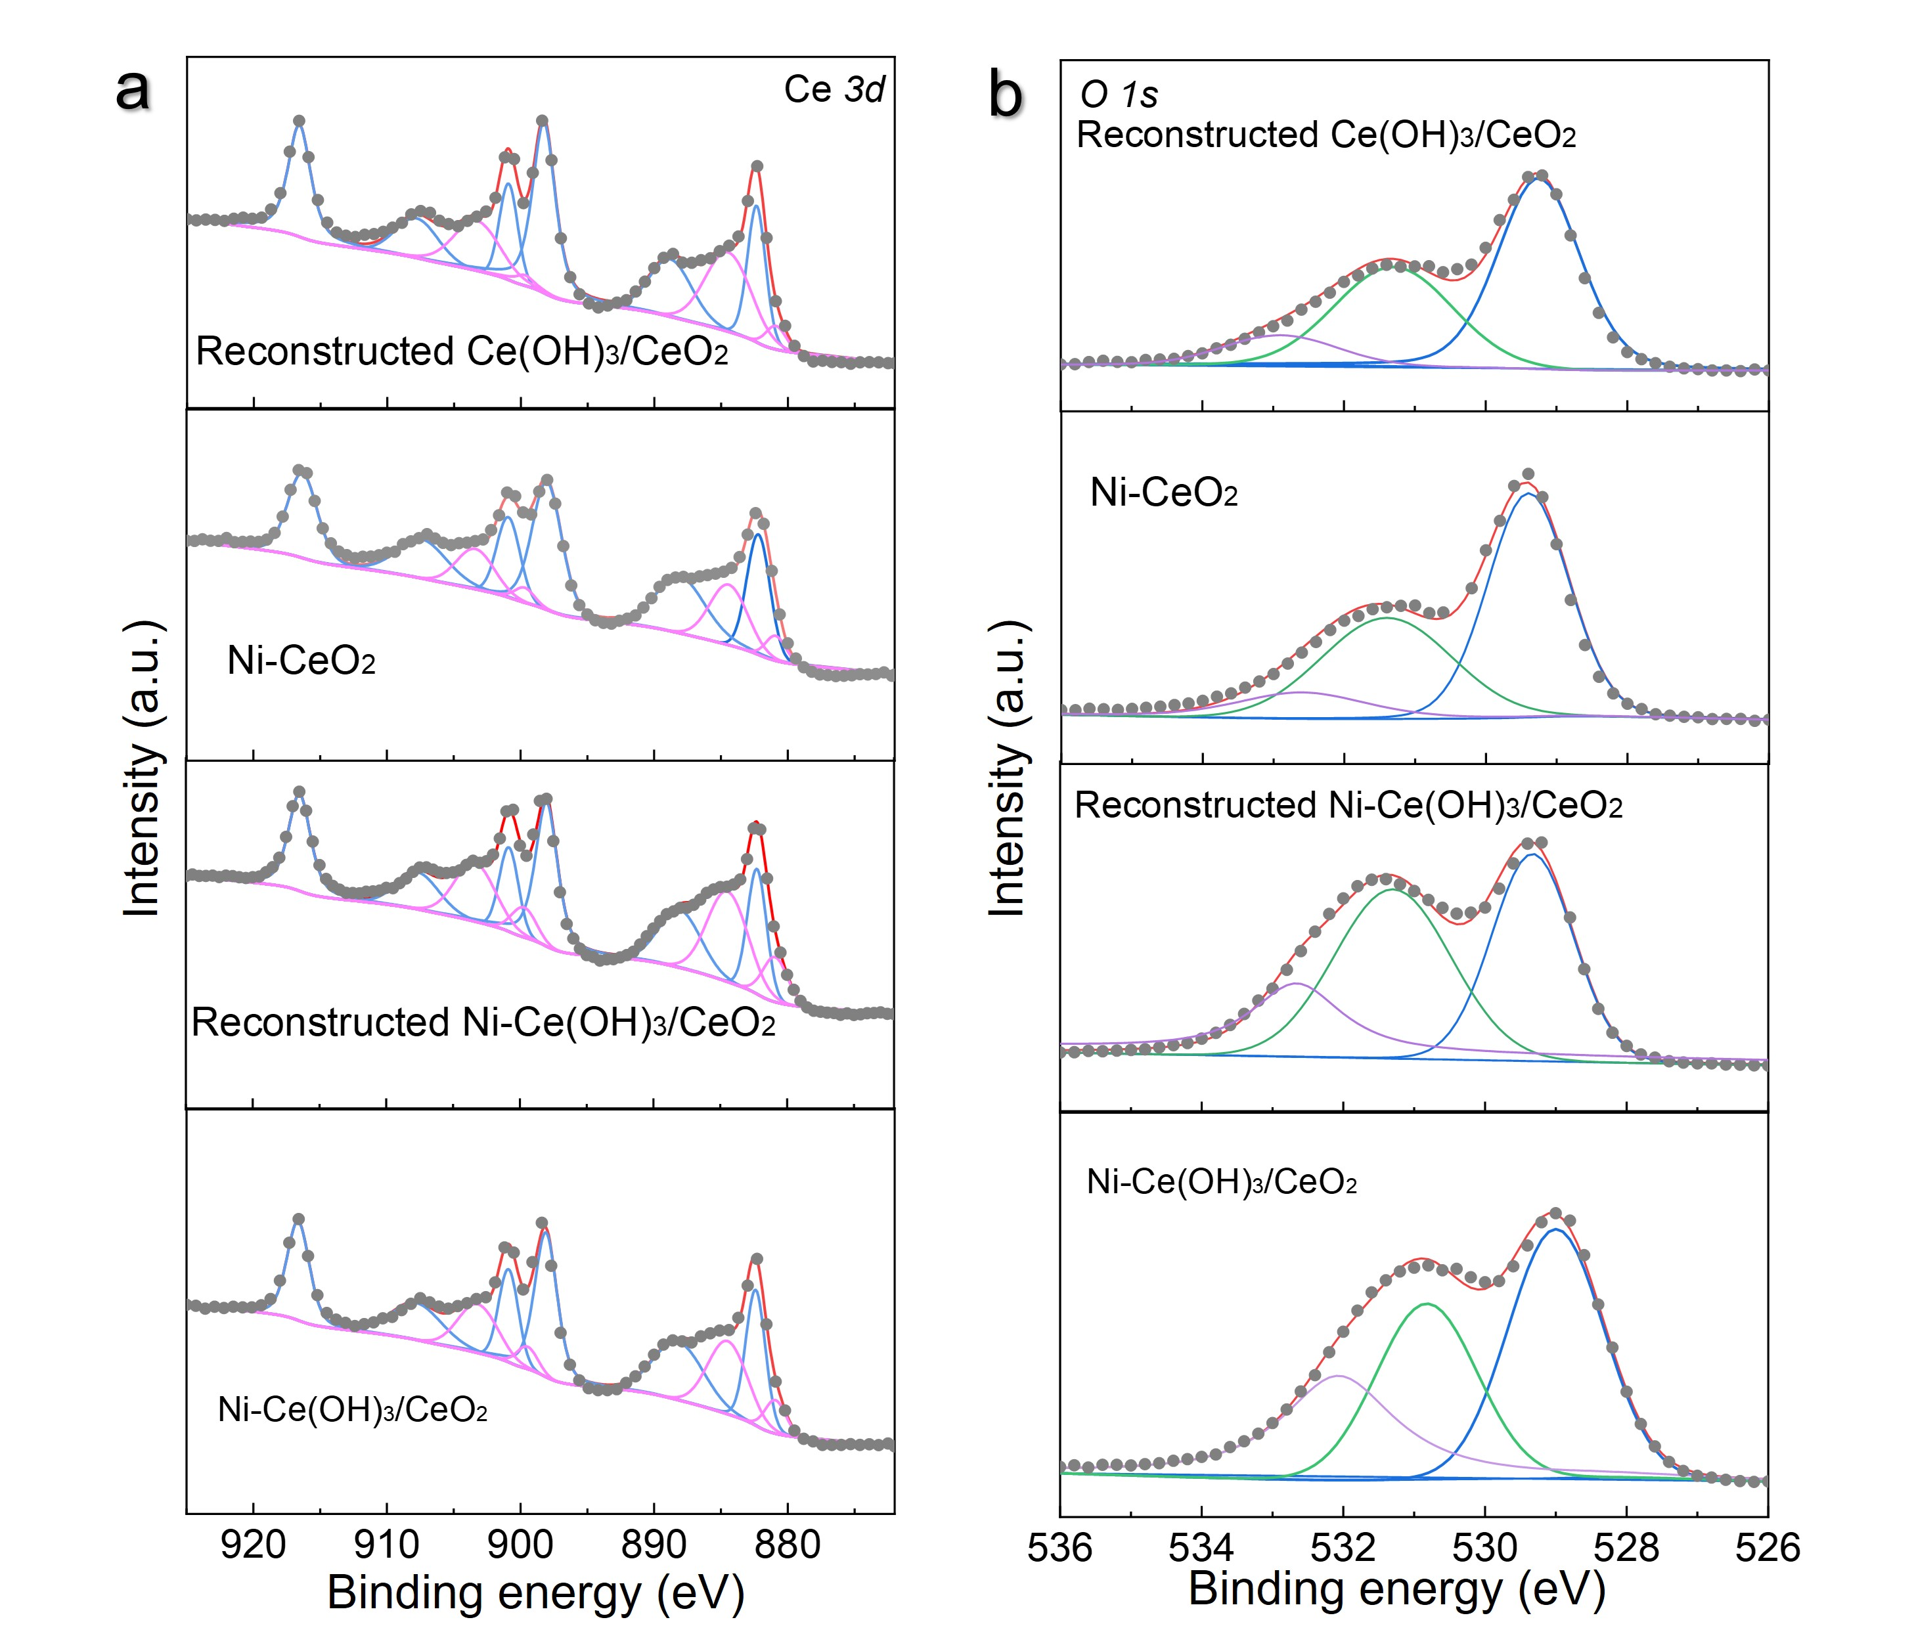
Figure S16. XPS analysis. XPS analysis of (a) Ce 3d and (b) O 1s peaks for reconstructed Ni-Ce(OH)₃/CeO₂, Ni-CeO₂, reconstructed Ce(OH)₃/CeO₂ and Ni-Ce(OH)₃/CeO₂ catalysts.

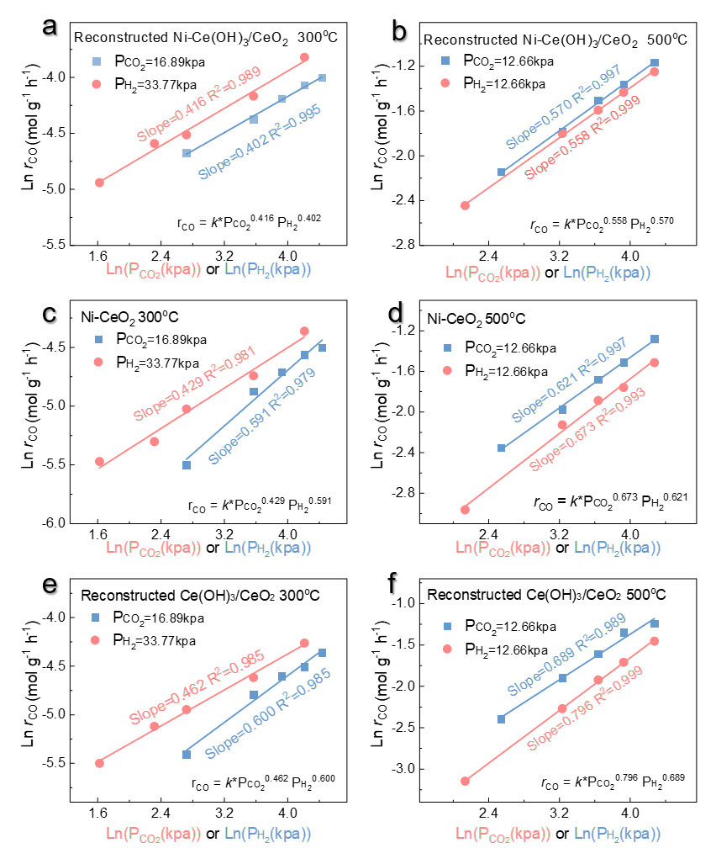
Figure S17. Kinetic measurements of the reconstructed Ni-Ce(OH)₃/CeO₂, Ni-CeO₂ and reconstructed Ce(OH)₃/CeO₂ catalysts. Test results of the reconstructed Ni-Ce(OH)₃/CeO₂ catalyst at (a) 300 °C and (b) 500 °C. Test results of the Ni-CeO₂ catalyst at (c) 300 °C and (d) 500 °C. Test results of the reconstructed Ce(OH)₃/CeO₂ catalyst at (e) 300 °C and (f) 500 °C. Note: The CO production rate serves as a function of CO₂ and H₂ concentrations on different catalysts. Reaction conditions: catalysts (40 mg), 100 mL min⁻¹ of a gas flow (H₂+CO₂+N₂), WHSV=150,000 mL g⁻¹ min⁻¹.

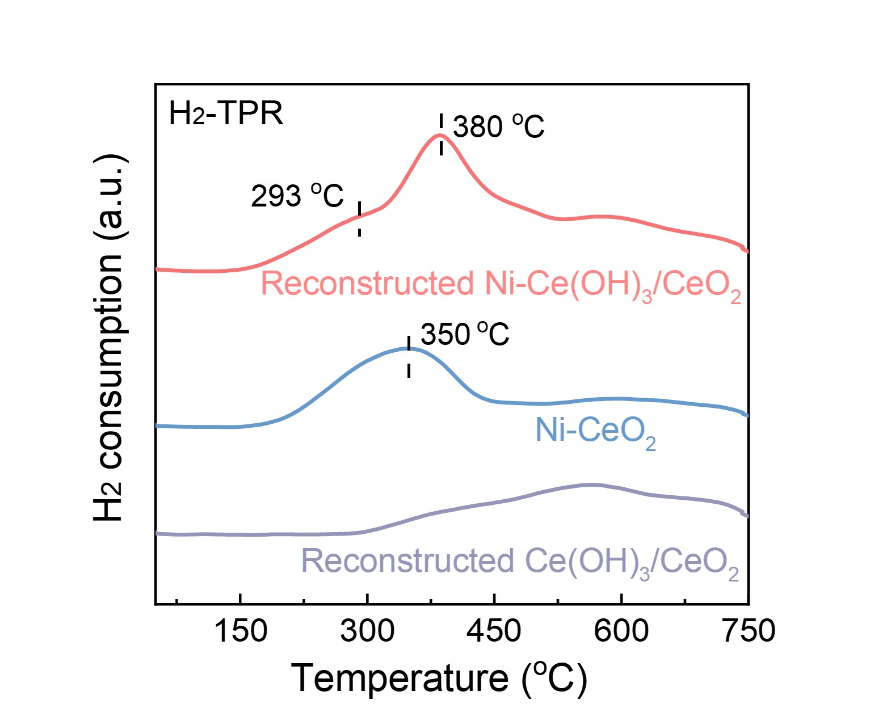
Figure S18. H₂-TPR of the reconstructed Ni-Ce(OH)₃/CeO₂, Ni-CeO₂ and reconstructed Ce(OH)₃/CeO₂ catalysts.

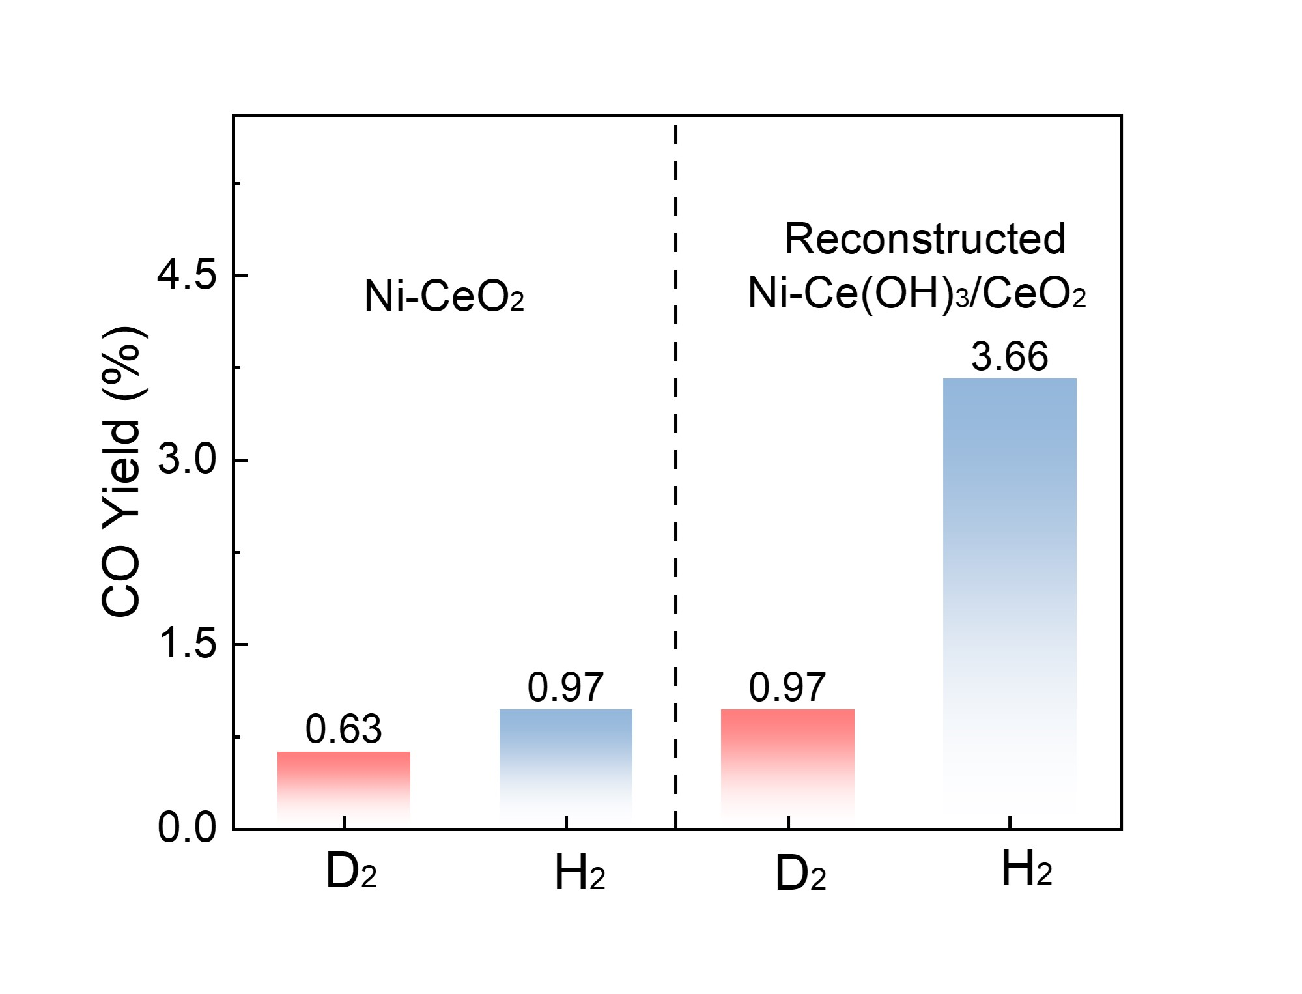
Figure S19. H₂/D₂ isotope experiments on the reconstructed Ni-Ce(OH)₃/CeO₂ and Ni-CeO₂ catalysts for the RWGS reaction. Reaction conditions: 50 mg of catalysts, 20 mL min⁻¹ of a gas flow (H₂/D₂: 15 mL min⁻¹ + CO₂: 5 mL min⁻¹), WHSV=24,000 mL g⁻¹ min⁻¹.
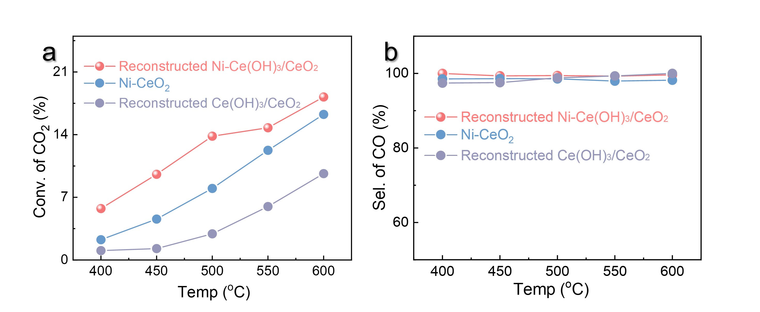
Figure S20. Catalytic performance of the reconstructed Ni-Ce(OH)₃/CeO₂, Ni-CeO₂ and reconstructed Ce(OH)₃/CeO₂ catalysts for RWGS reaction. (a) CO₂ conversions and (b) selectivity of CO as function of reaction temperatures. Reaction conditions: 10 mg of catalysts, 100 mL min⁻¹ gas flow (H₂: 75 mL min⁻¹ + CO₂: 25 mL min⁻¹), WHSV=600,000 mL g⁻¹ min⁻¹.

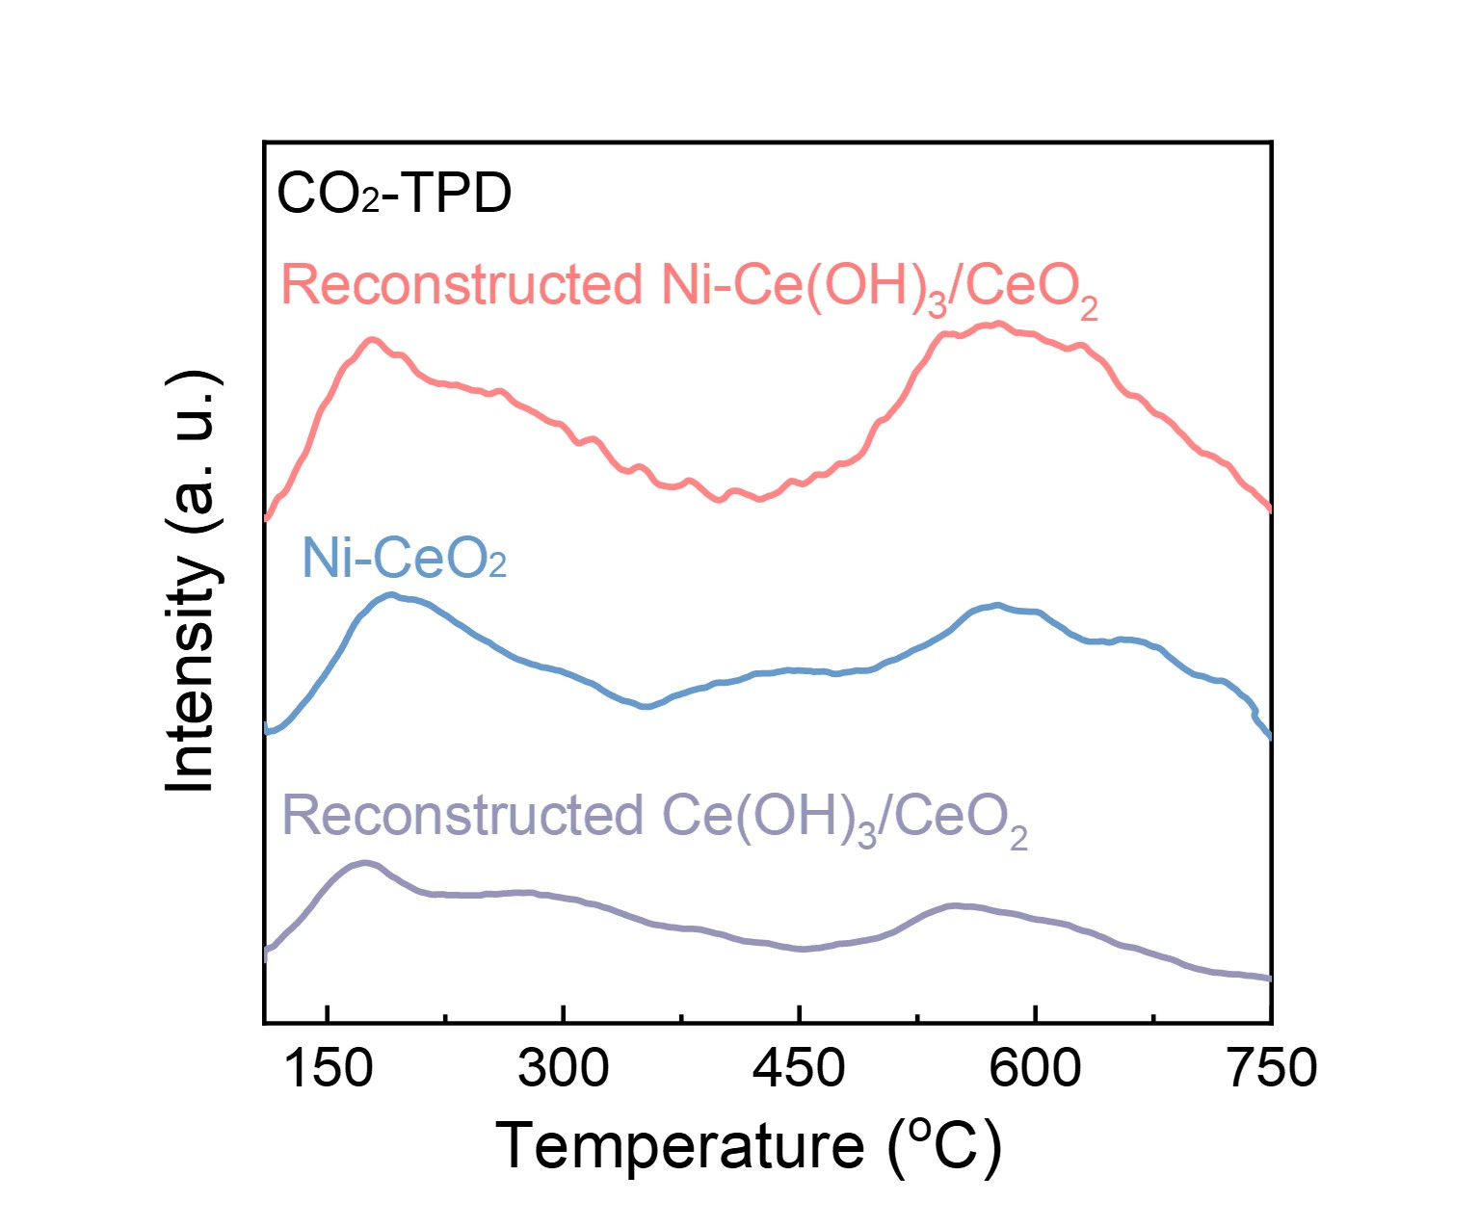
Figure S21. CO₂-TPD of the reconstructed Ni-Ce(OH)₃/CeO₂, Ni-CeO₂ and reconstructed Ce(OH)₃/CeO₂ catalysts.
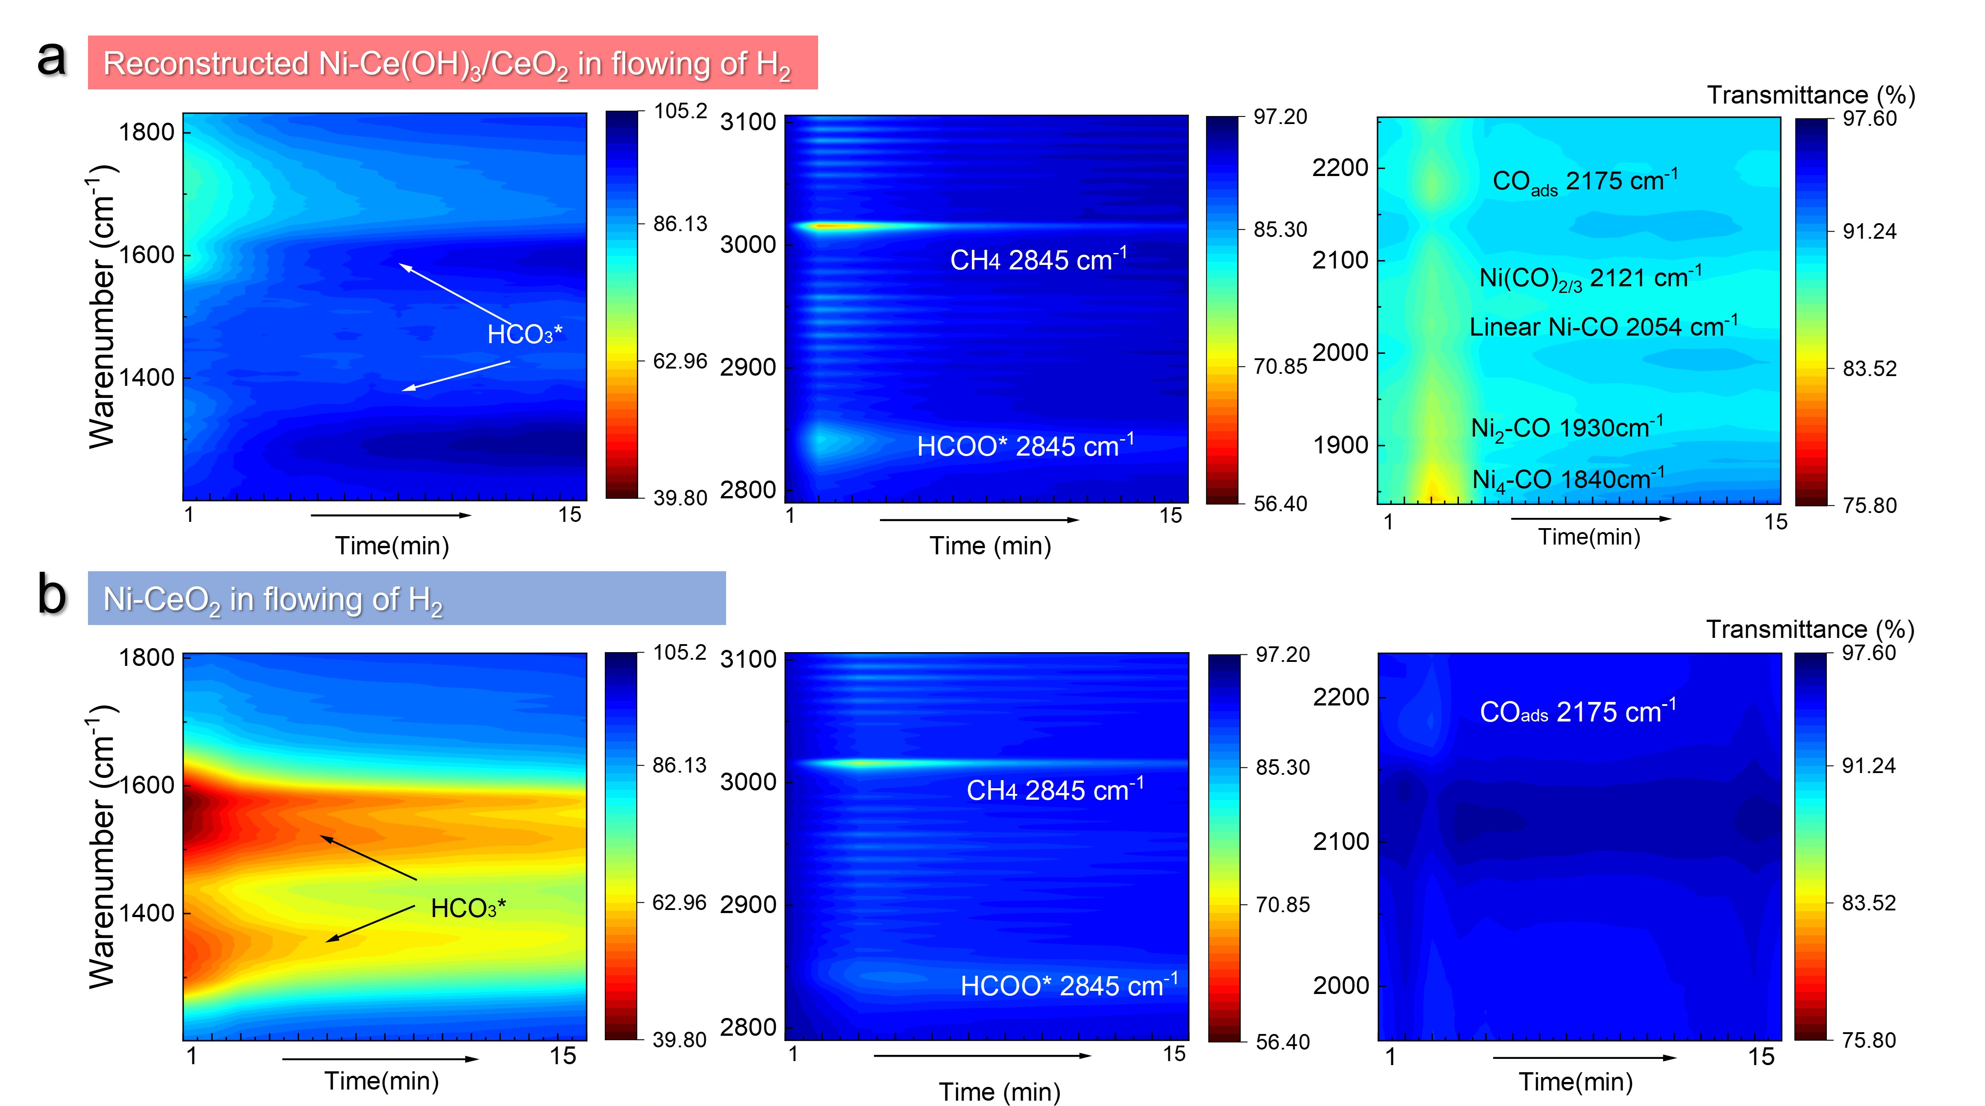
Figure S22. In situ DRIFTS analysis. In situ DRIFTS spectra of (a) reconstructed Ni-Ce(OH)₃/CeO₂ and (b) Ni-CeO₂ under the flowing of CO₂. Note: The catalysts underwent pre-treatment by a flow of 50 vol.% CO₂/Ar (50 mL min⁻¹) for 1 h. After removing excess CO₂ by a flow of Ar (50 mL min⁻¹), a flow of 50 vol.% H₂/Ar (50 mL min⁻¹) was introduced, and the DRIFTS signals were collected at 450 °C every 20 s during a period of 15 mins.

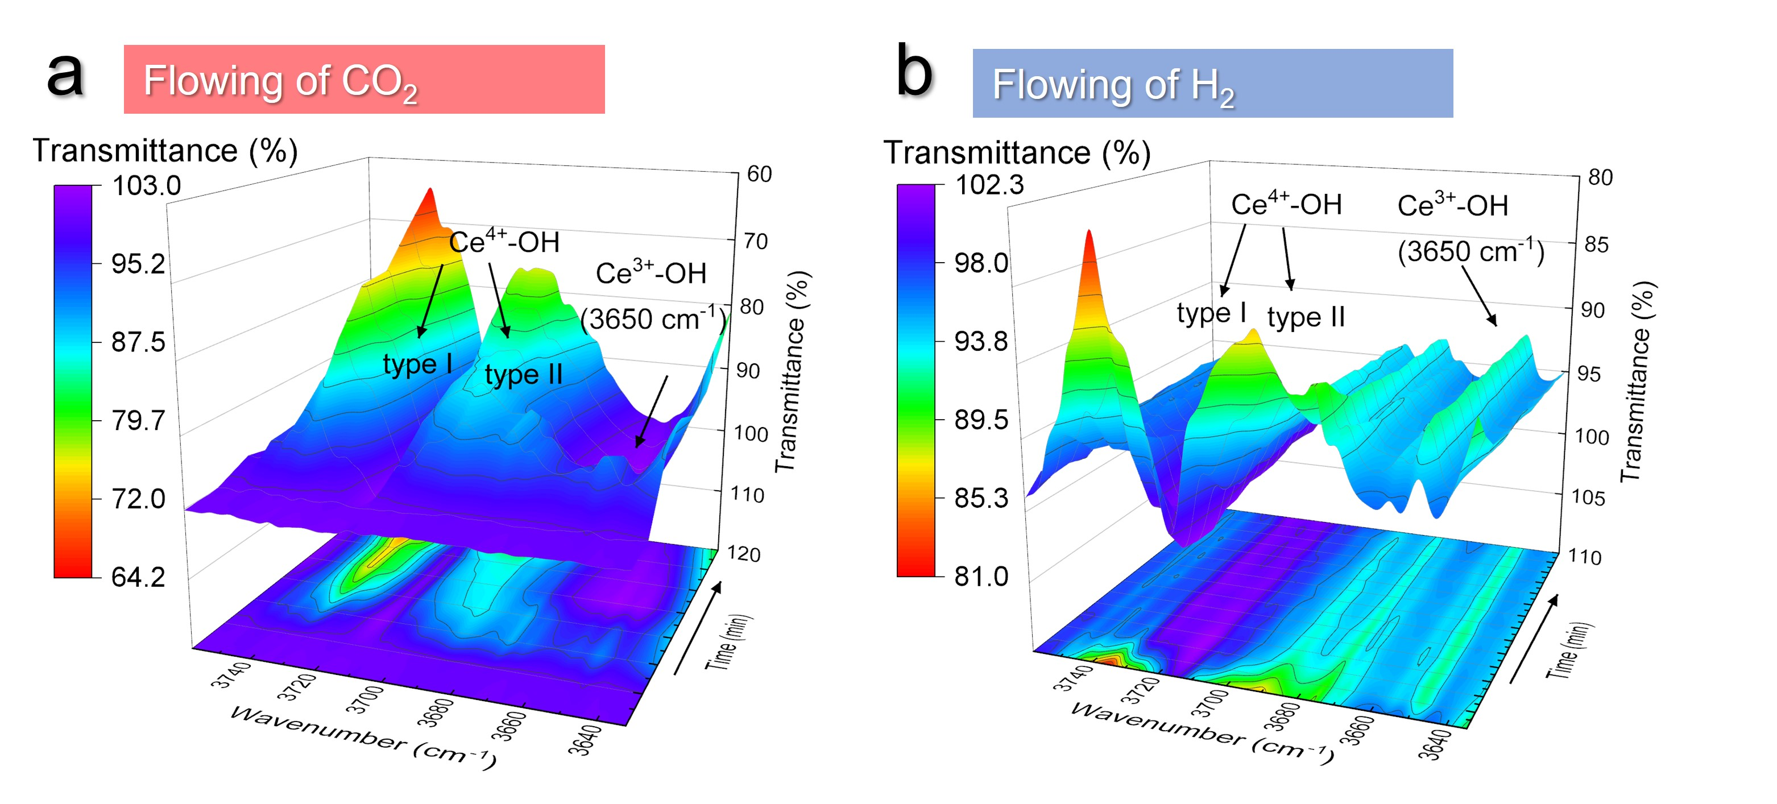
Figure S23. In-situ DRIFTS spectra of the reconstructed Ni-Ce(OH)₃/CeO₂ under the flowing of CO₂ and H₂. The reconstructed Ni-Ce(OH)₃/CeO₂ catalysts were pretreated by a flow of 50 vol.% H₂/Ar (50 mL min⁻¹) for 1 h. After removing of the free H₂ by a flow of Ar (50 mL min⁻¹) in the catalytic environments, a flow of 50 vol.% CO₂/Ar (50 mL min⁻¹) was introduced. The DRIFTS signals were collected at 450 °C every 20 s for a period of 15 mins. Subsequently, the flow of 50 vol.% CO₂/Ar gas (50 mL min⁻¹) was switched to a flow of 50 vol.% H₂/Ar (50 mL min⁻¹), which was kept for another 30 mins to collect the DRIFTS signal every 20 s.

Table S1. Summary of the catalytic performance of RWGS reaction.
Catalysts | Temp  (℃) | WHSV  (mL g⁻¹ h⁻¹) | CO₂ Conv.  (%) | CO Sel.  (%) | CO formation rate  (mol_{CO} g_{Ni}⁻¹ h⁻¹) | Ref.
Reconstructed Ni-Ce(OH)₃/CeO₂ | 350 | 72,000 | 4.4 | 99.9 | 2.2 | This work
Reconstructed Ni-Ce(OH)₃/CeO₂ | 400 | 72,000 | 15.5 | 99.4 | 7.6 | This work
Reconstructed Ni-Ce(OH)₃/CeO₂ | 450 | 72,000 | 27.9 | 99.5 | 13.6 | This work
Reconstructed Ni-Ce(OH)₃/CeO₂ | 500 | 72,000 | 41.7 | 99.6 | 20.2 | This work
Reconstructed Ni-Ce(OH)₃/CeO₂ | 550 | 72,000 | 55.0 | 99.9 | 27.3 | This work
Reconstructed Ni-Ce(OH)₃/CeO₂ | 600 | 72,000 | 60.2 | 99.9 | 29.4 | This work
15-Ni-CeO₂ | 300 | 60,000 | 52 | 22.1 | 0.2 | 10
2.4-Ni/nSiO₂ | 600 | / | 59.5 | 98.2 | 0.2 | 11
13.9-NiCuSap | 600 | 15,000 | 65.2 | 82.2 | 0.1 | 12
14.9-NiCoSap | 600 | 15,000 | 52.1 | 65.1 | 0.8 | 12
Ni/CeO₂ | 400 | 300,000 | 27.5 | 95.2 | 3.7 | 13
1.0-Ni-CeO₂-NC | 400 | / | 18.1 | 99.9 | 0.04 | 14
1.0-NiO-CeO₂-NC | 400 | / | 11.2 | 99.9 | 0.1 | 15
5.9-Ni@S16C | 500 | / | 20.2 | 93.1 | 2.5 | 16
SpNi | 250 | 15,000 | 40.2 | 5.0 | 0.5 | 17
1.0-Ni-CeO₂ | 350 | 18,000 | 99.9 | 10.9 | 1.4 | 18
1.0-Ni-CeO₂ | 400 | 60,000 | 99.9 | 15.9 | 6.2 | 18
NiMgO | 350 | / | 99.9 | / | 0.1 | 19
Ni@N-CNTs | 350 | 12,000 | 99.0 | / | 0.4 | 20
Ni@N-CNTs | 400 | 12,000 | 99.0 | / | 1.0 | 20
Ni@N-CNTs | 450 | 12,000 | 98.0 | / | 1.4 | 20
Ni@N-CNTs | 500 | 12,000 | 97.0 | / | 1.7 | 20
NiMgO | 300 | 30,000 | 89.0 | 45.0 | 2.7 | 21
Ni-Mg/SBA-15 | 350 | 30,000 | 87.0 | 62.0 | 3.6 | 21
Ni-Mg/SBA-15 | 400 | 30,000 | 80.0 | 64.0 | 3.6 | 21
15.1-Ni₂P/CeO₂ | 400 | 150,000 | 66.0 | 50.0 | 7.3 | 22
15.1-Ni₂P/CeO₂ | 450 | 150,000 | 71.0 | 55.0 | 8.9 | 22
15.1-Ni₂P/CeO₂ | 500 | 150,000 | 82.0 | 70.0 | 14.2 | 22
15.1-Ni₂P/CeO₂ | 550 | 150,000 | 85.0 | 78.0 | 18.9 | 22
15.1-Ni₂P/CeO₂ | 600 | 150,000 | 94.0 | 90.0 | 24.6 | 22
Ni/CeO₂ | 400 | 12,000 | 62.0 | 12.0 | 0.2 | 23
Ni/CeO₂ | 500 | 12,000 | 72.0 | 17.0 | 0.3 | 23
Ni/CeO₂ | 600 | 12,000 | 74.0 | 18.0 | 0.3 | 23
Ni-1Mo | 400 | 10,000 | 80.0 | 82.0 | 8.0 | 24
Ni-MgO-Ce_{x}Zr_{1–x}O₂ | 300 | 50,000 | 8.0 | 80.0 | 0.1 | 25
Ni-MgO-Ce_{x}Zr_{1–x}O₂ | 350 | 50,000 | 18.0 | 57.0 | 0.2 | 25
Ni-MgO-Ce_{x}Zr_{1–x}O₂ | 400 | 50,000 | 42.0 | 20.0 | 0.2 | 25
NiO/CeO₂ | 400 | / | 5.0 | 99.9 | 0.5 | 26
NiO/CeO₂ | 500 | / | 20.0 | 99.9 | 1.6 | 26
NiO/CeO₂ | 600 | / | 33.0 | 99.9 | 4.8 | 26
1%Ni-CeO₂ | 400 |  | 4.5 | 90.1 | 0.9 | 27
l%Ni-CeO₂ | 600 | 120,000 | 35.0 | 99.9 | 1.7 | 28
Ni/CeO₂-Al₂O₃ | 500 | 800,000 | 62.0 | 18.0 | 0.3 | 29
Ni-CeZrO_{x} | 700 | / | 50.1 | 95.0 | 6.5 | 30
Ni/Al₂O₃ | 500 | 240,000 | 28.0 | 50.0 | 12.1 | 31
Ni/Al₂O₃ | 550 | 240,000 | 33.0 | 64.0 | 18.0 | 31
Ni/Al₂O₃ | 600 | 240,000 | 36.0 | 78.0 | 24.2 | 31
Ni/Al₂O₃-CeO₂ | 700 | 50,000 | 50.0 | 80.0 | 3.5 | 32

Table S2. The assignment of IR bands occurred in the DRIFTS experiments
Wavenumber from the  literature (cm⁻¹) | Wavenumber in the  experiment(cm⁻¹) | Species | Ref.
2163 | 2175 | CO_{ads} | 18
2064 | 2125 | Ni-(CO)_{2/3} | 19
2030-2020 | 2057 | Ni-CO | 19
1930 | 1930 | Bridge Ni₃-CO | 19
1850 | 1840 | Carbided Ni-CO | 33

Reference:
1 Kresse, G.; Furthmuller, J. Efficient Iterative Schemes for ab initio Total-Energy Calculations Using a Plane-Wave Basis Set. Phys. Rev. B 54, 11169-11186, (1996).
2 Kresse, G.; Furthmuller, J. Efficiency of ab-initio Total Energy Calculation for Metals and Semiconductors Using a Plane-Wave Basis Set. Comput. Mater. Sci. 6, 15-50, (1996).
3 Liu, B.; Liu, J.; Xin, L.; Zhang, T.; Xu, Y.; Jiang, F.; Liu, X. Unraveling Reactivity Descriptors and Structure Sensitivity in Low-Temperature NH₃-SCR Reaction over CeTiOx Catalysts: A Combined Computational and Experimental Study. ACS Catal. 11, 7613-7636, (2021).
4 Grimme, S.; Antony, J.; Ehrlich, S.; Krieg, H. A Consistent and Accurate ab initio Parametrization of Density Functional Dispersion Correction (DFT-D) for the 94 Elements H-Pu. J. Chem. Phys., 132, 154104, (2010).
5 Blöchl, P. E. Projector Augmented-Wave Method. Phys. Rev. B, 50, 17953-17979, (1994).
6 Perdew, J. P.; Burke, K.; Ernzerhof, M. Generalized Gradient Approximation Made Simple. Phys. Rev. Lett. 77, 3865-3868, (1996).
7 Filtschew, A.; Hofmann, K.; Hess, C. Ceria and Its Defect Structure: New Insights from a Combined Spectroscopic Approach. J. Phys. Chem. C, 120, 6694-6703, (2016).
8 Zhang, S. et al. Interfacial frustrated Lewis pairs of CeO₂ activate CO₂ for selective tandem transformation of olefins and CO₂ into cyclic carbonates. J. Am. Chem. Soc. 141, 11353-11357, (2019).
9 Zhang, S. et al. Solid frustrated-Lewis-pair catalysts constructed by regulations on surface defects of porous nanorods of CeO₂. Nat Commun. 8, 15266, (2017).
10 Dai, B. et al. CO₂ reverse water‐gas shift reaction on mesoporous M‐CeO₂ catalysts. Can. J Chem. Eng. 95, 634-642, (2016).
11 Gonçalves, R. V. et al. Selective hydrogenation of CO₂ into CO on a highly dispersed nickel catalyst obtained by magnetron sputtering deposition: A step towards liquid fuels. Appl. Catal. B-Environ. 209, 240-246, (2017).
12 Nityashree, N. et al. Carbon stabilised saponite supported transition metal-alloy catalysts for chemical CO₂ utilisation via reverse water-gas shift reaction. Appl. Catal. B-Environ. l 261, 118241 (2020).
13 Ebrahimi, P., Kumar, A. & Khraisheh, M. A review of CeO₂ supported catalysts for CO₂ reduction to CO through the reverse water gas shift reaction. Catalysts 12, 12101101 (2022).
14 Liu, Y., Li, Z., Xu, H. & Han, Y. Reverse water-gas shift reaction over ceria nanocube synthesized by hydrothermal method. Catalysis Commun. 76, 1-6, (2016).
15 Cárdenas-Arenas, A. et al. Design of active sites in Ni/CeO₂ catalysts for the methanation of CO₂: tailoring the Ni-CeO₂ contact. Appl. Mater. Today 19, (2020).
16 Chen, C.-S., Budi, C. S., Wu, H.-C., Saikia, D. & Kao, H.-M. Size-tunable Ni nanoparticles supported on surface-modified, cage-type mesoporous silica as highly active catalysts for CO₂ Hydrogenation. ACS Catal. 7, 8367-8381, (2017).
17 Tada, S. et al. Sponge Ni catalyst with high activity in CO₂ methanation. Int. J. Hydrogen Energy 42, 30126-30134, (2017).
18 Shen, H. et al. Identifying the roles of Ce³⁺-OH and Ce-H in the reverse water-gas shift reaction over highly active Ni-doped CeO₂ catalyst. Nano Res. 15, 5831-5841, (2022).
19 Millet, M. M. et al. Ni single atom catalysts for CO₂ activation. J Am Chem Soc 141, 2451-2461, (2019).
20 Wang, D. D. et al. Ni single atoms confined in nitrogen-doped carbon nanotubes for active and selective hydrogenation of CO₂ to CO. ACS Catal. 13, 7132-7138, (2023).
21 Hongmanorom, P. et al. Enhanced performance and selectivity of CO methanation over phyllosilicate structure derived Ni-Mg/SBA-15 catalysts. Appl. Catal. B-Environ. 282, 119564 (2021).
22 Cui, S., Wang, X., Wang, L. & Zheng, X. Enhanced selectivity of the CO₂ reverse water-gas reaction over a Ni₂P/CeO₂ catalyst. Dalton Trans. 50, 5978-5987, (2021).
23 Gandara-Loe, J. et al. Design of full-temperature-range RWGS catalysts: Impact of alkali promoters on Ni/CeO₂. Energy Fuels 36, 6362-6373, (2022).
24 Zhang, R. et al. Tuning reverse water gas shift and methanation reactions during CO₂ reduction on Ni catalysts via surface modification by MoO_{x}. J. CO₂ Util. 52, 101678, (2021).
25 Kim, Y. et al. Highly CO-selective Ni-MgO-Ce_{x}Zr_{1–x}O₂ catalyst for efficient low-temperature reverse water–gas shift reaction. J Ind. Eng. Chem. 118, 341-350, (2023).
26 Lu, B. & Kawamoto, K. Preparation of mesoporous CeO₂ and monodispersed NiO particles in CeO₂, and enhanced selectivity of NiO/CeO₂ for reverse water gas shift reaction. Mater. Res. Bull 53, 70-78, (2014).
27 Wang, L., Zhang, S. & Liu, Y. Reverse water gas shift reaction over Co-precipitated Ni-CeO₂ catalysts. Journal of Rare Earths 26, 66-70, (2008).
28 Wang, L., Liu, H., Liu, Y., Chen, Y. & Yang, S. Effect of precipitants on Ni-CeO₂ catalysts prepared by a co-precipitation method for the reverse water-gas shift reaction. J. Rare Earths 31, 969-974, (2013).
29 Yang, L., Pastor-Pérez, L., Gu, S., Sepúlveda-Escribano, A. & Reina, T. R. Highly efficient Ni/CeO₂-Al₂O₃ catalysts for CO₂ upgrading via reverse water-gas shift: Effect of selected transition metal promoters. Appl. Catal. B-Environ. 232, 464-471, (2018).
30 Sun, F.-m., Yan, C.-f., Wang, Z.-d., Guo, C.-q. & Huang, S.-l. Ni/Ce-Zr-O catalyst for high CO₂ conversion during reverse water gas shift reaction (RWGS). Int. J. Hydrogen Energy 40, 15985-15993, (2015).
31 Gioria, E. et al. Boosting the performance of Ni/Al₂O₃ for the reverse water gas shift reaction through formation of CuNi nanoalloys. Catal. Sci. Technol. 12, 474-487, (2022).
32 Belekar, R. M. Suppression of coke formation during reverse water-gas shift reaction for CO₂ conversion using highly active Ni/Al₂O₃-CeO₂ catalyst material. Phys. Lett 395, (2021).
33 Bertolini, J. C. & Tardy, B. Vibrational EELS studies of CO chemisorption on clean and carbided (111), (100) and (110) nickel surfaces. Surf. Sci. 102, 131-150, (1981).

