Supplementary Information
April 3rd, 2025
Single pulse electrical stimulation of the medial thalamic surface induces narrower high gamma band activities in the sensorimotor cortex

Yawara Nakamura¹, Kiyohide Usami^{2*}, Haruo Yamanaka³, Daisuke Yamada⁴,
Yohei Mineharu^{4,5}, Takayuki Kikuchi⁴, Yoshiki Arakawa⁴, Takeharu Kunieda¹

¹Department of Neurosurgery, Ehime University School of Medicine
²Department of Clinical Laboratory, Kyoto University Hospital
³Department of Neurology, Kyoto University Graduate School of Medicine
⁴Department of Neurosurgery, Kyoto University Graduate School of Medicine
⁵Department of Artificial Intelligence in Healthcare and Medicine, Kyoto University Graduate School of Medicine

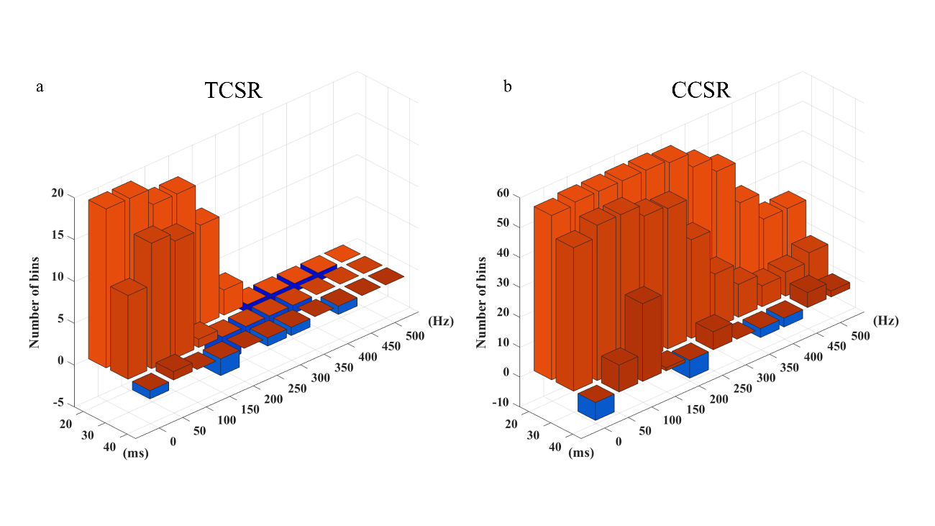
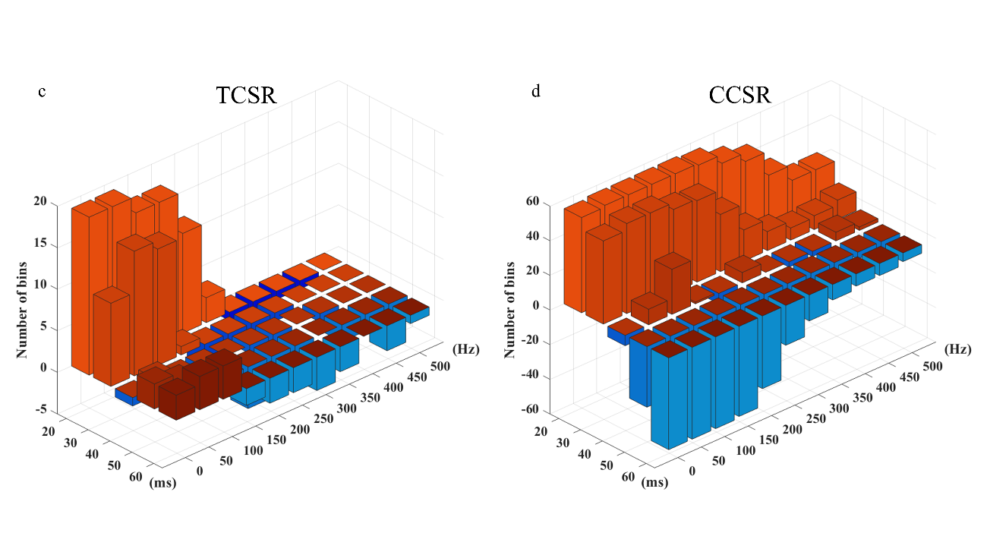
Supplementary Figure. 1. The average waveform of each trial is subtracted from the thalamocortical spectral response (TCSR) and cortico-cortical spectral response (CCSR), and it is created in the same way as Figure 4. The distribution of the number of clusters that showed a statistically significant increase in HGA power in (a) TCSR and (b) CCSR in the 20–40 ms, (c) TCSR and (d) CCSR in the 20-60 ms after stimulation is shown by a simple sum of significant bins across all patients. The red bars indicate an increase in power, the blue bars indicate a decrease in power. Note that the range of the y-axis differs in each graph.

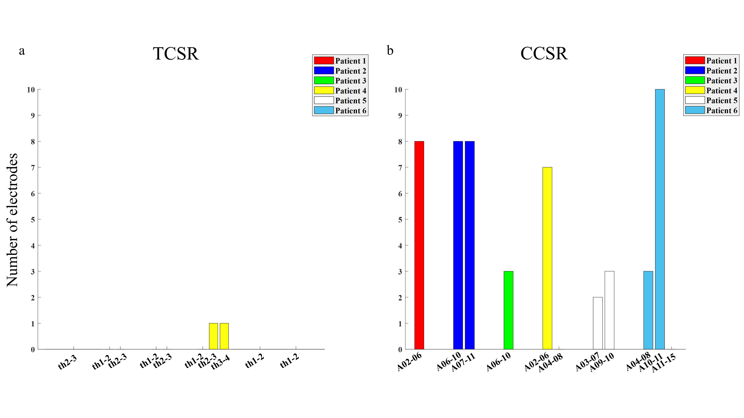
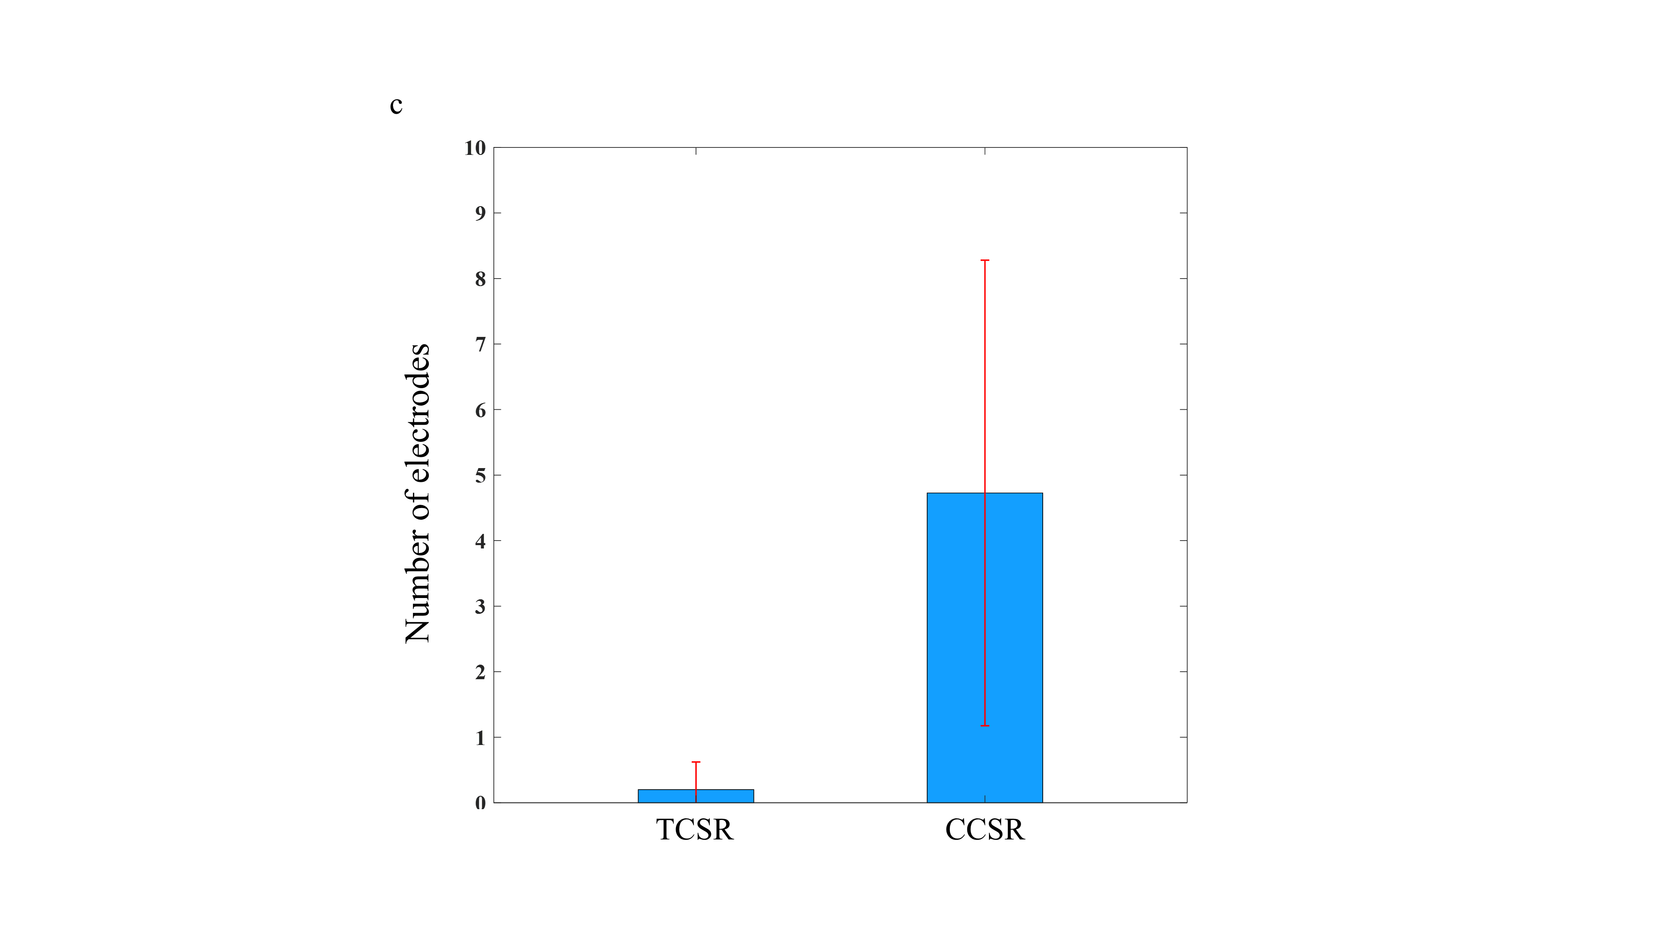
Supplementary Figure. 2. The number of electrodes that demonstrate a significant power decrease for each patient is shown for (a) TCSR and (b) CCSR. (c) The mean value for all patients is indicated by the blue bar, with the standard deviation (±1SD) represented by the red line.

Supplementary Table 1.
- Montreal Numerological Institute (MNI) coordinates of thalamic electrodes in all patient.
 | Th 1 | Th 2 | Th 3 | Th 4
Patient 1 | 1.57, -6.04, 6.04 | 5.49, -3.95, 9.17 | 9.81, -4.867, 19.76 | 16.47, 2.59, 23.30
Patient 2 | -12.94, -31.53, 14.6 | -8.24, -26.43, 15.84 | -4.71, -13.88, 17.41 | -4.31, -1.72, 12.70
Patient 3 | -2.35, -12.31, 13.02 | -2.35, -4.47, 13.02 | -5.49, 3.38, 13.10 | -8.24, 9.26, 13.10
Patient 4 | -8.63, -25.26, 16.23 | -7.63, -16.04, 17.00 | -6.61, -7.10, 16.19 | -7.83, 0.42, 13.14
Patient 5 | 11.89, -29.97, 18.22 | 8.23, -22.85, 17.41 | 8.03, -8.11, 17.41 | 8.03 5.50, 15.38
Patient 6 | 16.36, -34.73, 15.78 | 11.69, -26.40, 18.43 | 9.86, -16.04, 19.85 | 11.28, -4.46, 17.41

- The stimulation electrode pairs.
Patient 1_A02-06 | Patient 1_th2-3
Patient 2_A06-10 | Patient 2_th1-2
Patient 2_A07-11 | Patient 2_th2-3
Patient 3_A06-10 | Patient 3_th1-2
Patient 4_A02-06 | Patient 3_th2-3
Patient 4_A04-08 | Patient 4_th1-2
Patient 5_A03-07 | Patient 4_th2-3
Patient 5_A09-10 | Patient 4_th3-4
Patient 6_A02-06 | Patient 5_th1-2
Patient 6_A04-08 | Patient 5_th2-3
Patient 6_A10-11 | Patient 5_th3-4
Patient 6_A11-15 | Patient 6_th1-2
 | Patient 6_th2-3
 | Patient 6_th3-4

- The stimulation electrode pairs that showed significant CCSR and TCSR.
Patient 1_A02-06 | Patient 1_th2-3
Patient 2_A06-10 | Patient 2_th1-2
Patient 2_A07-11 | Patient 2_th2-3
Patient 3_A06-10 | Patient 3_th1-2
Patient 4_A02-06 | Patient 3_th2-3
Patient 4_A04-08 | Patient 4_th1-2
Patient 5_A03-07 | Patient 4_th2-3
Patient 5_A09-10 | Patient 4_th3-4
Patient 6_A04-08 | Patient 5_th1-2
Patient 6_A10-11 | Patient 6_th1-2
Patient 6_A11-15

Supplementary Table 2.
- Distribution of electrodes showed significant increase in power in the CCSR.
 | # of Electrodes with significant response | The electrodes placed in the frontal lobe | The electrodes placed in the parietal lobe | % of frontal lobe | Frequency band (Hz)
Patient 1_A02-06 | 11 | A05, 07, 09, 12, 13, 14, 15, 16 | A01, 03, 04 | 72.7 | 0-400
Patient 2_A06-10 | 14 | A01, 02, 03, 04, 05, 07, 08, 11, 12, 16 | A09, 13, 14, 15 | 71.4 | 0-500
Patient 2_A07-11 | 14 | A01, 02, 03, 04, 05, 06, 08, 12, 16 | A09, 10, 13, 14, 15 | 64.3 | 0-500
Patient 3_A06-10 | 14 | A01, 02, 03, 04, 05, 07, 08, 12 | A09, 11, 13, 14, 15, 16 | 57.1 | 0-500
Patient 4_A02-06 | 14 | A01, 03, 04, 07, 08 | A05, 09, 10, 11, 12, 13, 14, 15, 16 | 35.7 | 0-500
Patient 4_A04-08 | 3 | A01, 03 | A12 | 66.7 | 0-300
Patient 5_A03-07 | 7 | A08, 11, 15 | A01, 02, 06, 09 | 42.9 | 0-350
Patient 5_A09-10 | 6 | A11, 12, 15 | A05, 13, 14 | 50 | 0-350
Patient 6_A04-08 | 3 | None | A02, 03, 07 | 0 | 0-200
Patient 6_A10-11 | 13 | A08, 14, 15, 16 | A01, 02, 03, 04, 05, 06, 07, 09, 13 | 30.8 | 0-450
Patient 6_A11-15 | 3 | A16 | A06, 07 | 33.3 | 0-200

- Distribution of electrodes showed significant increase in power in the TCSR.
 | # of Electrodes with significant response | The electrodes placed in the frontal lobe | The electrodes placed in the parietal lobe | % of frontal lobe | Frequency band (Hz)
Patient 1_th2-3 | 4 | A12, 15, 16 | A01 | 75 | 0-250
Patient 2_th1-2 | 1 | A04 | None | 100 | 0-200
Patient 2_th2-3 | 1 | A03 | None | 100 | 0-500
Patient 3_th1-2 | 7 | A09, 13 | A01, 04, 05, 06, 08 | 28.4 | 0-250
Patient 3_th2-3 | 6 | A09, 13 | A01, 04, 05, 08 | 33.3 | 0-200
Patient 4_th1-2 | 1 | A03 | None | 100 | 0-50
Patient 4_th2-3 | 2 | A03, 04 | None | 100 | 0-150
Patient 4_th3-4 | 1 | A04 | None | 100 | 0-250
Patient 5_th1-2 | 1 | A11 | None | 100 | 0-100
Patient 6_th1-2 | 1 | A14 | None | 100 | 0-100

Supplementary Table 3.
- Distribution of electrodes showed significant decrease in power in the CCSR.
 | # of Electrodes with significant response | The electrodes placed in the frontal lobe | The electrodes placed in the parietal lobe
Patient 1_A02-06 | 8 | A05, 07, 09, 13, 14, 15 | A03, 04
Patient 2_A06-10 | 8 | A01, 02, 05, 11 | A09, 13, 14, 15
Patient 2_A07-11 | 8 | A01, 02, 05, 06 | A09, 10, 13, 14
Patient 3_A06-10 | 3 | None | A11, 15, 16
Patient 4_A02-06 | 7 | A01, 03, 07 | A05, 11, 15, 16
Patient 4_A04-08 | 0 | None | None
Patient 5_A03-07 | 2 | None | A02, 06
Patient 5_A09-10 | 3 | A15 | A05, 14
Patient 6_A04-08 | 3 | None | A02, 03, 07
Patient 6_A10-11 | 10 | A08, 15, 16 | A02, 03, 05, 06, 07, 09, 13
Patient 6_A11-15 | 0 | None | None

- Distribution of electrodes showed significant decrease in power in the TCSR.
 | # of Electrodes with significant response | The electrodes placed in the frontal lobe | The electrodes placed in the parietal lobe
Patient 1_th2-3 | 0 | None | None
Patient 2_th1-2 | 0 | None | None
Patient 2_th2-3 | 0 | None | None
Patient 3_th1-2 | 0 | None | None
Patient 3_th2-3 | 0 | None | None
Patient 4_th1-2 | 0 | None | None
Patient 4_th2-3 | 1 | A04 | None
Patient 4_th3-4 | 1 | A04 | None
Patient 5_th1-2 | 0 | None | None
Patient 6_th1-2 | 0 | None | None

