Supporting Information
Synthesis, evaluation, and mechanism study of novel benzimidazole
acylhydrazone derivatives for antitumor activity
Lihui shao^{1,2,3§}, Nianlin Feng^{2§}, Yue Zhou², Chengpeng Li², Danping Chen², Chenchen Li², Xiang Zhou¹, Zhurui Li^{2*}, Zhenchao Wang^{1,2*}

¹ State Key Laboratory of Green Pesticide, Key Laboratory of Green Pesticide and Agricultural Bioengineering, Ministry of Education, Center for R&D of Fine Chemicals of Guizhou University, Guiyang, Guizhou 550025, People’s Republic of China.
² College of Pharmacy, Guizhou Engineering Laboratory for Synthetic Drugs, Guizhou University, Guiyang, Guizhou 550025, People’s Republic of China.
³ School of Chemistry and Chemical engineering, Guizhou University, Guiyang, Guizhou 550025, People’s Republic of China.

§ These authors contributed equally to this work.
* Corresponding authors.
E-mail address: zcwang@gzu.edu.cn (Zhenchao Wang)
.

Contents
1. ¹H NMR, ¹³C NMR and HRMS spectra data for target compounds.

(E)-2-((1H-benzo[d]imidazol-2-yl)thio)-N-(4-(1-(2-(4-bromhydrazono)ethyl)phenyl)acetamide (5a)
White solid, m.p.198−199°C, yield 59%; ¹H NMR (500 MHz, DMSO-d₆) δ 12.67 (s, 1H), 10.73 (d, J = 52.4 Hz, 2H), 7.92 – 7.75 (m, 4H), 7.64 (dd, J = 28.7, 7.7 Hz, 4H), 7.47 (s, 1H), 7.35 (s, 1H), 7.09 (d, J = 4.8 Hz, 2H), 4.25 (s, 2H), 2.28 (s, 1H); ¹³C NMR (101 MHz, DMSO-d₆) δ 166.85, 150.27, 133.31, 131.07, 130.88, 130.07, 127.76, 122.00, 119.03, 36.65, 26.92, 15.01; HRMS (ESI) m/z [M+H]⁺calcd for C₂₄H₂₁BrN₅O₂S: 522.0594, found: 522.0582.
(E)-2-((1H-benzo[d]imidazol-2-yl)thio)-N-(4-(1-(2-(4-chlorobenzoyl)hydrazono)ethyl)phenyl)acetamide (5b)
White solid, m.p.207−208°C, yield 62%; ¹H NMR (500 MHz, DMSO-d₆) δ 10.80 (d, J = 69.1 Hz, 2H), 7.88 (dd, J = 13.6, 8.2 Hz, 2H), 7.79 (d, J = 7.9 Hz, 2H), 7.65 (dd, J = 28.6, 7.8 Hz, 2H), 7.54 (d, J = 7.7 Hz, 2H), 7.41 (s, 2H), 7.08 (dd, J = 5.7, 2.8 Hz, 2H), 4.26 (s, 2H), 2.29 (s, 3H); ¹³C NMR (101 MHz, DMSO-d₆) δ 153.52, 150.40, 145.12, 140.28, 132.57, 129.29, 126.90, 126.69, 125.45, 124.69, 122.51, 122.25, 121.76, 117.63, 115.26, 49.40, 32.06; HRMS (ESI) m/z [M+H]⁺calcd for C₂₄H₂₁ClN₅O₂S: 478.1099, found: 478.1086.
(E)-2-((1H-benzo[d]imidazol-2-yl)thio)-N-(4-(1-(2-(4-fluorobenzoyl)hydrazono)ethyl)phenyl)acetamide (5c)
White solid, m.p.201−202°C, yield 65%; ¹H NMR (500 MHz, DMSO-d₆) δ 12.65 (s, 1H), 10.70 (d, J = 27.8 Hz, 2H), 7.92 (d, J = 6.7 Hz, 2H), 7.80 (d, J = 6.9 Hz, 2H), 7.62 (d, J = 7.3 Hz, 2H), 7.48 (d, J = 6.6 Hz, 1H), 7.37 – 7.27 (m, 3H), 7.13 – 7.05 (m, 2H), 4.26 (s, 2H), 2.29 (s, 3H); ¹³C NMR (101 MHz, DMSO-d₆) δ 153.50, 140.26, 135.14, 128.81, 126.77, 124.86, 122.20, 117.84, 117.42, 115.26, 114.22, 112.71, 112.57, 108.78, 49.39, 31.98; HRMS (ESI) m/z [M+H]⁺calcd for C₂₄H₂₁FN₅O₂S: 462.1395, found: 462.1381.
(E)-2-((1H-benzo[d]imidazol-2-yl)thio)-N-(4-(1-(2-(4-methybenzoyl)hydrazineylidene)ethyl)phenyl)acetamide (5d)
White solid, m.p. 181−182°C, yield 51%; ¹H NMR (500 MHz, DMSO-d₆) δ 12.65 (s, 1H), 10.65 (s, 1H), 10.55 (s, 1H), 7.89 – 7.73 (m, 4H), 7.61 (d, J = 7.5 Hz, 2H), 7.48 (d, J = 6.9 Hz, 1H), 7.34 (d, J = 7.3 Hz, 1H), 7.13 – 7.05 (m, 2H), 7.00 (d, J = 8.3 Hz, 2H), 4.26 (s, 2H), 3.78 (s, 3H), 2.28 (s, 3H); ¹³C NMR (101 MHz, DMSO-d₆) δ 166.85, 150.34, 143.94, 136.01, 133.62, 122.31, 121.78, 119.08, 117.79, 110.98, 55.92, 36.74, 19.10; HRMS (ESI) m/z [M+H]⁺calcd for C₂₅H₂₄N₅O₂S: 458.1645, found: 458.1631.
(E)-2-((1H-benzo[d]imidazol-2-yl)thio)-N-(4-(1-(2-(4-hydroxybenzoyl)hydrazineylidene)ethyl)phenyl)acetamide (5e)
White solid, m.p.196−197°C, yield 58%; ¹H NMR (500 MHz, DMSO-d₆) δ 10.69 (s, 1H), 10.44 (s, 1H), 7.73 (d, J = 8.1 Hz, 4H), 7.61 (d, J = 8.1 Hz, 2H), 7.41 (d, J = 3.2 Hz, 2H), 7.08 (dd, J = 5.8, 3.1 Hz, 2H), 6.81 (d, J = 7.9 Hz, 2H), 4.26 (s, 2H), 2.27 (s, 3H); ¹³C NMR (101 MHz, DMSO-d₆) δ 166.82, 150.37, 140.34, 133.63, 127.52, 124.95, 121.93, 119.01, 115.30, 49.06, 36.68; HRMS (ESI) m/z [M+H]⁺calcd for C₂₄H₂₂N₅O₃S: 460.1438, found: 460.1421.
(E)-2-((1H-benzo[d]imidazol-2-yl)thio)-N-(4-(1-(2-(4-(tert-butyl)benzoyl)hydrazineylidene)ethyl)phenyl)acetamide (5f)
White solid, m.p.181−182°C, yield 49%; ¹H NMR (500 MHz, DMSO-d₆) δ 10.90 (s, 1H), 10.62 (s, 1H), 7.77 (d, J = 7.7 Hz, 4H), 7.62 (d, J = 7.2 Hz, 2H), 7.48 (d, J = 7.8 Hz, 2H), 7.43 – 7.37 (m, 2H), 7.10 – 7.01 (m, 2H), 4.24 (s, 2H), 2.28 (s, 3H), 1.74 (s, 1H), 1.27 (s, 9H); ¹³C NMR (101 MHz, DMSO-d₆) δ 166.90, 150.40, 133.50, 131.84, 130.07, 128.15, 127.65, 125.61, 121.91, 119.03, 36.61, 35.13, 31.39; HRMS (ESI) m/z [M+H]⁺calcd for C₂₈H₃₀N₅O₂S: 500.2115, found: 500.2102.
(E)-2-((1H-benzo[d]imidazol-2-yl)thio)-N-(4-(1-(2-benzoylhydrazineylidene)ethyl)phenyl)acetamide (5g)
White solid, m.p. 181−182°C, yield 52%; ¹H NMR (500 MHz, DMSO-d₆) δ 12.66 (s, 1H), 10.69 (d, J = 17.5 Hz, 2H), 7.82 (dd, J = 21.8, 6.8 Hz, 4H), 7.63 (d, J = 7.2 Hz, 21H), 7.53 (d, J = 7.0 Hz, 1H), 7.47 (d, J = 6.0 Hz, 3H), 7.35 (d, J = 6.9 Hz, 1H), 7.14 – 7.04 (m, 2H), 4.27 (s, 2H), 2.30 (s, 3H); ¹³C NMR (101 MHz, DMSO-d₆) δ 166.81, 150.28, 133.46, 128.81, 128.31, 127.68, 122.24, 121.72, 119.02, 117.73, 110.93, 36.69; HRMS (ESI) m/z [M+H]⁺calcd for C₂₄H₂₂N₅O₂S: 444.1489, found: 444.1478.
(E)-2-((1H-benzo[d]imidazol-2-yl)thio)-N-(4-(1-(2-(4-(trifluoromethyl)benzoyl)hydrazineylidene)ethyl)phenyl)acetamide (5h)
White solid, m.p.204−205°C, yield 51%; ¹H NMR (500 MHz, DMSO-d₆) δ 10.91 (d, J = 132.5 Hz, 2H), 8.03 (d, J = 7.6 Hz, 1H), 7.85 (td, J = 22.5, 8.3 Hz, 4H), 7.66 (dd, J = 24.4, 8.1 Hz, 2H), 7.52 (s, 1H), 7.40 (d, J = 2.8 Hz, 2H), 7.08 (d, J = 2.7 Hz, 2H), 4.26 (s, 2H), 2.30 (s, 3H); ¹³C NMR (101 MHz, DMSO-d₆) δ 153.58, 150.66, 145.28, 140.41, 132.63, 126.64, 124.10, 123.46, 122.27, 120.66, 117.54, 115.26, 49.38, 32.05; HRMS (ESI) m/z [M+H]⁺calcd for C₂₅H₂₁F₃N₅O₂S: 512.1383, found: 512.1351.
(E)-2-((1H-benzo[d]imidazol-2-yl)thio)-N-(4-(1-(2-(4-methoxybenzoyl)hydrazineylidene)ethyl)phenyl)acetamide (5i)
White solid, m.p.209−210°C, yield 48%; ¹H NMR (500 MHz, DMSO-d₆) δ 10.78 (s, 1H), 10.55 (s, 1H), 7.88 – 7.70 (m, 4H), 7.61 (d, J = 8.0 Hz, 2H), 7.44 – 7.38 (m, 2H), 7.08 (dd, J = 5.4, 2.6 Hz, 2H), 7.00 (d, J = 8.1 Hz, 2H), 4.25 (s, 2H), 3.78 (s, 3H), 2.28 (s, 2H); ¹³C NMR (101 MHz, DMSO-d₆) δ 153.57, 140.45, 126.88, 124.20, 124.11, 122.10, 121.32, 117.52, 115.25, 111.23, 64.74, 49.38; HRMS (ESI) m/z [M+H]⁺calcd for C₂₅H₂₄N₅O₃S: 474.1594, found: 474.1585.
(E)-2-((1H-benzo[d]imidazol-2-yl)thio)-N-(4-(1-(2-(3-chlorobenzoyl)hydrazineylidene)ethyl)phenyl)acetamide (5j)
White solid, m.p. 188−189°C, yield 84%; ¹H NMR (500 MHz, DMSO-d₆) δ 12.65 (s, 1H), 10.77 (d, J = 77.6 Hz, 2H), 7.89 (s, 1H), 7.80 (d, J = 7.8 Hz, 3H), 7.70 – 7.57 (m, 3H), 7.50 (t, J = 7.7 Hz, 1H), 7.41 (s, 2H), 7.09 (dd, J = 5.2, 2.7 Hz, 2H), 4.27 (s, 2H), 2.30 (s, 3H); ¹³C NMR (101 MHz, DMSO-d₆) δ 153.52, 150.40, 145.12, 140.28, 132.57, 129.29, 126.90, 126.69, 125.45, 124.69, 122.51, 122.25, 121.76, 117.63, 115.26, 49.40, 32.06; HRMS (ESI) m/z [M+H]⁺calcd for C₂₄H₂₁ClN₅O₂S: 478.1099, found: 478.1086.
(E)-2-((1H-benzo[d]imidazol-2-yl)thio)-N-(4-(1-(2-(3-bromobenzoyl)hydrazineylidene)ethyl)phenyl)acetamide (5k)
White solid, m.p. 178−179°C, yield 72%; ¹H NMR (500 MHz, DMSO-d₆) δ 10.80 (d, J = 86.1 Hz, 2H), 8.01 (s, 2H), 7.91 – 7.77 (m, 3H), 7.76 – 7.60 (m, 3H), 7.43 (dd, J = 14.5, 5.7 Hz, 3H), 7.08 (dd, J = 5.4, 2.7 Hz, 2H), 4.27 (s, 2H), 2.30 (s, 3H); ¹³C NMR (101 MHz, DMSO-d₆) δ 166.85, 150.27, 133.31, 131.07, 130.88, 130.07, 127.76, 122.00, 119.03, 36.65, 26.92, 15.01; HRMS (ESI) m/z [M+H]⁺calcd for C₂₄H₂₁BrN₅O₂S: 522.0594, found: 522.0576.
(E)-2-((1H-benzo[d]imidazol-2-yl)thio)-N-(4-(1-(2-(3-methoxybenzoyl)hydrazineylidene)ethyl)phenyl)acetamide (5l)
White solid, m.p.229−230°C, yield 47%; ¹H NMR (500 MHz, DMSO-d₆) δ 12.65 (s, 1H), 10.85 (s, 1H), 10.67 (s, 1H), 7.86 (d, J = 7.6 Hz, 1H), 7.79 (d, J = 8.3 Hz, 2H), 7.63 (d, J = 8.3 Hz, 2H), 7.49 (dd, J = 29.6, 21.8 Hz, 2H), 7.35 (d, J = 12.2 Hz, 1H), 7.19 (d, J = 8.3 Hz, 1H), 7.11 – 7.05 (m, 3H), 4.27 (s, 2H), 3.95 (s, 3H), 2.26 (s, 3H); ¹³C NMR (101 MHz, DMSO-d₆) δ 166.82, 161.69, 157.52, 152.16, 150.26, 140.40, 133.35, 131.37, 127.64, 122.04, 121.46, 119.07, 112.74, 56.89, 36.65, 13.93; HRMS (ESI) m/z [M+H]⁺calcd for C₂₅H₂₄N₅O₃S: 474.1594, found: 474.1581.
(E)-2-((1H-benzo[d]imidazol-2-yl)thio)-N-(4-(1-(2-(2-methylbenzoyl)hydrazineylidene)ethyl)phenyl)acetamide (5m)
White solid, m.p.219−220°C, yield 48%; ¹H NMR (500 MHz, DMSO-d₆) δ 10.81 (d, J = 109.0 Hz, 2H), 7.78 (d, J = 8.2 Hz, 1H), 7.62 (d, J = 8.2 Hz, 1H), 7.42 (t, J = 12.6 Hz, 3H), 7.37 – 7.30 (m, 1H), 7.24 (dd, J = 13.2, 7.2 Hz, 3H), 7.08 (s, 2H), 4.26 (s, 2H), 2.29 (d, J = 54.3 Hz, 6H); ¹³C NMR (101 MHz, DMSO-d₆) δ 153.53, 152.99, 143.31, 140.35, 132.41, 129.17, 128.98, 126.86, 124.74, 124.11, 122.61, 122.15, 121.56, 120.84, 117.58, 115.23, 49.39, 35.97, 31.87; HRMS (ESI) m/z [M+H]⁺calcd for C₂₅H₂₄N₅O₂S: 474.1594, found: 474.1582.
(E)-2-((1H-benzo[d]imidazol-2-yl)thio)-N-(4-(1-(2-(2-chlorobenzoyl)hydrazineylidene)ethyl)phenyl)acetamide (5n)
White solid, m.p.174−175°C, yield 52%; ¹H NMR (500 MHz, DMSO-d₆) δ 12.65 (s, 1H), 10.77 (d, J = 77.6 Hz, 2H), 7.89 (s, 1H), 7.80 (d, J = 7.8 Hz, 3H), 7.70 – 7.57 (m, 3H), 7.50 (t, J = 7.7 Hz, 1H), 7.41 (s, 2H), 7.09 (dd, J = 5.2, 2.7 Hz, 2H), 4.27 (s, 2H), 2.30 (s, 3H); ¹³C NMR (101 MHz, DMSO-d₆) δ 153.52, 150.40, 145.12, 140.28, 132.57, 129.29, 126.90, 126.69, 125.45, 124.69, 122.51, 122.25, 121.76, 117.63, 115.26, 49.40, 32.06; HRMS (ESI) m/z [M+H]⁺calcd for C₂₄H₂₁ClN₅O₂S: 478.1099, found: 478.1086.
(E)-2-((1H-benzo[d]imidazol-2-yl)thio)-N-(4-(1-(2-(2-bromobenzoyl)hydrazineylidene)ethyl)phenyl)acetamide (5o)
White solid, m.p. 158−159°C, yield 56%; ¹H NMR (500 MHz, DMSO-d₆) δ 10.84 (d, J = 80.0 Hz, 2H), 7.78 (d, J = 8.4 Hz, 1H), 7.64 (dd, J = 19.3, 8.0 Hz, 2H), 7.49 (d, J = 7.5 Hz, 1H), 7.45 – 7.37 (m, 4H), 7.36 – 7.30 (m, 2H), 7.10 – 7.04 (m, 2H), 4.25 (s, 2H), 2.23 (s, 3H); ¹³C NMR (101 MHz, DMSO-d₆) δ 166.85, 150.27, 133.31, 131.07, 130.88, 130.07, 127.76, 122.00, 119.03, 36.65, 26.92, 15.01; HRMS (ESI) m/z [M+H]⁺calcd for C₂₄H₂₁BrN₅O₂S: 522.0594, found: 522.0584.
(E)-2-((1H-benzo[d]imidazol-2-yl)thio)-N-(4-(1-(2-isonicotinoylhydrazineylidene)ethyl)phenyl)acetamide (5p)
White solid, m.p. 162−163°C, yield 60%; ¹H NMR (500 MHz, DMSO-d₆) δ 12.64 (s, 1H), 10.93 (d, J = 128.4 Hz, 2H), 9.04 (s, 1H), 8.72 (d, J = 21.7 Hz, 1H), 8.23 (d, J = 7.5 Hz, 1H), 7.76 (dd, J = 69.7, 8.3 Hz, 3H), 7.56 (d, J = 5.2 Hz, 2H), 7.46 (dd, J = 5.4, 3.1 Hz, 2H), 7.13 (dd, J = 5.9, 3.1 Hz, 2H), 4.30 (s, 2H), 2.36 (s, 3H); ¹³C NMR (101 MHz, DMSO-d₆) δ 166.88, 150.39, 149.23, 136.17, 133.30, 127.76, 123.94, 121.91, 119.03, 36.68, 14.99; HRMS (ESI) m/z [M+H]⁺calcd for C₂₃H₂₁N₆O₂S: 445.1441, found: 445.1427.
(E)-2-((1H-benzo[d]imidazol-2-yl)thio)-N-(4-(1-(2-(2H-indole-3-carbonyl)hydrazineylidene)ethyl)phenyl)acetamide (5q)
White solid, m.p.247−248°C, yield 47%; ¹H NMR (500 MHz, DMSO-d₆) δ 10.70 (d, J = 32.4 Hz, 2H), 7.90 (d, J = 7.6 Hz, 1H), 7.80 (d, J = 6.9 Hz, 2H), 7.67 (dd, J = 19.5, 9.6 Hz, 4H), 7.44 – 7.39 (m, 2H), 7.34 (s, 2H), 7.08 (dd, J = 5.8, 2.9 Hz, 2H), 4.26 (s, 2H), 2.34 (s, 3H); ¹³C NMR (101 MHz, DMSO-d₆) δ 153.46, 140.28, 135.15, 132.05, 128.81, 127.33, 121.90, 118.12, 117.85, 117.43, 116.97, 115.34, 114.23, 109.93, 108.79, 49.40; HRMS (ESI) m/z [M+H]⁺calcd for C₂₆H₂₃N₆O₂S: 483.1598, found: 483.1586.

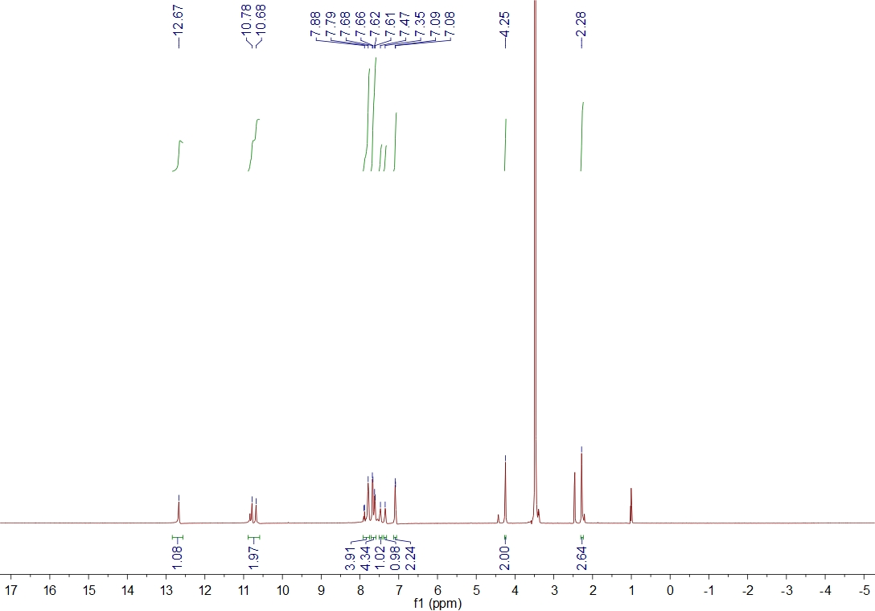
Fig. S1 ¹H NMR sprectrum of title compound 5a
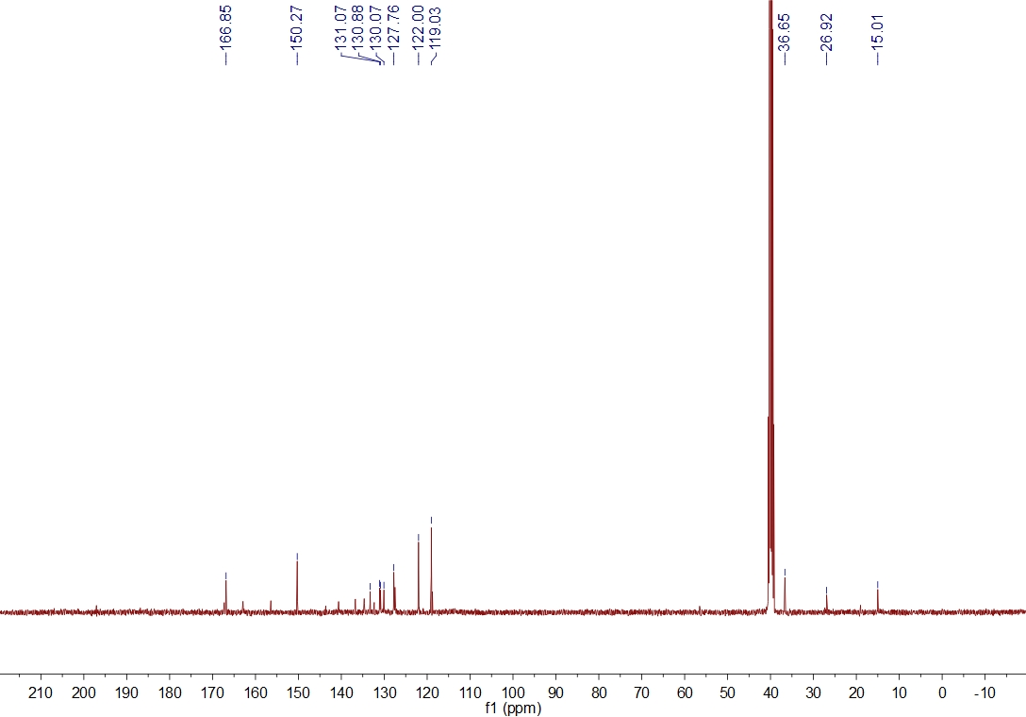
Fig. S2¹³C NMR sprectrum of title compound 5a
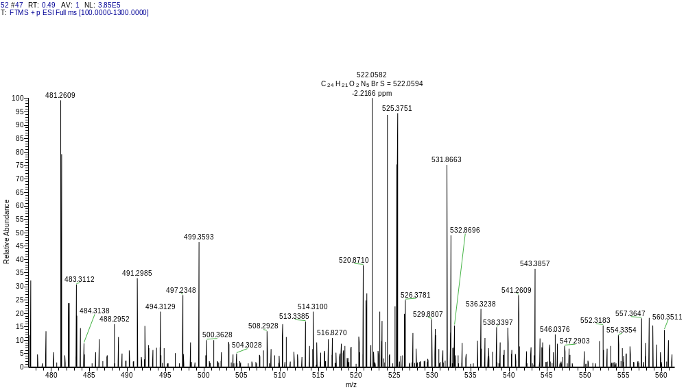
Fig. S3 HRMS sprectrum of title compound 5a
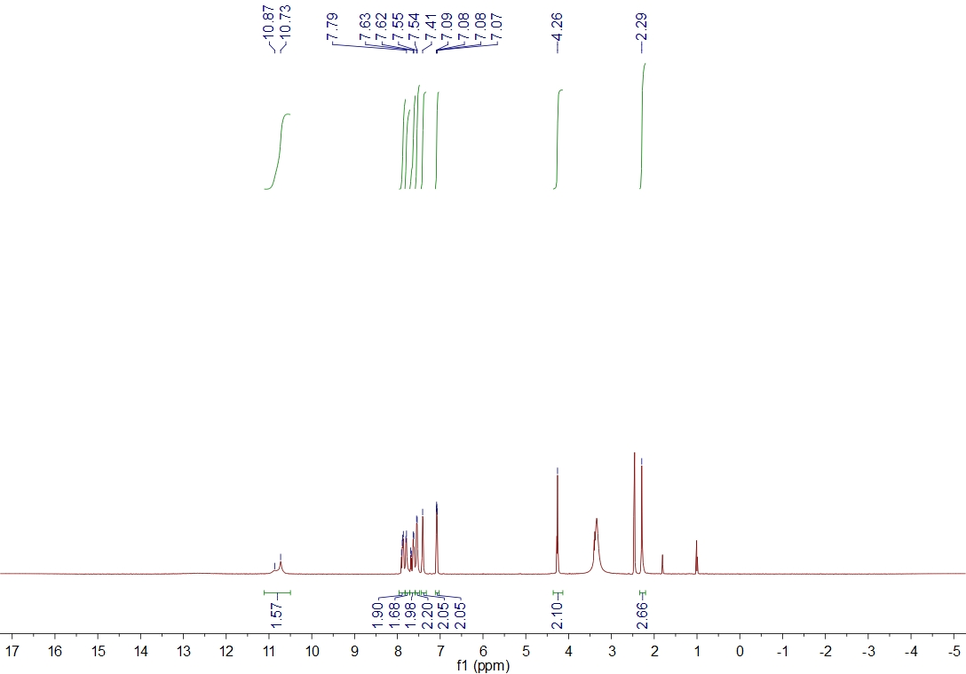
Fig. S4¹H NMR sprectrum of title compound 5b
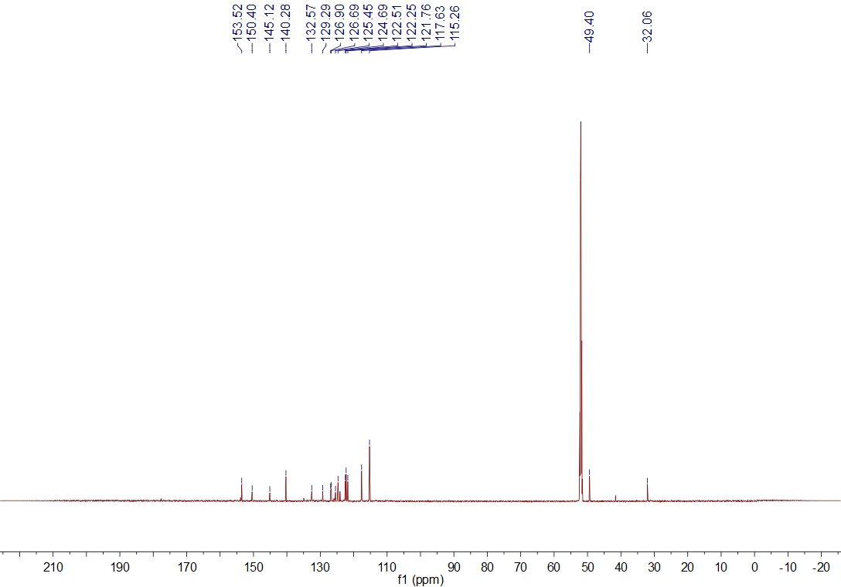
Fig. S5¹³C NMR sprectrum of title compound 5b
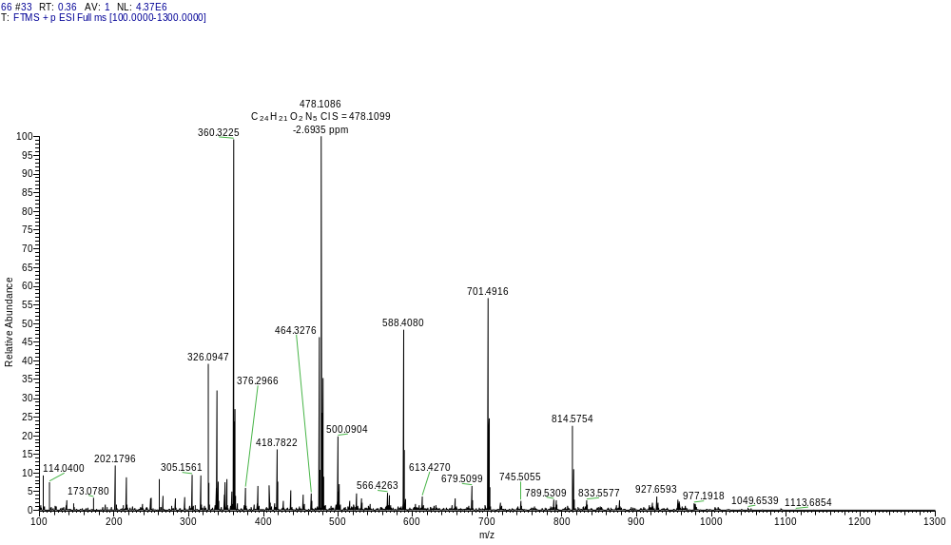
Fig. S6 HRMS sprectrum of title compound 5b
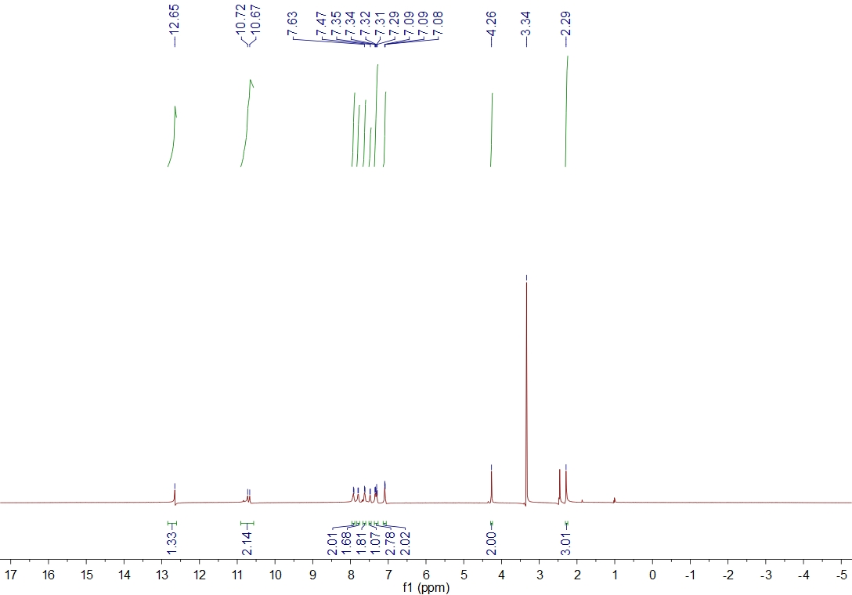
Fig. S7¹H NMR sprectrum of title compound 5c
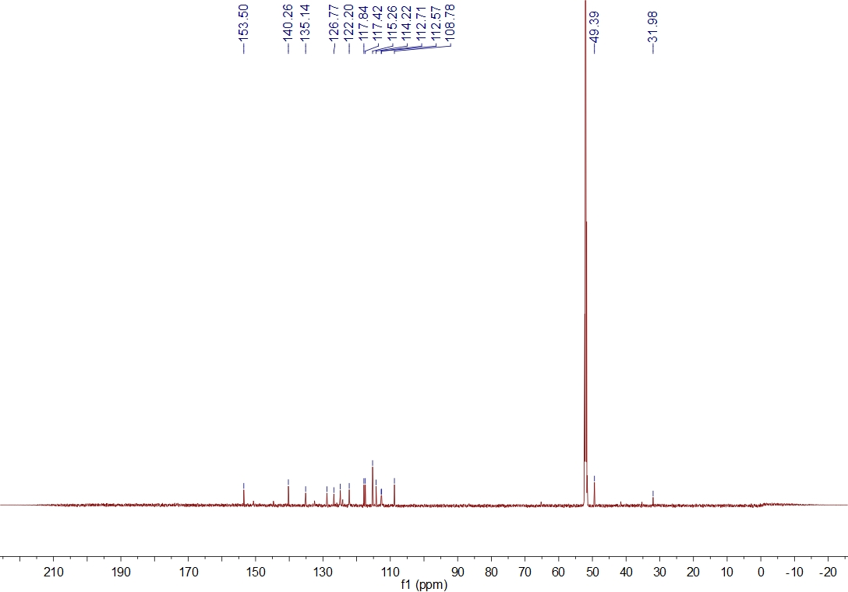
Fig. S8¹³C NMR sprectrum of title compound 5c
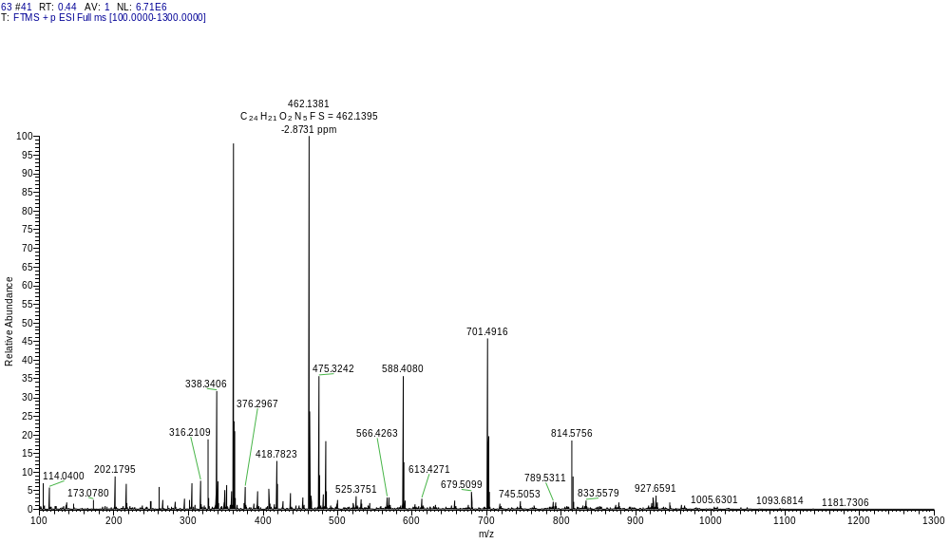
Fig. S9 HRMS sprectrum of title compound 5c
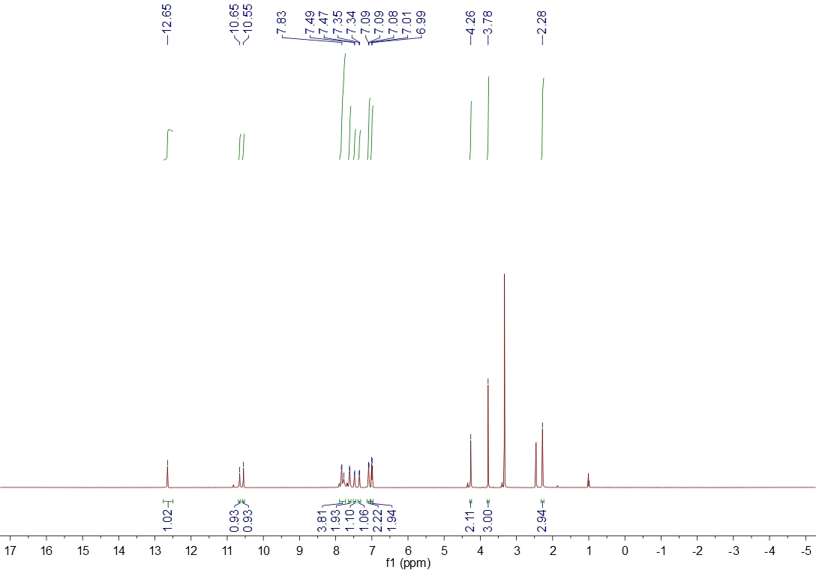
Fig. S10¹H NMR sprectrum of title compound 5d
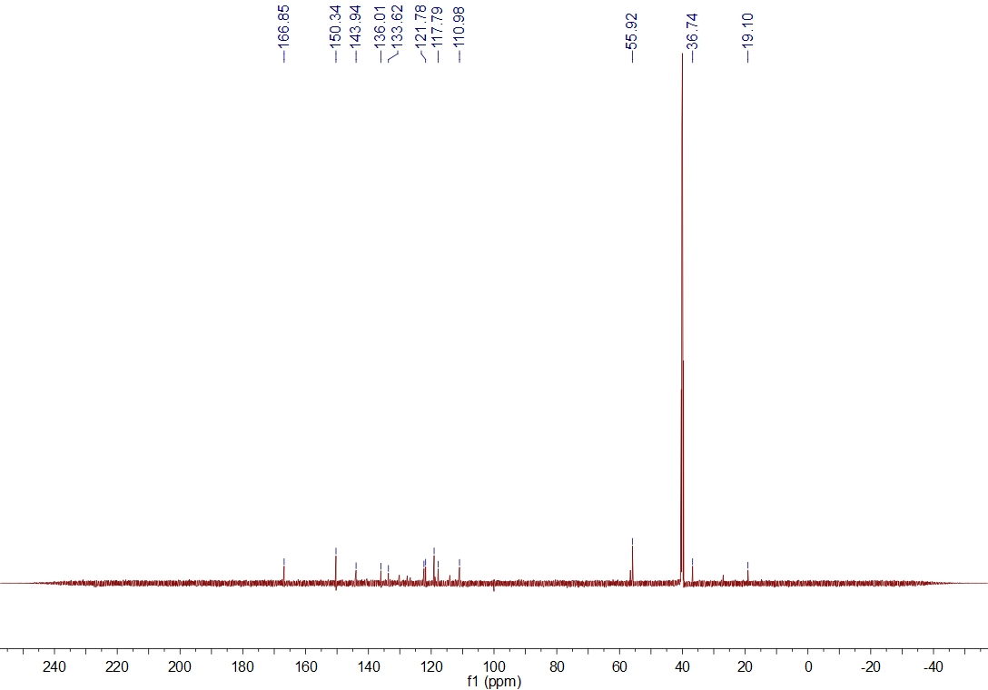
Fig. S11¹³C NMR sprectrum of title compound 5d
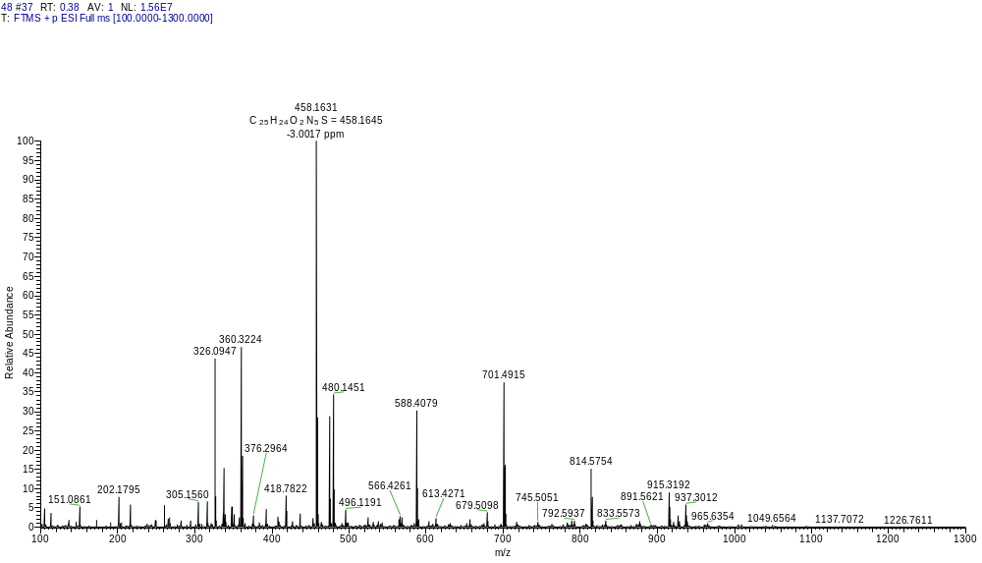
Fig. S12 HRMS sprectrum of title compound 5d
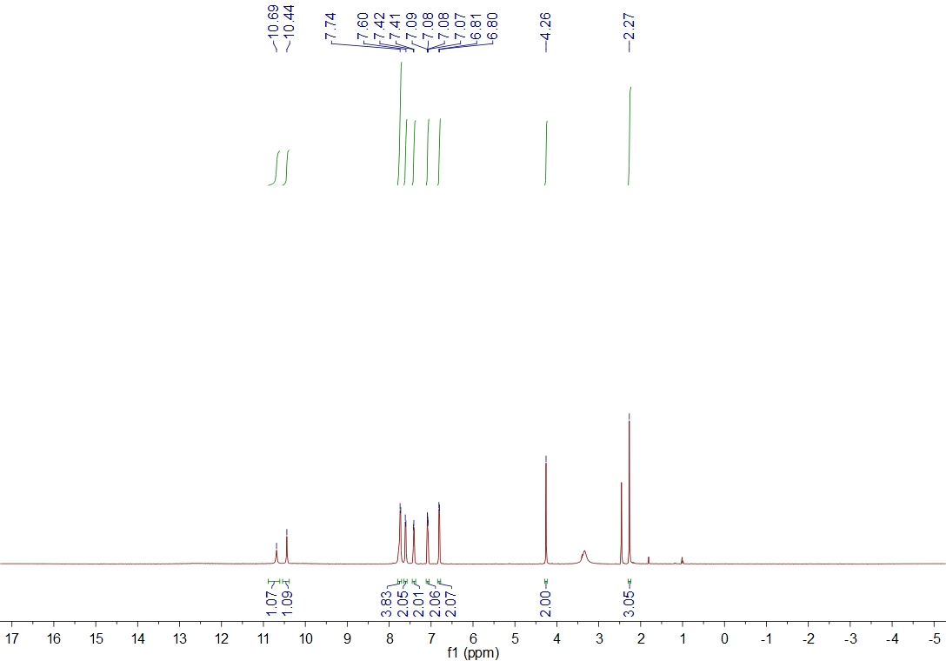
Fig. S13¹H NMR sprectrum of title compound 5e
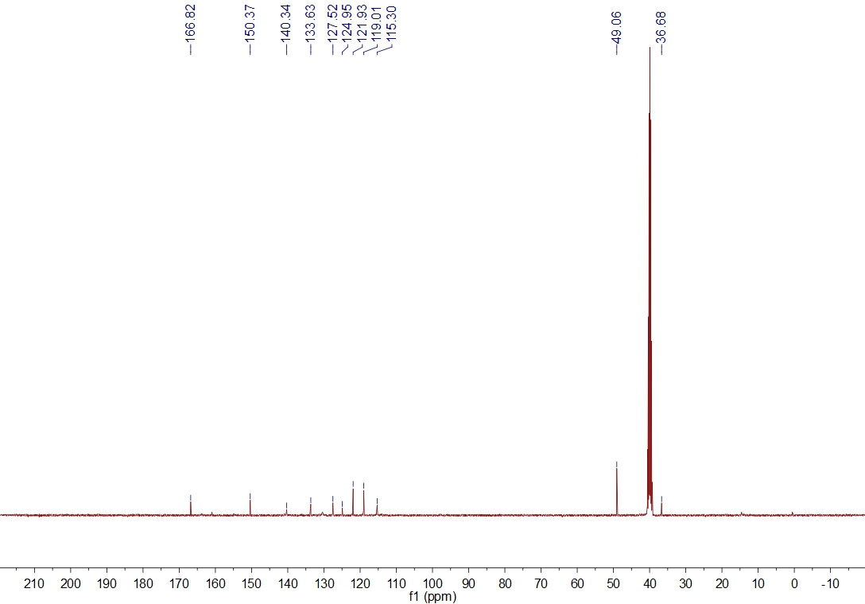
Fig. S14¹³CNMR sprectrum of title compound 5e
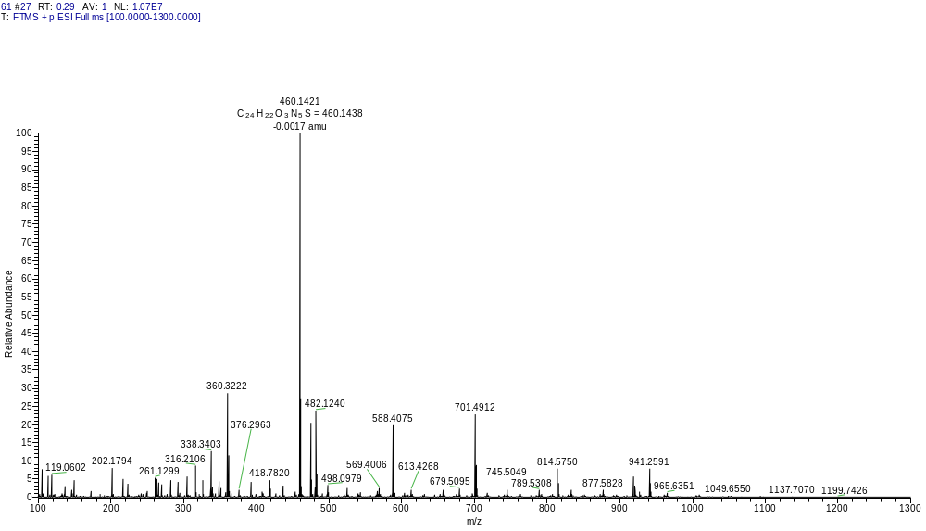
Fig. S15 HRMS sprectrum of title compound 5e
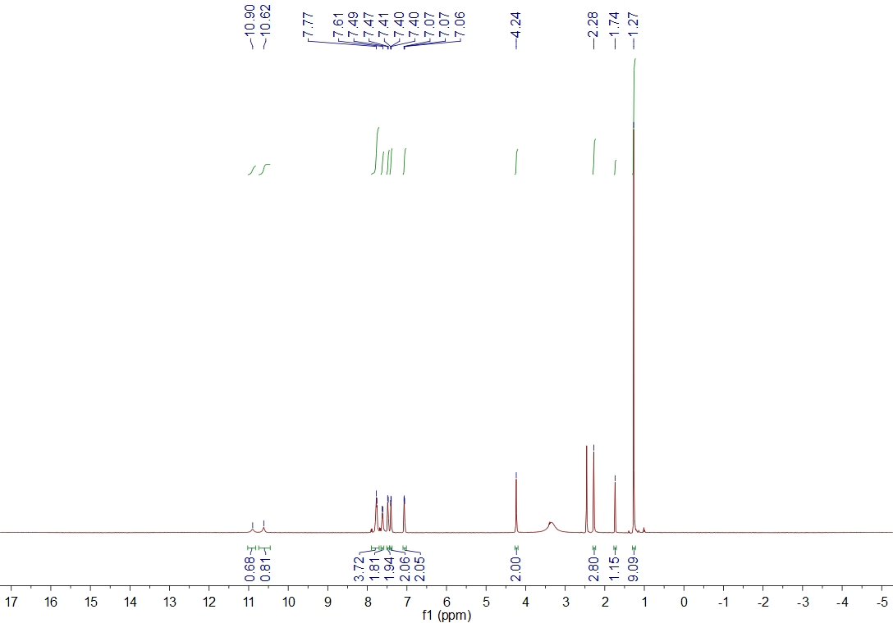
Fig. S13¹H NMR sprectrum of title compound 5f
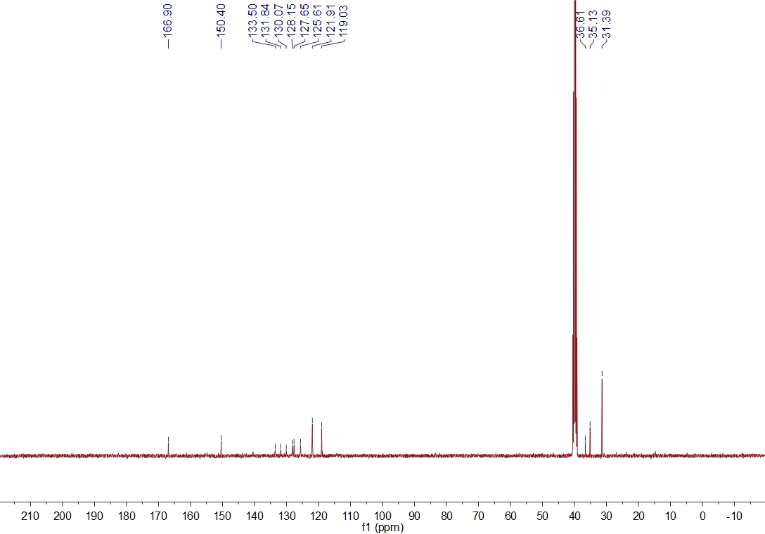
Fig. S17¹³CNMR sprectrum of title compound 5f
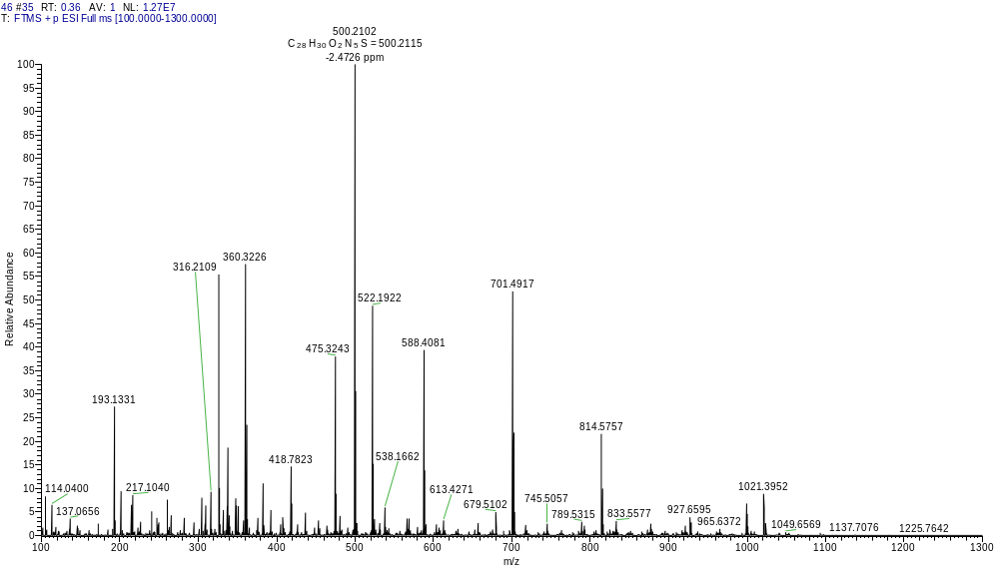
Fig. S18 HRMS sprectrum of title compound 5f
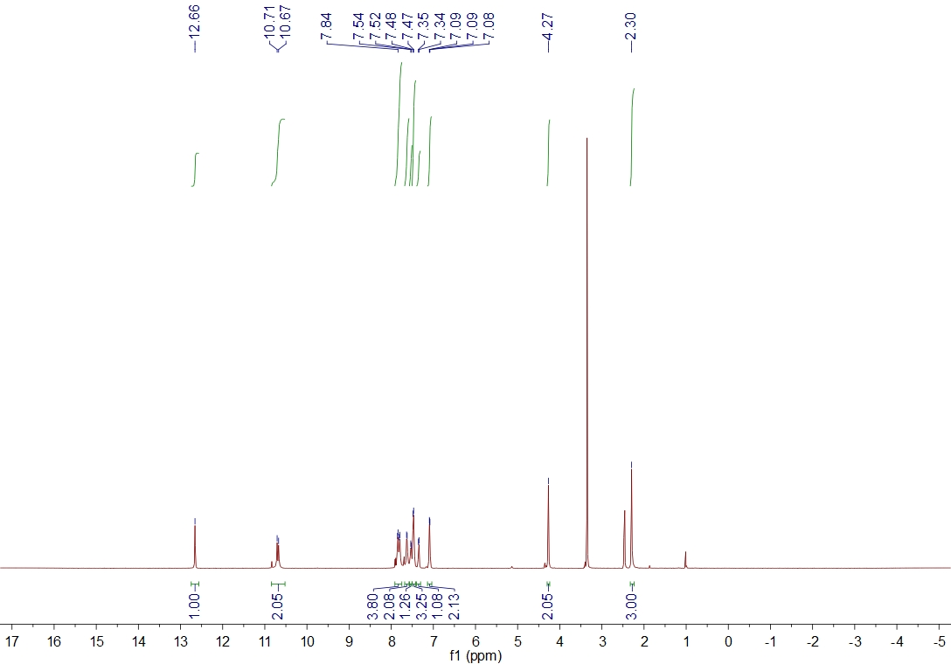
Fig. S19¹H NMR sprectrum of title compound 5g
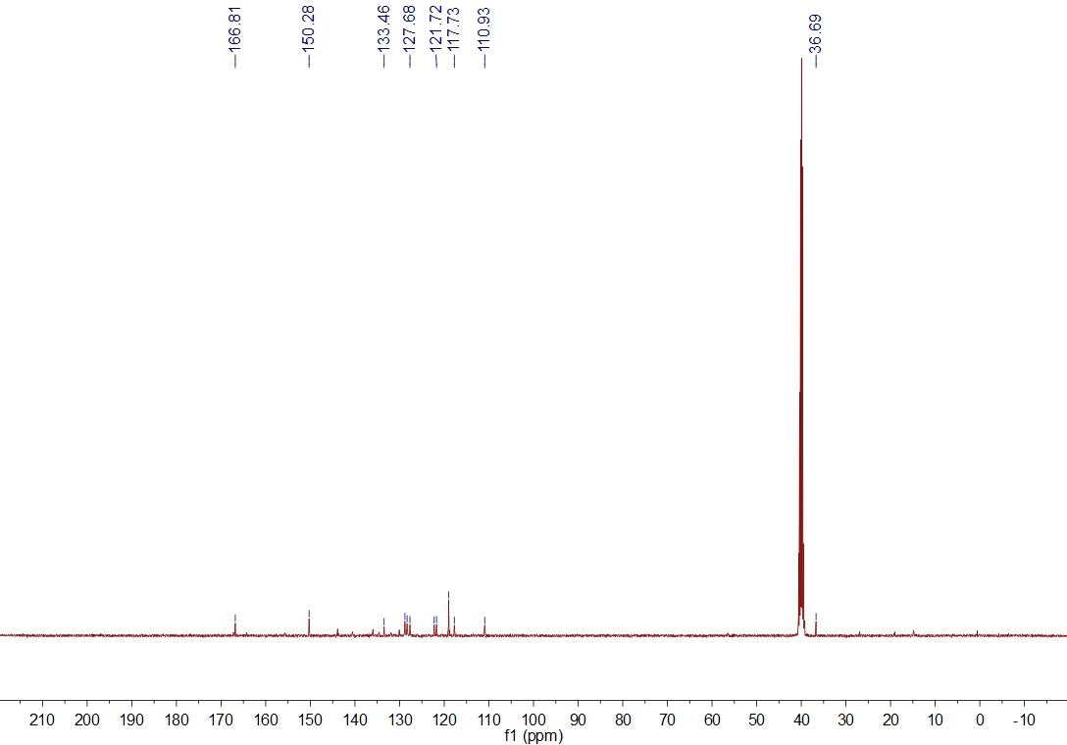
Fig. S20¹³C NMR sprectrum of title compound 5g
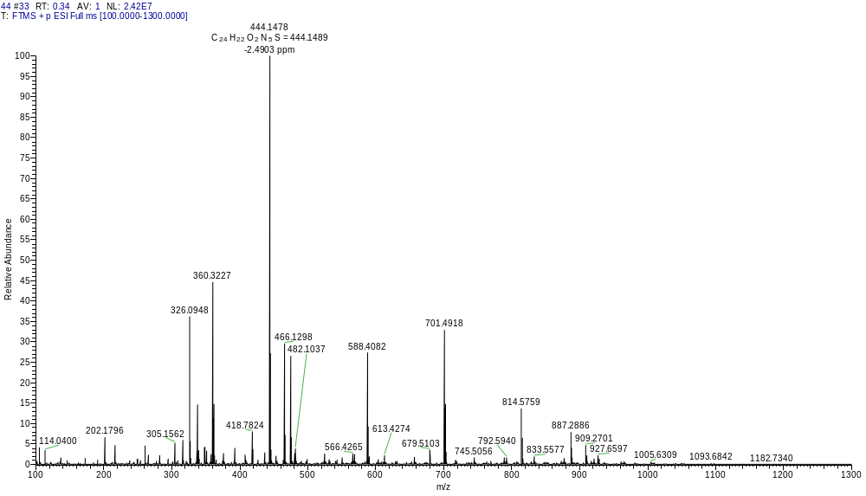
Fig. S21 HRMS sprectrum of title compound 5g
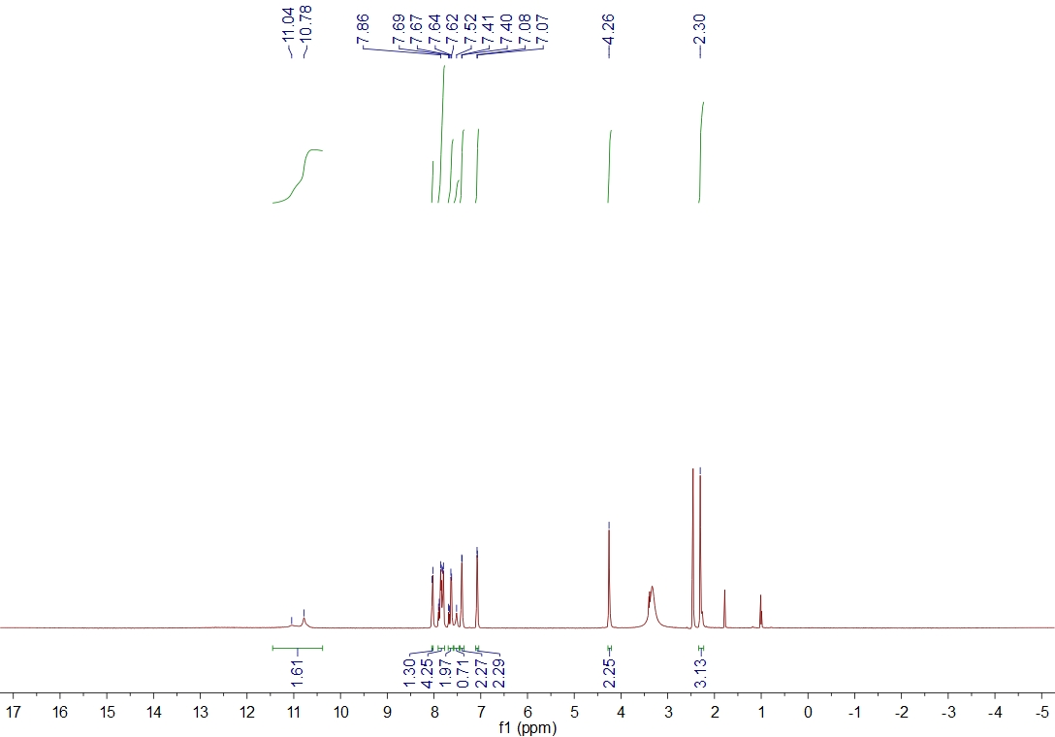
Fig. S22¹H NMR sprectrum of title compound 5h
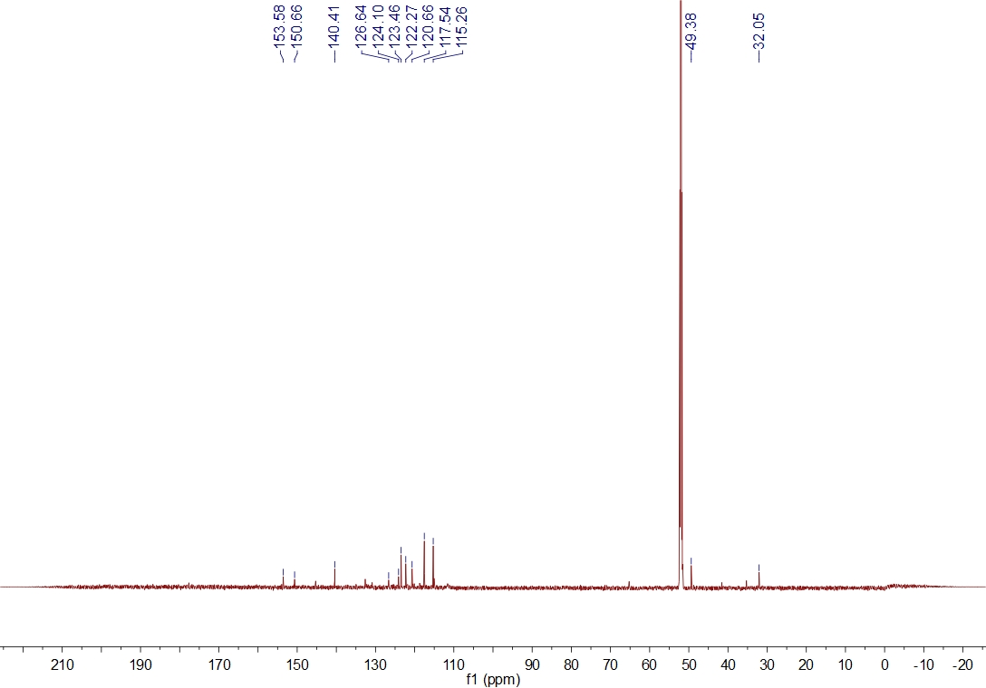
Fig. S23¹³CNMR sprectrum of title compound 5h
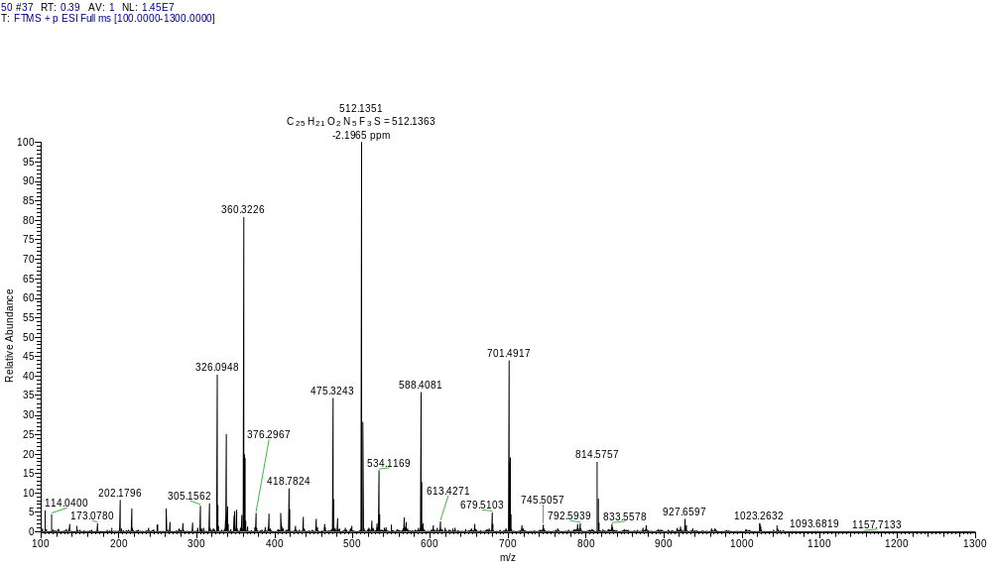
Fig. S24 HRMS sprectrum of title compound 5h
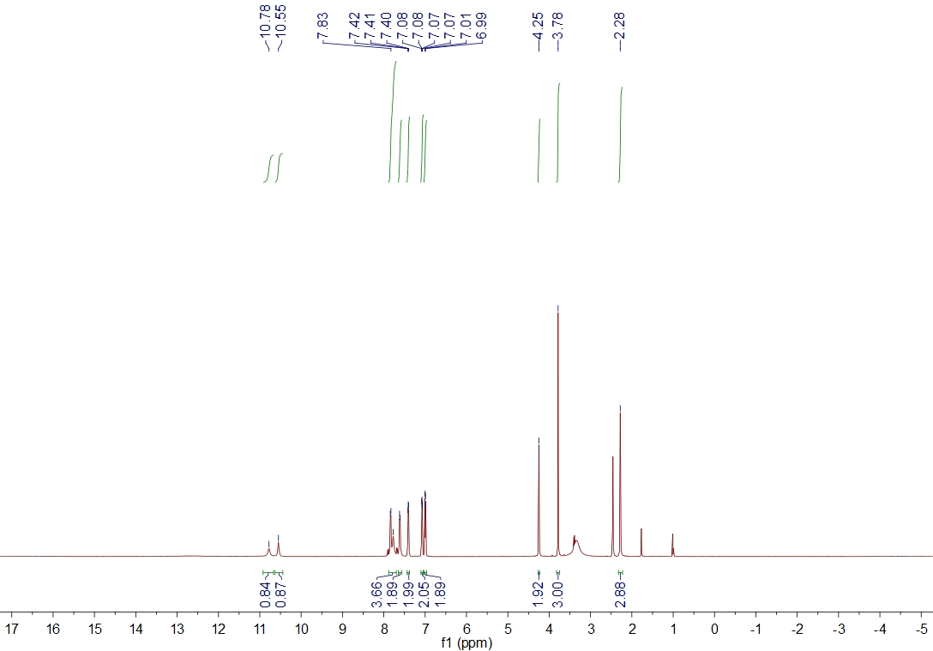
Fig. S25¹H NMR sprectrum of title compound 5i
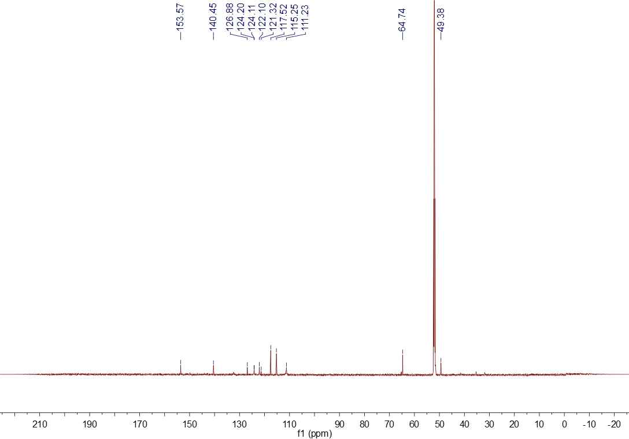
Fig. S26¹³CNMR sprectrum of title compound 5i
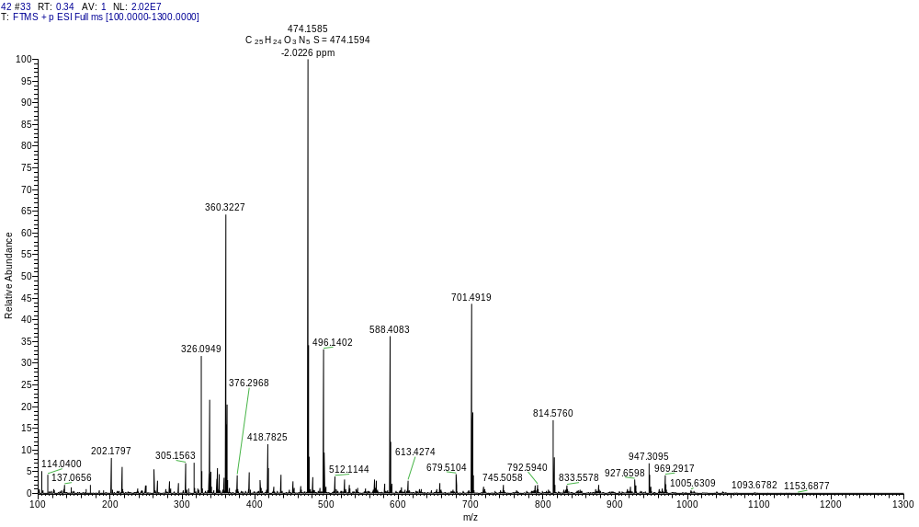
Fig. S27 HRMS sprectrum of title compound 5i
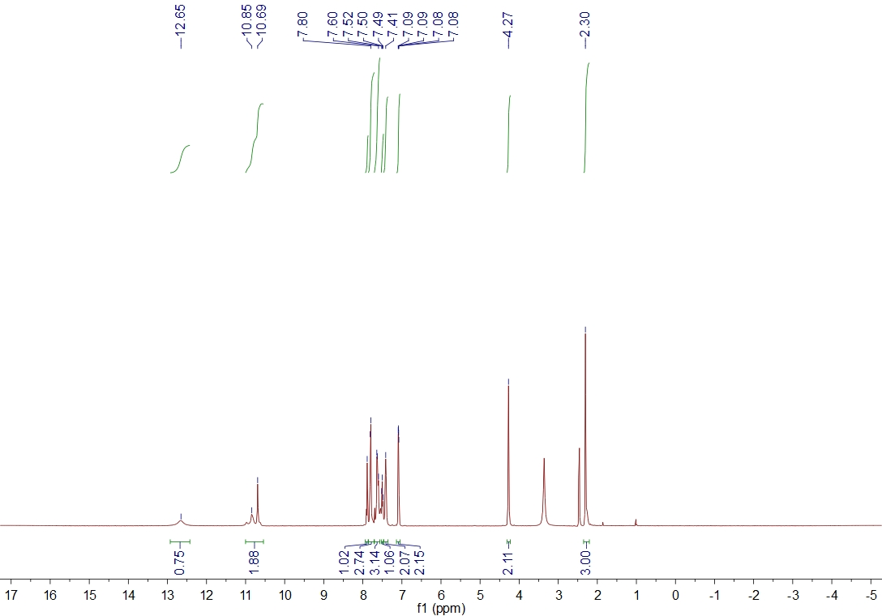
Fig. S28¹H NMR sprectrum of title compound 5j
Fig. S29¹³CNMR sprectrum of title compound 5j
Fig. S30 HRMS sprectrum of title compound 5j
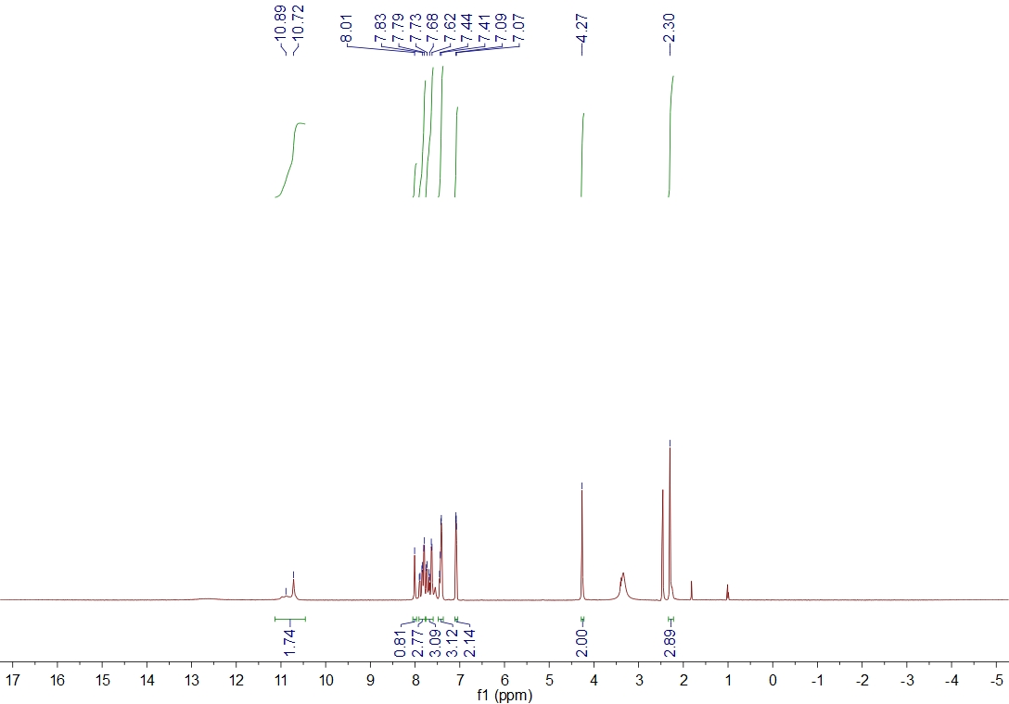
Fig. S31¹H NMR sprectrum of title compound 5k
Fig. S32¹³CNMR sprectrum of title compound 5k
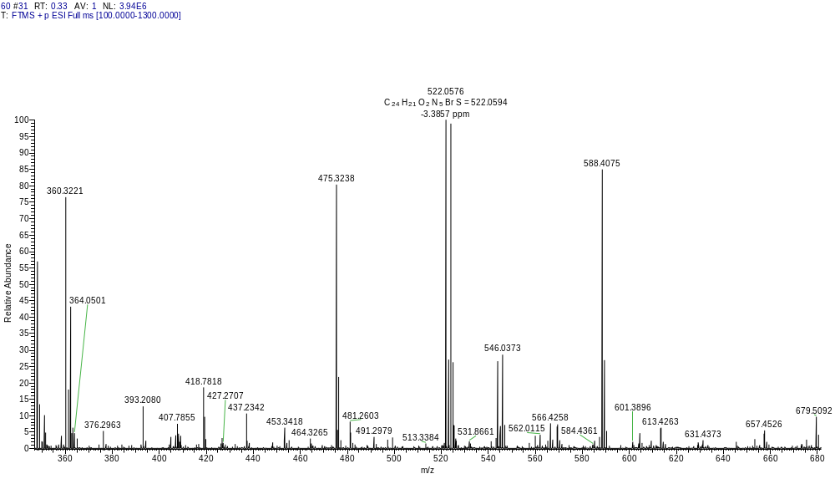
Fig. S33 HRMS sprectrum of title compound 5k
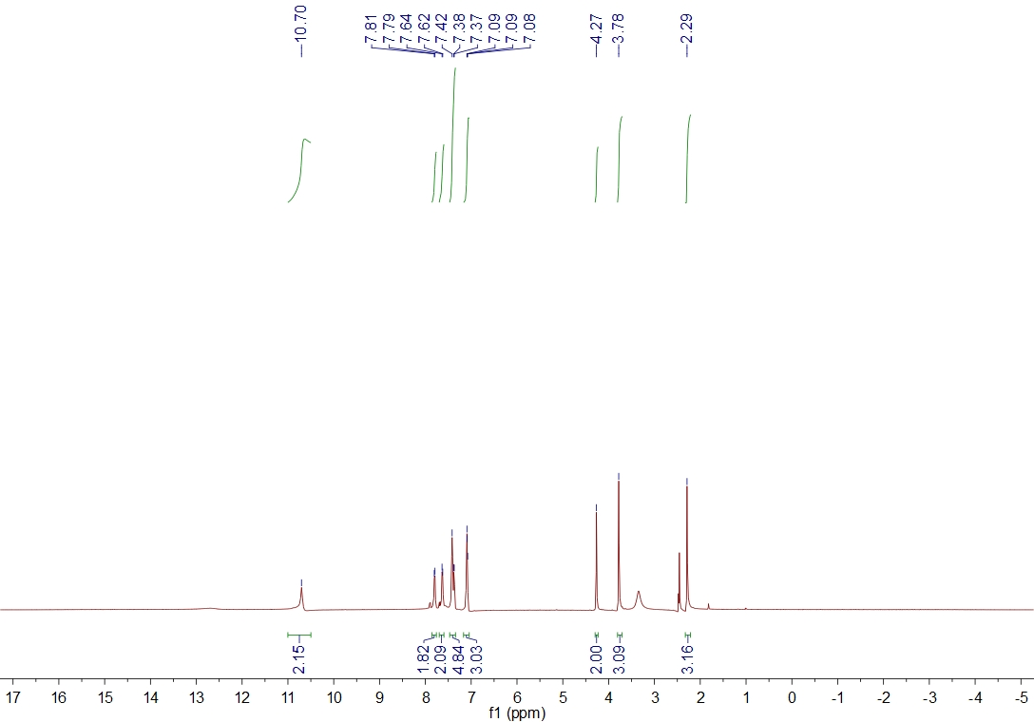
Fig. S34¹H NMR sprectrum of title compound 5l
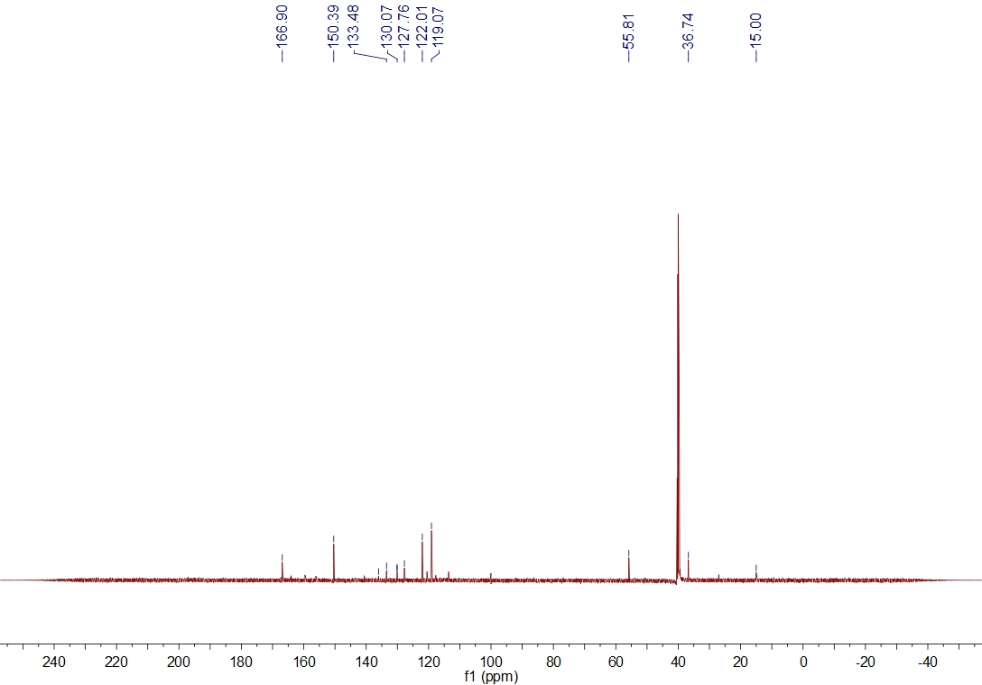
Fig. S35¹³CNMR sprectrum of title compound 5l
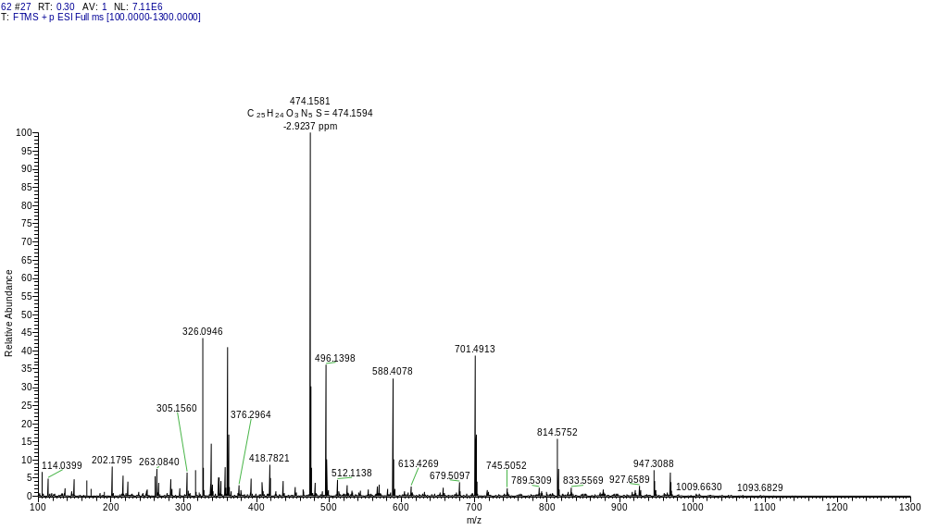
Fig. S36 HRMS sprectrum of title compound 5l
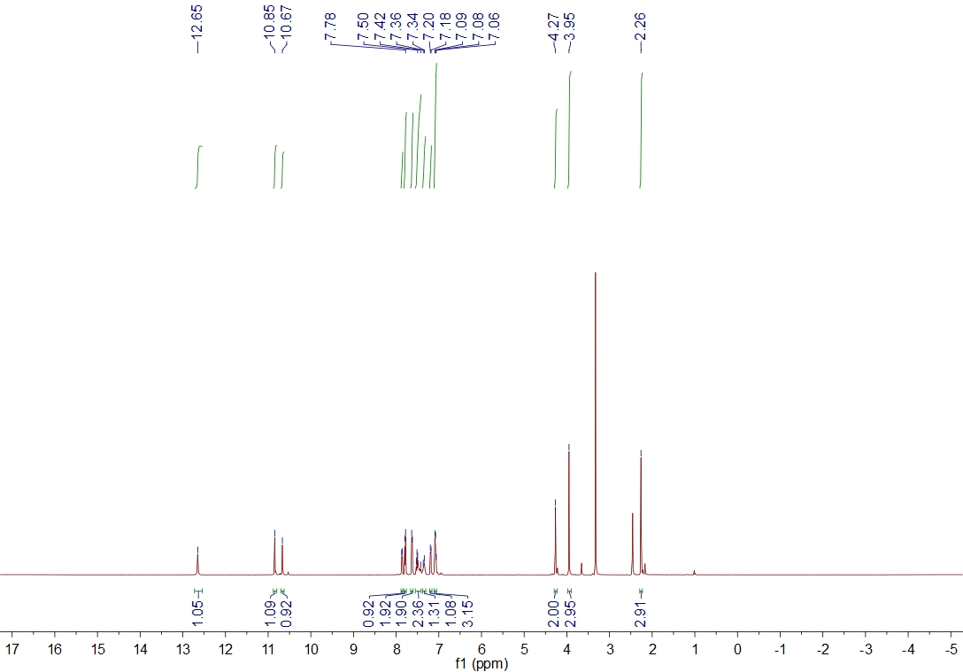
Fig. S37¹H NMR sprectrum of title compound 5m
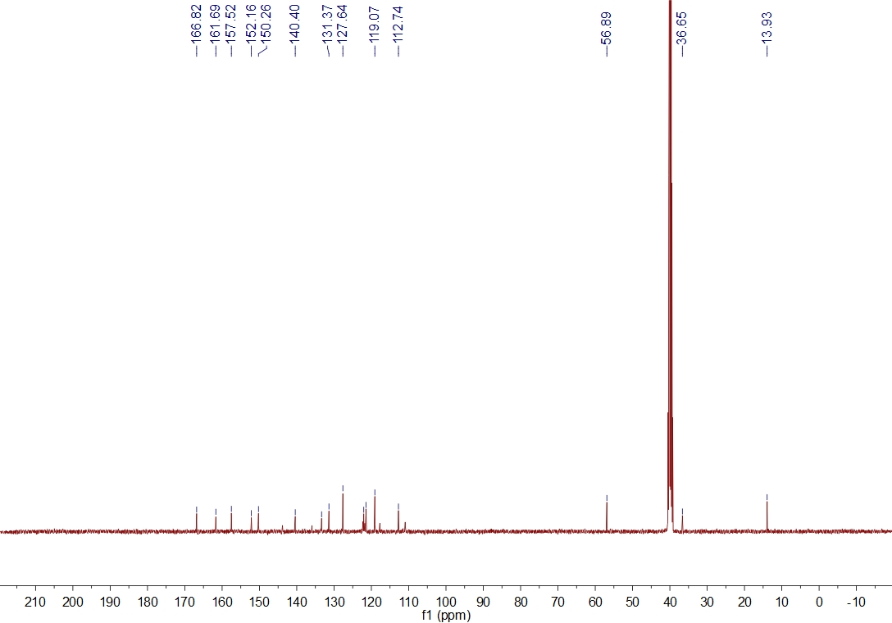
Fig. S38¹³C NMR sprectrum of title compound 5m
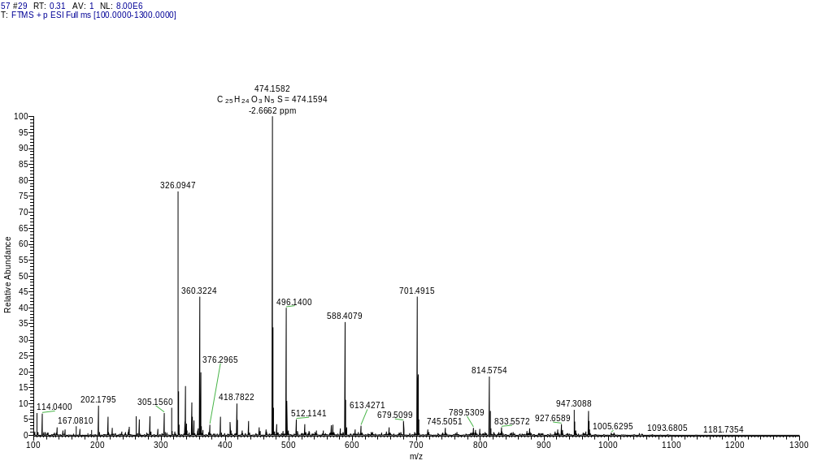
Fig. S39 HRMS sprectrum of title compound 5m
Fig. S40¹H NMR sprectrum of title compound 5n
Fig. S41¹³CNMR sprectrum of title compound 5n
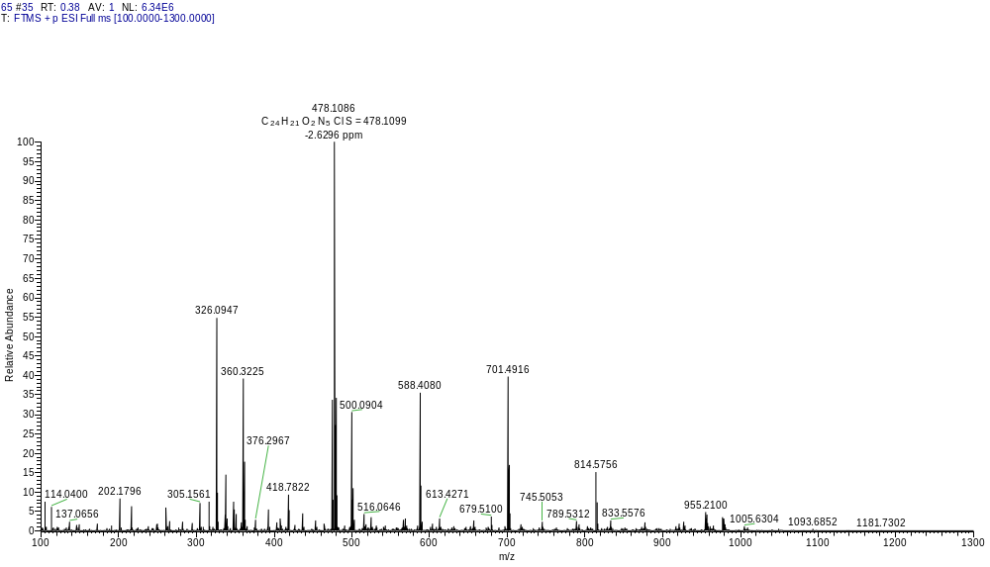
Fig. S42 HRMS sprectrum of title compound 5n
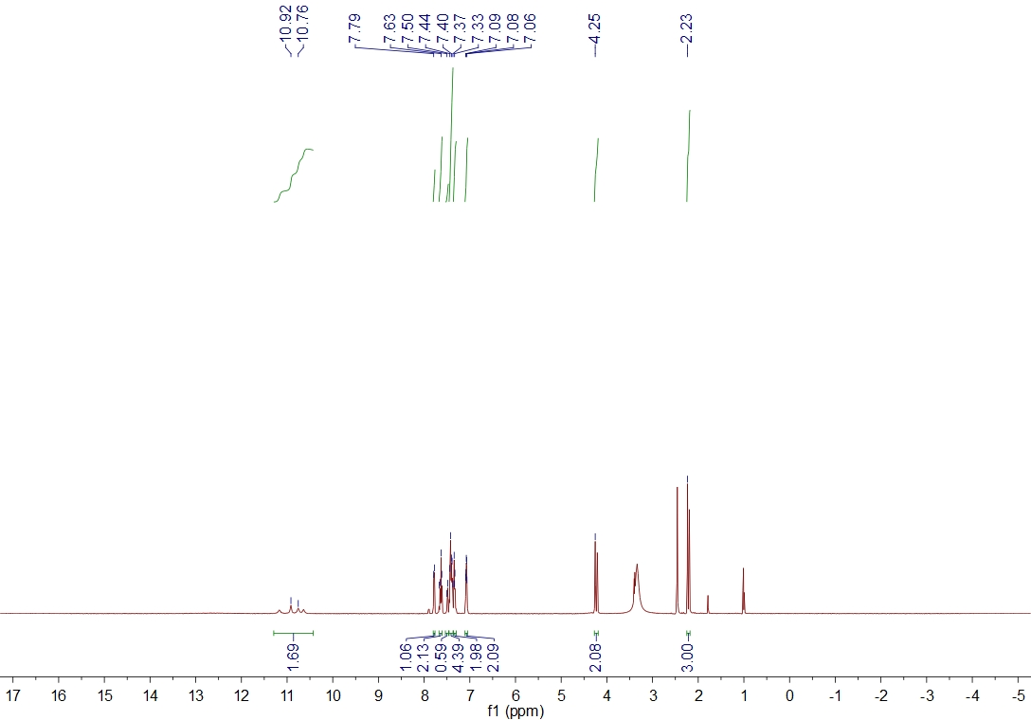
Fig. S43¹H NMR sprectrum of title compound 5o
Fig. S44¹³C NMR sprectrum of title compound 5o
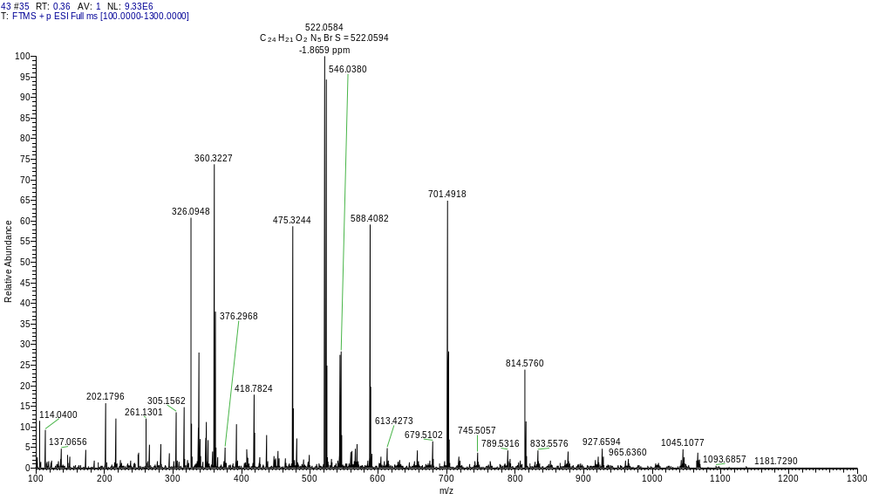
Fig. S45 HRMS sprectrum of title compound 5o
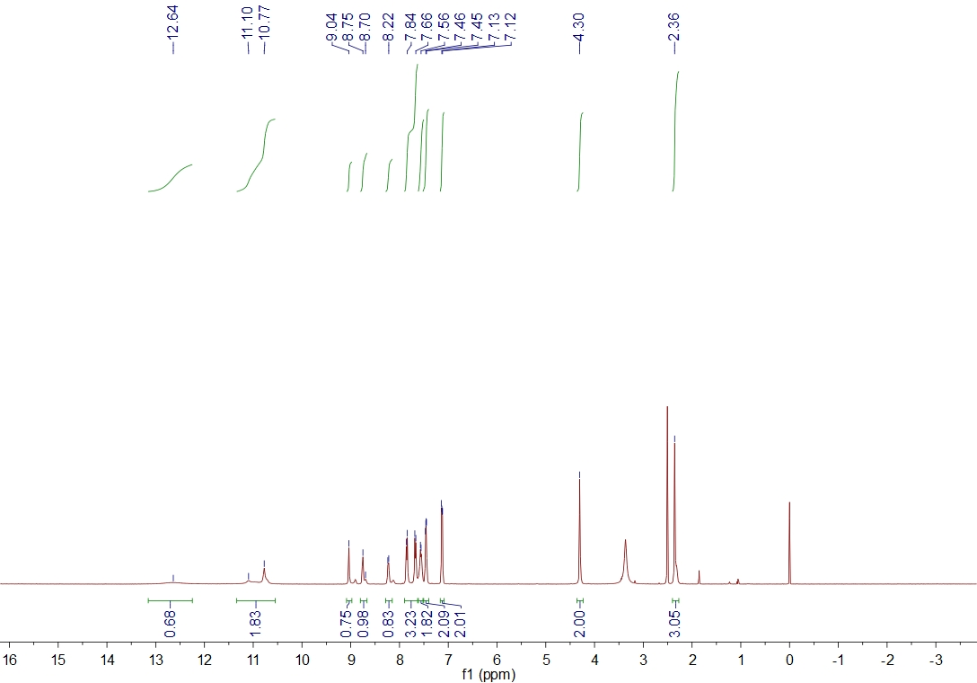
Fig. S46¹H NMR sprectrum of title compound 5p
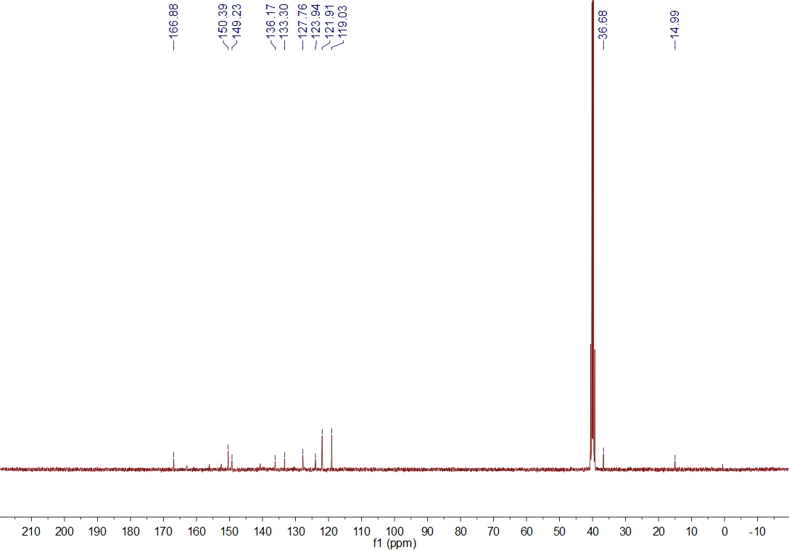
Fig. S47¹³C NMR sprectrum of title compound 5p
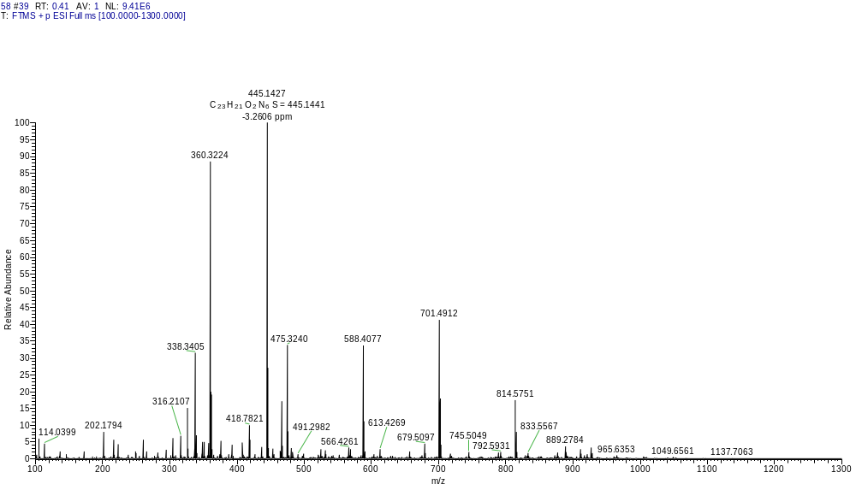
Fig. S48 HRMS sprectrum of title compound 5p
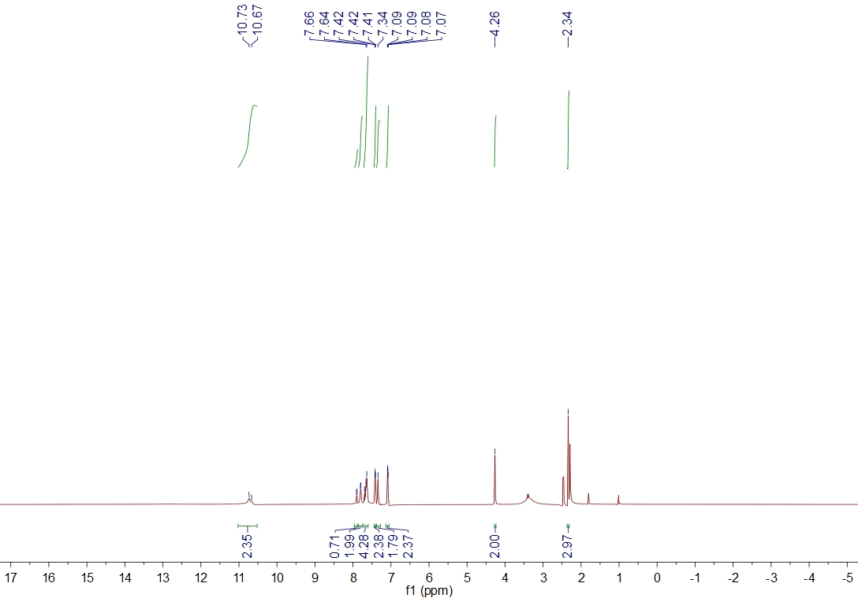
Fig. S49¹H NMR sprectrum of title compound 5q
Fig. S50¹³C NMR sprectrum of title compound 5q
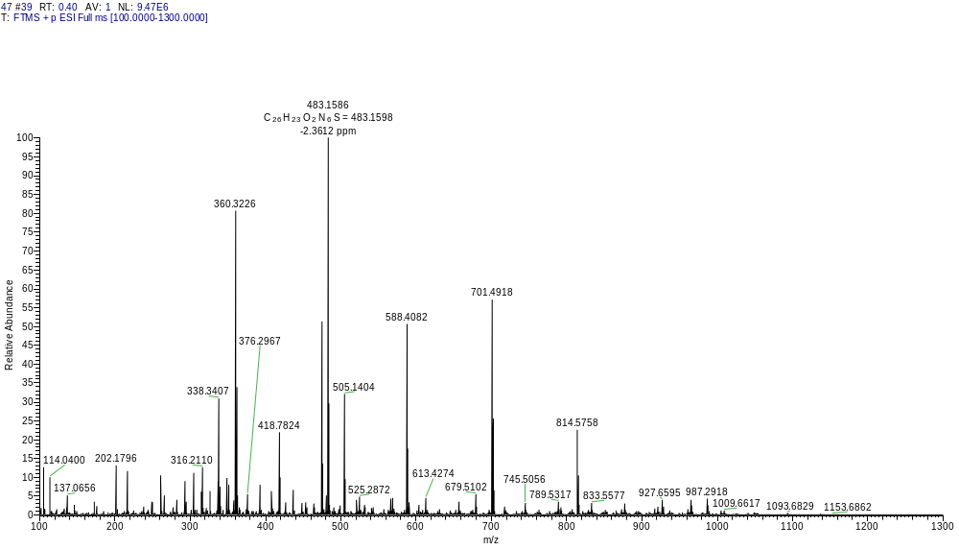
Fig. S51 HRMS sprectrum of title compound 5q

