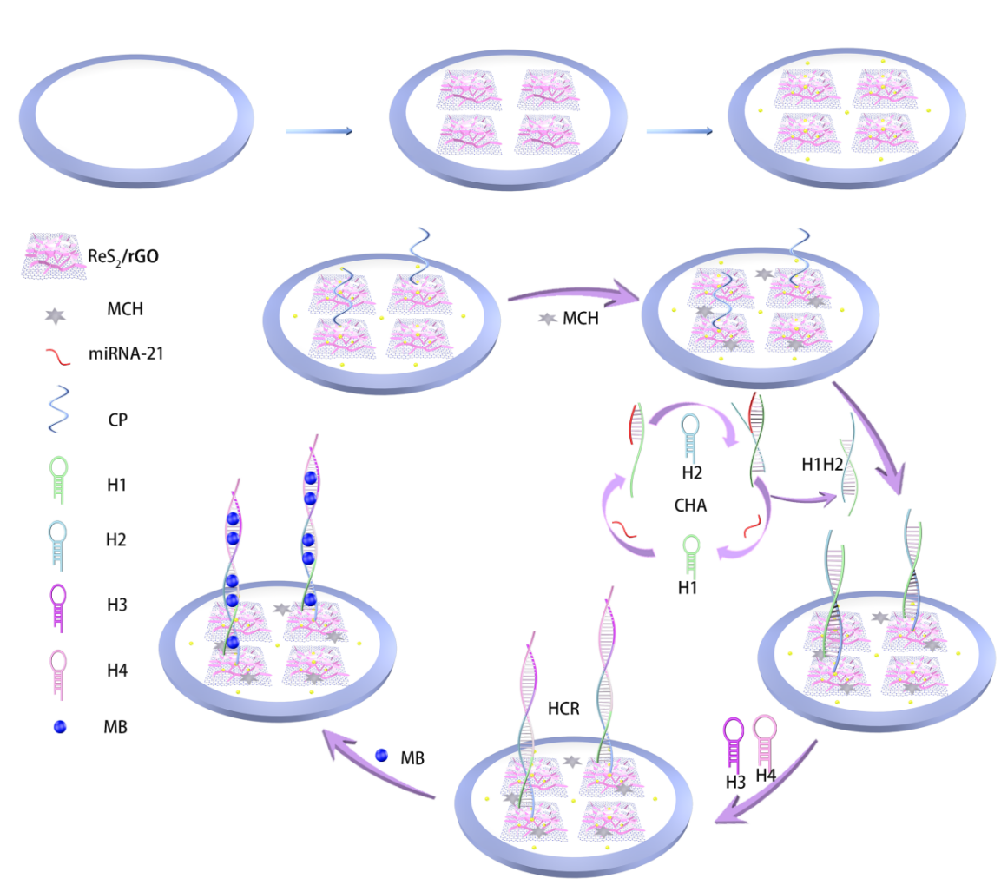
Scheme 1. Illustration of the electrochemical sensor empowered by the unique ReS₂/rGO nanoframeworks combined with CHA-HCR double amplification strategy for the ultrasensitive detection of miRNA-21.

