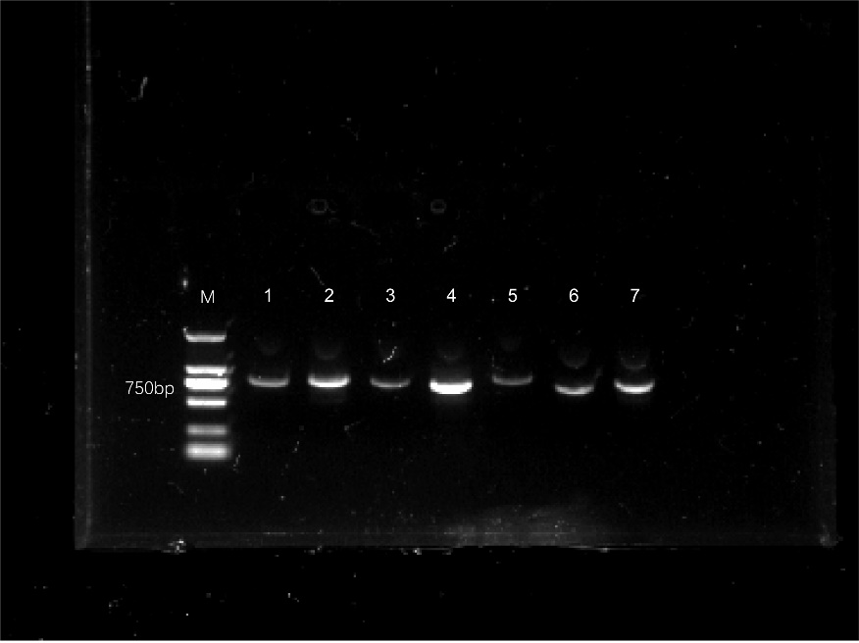
Fig. S1 Full uncropped Gels and Blots image of GhBEH1-7.
M: DM2000 DNA Marker, 1-7: GhBEH1-7

