Advancing Phototherapies in Glioblastomas: Plasma Membrane Damage by Single-Point Laser Irradiation Using Clinical Cancer Markers.
Cristina Carrizo^{1,2}, Jaime Fernández de Córdoba³, Ana Oña³, Gianluca D´Agostino³* and Sebastian A. Thompson^{1,2}*
–––––––––
1 Madrid Institute for Advanced Studies in Nanoscience (IMDEA Nanociencia), Madrid, Spain.
2 Nanobiotechnology Unit Associated to the National Center for Biotechnology (CNB-CSIC-IMDEA), Madrid, Spain.
3 Advanced Light Microscopy, Centro Nacional de Biotecnología (CNB-CSIC), Madrid, Spain.
Running title: Point laser Photodynamic Therapy

*Correspondence:
Sebastian Thompson, IMDEA Nanociencia ORCID: 0000-0002-0196-1124
Email: sebastian.thompson@imdea.org
Gianluca D´Agostino, CNB-CSIC ORCID: 0000-0002-7346-9278
Email: gdagostino@cnb.csic.es

Abstract
Purpose: This study aimed to present a novel phototherapeutic approach by inducing plasma membrane damage and cell death in glioblastoma cells using single-point laser irradiation rather than larger area irradiation.
Methods:
Glioblastoma cells were cultured in 2D monolayers and 3D spheroid models. Fluorescent markers like 5-aminolevulinic acid (5-ALA), the precursor of Protoporphyrin IX (PPIX), and Sodium Fluorescein (NaF) aid in tumor visualization during surgery and are being explored for photodynamic therapy (PDT). 5-ALA and NaF were applied to induce PPIX production or dye uptake, respectively. Fluorescence microscopy confirmed dye localization—PPIX on the plasma membrane and NaF in the extracellular space. Cells were irradiated with a focused laser, and the resulting plasma membrane damage was assessed through viability assays and membrane integrity markers. Cell death was quantified in both monolayers and spheroids.
Results:
PPIX localized on the plasma membrane, while NaF remained in the extracellular space, contacting the membrane. Single-point laser irradiation induced plasma membrane disruption in both conditions, resulting in selective cancer cell death. Both dyes led to significant cell death, even at the center of spheroids, demonstrating the effectiveness of this method in 3D structures.
Conclusions:
This study presents a novel approach using focused laser irradiation and clinically approved dyes to induce precise, targeted cell death in glioblastoma models, suggesting a promising potential for theranostic applications in tumor eradication.
Keywords
Glioblastoma, Photodynamic Therapy, Spheroids, Laser.

Fig SI1: Control NaF Laser Bleaching in U87 Spheroids
To verify that the spheroids damage was produced by the excitation of NaF with the 488 nm laser, control experiments where there is not spheroid’s damage when is first irradiated with 580 nm red laser is shown in the following figure. After there is no damage, the use of 488 nm laser induce the damage.
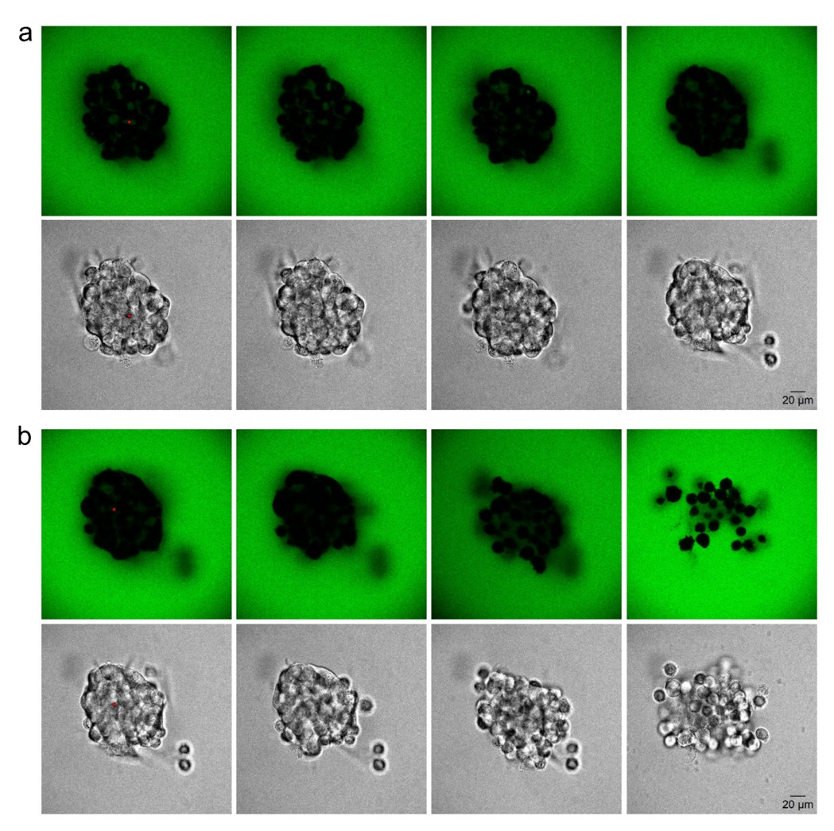
Fig SI1. Fluorescein localization after laser bleaching in U87 spheroids. (a) Representative confocal images of fluorescein (upper panel) and bright field image (lower panel) of a U87 spheroid treated with fluorescein before bleaching (left panel), after bleaching with red laser (central left panel) 10 minutes (central right panel), and 1 hour (right panel) after laser irradiation. Scale bar is 20 µm. (b) Same spheroid and image sequence presented in panel a using 488 nm laser irradiation. Scale bar is 20 µm.

Fig SI2: Control PIIX Laser Bleaching in U87 Spheroids
Control experiment performed in PPIX-untreated spheroids irradiated with laser, show no accumulation of propidium iodide both at 10 minutes and 1 hour post dye addition (Fig SI2).
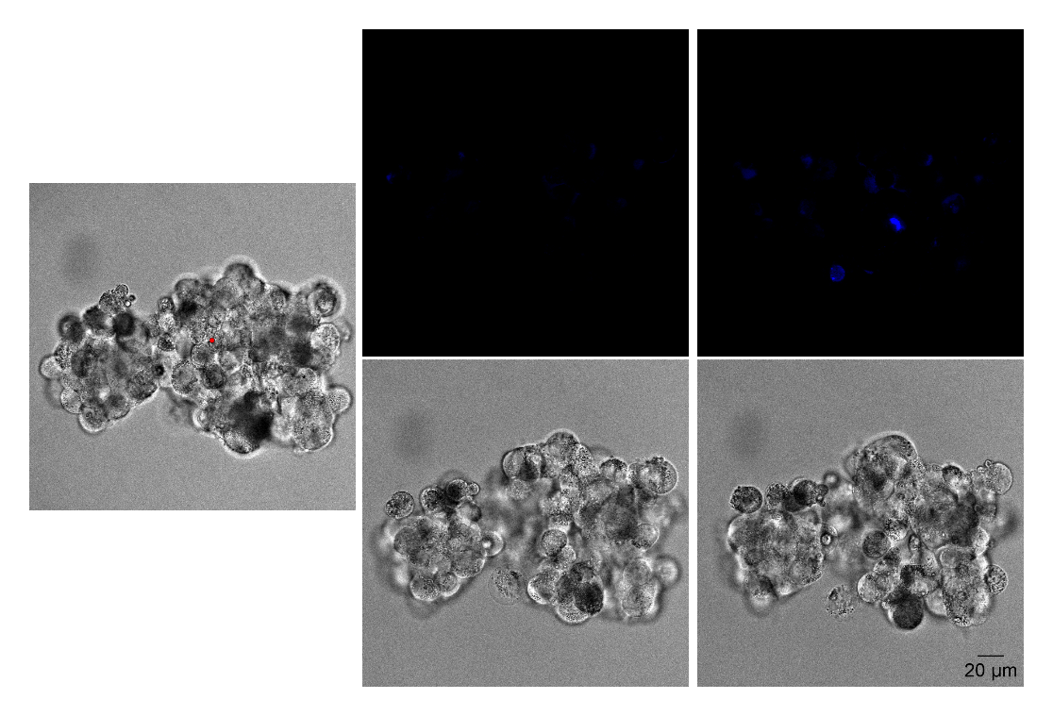
Fig. SI2. Propidium iodide localization after laser bleaching in U87 spheroids without PPIX treatment. Representative confocal images propidium iodide (blue-upper panel) and bright field image (lower panel) of a U87 spheroid untreated with 5-ALA before bleaching (left panel), 10 minutes after bleaching (central panel) and 1 hour after laser bleaching (right panel). Scale bar is 20 µm.

