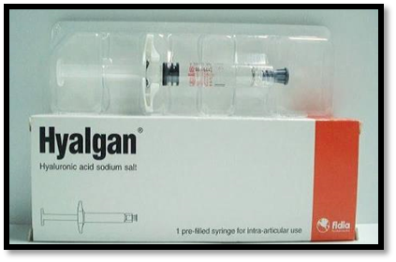

Supplementary Figure (S1): HYALGAN®, HA gel in pre-packed syringe

A 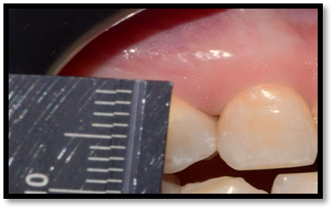
B 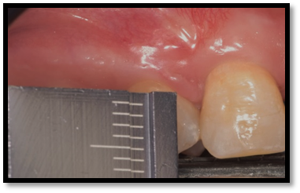
Supplementary Figure (S2): Clinical measurement of papilla-tip contact point of distance at baseline (A) and 6 months (B) with a ruler used as reference in (L-PRF) group

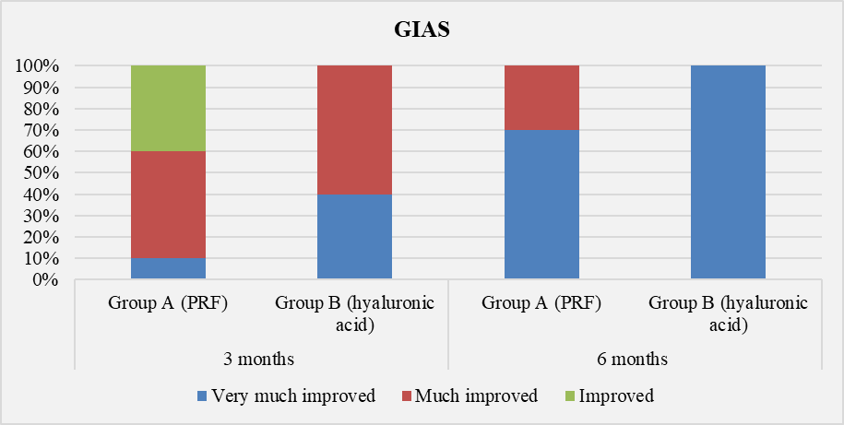
Supplementary Figure (S3): Frequency of GAIS scores in group A (L-PRF) and group B (HA) at baseline, 3 and 6 months
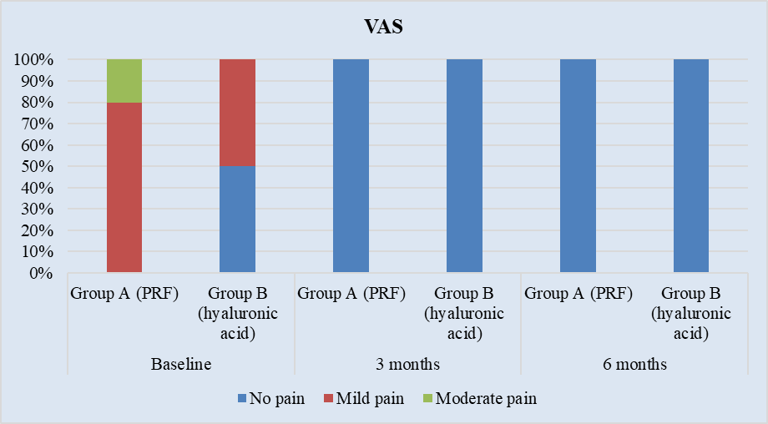

Supplementary Figure (S4): Frequency of VAS scores in (L-PRF) group and (HA) group at baseline, 3 and 6 months

