Supplementary Files
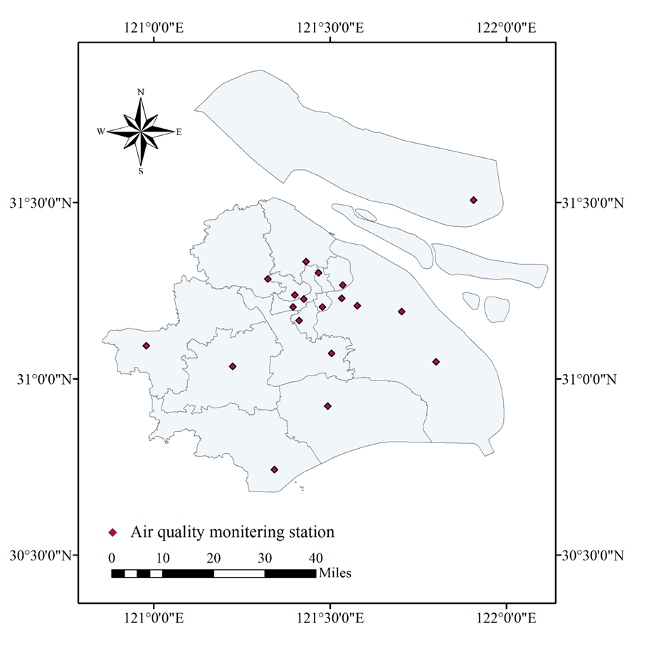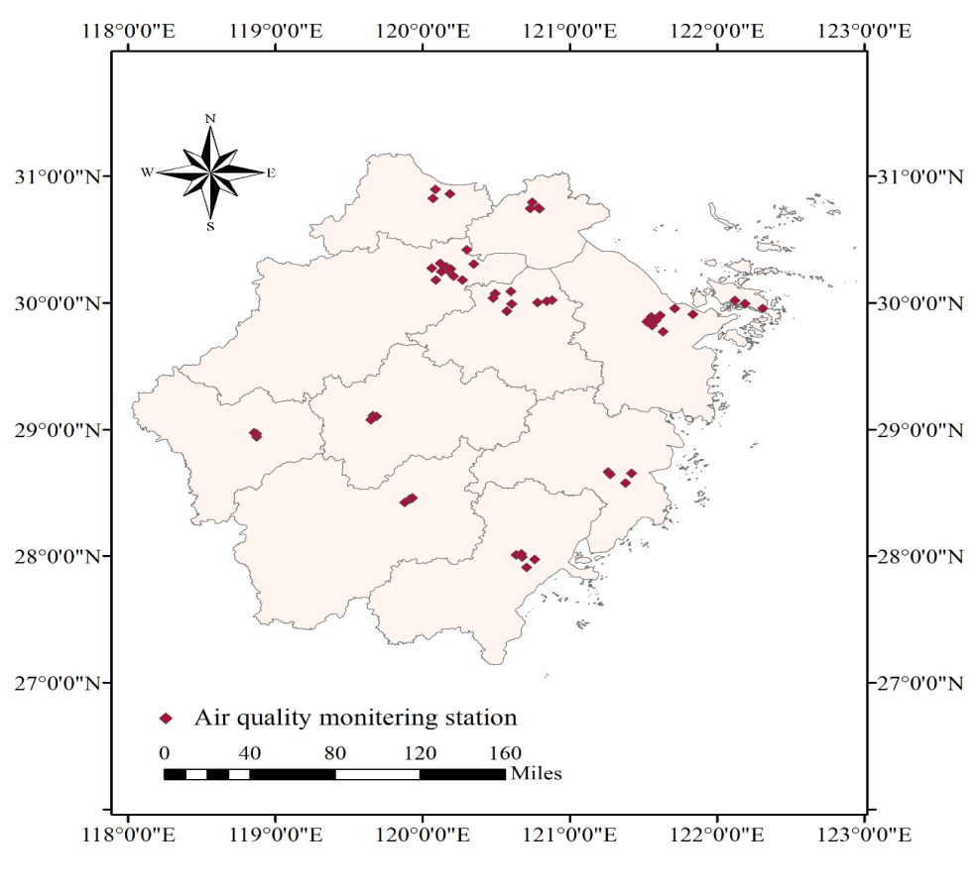
1a 1b
Supplementary Figure 1. The geographical location of air quality monitoring stations from 2017–2020 in Shanghai and Zhejiang Province, China
Notes: 1a: Air quality monitoring stations in Shanghai (n = 19); 1b: Air quality monitoring stations in Zhejiang Province (n = 56)
Supplementary table 1-1: The diagnostic criteria for pulmonary tuberculosis in China
Standard Name | Diagnostic Criteria of Pulmonary Tuberculosis
1 Scope | This standard is applicable to the diagnosis of tuberculosis in all kinds of medical and health institutions and their medical personnel at all levels in the country.
2 Terms and definitions | 2.1 Pulmonary tuberculosis  2.2 Mycobacterium tuberculosis
3 Diagnostic basis
3.1 Epidemiologic Linkage | The patient has an epidemiologic history of contact with acute active pulmonary tuberculosis
3.2 Clinical manifestations | 3.2.1 Symptoms: Cough, sputum or blood or haemoptysis in sputum lasting longer than two weeks
3.2 Clinical manifestations | 3.2.2 Physical examination: A physical examination is done to assess the patient's general health. It cannot be used to confirm or rule out TB. However, certain findings are suggestive of TB; for example, blood in the sputum, significant weight loss and drenching wet rales, wheezing sound, superficial lymphadenopathy, and night sweats may be due to TB.
3.3 Chest Imaging Examination | 3.3.1 Primary pulmonary tuberculosis: Primary pulmonary lesions and intrathoracic lymphadenopathy, or simple intrathoracic lymphadenopathy;  3.3.2 Haematogenous disseminated pulmonary tuberculosis: Miliary shadow with uniform size and density in both lungs;  3.3.3 Secondary tuberculosis: The chest imaging manifestations of secondary pulmonary tuberculosis are diverse. In light cases, patches, nodules and striations are the main manifestations, or tuberculoma or solitary voids; in heavy cases, lobar infiltration, caseous pneumonia, multiple void formation and bronchial dissemination are the main manifestations; in repeated delays of progression, pulmonary lesions may occur, the volume of damaged lung tissue is reduced, multiple thick-walled fibrous holes, secondary bronchiectasis, or multiple calcification are the main manifestations. Pulmonary hilum and mediastinum structure show traction displacement, thoracic collapse, pleural thickening and adhesion; other lung tissues show compensatory emphysema and new and old bronchial disseminated lesions;  3.3.4 Tuberculosis of trachea and bronchi: The main manifestations of tracheobronchial tuberculosis are irregular thickening of the trachea or bronchial wall, stenosis or obstruction of the lumen, secondary atelectasis or consolidation, bronchiectasis, and other bronchial disseminated lesions in the distal lung tissue of the stenosed bronchus;  3.3.5 Tuberculous Pleurisy: Tuberculous pleurisy is divided into dry pleurisy and exudative pleurisy. Dry pleurisy is an early inflammatory response of the pleura, usually without obvious imaging manifestations; exudative pleurisy is mainly manifested as pleural effusion; and pleural effusion can be manifested as a small or medium amount of free effusion, or a limited effusion in any part of the pleura. Those patients with slow absorption are often accompanied by pleural thickening and adhesion, and can also evolve into pleural tuberculoma and empyema.
3.4 Laboratory Tests | 3.4.1 Bacteriological test: (a) Positive for Mycobacterium tuberculosis by smear microscopy; (b) Mycobacterium was positive in culture and identified as Mycobacterium tuberculosis complex.  3.4.2 Molecular Biology Examination: Positive nucleic acid for Mycobacterium tuberculosis  3.4.3 Pathological examination of tuberculosis: Histopathological changes typical of tuberculosis  3.4.4 Immunological examination  3.4.4.1 Moderate or strong positive tuberculin skin test;  3.4.4.2 Positive IFN-gamma release test;  3.4.4.3 Positive Mycobacterium tuberculosis antibody test.  3.4.5 Bronchoscopy: Bronchoscopy can directly reveal the pathological changes in the trachea and bronchus, as well as allow collection of aspirate secretions, brush samples and biopsies.
4. Diagnostic principles | The diagnosis of pulmonary tuberculosis is based on etiology (including bacteriology and molecular biology), combined with epidemiological history, clinical manifestations, chest imaging, related auxiliary examinations and differential diagnosis; together, these provide a comprehensive diagnosis. Pathogenic and pathological results are used as the basis for confirmation. In the diagnosis of pulmonary tuberculosis in children, besides a sputum etiology examination, young patients should also undergo a gastric etiology examination.
5. Diagnosis and Classification
5.1 Suspected cases | Those who meet one of the following criteria:  (a) having any of the 3.3 items;  (b) Children under 5 years old with 3.2 and 3.1, 3.4.4.1 and 3.4.4.2.
5.2 Clinically diagnosed cases | Other pulmonary diseases are excluded by differential diagnosis, and one of the following criteria is met:  (a) with any of 3.3 and 3.2;  (b) with any of 3.3 and 3.4.4.1;  (c) with any of 3.3 and 3.4.4.2;  (d) with any of 3.3 and 3.4.4.3;  (e) with any of the 3.3 items and with extrapulmonary pathological examination confirming tuberculosis lesions;  (f) Tracheal and bronchial tuberculosis are diagnosed with 3.3.4 and 3.5.
5.3 Confirmed cases | 5.3.1 Diagnosis of sputum smear positive tuberculosis  Those who meet one of the following criteria:  (a) 2 sputum smears with acid-fast bacilli conform to 3.4.1.a;  (b) The acid-fast bacillus test of one sputum specimen conforms to 3.4.1.a, with any of the 3.3 items concomitantly;  (c) The acid-fast bacilli test of one sputum specimen is 3.4.1.a, and the culture of Mycobacterium in one sputum specimen is 3.4.1.b.  5.3.2 Diagnosis of Mycobacterium tuberculosis  In accordance with any of 3.3, at least 2 sputum smears are negative, and mycobacterium culture agrees with 3.4.1.b.  5.3.3 Molecular Biology Examination Positive Diagnosis of Tuberculosis  Compliance with either 3.3 or 3.4.2.  5.3.4 Diagnosis of Pulmonary Tuberculosis Positive by Histopathological Examination of Lung  Compliance with 3.4.3.  5.3.5 Diagnosis of Tracheobronchial Tuberculosis  Those who meet one of the following criteria:  (a) Those with 3.5 and 3.4.3 coincidence in pathological examination of trachea and bronchus;  (b) Those with 3.5 and 3.4.1.a or 3.4.1.b or 3.4.2 of tracheal and bronchial secretions.  5.3.6 Diagnosis of tuberculous pleurisy  Those who meet one of the following criteria:  (a) Those with 3.3 pleural effusion or pleural pathology accorded with 3.4.3;  (b) Those with 3.3 and 3.4.1.a or 3.4.1.b or 3.4.2 of pleural effusion etiology.
Chinese Standard Number | WS 288-2017
Issued by | National Health Commission of the People’s Republic of China
Date issued | November 9, 2017
Official Source | http://www.nhc.gov.cn/ewebeditor/uploadfile/2017/11/20171128164254246.pdf

Supplementary table 1-2: The diagnostic criteria for influenza in China
Standard Name | Diagnostic Criteria of Influenza
1 Scope | This standard is applicable to all levels of medical and health institutions and personnel in the country for the diagnosis and reporting of influenza.
2 Terms and definitions | Type of influenza virus; Subtype of influenza A virus; Influenza-like illness
3 Diagnostic basis
3.1 Epidemiologic Linkage | In the local epidemic season (i.e. winter and spring in northern China and winter, spring and summer in southern China), a large number of upper respiratory tract infections occur in a unit or area, or the number of patients with upper respiratory tract infections in hospital outpatient and emergency departments increases significantly.
3.2 Clinical manifestations | 3.2.1 The common manifestations are acute fever (axillary body temperature (> 38 C), chills, headache, dizziness, soreness, fatigue and other toxic symptoms, as well as respiratory symptoms, such as pharyngalgia and dry cough, but the catarrhal symptoms are often not obvious.  3.2.2 A few cases can have anorexia accompanied by gastrointestinal symptoms, such as abdominal pain, abdominal distention, vomiting and diarrhoea.  3.2.3 A few cases can also be complicated with sinusitis, otitis media, laryngitis, bronchitis, pneumonia, and even respiratory and circulatory failure and death.  3.2.4 Children under two years of age, or those with chronic underlying diseases, may have lower respiratory sounds and wet beeps or wheezing sounds in both lungs, but no signs of lung consolidation.  3.2.5 Thoracic X-ray examination of severe patients can show unilateral or bilateral pulmonary parenchymal lesions, and a few lesions may be accompanied by pleural effusion.  3.2.6 The total number of white blood cells in peripheral haemogram is neither high nor low, and the lymphocytes increase relatively. The total numbers of white blood cells and lymphocyte decrease in severe patients.
3.3 Laboratory Tests | The procedures for collecting, transporting and treating influenza specimens can be found in Appendix G.  3.3.1 Influenza viruses are isolated and identified from patients' respiratory tract specimens (see Appendix A).  3.3.2 The titre of serum anti-influenza virus antibody is 4 or more times higher in convalescent patients than in acute patients (see Appendix B and C).  3.3.3 Influenza virus specific nucleic acid (see Appendix D) or specific antigen (see Appendix E) is detected in the patients' respiratory tract specimens.  3.3.4 After the virus proliferates in sensitive cells for one generation, the specific nucleic acid of influenza virus gives a positive test (see Appendix D for details) or a specific antigen is detected (see Appendix E).
4. Diagnostic principles | If only clinical manifestations in a non-epidemic season are considered, distinguishing influenza virus from other pathogens is difficult, especially for diseases caused by other respiratory pathogens. The diagnosis of influenza cases often requires laboratory diagnosis. However, in the flu season, when a large number of patients with upper respiratory tract infections or outpatient and emergency upper respiratory tract infections in a local unit or local area increase significantly, the patients with corresponding clinical manifestations can be considered clinically diagnostic cases of influenza. See Appendix F for the etiology, epidemiology and clinical manifestations of influenza.
5. Diagnosis and Classification
5.1 Clinically diagnosed cases | Those with any of the clinical manifestations in 3.1 and 3.2.
5.2 Confirmed cases | 5.2.1 Influenza-like cases with any of 3.3.  5.2.2 Clinically diagnosed cases with any of 3.3.
Chinese Standard Number | WS285-2008
Issued by | National Health Commission of the People’s Republic of China
Date issued | February 28, 2008
Official Source

Supplementary table 1-3: The diagnostic criteria for measles in China
Standard Name | Diagnostic Criteria of Measles
1 Scope | This standard is applicable to the diagnosis of measles by medical and health institutions at all levels and their medical personnel
2 Terms and definitions | CPE ：cytopathic effect  DEPC：diethyl pyrocarbonate  ELISA ：enzyme-linked immunosorbent assay  IgG：immunoglobulin G  IgM：immunoglobulin M  RF：rheumatoid factor  RNA：ribonucleic acid  RT-PCR：reverse transcription-polymerase chain reaction  RPM：revolutions per minute  OD：optical density value  VTM：virus transportation medium
3 Diagnostic basis
3.1 Epidemiologic Linkage | 3.1.1 At 7-21 days before the onset of measles, a patient with measles had contact history.  3.1.2 The patient had a history of residence or travel in measles-endemic areas 7 to 21 days before the onset of measles.
3.2 Clinical manifestations | 3.2.1 Fever, body temperature generally (> 38 C).  3.2.2 Red macular papules appear on the 3rd to 4th day of the course of the disease, and the skin between the rashes is normal. The order of eruption usually starts from the back of the ear and the face and extends from top to bottom to the whole body; it can involve the mucosa. The eruption lasts for 3 to 5 days.  3.2.3 Upper respiratory catarrhal symptoms, such as cough, runny nose and sneezing, as well as photophobia, tearing and conjunctivitis.  3.2.4 Measles mucosal plaques (Koplik plaques) are found on the oral and buccal mucosa at the early stage of onset (usually on the 2nd to 3rd day of the course).
3.3 Laboratory Tests | 3.3.1 No live attenuated measles vaccine containing measles components were inoculated within 8 to 56 days before blood collection, but measles IgM is positive in blood samples within 28 days after measles emergence  3.3.2 Measles virus nucleic acid is positive in throat swabs or urine samples or is isolated from measles virus  3.3.3 The titre of measles IgG antibody increases more than 4 times in convalescent blood samples than in acute stage, or the antibody test is negative in the acute stage and positive in the convalescent stage.
4. Diagnostic principles | Diagnosis is made according to epidemiological history, clinical manifestations and laboratory results.
5. Diagnosis and Classification
5.1 Suspected cases | The patient has 3.2.1, 3.2.2 and 3.2.3.
5.2 Clinically diagnosed cases | A suspected case meets any of the following criteria:  (a) Has 3.1.1 and/or 3.1.2, and has not been clearly diagnosed as other diseases;  (b) 3.2.4;  (c) No specimens were collected for laboratory testing, but no other diseases were definitely diagnosed.
5.3 Confirmed cases | The suspected cases had any one of 3.3.1, 3.3.2 and 3.3.3.
Chinese Standard Number | WS 296-2017
Issued by | National Health Commission of the People’s Republic of China
Date issued | July 24, 2017
Official Source | http://www.nhc.gov.cn/ewebeditor/uploadfile/2017/07/20170727145913239.pdf

Supplementary table 1-4: The diagnostic criteria for mumps in China
Standard Name | Diagnostic Criteria of Mumps
1 Scope | This standard is applicable to the diagnosis and reporting of mumps in all kinds of medical and health institutions and their staff at all levels in China.
2 Diagnostic basis
2.1 Epidemiologic Linkage | The patient has a history of contact with patients with mumps or an epidemic of mumps has occurred in the area from 14 to 28 days before the onset of the disease.
2.2 Clinical manifestations | 2.2.1 Fever, headache, fatigue, loss of appetite, etc.  2.2. Swelling and pain of the unilateral or bilateral parotid glands and/or other salivary glands are aggravated when opening the mouth, chewing or eating acidic foods.  2.2.3 Headache, vomiting, meningeal irritation or changes of consciousness occur in patients with meningoencephalitis.  2.2.4 When accompanied by orchitis, swelling and pain occurs in the testis or epididymis.  2.2.5 Patients with pancreatitis show vomiting, upper and middle abdominal pain and tenderness.
2.3 Laboratory Tests | 2.3.1 Leukocyte counts and routine urine tests are normal; leucocyte counts can be increased in patients with orchitis.  2.3.2 Most (90%) patients have increased serum and urinary amylase in the early stage of onset. In patients with meningoencephalitis without parotid gland enlargement, amylase can also be elevated in the blood and urine. The increase in serum lipase is helpful in the diagnosis of pancreatitis.  2.3.3 About half of the patients may have cerebrospinal fluid changes in viral meningoencephalitis.  2. 3. 4 The mumps virus specific IgM antibody is detected in the serum of patients who had not been vaccinated with live attenuated vaccine in the past month.  2.3.5 The titre ratio of mumps virus IgG antibody in convalescent and acute sera (interval 2 to 4 weeks) is 4 or more times higher (including positive antibody conversion).  2.3.6 Mumps virus is isolated from saliva, urine, cerebrospinal fluid and other body fluids (Appendix A.2 Mumps virus can be isolated by any method).
3. Diagnostic principles | The diagnosis of parotid gland enlargement depends mainly on the epidemiological history and parotid gland and/or other acute salivary gland enlargement. Laboratory-specific examinations are required for confirmed cases.
4. Diagnosis and Classification
4.1 Suspected cases | Any of the following is a suspected case:  4.1.1 Compliance with 2.2.2;  4.1.2: 2.1 and 2.2.1;  4.1.3 Agrees with 2.1 and 2.2.3;  4.1.4 Agrees with 2.1 and 2.2.4;  4.1.5 Agrees with 2.1 and 2.2.5.
4.2 Clinically diagnosed cases | Any of the following is a clinically diagnosed case:  4.2.1 Compliance with 2.2.2 and 2.2.1;  4.2.2 Compliance with 2.2.2 and 2.2.3;  4.2.3 Compliance with 2.2.2 and 2.2.4;  4.2.4 Compliance with 2.2.2 and 2.2.5;  4.2.5 Compliance with 2.1 and 2.2.1 and 2.3.1;  4.2.6 Compliance with 2.1 and 2.2.1 and 2.3.2;  4.2.7 Is consistent with 2.1 and 2.2.1 and 2.3.3.
4.3 Confirmed cases | In accordance with any of the following items,  5.3.1 Suspected cases or clinically diagnosed cases with 2.3.4  5.3.2 Suspected cases or clinically diagnosed cases with 2.3.5  5.3.3 suspected cases or clinically diagnosed cases with 2.3.6
Chinese Standard Number | WS 270-2007
Issued by | National Health Commission of the People’s Republic of China
Date issued | April 17, 2007
Official Source | http://www.nhc.gov.cn/wjw/s9491/200704/38797/files/4b993dfd62834ccda16b8240ab078a00.pdf

Supplementary table 1-5: The diagnostic criteria for rubella in China
Standard Name | Diagnostic Criteria of Rubella
1 Scope | This standard is applicable to the diagnosis and report of rubella and congenital rubella syndrome in all medical and health institutions and their staff at all levels in China.
2 Terms and definitions | RNA: ribonucleic acid  CRS: congenital rubella syndrome  IgM: immunoglobulin M  IgG: immunoglobulin G  CPE: cytopathic effect  RT: reverse transcription  PCR: polymerase chain reaction  ELISA: enzyme-linked immunosorbent assay
3 Diagnostic basis
3.1 Rubella
3.1.1 Epidemiologic Linkage | No rubella has ever occurred before, and a clear contact history had occurred with confirmed rubella patients within 14 days and 21 days before the onset of the disease.
3.1.2 Clinical manifestations | 3.1.2.1 Fever, generally low or moderate  3.1.2.2. Red congestive maculopapular rash over the whole skin within 2 days of onset.  3.1.2.3 Posterior auricular, occipital, cervical lymph node enlargement or conjunctivitis or joint pain (arthritis).
3.1.3 Laboratory Tests | 3. 1. 3.1 Rubella virus is isolated from throat swabs or urine samples, or rubella virus nucleic acid is detected.  3.1.3.2 Serum is positive for rubella IgM antibody (no live attenuated rubella vaccine were inoculated in the past month)  3. 1. 3. 3. The titres of serum rubella IgG antibody or rubella haemagglutination inhibitory antibody are more than 4 times higher in the convalescent stage than in the acute stage.  3.1.3.4 The antibody test is negative in the acute phase and positive in the convalescent phase.
4. Diagnostic principles | Clinical diagnosis is made according to clinical manifestations and epidemiology. The diagnosis is confirmed according to the results of the serum rubella antibody test or the rubella etiology test.
5. Diagnosis and Classification
5.1 Rubella
5.1.1 Suspected cases | Compliance with either of the following:  5.1.1.1 3.1.2.1 and 3.1.2.2  5.1.1.2 3.1.2.2 and 3.1.2.3
5.1.2 Clinically diagnosed cases | Suspected cases and concurrent coincidence 3.1.1
5.1.3 Confirmed cases | Simultaneous merger of suspected cases with any of 3.1.3
Chinese Standard Number | WS297-2008
Issued by | National Health Commission of the People’s Republic of China
Date issued | December 11, 2008
Official Source | http://www.nhc.gov.cn/wjw/s9491/200908/42159/files/f6ed02c7a47a49f9a30570ce2adbf058.pdf

Supplementary table 1-6: The diagnostic criteria for pertussis in China
Standard Name | Diagnostic Criteria of Pertussis
1 Scope | This standard is applicable to the diagnosis and reporting of pertussis by medical and health institutions and their staff at all levels in China.
2 Terms and definitions
3 Diagnostic basis
3.1 Epidemiologic Linkage | The incidence of pertussis occurs in spring and summer. Pertussis is epidemic in the area. The patient has a history of close contact with pertussis patients.  The patient has no history of vaccination.
3.2 Clinical manifestations | 3.2.1 Typical cases have paroxysmal and spastic cough and persistent cough for more than 2 weeks.  3.2.2 Infants with atypical cases have recurrent apnea, asphyxia, cyanosis and bradycardia symptoms, or intermittent paroxysmal cough; adolescents and adults have atypical mild symptoms. Symptoms of catarrhal, spastic and convalescent stages are shortened or show no obvious stages other than a long-term cough lasting more than two weeks.
3.3 Laboratory Tests | 3.3.1 Peripheral white blood cell count and lymphocyte count increase significantly.  3.3.2 Bordetella pertussis is isolated from sputum and nasopharyngeal secretions.  3.3.3 The serum specific antibody increases by more than 4 times in the convalescent stage than in the acute stage.
4. Diagnostic principles | Pertussis cases can be diagnosed based on the epidemiological history, clinical manifestations and laboratory examination results.
5. Diagnosis and Classification
5.1 Suspected cases | Comply with any of the provisions of 3.2.1, 3.2.2, or with the provisions of 3.1
5.2 Clinically diagnosed cases | Suspected cases meet the requirements of 3.3.1 at the same time
5.3 Confirmed cases | The clinically diagnosed cases also conform to any of the provisions of 3.3.2 and 3.3.3 in laboratory tests.
Chinese Standard Number | WS 274-2007
Issued by | National Health Commission of the People’s Republic of China
Date issued | April 17, 2007
Official Source | http://www.nhc.gov.cn/ewebeditor/uploadfile/2014/10/20141010173745664.PDF

Supplementary table 1-7: The diagnostic criteria for scarlet fever in China
Standard Name | Diagnostic Criteria of Scarlet Fever
1 Scope | This standard applies to nationwide medical institutions and their staff to diagnose and report scarlet fever.
2 Terms and definitions | 2.1 White strawberry tongue  The tongue has a white coating on it, while the papillae of the tongue are swollen and reddened, standing out on the white coating, making the tongue resemble a strawberry.  2.2 Red strawberry tongue  White strawberry tongue following the desquamating process, or the shedding of the tissue which created the white coating) the whiteness disappears while the red and enlarged papillae give it the "red strawberry" appearance.  2.3 Pastia's lines  Lines of petechiae which appear as pink/red areas located in arm pits and elbow pits.  2.4 Circumoral pallor  Obvious facial hyperemia compared to hyperemia of the nose and mouth, appearing to be white.
3 Diagnostic basis
3.1 Epidemiologic Linkage | Local occurrence and prevalence of the disease, with exposure to scarlet fever patients or to tonsillitis, angina, otitis media, erysipelas or other streptococcal infected patients.
3.2 Clinical manifestations | 3.2.1 Common scarlet fever  Abrupt onset with fever, angina, and rash. Rash is observed on the second day of fever; the skin has disseminated hyperemia and flushing, among which congestive rash as small as a needle’s point can be seen that fades with pressing, accompanied by itching. A small number of patients can have a rash with yellow-white pustules, which do not break easily. Pastia’s lines may form on skin creases. Facial hyperemia emerges without rash, accompanied by “circumoral pallor”. In early onset of the disease, “white strawberry tongue” is seen and is more severe toward the edge of the tongue. After 2-3 days the white coating begins to fall off, forming a “red strawberry tongue”. After 2-5 days the rash subsides, after which the skin has desquamation or furfur.  3.2.2 Mild scarlet fever  Fever, angina and rash are mild and short of duration; desquamation is also mild.  3.2.3 Toxic type  The main clinical manifestation is toxemia, with obvious poisoning symptoms, like fever, headache, vomiting, hemorrhagic rash, confusion, etc. Angina is not severe. Toxic myocarditis, toxic hepatitis and septic shock can occur.  3.2.4 Sepsis type  Pharyngeal swelling with exudation of pus or even ulcers, causing cervical lymphadenitis, acute otitis media, acute sinusitis, etc. Can also cause sepsis.  3.2.5 Surgical and obstetric type  Pathogenic bacteria invade from the wound or birth canal. Local rash at first, which extends to the whole body with no pharyngitis. Systemic symptoms are mostly mild.
3.3 Laboratory Tests | 3.3.1 The total number of leukocytes and neutrophils increases, with possible toxic granulation for severe patients.  3.3.2 Group A Streptococcus by rapid antigen detection is positive.  3.3.3 The result of bacteria identification is the β hemolytic streptococcus by bacterial culture and by microscopy.  3.3.4 The result of a bacitracin-sensitive test is positive.  3.3.5 The result of biochemical identification is Streptococcus pyogenes.  3.3.6 Throat swab or other focal secretion is identified as Group A β hemolytic streptococcus by bacteria seroty
4. Diagnostic principles | Comprehensive diagnosis should be based on epidemiological data, clinical manifestations and laboratory tests. Confirmation must be based on etiological examination.
5. Diagnosis and Classification
5.1 Suspected cases | Satisfying clinical manifestations in 3.2 and 3.3.1.
5.2 Clinically diagnosed cases | Meeting any of the following for diagnosis:  5.2.1 Probable cases satisfying 3.1.  5.2.2 Probable cases satisfying at least one of 3.3.2, 3.3.3, 3.3.4, or 3.3.5.
5.3 Confirmed cases | Clinical diagnosis of cases satisfying 3.3.6.
Chinese Standard Number | WS282-2008
Issued by | National Health Commission of the People’s Republic of China
Date issued | February 28, 2008
Official Source | http://www.nhc.gov.cn/wjw/s9491/200802/38805/files/2c4dd2444eb24922afca4bb3abed613c.pdf

Supplementary Table 2. Changes in the average yearly incidence rates of 8 respiratory infectious diseases in Shanghai, China
Eight Respiratory infectious diseases(RID) | Average yearly incidence (per 100,000) |  | Average yearly cases |  | Changes (%)  (95%CI) | P-value
Eight Respiratory infectious diseases(RID) | 2020 | 2019 | 2020 | 2019 | Changes (%)  (95%CI) | P-value
Influenza | 93.53 | 185.46 | 13527 | 26823 | -49.57(-51.04 to -48.10) | <.001
Seven RID | 2020 | 2017–2019 | 2020 | 2017–2019 | Changes (%)  (95%CI) | P-value
Overall | 38.10 | 61.26 | 5511 | 8858 | -37.80(-40.45 to -35.15) | <.001
COVID-19 | 1.36 | 0.00 | 196 | 0 | NA | NA
Epidemic Parotitis | 6.44 | 10.97 | 931 | 1586 | -41.30(-47.50 to -35.10) | <.001
Measles | 0.03 | 0.19 | 5 | 27 | -81.49(-122.55 to -40.42) | <.001
Pulmonary Tuberculosis | 25.42 | 27.92 | 3677 | 4037 | -8.95(-13.21 to -4.69) | <.001
Rubella | 0.06 | 0.26 | 8 | 37 | -78.38(-113.92 to -42.85) | <.001
Scarlet Fever | 4.76 | 21.63 | 689 | 3128 | -77.98(-81.85 to -74.11) | <.001
Pertussis | 0.03 | 0.30 | 5 | 43 | -88.28(-120.00 to -56.57) | <.001
Notes: Changes = (x₂-x₁)/x₁×100%, x₁: average yearly incidence in 2017-2019; x₂: average yearly incidence in 2020. The p-values were computed using two proportional tests.

Supplementary Table 3. Changes in the average yearly incidence rates of 8 respiratory infectious diseases in Zhejiang Province, China
Respiratory infectious diseases | Average yearly incidence (per 100,000) |  | Average yearly cases |  | Changes (%)  (95%CI) | P-value
Respiratory infectious diseases | 2020 | 2019 | 2020 | 2019 | Changes (%)  (95%CI) | P-value
Influenza | 537.61 | 949.90 | 270897 | 476788 | -43.40(-43.76 to -43.05) | <.001
Seven RID | 2020 | 2017–2019 | 2020 | 2017–2019 | Changes (%)  (95%CI) | P-value
Overall | 74.05 | 93.02 | 37314 | 46299 | -20.39(-21.61 to -19.17) | <.001
COVID-19 | 2.56 | 0.00 | 1291 | 0 | NA | NA
Epidemic Parotitis | 8.35 | 12.74 | 4208 | 6341 | -34.44(-37.60 to -31.28) | <.001
Measles | 0.09 | 0.44 | 46 | 220 | -79.31(-93.83 to -64.80) | <.001
Pulmonary Tuberculosis | 61.23 | 73.07 | 30853 | 36371 | -16.21(-17.60 to -14.82) | <.001
Rubella | 0.17 | 0.66 | 86 | 329 | -74.15(-86.27 to -62.04) | <.001
Scarlet Fever | 1.52 | 4.88 | 766 | 2429 | -68.84(-73.39 to -64.30) | <.001
Pertussis | 0.13 | 1.22 | 64 | 609 | -89.62(-97.96 to -81.28) | <.001
Notes: Changes = (x₂-x₁)/x₁×100%, x₁: average yearly incidence in 2017-2019; x₂: average yearly incidence in 2020. The p-values were computed using two proportional tests.

Supplementary Table 4. Comparison of the average yearly incidence rates of 8 respiratory infectious diseases between Shanghai and Zhejiang, China
Respiratory infectious diseases | 2017-2019  Average yearly incidence (per 100,000) |  |  |  |  | 2020  Average yearly incidence (per 100,000)
Respiratory infectious diseases | Shanghai | Zhejiang | P-value  (Difference) | Correlation  coefficient | P-value | Shanghai | Zhejiang | P-value  (Difference) | Correlation  coefficient | P-value
Overall | 143.66 | 495.79 | <.001 | 0.99 | <.001 | 131.64 | 611.67 | <.001 | 1.00 | <.001
COVID-19 | 0.00 | 0.00 | NA | NA | NA | 1.36 | 2.56 | <.001 | 0.94 | <.001
Epidemic Parotitis | 10.97 | 12.74 | <.001 | 0.91 | <.001 | 6.44 | 8.35 | <.001 | 0.85 | <.001
Influenza | 82.38 | 402.75 | <.001 | 0.99 | <.001 | 93.53 | 537.61 | <.001 | 1.00 | <.001
Measles | 0.19 | 0.44 | <.001 | 0.56 | 0.058 | 0.03 | 0.09 | 0.006 | 0.05 | 0.890
Pulmonary Tuberculosis | 27.92 | 73.07 | <.001 | 0.72 | 0.009 | 25.42 | 61.23 | <.001 | 0.71 | 0.010
Rubella | 0.26 | 0.66 | <.001 | 0.96 | <.001 | 0.06 | 0.17 | <.001 | 0.03 | 0.929
Scarlet Fever | 21.63 | 4.88 | <.001 | 0.97 | <.001 | 4.76 | 1.52 | <.001 | 0.97 | <.001
Pertussis | 0.30 | 1.22 | <.001 | 0.69 | 0.013 | 0.03 | 0.13 | <.001 | 0.80 | 0.002
Notes: The differences in the p-values were computed using the two proportional tests.

Supplementary Table 5. Changes in the average monthly incidence rates of 8 respiratory infectious diseases in the emergency response stage (January to April 2020) and the routine response stage (May to December 2020) in Shanghai, China
Eight RID | Emergency stage (January to April 2020)  Average monthly incidence (per 100,000) |  |  |  | Routine stage (May to December 2020)  Average monthly incidence (per 100,000) |  |  |  | P value  (Emergency vs. Routine)
Eight RID | 2020 | 2019 | Changes (%)  (95%CI) | P-value | 2020 | 2019 | Changes (%)  (95%CI) | P-value | P value  (Emergency vs. Routine)
Influenza | 22.43 | 24.43 | -8.19  (-12.75 to -3.62) | <.001 | 0.48 | 10.97 | -95.65  (-100.68 to -90.62) | <.001 | <.001
Seven RID | 2020 | 2017–2019 | Changes (%)  (95%CI) | P-value | 2020 | 2017–2019 | Changes (%)  (95%CI) | P-value | P value  (Emergency vs. Routine)
Overall | 2.85 | 4.59 | -37.76(-47.46 to -28.07) | <.001 | 3.34 | 5.36 | -37.81(-46.78 to -28.85) | <.001 | 0.994
COVID-19 | 0.26 | 0.00 | NA | NA | 0.04 | 0.00 | NA | NA | NA
Epidemic Parotitis | 0.26 | 0.69 | -62.57(-85.61 to -39.54) | <.001 | 0.68 | 1.03 | -34.18(-54.89 to -13.46) | 0.001 | 0.072
Measles | 0.00 | 0.01 | -100.00(-235.79 to 35.79) | 0.149 | 0.00 | 0.02 | -73.22(-217.69 to 71.25) | 0.321 | 0.791
Pulmonary Tuberculosis | 1.60 | 2.12 | -24.39(-39.23 to -9.54) | 0.001 | 2.38 | 2.43 | -2.23(-16.93 to 12.47) | 0.766 | 0.038
Rubella | 0.01 | 0.02 | -78.06(-195.15 to 39.04) | 0.191 | 0.00 | 0.02 | -78.58(-205.04 to 47.88) | 0.223 | 0.995
Scarlet Fever | 0.73 | 1.72 | -57.91(-72.71 to -43.12) | <.001 | 0.23 | 1.84 | -87.37(-100.12 to -74.63) | <.001 | 0.003
Pertussis | 0.01 | 0.02 | -50.01(-201.82 to 101.79) | 0.518 | 0.00 | 0.03 | -100.00(-196.99 to -3.01) | 0.043 | 0.587
Notes: Changes =(x₂-x₁)/x₁×100%, x₁: average monthly incidence in 2017-2019; x₂: average monthly incidence in 2020. The p-values were computed using two proportional tests. For the emergency or routine response stages, the p-values for the emergency versus the routine response stages were computed using two ratio tests.

Supplementary Table 6. Changes in the average monthly incidence rates of 8 respiratory infectious diseases in the emergency response stage (January to April 2020) and the routine response stage (May to December 2020) compared with the previous three years in Zhejiang Province, China
Respiratory infectious diseases | Emergency stage (January to April 2020)  Average monthly incidence (per 100,000) |  |  |  | Routine stage (May to December 2020)  Average monthly incidence (per 100,000) |  |  |  | P value  (Emergency vs. Routine)
Respiratory infectious diseases | 2020 | 2019 | Changes (%)  (95%CI) | P-value | 2020 | 2019 | Changes (%)  (95%CI) | P-value | P value  (Emergency vs. Routine)
Influenza | 131.49 | 113.15 | 16.21  (15.00 to 17.41) | <.001 | 1.46 | 62.16 | -97.66  (-98.78 to -96.54) | <.001 | <.001
Respiratory infectious diseases | 2020 | 2017–2019 | Changes (%)  (95%CI) | P-value | 2020 | 2017–2019 | Changes (%)  (95%CI) | P-value | P value  (Emergency vs. Routine)
Overall | 5.64 | 7.31 | -22.76  (-27.07 to -18.44) | <.001 | 6.43 | 7.97 | -19.30(-23.47 to -15.13) | <.001 | 0.259
COVID-19 | 0.63 | 0.00 | NA | NA | 0.01 | 0.00 | NA | NA | NA
Epidemic Parotitis | 0.39 | 0.80 | -51.53(-63.44 to -39.63) | <.001 | 0.85 | 1.19 | -28.67(-39.18 to -18.15) | <.001 | 0.005
Measles | 0.00 | 0.04 | -90.52(-135.42 to -45.61) | <.001 | 0.01 | 0.03 | -72.47(-126.01 to -18.92) | 0.008 | 0.613
Pulmonary Tuberculosis | 4.43 | 5.99 | -26.02(-30.74 to -21.30) | <.001 | 5.44 | 6.14 | -11.42(-16.28 to -6.57) | <.001 | <.001
Rubella | 0.02 | 0.06 | -67.07(-106.81 to -27.34) | <.001 | 0.01 | 0.05 | -78.73(-121.89 to -35.57) | <.001 | 0.697
Scarlet Fever | 0.15 | 0.34 | -55.29(-73.45 to -37.13) | <.001 | 0.11 | 0.44 | -74.03(-88.85 to -59.20) | <.001 | 0.117
Pertussis | 0.02 | 0.07 | -70.08(-107.97 to -32.19) | <.001 | 0.01 | 0.12 | -95.38(-121.52 to -69.24) | <.001 | 0.281
Notes: Changes = (x₂-x₁)/x₁×100%, x₁: average monthly incidence in 2017-2019; x₂: average monthly incidence in 2020. The p-values were computed using two proportional tests. For the emergency or routine response stages, the p-values for the emergency versus the routine response stages were computed using two ratio tests.

Supplementary Table 7. Comparison of the actual and predicted average incidence rates of 8 respiratory infectious diseases in Shanghai in 2020
Respiratory infectious diseases | Average yearly incidence (per 100,000) |  | Average yearly cases |  | Changes (%)  (95%CI) | P-value
Respiratory infectious diseases | 2020 | 2020 prediction | 2020 | 2020 prediction | Changes (%)  (95%CI) | P-value
Overall | 131.63 | 277.69 | 19038 | 40163 | -52.60(-53.78 to -51.41) | <.001
COVID-19 | 1.36 | 0.00 | 196 | 0 | NA | NA
Epidemic Parotitis | 6.44 | 11.40 | 931 | 1649 | -43.55(-49.59 to -37.52) | <.001
Influenza | 93.53 | 189.27 | 13527 | 27375 | -50.59(-52.03 to -49.14) | <.001
Measles | 0.03 | 0.19 | 5 | 27 | -81.81(-122.45 to -41.17) | <.001
Pulmonary Tuberculosis | 25.42 | 27.75 | 3677 | 4014 | -8.40(-12.68 to -4.11) | <.001
Rubella | 0.06 | 29.04 | 8 | 4200 | -99.81(-102.84 to -96.78) | <.001
Scarlet Fever | 4.76 | 19.61 | 689 | 2836 | -75.71(-79.81 to -71.60) | <.001
Pertussis | 0.03 | 0.42 | 5 | 61 | -91.80(-117.91 to -65.70) | <.001
Notes: Changes =(x₂-x₁)/x₁×100%, x₁: average yearly incidence in 2020 prediction; x₂: average yearly incidence in 2020. The p-values were computed using two proportional tests.

Supplementary Table 8. Comparison of the true and predicted average incidence rates of 8 respiratory infectious diseases in Zhejiang Province in 2020
Respiratory infectious diseases | Average yearly incidence (per 100,000) |  | Average yearly cases |  | Changes (%)  (95%CI) | P-value
Respiratory infectious diseases | 2020 | 2020 prediction | 2020 | 2020 prediction | Changes (%)  (95%CI) | P-value
Overall | 611.67 | 805.49 | 308219 | 405877 | -24.06(-24.46 to -23.66) | <.001
COVID-19 | 2.56 | 0.00 | 1291 | 0 | NA | NA
Epidemic Parotitis | 8.35 | 13.08 | 4208 | 6589 | -36.14(-39.23 to -33.05) | <.001
Influenza | 537.61 | 715.69 | 270897 | 360629 | -24.88(-25.31 to -24.45) | <.001
Measles | 0.09 | 0.24 | 46 | 122 | -62.30(-83.12 to -41.47) | <.001
Pulmonary Tuberculosis | 61.23 | 68.86 | 30853 | 34700 | -11.09(-12.53 to -9.64) | <.001
Rubella | 0.17 | 0.60 | 86 | 300 | -71.33(-84.17 to -58.50) | <.001
Scarlet Fever | 1.52 | 5.37 | 766 | 2708 | -71.71(-75.98 to -67.44) | <.001
Pertussis | 0.13 | 1.65 | 64 | 830 | -92.29(-99.35 to -85.22) | <.001
Notes: Changes = (x₂-x₁)/x₁×100%, x₁: average yearly incidence in 2020 prediction; x₂: average yearly incidence in 2020. The p-values were computed using two proportional tests.

Supplementary Table 9. Changes in average monthly concentration of 6 air pollutants in 2020 compared with the previous three years in Shanghai and Zhejiang Province, China
Air pollutant | Average monthly concentration in Shanghai |  | Changes (%)  (95%CI) | P-value | Average monthly concentration in Zhejiang |  | Changes (%)  (95%CI) | P-value | §China  guideline II
Air pollutant | 2020 | 2017–2019 | Changes (%)  (95%CI) | P-value | 2020 | 2017–2019 | Changes (%)  (95%CI) | P-value | §China  guideline II
Overall | 214.64 | 245.75 | -12.7 (-4.82 to -20.49%) | 0.003 | 198.92 | 228.24 | -12.85 (-3.80 to -21.89) | 0.008
SO₂ (μg/m³) | 6.39 | 9.45 | -32.39 (-44.17 to -20.61) | <.001 | 5.86 | 8.79 | -33.37 (-45.53 to -21.21) | <.001 | 60
NO₂ (μg/m³) | 37.02 | 42.11 | -12.09 (-26.98 to 2.79) | 0.107 | 28.53 | 31.92 | -10.62 (-30.32 to -9.08) | 0.274 | 40
CO (mg/m³) | 0.66 | 0.69 | -4.39 (-14.84 to 6.06) | 0.393 | 0.62 | 0.74 | -16.28 (-26.90 to -5.65) | 0.005 | 4
O₃ (μg/m³) | 97.61 | 103.98 | -6.13 (-21.93 to 9.68) | 0.431 | 93.23 | 95.88 | -2.77 (-20.99 to 15.46) | 0.755 | 160
PM_{2.5} (μg/m³) | 31.73 | 36.39 | -12.80 (-32.84 to -7.24) | 0.197 | 25.14 | 34.12 | -26.30 (-43.62 to -8.97) | 0.004 | 35
PM₁₀ (μg/m³) | 41.24 | 53.14 | -22.39 (-34.54 to -10.23) | <.001 | 45.54 | 56.80 | -19.82 (-35.43 to -4.21) | 0.015 | 70
Notes: Changes = (x₂-x₁)/x₁×100%, x₁: average monthly concentration in 2017-2019, x₂: average monthly concentration in 2020. The p-values were computed using t-test.

