Supplementary information

Crystallized and fluid cognitive abilities have different genetic associations with neuropsychiatric disorders

Diego Londono-Correa, Javier de la Fuente, Gail Davies, Simon R. Cox, Ian J. Deary, K. Paige Harden, Elliot M. Tucker-Drob
Table of Contents
Supplementary Figure 1. Genomic factor model of four tests of verbal ability 2
Supplementary Figure 2. Genetic correlations with factors derived from decomposition in Figure 2 3

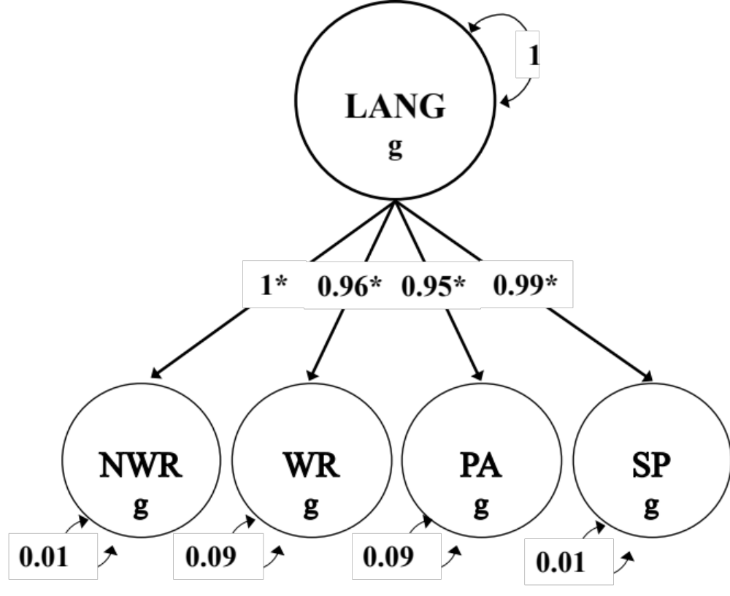
Supplementary Figure 1. Genomic factor model of four tests of verbal ability. The model used unit loading identification constraining the loading on NWR to 1. Model fit: χ2(2) = 1.148, P = 0.56; CFI = 1; SRMR = 0.014. LANG genetic factor descriptive statistics: mean χ² =1.145; LDSC intercept = 1.004; SNP heritability = 0.291; N_hat = 28,269, interpretable as the expected sample size for the factor scaled in the heritability units of NWR. The g subscript is used to denote that the variables in these models are strictly defined by the genetic variance captured by GWAS estimates. LANG, language factor; NWR, nonword reading; WR, word reading; PA, phoneme awareness; SP, spelling. Asterisks (*) represent significant estimates (p < 0.05).

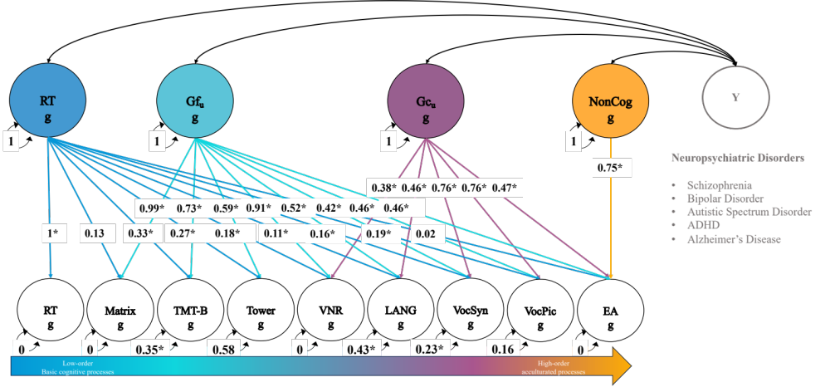
Supplementary Figure 2. Genetic correlations with factors derived from decomposition in Figure 2. Results of the genetic correlations are shown in Figure 4 and Supplementary Table 5. RT, reaction time; Gf_{u}, fluid intelligence unique of RT; Gc_{u}, crystallized knowledge unique of RT and Gf_{u}; NonCog, noncognitive education-related factor; Matrix, matrix pattern recognition; TMT-B, trail making test-B; Tower, tower rearranging; VNR, verbal numerical reasoning; LANG, language factor; VocSyn, synonyms vocabulary; VocPic, picture vocabulary; EA, educational attainment; ADHD, attention-deficit/hyperactivity disorder.

