A Differential Therapeutic consideration for use of Corticosteroids according to Established COVID-19 Clinical Phenotypes in Critically ill Patients
Supplementary Online Content

e-Methods. Supplemental Methods
e-Table 1: Variables recorded in the study
e-Table 2: Ranking of variables according to the information value to select important variables in a predictive model
e-Table 3: Characteristics of 2017 critically ill patients included in machine learning analysis according to overall or cluster (phenotype) population
e-Figure 1: Mean differences plot of variables before and after propensity full matching
e-Table 4: Forest plot of variables associated with ICU mortality in the multivariate analysis in whole population
e-Figure 2: Area under ROC curve for ICU mortality multivariate model in the whole population
e-Table 5: Characteristics of 537 A phenotype patients according to ICU mortality
e-Figure 3: Unadjusted survival plot (Kaplan-Meier plot) for A phenotype patients according to corticosteroids treatment
e-Table 6: Ranking of variables according to the information value to select important variables in each phenotype.
e-Table 7: Factors associated with ICU mortality in Cox Hazard regression analysis for patients among A phenotype
e-Figure 4: Shoenfeld test plot for Cox proportional Hazard regression in A phenotype
e-Table 8: Factors associated with corticosteroids use in multivariate analysis for A phenotype patient
e-Table 9: Characteristics of 623 B phenotype patients according to ICU mortality
e-Figure 5: Unadjusted survival plot (Kaplan-Meier) for B phenotype patients according to corticosteroids treatment
e-Figure 6: Shoenfeld test plot for Cox proportional Hazard regression in B phenotype
e-Table 10: Factors associated with ICU mortality in Cox Hazard regression analysis for patients among B phenotype
e-Table 11: Factors associated with corticosteroids use in multivariate analysis for B phenotype patient
e-Table 12: Characteristics of 857 C phenotype patients according to ICU mortality
e-Figure 7: Unadjusted survival plot (Kaplan-Meier) for C phenotype patients according to corticosteroids treatment
e-Figure 8: Shoenfeld test plot for Cox proportional Hazard regression in C phenotype
e-Table 13: Factors associated with ICU mortality in Cox Hazard regression analysis for patients among C phenotype
e-Table 14: Variables associated with corticosteroid use in C phenotype patients

e-Methods. Supplemental Methods
Data Collection and Validation
Data were collected using a paper CRF (case Report Form). CRF collect and record all protocol-required information, which is transcribed from patient source documents, such as hospital records and laboratory reports during the patient's participation in the study. Before being sent to the Study Coordinator (AR) this data was de-identified (not traceable to the patient) by removing the patient's name, medical record number, etc., and giving the patient a unique study number. We implemented a double data entry model for potential errors in real-time. Data was entered twice by two different Data Entry personnel based on the same set of data collected in the paper CRFs. All data were reviewed, and values that appeared incongruent or out of range were manually validated by confirming the accuracy of the data with the Study Coordinator (AR). The database was validated and cleaned before the statistical analysis and finally, the study database was locked to prevent any further changes, and to ensure data consistency and integrity for the statistical reporting and analysis.
Study population
The study enrolled consecutive adult patients (>16 years) with laboratory confirmed SARS-CoV-2 infection, detected by RT-PCR positive test of nasopharyngeal, oropharyngeal swab or invasive respiratory samples according to the WHO recommendations. The follow-up of patients was scheduled until August 11, 2020, which confirmed ICU discharge or death whichever occurred first. The study was approved by the reference institutional review board at Joan XXIII University Hospital (IRB# CEIM/066/2020) and each participating site with a waiver of informed consent.
Outcomes The primary outcome included all-causes of ICU mortality. Patients who were discharged alive from ICU were evaluated in the data as alive considering mortality was defined as any in-ICU death. All complications and outcomes were followed during ICU admission.
Approach to missing data
Continuous variables with missing data > 30% were excluded of database. Missing data for continuous variables were imputed using R-package "missForest" for the statistical software R/CRAN. The imputation was applied to impute the missing values of D dimer (20%), Ferritin (20%), D-Lactate dehydrogenase (17%), Procalcitonin (17%), creatinine (16%), SOFA score (16%), APACHE II score (10%) and C-reactive protein (CRP) (5%). Categorical data (including ICU mortality) were available for all patients.
Development of phenotypes
All consecutive cases admitted to the ICU were collected. There were no patients excluded from the analysis that were enrolled based on the participating ICUs’ established criteria. The ICU admission criteria, use of antiviral, antibiotic or co-adjuvant treatment, and also the measures that would determine the need to intubate and type of ventilator support required (oxygenation, high flow nasal cannula [HFNC], noninvasive [NIMV] or invasive [IMV] mechanical ventilation) were not standardized between centers. These guidelines were left to the discretion of the attending physician, according to SEMICYUC and National Ministry of Health and were included in the case report form and confirmed by the medical records. Defining variables recorded, comorbidities, treatments, and outcomes collected in all patients are shown in e-Table 1 in supplementary online content.
To determine presence of distinct clinical phenotypes, an unsupervised clustering analysis was applied to the database at ICU admission. The optimal number of clusters identified were three after studying the silhouette (1) and the PAM (2) objective. Each of these clusters represent a specific patient’s phenotype i.e., differential immune response profile. A detailed description of the development and analysis of clusters can be found in the original paper (3).
References
1.-Rousseeuw, P.J. (1987) Silhouettes: A graphical aid to the interpretation and validation of cluster analysis. J. Comput. Appl. Math. 1987; 20:53–65 https://doi.org/10.1016/0377-0427(87)90125-7ç
2.- Van der Laan M, Pollard K, Bryan J. A new partitioning around medoids algorithm, Journal of Statistical Computation and Simulation 2003; 73:8, 575-584. https://www/doi/10.1080/0094965031000136012
3.- Rodríguez A, Ruiz-Botella M, Martín-Loeches I, et al. Deploying unsupervised clustering analysis to derive clinical phenotypes and risk factors associated with mortality risk in 2022 critically ill patients with COVID-19 in Spain. Crit Care. 2021;25:63. doi:10.1186/s13054-021-03487-8

Study definitions
Community-acquired pneumonia (CAP) was defined in accordance with current American Thoracic Society and Infectious Diseases Society of America guidelines (ATS/IDSA )(4).
Primary viral pneumonia due to SARS-CoV-2 infection was defined by the presence of acute respiratory failure and unequivocal alveolar opacities involving one or more lobes, with negative respiratory and blood bacterial cultures at ICU admission.
Community-acquired respiratory co-infection (CARC) was considered in patients with confirmation of SARS-CoV-2 infection showing recurrence of fever, increase in cough and production of purulent sputum plus positive bacterial/fungal respiratory or blood cultures at ICU admission (5).
Shock was defined in accordance with the Surviving Sepsis Campaign guidelines (6); that is, patients in whom adequate fluid resuscitation and vasopressor therapy are unable to restore hemodynamic stability.
Acute Kidney injury (AKI) was defined according to Consensus Conference of the Acute Dialysis Quality Initiative (7).
Acute respiratory distress syndrome (ARDS) was defined according Berlin definition (8) in 3 categories based on degree of hypoxemia: mild (PaO2/FIO2 ≤ 300 mm Hg), moderate (PaO2/FIO2 ≤ 200 mm Hg), and severe (PaO2/FIO2 ≤ 100 mm Hg)
References
4.- Metlay JP,Waterer GW,Long AC, Anzueto A, Brozek J, Crothers K, et al. Diagnosis and Treatment of Adults with Community-acquired Pneumonia. An Official Clinical Practice Guideline of the American Thoracic Society and Infectious Diseases Society of America. Am J Resp Crit Care Med 2019 ;200(7): e45-e67. https://www.atsjournals.org/doi/full/10.1164/rccm.201908-1581ST
5.- Martin-Loeches I, Schultz MJ, Vincent JL, Alvarez-Lerma F, Bos LD, Sole-Violan J et al. Increased incidence of co-infection in critically ill patients with influenza. Intensive Care Med 2017; 43:48–58. https://www/doi/10.1007/s00134-016-4578-y
6.-Dellinger RP, Levy MM, Rhodes A, Annane D, Gerlach H, Opal SM et al. Surviving sepsis campaign: international guidelines for management of severe sepsis and septic shock: 2012. Crit Care Med 2013;41(2):580-637. https://www/doi/10.1097/CCM.0b013e31827e83af.
7.- Bellomo R. Ronco C. Kellum J.A. et al. Acute renal failure—definition, outcome measures, animal models, fluid therapy and information technology needs: the Second International Consensus Conference of the Acute Dialysis Quality Initiative (ADQI) Group. Crit Care. 2004; 8: R204-R212
8.- Ranieri VM, Rubenfeld GD, Thompson BT, Ferguson ND, Caldwell E, Fan E, Camporota L, Slutsky AS. Acute respiratory distress syndrome: The Berlin Definition ARDS Definition Task Force. JAMA 2012;307(23):2526-33. https://doi/10.1001/jama.2012.5669.

Statistical analysis
To determine if a significant inter-hospital variation in corticosteroids is present, multilevel conditional logistic modelling with patients nested in hospital to characterize hospital-level variation of ICU mortality was done. We built a model with corticosteroids (treatment) and hospital as random variable, to assess the variation of the log-odds from one hospital to another and calculate the intraclass correlation coefficient (ICC) for one-way random-effects model.
The ICC quantifies the degree of homogeneity of the outcome within clusters and represents the proportion of the between-hospital variation in the total variation. When the ICC is not different from zero or negligible, indicates perfect independence of residuals and traditional one level regression analysis can be done (6). The ICC obtained when considering all hospital (n=63) was 0.04. This ICC represents that the hospital-level variation was very poor (4%).
model_cov<- lmer(muereUCI ~ cortis +(1|hospital), REML = FALSE, data=covid_mis)
summary(model_cov)
confint(model_cov)

Linear mixed model fit by maximum likelihood ['lmerMod']
Formula: muereUCI ~ cortis + (1 | hospital)
Data: covid_mis
AIC BIC logLik deviance df.resid
2661.9 2684.4 -1327.0 2653.9 2018
Scaled residuals:
Min 1Q Median 3Q Max
-1.0293 -0.7188 -0.5961 1.2942 1.7045
Random effects:
Groups Name Variance Std.Dev.
hospital (Intercept) 0.006893 0.08302
Residual 0.213283 0.46183
Number of obs: 2022, groups: hospital, 63
Fixed effects:
Estimate Std. Error t value
(Intercept) 1.32097 0.02068 63.872
cortissi 0.01084 0.02210 0.491
Correlation of Fixed Effects:
(Intr)
cortissi -0.643
Computing profile confidence intervals ...
2.5 % 97.5 %
.sig01 0.05308768 0.11813691
.sigma 0.44775260 0.47664905
(Intercept) 1.28038742 1.36242446
cortissi -0.03273725 0.05431544
Show in New Window
[1] 0.009727901

intraclass correlation coefficient
icc <- model_cov@theta[1]^2/ (model_cov@theta[1]^2 + (3.14159^2/3))
icc
[1] 0.009727901

To determine presence of distinct clinical phenotypes in our population of COVID-19 patients, an unsupervised clustering analysis was applied to the database at ICU admission. In order to carry out this analysis, a discretization of the numerical variables into categorical ones was done using “ChiMerger” packages for R software.

The information provided by each variable regarding ICU mortality was defined using the Information Value (IV). A IV greater than 0.03 was considered clinically important and this variable was included in the multivariate logistic regression analysis. Model performance was examined using accuracy test, Sensitivity, Specificity and AUC modeling.
The unsupervised cluster analysis was performed using the important variables according IV. The Podani distance was used to calculate the distance between patients and the “partition around medoids” (PAM) algorithm to perform the clustering (16). The optimal number of clusters were determined after studying the silhouette (17) and the PAM objective for different numbers of clusters. We obtain the important variables according to IV for each phenotype, and the OR of these variables were obtained after applying a GLM (Generalize linear Regression model) analysis. GLM is how statistical software R performs multiple logistic regression analysis when the command family = “binomial” is indicated. Multinomial regression models were fit to further compare patient comorbidities across phenotype classification. Model performance in each phenotype was examined using accuracy test, Sensibility, Specificity and AUC.
For all model validation, database was randomly split into two subsets: (a) a “training set” (80%), and (b) a “validation set” (20%). Model performance was examined using accuracy test, precision, sensitivity, specificity and area under ROC curve (AUC).
Finally, we computed the cumulative incidence function (CIF) of death over time. At time t, the CIF defines the probability of dying in the ICU by that time t when the population can be discharged alive. The CIF was estimated from the data using the “cmprsk” package developed by Gray. We used the Fine and Gray model28 which extends the Cox model to competing risks data by considering the sub-distribution hazard (for instance, the hazard function associated with the CIF). The strength of the association between each variable and the outcome was assessed using the sub-hazard ratio (SHR), which is the ratio of hazards associated with the CIF in the presence of and in the absence of a prognostic factor.
Data analysis was performed using R software (cran.r-project.org).
Testing proportional Hazards assumption
The proportional hazards assumption is so important to Cox regression, what it essentially means is that the ratio of the hazards for any two individuals is constant over time. The proportional hazards (PH) assumption was checked using statistical tests and graphical diagnostics based on the scaled Schoenfeld residuals (1). In principle, the Schoenfeld residuals are independent of time. We make a plot that shows a non-random pattern against time is evidence of violation of the PH assumption. Plot was realized using the function ggcoxzph() [“survminer” package, R software], which produces, for each covariate, graphs of the scaled Schoenfeld residuals against the transformed time.
The function cox.zph() [“survival” package, R software] provides a convenient solution to test the proportional hazards assumption for each covariate included in a Cox regression model fit. For each covariate, the function cox.zph() correlates the corresponding set of scaled Schoenfeld residuals with time, to test for independence between residuals and time. Additionally, it performs a global test for the model as a whole.
The proportional hazard assumption is supported by a non-significant relationship between residuals and time, and refuted by a significant relationship (p<0.05). A plot that shows a non-random pattern against time with a Shoenfeld’ test p<0.05 is evidence of violation of the PH assumption. If Shoenfeld’ test shows evidence of proportional hazard violation, a Cox covariate*time interaction and Weighted Cox Regression were performed to resolve the violations of proportional hazards assumption.
Due to the covariate of primary interest (corticosteroids) has different short-term and long-term effects, we express these effects by estimating piecewise constant HRs for consecutive periods using separate models. Cox regression can be extended to accommodate different types of non-proportional hazards by including an interaction of a covariate (corticosteroids) with time. This is technically realized by a time-dependent covariate, which is a product of the value of a covariate with a pre-specified function of time t,
(t).(2)
On the other hand, Weighted estimation of Cox regression is a parsimonious alternative which supplies well interpretable average effects also in case of non-proportional hazards. We estimated the time-dependent effects interactions of covariates with arbitrary functions of time by “coxphw” package (R software)(3).
References
1.- Schoenfeld D. Partial Residuals for The Proportional Hazards Regression Model. Biometrika, 1982 ;69(1): 239-241.
2.- Lehr S, Schemper M. Parsimonious Analysis of Time-Dependent Effects in the Cox Model. Statistics in Medicine, 2007;26(13):2686–2698. doi:10.1002/sim.2742.
3.- Dunkler D, Ploner M, Schemper M. Weighted Cox Regression Using the R Package coxphw. Journal of Statistical Software 2018, 84(2):1-7. doi: 10.18637/jss.v084.i02

e-Table 1: Definitions of variables recorded, Comorbidities, Treatments, and Outcomes Collected in patients
General characteristics and severity of illness
Hospital type | According to beds number (<200 ; 200-500 and > 500 beds)
Sex | 1:Male; 0: Female
Age | Number of years of age at the time of ICU admission
Date of Hospital admission | Per chart review
Data of ICU admission | Per chart review
Data of ICU discharge | Per chart review
Data of Hospital discharge | Per chart review
GAP ICU | Time in days from Hospital to ICU admission
GAP diagnosis | Time in days from onset of symptoms to diagnosis
GAP antiviral treatment | Time in days from onset of symptoms to first dose of antiviral
APACHE II score | Acute Physiology and Chronic Health Evaluation (APACHE) II score was calculated for all patients within the first 24 h of ICU admission
SOFA score | Sequential Organ Failure Assessment (SOFA) scoring system was calculated for all patients within the first 24 h of ICU admission.
Health worker | People who work in the hospital or other areas of health care
Comorbidities and coexisting conditions
9.- Asthma | Per chart review
10.- Chronic Pulmonary Obstructive Disease | Per chart review
11.- Arterial Hypertension | Per chart review
12.- Chronic Heart disease | Per chart review. New York Heart Association (NYHA) Functional Classification III and IV
13.- Chronic kidney disease | Baseline eGFR< 60 on at least two consecutive values at least 12 weeks apart prior or hemodialysis
14.- Hematologic disease | Per chart review, included acute leukemia, myelodysplastic syndrome and Lymphomas.
15.- Pregnancy | Per chart review
16.- Obesity | Body mass index > 30
17.- Diabetes mellitus | Per chart review
18.- HIV/AIDS | Per chart review
19.- Coronary artery disease | Per chart review
20.- Neuromuscular disease | Per chart review
21.- Immunological disease | Per chart review
22.- Other Immunodeficiency disorders | Per chart review
Laboratory findings
D-Lactate dehydrogenase | U/L, Per laboratory report
White blood cell | x10⁹ Per laboratory report
Serum Creatinine | mg/dL, Per laboratory report
C-Reactive Protein (CRP) | mg/mL, Per laboratory report
Procalcitonin (PCT) | ng/mL, Per laboratory report
Serum lactate | mmol/L, Per laboratory report
D dimer | ng/mL, Per laboratory report
Ferritin | ng/mL, Per laboratory report
Arterial blood gas (ABG) test | Per laboratory report
Treatment at ICU admission
Corticosteroids | Per chart review
Antibiotics | Per chart review
Lopinavir/ritonavir | Per chart review
Hydroxychloroquine | Per chart review
Tocilizumab | Per chart review
Interferon β | Per chart review
Anti-hypertensive treatment | ACEI: Angiotensin Converting Enzyme Inhibitors; ARB: Angiotensin receptor blockers
Oxygenation and ventilator support at ICU admission and at first 24 hours
Oxygen mask | Per chart review
High Flow nasal cannula | Per chart review
Non-invasive ventilation | Per chart review
Invasive mechanical ventilation | Per chart review
Oxygen mask | Per chart review
High Flow nasal cannula | Per chart review
Complications at ICU admission
Shock | Per chat review
Acute kidney dysfunction | Per chat review
Myocardial dysfunction | Per chat review
Community-acquired co-infection | Per chat review
> 2 Quadrant infiltrates in chest x-ray | Per chest x-ray review
Outcome
ICU crude mortality | Per chart review

e-Table 2: Ranking of variables according to the information value to select important variables in a predictive model. Highly and somewhat predictive variables were included in the model.
## VARIABLES Information Value HSTRENGTH
## 1 Hospital type 4.041964e-03 Not Predictive
## 2 Male 9.730608e-03 Not Predictive
## 3 Influenza vaccine 2.719595e-02 Not Predictive
## 4 shock 1.025376e-01 Highly Predictive
## 5 Health worker 3.939070e-02 Somewhat Predictive
## 6 ACEI 5.176515e-02 Somewhat Predictive
## 7 ARB 1.407840e-02 Not Predictive
## 8 asthma 4.023492e-04 Not Predictive
## 9 COPD 4.605924e-02 Somewhat Predictive
## 10 Chronic Cardiac Dis 3.472710e-03 Not Predictive
## 11 Chronic Renal Dis 2.721800e-02 Not Predictive
## 12 Hematological Dis 2.144353e-02 Not Predictive
## 13 Pregnancy 2.253727e-03 Not Predictive
## 14 Obesity 2.452981e-03 Not Predictive
## 15 Diabetes 4.266095e-02 Somewhat Predictive
## 16 HIV 9.368383e-04 Not Predictive
## 17 Neuromuscular Dis 8.444705e-03 Not Predictive
## 18 Autoimmune Dis 5.088465e-04 Not Predictive
## 19 Coronary Dis 5.313002e-02 Somewhat Predictive
## 20 Hypertension 9.908557e-02 Somewhat Predictive
## 21 Infiltrates chest x-ray 3.931693e-02 Somewhat Predictive
## 22 Corticosteroids 4.460850e-03 Not Predictive
## 23 Antibiotics 7.133596e-05 Not Predictive
## 24 Empiric treatment 1.926115e-04 Not Predictive
## 25 Lopinavir/ritonavir 2.828696e-03 Not Predictive
## 26 interferon beta-1 1.351955e-02 Not Predictive
## 27 Hydroxychloroquine 8.557354e-03 Not Predictive
## 28 Tocilizumab 9.848787e-03 Not Predictive
## 29 O2 7.471572e-03 Not Predictive
## 30 Bacterial coinfection 6.317831e-03 Not predictive
## 31 HFNC 6.584694e-02 Somewhat Predictive
## 32 NIV 1.044679e-03 Not Predictive
## 33 MV 1.195287e-01 Highly Predictive
## 34 Myocardial Dysf. 1.020782e-01 Highly Predictive
## 35 Acute Kidney injury 4.267500e-01 Highly Predictive
## 36 Age 5.583901e-01 Highly Predictive
## 37 APACHE II 5.038235e-01 Highly Predictive
## 38 SOFA 3.964658e-01 Highly Predictive
## 39 Lactate dehydrogenase 1.623883e-01 Highly Predictive
## 40 WBC 5.118266e-02 Somewhat Predictive
## 41 Creatinine 2.605650e-01 Highly Predictive
## 42 CRP 5.374965e-02 Somewhat Predictive
## 43 PCT 1.590328e-01 Highly Predictive
## 44 Lactate 1.674733e-01 Highly Predictive
## 45 D Dimer 1.728036e-01 Highly Predictive
## 46 Ferritin 3.332789e-01 Highly Predictive
## 47 Gap antiviral 0.000000e+00 Not Predictive
## 48 PaO2/FiO2 6.116536e-02 Somewhat Predictive
## 49 Gap diagnostic 1.738805e-02 Not Predictive
## 50 Gap ICU 5.325043e-02 Somewhat Predictive

ACEI: Angiotensin Converting Enzyme Inhibitors; ARB: Angiotensin receptor blockers; WBC: White blood cells; HFNC: High Flow nasal cannula, NIV: non-invasive ventilation, MV: invasive mechanical ventilation, CRP: C-Reactive Protein; PCT: Procalcitonin ; GAP antiviral: Time from the symptoms onset to the first dose of antiviral, GAP diagnostic: Time from the symptoms onset to diagnosis, GAP ICU: time from the symptoms onset to ICU admission.

e-Table 3: Characteristics of 2017 critically ill patients included in machine learning analysis according to overall or cluster (phenotype) population.
Variable ª | Overall  n=2017 | A Phenotype (mild)  n=537 | B Phenotype (moderate)  n=623 | C Phenotype (Severe)  n=857
General characteristics and severity of illness
Age , mean (IQR),years | 64(55-71) | 63 (53-70)*** | 63(53.5-71.5) | 66(58-72)
Male, n(%) | 1419(70.3) | 377(70.2)* | 416(66.8) | 626(73.0)
APACHE II, mean (IQR) ^{b} | 13(10-17) | 12(9-16)*** | 13(10-16) | 17(14-22)
SOFA, mean (IQR) ^{c} | 5(3.7) | 4(3-5)*** | 5(3-7) | 7(6-8)
Laboratory findings
D-Lactate dehydrogenase, mean (IQR), U/L | 537(417-707) | 474(372-564)*** | 477(378-570) | 670(554-929)
White blood cell, mean (IQR), x10⁹ | 8.8(6.2-12.2) | 7.7(5.8-10.2)*** | 8.5(6-11.7) | 10(6.9-13.6)
Serum Creatinine, mean (IQR), mg/dL | 0.88(0.7-1.1) | 0.80(0.66-1.01)*** | 0.80(0.66-1.00) | 0.99(0.76-1.36)
C-Reactive Protein, mean (IQR), mg/mL | 15.5(9.1-24.3) | 14(8-2)*** | 14(9-22) | 18(10-26)
Procalcitonin , mean (IQR), ng/mL | 0.3(0.1-2.0) | 0.2(0.1-0.6)*** | 0.2(0.1-0.5) | 0.5(0.2-1.3)
Serum lactate, mean (IQR), mmol/L | 1.5(1.1-2.0) | 1.5(1.1-1.9)*** | 1.4(1.0-1.9) | 1.6(1.2-2.2)
D dimer, mean (IQR), ng/mL | 1593(720-3790) | 1090(580-2100)*** | 1319(634-3548) | 2260(1009-4894)
Ferritin, mean (IQR), ng/mL | 1600(1290-2240) | 1538(1280-1899)*** | 1554(1271-1936) | 1800(1416-2377)
Coexisting condition and Comorbidities
Arterial hypertension, n(%) | 932(46.2) | 211(39.3)*** | 173(27.8) | 548(63.9)
Obesity (BMI>30), n(%) ^{d} | 653(32.3) | 159(29.6) | 200(32.1) | 294(34.3)
Diabetes , n(%) | 418(20.7) | 112(20.9)* | 108(17.3) | 198(23.1)
Coronary arterial disease, n(%) | 124(6.1) | 35(6.5) | 41(6.6) | 48(5.6)
COPD, n(%) | 148(7.3) | 37(6.9) | 38(6.1) | 73(8.5)
Chronic renal disease , n(%) ^{e} | 85(4.2) | 31(5.8)*** | 10(1.6) | 44(5.1)
Hematologic disease, n(%) | 72(3.5) | 20(3.7) | 22(3.5) | 30(3.5)
Asthma, n(%) | 120(5.9) | 41(7.6)** | 45(7.2) | 34(4.0)
HIV, n(%) | 5(0.2) | 2(0.4) | 1(0.2) | 2(0.2)
Pregnancy , n(%) | 4(0.19) | 1(0.2) | 3(0.5) | 0(0.0)
Autoimmune disease, n(%) ^{f} | 74(3.6) | 20(3.7) | 18(2.9) | 36(4.2)
Chronic heart disease , n(%) ^{g} | 57(2.8) | 21(3.9) | 10(1.6) | 26(3.0)
Neuromuscular disease , n(%) | 16(0.8) | 3(0.6) | 5(0.8) | 8(0.9)
Oxygenation and ventilator support
Oxygen mask , n(%) | 325(16.1) | 124(23.1)*** | 105(16.9) | 96(11.2)
High Flow nasal cannula, n(%) | 375(18.6) | 345(64.2)*** | 3(0.5) | 27(3.2)
Non-invasive ventilation , n(%) | 140(6.9) | 64(11.9)*** | 26(4.2) | 50(5.8)
Invasive mechanical ventilation , n(%) | 1172(58.1) | 3(0.6)*** | 475(76.2) | 694(81.0)
PaO2/FiO2, mean (IQR) | 132(96-163) | 111(82-133)*** | 165(144-212) | 126(88-155)
Complications and outcome
Shock , n(%) ^{h} | 904(44.8) | 56(10.4) | 196(31.5) | 652(76.1)
Acute kidney dysfunction , n(%) ^{i} | 579(28.7) | 111(20.7)*** | 118(18.9) | 350(40.8)
Myocardial dysfunction, n(%) ^{j} | 169(8.3) | 30(5.6)*** | 43(6.9) | 96(11.2)
> 2 Quadrant infiltrates in chest x-ray, n(%) | 1327(65.7) | 341(63.5) | 413(66.3) | 573(66.8)
ICU crude mortality , n(%) | 657(32.6) | 109(20.3)*** | 159(25.5) | 389(45.4)

All comparison between clusters. *p<.05; ** p<.01 ; ***p<.001 , others comparison p>.01
Abbreviations: IQR, interquartile range; APACHE II, Acute Physiology and Chronic Health Evaluation II; SOFA, Sequential Organ Failure Assessment; BMI, body mass index; COPD, Chronic obstructive pulmonary disease; HIV, human immunodeficiency viruses; PaO2/FiO2, Partial pressure arterial oxygen/ fraction of inspired oxygen
a Corresponds to minimum or maximum value, as appropriate, within 12 hours of ICU admission. The variables in this Table were no transformed for your comparison.
b APACHE II score to the severity of illness, the score is obtained by adding the following components 1) 12 clinical and laboratory variables each with a score range of 0 to 4 points (APS). The APS is determined from the worst physiologic values during the initial 24 h after ICU admission, 2) age with a range 0 to 6 points and 3) Chronic health points if the patients has history of severe organ system insufficiency or is immunocompromised assign 5 points if the patients is no operative or emergency postoperative and 2 points for elective postoperative patients with a total score range of 0 to 71.
c SOFA score corresponds to the severity of organ dysfunction, reflecting six organ systems each with a score range of 0 to 4 points (cardiovascular, hepatic, hematologic, respiratory, neurological, renal), with a total score range of 0 to 24,

e-Figure 1: Mean differences plot of variables before and after propensity full matching

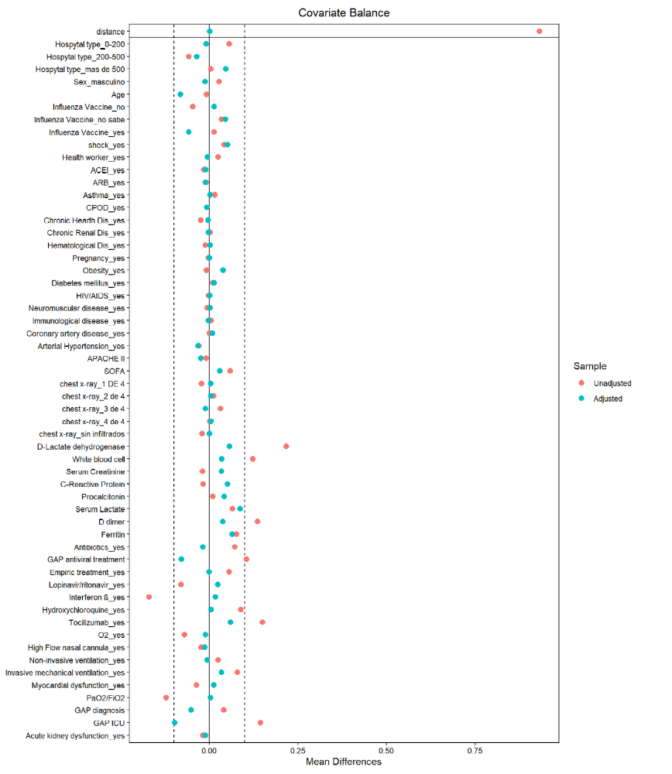

e-Table 4: Forest plot of variables associated with ICU mortality in the multivariate analysis in whole population

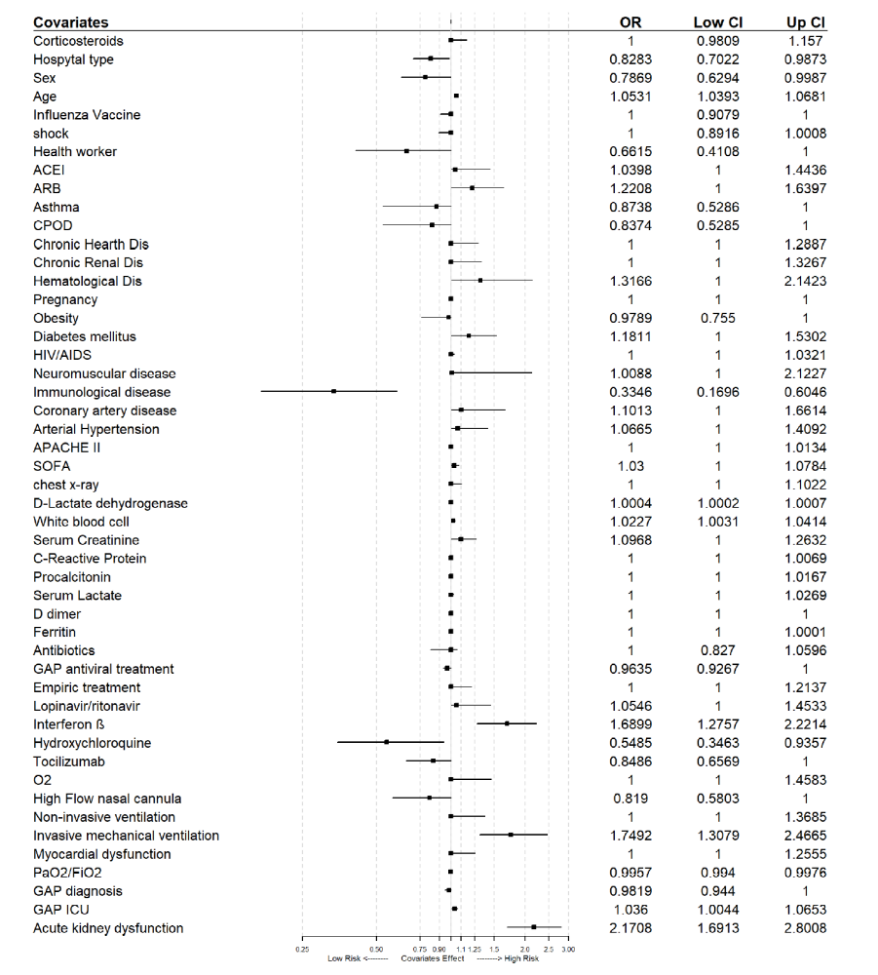

e-Figure 2: Area under ROC curve for ICU mortality multivariate model in the whole population

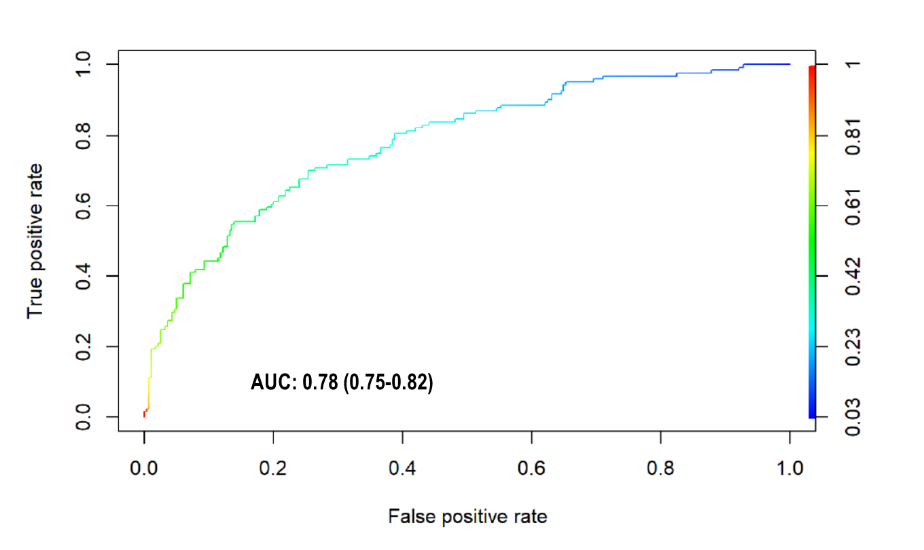

e-Table 5: Characteristics of 537 A phenotype patients according to ICU mortality
Variable ª | Survivors n=428 | Non- survivors n=109 | p-value
General characteristics and severity of illness
Age, median (IQR), year | 60.5(51-68) | 70(64-74) | 0.001
Male, n(%) | 300 (70.1) | 77(70.6) | 1.00
APACHE II ^{b}, median (IQR) | 11(8-15) | 15(11-18) | 0.001
SOFA ^{c}, median(IQR) | 3(3-5) | 5(3-7) | 0.001
Laboratory findings
D-lactate dehydrogenase, median (IQR) U/L | 467(369-549) | 488(384-582) | 0.07
White blood cell, median (IQR), x10⁹ | 7.6(5.8-10.2) | 8.0(5.8-10.8) | 0.93
Serum creatinine, median (IQR), mg/dL | 0.79(0.64-0.94) | 0.96(0.77-1.42) | 0.001
C-Reactive Protein , median (IQR), mg/dL | 14(7-22) | 15 (10-22.7) | 0.09
Procalcitonin, median (IQR), ng/mL | 0.25(0.10-0.53) | 0.55(0.20-1.28) | 0.001
Serum lactate, median (IQR), mmol/L | 1.5(1.1-1.9) | 1.7(1.2-2.2) | 0.03
D dimer, median (IQR), ng/mL | 1960(512-1965) | 1620(875-3770) | 0.001
Ferritin, median (IQR), ng/mL | 1500(1260-1820) | 1820(1390-2190) | 0.001
Coexisting condition and comorbidities
Arterial hypertension, n(%) | 148(34.6) | 63(57.8) | 0.001
Obesity (BMI>30), n(%) | 119(27.8) | 40(36.7) | 0.08
Diabetes, n(%) | 73(17.1) | 39(35.8) | 0.001
Coronary arterial disease, n(%) | 19(4.4) | 16(14.7) | 0.001
COPD, n(%) | 19(4.4) | 18(16.5) | 0.001
Chronic renal disease, n(%) | 15(3.5) | 16(14.7) | 0.001
Hematologic disease, n(%) | 13(3.0) | 7(6.4) | 0.16
Asthma, n(%) | 30(7.0) | 11(10.1) | 0.37
HIV, n(%) | 2(0.5) | 0(0.0) | 1.00
Pregnancy, n(%) | 1(0.2) | 0(0.0) | 1.00
Autoimmune disease, n(%) | 16(3.7) | 4(3.7) | 1.00
Chronic heart disease, n(%) | 12(2.8) | 9(8.3) | 0.01
Neuromuscular disease, n(%) | 1(0.2) | 1(0.3) | 0.84
Oxygenation and ventilator support
Oxygen mask, n(%) | 99(23.1) | 25(22.9) | 1.00
High flow nasal cannula, n(%) | 277(64.7) | 68(62.4) | 0.73
Non-invasive ventilation, n(%) | 48(11.2) | 16(14.7) | 0.40
Invasive mechanical ventilation, n(%) | 2(0.5) | 1(0.9) | 1.00
PaO2/FiO2, median (IQR) | 114(85-136) | 98(70-122) | 0.001
Treatment
Corticosteroids, n(%) | 236(55.1) | 62(56.9) | 0.82
Antibiotics, n(%) | 370(86.4) | 91(83.5) | 0.52
Lopinavir/ritonavir, n(%) | 359(83.9) | 93(85.3) | 0.82
Hydroxychloroquine, No.(%) | 396(92.5) | 94(86.2) | 0.06
Tocilizumab , No.(%) | 107(25.0) | 21(19.3) | 0.25
Interferon β, No.(%) | 143(33.4) | 45(41.3) | 0.15
Complications and Outcome
Shock, n(%) | 39(9.1) | 17(15.6) | 0.08
AKI, n(%) | 58(13.6) | 53(48.6) | 0.001
Myocardial dysfunction, n(%) | 13(3.0) | 17(15.6) | 0.001
>2 quadrant infiltrates in chest x-ray, n(%) | 271(63.3) | 73(66.9) | 0.50
LOS UCI, median (IQR) days | 11(5.7-22) | 14.5(7-29) | 0.10
Abbreviations: IQR, interquartile range; APACHE II, Acute Physiology and Chronic Health Evaluation II; SOFA, Sequential Organ Failure Assessment; BMI, body mass index; COPD, Chronic obstructive pulmonary disease; HIV, human immunodeficiency viruses; PaO2/FiO2, Partial pressure arterial oxygen/ fraction of inspired oxygen
a Corresponds to minimum or maximum value, as appropriate, within 12 hours of ICU admission. The variables in this Table were no transformed for your comparison.
b APACHE II score to the severity of illness, the score is obtained by adding the following components 1) 12 clinical and laboratory variables each with a score range of 0 to 4 points (APS). The APS is determined from the worst physiologic values during the initial 24 h after ICU admission, 2) age with a range 0 to 6 points and 3) Chronic health points if the patients has history of severe organ system insufficiency or is immunocompromised assign 5 points if the patients is no operative or emergency postoperative and 2 points for elective postoperative patients with a total score range of 0 to 71.
c SOFA score corresponds to the severity of organ dysfunction, reflecting six organ systems each with a score range of 0 to 4 points (cardiovascular, hepatic, hematologic, respiratory, neurological, renal), with a total score range of 0 to 24,

e-Figure 3: Unadjusted survival plot (Kaplan-Meier) for A phenotype patients according to corticosteroids treatment (cortis)

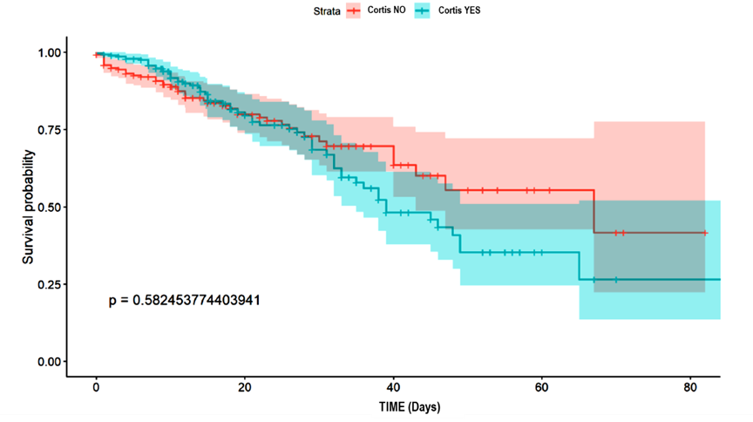

e-Table 6: Ranking of variables according to the information value to select important variables in each phenotype. Variables highlighted in red were included in each model.

 | A Phenotype | B Phenotype | C Phenotype
Variables | IV PREDICTIVE | IV PREDICTIVE | IV PREDICTIVE
## 1 Hospital type | 9.132863e-03 No | 1.559446e-03 No | 2.944340e-02 No
## 2 Male | 1.444146e-04 No | 2.590207e-02 No | 3.869809e-03 No
## 3 Influenza vaccine | 9.431129e-02 Somewhat | 2.126550e-02 No | 3.765656e-02 Somewhat
## 4 shock | 3.964703e-02 Somewhat | 5.164118e-03 No | 4.618684e-04 No
## 5 Health worker | 7.215440e-02 Somewhat | 6.021809e-02 Somewhat | 9.813392e-03 No
## 6 ACEI | 1.684165e-01 Highly | 6.080522e-03 No | 1.076237e-02 No
## 7 ARB | 1.828984e-02 No | 2.404218e-04 No | 1.177667e-03 No
## 8 asthma | 1.227356e-02 No | 2.533545e-04 No | 1.092745e-04 No
## 9 COPD | 1.749341e-01 Highly | 7.302773e-02 Somewhat | 6.691157e-03 No
## 10 Chronic Cardiac Disease | 6.204765e-02 Somewhat | 1.492305e-03 No | 2.960268e-05 No
## 11 Chronic Renal Disease | 1.738024e-01 Highly | 1.492305e-03 No | 1.146307e-02 No
## 12 Hematological Disease | 2.654456e-02 No | 3.754947e-03 No | 4.883194e-02 Somewhat
## 13 Pregnancy | 9.222784e-03 No | 1.283035e-02 No | 0.000000e+00 No
## 14 Obesity | 3.637363e-02 Somewhat | 6.145638e-07 No | 2.066138e-04 No
## 15 Diabetes | 1.866242e-01 Highly | 5.704696e-03 No | 2.479443e-02 No
## 16 HIV | 1.819062e-02 No | 4.376645e-03 No | 8.041982e-05 No
## 17 Neuromuscular Disease | 3.325893e-02 Somewhat | 4.106090e-03 No | 4.524557e-03 No
## 18 Autoimmune Disease | 1.319137e-05 No | 7.433381e-03 No | 3.870564e-03 No
## 19 Coronary Disease | 1.340642e-01 Highly | 2.627084e-03 No | 1.221929e-01 Highly
## 20 Hypertension | 2.210587e-01 Highly | 1.186944e-02 No | 1.223492e-02 No
## 21 Infiltrates chest x-ray | 2.817873e-02 No | 1.564487e-01 Highly | 3.578773e-02 Somewhat
## 22 Corticosteroids | 1.229703e-03 No | 1.560437e-04 No | 1.635793e-03 No
## 23 Antibiotics | 6.889626e-03 No | 3.134299e-03 No | 2.975869e-04 No
## 24 Empiric treatment | 5.959459e-03 No | 4.937022e-03 No | 2.287937e-03 No
## 25 Lopinavir/ritonavir | 1.598323e-03 No | 5.711297e-02 Somewhat | 1.005827e-04 No
## 26 interferon beta-1 | 2.656602e-02 No | 2.371890e-02 No | 8.530341e-03 No
## 27 Hydroxychloroquine | 4.276412e-02 Somewhat | 2.599639e-04 No | 3.468705e-02 Somewhat
## 28 Tocilizumab | 1.916296e-02 No | 2.610744e-03 No | 1.415470e-02 No
## 29 O2 | 2.146274e-05 No | 3.402079e-02 Somewhat | 4.340230e-03 No
## 30 HFNC | 2.353027e-03 No | 7.516552e-04 No | 1.157880e-03 No
## 31 NIV | 1.070219e-02 No | 3.063022e-02 Somewhat | 3.737383e-05 No
## 32 MV | 3.057185e-03 No | 1.653186e-01 Highly | 2.370305e-08 No
## 33 Myocardial Dysfunction | 2.228904e-01 Highly | 6.177601e-02 Somewhat | 6.055540e-02 Somewhat
## 34 Acute Kidney injury | 6.306028e-01 Highly | 3.646921e-01 Highly | 2.337694e-01 Highly
## 35 Age | 6.513748e-01 Highly | 7.408417e-01 Highly | 4.622984e-01 Highly
## 36 APACHE II | 4.310389e-01 Highly | 2.986345e-01 Highly | 2.939476e-01 Highly
## 37 SOFA | 4.038444e-01 Highly | 2.953304e-01 Highly | 1.487510e-01 Highly
## 38 Lactate dehydrogenase | 5.366081e-02 Somewhat | 1.041057e-01 Highly | 3.504073e-02 Somewhat
## 39 WBC | 4.581520e-02 Somewhat | 2.181871e-03 No | 3.820653e-02 Somewhat
## 40 Creatinine | 5.615214e-01 Highly | 2.412052e-01 Highly | 9.217995e-02 Somewhat
## 41 CRP | 7.164503e-02 Somewhat | 8.547374e-02 Somewhat | 3.204018e-03 No
## 42 PCT | 3.048025e-01 Highly | 8.008344e-02 Somewhat | 0.000000e+00 No
## 43 Lactate | 6.190517e-02 Somewhat | 1.543924e-01 Highly | 2.290830e-01 Highly
## 44 D Dimer | 2.521748e-01 Highly | 4.644420e-01 Highly | 8.243056e-02 Somewhat
## 45 Ferritin | 4.180265e-01 Highly | 3.490296e-01 Highly | 1.818192e-01 Highly
## 46 Gap antiviral | 2.766619e-01 Highly | 0.000000e+00 No | 0.000000e+00 No
## 47 PaO2/FiO2 | 0.000000e+00 No | 0.000000e+00 No | 1.018619e-01 Highly
## 48 Gap diagnostic | 0.000000e+00 No | 0.000000e+00 No | 0.000000e+00 No
## 49 Gap ICU | 6.204765e-02 Somewhat | 0.000000e+00 No | 7.482980e-02 Somewhat

ACEI: Angiotensin Converting Enzyme Inhibitors; ARB: Angiotensin receptor blockers; WBC: White blood cells; HFNC: High Flow nasal cannula, NIV: non-invasive ventilation, MV: invasive mechanical ventilation, CRP: C-Reactive Protein; PCT: Procalcitonin; GAP antiviral: Time from the symptoms onset to the first dose of antiviral, GAP diagnostic: Time from the symptoms onset to diagnosis, GAP ICU: time from the symptoms onset to ICU admission.

e-Table 7: Factors associated with ICU mortality in Cox Hazard regression analysis for patients among A phenotype
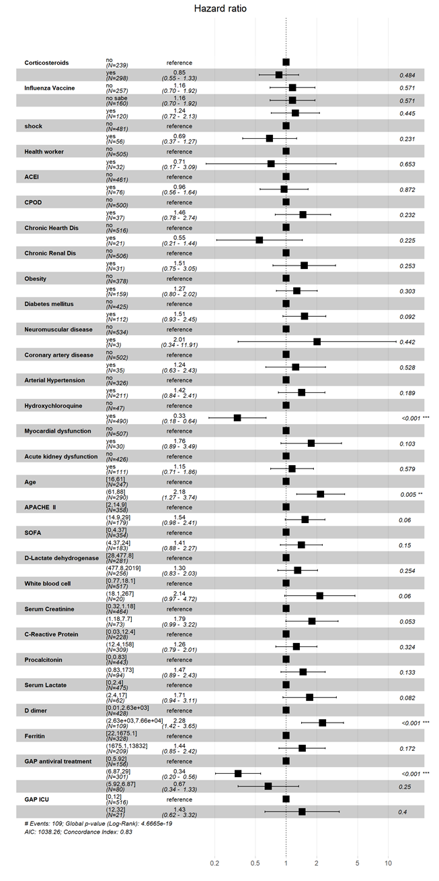

e-Figure 4: Proportional-hazards (PH) assumption test for Cox proportional Hazard regression in A phenotype. A plot shows a non-random pattern against time is evidence no violation of the PH assumption as is determined by global and individual Shoenfeld test. The solid line is a smoothing spline fit to the plot, with the dashed lines representing a +/- 2-standard-error band around the fit.

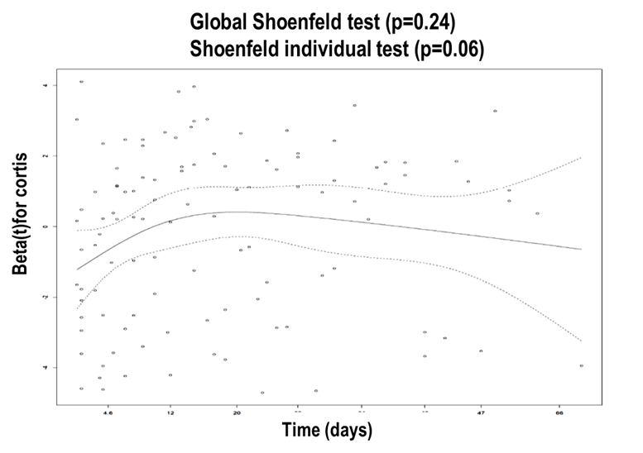

e-Table 8: Factors associated with corticosteroids use in A phenotype patients’
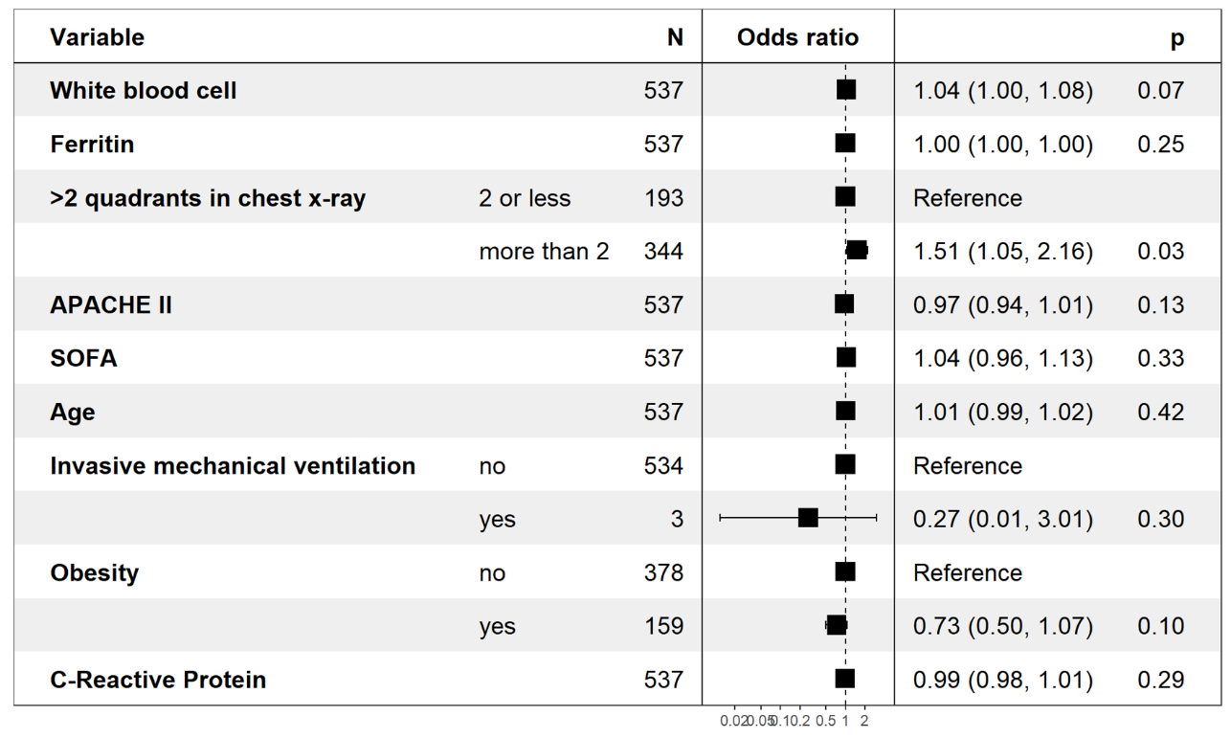

e-Table 9: Characteristics of 623 B phenotype patients according to ICU mortality
Variable ª | Survivors n=464 | Non- survivors n=159 | p-value
General characteristics and severity of illness
Age, median (IQR), year | 61(51-69) | 71(63-75) | 0.001
Male, n(%) | 301(64.9) | 115(72.3) | 0.10
APACHE II ^{b}, median (IQR) | 12(9-16) | 15(12-18) | 0.001
SOFA ^{c}, median(IQR) | 4.5(3-6) | 6.(4-7.5) | 0.001
Laboratory findings
D-lactate dehydrogenase, median (IQR) U/L | 463(366-555) | 511(418-650) | 0.001
White blood cell, median (IQR), x10⁹ | 8.3(5.9-11.3) | 9.6(6.4-13.7) | 0.01
Serum creatinine, median (IQR), mg/dL | 0.78(0.64-0.94) | 0.88(0.7-1.18) | 0.001
C-Reactive Protein , median (IQR), mg/dL | 13.8(7.7-21.3) | 17.3(10.0-25.5) | 0.001
Procalcitonin, median (IQR), ng/mL | 0.21(0.10-0.45) | 0.27(0.14-0.79) | 0.002
Serum lactate, median (IQR), mmol/L | 1.4(1.0-1.8) | 1.7(1.1-2.2) | 0.001
D dimer, median (IQR), ng/mL | 1140(575-2790) | 1870(790-5780) | 0.001
Ferritin, median (IQR), ng/mL | 1500(1200-1760) | 1775(1480-2350) | 0.001
Coexisting condition and comorbidities
Arterial hypertension, n(%) | 123(26.5) | 50(31.4) | 0.27
Obesity (BMI>30), n(%) | 149(32.1) | 51(32.1) | 1.00
Diabetes, n(%) | 77(16.6) | 31(19.5) | 0.47
Coronary arterial disease, n(%) | 29(6.2) | 12(7.5) | 0.70
COPD, n(%) | 20(4.3) | 18(11.3) | 0.003
Chronic renal disease, n(%) | 8(1.7) | 2(1.3) | 0.97
Hematologic disease, n(%) | 15(3.2) | 7(4.4) | 0.65
Asthma, n(%) | 34(7.3) | 11(6.9) | 1.00
HIV, n(%) | 1(0.2) | 0(0.0) | 1.00
Pregnancy, n(%) | 3(0.6) | 0(0.0) | 0.72
Autoimmune disease, n(%) | 15(3.2) | 3(1.9) | 0.54
Chronic heart disease, n(%) | 8(1.7) | 2(1.3) | 0.97
Neuromuscular disease, n(%) | 3(0.6) | 2(1.3) | 0.81
Oxygenation and ventilator support
Oxygen mask, n(%) | 86(18.5) | 19(11.9) | 0.07
High flow nasal cannula, n(%) | 2(0.4) | 1(0.6) | 1.00
Non-invasive ventilation, n(%) | 23(5.0) | 3(1.9) | 0.15
Invasive mechanical ventilation, n(%) | 335(72.2) | 140(88.1) | 0.001
PaO2/FiO2, median (IQR) | 169(147-220) | 154(130-206) | 0.001
Treatment
Corticosteroids, n(%) | 251(54.1) | 87(54.7) | 0.96
Antibiotics, n(%) | 425(91.6) | 148(93.1) | 0.67
Lopinavir/ritonavir, n(%) | 368(79.3) | 140(88.1) | 0.02
Hydroxychloroquine, No.(%) | 421(90.7) | 145(91.2) | 0.98
Tocilizumab , No.(%) | 160(34.5) | 51(32.1) | 0.64
Interferon β, No.(%) | 158(34.1) | 66(41.5) | 0.11
Complications and Outcome
Shock, n(%) | 142(30.6) | 54(34.0) | 0.49
AKI, n(%) | 58(12.5) | 60(37.7) | 0.001
Myocardial dysfunction, n(%) | 24(5.2) | 19(11.9) | 0.006
>2 quadrant infiltrates in chest x-ray, n(%) | 292(62.9) | 121(76.1) | 0.001
LOS UCI, median (IQR) days | 13(6.7-23.0) | 14(8.0-23.0) | 0.29
Abbreviations: IQR, interquartile range; APACHE II, Acute Physiology and Chronic Health Evaluation II; SOFA, Sequential Organ Failure Assessment; BMI, body mass index; COPD, Chronic obstructive pulmonary disease; HIV, human immunodeficiency viruses; PaO2/FiO2, Partial pressure arterial oxygen/ fraction of inspired oxygen
a Corresponds to minimum or maximum value, as appropriate, within 12 hours of ICU admission. The variables in this Table were no transformed for your comparison.
b APACHE II score to the severity of illness, the score is obtained by adding the following components 1) 12 clinical and laboratory variables each with a score range of 0 to 4 points (APS). The APS is determined from the worst physiologic values during the initial 24 h after ICU admission, 2) age with a range 0 to 6 points and 3) Chronic health points if the patients has history of severe organ system insufficiency or is immunocompromised assign 5 points if the patients is no operative or emergency postoperative and 2 points for elective postoperative patients with a total score range of 0 to 71.
c SOFA score corresponds to the severity of organ dysfunction, reflecting six organ systems each with a score range of 0 to 4 points (cardiovascular, hepatic, hematologic, respiratory, neurological, renal), with a total score range of 0 to 24,

e-Figure 5: Unadjusted survival plot (Kaplan-Meier) for B phenotype patients according to corticosteroids treatment

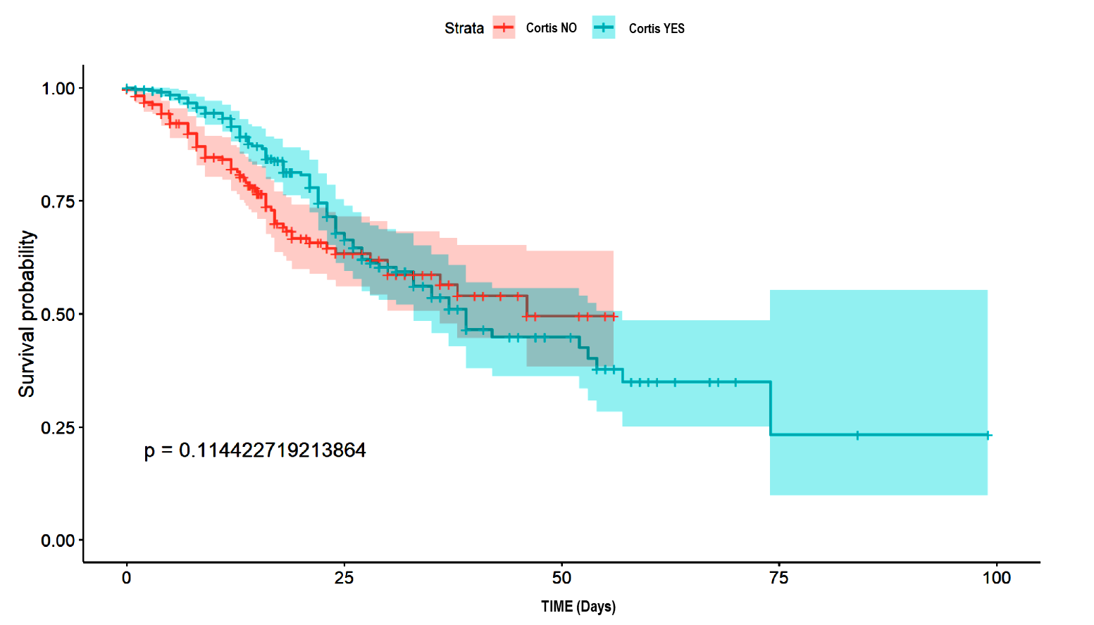

e-Table 10: Factors associated with ICU mortality in Cox Hazard regression analysis for patients among B phenotype
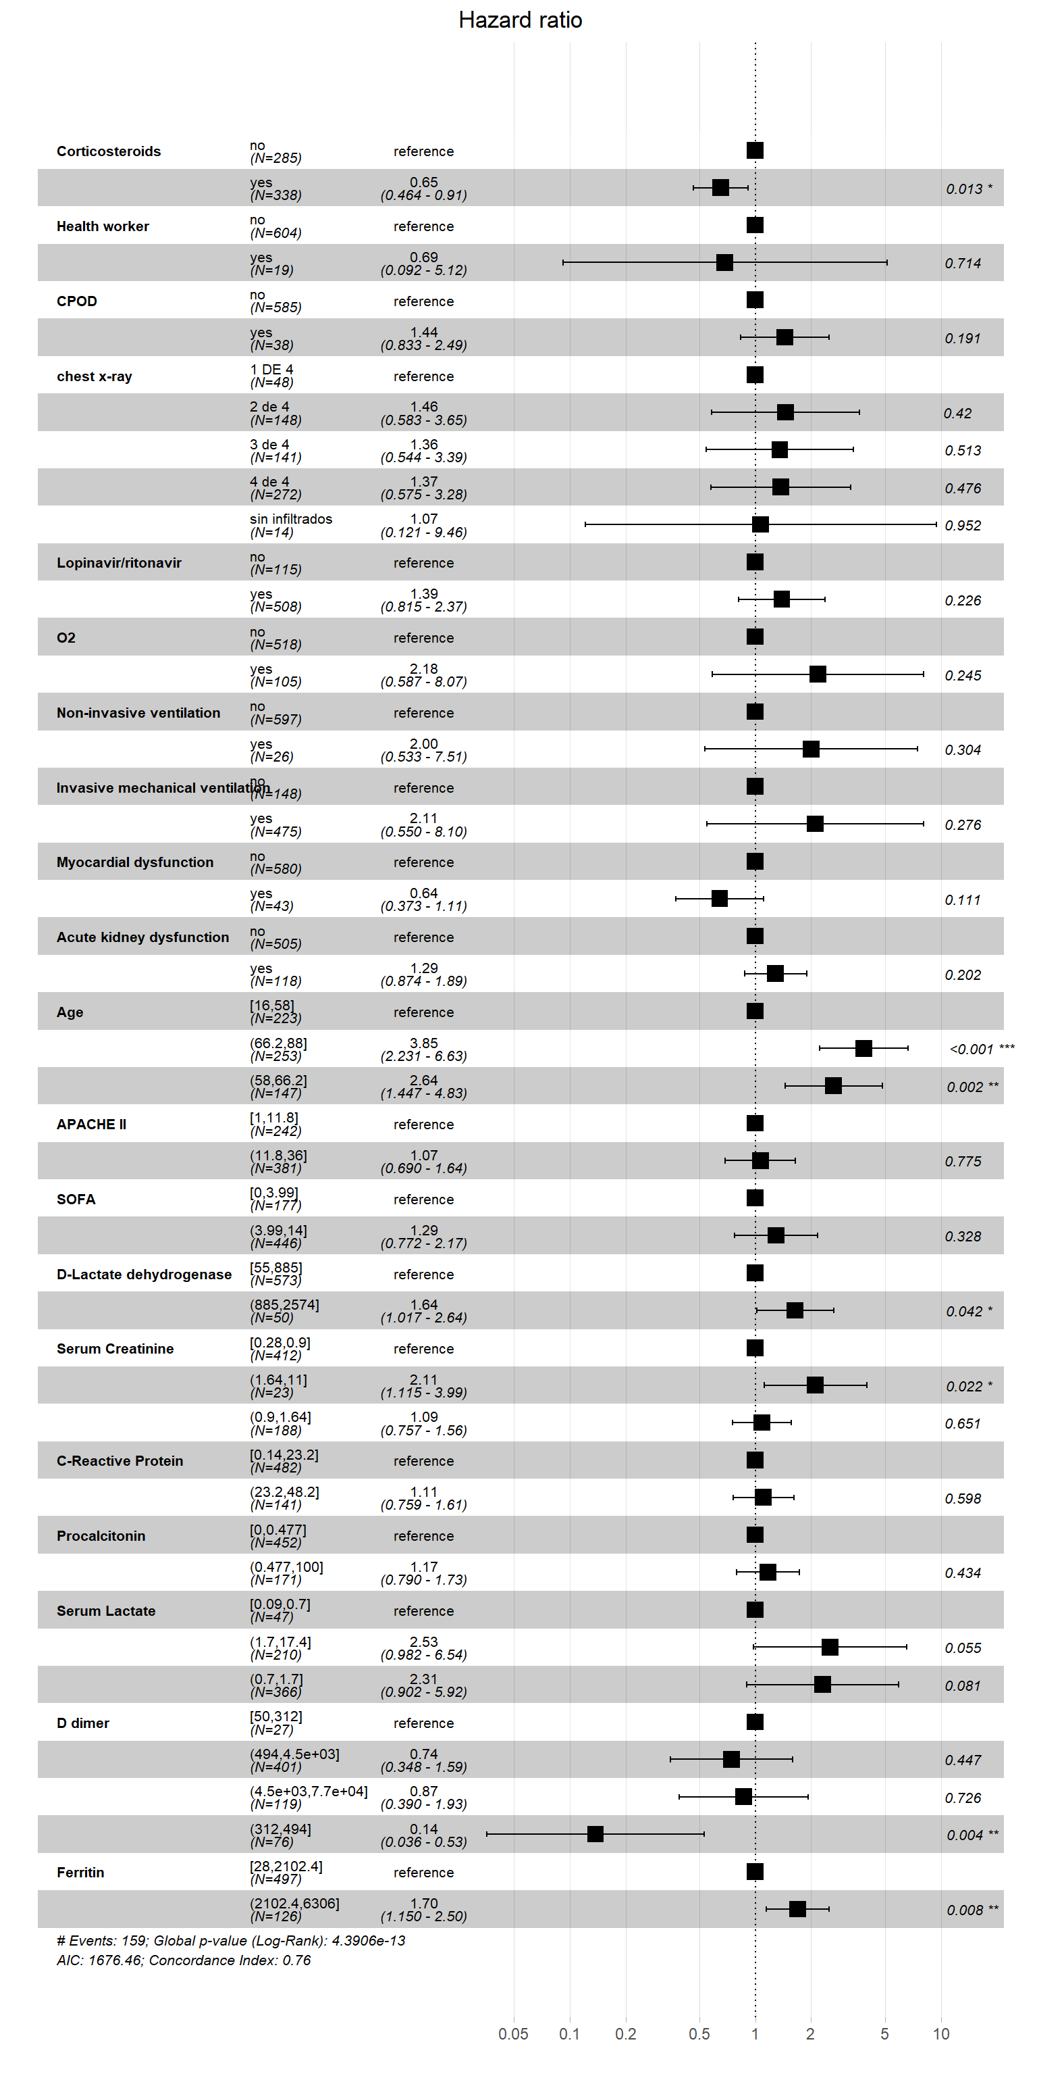

e-Figure 6: Proportional-hazards (PH) assumption test for Cox proportional Hazard regression in B phenotype. A plot shows a non-random pattern against time is evidence of violation of the PH assumption as is determined by global and individual Shoenfeld test. The solid line is a smoothing spline fit to the plot, with the dashed lines representing a +/- 2-standard-error band around the fit.

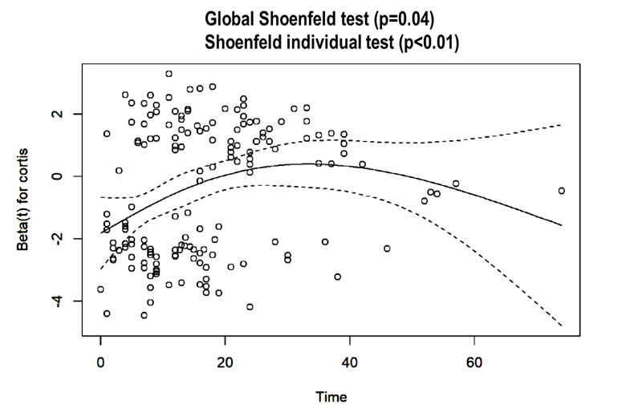

e-Table11: Factors associated with corticosteroids use in B phenotype patient’
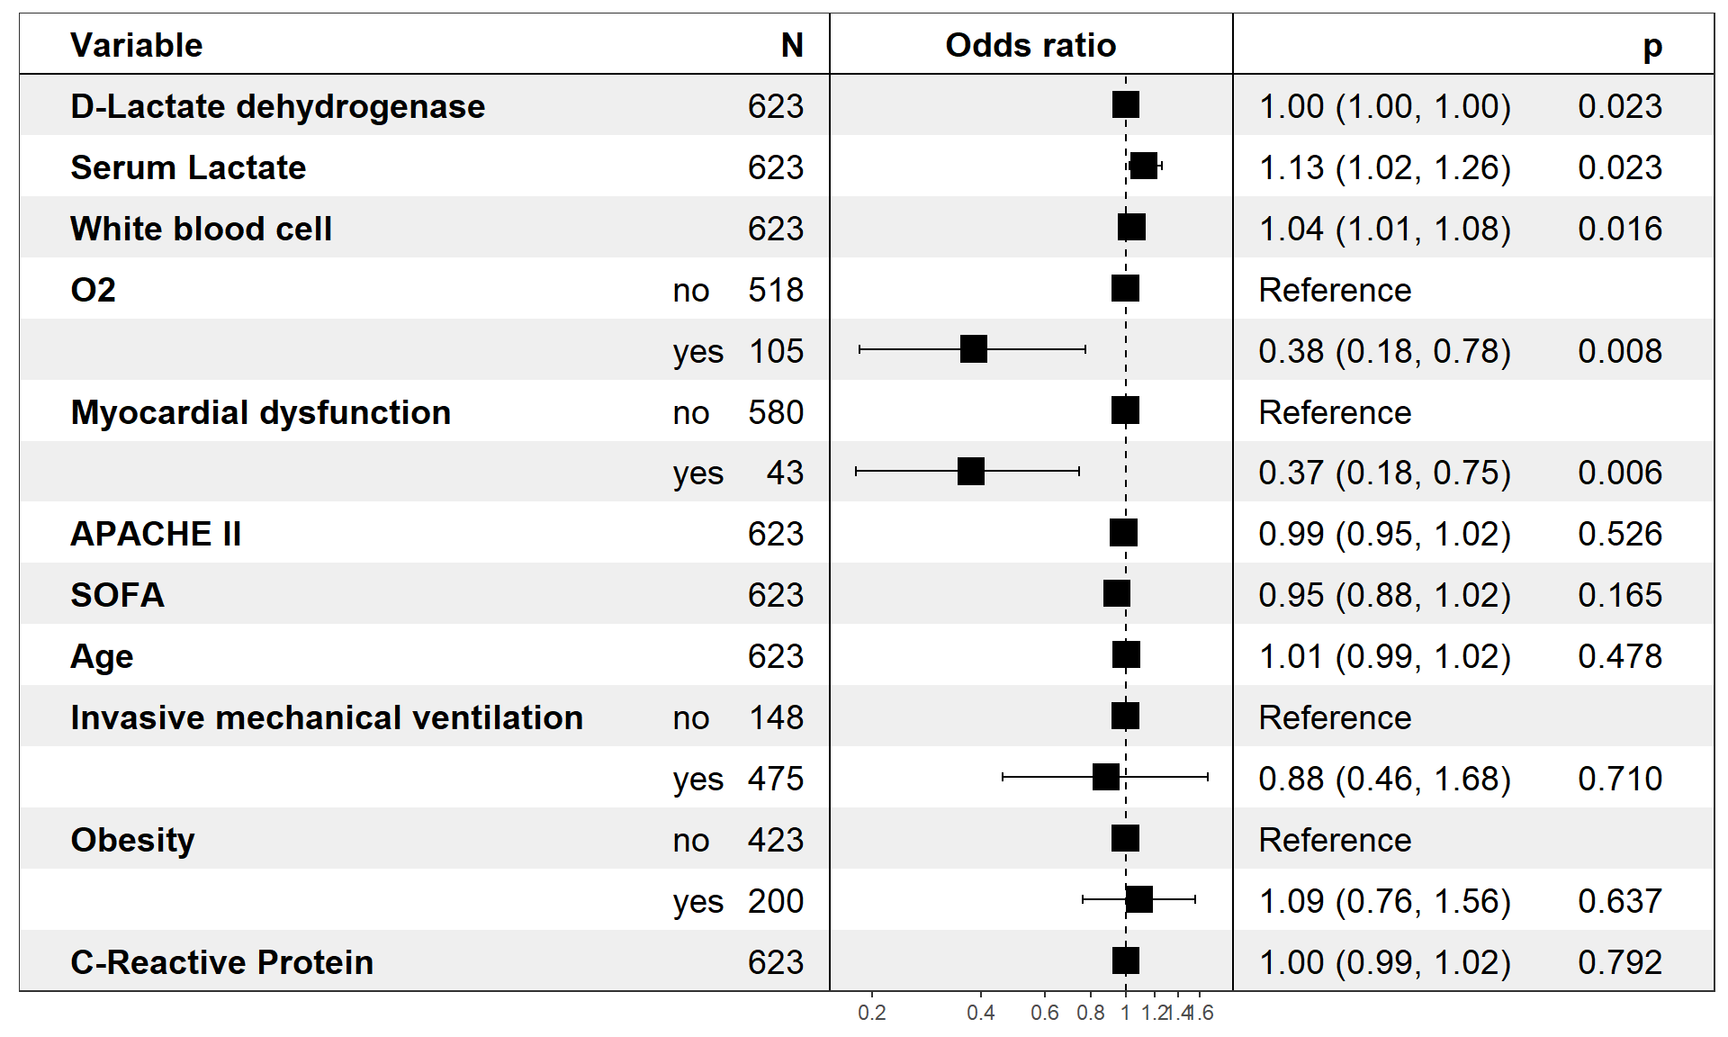

e-Table 12: Characteristics of 857 C phenotype patients according to ICU mortality
Variable ª | Survivors n=468 | Non-survivors n=389 | p-value
General characteristics and severity of illness
Age, median (IQR), year | 63(55-69) | 68(63-74) | 0.001
Male, n(%) | 336(71.8) | 290(74.6) | 0.40
APACHE II ^{b}, median (IQR) | 15(12-20) | 18(15-23) | 0.001
SOFA ^{c}, median(IQR) | 7.0(5-8) | 7.4(6-9) | 0.001
Laboratory findings
D-lactate dehydrogenase, median (IQR) U/L | 655(548-909) | 680(565-933) | 0.07
White blood cell, median (IQR), x10⁹ | 9.6(6.6-13.2) | 10.3(7.3-14.3) | 0.01
Serum creatinine, median (IQR), mg/dL | 0.9(0.7-1.26) | 1.0(0.7-1.4) | 0.001
C-Reactive Protein , median (IQR), mg/dL | 17(10-26) | 18(10-27) | 0.54
Procalcitonin, median (IQR), ng/mL | 0.5(0.2-1.1) | 0.6(0.2-1.6) | 0.05
Serum lactate, median (IQR), mmol/L | 1.5(1.1-1.9) | 1.8(1.4-2.5) | 0.001
D dimer, median (IQR), ng/mL | 2046(880-4260) | 3060(1250-5820) | 0.001
Ferritin, median (IQR), ng/mL | 1700(1330-2260) | 2000(1530-2690) | 0.001
Coexisting condition and comorbidities
Arterial hypertension, n(%) | 288(61.5) | 260(66.8) | 0.12
Obesity (BMI>30), n(%) | 162(34.6) | 132(33.9) | 0.89
Diabetes, n(%) | 94(20.1) | 104(26.7) | 0.02
Coronary arterial disease, n(%) | 10(2.1) | 38(9.8) | 0.001
COPD, n(%) | 35(7.5) | 38(9.8) | 0.28
Chronic renal disease, n(%) | 19(4.1) | 25(6.4) | 0.15
Hematologic disease, n(%) | 8(1.7) | 22(5.7) | 0.03
Asthma, n(%) | 19(4.1) | 15(3.9) | 1.00
HIV, n(%) | 1(0.2) | 1(0.3) | 1.00
Pregnancy, n(%) | 0(0.0) | 0(0.0) | NA
Autoimmune disease, n(%) | 17(3.6) | 19(4.9) | 0.46
Chronic heart disease, n(%) | 14(3.0) | 12(3.1) | 1.00
Neuromuscular disease, n(%) | 3(0.6) | 5(1.3) | 0.53
Oxygenation and ventilator support
Oxygen mask, n(%) | 48(10.3) | 48(12.3) | 0.39
High flow nasal cannula, n(%) | 16(3.4) | 11(2.8) | 0.76
Non-invasive ventilation, n(%) | 27(5.8) | 23(5.9) | 1.00
Invasive mechanical ventilation, n(%) | 379(81.0) | 315(81.0) | 1.00
PaO2/FiO2, median (IQR) | 132(96-164) | 116(82-144) | 0.001
Treatment
Corticosteroids, n(%) | 288(61.5) | 247(63.5) | 0.64
Antibiotics, n(%) | 427(91.2) | 353(90.7) | 0.89
Lopinavir/ritonavir, n(%) | 382(81.6) | 316(81.2) | 0.95
Hydroxychloroquine, No.(%) | 449(95.9) | 356(91.5) | 0.01
Tocilizumab , No.(%) | 139(29.7) | 95(24.4) | 0.09
Interferon β, No.(%) | 155(33.1) | 146(37.5) | 0.20
Complications and Outcome
Shock, n(%) | 358(76.5) | 294(75.6) | 0.81
AKI, n(%) | 141(30.1) | 209(53.7) | 0.001
Myocardial dysfunction, n(%) | 36(7.7) | 60(15.4) | 0.001
>2 quadrant infiltrates in chest x-ray, n(%) | 301(64.3) | 272(69.9) | 0.08
LOS UCI, median (IQR) days | 20(13-32) | 15(8-24) | 0.001
Abbreviations: IQR, interquartile range; APACHE II, Acute Physiology and Chronic Health Evaluation II; SOFA, Sequential Organ Failure Assessment; BMI, body mass index; COPD, Chronic obstructive pulmonary disease; HIV, human immunodeficiency viruses; PaO2/FiO2, Partial pressure arterial oxygen/ fraction of inspired oxygen
a Corresponds to minimum or maximum value, as appropriate, within 12 hours of ICU admission. The variables in this Table were no transformed for your comparison.
b APACHE II score to the severity of illness, the score is obtained by adding the following components 1) 12 clinical and laboratory variables each with a score range of 0 to 4 points (APS). The APS is determined from the worst physiologic values during the initial 24 h after ICU admission, 2) age with a range 0 to 6 points and 3) Chronic health points if the patients has history of severe organ system insufficiency or is immunocompromised assign 5 points if the patients is no operative or emergency postoperative and 2 points for elective postoperative patients with a total score range of 0 to 71.
c SOFA score corresponds to the severity of organ dysfunction, reflecting six organ systems each with a score range of 0 to 4 points (cardiovascular, hepatic, hematologic, respiratory, neurological, renal), with a total score range of 0 to 24,

e-Figure 7: Unadjusted survival plot (Kaplan-Meier) for C phenotype patients according to corticosteroids treatment

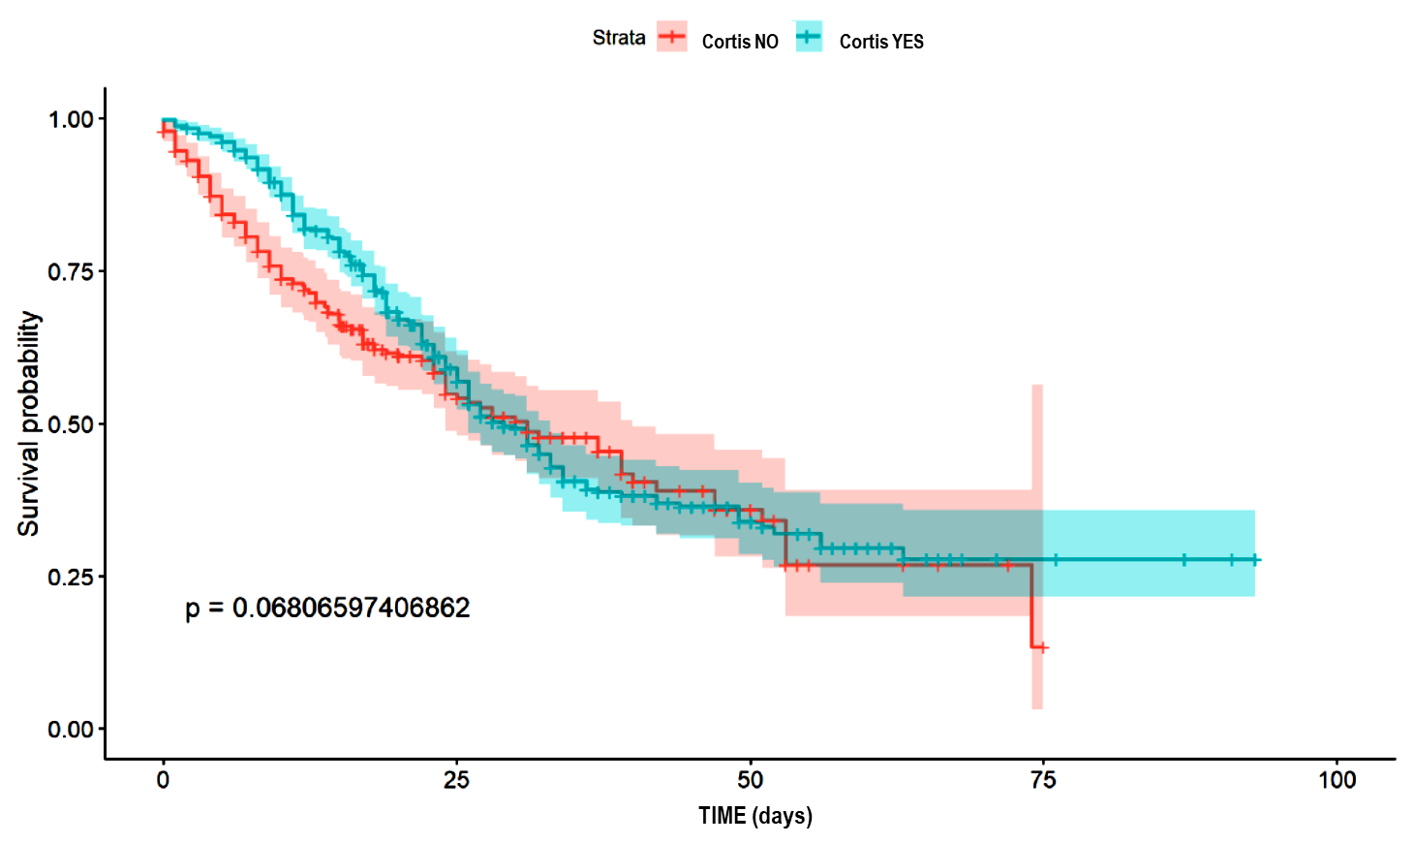

e-Figure 8: Proportional-hazards (PH) assumption test for Cox proportional Hazard regression in C phenotype. A plot shows a non-random pattern against time is evidence of violation of the PH assumption as is determined by global and individual Shoenfeld test. The solid line is a smoothing spline fit to the plot, with the dashed lines representing a +/- 2-standard-error band around the fit.

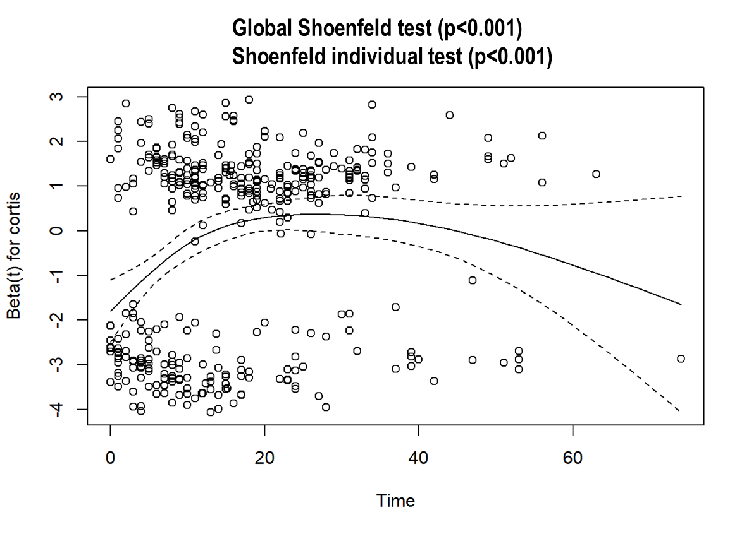

e-Table 13: Factors associated with ICU mortality in Cox Hazard regression analysis for patients among C phenotype
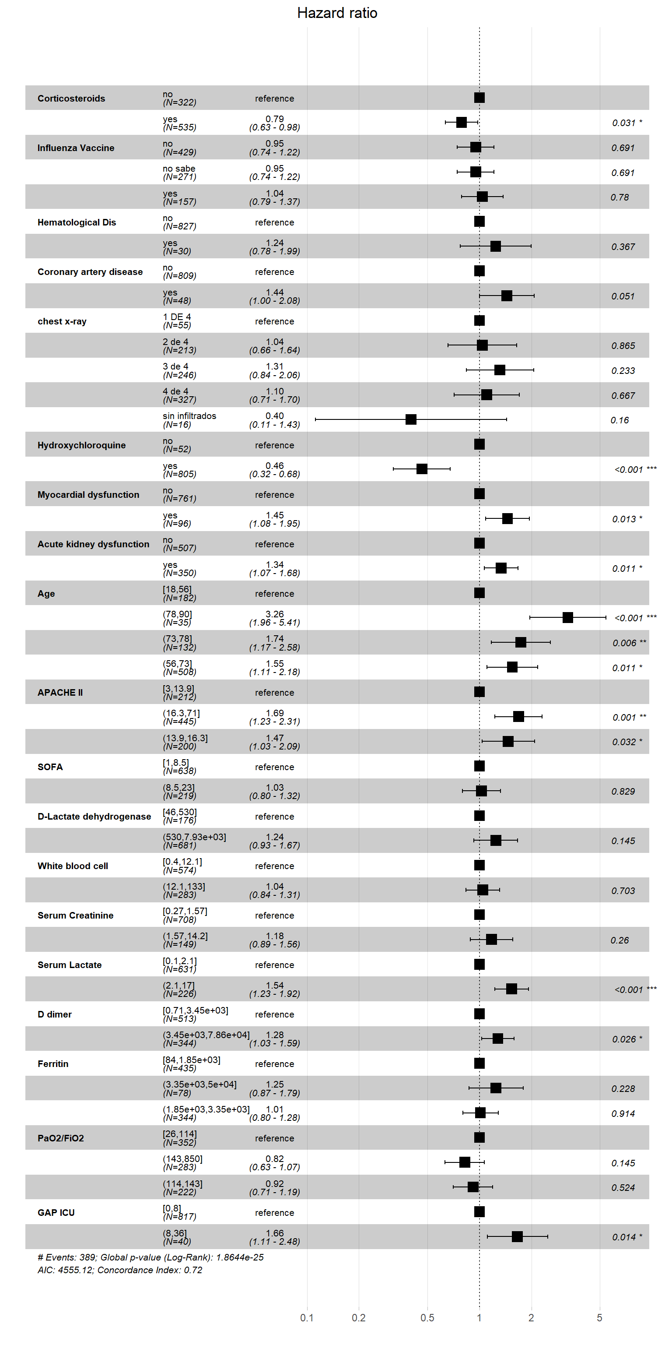

e-Table 14: Variables associated with corticosteroid use in C phenotype patients

