Marine Heatwaves Modulate Food Webs and Carbon Transport Processes
Mariana B. Bif^{1,2}, Colleen T. E. Kellogg³, Yibin Huang⁴, Julia Anstett^{5,6}, Sachia Traving⁷, M. Angelica Peña⁸, Steven J. Hallam^{5,6,9-12}, Kenneth S. Johnson¹

¹ Monterey Bay Aquarium Research Institute (MBARI), Moss Landing CA, United States
² University of Miami, Rosenstiel School of Marine, Atmospheric and Earth Sciences, Miami FL, United States
³ Hakai Institute, Heriot Bay BC, Canada
⁴ State Key Laboratory of Marine Environmental Science, Xiamen University, Xiamen, China
⁵ Department of Microbiology & Immunology, University of British Columbia, Vancouver, BC, Canada
⁶ Genome Science and Technology Program, University of British Columbia, Vancouver, BC Canada
⁷ University of Southern Denmark, Denmark
⁸ Institute of Ocean Sciences, Fisheries and Oceans Canada, Sidney BC, Canada
⁹ Graduate Program in Bioinformatics, University of British Columbia, Vancouver, BC, Canada
¹⁰ Bradshaw Research Institute for Minerals and Mining (BRIMM), University of British Columbia, Vancouver, BC, Canada
¹¹ Life Sciences Institute, University of British Columbia, Vancouver, BC, Canada
¹² ECOSCOPE Training Program, University of British Columbia, Vancouver, BC, Canada

Extended Data

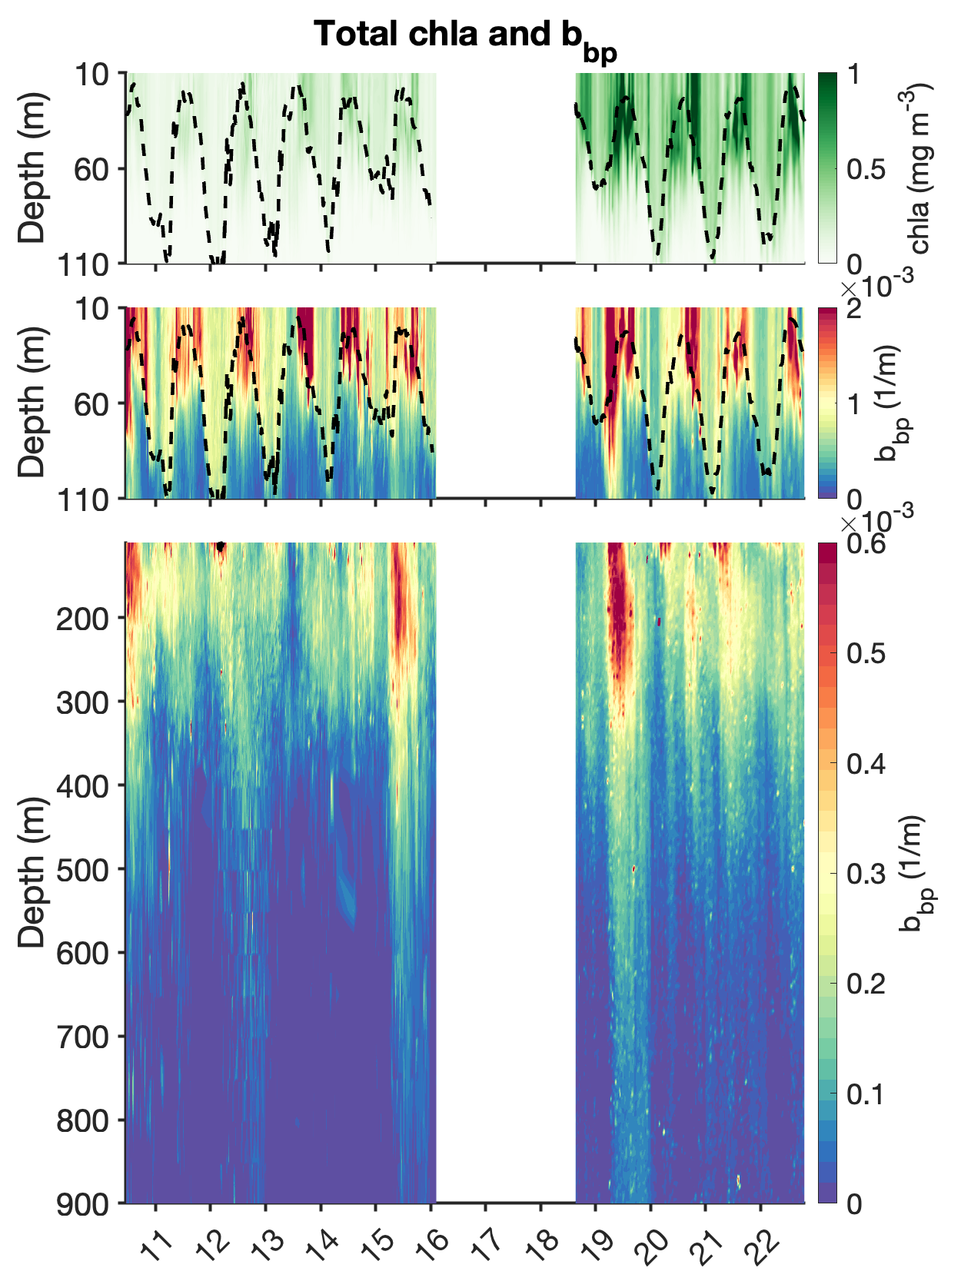
Fig. S1: Time-series of BGC-float data in the Gulf of Alaska between 2010 and 2022. The upper plot shows chlorophyll concentrations in the upper 110 m overlain by mixed layer depths (MLDs). The middle plot shows total particles (total b_{bp}) in the upper 100 m of depth, also overlain by MLDs, and the bottom plot shows total b_{bp} concentrations between 110 m and 900 m of depth. Notice that the z-axis limits are different for the middle and bottom b_{bp} plots.

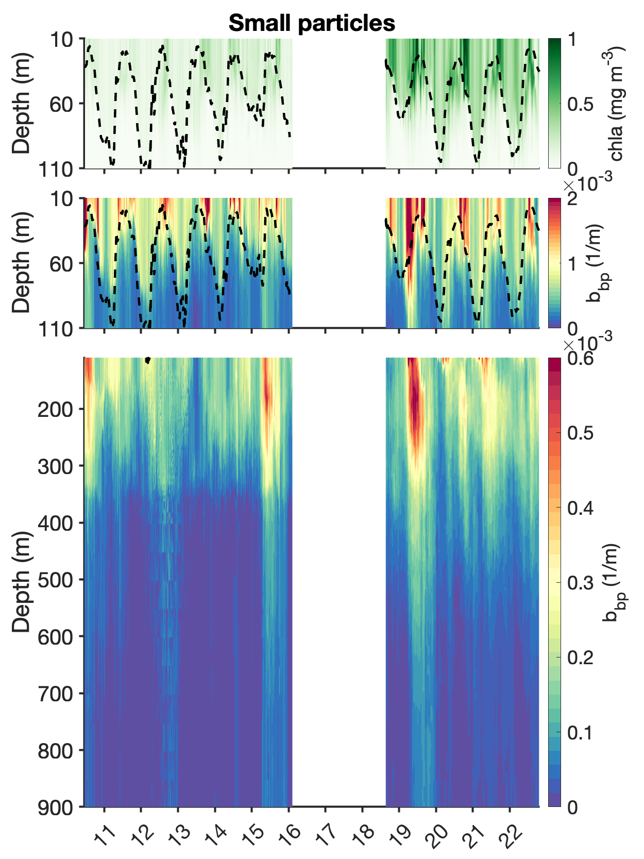
Fig. S2: A closer look at Fig. S1 focusing on the small b_{bp} particle fraction (<100 µm) and the portion of chlorophyll that belongs to small particles.

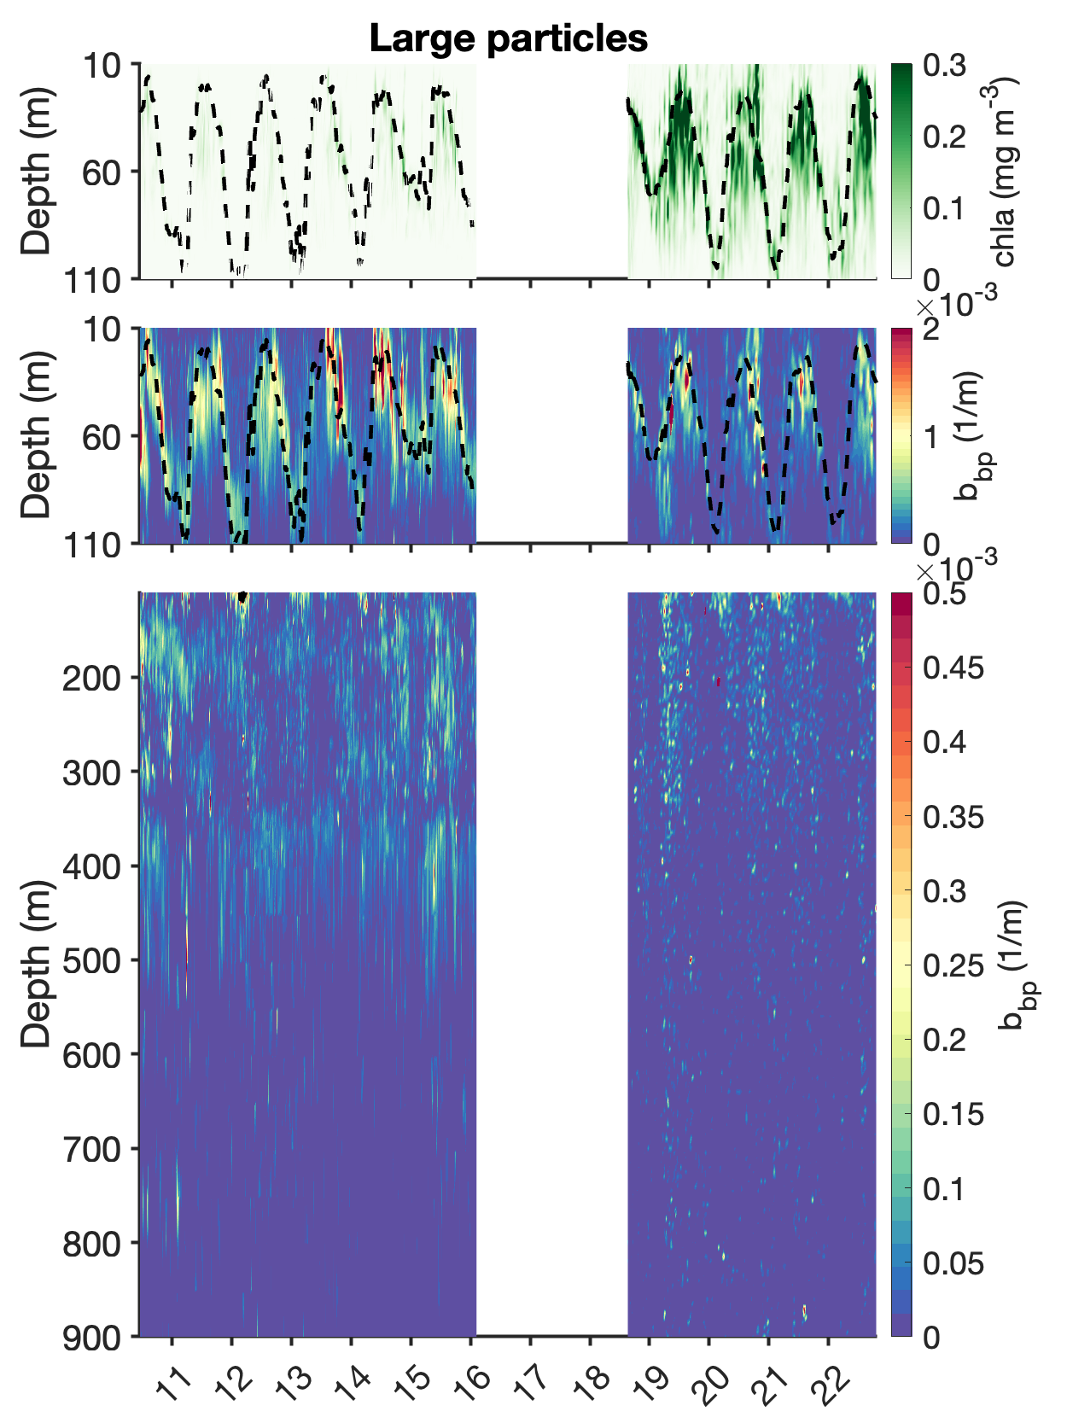
Fig. S3: A closer look at Fig. S1 focusing on the large b_{bp} particle fraction (>100 µm) and the portion of chlorophyll that belongs to large particles.

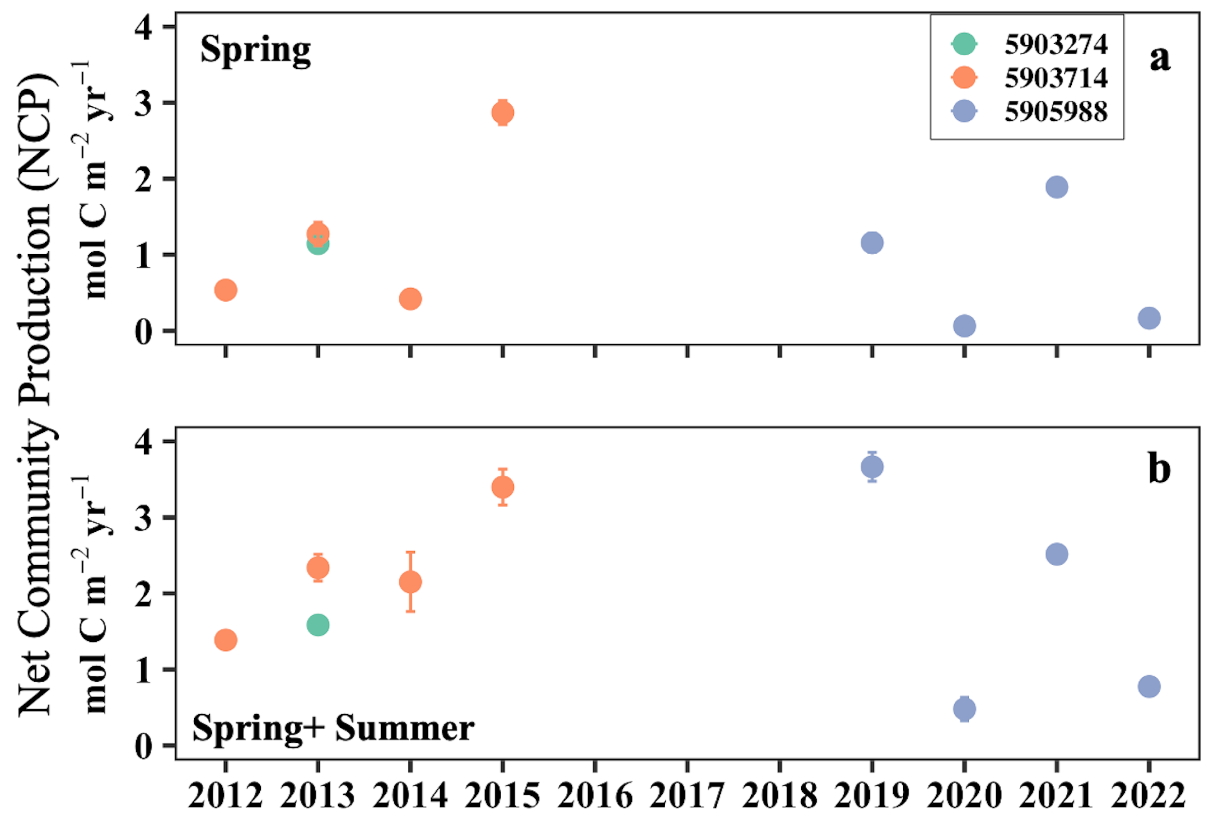
Fig. S4: Net community production (NCP) during productive seasons in the northeastern subarctic Pacific Ocean (NESAP). Values were calculated from the nitrate drawdown within the mixed layer during the productive seasons. The different colors represent NCP computed using different BGC-Argo floats. The upper plot represents the fraction of carbon produced during the Spring bloom. The lower plot shows carbon produced during the entire productive season, encompassing Spring and Summer months collectively.
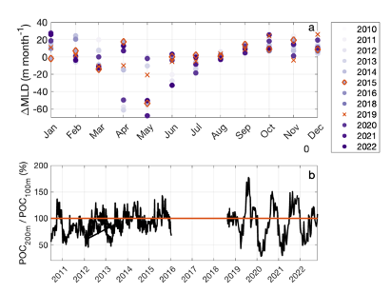
Fig. S5: The effect of mixed layer depth (MLD) shoaling and vertical migration on particle export. (a) Mean monthly mixed layer variability in comparison to the previous month (∆MLD). Negative values indicate mixed layer shoaling while positive values indicate mixed layer deepening. Orange diamonds highlight the year 2015, while orange crosses highlight the year 2019. (b) Percentage of particulate organic carbon (POC) at 200 m depth to the Ez (100 m) over the time series. Values over 100% (continuous orange line) means [POC_{200m}] > [POC_{100m}].

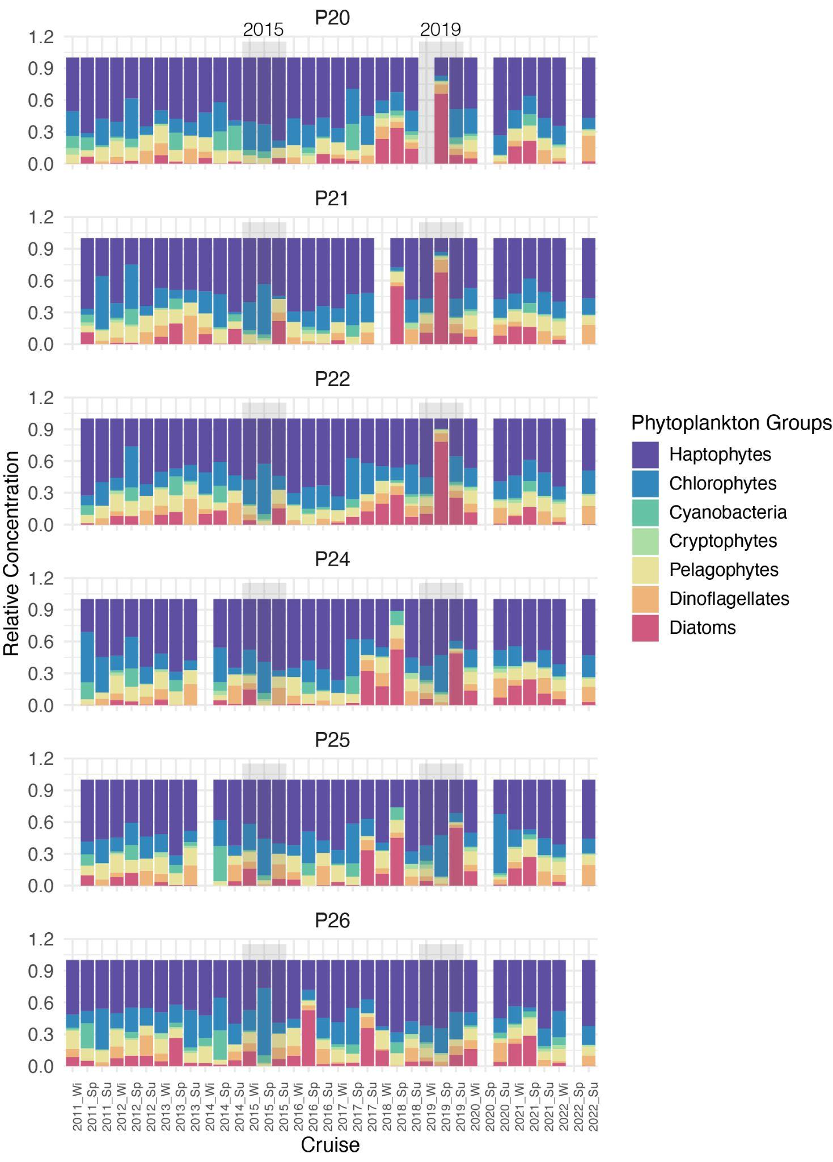
Fig. S6. Time series of relative abundance of major phytoplankton lineages at Stations P20 and P26 along the Line P transect in NESAP ocean waters.

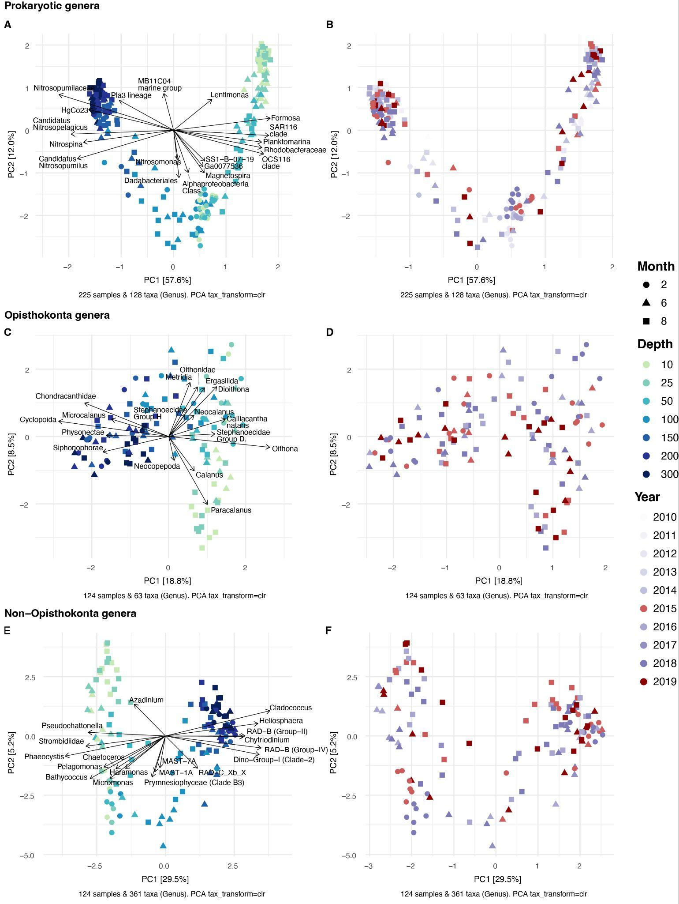
Fig. S7. Principal components analysis of centered log-ratio (CLR)-transformed small subunit ribosomal RNA (SSU rRNA) gene amplicon sequence data grouped at the genus level for Opisthokonta eukaryotes (a, b), non-Opisthokonta eukaryotes (c, d) and prokaryotic (bacterial and archaeal) lineages (e, f) generated from samples collected throughout the surface mixed layer and upper mesopelagic waters at Stations P20 and P26 along the Line P transect between 2010 to 2019. The 10 genera that contributed the most to PC1 and PC2 are plotted to highlight which genera were important in driving observed patterns in beta-diversity among samples.
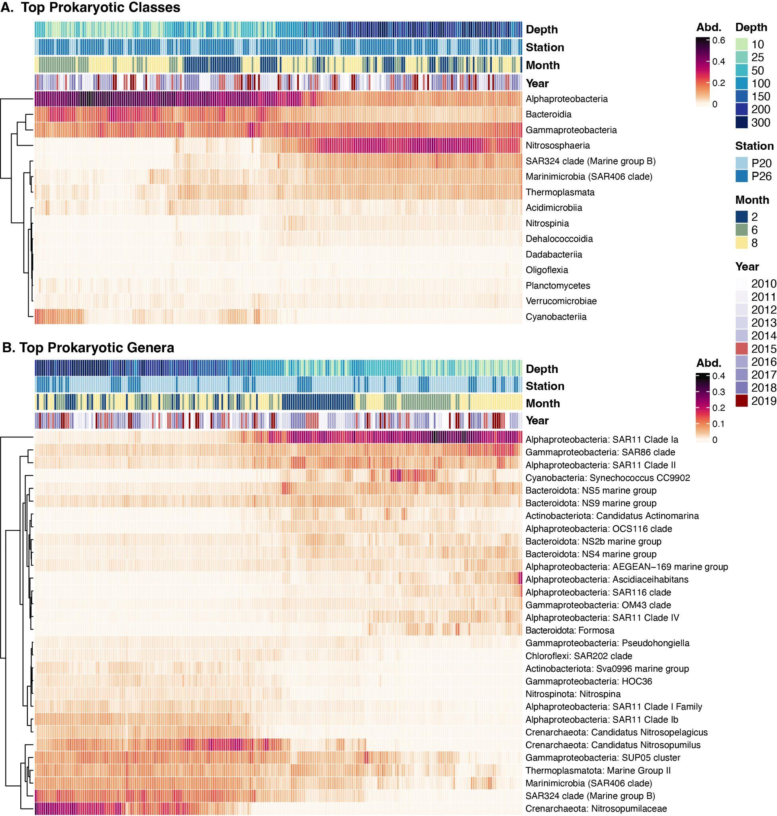
Fig. S8. Heatmaps displaying the relative abundance of the (a) top 15 prokaryotic classes (or proteobacterial orders) and (b) top 30 prokaryotic genera (with higher taxonomic levels provided when applicable) in the upper 300 m at Stations P20 and P26 along the Line P transect.

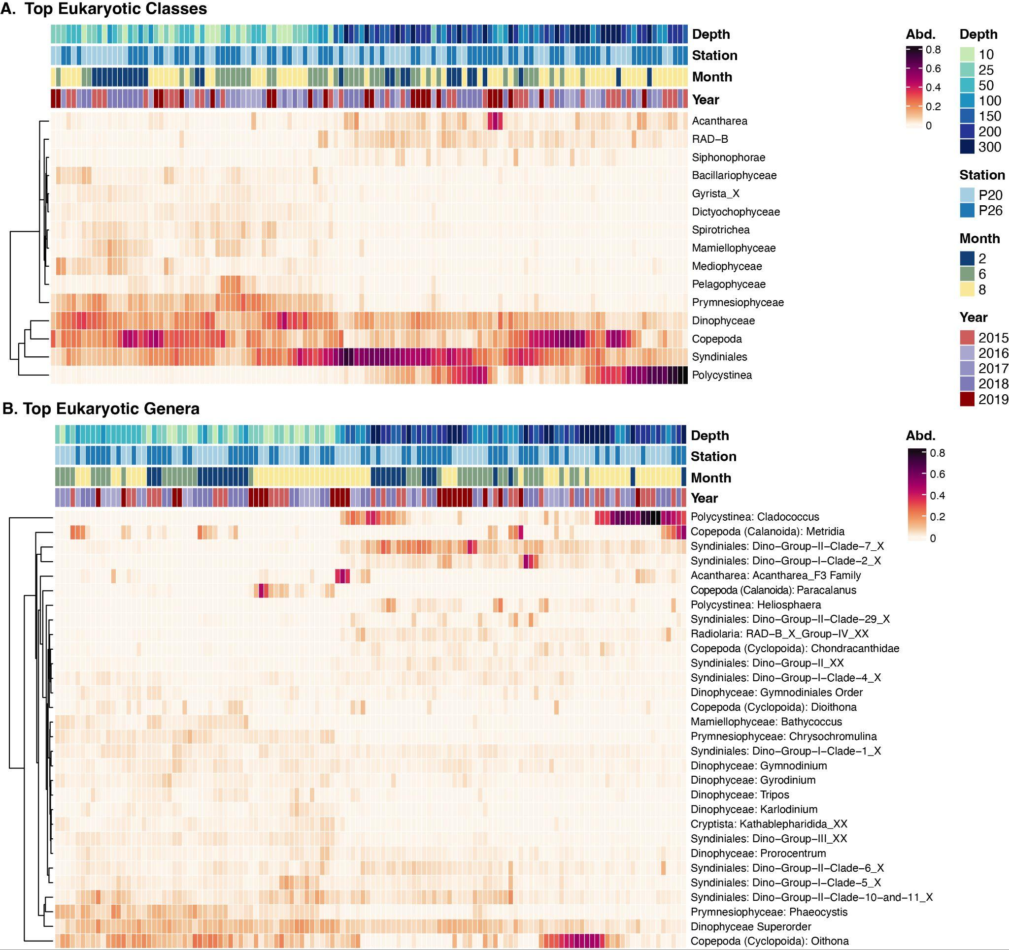
Fig. S9. Heatmaps displaying the relative abundance of the (a) top 15 eukaryotic classes and (b) top 30 eukaryotic genera (with higher taxonomic levels, e.g. Class, also provided when applicable) in the upper 300 m of at Stations P20 and P26 along the Line P transect the waters of Stations P20 and P26.

Table S1. PERMANOVA results comparing the DNA-derived community composition in spring and summer samples between 2015 and 2019 MHW years.
 | Prokaryotes | All Eukaryotes | Animals only | Non-animal eukaryotes
Surface Mixed Layer  (10-100 m) | R = 0.0358  p_{adj} = 0.297 | R = 0.05555 p_{adj} = 0.1157 | R =0.04554  p_{adj} = 0.3718 | R = 0.05734 p_{adj} = 0.08143
Upper Mesopelagic Waters (150-300 m) | R = 0.13428  p_{adj} = 0.009333* | R = 0.16982 p_{adj} = 0.0015* | R = 0.11704 p_{adj} = 0.04125* | R = 0.1704  p_{adj} = 0.0030*

