Effective removal of As⁵⁺ from aqueous medium using date palm fiber biochar/chitosan/glutamine nanocomposite: kinetic and thermodynamic studies
Al Isaee Khalifa^{1**}, Laila M. Alshandoudi¹, Asaad F. Hassan^{2*}, Amany G. Braish²
¹Science department, Al Rustaq College of Education, University of Technology and Applied Sciences, Al Rustaq, Sultanate of Oman.
²Chemistry Department, Faculty of Science, Damanhour University, Damanhour, Egypt
*Corresponding author: asmz68@sci.dmu.edu.eg
**Corresponding author: ki7276@utas.edu.om

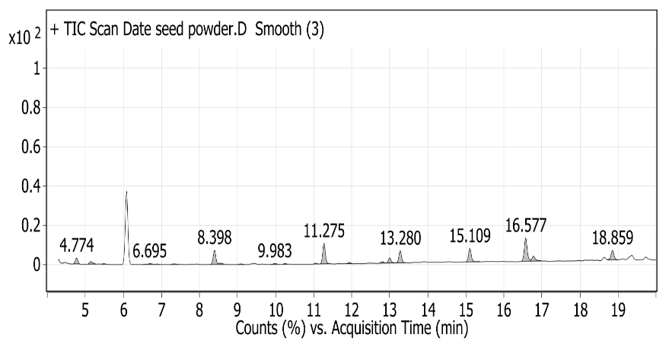

Fig.S1: GC-M analysis for date palm pits extract

Table S1: Chemical composition of date palm pits extract

Peak | R_{T} (min) | Name | Area Sum %
1 | 4.774 | Diphenyl(trimethylsilyl)phosphine | 4.23
2 | 5.143 | 1-(Trimethylsilyl)-3-[(trimethylsilyl)oxy] urea | 2.36
3 | 5.487 | 2-Ethoxyethanol, TMS derivative | 0.36
4 | 6.695 | 6-Methylheptanoic acid, TMS | 0.97
5 | 6.879 | Silanol, trimethyl-, phosphate (3:1) | 0.23
6 | 7.332 | Catechol, 2TMS derivative | 0.56
7 | 8.398 | Hydroquinone, 2TMS derivative | 12.41
8 | 9.086 | Decanoic acid, TMS derivative | 0.46
9 | 9.983 | 2,6-Bis(tert-butyl) phenol, TMS derivative | 0.77
10 | 10.252 | 5-Hydroxymethyl-2-furoic acid, 2TMS derivative | 0.48
11 | 11.049 | 4-Hydroxybenzoic acid, 2TMS derivative | 0.33
12 | 11.275 | Dodecanoic acid, TMS derivative | 15.89
13 | 11.938 | 4-Amino-2-nitrobenzoic acid, 2 TMS derivative | 0.82
14 | 12.81 | Azelaic acid, 2TMS derivative | 0.96
15 | 13.003 | Protocatechuic acid, 3TMS derivative | 4.08
16 | 13.28 | Myristic acid, TMS derivative | 9.68
17 | 15.109 | Palmitic Acid, TMS derivative | 11.64
18 | 16.577 | 9-Octadecenoic acid, (E)-, TMS derivative | 20.33
19 | 16.778 | Stearic acid, TMS derivative | 4.84
20 | 18.858 | (Z)-Docos-9-enenitrile | 8.58

