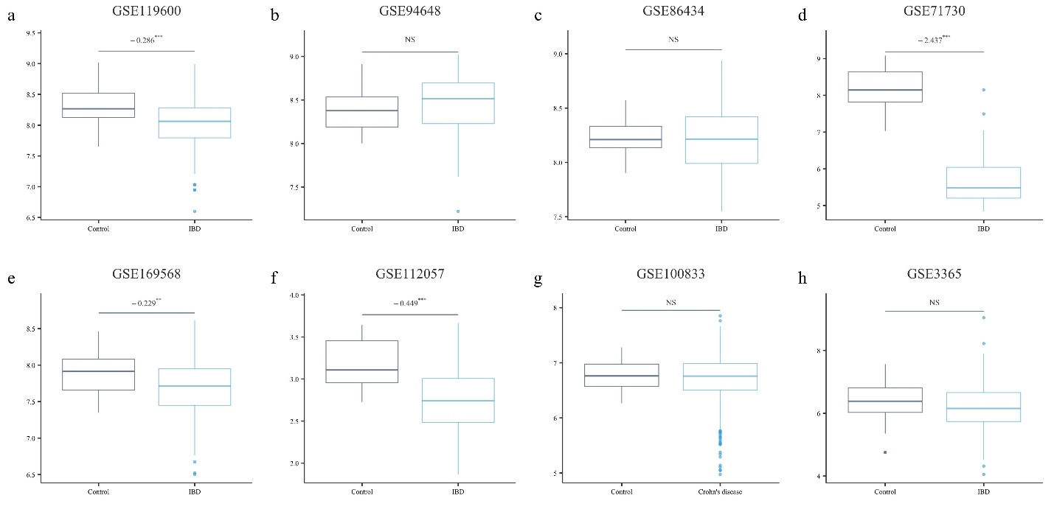
Supplementary Fig. S1. Screening of TNF expression levels in patients with IBD compared to controls across the analyzed datasets. The y-axis represents the expression level. The log fold change (logFC) values from independent differential expression analyses are documented above the boxes. The statistical significance of correlations is represented by asterisks (*P < 0.05, **P < 0.01, ***P < 0.001, NS: not significant). (a) GSE119600, (b) GSE94648, (c) GSE86434, (d) GSE71730, (e) GSE169568, (f) GSE112057, (g) GSE100833, and (h) GSE3365.

