Figure S1. Phase difference between orthogonal directions at all periods of each station obtained from unconstrained GB decomposition.

Figure S2. Data misfit values at all periods of each station obtained from unconstrained GB decomposition.

Figure S3. Ratio of the median of the principal apparent resistivities for 1D section of all sounding curves along profile 21.

Figure S4. Joint inversion result of TE and TM-mode apparent resistivities and phases.

Figure S5. The model conductance along profile P21. Conductances are shown for five models with the top of the resistive half-space at different depths

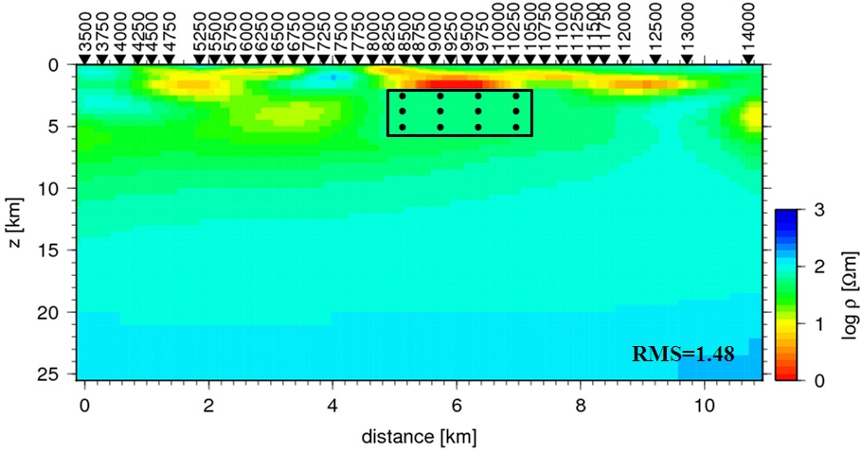

Figure S6. Constrained inversion result obtained from a starting model whose resistivity was fixed at two regions: (i) throughout the area of the conductive blub and (ii) outside of the rectangular region extending from -11 to 25 Km along the profile and from surface to a depth of 27 Km.

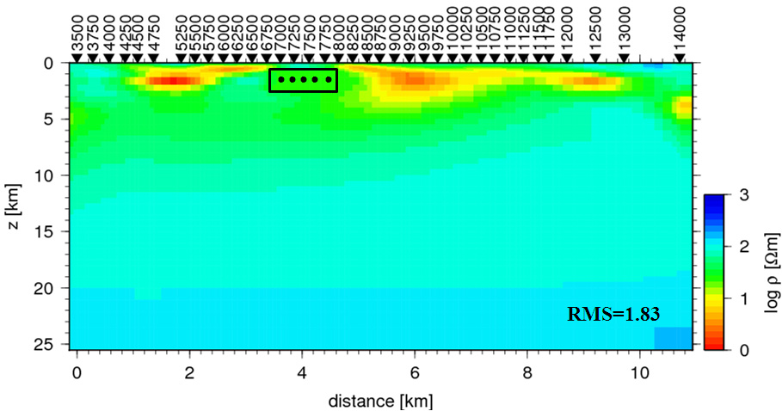
Figure S7. Constrained inversion result obtained from a starting model whose resistivity was fixed at two regions: (i) throughout the area of the resistor R1 and (ii) outside of the rectangular region extending from -11 to 25 Km along the profile and from surface to a depth of 27 Km.

