Extended Tables and Figures

EXT. TABLE A1: Effect of Vaccines (one dose) on COVID-19 Cases and Economic Activity (with region-specific time trends)
 | New COVID-19 Cases | NTL  (change) | AOD  (change) |  | Mobility  (change)
Vaccinated persons, 1 dose | -0.009602*** | 0.983556*** | 144.343144*** | 0.108500***
 | (0.002) | (0.316) | (49.978) | (0.042)
COVID-19 cases (lag) | -0.602423*** | -0.679126 | -5.346130 | -0.045236
 | (0.069) | (0.570) | (6.117) | (0.081)
NTL (lag) | -0.000002 | -0.029734*** | 0.146927 | -0.000118
 | (0.000) | (0.008) | (0.100) | (0.000)
AOD (lag) | 0.000001 | -0.000708 | -0.226605*** | 0.000072**
 | (0.000) | (0.001) | (0.061) | (0.000)
Mobility (lag) | -0.000746 | 0.041809 | 3.109355 | -0.544787***
 | (0.001) | (0.030) | (2.907) | (0.022)
Constant | 2.830979*** | 0.796396 | -190.737320 | -10.847172***
 | (0.324) | (2.721) | (132.853) | (0.810)
Observations | 15,540 | 21,214 | 21,077 | 21,302
R-squared | 0.344 | 0.397 | 0.187 | 0.844
Vaccination Lags | 21 days | 1 day | 1 day | 1 day
Note: results reported are based on a sample of 17 countries (314 states) using daily data from December 21, 2020–February 28, 2021. Estimates are based on ${∆C}_{i,j,t}= α+ u_{i}+μ_{j,t}+ βV_{i,j,t-l}+ θX_{i,j,t-1}+ ε_{i,j,t}$ , where $C_{i,j,t}$ alternatively denotes: the number of new COVID-19 infections as share of population, night-time lights and AOD per capita and google mobility in region i and country j at day t. $V_{i,j,t}$ denotes the share of individuals in the population which have received one vaccine shot. $u_{i}$ are country-fixed effects, $μ_{j,t}$ are country-time fixed effects. $X$ is a vector of control variables which includes the level of new cases and economic indicators at t-1. $l$ denotes the lags in the response of the endogenous variable to vaccine. Region-specific time trends are included in the regression. Standard errors clustered at the country-date level in parentheses. ***, **, * denote statistical significance at 1 percent, 5 percent, and 10 percent, respectively.

EXT. TABLE A2: Effect of Vaccines (one dose) on COVID-19 Cases and Economic Activity (with winsorizing of dependent variables)
 | New COVID-19 Cases | NTL  (change) | AOD  (change) |  | Mobility  (change)
Vaccinated persons, 1 dose | -0.004588*** | 0.982974*** | 83.936907*** | 0.148435***
 | (0.001) | (0.316) | (30.841) | (0.057)
COVID-19 cases (lag) | -0.297146*** | -0.702410 | 2.225419 | -0.045497
 | (0.046) | (0.572) | (3.986) | (0.081)
NTL (lag) | -0.000003 | -0.029716*** | 0.183480*** | -0.000045
 | (0.000) | (0.008) | (0.066) | (0.000)
AOD (lag) | 0.000001* | -0.000707 | -0.181260*** | 0.000062
 | (0.000) | (0.001) | (0.041) | (0.000)
Mobility (lag) | -0.000872** | 0.041001 | 2.698265 | -0.522924***
 | (0.000) | (0.029) | (1.871) | (0.022)
Constant | 1.391484*** | 1.165855 | -123.097623 | -10.067243***
 | (0.213) | (2.683) | (85.191) | (0.584)
Observations | 15,542 | 21,214 | 21,375 | 21,375
R-squared | 0.403 | 0.396 | 0.442 | 0.820
Vaccination Lags | 21 days | 1 day | 1 day | 1 day

Note: Results reported are based on a sample of 17 countries (314 states) using daily data from December 21, 2020–February 28, 2021. Estimates are based on ${∆C}_{i,j,t}= α+ u_{i}+μ_{j,t}+ βV_{i,j,t-l}+ θX_{i,j,t-1}+ ε_{i,j,t}$ , where $C_{i,j,t}$ alternatively denotes: the number of new COVID-19 infections as share of population, night-time lights and AOD per capita and google mobility in region i and country j at day t. $V_{i,j,t}$ denotes the share of individuals in the population which have received one vaccine shot. $u_{i}$ are country-fixed effects, $μ_{j,t}$ are country-time fixed effects. $X$ is a vector of control variables which includes the level of new cases and economic indicators at t-1. $l$ denotes the lags in the response of the endogenous variable to vaccine. The dependent variable is winsorized to the 99th percentile of the distribution. Standard errors clustered at the country-date level in parentheses. ***, **, * denote statistical significance at 1 percent, 5 percent, and 10 percent, respectively.

EXT. TABLE A3. Instrumental Variable: Effect of Vaccines (one dose) on COVID-19 Cases and Economic Activity
 | New COVID-19  Cases | NTL  (change) | AOD  (change) |  | Mobility  (change)
Vaccinated persons, 1 dose | -0.087803* | 2.239933** | 221.238174*** | 0.365359***
 | (0.047) | (1.024) | (60.398) | (0.141)
COVID-19 cases (lag) | -0.608188*** | -0.596970 | -0.978819 | -0.021341
 | (0.069) | (0.566) | (7.395) | (0.080)
NTL (lag) | 0.000005 | -0.027962*** | 0.157359 | -0.000074
 | (0.000) | (0.008) | (0.100) | (0.000)
AOD (lag) | 0.000010 | -0.001156 | -0.251665*** | -0.000016
 | (0.000) | (0.001) | (0.062) | (0.000)
Mobility (lag) | -0.000518 | 0.024226 | 1.416896 | -0.550184***
 | (0.001) | (0.033) | (2.902) | (0.023)
Observations | 15,540 | 21,214 | 21,077 | 21,302
R-squared | 0.277 | 0.075 | 0.093 | 0.266
Country term | Vaccine  procurements | Vaccine procurements | Vaccine procurements | Vaccine procurements
Regional term | Hospitals  per capita | Hospitals  per capita | Hospitals  per capita | Hospitals  per capita
KP F-Statistic | 88.54 | 245.28 | 232.45 | 232.29
Vaccination Lags | 21 days | 1 day | 1 day | 1 day

Note: Results reported are based on a sample of 17 countries (314 states) using daily data from December 21, 2020–February 28, 2021. Estimates are based on $C_{i,j,t}= α+ u_{i}+μ_{j,t}+ β{\hat{V}}_{i,j,t-l}+ θX_{i,j,t-1}+ ε_{i,j,t}$ , with $V_{i,j,t}= α+ u_{i}+μ_{j,t}+ δZ_{jt-180}*R_{i}+ θX_{i,j,t-1}+ ε_{i,j,t}$ where $V_{i,j,t}$ denotes the cumulative number of vaccine deals/procurement made in country j 180 days before vaccine administration at time t, and $R_{i}$ denotes the number of hospitals per capita (in logs). $C_{i,j,t}$ alternatively denotes: the number of new COVID-19 infections as share of population, night-time lights and AOD per capita and google mobility in region i and country j at day t. $u_{i}$ are country-fixed effects, $μ_{j,t}$ are country-time fixed effects. $X$ is a vector of control variables which includes the level of new cases and economic indicators at t-1. $l$ denotes the lags in the response of the endogenous variable to vaccine. Standard errors clustered at the country-date level in parentheses. ***, **, * denote statistical significance at 1 percent, 5 percent, and 10 percent, respectively.

EXT. TABLE A4. Instrumental Variable: Effect of Vaccines (one dose) on COVID-19 Cases and Economic Activity, with procurements 150 days prior
 | New COVID-19  Cases | NTL  (change) | AOD  (change) |  | Mobility  (change)
Vaccinated persons, 1 dose | -0.128292*** | 2.059113*** | 251.720738*** | -0.040018
 | (0.025) | (0.729) | (95.241) | (0.156)
COVID-19 cases (lag) | -0.611330*** | -0.612079 | 0.909441 | -0.042790
 | (0.069) | (0.573) | (8.845) | (0.080)
NTL (lag) | 0.000009 | -0.028214*** | 0.161487 | -0.000146
 | (0.000) | (0.008) | (0.101) | (0.000)
AOD (lag) | 0.000015** | -0.001091 | -0.261602*** | 0.000122*
 | (0.000) | (0.001) | (0.066) | (0.000)
Mobility (lag) | -0.000416 | 0.026632 | 0.765560 | -0.541995***
 | (0.001) | (0.027) | (2.859) | (0.023)
Observations | 15,540 | 21,214 | 21,077 | 21,302
R-squared | 0.246 | 0.077 | 0.087 | 0.268
Country term | Procurements 150 days prior | Procurements 150 days prior | Procurements 150 days prior | Procurements 150 days prior
Regional term | Hospitals  per capita | Hospitals  per capita | Hospitals  per capita | Hospitals  per capita
KP F-Statistic | 57.21 | 54.21 | 86.52 | 76.31
Vaccination Lags | 21 days | 1 day | 1 day | 1 day

Note: Results reported are based on a sample of 17 countries (314 states) using daily data from December 21, 2020–February 28, 2021. Estimates are based on $C_{i,j,t}= α+ u_{i}+μ_{j,t}+ β{\hat{V}}_{i,j,t-l}+ θX_{i,j,t-1}+ ε_{i,j,t}$ , with $V_{i,j,t}= α+ u_{i}+μ_{j,t}+ δZ_{jt-150}*R_{i}+ θX_{i,j,t-1}+ ε_{i,j,t}$ where $V_{i,j,t}$ denotes the cumulative number of vaccine deals/procurement made in country j 150 days before vaccine administration at time t, and $R_{i}$ denotes the number of hospitals per capita (in logs). $C_{i,j,t}$ alternatively denotes: the number of new COVID-19 infections as share of population, night-time lights and AOD per capita and google mobility in region i and country j at day t. $u_{i}$ are country-fixed effects, $μ_{j,t}$ are country-time fixed effects. $X$ is a vector of control variables which includes the level of new cases and economic indicators at t-1. $l$ denotes the lags in the response of the endogenous variable to vaccine. Standard errors clustered at the country-date level in parentheses. ***, **, * denote statistical significance at 1 percent, 5 percent, and 10 percent, respectively.

EXT. TABLE A5. Instrumental Variable: Effect of Vaccines (one dose) on COVID-19 Cases and Economic Activity, with procurements 120 days prior
 | New COVID-19  Cases | NTL  (change) | AOD  (change) |  | Mobility  (change)
Vaccinated persons, 1 dose | -0.025854*** | 3.921812*** | 394.552190*** | 0.130642
 | (0.006) | (0.994) | (102.198) | (0.177)
COVID-19 cases (lag) | -0.603380*** | -0.456433 | 9.757214 | -0.033760
 | (0.069) | (0.558) | (10.598) | (0.081)
NTL (lag) | -0.000001 | -0.025624*** | 0.180827* | -0.000116
 | (0.000) | (0.007) | (0.101) | (0.000)
AOD (lag) | 0.000003* | -0.001757* | -0.308162*** | 0.000064
 | (0.000) | (0.001) | (0.064) | (0.000)
Mobility (lag) | -0.000674 | 0.001842 | -2.286389 | -0.545443***
 | (0.001) | (0.023) | (2.781) | (0.023)
Observations | 15,540 | 21,214 | 21,077 | 21,302
R-squared | 0.300 | 0.036 | 0.031 | 0.270
Country term | Procurements 120 days prior | Procurements 120 days prior | Procurements 120 days prior | Procurements 120 days prior
Regional term | Hospitals  per capita | Hospitals  per capita | Hospitals  per capita | Hospitals  per capita
KP F-Statistic | 43.09 | 55.33 | 93.76 | 79.48
Vaccination Lags | 21 days | 1 day | 1 day | 1 day

Note: Results reported are based on a sample of 17 countries (314 states) using daily data from December 21, 2020–February 28, 2021. Estimates are based on $C_{i,j,t}= α+ u_{i}+μ_{j,t}+ β{\hat{V}}_{i,j,t-l}+ θX_{i,j,t-1}+ ε_{i,j,t}$ , with $V_{i,j,t}= α+ u_{i}+μ_{j,t}+ δZ_{jt-150}*R_{i}+ θX_{i,j,t-1}+ ε_{i,j,t}$ where $V_{i,j,t}$ denotes the cumulative number of vaccine deals/procurement made in country j 120 days before vaccine administration at time t, and $R_{i}$ denotes the number of hospitals per capita (in logs). $C_{i,j,t}$ alternatively denotes: the number of new COVID-19 infections as share of population, night-time lights and AOD per capita and google mobility in region i and country j at day t. $u_{i}$ are country-fixed effects, $μ_{j,t}$ are country-time fixed effects. $X$ is a vector of control variables which includes the level of new cases and economic indicators at t-1. $l$ denotes the lags in the response of the endogenous variable to vaccine. Standard errors clustered at the country-date level in parentheses. ***, **, * denote statistical significance at 1 percent, 5 percent, and 10 percent, respectively.

EXT. TABLE A6. Instrumental Variable: Effect of Vaccines (one dose) on COVID-19 Cases and Economic Activity, with procurements 180 days prior and hospitals per capita, with current NPI controls
 | New COVID-19  Cases | NTL  (change) | AOD  (change) |  | Mobility  (change)
Vaccinated persons, 1 dose | -0.085357* | 1.998933* | 197.397914*** | 0.314914**
 | (0.047) | (1.079) | (58.982) | (0.146)
COVID-19 cases (lag) | -0.608108*** | -0.626871 | -3.674150 | -0.026579
 | (0.069) | (0.571) | (7.454) | (0.080)
NTL (lag) | 0.000005 | -0.028260*** | 0.155463 | -0.000080
 | (0.000) | (0.008) | (0.100) | (0.000)
AOD (lag) | 0.000010 | -0.001091 | -0.246431*** | -0.000005
 | (0.000) | (0.001) | (0.062) | (0.000)
Mobility (lag) | -0.000527 | 0.025435 | 1.600189 | -0.549800***
 | (0.001) | (0.033) | (2.930) | (0.023)
Hospital per capita * current NPIs | 0.002415 | 0.171791** | 21.689692*** | 0.044456*
 | (0.002) | (0.077) | (7.915) | (0.024)
Observations | 15,540 | 21,214 | 21,077 | 21,302
R-squared | 0.278 | 0.078 | 0.098 | 0.268
Country term | Procurements 180 days prior | Procurements 180 days prior | Procurements 180 days prior | Procurements 180 days prior
Regional term | Hospitals  per capita | Hospitals  per capita | Hospitals  per capita | Hospitals  per capita
KP F-Statistic | 86.60 | 259.41 | 245.30 | 247.99
Vaccination Lags | 21 days | 1 day | 1 day | 1 day

Note: Results reported are based on a sample of 17 countries (314 states) using daily data from December 21, 2020–February 28, 2021. Estimates are based on $C_{i,j,t}= α+ u_{i}+μ_{j,t}+ β{\hat{V}}_{i,j,t-l}+ θX_{i,j,t-1}+ ε_{i,j,t}$ , with $V_{i,j,t}= α+ u_{i}+μ_{j,t}+ δZ_{jt-180}*R_{i}+ θX_{i,j,t-1}+ ε_{i,j,t}$ where $V_{i,j,t}$ denotes the cumulative number of vaccine deals/procurement made in country j 180 days before vaccine administration at time t, and $R_{i}$ denotes the number of hospitals per capita (in logs) * NPIs in place. $C_{i,j,t}$ alternatively denotes: the number of new COVID-19 infections as share of population, night-time lights and AOD per capita and google mobility in region i and country j at day t. $u_{i}$ are country-fixed effects, $μ_{j,t}$ are country-time fixed effects. $X$ is a vector of control variables which includes the level of new cases and economic indicators at t-1. $l$ denotes the lags in the response of the endogenous variable to vaccine. Standard errors clustered at the country-date level in parentheses. ***, **, * denote statistical significance at 1 percent, 5 percent, and 10 percent, respectively.

EXT. TABLE A7. Instrumental Variable: Effect of Vaccines (one dose) on COVID-19 Cases and Economic Activity, with procurements 180 days prior and hospitals per capita, with past NPI and health and economic indicators as controls
 | New COVID-19  Cases | NTL  (change) | AOD  (change) |  | Mobility  (change)
Vaccinated persons, 1 dose | -0.178470** | 2.509017** | 267.346983*** | 0.412536*
 | (0.088) | (1.155) | (97.678) | (0.233)
COVID-19 cases (lag) | -0.657348*** | -0.334891 | 16.728364 | -0.061818
 | (0.072) | (0.525) | (14.244) | (0.084)
NTL (lag) | -0.000391** | -0.036287*** | 0.532651 | 0.000003
 | (0.000) | (0.009) | (0.329) | (0.000)
AOD (lag) | 0.000003 | -0.002287* | -0.283786*** | -0.000009
 | (0.000) | (0.001) | (0.092) | (0.000)
Mobility (lag) | -0.000869 | 0.002933 | 1.704568 | -0.573216***
 | (0.001) | (0.026) | (2.491) | (0.023)
Hospitals per capita * Past NPIs (-180 days) | -0.005721* | -0.133172 | 12.111965 | -0.102057***
 | (0.003) | (0.109) | (9.007) | (0.033)
Hospitals per capita * Past COVID-19 cases (-180 days) | -0.000000 | -0.000001** | -0.000063** | -0.000000
 | (0.000) | (0.000) | (0.000) | (0.000)
Hospitals per capita * past mobility (-180 days) | -0.000037 | 0.001920 | -0.165594 | 0.002339***
 | (0.000) | (0.003) | (0.162) | (0.001)
Observations | 14,356 | 19,620 | 19,477 | 19,719
R-squared | 0.289 | 0.130 | 0.073 | 0.278
Country term | Procurements 180 days prior | Procurements 180 days prior | Procurements 180 days prior | Procurements 180 days prior
Regional term | Hospitals  per capita | Hospitals  per capita | Hospitals  per capita | Hospitals  per capita
KP F-Statistic | 108.96 | 162.11 | 135.65 | 138.45
Vaccination Lags | 21 days | 1 day | 1 day | 1 day

Note: Results reported are based on a sample of 17 countries (314 states) using daily data from December 21, 2020–February 28, 2021. Estimates are based on $C_{i,j,t}= α+ u_{i}+μ_{j,t}+ β{\hat{V}}_{i,j,t-l}+ θX_{i,j,t-1}+ ε_{i,j,t}$ , with $V_{i,j,t}= α+ u_{i}+μ_{j,t}+ δZ_{jt-180}*R_{i}+ θX_{i,j,t-1}+ ε_{i,j,t}$ where $V_{i,j,t}$ denotes the cumulative number of vaccine deals/procurement made in country j 180 days before vaccine administration at time t, and $R_{i}$ denotes the number of hospitals per capita (in logs) * NPIs in place. $C_{i,j,t}$ alternatively denotes: the number of new COVID-19 infections as share of population, night-time lights and AOD per capita and google mobility in region i and country j at day t. $u_{i}$ are country-fixed effects, $μ_{j,t}$ are country-time fixed effects. $X$ is a vector of control variables which includes the level of new cases and economic indicators at t-1. $l$ denotes the lags in the response of the endogenous variable to vaccine. Standard errors clustered at the country-date level in parentheses. ***, **, * denote statistical significance at 1 percent, 5 percent, and 10 percent, respectively.

EXT. TABLE A8. List of Countries and Regions
Country | Regions
Argentina | Buenos Aires, Catamarca, Chaco, Chubut, Cordoba, Corrientes, Entre Rios, Formosa, Jujuy, La Pampa, La Rioja, Mendoza, Misiones, Neuquen, Rio Negro, Salta, San Juan, San Luis, Santa Cruz, Santa Fe, Santiago del Estero, Tierra del Fuego
Austria | Burgenland, Karnten, Niederosterreich, Oberosterreich, Salzburg, Steiermark, Tirol, Vorarlberg, Wien
Belgium | Brussels, Flanders, Wallonia
Brazil | Acre, Alagoas, Amapa, Amazonas, Bahia, Ceara, Distrito Federal, Espirito Santo, Goias, Maranhao, Mato Grosso, Mato Grosso do Sul, Minas Gerais, Para, Paraiba, Parana, Pernambuco, Piaui, Rio Grande do Norte, Rio Grande do Sul, Rio de Janeiro, Rondonia, Roraima, Santa Catarina, Sao Paulo, Sergipe, Tocantins
Canada | Alberta, British Columbia, Manitoba, New Brunswick, Newfoundland and Labrador, Northwest Territories, Nova Scotia, Nunavut, Ontario, Prince Edward Island, Quebec, Saskatchewan, Yukon
Chile | Aisen del General Carlos Ibanez del Campo, Antofagasta, Arica y Parinacota, Atacama, Biobio, Coquimbo, La Araucania, Libertador General Bernardo, O'Higgins, Los Lagos, Los Rios, Magallanes, Maule, Nuble, Region Metropolitana de Santiago, Tarapaca, Valparaiso
Czech Republic | Jihocesky kraj, Jihomoravsky kraj, Karlovarsky kraj, Kraj Vysocina, Kralovehradecky kraj, Liberecky kraj, Moravskoslezsky kraj, Olomoucky kraj Pardubicky kraj, Plzensky kraj, Praha, Hlavni mesto, Stredocesky kraj, Ustecky kraj, Zlinsky kraj
Germany | Baden-Wurttemberg, Bayern, Berlin, Brandenburg, Bremen, Hamburg, Hessen, Mecklenburg-Vorpommern, Niedersachsen, Nordrhein-Westfalen, Rheinland-Pfalz, Saarland, Sachsen, Sachsen-Anhalt, Schleswig-Holstein, Thuringen
India | Andaman and Nicobar Islands, Andhra Pradesh, Arunachal Pradesh, Assam, Bihar, Chandigarh, Chhattisgarh, Dadra and Nagar Haveli, Daman and Diu, Delhi, Goa, Gujarat, Haryana, Himachal Pradesh, Jammu and Kashmir, Jharkhand, Karnataka, Kerala, Lakshadweep, Madhya Pradesh, Maharashtra, Manipur, Meghalaya, Mizoram, Nagaland, Odisha, Puducherry, Punjab, Rajasthan, Sikkim, Tamil Nadu, Telangana, Tripura, Uttar Pradesh, Uttarakhand, West Bengal
Italy | Abruzzo, Basilicata, Calabria, Campania, Emilia-Romagna, Friuli Venezia Giulia,  Lazio, Liguria, Lombardia, Marche, Molise, Piemonte, Provincia autonoma di Bolzano - Alto Adige, Puglia, Sardegna, Sicilia, Toscana, Umbria, Valle d'Aosta, Veneto
Norway | Agder, Innlandet, More og Romsdal, Nordland, Oslo, Rogaland, Troms og Finnmark, Trondelag, Vestfold og Telemark, Vestland, Viken
Poland | Dolnoslaskie, Kujawsko-pomorskie, Lodzkie, Lubelskie, Lubuskie, Malopolskie, Mazowieckie, Opolskie, Podkarpackie, Podlaskie, Pomorskie, Slaskie, Swietokrzyskie, Warminsko-mazurskie, Wielkopolskie, Zachodniopomorskie
Slovakia | Banskobystricky kraj, Bratislavsky kraj, Kosicky kraj, Nitriansky kraj, Presovsky kraj, Trenciansky kraj, Trnavsky kraj, Zilinsky kraj
Spain | Andalucia, Aragon, Principado de Asturias, Canarias, Cantabria, Castilla y Leon, Castilla-La Mancha, Catalunya, Extremadura, Galicia, Illes Balears, La Rioja, Comunidad de Madrid, Region de Murcia, Comunidad Foral de Navarra, Pais Vasco, Comunidad Valenciana
Sweden | Blekinge lan, Dalarnas lan, Gavleborgs lan, Gotlands lan, Hallands lan, Jamtlands lan, Jonkopings lan, Kalmar lan, Kronobergs lan, Norrbottens lan, Orebro lan, Ostergotlands lan, Skane lan, Sodermanlands lan, Stockholms lan, Uppsala lan, Varmlands lan, Vasterbottens lan, Vasternorrlands lan, Vastmanlands lan, Vastra Gotalands lan
Switzerland | Aargau, Appenzell Ausserrhoden, Appenzell Innerrhoden, Basel-Landschaft, Basel-Stadt, Bern, Fribourg, Geneve, Glarus, Graubunden, Jura, Luzern, Neuchatel, Nidwalden, Obwalden, Sankt Gallen, Schwyz, Solothurn, Thurgau, Ticino, Uri, Valais, Vaud, Zug, Zurich
United States | Alabama, Alaska, Arizona, Arkansas, California, Colorado, Connecticut, Delaware, District of Columbia, Florida, Georgia, Hawaii, Idaho, Illinois, Indiana, Iowa, Kansas, Kentucky, Louisiana, Maine, Maryland, Massachusetts, Michigan, Minnesota, Mississippi, Missouri, Montana, Nebraska, Nevada, New Hampshire, New Jersey, New Mexico, New York, North Carolina, North Dakota, Ohio, Oklahoma, Oregon, Pennsylvania, Rhode Island, South Carolina, South Dakota, Tennessee, Texas, Utah, Vermont, Virginia, Washington, West Virginia, Wisconsin, Wyoming

EXT. TABLE A9. Descriptive Statistics
 | No of Obs. | Mean | Std. Dev. | No. of countries | No. of regions
Vaccinated persons (1 dose) | 26,732 | 3.26 | 4.73 | 17 | 326
Vaccinated persons (2 doses) | 26,732 | 1.10 | 2.019 | 17 | 326
New COVID-19 cases | 23,545 | 0.02 | 0.281 | 17 | 316
Nighttime lights (change) | 25,428 | 5.13 | 200.29 | 17 | 326
Aerosol Optical Depth (change) | 22,820 | 5.20 | 909.27 | 17 | 326
Mobility (change) | 23,895 | -0.04 | 7.78 | 17 | 321
Hospitals per capita (log) | 26,732 | -7.91 | 0.91 | 17 | 326
Doctors per capita (log) | 25,256 | -9.64 | 1.85 | 17 | 308
Inverse of population (log) | 26,732 | -14.28 | 1.62 | 17 | 326
Vaccine procurements (180 days prior) | 26,732 | 33.98 | 45.00 | 17 | 326
Vaccine procurements (150 days prior) | 26,732 | 53.37 | 51.15 | 17 | 326
Vaccine procurements (120 days prior) | 26,732 | 81.01 | 60.84 | 17 | 326
Nonpharmaceutical Intervention Index | 26,732 | 69.52 | 5.77 | 17 | 326

Note: Vaccinated persons (one dose, two doses), new COVID-19 cases, nighttime lights and AOD are as a share of the population.

EXT. FIGURE A1. Vaccine Rollout across Countries
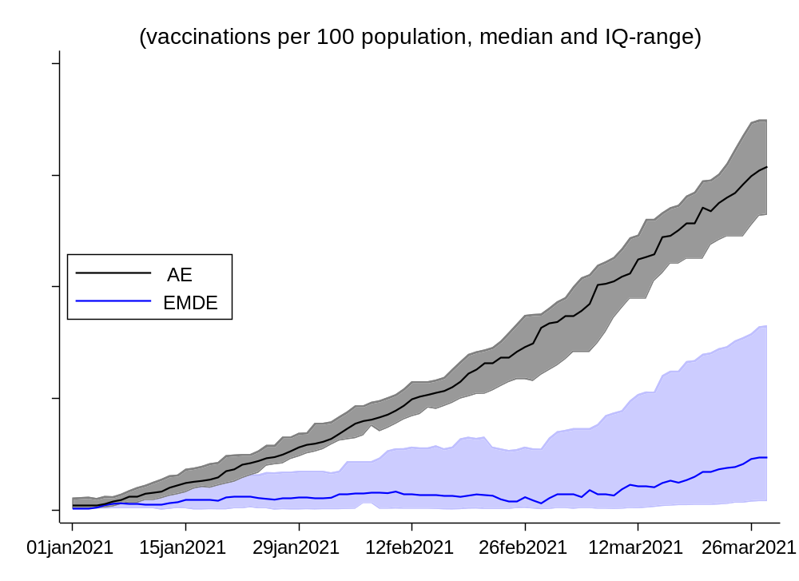

EXT. FIGURE A2. Cumulative Effect of Vaccines (one dose) on COVID-19 Cases and Economic Activity
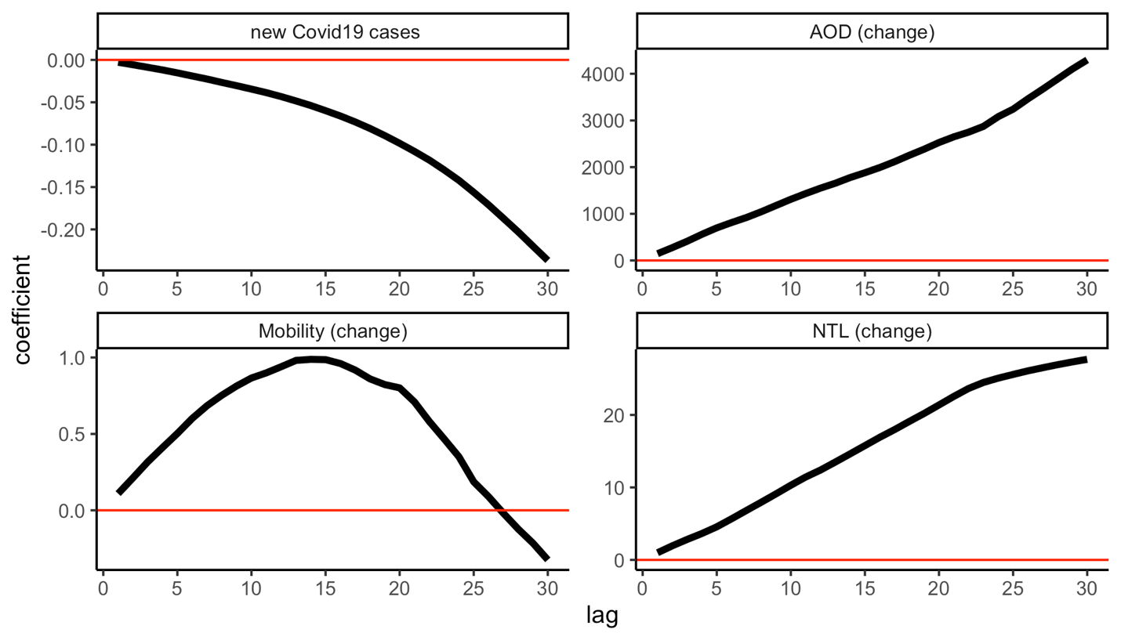

Note: the figures above denote the cumulative effect of vaccines (one dose) on COVID-19 cases and economic activity through a rolling sum of coefficients $β$, reported for each lag $l$ (1-30), and based on ${∆C}_{i,j,t}= α+ u_{i}+μ_{j,t}+ βV_{i,j,t-l}+ θX_{i,j,t-1}+ ε_{i,j,t}$ for a sample of 17 countries (314 states) using daily data from December 21, 2020–February 28, 2021. $C_{i,j,t}$ alternatively denotes: the number of new COVID-19 infections as share of population, night-time lights and AOD per capita and google mobility in region i and country j at day t. $V_{i,j,t}$ denotes the share of individuals in the population which have received one vaccine shot. $u_{i}$ are country-fixed effects, $μ_{j,t}$ are country-time fixed effects. $X$ is a vector of control variables which includes the level of new cases and economic indicators at t-1.

EXT. FIGURE A3. Effect of Vaccines (one dose) on COVID-19 Cases and Economic Activity (including region-specific time trends)
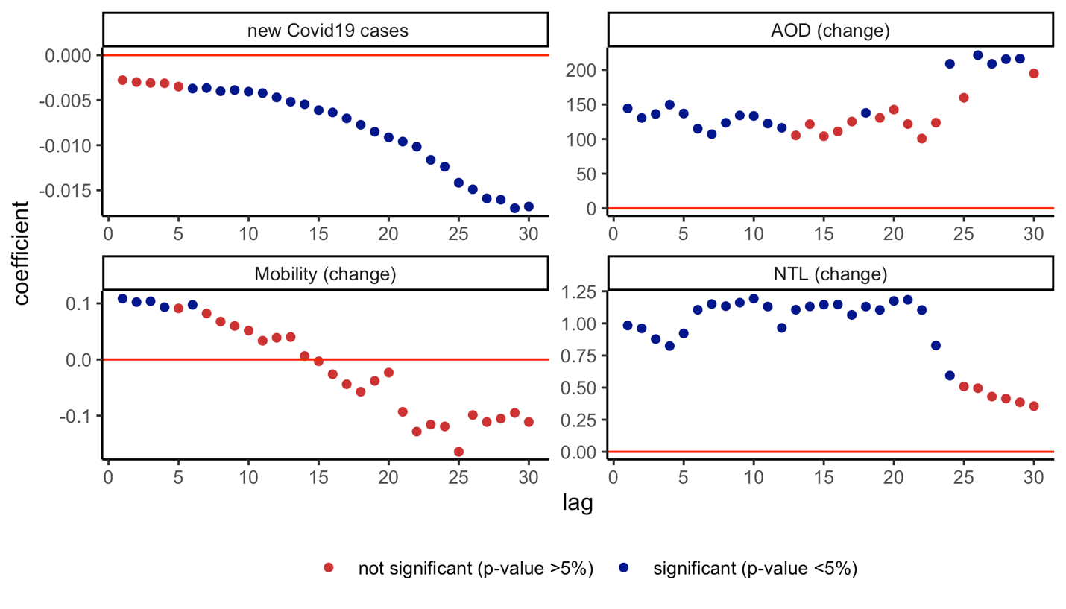

Note: Coefficient $β$ is reported for each lag $l$ (1-30), and based on ${∆C}_{i,j,t}= α+ u_{i}+μ_{j,t}+ βV_{i,j,t-l}+ θX_{i,j,t-1}+ ε_{i,j,t}$ for a sample of 17 countries (314 states) using daily data from December 21, 2020–February 28, 2021. Time trends are included. $C_{i,j,t}$ alternatively denotes: the number of new COVID-19 infections as share of population, night-time lights and AOD per capita and google mobility in region i and country j at day t. $V_{i,j,t}$ denotes the share of individuals in the population which have received one vaccine shot. $u_{i}$ are country-fixed effects, $μ_{j,t}$ are country-time fixed effects. $X$ is a vector of control variables which includes the level of new cases and economic indicators at t-1.

EXT. FIGURE A4. Effect of Vaccines (one dose) on COVID-19 Cases and Economic Activity (with winsorizing of dependent variables)
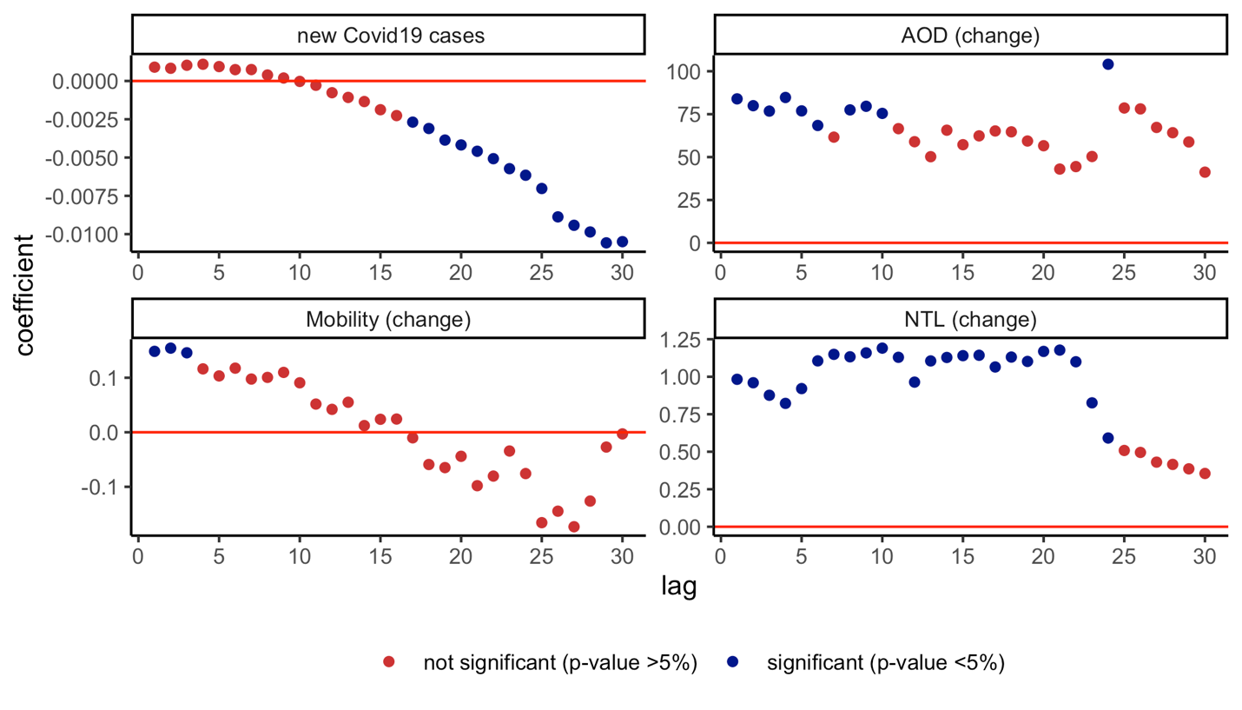

Note: Coefficient $β$ is reported for each lag $l$ (1-30), and based on ${∆C}_{i,j,t}= α+ u_{i}+μ_{j,t}+ βV_{i,j,t-l}+ θX_{i,j,t-1}+ ε_{i,j,t}$ for a sample of 17 countries (314 states) using daily data from December 21, 2020–February 28, 2021. The dependent variable is winsorized to the 99th percentile of the distribution. $C_{i,j,t}$ alternatively denotes: the number of new COVID-19 infections as share of population, night-time lights and AOD per capita and google mobility in region i and country j at day t. $V_{i,j,t}$ denotes the share of individuals in the population which have received one vaccine shot. $u_{i}$ are country-fixed effects, $μ_{j,t}$ are country-time fixed effects. $X$ is a vector of control variables which includes the level of new cases and economic indicators at t-1.

EXT. FIGURE A5. Effect of Vaccines (one dose) on COVID-19 Cases and Economic Activity (excluding one country at a time)
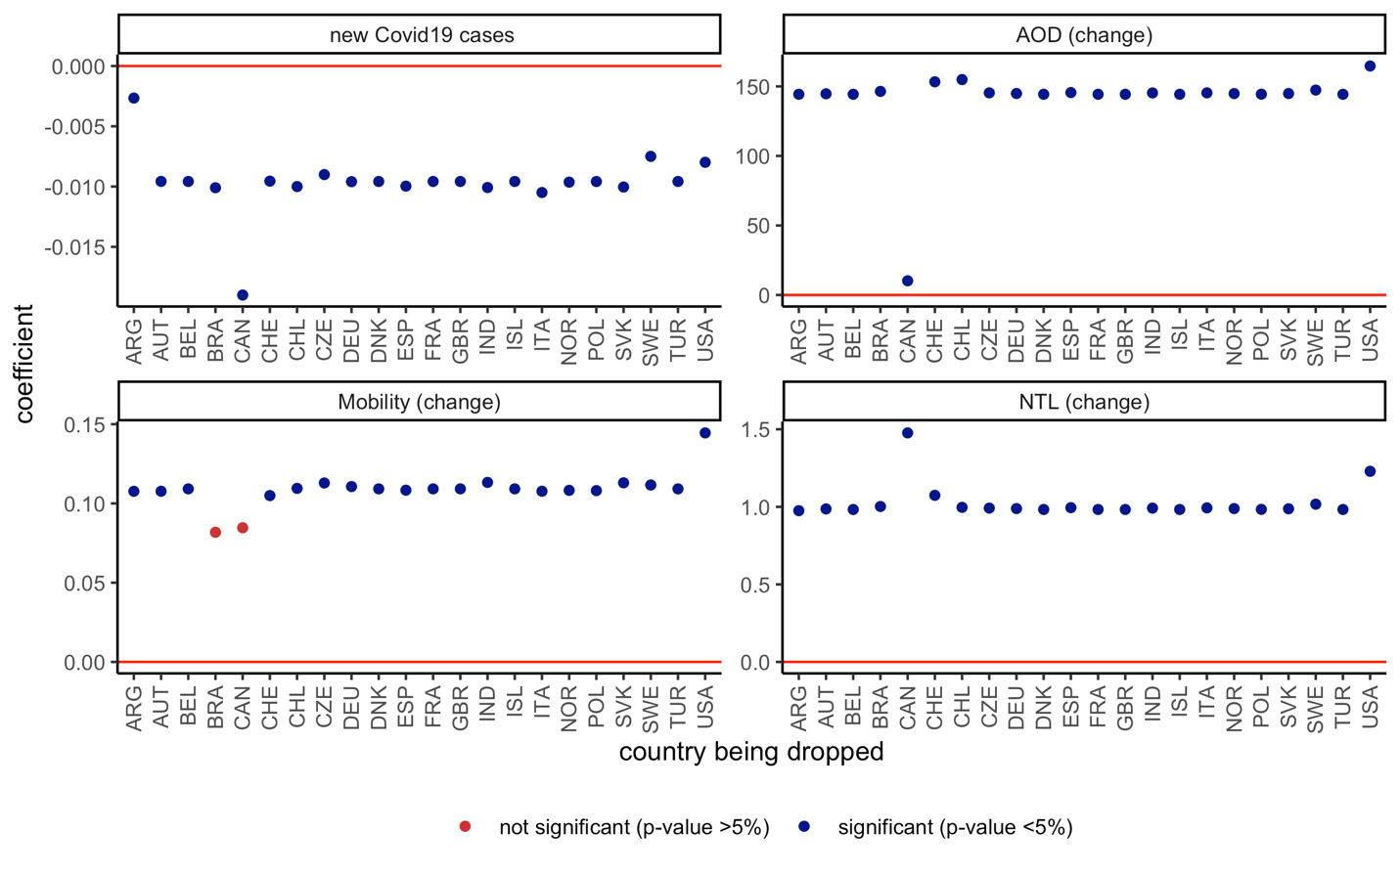

Note: Coefficient $β$ is reported based on ${∆C}_{i,j,t}= α+ u_{i}+μ_{j,t}+ βV_{i,j,t-l}+ θX_{i,j,t-1}+ ε_{i,j,t}$ for a sample of 17 countries (314 states) using daily data from December 21, 2020–February 28, 2021. $C_{i,j,t}$ alternatively denotes: the number of new COVID-19 infections as share of population, night-time lights and AOD per capita and google mobility in region i and country j at day t. $V_{i,j,t}$ denotes the share of individuals in the population which have received one vaccine shot. $u_{i}$ are country-fixed effects, $μ_{j,t}$ are country-time fixed effects. $X$ is a vector of control variables which includes the level of new cases and economic indicators at t-1. Regression is run excluding one country at a time. For the night-time light estimation where Chile is dropped, we keep all observations where the change in the night-time light series is smaller than 500 (this threshold is equal to 2 for all other night-time light per capita estimations). Results are reported for lag $l$= 21 if $C_{i,j,t}$ is COVID-19 infections, and lag $l$= 1 if $C_{i,j,t}$ is night-time lights and AOD per capita, or mobility.

EXT. FIGURE A6. Vaccine Rollout and Vaccine Procurement—cross-country
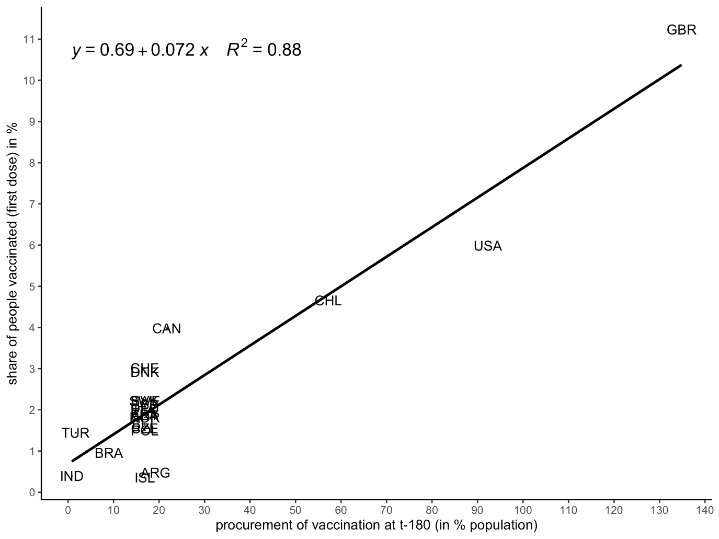

EXT. FIGURE A7. Vaccine Rollout and Vaccine Procurement— within each country
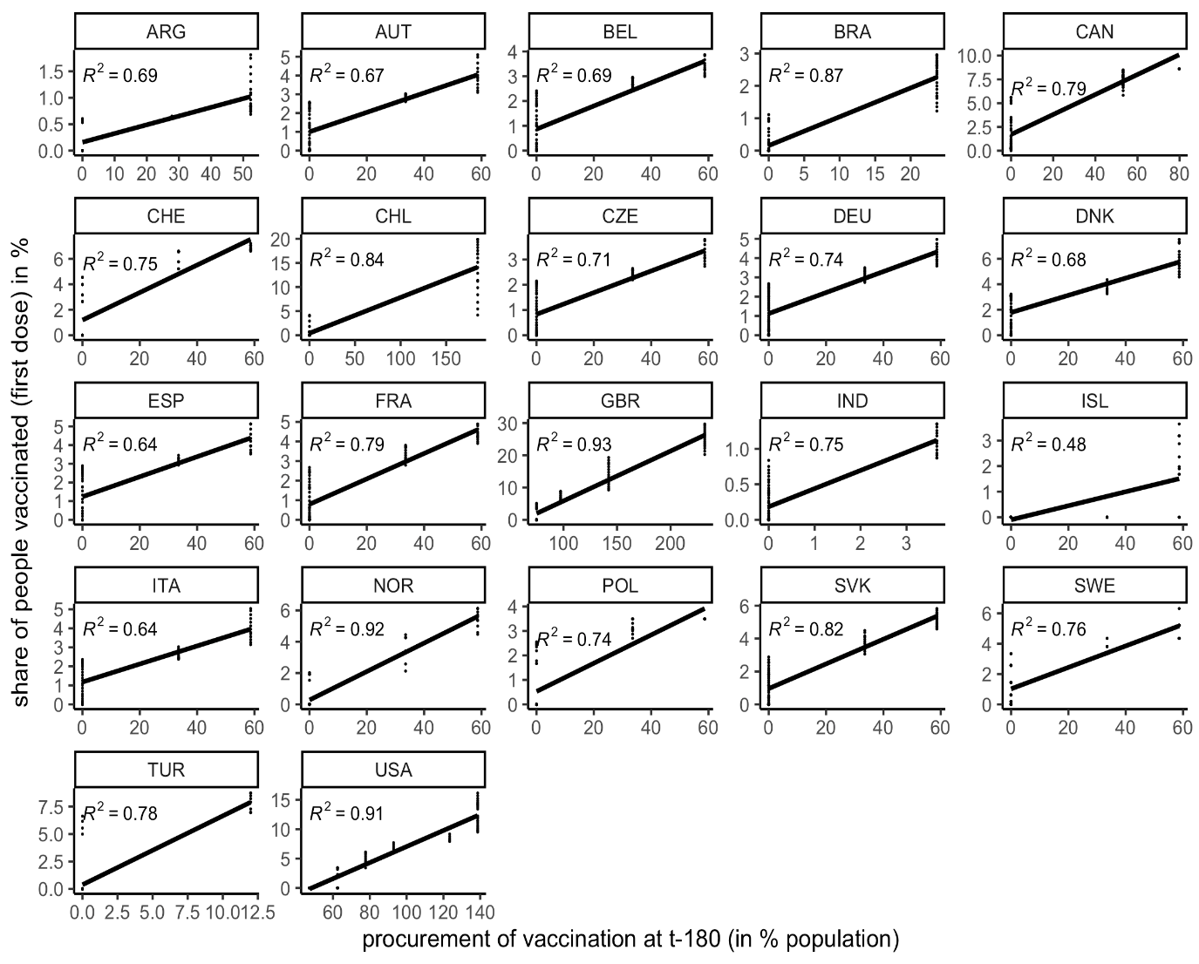

EXT. FIGURE A8. Progress in Vaccine Rollout across regions – High vs. Low Number of Hospitals
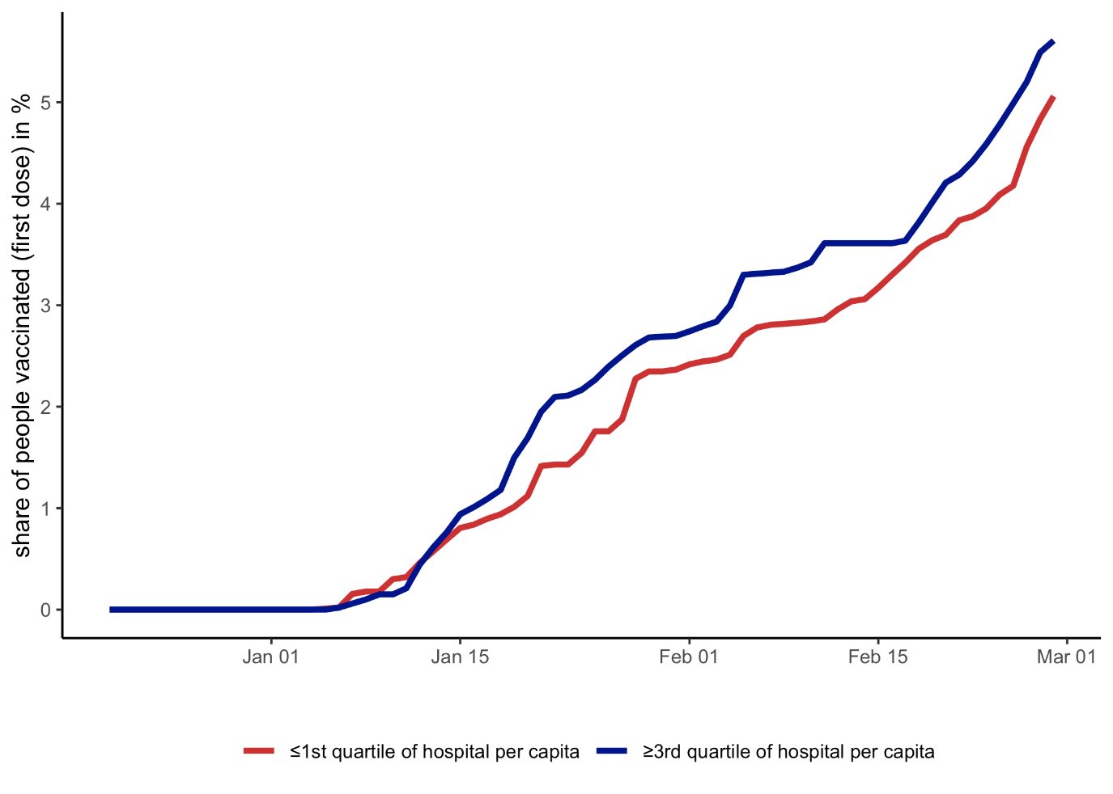

EXT. FIGURE A9. Progress in Vaccine Rollout across regions – High vs. Low Number of Hospitals, by County
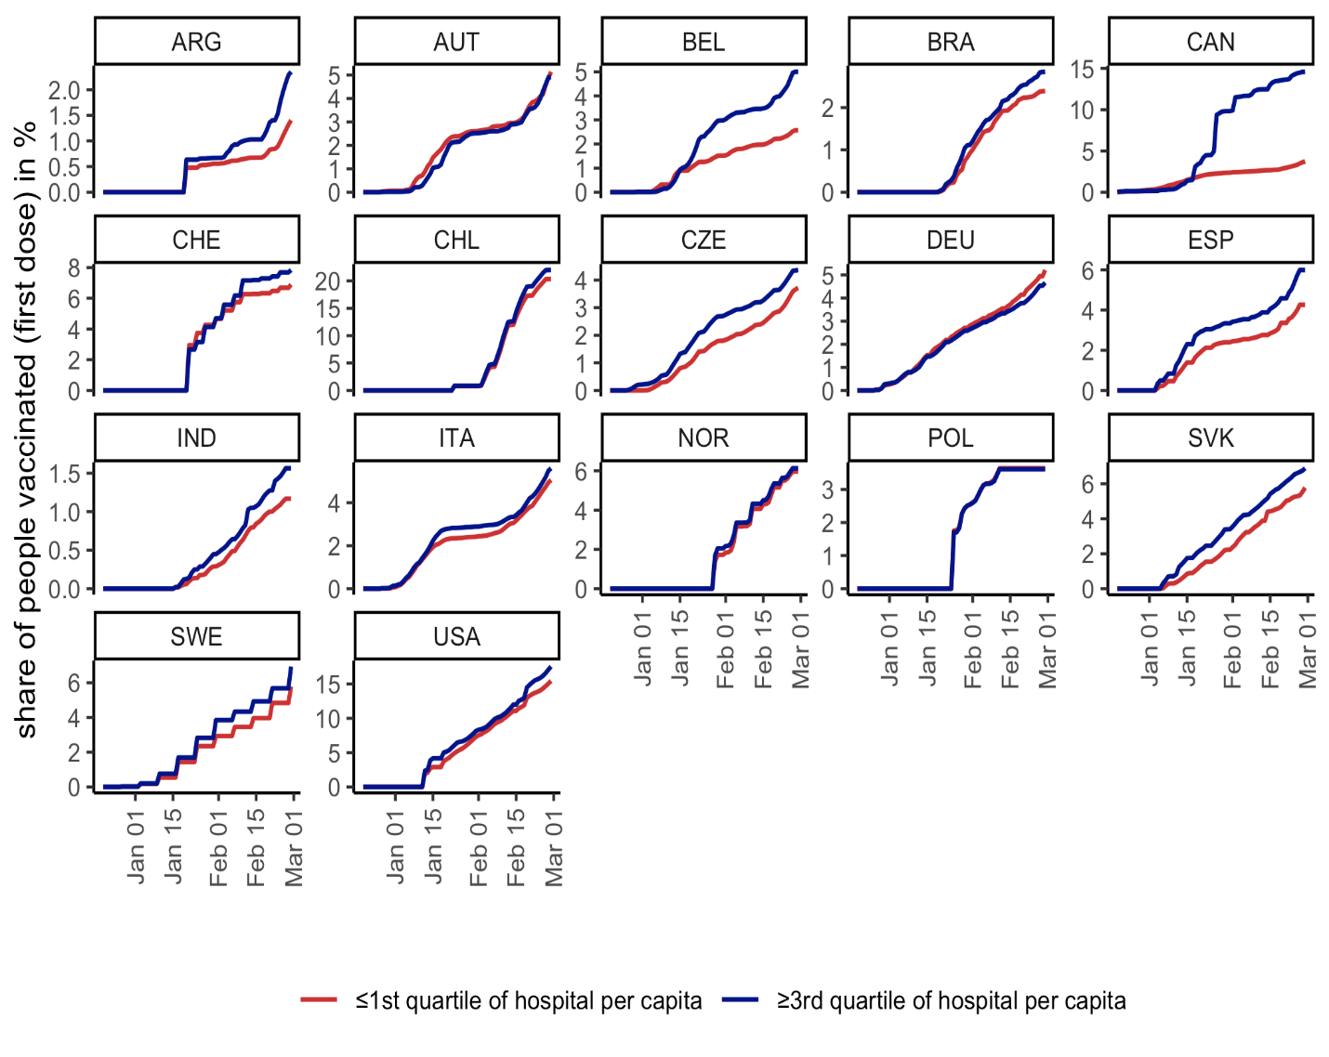

EXT. FIGURE A10. Instrumental Variable – Effect of Vaccines (one dose) on COVID-19 Cases and Economic Activity, with vaccine procurements 150 days prior
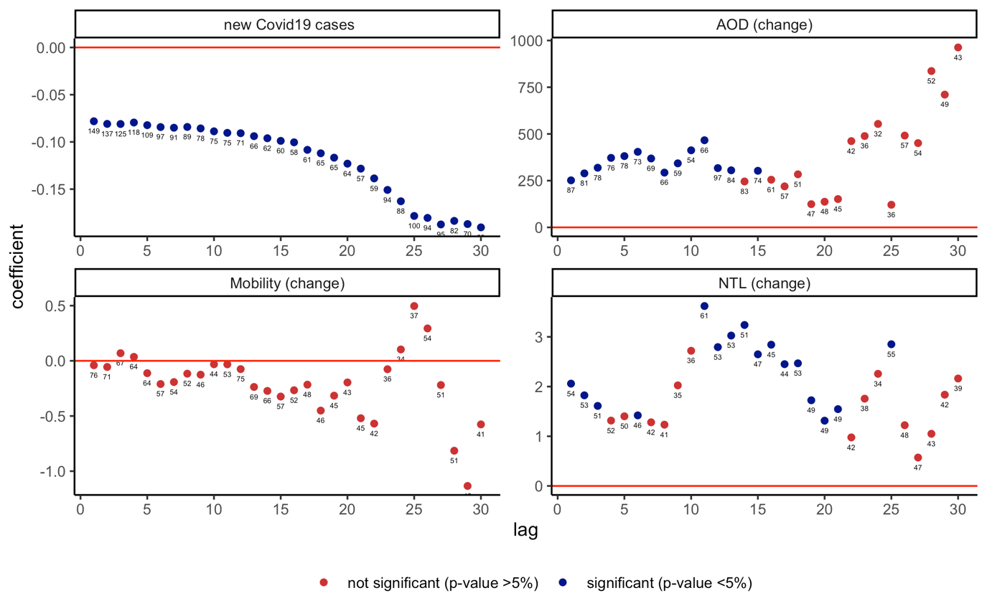

Note: Coefficient $β$ is reported for each lag $l$ (1-30), and based on $C_{i,j,t}= α+ u_{i}+μ_{j,t}+ β{\hat{V}}_{i,j,t-l}+ θX_{i,j,t-1}+ ε_{i,j,t}$ , with $V_{i,j,t}= α+ u_{i}+μ_{j,t}+ δZ_{jt-120}*R_{i}+ θX_{i,j,t-1}+ ε_{i,j,t}$ , for a sample of 17 countries (314 states) using daily data from December 21, 2020–February 28, 2021. $V_{i,j,t}$ denotes the cumulative number of vaccine deals/procurement made in country j 150 days before vaccine administration at time t, and $R_{i}$ denotes the number of hospitals per capita (in logs). $C_{i,j,t}$ alternatively denotes: the number of new COVID-19 infections as share of population, night-time lights and AOD per capita and google mobility in region i and country j at day t. $u_{i}$ are country-fixed effects, $μ_{j,t}$ are country-time fixed effects. $X$ is a vector of control variables which includes the level of new cases and economic indicators at t-1. Standard errors clustered at the country-date level in parentheses. ***, **, * denote statistical significance at 1 percent, 5 percent, and 10 percent, respectively. Numbers above dots denote the corresponding Kleibergen‒Paap rk Wald F statistic.

EXT. FIGURE A11. Instrumental Variable – Effect of Vaccines (one dose) on COVID-19 Cases and Economic Activity, with vaccine procurements 120 days prior
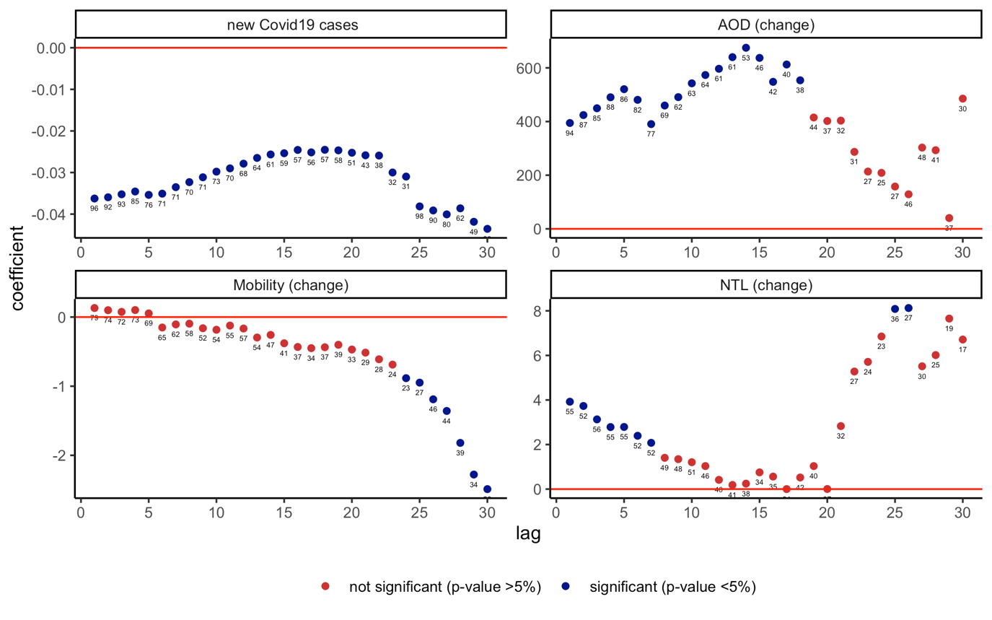

Note: Coefficient $β$ is reported for each lag $l$ (1-30), and based on $C_{i,j,t}= α+ u_{i}+μ_{j,t}+ β{\hat{V}}_{i,j,t-l}+ θX_{i,j,t-1}+ ε_{i,j,t}$ , with $V_{i,j,t}= α+ u_{i}+μ_{j,t}+ δZ_{jt-120}*R_{i}+ θX_{i,j,t-1}+ ε_{i,j,t}$ , for a sample of 17 countries (314 states) using daily data from December 21, 2020–February 28, 2021. $V_{i,j,t}$ denotes the cumulative number of vaccine deals/procurement made in country j 120 days before vaccine administration at time t, and $R_{i}$ denotes the number of hospitals per capita (in logs). $C_{i,j,t}$ alternatively denotes: the number of new COVID-19 infections as share of population, night-time lights and AOD per capita and google mobility in region i and country j at day t. $u_{i}$ are country-fixed effects, $μ_{j,t}$ are country-time fixed effects. $X$ is a vector of control variables which includes the level of new cases and economic indicators at t-1. Standard errors clustered at the country-date level in parentheses. ***, **, * denote statistical significance at 1 percent, 5 percent, and 10 percent, respectively. Numbers above dots denote the corresponding Kleibergen‒Paap rk Wald F statistic.

EXT. FIGURE A12. Instrumental Variable – Effect of Vaccines (one dose) on COVID-19 Cases and Economic Activity, with vaccine procurements 180 days prior and hospitals per capita, with current NPI controls
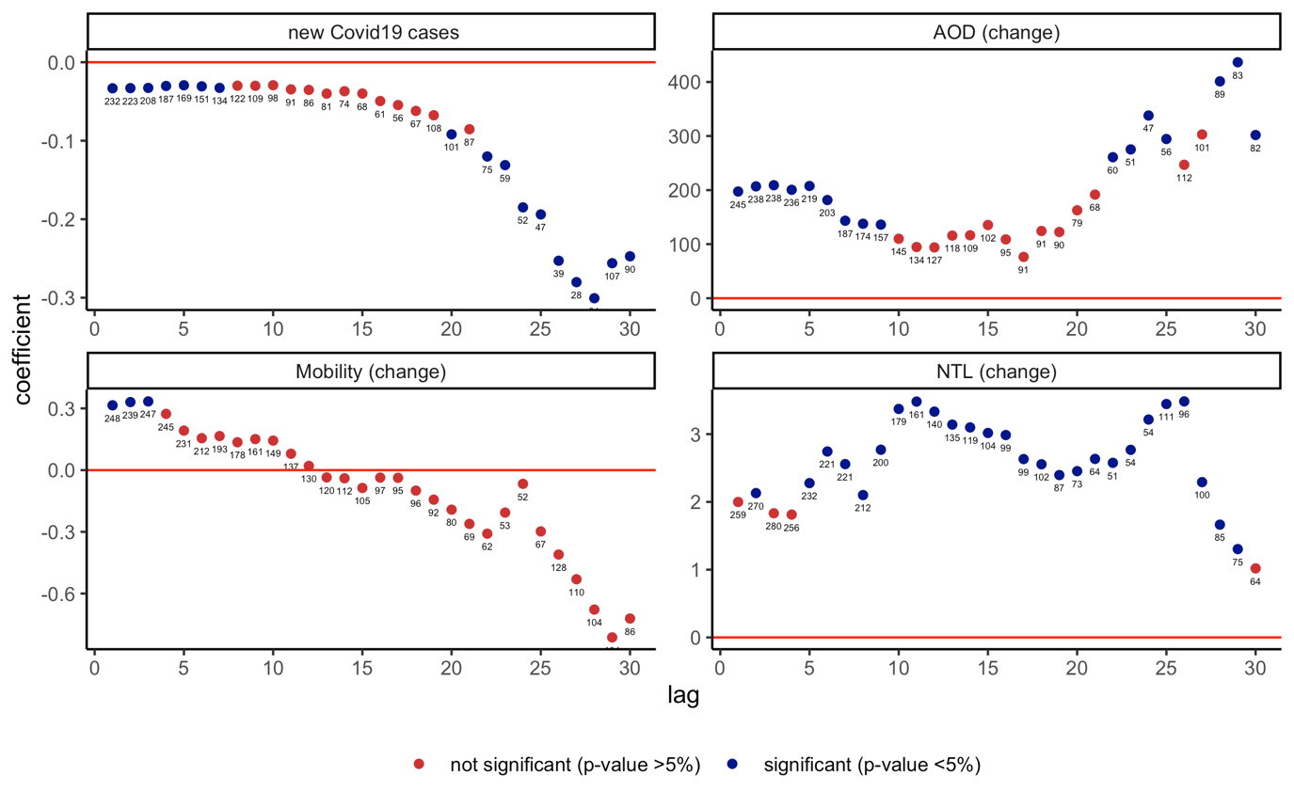

Note: Coefficient $β$ is reported for each lag $l$ (1-30), and based on $C_{i,j,t}= α+ u_{i}+μ_{j,t}+ β{\hat{V}}_{i,j,t-l}+ θX_{i,j,t-1}+ ε_{i,j,t}$ , with $V_{i,j,t}= α+ u_{i}+μ_{j,t}+ δZ_{jt-180}*R_{i}+ θX_{i,j,t-1}+ ε_{i,j,t}$ , for a sample of 17 countries (314 states) using daily data from December 21, 2020–February 28, 2021. $V_{i,j,t}$ denotes the cumulative number of vaccine deals/procurement made in country j 180 days before vaccine administration at time t, and $R_{i}$ denotes the number of hospitals per capita (in logs) * NPIs in place. $C_{i,j,t}$ alternatively denotes: the number of new COVID-19 infections as share of population, night-time lights and AOD per capita and google mobility in region i and country j at day t. $u_{i}$ are country-fixed effects, $μ_{j,t}$ are country-time fixed effects. $X$ is a vector of control variables which includes the level of new cases and economic indicators at t-1. Standard errors clustered at the country-date level in parentheses. ***, **, * denote statistical significance at 1 percent, 5 percent, and 10 percent, respectively. Numbers above dots denote the corresponding Kleibergen‒Paap rk Wald F statistic.

EXT. FIGURE A13. Instrumental Variable – Effect of Vaccines (one dose) on COVID-19 Cases and Economic Activity, with vaccine procurements 180 days prior and hospitals per capita, with past NPI and health and economic indicators as controls
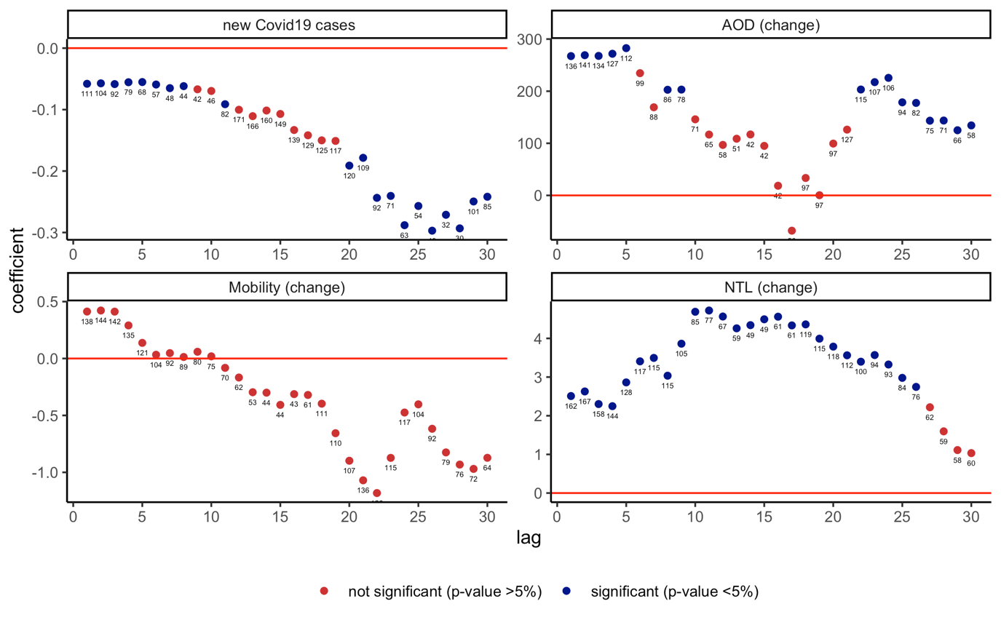

Note: Coefficient $β$ is reported for each lag $l$ (1-30), and based on $C_{i,j,t}= α+ u_{i}+μ_{j,t}+ β{\hat{V}}_{i,j,t-l}+ θX_{i,j,t-1}+ ε_{i,j,t}$ , with $V_{i,j,t}= α+ u_{i}+μ_{j,t}+ δZ_{jt-180}*R_{i}+ θX_{i,j,t-1}+ ε_{i,j,t}$ , for a sample of 17 countries (314 states) using daily data from December 21, 2020–February 28, 2021. $V_{i,j,t}$ denotes the cumulative number of vaccine deals/procurement made in country j 180 days before vaccine administration at time t, and $R_{i}$ denotes the number of hospitals per capita (in logs) * NPIs in place. $C_{i,j,t}$ alternatively denotes: the number of new COVID-19 infections as share of population, night-time lights and AOD per capita and google mobility in region i and country j at day t. $u_{i}$ are country-fixed effects, $μ_{j,t}$ are country-time fixed effects. $X$ is a vector of control variables which includes the level of new cases and economic indicators at t-1. Standard errors clustered at the country-date level in parentheses. ***, **, * denote statistical significance at 1 percent, 5 percent and 10 percent, respectively. Numbers above dots denote the corresponding Kleibergen‒Paap rk Wald F statistic

