Interactive analysis and exploration of cell-cell communication in single-cell transcriptomics with InterCellar

Marta Interlandi¹,²*, Kornelius Kerl² and Martin Dugas¹,³

Supplementary Information

Supplementary Figures

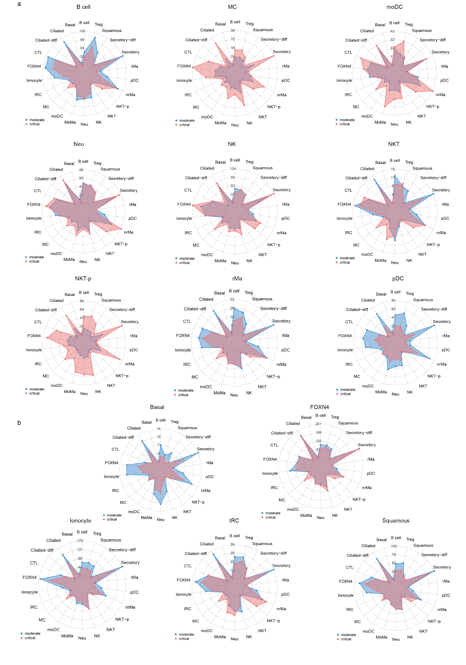
Supplementary Figure 1. InterCellar generates comprehensive insights on the number of interactions per cell cluster. Relative differences in the number of interactions are shown using radar plots, in the comparison between COVID-19 moderate and critical cases. Each plot displays the number of interactions between a specific cell type and all other cell types participating in the communication. A subset of cell types belonging to the immune group is reported in (a), while a subset of epithelial-related cell types is shown in (b).
Cell types are abbreviated as: -diff - differentiating; CTL - cytotoxic T cell; FOXN4 - FOXN4+ epithelial cells; IRC - IFNG responsive cell; MC - mast cell; moDC - monocyte-derived dendritic cell; MoMa - monocyte-derived macrophage; Neu - neutrophil; NK - natural killer cell; NKT - NK T cell; NKT-p - proliferating NKT; nrMa - non-resident macrophage; pDC - plasmacytoid dendritic cell; rMa - resident macrophage; Treg - regulatory T cell.

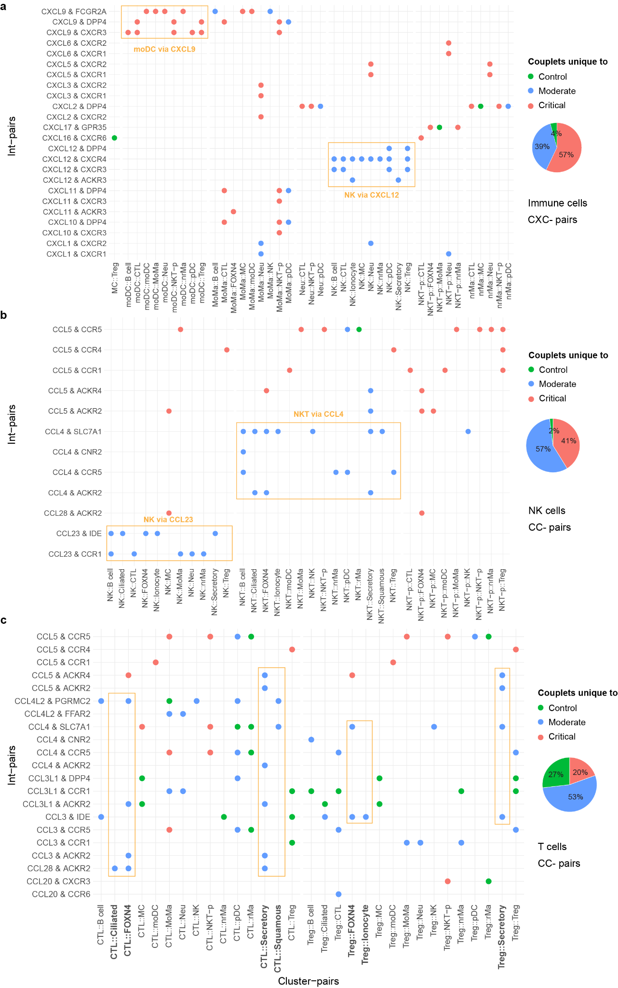
Supplementary Figure 2. InterCellar allows in-depth analysis of interaction pairs and their enriched cell clusters. (a) Int-pairs belonging to the CXC-chemokine subfamily are evaluated in immune cell clusters. The dot plot represents only unique occurrences of int-pair/cluster-pair couplets, for each phenotype (control, moderate, critical). The overall contribution of each phenotype is summarized in a pie chart. (b) Int-pairs belonging to the CC-chemokine subfamily are evaluated in NK, NKT and NKT-p cell clusters. As in (a), only unique couplets are represented in the dot plot and overall contributions by phenotype are summarized in a pie chart. (c) As in (b), but focusing on T cells (CTL and Tregs).

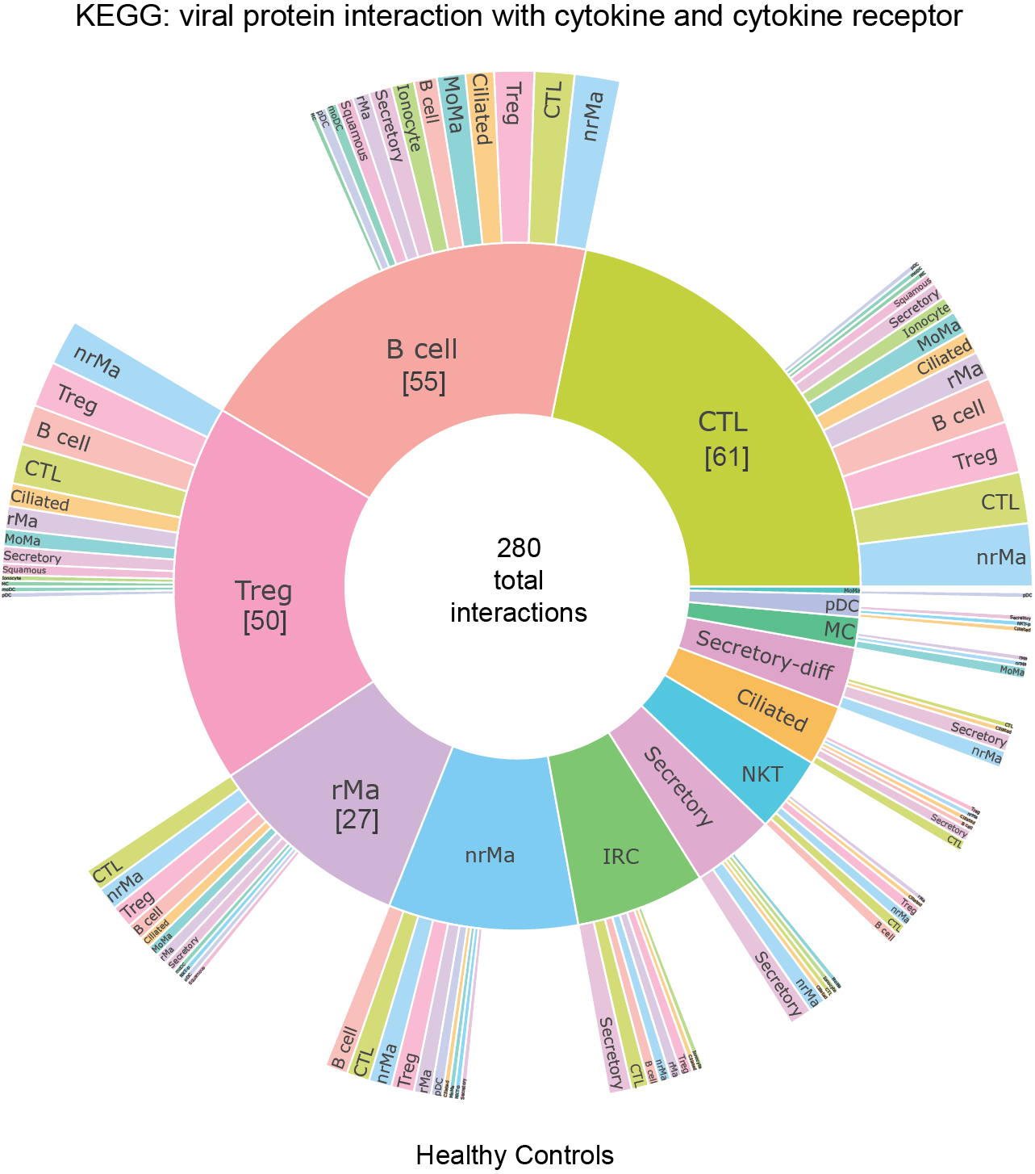
Supplementary Figure 3. InterCellar associates cell-cell communication with biological pathways. Sunburst plot for the selected functional term “viral protein interaction with cytokine and cytokine receptor”, in control healthy cases. Only int-pairs annotated to the selected functional term are considered in the generation of the plot. For a generic int-pair ‘geneA & geneB’, enriched in ‘cluster1::cluster2’, the first cell cluster (cluster1, expressing geneA) is represented in the inner circle, while the second (cluster2, expressing geneB) is shown in the outer circle. The width of each section indicates the relative fraction of int-pairs enriched in that cell type. Sections are arranged in descending order, counterclockwise. The total numbers of interactions per cell type are reported in brackets.

Supplementary Tables

 | Implementation | Standalone app | App web address | Data type | DOI | Source code
CCCExplorer | Java | YES | N/A | bulk RNA-seq | 10.1016/j.celrep.2015.01.040 | https://github.com/methodistsmab/CCCExplorer
CellChat | R | YES | http://www.cellchat.org/ | scRNA-seq | 10.1038/s41467-021-21246-9 | https://github.com/sqjin/CellChat
Cellinker | HTML/PHP + mySQL | YES | http://www.rna-society.org/cellinker/ | scRNA-seq | 10.1093/bioinformatics/btab036 | N/A
CellPhoneDB | Python | disabled upload | https://www.cellphonedb.org/explore-sc-rna-seq | scRNA-seq | 10.1038/s41596-020-0292-x | https://github.com/Teichlab/cellphonedb
CellTalker | R | NO | N/A | scRNA-seq | 10.1016/j.immuni.2019.11.014 | https://github.com/arc85/celltalker
COMUNET | R | NO | N/A | scRNA-seq | 10.1093/bioinformatics/btaa482 | https://github.com/ScialdoneLab/COMUNET
Connectome | R | NO | N/A | scRNA-seq | 10.1101/2021.01.21.427529 | https://github.com/msraredon/Connectome
CrossTalkeR | R | NO | N/A | scRNA-seq | 10.1101/2021.01.20.427390 | https://github.com/CostaLab/CrossTalkeR
ICELLNET | R | NO | N/A | scRNA-seq | 10.1101/2020.03.05.976878 | https://github.com/soumelis-lab/ICELLNET
iTALK | R | NO | N/A | scRNA-seq | 10.1101/507871 | https://github.com/Coolgenome/iTALK
NATMI | Python | NO | N/A | bulk and scRNA-seq | 10.1038/s41467-020-18873-z | https://github.com/forrest-lab/NATMI
NicheNet | R | NO | N/A | bulk and scRNA-seq | 10.1038/s41592-019-0667-5 | https://github.com/saeyslab/nichenetr
pyMINEr | Python | YES | https://www.sciencescott.com/pyminer | scRNA-seq | 10.1016/j.celrep.2019.01.063 | https://www.sciencescott.com/pyminer
scTensor | R | NO | N/A | scRNA-seq | 10.1101/566182 | https://github.com/rikenbit/scTensor
SingleCellSignalR | R | NO | N/A | scRNA-seq | 10.1093/nar/gkaa183 | https://github.com/SCA-IRCM/SingleCellSignalR_v1
SoptSC | R/MATLAB | NO | N/A | scRNA-seq | 10.1093/nar/gkz204 | https://mkarikom.github.io/RSoptSC/
SpaOTsc | Python | NO | N/A | scRNA-seq | 10.1038/s41467-020-15968-5 | https://github.com/zcang/SpaOTsc
talklr | R | YES (error) | https://yuliangwang.shinyapps.io/talklr/ | scRNA-seq | 10.1101/2020.02.01.930602 | https://github.com/yuliangwang/talklr

Supplementary Table 1. Collection of methods to predict and analyze cell-cell communication. The table contains 18 methods retrieved as of April 2021. All methods concern cell-cell communication prediction and/or analysis. The following information was collected: (a) programming language used for implementation; (b) whether the method is available as a standalone application (thus, not requiring programming skills to conduct the analysis); (c) corresponding web address of the application; (d) data type required for the prediction of cell-cell interactions; (e) DOI of the corresponding manuscript; and (f) web address of the source code. Five methods that do not require programming skills (shown with colored background) were compared to InterCellar. However, we could not assess the features of talklr, which could not be executed due to an error that occurred while importing the data (“Error: An error has occurred. Check your logs or contact the app author for clarification.”). We contacted the authors and are waiting for a reply.

