 | variable | definition
skeletal sagittal | SNA [°] | caudal angle between Sella, Nasion and point A
skeletal sagittal | SNB [°] | caudal angle between Sella, Nasion and point B
skeletal sagittal | ANB [°] | caudal angle between Nasion, point A and point B
skeletal sagittal | NSBa [°] | anterior angle between Nasion, Sella and Basion
skeletal sagittal | SNPg [°] | caudal angle between Sella, Nasion and Pogonion
skeletal sagittal | SN [mm] | linear distance between the points Sella and Nasion, describing the anterior skull base
skeletal sagittal | GoMe [mm] | linear distance between the points Gonion and Menton, describing the length of the mandible
skeletal sagittal | Wits [mm] | linear distance between perpendiculars from point A and point B on the occlusal plane, describing skeletal class
skeletal vertical | NL-ML [°] | anterior angle between the lines NL (Spa-Spp) and ML (T2-Me), describing the divergence of the jaw bases
skeletal vertical | ML-NSL [°] | anterior angle between the lines NSL (Nasion-Sella) and ML, describing the inclination of the mandible
skeletal vertical | NL-NSL [°] | anterior angle between lines NL and NSL, describing the inclination of the maxilla
skeletal vertical | PFH/AFH [%] | ratio between the posterior (PFH = distance Sella-Gonion) and anterior (AFH = distance Nasion-Menton) facial height
skeletal vertical | Gonion angle [°] | anterior angle between the lines ML and GoAr
skeletal vertical | Facial axis [°] | caudal angle between the lines NBa and PtGN’
dental | +1/NL [°] | anterior angle between the upper incisor’s tooth axis and the line NL
dental | +1/NSL [°] | anterior angle between the upper incisor’s tooth axis and the line NSL
dental | +1/NA [°] | caudal angle between the upper incisor’s tooth axis and the line NA
dental | +1/NA [mm] | linear perpendicular distance between the incisal edge of the upper incisor to the line NA, describing its sagittal position
dental | -1/ML [°] | anterior angle between the lower incisor’s tooth axis and the line ML, describing its inclination
dental | -1/NB [°] | caudal angle between the lower incisor’s tooth axis and the line NB, describing its inclination
dental | -1/NB [mm] | linear perpendicular distance between the lower incisor’s tooth axis and the line NB, describing its sagittal position
dental | Interincisal angle [°] | horizontal angle between the tooth axes of the upper and lower incisors, describing the relation of their inclination to each other
Supplementary Table 1.

Supplementary Table 2
Variable | Mean |  | SD |  | Min |  | Pctl. 25 |  | Pctl. 75 |  | Max
Variable | I | III | I | III | I | III | I | III | I | III | I | III
SNA [°] | 81 | 81 | 3.8 | 3.9 | 63 | 70 | 79 | 79 | 84 | 84 | 92 | 89
SNB [°] | 78 | 81 | 3.2 | 3.7 | 66 | 71 | 76 | 78 | 80 | 83 | 87 | 92
ANB [°] | 3.7 | 0.32 | 1.6 | 2.3 | -2.5 | -10 | 2.6 | -0.8 | 4.7 | 1.9 | 9 | 4.9
ANB_{ind} [°] | 3.6 | 3.6 | 1.4 | 1.5 | -3.2 | -0.72 | 2.8 | 2.7 | 4.5 | 4.7 | 7.8 | 7.2
Calculated_ANB [°] | 0.019 | -3.3 | 0.83 | 1.7 | -1.5 | -13 | -0.68 | -4 | 0.74 | -2.1 | 1.5 | -1.5
Wits appraisal [mm] | 0.26 | -4.1 | 2.3 | 3 | -6.4 | -18 | -1.3 | -5.6 | 1.7 | -2.3 | 8.6 | 3
S-N [mm] | 67 | 67 | 4.4 | 4.3 | 42 | 56 | 64 | 64 | 69 | 68 | 81 | 80
Go-Me [mm] | 67 | 70 | 5.3 | 6.2 | 43 | 54 | 63 | 66 | 70 | 72 | 85 | 90
NL-ML [°] | 24 | 25 | 5.8 | 5.4 | 5.3 | 11 | 20 | 21 | 27 | 28 | 46 | 40
NL-NSL [°] | 7.3 | 6.9 | 3.6 | 3.1 | -3.1 | -1.5 | 5.1 | 4.9 | 9.8 | 9.1 | 18 | 16
ML-NSL [°] | 31 | 32 | 6 | 6.1 | 16 | 14 | 27 | 27 | 35 | 36 | 52 | 48
PFH/AFH [%] | 67 | 66 | 5.1 | 5.3 | 50 | 54 | 63 | 63 | 71 | 70 | 80 | 84
Gonial_angle [°] | 123 | 125 | 5.8 | 6.5 | 101 | 103 | 119 | 122 | 126 | 129 | 139 | 142
Facial axis [°] | 90 | 92 | 4.3 | 4.7 | 76 | 80 | 88 | 89 | 93 | 95 | 101 | 105
NS-Ba [°] | 132 | 130 | 4.8 | 5.4 | 117 | 110 | 129 | 127 | 135 | 134 | 144 | 144
SN-Pg [°] | 79 | 82 | 3.3 | 3.9 | 67 | 72 | 76 | 79 | 81 | 84 | 88 | 94
+1/NL [°] | 68 | 65 | 8.1 | 7.1 | 37 | 46 | 64 | 61 | 73 | 69 | 94 | 85
+1/NSL [°] | 76 | 72 | 8.5 | 7.4 | 43 | 53 | 71 | 67 | 81 | 77 | 98 | 90
+1/NA [°] | 23 | 27 | 8 | 6.7 | 2.2 | 10 | 18 | 22 | 28 | 32 | 54 | 44
+1/NA [mm] | 3.7 | 5.1 | 2.6 | 2.5 | -2.4 | -1.3 | 1.9 | 3.7 | 5.3 | 6.5 | 11 | 14
-1/ML[°] | 84 | 90 | 6.7 | 7.6 | 65 | 68 | 79 | 85 | 88 | 94 | 105 | 111
-1/NB [°] | 25 | 23 | 6.9 | 7.4 | -1.1 | 2.5 | 21 | 18 | 30 | 28 | 44 | 42
-1/NB [mm] | 3.9 | 3.1 | 2.4 | 2.4 | -3.3 | -2.8 | 2.2 | 1.7 | 5.6 | 4.8 | 12 | 11
Interincisal angle [°] | 128 | 130 | 12 | 12 | 96 | 94 | 120 | 123 | 135 | 137 | 172 | 162
SD = standard deviation, Min = Minimum, Max = Maximum

Supplementary Table 3.
Parameter | Groups | diff | lwr | upr | p adj
SNB [°] | III_Female-I_Female | 3.19 | 2.09 | 4.29 | 0.00
SNB [°] | III_Male-I_Female | 3.23 | 2.06 | 4.41 | 0.00
SNB [°] | III_Female-I_Male | 2.98 | 1.83 | 4.14 | 0.00
SNB [°] | III_Male-I_Male | 3.03 | 1.81 | 4.25 | 0.00
SNB [°] | III_0<Age<13-I_0<Age<13 | 3.17 | 2.12 | 4.22 | 0.00
SNB [°] | III_14<Age<20-I_0<Age<13 | 3.51 | 1.70 | 5.33 | 0.00
SNB [°] | III_Age>21-I_0<Age<13 | 4.06 | 1.73 | 6.39 | 0.00
SNB [°] | III_0<Age<13-I_14<Age<20 | 2.00 | 0.46 | 3.55 | 0.00
SNB [°] | III_14<Age<20-I_14<Age<20 | 2.35 | 0.21 | 4.49 | 0.02
SNB [°] | III_Age>21-I_14<Age<20 | 2.90 | 0.31 | 5.49 | 0.02
SNB [°] | III_0<Age<13-I_Age>21 | 2.85 | 0.15 | 5.56 | 0.03
SNB [°] | III_14<Age<20-I_Age>21 | 3.19 | 0.11 | 6.28 | 0.04
SNB [°] | III_Age>21-I_Age>21 | 3.75 | 0.33 | 7.16 | 0.02
SNB [°] | III_Female_0<Age<13-I_Female_0<Age<13 | 3.36 | 1.76 | 4.96 | 0.00
SNB [°] | III_Female_14<Age<20-I_Female_0<Age<13 | 3.55 | 0.35 | 6.74 | 0.02
SNB [°] | III_Female_Age>21-I_Female_0<Age<13 | 3.87 | 0.26 | 7.48 | 0.02
SNB [°] | III_Male_0<Age<13-I_Female_0<Age<13 | 3.22 | 1.42 | 5.02 | 0.00
SNB [°] | III_Male_14<Age<20-I_Female_0<Age<13 | 3.72 | 0.96 | 6.47 | 0.00
SNB [°] | III_Male_Age>21-I_Female_0<Age<13 | 4.61 | 0.60 | 8.61 | 0.01
SNB [°] | III_Female_0<Age<13-I_Male_0<Age<13 | 3.05 | 1.37 | 4.73 | 0.00
SNB [°] | III_Female_14<Age<20-I_Male_0<Age<13 | 3.24 | 0.01 | 6.47 | 0.05
SNB [°] | III_Male_0<Age<13-I_Male_0<Age<13 | 2.92 | 1.05 | 4.78 | 0.00
SNB [°] | III_Male_14<Age<20-I_Male_0<Age<13 | 3.41 | 0.61 | 6.21 | 0.00
SNB [°] | III_Male_Age>21-I_Male_0<Age<13 | 4.30 | 0.26 | 8.34 | 0.03
ANB [°] | III_Female-I_Female | -3.20 | -3.80 | -2.59 | 0.00
ANB [°] | III_Male-I_Female | -3.60 | -4.24 | -2.95 | 0.00
ANB [°] | III_Female-I_Male | -3.12 | -3.75 | -2.49 | 0.00
ANB [°] | III_Male-I_Male | -3.52 | -4.19 | -2.85 | 0.00
ANB [°] | III_0<Age<13-I_0<Age<13 | -3.20 | -3.77 | -2.62 | 0.00
ANB [°] | III_14<Age<20-I_0<Age<13 | -3.10 | -4.09 | -2.11 | 0.00
ANB [°] | III_Age>21-I_0<Age<13 | -4.88 | -6.15 | -3.61 | 0.00
ANB [°] | III_0<Age<13-I_14<Age<20 | -3.20 | -4.04 | -2.36 | 0.00
ANB [°] | III_14<Age<20-I_14<Age<20 | -3.10 | -4.27 | -1.94 | 0.00
ANB [°] | III_Age>21-I_14<Age<20 | -4.89 | -6.30 | -3.47 | 0.00
ANB [°] | III_0<Age<13-I_Age>21 | -2.87 | -4.34 | -1.39 | 0.00
ANB [°] | III_14<Age<20-I_Age>21 | -2.77 | -4.45 | -1.08 | 0.00
ANB [°] | III_Age>21-I_Age>21 | -4.55 | -6.41 | -2.69 | 0.00
ANB [°] | III_Female_0<Age<13-I_Female_0<Age<13 | -3.07 | -3.94 | -2.20 | 0.00
ANB [°] | III_Female_14<Age<20-I_Female_0<Age<13 | -3.23 | -4.97 | -1.50 | 0.00
ANB [°] | III_Female_Age>21-I_Female_0<Age<13 | -4.40 | -6.36 | -2.44 | 0.00
ANB [°] | III_Male_0<Age<13-I_Female_0<Age<13 | -3.51 | -4.49 | -2.53 | 0.00
ANB [°] | III_Male_14<Age<20-I_Female_0<Age<13 | -3.10 | -4.60 | -1.61 | 0.00
ANB [°] | III_Male_Age>21-I_Female_0<Age<13 | -5.62 | -7.80 | -3.44 | 0.00
ANB [°] | III_Female_0<Age<13-I_Female_14<Age<20 | -2.95 | -4.24 | -1.67 | 0.00
ANB [°] | III_Female_14<Age<20-I_Female_14<Age<20 | -3.11 | -5.09 | -1.14 | 0.00
ANB [°] | III_Female_Age>21-I_Female_14<Age<20 | -4.28 | -6.46 | -2.10 | 0.00
ANB [°] | III_Male_0<Age<13-I_Female_14<Age<20 | -3.39 | -4.75 | -2.03 | 0.00
ANB [°] | III_Male_14<Age<20-I_Female_14<Age<20 | -2.98 | -4.75 | -1.21 | 0.00
ANB [°] | III_Male_Age>21-I_Female_14<Age<20 | -5.50 | -7.87 | -3.12 | 0.00
ANB [°] | III_Female_0<Age<13-I_Female_Age>21 | -2.54 | -4.79 | -0.30 | 0.01
ANB [°] | III_Female_14<Age<20-I_Female_Age>21 | -2.70 | -5.41 | 0.00 | 0.05
ANB [°] | III_Female_Age>21-I_Female_Age>21 | -3.87 | -6.72 | -1.02 | 0.00
ANB [°] | III_Male_0<Age<13-I_Female_Age>21 | -2.98 | -5.27 | -0.70 | 0.00
ANB [°] | III_Male_14<Age<20-I_Female_Age>21 | -2.57 | -5.13 | -0.02 | 0.05
ANB [°] | III_Male_Age>21-I_Female_Age>21 | -5.09 | -8.09 | -2.08 | 0.00
ANB [°] | III_Female_0<Age<13-I_Male_0<Age<13 | -2.93 | -3.84 | -2.02 | 0.00
ANB [°] | III_Female_14<Age<20-I_Male_0<Age<13 | -3.09 | -4.85 | -1.33 | 0.00
ANB [°] | III_Female_Age>21-I_Male_0<Age<13 | -4.26 | -6.24 | -2.28 | 0.00
ANB [°] | III_Male_0<Age<13-I_Male_0<Age<13 | -3.37 | -4.39 | -2.36 | 0.00
ANB [°] | III_Male_14<Age<20-I_Male_0<Age<13 | -2.96 | -4.48 | -1.44 | 0.00
ANB [°] | III_Male_Age>21-I_Male_0<Age<13 | -5.48 | -7.67 | -3.28 | 0.00
ANB [°] | III_Female_0<Age<13-I_Male_14<Age<20 | -3.10 | -4.50 | -1.70 | 0.00
ANB [°] | III_Female_14<Age<20-I_Male_14<Age<20 | -3.26 | -5.32 | -1.21 | 0.00
ANB [°] | III_Female_Age>21-I_Male_14<Age<20 | -4.43 | -6.68 | -2.18 | 0.00
ANB [°] | III_Male_0<Age<13-I_Male_14<Age<20 | -3.54 | -5.02 | -2.07 | 0.00
ANB [°] | III_Male_14<Age<20-I_Male_14<Age<20 | -3.13 | -4.99 | -1.28 | 0.00
ANB [°] | III_Male_Age>21-I_Male_14<Age<20 | -5.65 | -8.09 | -3.21 | 0.00
ANB [°] | III_Female_0<Age<13-I_Male_Age>21 | -2.86 | -5.42 | -0.30 | 0.01
ANB [°] | III_Female_14<Age<20-I_Male_Age>21 | -3.03 | -5.99 | -0.06 | 0.04
ANB [°] | III_Female_Age>21-I_Male_Age>21 | -4.19 | -7.30 | -1.09 | 0.00
ANB [°] | III_Male_0<Age<13-I_Male_Age>21 | -3.31 | -5.90 | -0.71 | 0.00
ANB [°] | III_Male_14<Age<20-I_Male_Age>21 | -2.89 | -5.73 | -0.06 | 0.04
ANB [°] | III_Male_Age>21-I_Male_Age>21 | -5.41 | -8.65 | -2.16 | 0.00
Calculated_ANB | III_Female-I_Female | -3.21 | -3.60 | -2.83 | 0.00
Calculated_ANB | III_Male-I_Female | -3.49 | -3.90 | -3.08 | 0.00
Calculated_ANB | III_Female-I_Male | -3.12 | -3.53 | -2.72 | 0.00
Calculated_ANB | III_Male-I_Male | -3.40 | -3.83 | -2.97 | 0.00
Calculated_ANB | III_0<Age<13-I_0<Age<13 | -3.21 | -3.58 | -2.84 | 0.00
Calculated_ANB | III_14<Age<20-I_0<Age<13 | -3.13 | -3.76 | -2.50 | 0.00
Calculated_ANB | III_Age>21-I_0<Age<13 | -4.49 | -5.30 | -3.68 | 0.00
Calculated_ANB | III_0<Age<13-I_14<Age<20 | -3.10 | -3.63 | -2.56 | 0.00
Calculated_ANB | III_14<Age<20-I_14<Age<20 | -3.01 | -3.76 | -2.27 | 0.00
Calculated_ANB | III_Age>21-I_14<Age<20 | -4.38 | -5.28 | -3.48 | 0.00
Calculated_ANB | III_0<Age<13-I_Age>21 | -2.88 | -3.83 | -1.94 | 0.00
Calculated_ANB | III_14<Age<20-I_Age>21 | -2.80 | -3.88 | -1.73 | 0.00
Calculated_ANB | III_Age>21-I_Age>21 | -4.17 | -5.36 | -2.98 | 0.00
Calculated_ANB | III_Female_0<Age<13-I_Female_0<Age<13 | -3.20 | -3.75 | -2.64 | 0.00
Calculated_ANB | III_Female_14<Age<20-I_Female_0<Age<13 | -2.83 | -3.93 | -1.72 | 0.00
Calculated_ANB | III_Female_Age>21-I_Female_0<Age<13 | -4.42 | -5.67 | -3.17 | 0.00
Calculated_ANB | III_Male_0<Age<13-I_Female_0<Age<13 | -3.40 | -4.02 | -2.77 | 0.00
Calculated_ANB | III_Male_14<Age<20-I_Female_0<Age<13 | -3.47 | -4.42 | -2.51 | 0.00
Calculated_ANB | III_Male_Age>21-I_Female_0<Age<13 | -4.75 | -6.14 | -3.36 | 0.00
Calculated_ANB | III_Female_0<Age<13-I_Female_14<Age<20 | -2.89 | -3.70 | -2.07 | 0.00
Calculated_ANB | III_Female_14<Age<20-I_Female_14<Age<20 | -2.52 | -3.77 | -1.26 | 0.00
Calculated_ANB | III_Female_Age>21-I_Female_14<Age<20 | -4.11 | -5.49 | -2.72 | 0.00
Calculated_ANB | III_Male_0<Age<13-I_Female_14<Age<20 | -3.08 | -3.95 | -2.22 | 0.00
Calculated_ANB | III_Male_14<Age<20-I_Female_14<Age<20 | -3.16 | -4.28 | -2.03 | 0.00
Calculated_ANB | III_Male_Age>21-I_Female_14<Age<20 | -4.44 | -5.95 | -2.92 | 0.00
Calculated_ANB | III_Female_0<Age<13-I_Female_Age>21 | -2.86 | -4.29 | -1.44 | 0.00
Calculated_ANB | III_Female_14<Age<20-I_Female_Age>21 | -2.49 | -4.21 | -0.78 | 0.00
Calculated_ANB | III_Female_Age>21-I_Female_Age>21 | -4.09 | -5.90 | -2.27 | 0.00
Calculated_ANB | III_Male_0<Age<13-I_Female_Age>21 | -3.06 | -4.52 | -1.61 | 0.00
Calculated_ANB | III_Male_14<Age<20-I_Female_Age>21 | -3.13 | -4.76 | -1.51 | 0.00
Calculated_ANB | III_Male_Age>21-I_Female_Age>21 | -4.42 | -6.33 | -2.50 | 0.00
Calculated_ANB | III_Female_0<Age<13-I_Male_0<Age<13 | -3.03 | -3.61 | -2.45 | 0.00
Calculated_ANB | III_Female_14<Age<20-I_Male_0<Age<13 | -2.66 | -3.78 | -1.54 | 0.00
Calculated_ANB | III_Female_Age>21-I_Male_0<Age<13 | -4.25 | -5.51 | -2.99 | 0.00
Calculated_ANB | III_Male_0<Age<13-I_Male_0<Age<13 | -3.23 | -3.88 | -2.58 | 0.00
Calculated_ANB | III_Male_14<Age<20-I_Male_0<Age<13 | -3.30 | -4.27 | -2.33 | 0.00
Calculated_ANB | III_Male_Age>21-I_Male_0<Age<13 | -4.58 | -5.98 | -3.18 | 0.00
Calculated_ANB | III_Female_0<Age<13-I_Male_14<Age<20 | -3.18 | -4.07 | -2.28 | 0.00
Calculated_ANB | III_Female_14<Age<20-I_Male_14<Age<20 | -2.81 | -4.11 | -1.50 | 0.00
Calculated_ANB | III_Female_Age>21-I_Male_14<Age<20 | -4.40 | -5.83 | -2.97 | 0.00
Calculated_ANB | III_Male_0<Age<13-I_Male_14<Age<20 | -3.37 | -4.31 | -2.44 | 0.00
Calculated_ANB | III_Male_14<Age<20-I_Male_14<Age<20 | -3.45 | -4.63 | -2.26 | 0.00
Calculated_ANB | III_Male_Age>21-I_Male_14<Age<20 | -4.73 | -6.28 | -3.17 | 0.00
Calculated_ANB | III_Female_0<Age<13-I_Male_Age>21 | -2.72 | -4.35 | -1.09 | 0.00
Calculated_ANB | III_Female_14<Age<20-I_Male_Age>21 | -2.35 | -4.24 | -0.46 | 0.00
Calculated_ANB | III_Female_Age>21-I_Male_Age>21 | -3.94 | -5.91 | -1.96 | 0.00
Calculated_ANB | III_Male_0<Age<13-I_Male_Age>21 | -2.92 | -4.57 | -1.26 | 0.00
Calculated_ANB | III_Male_14<Age<20-I_Male_Age>21 | -2.99 | -4.79 | -1.18 | 0.00
Calculated_ANB | III_Male_Age>21-I_Male_Age>21 | -4.27 | -6.33 | -2.20 | 0.00
SN-Pg [°] | III_Female-I_Female | 3.36 | 2.22 | 4.50 | 0.00
SN-Pg [°] | III_Male-I_Female | 3.36 | 2.14 | 4.58 | 0.00
SN-Pg [°] | III_Female-I_Male | 3.03 | 1.84 | 4.23 | 0.00
SN-Pg [°] | III_Male-I_Male | 3.03 | 1.76 | 4.30 | 0.00
SN-Pg [°] | III_0<Age<13-I_0<Age<13 | 3.15 | 2.06 | 4.24 | 0.00
SN-Pg [°] | III_14<Age<20-I_0<Age<13 | 3.79 | 1.91 | 5.67 | 0.00
SN-Pg [°] | III_Age>21-I_0<Age<13 | 4.97 | 2.56 | 7.38 | 0.00
SN-Pg [°] | III_0<Age<13-I_14<Age<20 | 1.82 | 0.23 | 3.42 | 0.01
SN-Pg [°] | III_14<Age<20-I_14<Age<20 | 2.46 | 0.25 | 4.67 | 0.02
SN-Pg [°] | III_Age>21-I_14<Age<20 | 3.64 | 0.97 | 6.32 | 0.00
SN-Pg [°] | III_14<Age<20-I_Age>21 | 3.22 | 0.03 | 6.41 | 0.05
SN-Pg [°] | III_Age>21-I_Age>21 | 4.40 | 0.87 | 7.93 | 0.01
SN-Pg [°] | III_Female_0<Age<13-I_Female_0<Age<13 | 3.45 | 1.80 | 5.11 | 0.00
SN-Pg [°] | III_Female_14<Age<20-I_Female_0<Age<13 | 4.11 | 0.82 | 7.41 | 0.00
SN-Pg [°] | III_Female_Age>21-I_Female_0<Age<13 | 4.59 | 0.86 | 8.31 | 0.00
SN-Pg [°] | III_Male_0<Age<13-I_Female_0<Age<13 | 3.22 | 1.37 | 5.08 | 0.00
SN-Pg [°] | III_Male_14<Age<20-I_Female_0<Age<13 | 3.91 | 1.06 | 6.75 | 0.00
SN-Pg [°] | III_Male_Age>21-I_Female_0<Age<13 | 5.91 | 1.77 | 10.05 | 0.00
SN-Pg [°] | III_Female_0<Age<13-I_Male_0<Age<13 | 2.98 | 1.25 | 4.71 | 0.00
SN-Pg [°] | III_Female_14<Age<20-I_Male_0<Age<13 | 3.64 | 0.31 | 6.98 | 0.02
SN-Pg [°] | III_Female_Age>21-I_Male_0<Age<13 | 4.12 | 0.36 | 7.88 | 0.02
SN-Pg [°] | III_Male_0<Age<13-I_Male_0<Age<13 | 2.75 | 0.83 | 4.68 | 0.00
SN-Pg [°] | III_Male_14<Age<20-I_Male_0<Age<13 | 3.44 | 0.55 | 6.33 | 0.01
SN-Pg [°] | III_Male_Age>21-I_Male_0<Age<13 | 5.44 | 1.27 | 9.61 | 0.00
Wits appraisal [mm] | III_Female-I_Female | -4.09 | -4.90 | -3.27 | 0.00
Wits appraisal [mm] | III_Male-I_Female | -4.19 | -5.07 | -3.32 | 0.00
Wits appraisal [mm] | III_Female-I_Male | -4.71 | -5.56 | -3.85 | 0.00
Wits appraisal [mm] | III_Male-I_Male | -4.81 | -5.73 | -3.90 | 0.00
Wits appraisal [mm] | III_0<Age<13-I_0<Age<13 | -4.14 | -4.94 | -3.35 | 0.00
Wits appraisal [mm] | III_14<Age<20-I_0<Age<13 | -4.51 | -5.87 | -3.15 | 0.00
Wits appraisal [mm] | III_Age>21-I_0<Age<13 | -4.83 | -6.58 | -3.08 | 0.00
Wits appraisal [mm] | III_0<Age<13-I_14<Age<20 | -4.82 | -5.98 | -3.66 | 0.00
Wits appraisal [mm] | III_14<Age<20-I_14<Age<20 | -5.18 | -6.79 | -3.58 | 0.00
Wits appraisal [mm] | III_Age>21-I_14<Age<20 | -5.50 | -7.44 | -3.56 | 0.00
Wits appraisal [mm] | III_0<Age<13-I_Age>21 | -4.30 | -6.33 | -2.27 | 0.00
Wits appraisal [mm] | III_14<Age<20-I_Age>21 | -4.66 | -6.98 | -2.35 | 0.00
Wits appraisal [mm] | III_Age>21-I_Age>21 | -4.98 | -7.54 | -2.42 | 0.00
Wits appraisal [mm] | III_Female_0<Age<13-I_Female_0<Age<13 | -3.92 | -5.11 | -2.72 | 0.00
Wits appraisal [mm] | III_Female_14<Age<20-I_Female_0<Age<13 | -4.22 | -6.61 | -1.84 | 0.00
Wits appraisal [mm] | III_Female_Age>21-I_Female_0<Age<13 | -4.29 | -6.98 | -1.60 | 0.00
Wits appraisal [mm] | III_Male_0<Age<13-I_Female_0<Age<13 | -3.90 | -5.24 | -2.55 | 0.00
Wits appraisal [mm] | III_Male_14<Age<20-I_Female_0<Age<13 | -4.31 | -6.36 | -2.25 | 0.00
Wits appraisal [mm] | III_Male_Age>21-I_Female_0<Age<13 | -4.96 | -7.96 | -1.97 | 0.00
Wits appraisal [mm] | III_Female_0<Age<13-I_Female_14<Age<20 | -4.40 | -6.16 | -2.63 | 0.00
Wits appraisal [mm] | III_Female_14<Age<20-I_Female_14<Age<20 | -4.70 | -7.42 | -1.99 | 0.00
Wits appraisal [mm] | III_Female_Age>21-I_Female_14<Age<20 | -4.77 | -7.76 | -1.78 | 0.00
Wits appraisal [mm] | III_Male_0<Age<13-I_Female_14<Age<20 | -4.38 | -6.25 | -2.51 | 0.00
Wits appraisal [mm] | III_Male_14<Age<20-I_Female_14<Age<20 | -4.79 | -7.22 | -2.35 | 0.00
Wits appraisal [mm] | III_Male_Age>21-I_Female_14<Age<20 | -5.44 | -8.71 | -2.18 | 0.00
Wits appraisal [mm] | III_Female_0<Age<13-I_Female_Age>21 | -4.08 | -7.16 | -0.99 | 0.00
Wits appraisal [mm] | III_Female_14<Age<20-I_Female_Age>21 | -4.39 | -8.09 | -0.68 | 0.01
Wits appraisal [mm] | III_Female_Age>21-I_Female_Age>21 | -4.45 | -8.37 | -0.54 | 0.01
Wits appraisal [mm] | III_Male_0<Age<13-I_Female_Age>21 | -4.06 | -7.20 | -0.92 | 0.00
Wits appraisal [mm] | III_Male_14<Age<20-I_Female_Age>21 | -4.47 | -7.98 | -0.96 | 0.00
Wits appraisal [mm] | III_Male_Age>21-I_Female_Age>21 | -5.13 | -9.25 | -1.00 | 0.00
Wits appraisal [mm] | III_Female_0<Age<13-I_Male_0<Age<13 | -4.46 | -5.71 | -3.21 | 0.00
Wits appraisal [mm] | III_Female_14<Age<20-I_Male_0<Age<13 | -4.77 | -7.18 | -2.36 | 0.00
Wits appraisal [mm] | III_Female_Age>21-I_Male_0<Age<13 | -4.84 | -7.56 | -2.12 | 0.00
Wits appraisal [mm] | III_Male_0<Age<13-I_Male_0<Age<13 | -4.45 | -5.84 | -3.05 | 0.00
Wits appraisal [mm] | III_Male_14<Age<20-I_Male_0<Age<13 | -4.85 | -6.94 | -2.76 | 0.00
Wits appraisal [mm] | III_Male_Age>21-I_Male_0<Age<13 | -5.51 | -8.53 | -2.49 | 0.00
Wits appraisal [mm] | III_Female_0<Age<13-I_Male_14<Age<20 | -5.37 | -7.30 | -3.45 | 0.00
Wits appraisal [mm] | III_Female_14<Age<20-I_Male_14<Age<20 | -5.68 | -8.51 | -2.86 | 0.00
Wits appraisal [mm] | III_Female_Age>21-I_Male_14<Age<20 | -5.75 | -8.84 | -2.66 | 0.00
Wits appraisal [mm] | III_Male_0<Age<13-I_Male_14<Age<20 | -5.36 | -7.38 | -3.34 | 0.00
Wits appraisal [mm] | III_Male_14<Age<20-I_Male_14<Age<20 | -5.77 | -8.32 | -3.21 | 0.00
Wits appraisal [mm] | III_Male_Age>21-I_Male_14<Age<20 | -6.42 | -9.78 | -3.07 | 0.00
Wits appraisal [mm] | III_Female_0<Age<13-I_Male_Age>21 | -4.61 | -8.13 | -1.10 | 0.00
Wits appraisal [mm] | III_Female_14<Age<20-I_Male_Age>21 | -4.92 | -9.00 | -0.85 | 0.00
Wits appraisal [mm] | III_Female_Age>21-I_Male_Age>21 | -4.99 | -9.25 | -0.73 | 0.01
Wits appraisal [mm] | III_Male_0<Age<13-I_Male_Age>21 | -4.60 | -8.16 | -1.03 | 0.00
Wits appraisal [mm] | III_Male_14<Age<20-I_Male_Age>21 | -5.01 | -8.90 | -1.11 | 0.00
Wits appraisal [mm] | III_Male_Age>21-I_Male_Age>21 | -5.66 | -10.12 | -1.20 | 0.00
S-N (mm) | III_Male-I_Female | 1.70 | 0.22 | 3.19 | 0.02
S-N (mm) | III_Female-I_Male | -2.15 | -3.61 | -0.70 | 0.00
S-N (mm) | III_14<Age<20-I_0<Age<13 | 2.46 | 0.14 | 4.77 | 0.03
S-N (mm) | III_0<Age<13-I_14<Age<20 | -2.55 | -4.51 | -0.58 | 0.00
S-N (mm) | III_Female_0<Age<13-I_Male_0<Age<13 | -2.70 | -4.77 | -0.63 | 0.00
S-N (mm) | III_Female_0<Age<13-I_Male_14<Age<20 | -5.18 | -8.36 | -2.00 | 0.00
Go-Me (mm) | III_Female-I_Female | 2.77 | 0.95 | 4.58 | 0.00
Go-Me (mm) | III_Male-I_Female | 4.49 | 2.55 | 6.43 | 0.00
Go-Me (mm) | III_Male-I_Male | 2.62 | 0.60 | 4.64 | 0.00
Go-Me (mm) | III_0<Age<13-I_0<Age<13 | 1.89 | 0.25 | 3.53 | 0.01
Go-Me (mm) | III_14<Age<20-I_0<Age<13 | 7.19 | 4.36 | 10.01 | 0.00
Go-Me (mm) | III_Age>21-I_0<Age<13 | 8.77 | 5.14 | 12.39 | 0.00
Go-Me (mm) | III_0<Age<13-I_14<Age<20 | -2.98 | -5.38 | -0.58 | 0.01
Go-Me (mm) | III_14<Age<20-I_Age>21 | 5.83 | 1.03 | 10.63 | 0.01
Go-Me (mm) | III_Age>21-I_Age>21 | 7.41 | 2.10 | 12.72 | 0.00
Go-Me (mm) | III_Female_14<Age<20-I_Female_0<Age<13 | 7.54 | 2.67 | 12.40 | 0.00
Go-Me (mm) | III_Female_Age>21-I_Female_0<Age<13 | 7.44 | 1.94 | 12.94 | 0.00
Go-Me (mm) | III_Male_0<Age<13-I_Female_0<Age<13 | 3.20 | 0.46 | 5.95 | 0.01
Go-Me (mm) | III_Male_14<Age<20-I_Female_0<Age<13 | 8.38 | 4.19 | 12.58 | 0.00
Go-Me (mm) | III_Male_Age>21-I_Female_0<Age<13 | 12.31 | 6.20 | 18.42 | 0.00
Go-Me (mm) | III_Male_Age>21-I_Female_14<Age<20 | 7.90 | 1.24 | 14.56 | 0.01
Go-Me (mm) | III_Female_14<Age<20-I_Male_0<Age<13 | 5.60 | 0.67 | 10.52 | 0.01
Go-Me (mm) | III_Male_14<Age<20-I_Male_0<Age<13 | 6.44 | 2.18 | 10.71 | 0.00
Go-Me (mm) | III_Male_Age>21-I_Male_0<Age<13 | 10.37 | 4.22 | 16.53 | 0.00
Go-Me (mm) | III_Female_0<Age<13-I_Male_14<Age<20 | -4.98 | -8.91 | -1.05 | 0.00
Go-Me (mm) | III_Male_0<Age<13-I_Male_14<Age<20 | -4.17 | -8.29 | -0.04 | 0.05
Go-Me (mm) | III_Male_14<Age<20-I_Male_Age>21 | 8.59 | 0.65 | 16.54 | 0.02
Go-Me (mm) | III_Male_Age>21-I_Male_Age>21 | 12.53 | 3.43 | 21.62 | 0.00
NL/ML angle | III_0<Age<13-I_14<Age<20 | 2.75 | 0.16 | 5.34 | 0.03
PFH/AFH ratio | III_0<Age<13-I_14<Age<20 | -2.68 | -5.04 | -0.32 | 0.02
Gonial angle [°] | III_Female-I_Female | 2.24 | 0.26 | 4.22 | 0.02
Gonial angle [°] | III_Male-I_Female | 3.25 | 1.13 | 5.36 | 0.00
Gonial angle [°] | III_Male-I_Male | 2.87 | 0.66 | 5.07 | 0.00
Gonial angle [°] | III_0<Age<13-I_0<Age<13 | 2.41 | 0.52 | 4.31 | 0.00
Gonial angle [°] | III_0<Age<13-I_14<Age<20 | 5.14 | 2.37 | 7.91 | 0.00
Gonial angle [°] | III_Male_0<Age<13-I_Female_0<Age<13 | 3.68 | 0.48 | 6.89 | 0.01
Gonial angle [°] | III_Male_0<Age<13-I_Female_14<Age<20 | 5.70 | 1.24 | 10.15 | 0.00
Gonial angle [°] | III_Female_0<Age<13-I_Male_14<Age<20 | 5.02 | 0.43 | 9.61 | 0.02
Gonial angle [°] | III_Male_0<Age<13-I_Male_14<Age<20 | 6.86 | 2.04 | 11.68 | 0.00
Facial Axis [°] | III_Female-I_Female | 2.35 | 0.89 | 3.82 | 0.00
Facial Axis [°] | III_Female-I_Male | 2.04 | 0.51 | 3.58 | 0.00
Facial Axis [°] | III_0<Age<13-I_0<Age<13 | 1.85 | 0.44 | 3.27 | 0.00
Facial Axis [°] | III_Female_0<Age<13-I_Female_0<Age<13 | 2.23 | 0.09 | 4.36 | 0.03
Facial Axis [°] | III_Female_14<Age<20-I_Female_0<Age<13 | 4.33 | 0.08 | 8.58 | 0.04
+1/NL [°] | III_Female-I_Female | -3.17 | -5.70 | -0.64 | 0.01
+1/NL [°] | III_Male-I_Female | -4.42 | -7.12 | -1.71 | 0.00
+1/NL [°] | III_Male-I_Male | -3.10 | -5.91 | -0.28 | 0.02
+1/NL [°] | III_0<Age<13-I_0<Age<13 | -3.43 | -5.86 | -0.99 | 0.00
+1/NL [°] | III_0<Age<13-I_14<Age<20 | -5.18 | -8.74 | -1.62 | 0.00
+1/NL [°] | III_Male_0<Age<13-I_Female_0<Age<13 | -4.28 | -8.41 | -0.15 | 0.03
+1/NL [°] | III_Female_0<Age<13-I_Female_14<Age<20 | -5.67 | -11.09 | -0.25 | 0.03
+1/NL [°] | III_Male_0<Age<13-I_Female_14<Age<20 | -6.42 | -12.16 | -0.69 | 0.01
+1/NSL [°] | III_Female-I_Female | -3.58 | -6.22 | -0.94 | 0.00
+1/NSL [°] | III_Male-I_Female | -5.47 | -8.30 | -2.65 | 0.00
+1/NSL [°] | III_Male-I_Male | -3.52 | -6.46 | -0.57 | 0.01
+1/NSL [°] | III_0<Age<13-I_0<Age<13 | -3.77 | -6.32 | -1.22 | 0.00
+1/NSL [°] | III_0<Age<13-I_14<Age<20 | -6.06 | -9.80 | -2.33 | 0.00
+1/NSL [°] | III_Female_0<Age<13-I_Female_0<Age<13 | -3.98 | -7.82 | -0.13 | 0.04
+1/NSL [°] | III_Male_0<Age<13-I_Female_0<Age<13 | -5.62 | -9.94 | -1.29 | 0.00
+1/NSL [°] | III_Female_0<Age<13-I_Female_14<Age<20 | -5.78 | -11.46 | -0.11 | 0.04
+1/NSL [°] | III_Male_0<Age<13-I_Female_14<Age<20 | -7.43 | -13.43 | -1.42 | 0.00
+1/NA [°] | III_Female-I_Female | 3.58 | 1.12 | 6.05 | 0.00
+1/NA [°] | III_Male-I_Female | 5.84 | 3.21 | 8.48 | 0.00
+1/NA [°] | III_Male-I_Male | 4.02 | 1.27 | 6.76 | 0.00
+1/NA [°] | III_0<Age<13-I_0<Age<13 | 3.80 | 1.43 | 6.17 | 0.00
+1/NA [°] | III_0<Age<13-I_14<Age<20 | 7.26 | 3.80 | 10.73 | 0.00
+1/NA [°] | III_14<Age<20-I_14<Age<20 | 5.43 | 0.62 | 10.24 | 0.02
+1/NA [°] | III_Age>21-I_14<Age<20 | 5.92 | 0.09 | 11.74 | 0.04
+1/NA [°] | III_Female_0<Age<13-I_Female_0<Age<13 | 3.68 | 0.11 | 7.25 | 0.04
+1/NA [°] | III_Male_0<Age<13-I_Female_0<Age<13 | 5.91 | 1.91 | 9.92 | 0.00
+1/NA [°] | III_Female_0<Age<13-I_Female_14<Age<20 | 6.78 | 1.51 | 12.04 | 0.00
+1/NA [°] | III_Male_0<Age<13-I_Female_14<Age<20 | 9.01 | 3.44 | 14.58 | 0.00
+1/NA [°] | III_Male_14<Age<20-I_Female_14<Age<20 | 7.64 | 0.39 | 14.89 | 0.03
+1/NA [°] | III_Female_0<Age<13-I_Male_14<Age<20 | 5.75 | 0.00 | 11.49 | 0.05
+1/NA [°] | III_Male_0<Age<13-I_Male_14<Age<20 | 7.98 | 1.95 | 14.01 | 0.00
+1/NA [mm] | III_Female-I_Female | 1.18 | 0.34 | 2.01 | 0.00
+1/NA [mm] | III_Male-I_Female | 2.03 | 1.14 | 2.92 | 0.00
+1/NA [mm] | III_Male-I_Male | 1.58 | 0.65 | 2.51 | 0.00
+1/NA [mm] | III_0<Age<13-I_0<Age<13 | 1.17 | 0.36 | 1.97 | 0.00
+1/NA [mm] | III_14<Age<20-I_0<Age<13 | 1.62 | 0.23 | 3.00 | 0.01
+1/NA [mm] | III_Age>21-I_0<Age<13 | 2.08 | 0.30 | 3.86 | 0.01
+1/NA [mm] | III_0<Age<13-I_14<Age<20 | 1.63 | 0.45 | 2.81 | 0.00
+1/NA [mm] | III_14<Age<20-I_14<Age<20 | 2.08 | 0.44 | 3.71 | 0.00
+1/NA [mm] | III_Age>21-I_14<Age<20 | 2.54 | 0.56 | 4.52 | 0.00
+1/NA [mm] | III_Male_0<Age<13-I_Female_0<Age<13 | 1.92 | 0.55 | 3.28 | 0.00
+1/NA [mm] | III_Male_14<Age<20-I_Female_0<Age<13 | 2.41 | 0.33 | 4.50 | 0.01
+1/NA [mm] | III_Male_0<Age<13-I_Female_14<Age<20 | 2.20 | 0.30 | 4.09 | 0.01
+1/NA [mm] | III_Male_14<Age<20-I_Female_14<Age<20 | 2.69 | 0.23 | 5.16 | 0.02
+1/NA [mm] | III_Male_0<Age<13-I_Male_14<Age<20 | 2.08 | 0.03 | 4.13 | 0.04
-1/ML [°] (anatomic) | III_Female-I_Female | 5.83 | 3.53 | 8.13 | 0.00
-1/ML [°] (anatomic) | III_Male-I_Female | 5.97 | 3.51 | 8.42 | 0.00
-1/ML [°] (anatomic) | III_Female-I_Male | 5.48 | 3.07 | 7.89 | 0.00
-1/ML [°] (anatomic) | III_Male-I_Male | 5.62 | 3.06 | 8.17 | 0.00
-1/ML [°] (anatomic) | III_0<Age<13-I_0<Age<13 | 5.43 | 3.22 | 7.64 | 0.00
-1/ML [°] (anatomic) | III_14<Age<20-I_0<Age<13 | 4.74 | 0.93 | 8.55 | 0.01
-1/ML [°] (anatomic) | III_Age>21-I_0<Age<13 | 7.24 | 2.35 | 12.14 | 0.00
-1/ML [°] (anatomic) | III_0<Age<13-I_14<Age<20 | 6.47 | 3.23 | 9.70 | 0.00
-1/ML [°] (anatomic) | III_14<Age<20-I_14<Age<20 | 5.77 | 1.29 | 10.26 | 0.00
-1/ML [°] (anatomic) | III_Age>21-I_14<Age<20 | 8.28 | 2.85 | 13.72 | 0.00
-1/ML [°] (anatomic) | III_0<Age<13-I_Age>21 | 7.17 | 1.49 | 12.85 | 0.00
-1/ML [°] (anatomic) | III_14<Age<20-I_Age>21 | 6.48 | 0.01 | 12.95 | 0.05
-1/ML [°] (anatomic) | III_Age>21-I_Age>21 | 8.99 | 1.83 | 16.15 | 0.00
-1/ML [°] (anatomic) | III_Female_0<Age<13-I_Female_0<Age<13 | 5.60 | 2.24 | 8.97 | 0.00
-1/ML [°] (anatomic) | III_Male_0<Age<13-I_Female_0<Age<13 | 5.60 | 1.82 | 9.38 | 0.00
-1/ML [°] (anatomic) | III_Female_0<Age<13-I_Female_14<Age<20 | 6.24 | 1.28 | 11.20 | 0.00
-1/ML [°] (anatomic) | III_Male_0<Age<13-I_Female_14<Age<20 | 6.24 | 0.99 | 11.49 | 0.01
-1/ML [°] (anatomic) | III_Female_0<Age<13-I_Male_0<Age<13 | 5.20 | 1.68 | 8.72 | 0.00
-1/ML [°] (anatomic) | III_Male_0<Age<13-I_Male_0<Age<13 | 5.20 | 1.28 | 9.12 | 0.00
-1/ML [°] (anatomic) | III_Female_0<Age<13-I_Male_14<Age<20 | 6.76 | 1.34 | 12.17 | 0.00
-1/ML [°] (anatomic) | III_Male_0<Age<13-I_Male_14<Age<20 | 6.75 | 1.07 | 12.43 | 0.01
-1/NB [°] | III_Female-I_Female | -2.54 | -4.86 | -0.23 | 0.02
-1/NB [°] | III_Male-I_Female | -2.53 | -5.00 | -0.05 | 0.04
-1/NB [mm] | III_Female-I_Female | -0.90 | -1.68 | -0.12 | 0.02
-1/NB [mm] | III_Female-I_Male | -1.04 | -1.86 | -0.22 | 0.01
-1/NB [mm] | III_0<Age<13-I_0<Age<13 | -0.87 | -1.62 | -0.12 | 0.01
-1/NB [mm] | III_0<Age<13-I_14<Age<20 | -1.24 | -2.35 | -0.14 | 0.02

Supplementary Figure 1.

Supplementary Figure 2.
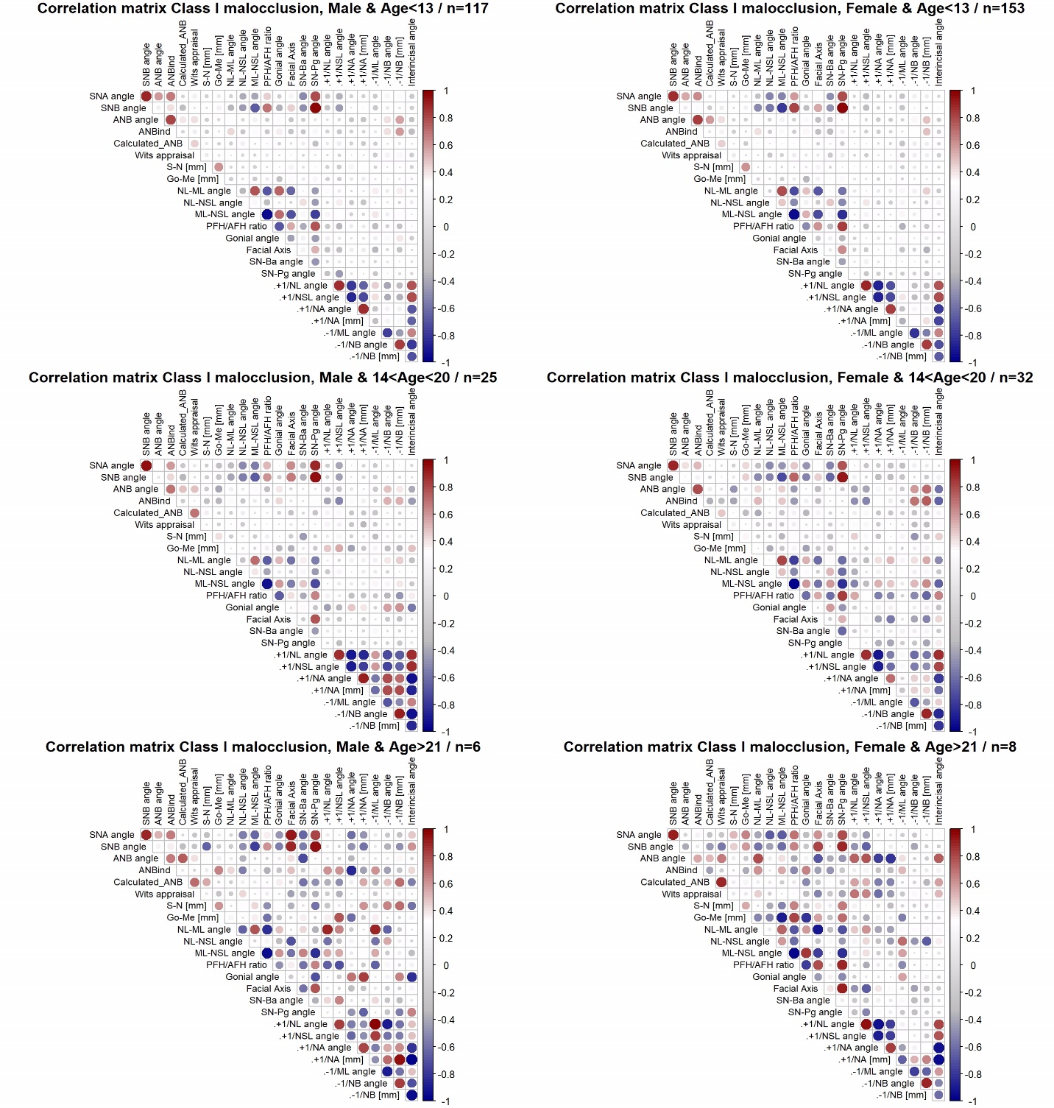
vi
v
iv
iii
ii
i

Supplementary Figure 3.
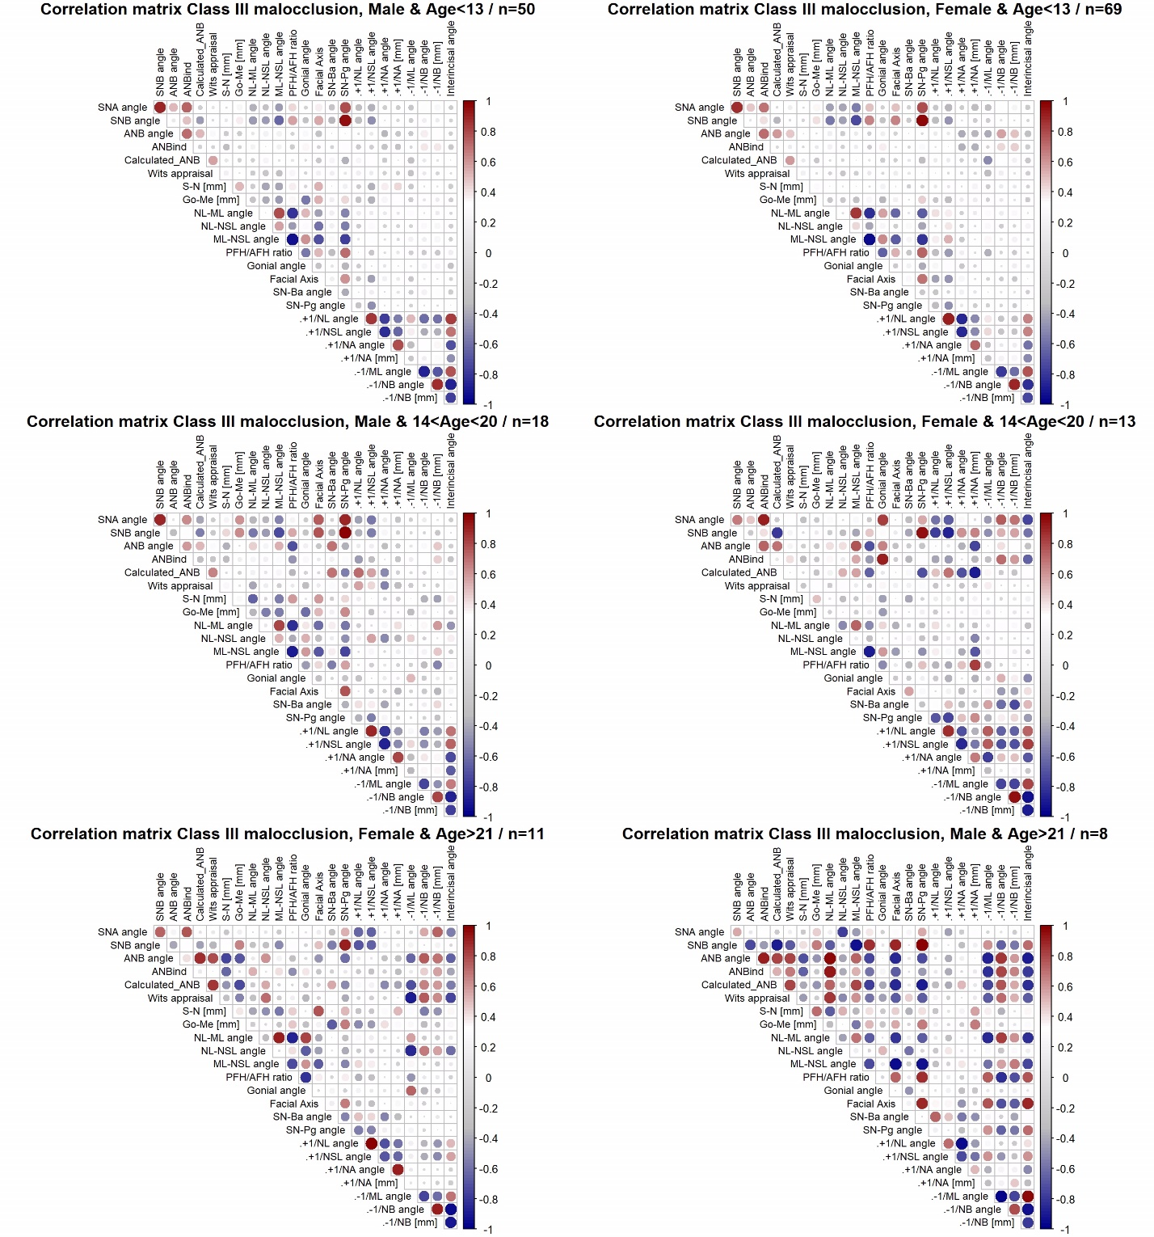
vi
v
iv
iii
i
ii

