Supporting Information
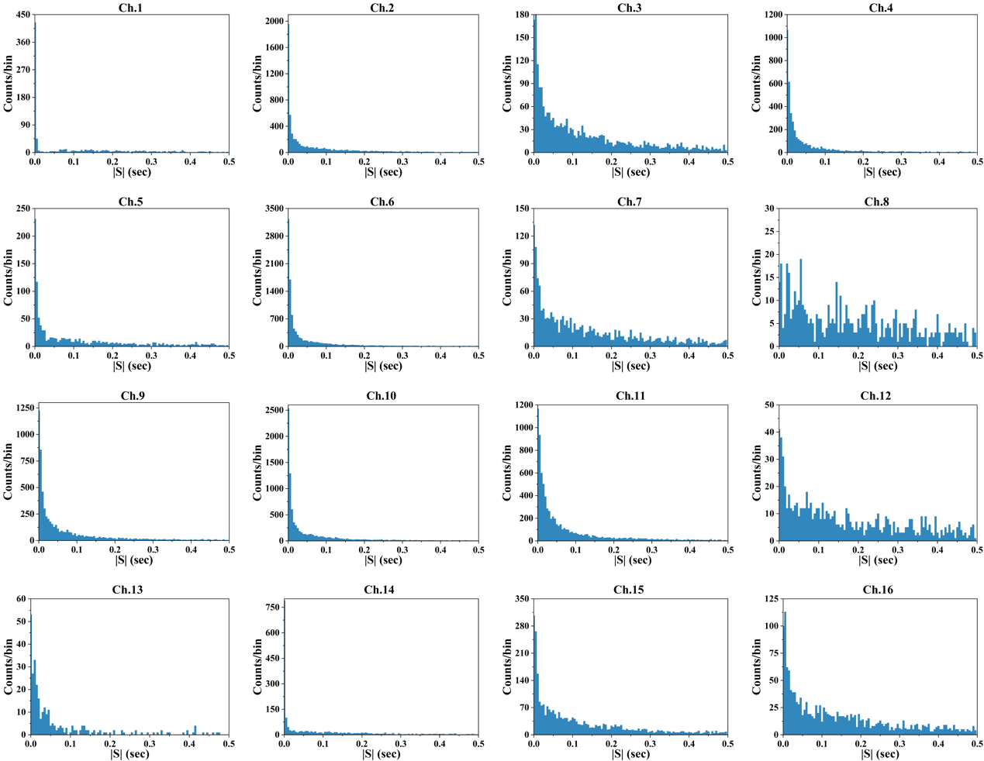
Fig. S1. The interspike interval histograms across 16 channels, bin=5 ms.

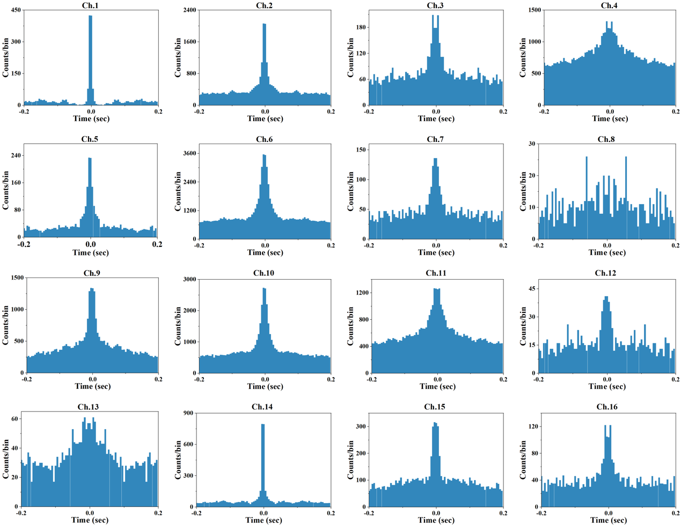
Fig. S2. The autocorrelation plots for 16 channels, bin=5 ms.

