Integrating DNA metabarcoding and morphological analysis improves marine zooplankton biodiversity assessment

So-yeon Kim ^{1#}, Seongmin Cheon ^{2#}, Chungoo Park ^{1,2,3,*}, and Ho Young Soh ^{1,4,*}
# These authors contributed equally to this work

¹ Interdisciplinary Program of Bigdata Fishery Resources Management, Chonnam National University, Yeosu, Republic of Korea
² School of Biological Sciences and Technology, Chonnam National University, Yongbong-ro 77, Gwangju 61186, Republic of Korea
³ Institute of Systems Biology & Life Science Informatics, Chonnam National University, Yongbong-ro 77, Gwangju 61186, Republic of Korea
⁴ Department of Ocean Integrated Science, Chonnam National University, Yeosu, Republic of Korea

Corresponding authors
Chungoo Park
E-mail: chungoo@jnu.ac.kr
Ho Young Soh
E-mail: hysoh@jnu.ac.kr
Supplementary Information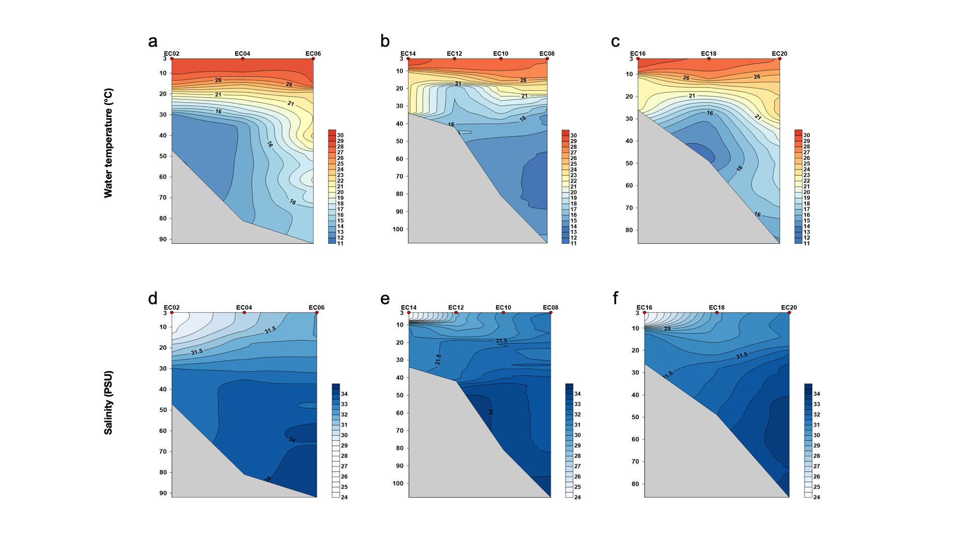
Supplementary Fig. 1 Vertical profiles of temperature (a-c) and salinity (PSU) (d-f) across three transects in the northern East China Sea. (a,d) EC02, EC04, EC06 transect, (b,e) EC14, EC12, EC10, EC08 transect, (c,f) EC16, EC18, EC20 transect. Gray areas represent sea bottom. Color scales indicate temperature and salinity values.

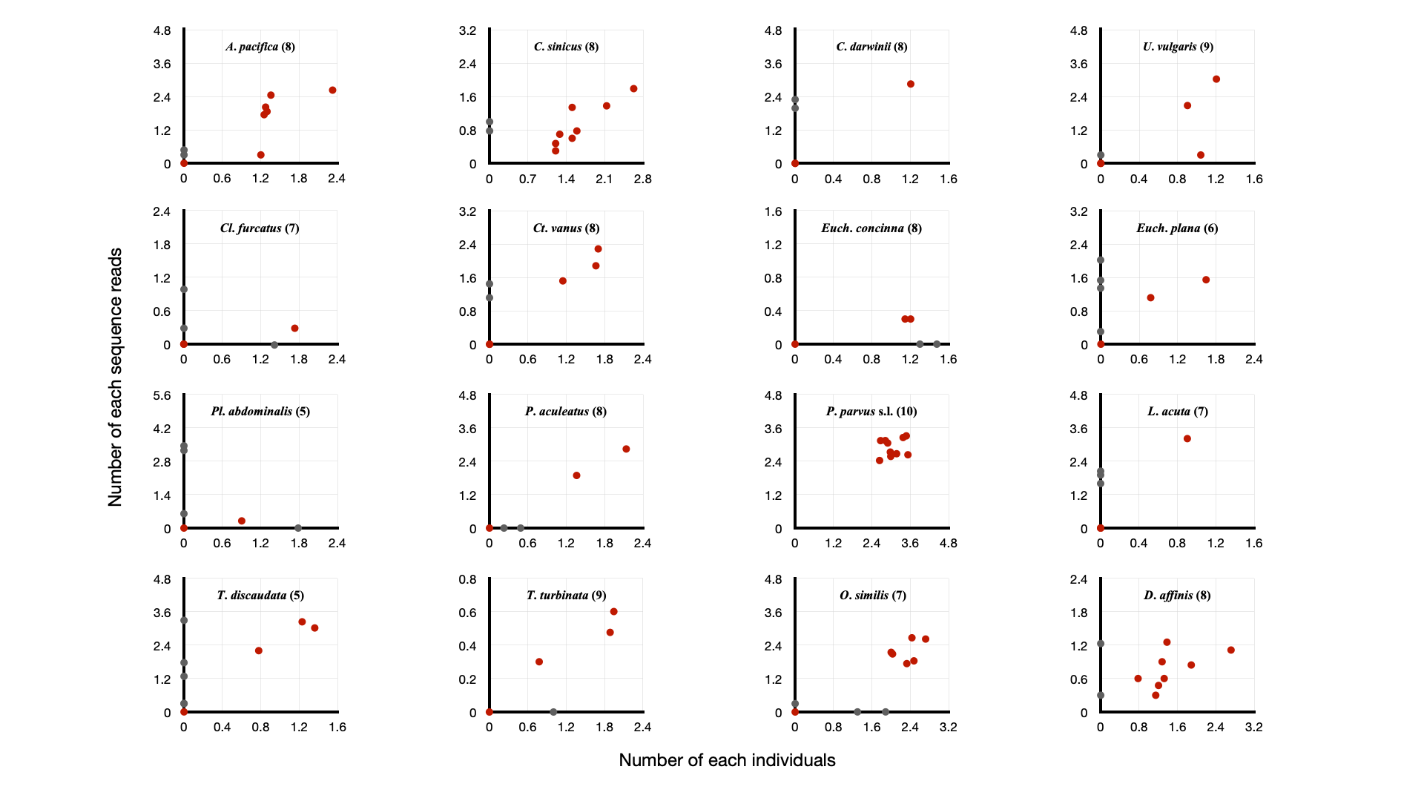
Supplementary Fig. 2 Comparison of morphology-based individual counts (x-axis) and DNA metabarcoding sequence reads (y-axis) for 16 copepod species. Each plot represents a different species. Both axes are log10-transformed. Red points indicate stations where the species was identified by both methods; gray points represent identification by only one method. Numbers in parentheses show the count of stations where the species was identified by both methods.
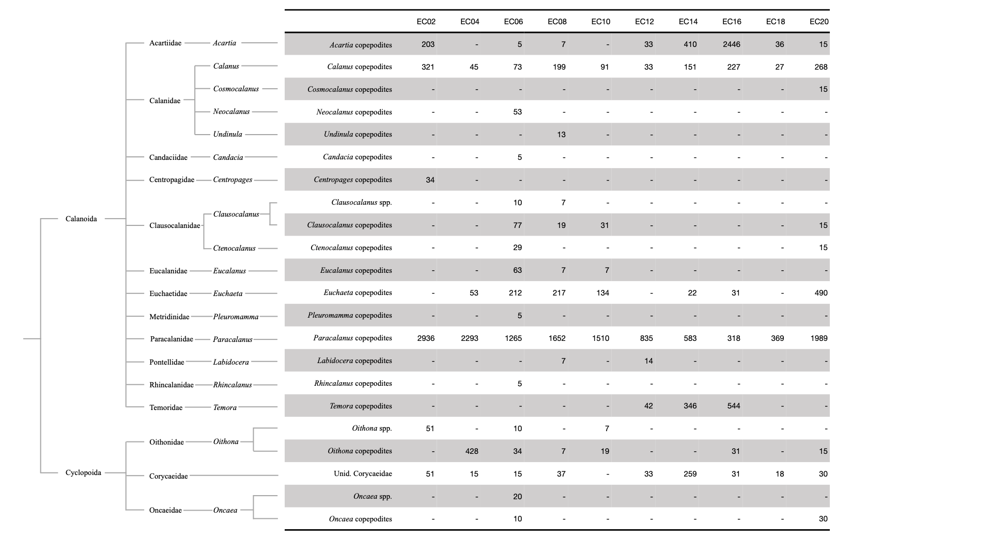
Supplementary Fig. 3 Taxonomic composition and abundance (individuals/m³) of copepod copepodites based on morphological analysis across 10 sampling stations in the northern East China Sea. Taxonomic hierarchy is shown on the left. Rows indicate detected taxa and blank spaces denote absence.

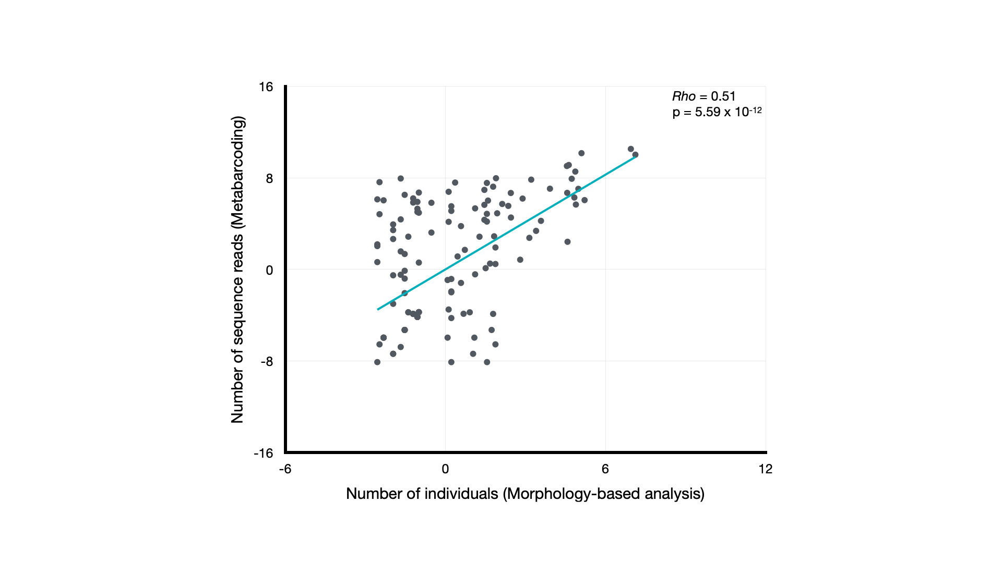
Supplementary Fig. 4 Correlation between morphology-based individual counts and DNA metabarcoding sequence reads for copepod genera. Data are centered log-ratio (clr) transformed. Spearman’s rank correlation coefficient (Rho) and p-value are shown. Each point represents a genus at a sampling station.

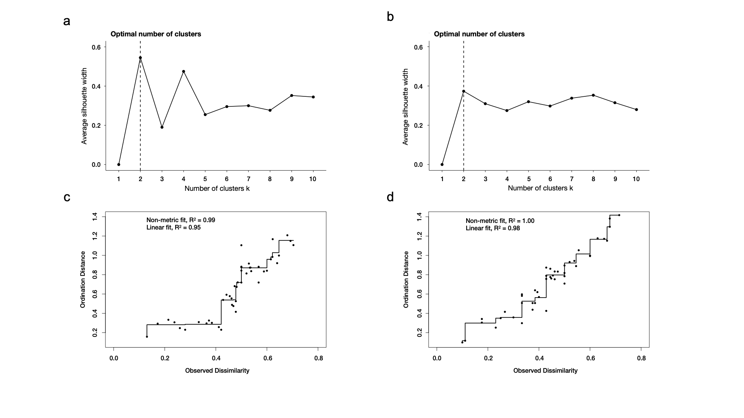
Supplementary Fig. 5 Cluster analysis of copepod community data. (a,b) Average silhouette width for determining optimal number of clusters in (a) morphological and (b) DNA metabarcoding data. Dashed lines indicate optimal cluster number. (c,d) Correlation between observed dissimilarities and dendrogram-derived distances for (c) morphological and (d) DNA metabarcoding data. Non-metric and linear R² values are provided to assess the quality of hierarchical clustering.

Table S1. Sampling locations and environmental conditions

 | Longitude (°E) | Latitude (°N) | Sampling date | Sampling time |  | Average  Temperature (°C) | Average  Salinity (PSU)
 |  |  |  | Start | End | Average  Temperature (°C) | Average  Salinity (PSU)
EC01 | 124.00 | 32.99 | Aug. 05 |  |  | 21.02 | 31.10
EC02 | 124.49 | 32.99 | Aug. 06 | 11: 43 | 11:47 | 18.75 | 31.54
EC03 | 125.00 | 32.99 | Aug. 06 |  |  | 15.22 | 32.40
EC04 | 125.51 | 33.00 | Aug. 06 | 06:30 | 06:34 | 17.06 | 32.91
EC05 | 126.02 | 33.00 | Aug. 06 |  |  | 18.27 | 33.12
EC06 | 126.52 | 33.00 | Aug. 06 | 00:45 | 00:51 | 20.34 | 33.43
EC07 | 126.99 | 33.02 | Aug. 05 |  |  | 19.58 | 33.32
EC08 | 126.91 | 32.45 | Aug. 08 | 01:55 | 02:01 | 16.56 | 32.98
EC09 | 126.60 | 32.54 | Aug. 08 |  |  | 19.19 | 33.38
EC10 | 125.52 | 32.48 | Aug. 07 | 16:08 | 16:12 | 18.58 | 32.79
EC11 | 125.52 | 32.46 | Aug. 07 |  |  | 17.83 | 32.64
EC12 | 125.00 | 32.49 | Aug. 07 | 04:37 | 04:39 | 20.22 | 30.92
EC13 | 124.53 | 32.46 | Aug. 07 |  |  | 23.21 | 29.96
EC14 | 124.04 | 32.51 | Aug. 06 | 16:48 | 16:52 | 24.64 | 29.73
EC15 | 124.06 | 32.02 | Aug. 06 |  |  | 25.13 | 29.81
EC16 | 124.43 | 32.02 | Aug. 06 | 11:43 | 11:45 | 24.47 | 29.23
EC17 | 125.09 | 32.07 | Aug. 07 |  |  | 23.37 | 30.08
EC18 | 125.50 | 32.16 | Aug. 07 | 11:15 | 11:17 | 19.34 | 31.31
EC19 | 126.09 | 32.06 | Aug. 07 |  |  | 16.87 | 32.26
EC20 | 126.48 | 32.06 | Aug. 07 | 21:04 | 21:08 | 20.40 | 33.04
EC21 | 126.91 | 32.05 | Aug. 07 |  |  | 21.03 | 33.46

