Supplementary Figure S9
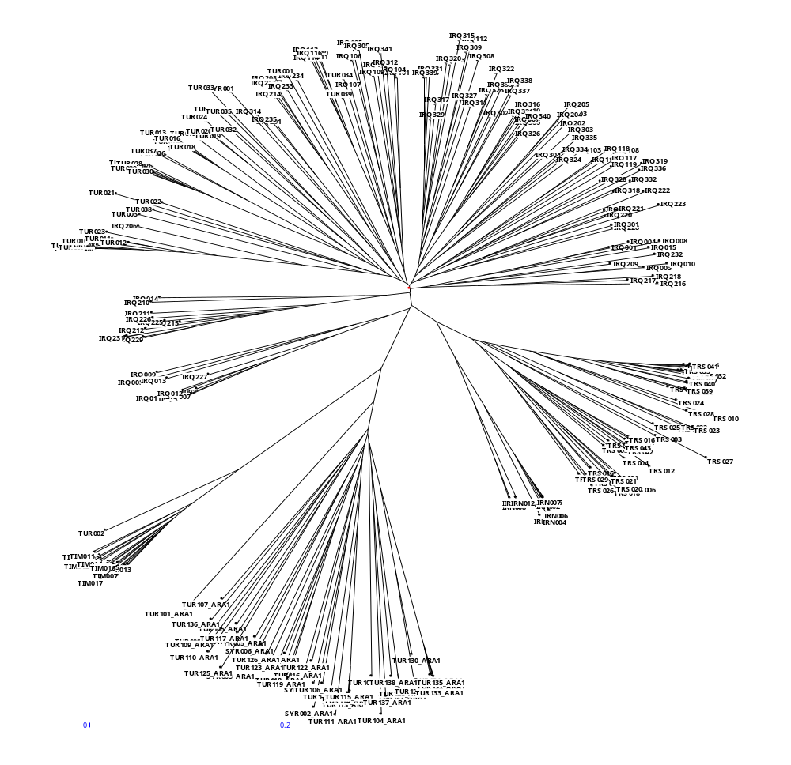
ARA-1
ARA-0
TIM
TUR002: TA1900

Neighbor-Joining (NJ) tree for 265 genotypes of T. araraticum and T. timopheevii using 379 C-banding markers based on Jaccard distances (Jaccard 1908; Perrier et al. 2003).

