Supplementary Material S28
Was the cultivation range of T. timopheevii (s.str.) wider in the recent past?
Materials and Methods:
Based on the Chapter on T. timopheevii of Dorofeev et al. (1979) – see Supplementary Material SM19, the recent past distribution range of T. timopheevii s.str. has been described as: “The Georgian triticologists Dekaprelevich and Menabde noted in a number of their works that the northern limit of Timofeev’s wheat cultivation centered around the towns of Tsageri, Orbeli, Lailashi, and Oni; its southern limit centered around Mekvena and Dgnorisa. Geographically, its cultivation was south of the Lechkhumi Range in the Caucasus Mountains in the present-day Ambrolauri, Oni, and Tsageri districts. Timofeev’s wheat is no longer cultivated there. Ecologically, Timofeev’s wheat flourishes in the foothills of western Georgia (400–800 m) in a humid, cool climate.”

Based on Supplementary Table S2, the following detailed collection site information is available for T. timopheevii samples:
Species | Subspecies | ACC NUMB | Collection site
T. timopheevii | timopheevii | IG 45097 | Tsageri. Region of town Kutaisi, Georgia
T. timopheevii | timopheevii | PI 341802 | Khachuri, Shida Kartli region, Georgia
T. timopheevii | timopheevii | PI 343447 | Khachuri, Shida Kartli region, Georgia
T. timopheevii | viticulosum | PI 349054 | Khachuri, Shida Kartli region, Georgia
T. timopheevii | viticulosum | PI 352506 | Khachuri, Shida Kartli region, Georgia
T. timopheevii | typicum | PI 352508 | Khachuri, Shida Kartli region, Georgia
T. timopheevii | viticulosum | PI 352510 | Khachuri, Shida Kartli region, Georgia
T. timopheevii | timopheevii | PI 418585 | Khachuri, Shida Kartli region, Georgia

Additional collection site details for T. timopheevii samples were obtained from Dr. E.V. Zuev, the head of the Department of Wheat Genetic Resources, VIR, St-Petersburg, Russia:
Species | ACC NUMB | Collection site
T. timopheevii | K-30922 | Tsageri, 45 km to N from t.Kutaisi
T. timopheevii | K-31684 | Tsageri, v.Acaras, 60 km to N from t.Kutaisi
T. timopheevii | K-35914 | Tsageri, 45 km to N from t.Kutaisi
T. timopheevii | K-35915 | Tsageri, 52 km to N from t.Kutaisi
T. timopheevii | K-35916 | Tsageri, 52 km to N from t.Kutaisi

The following collecting site information is known for two T. timopheevii samples reported presumably to be collected in Turkey:
Species | Subspecies | ACC NUMB | Collection site
T. timopheevii | viticulosum Zhuk. | PI 119442 | Market, Araç, near Kastamonu, Turkey
T. timopheevii | viticulosum Zhuk. | TA1900 | 32 km S of Denizli, near Kahramanmaraş, Turkey

The geo-referenced collection sites are as follows:
Georgia | City/village | Geographic coordinates
North | Tsageri/ Tsagera | 42.64745404707501, 42.771396142564484
 | Orbeli | 42.632624005949765, 42.83203989860203
 | Lailashi | 42.60731908705502, 42.85927891794966
East | Oni | 42.584715963856326, 43.44372862743692
South | Mekvena | 42.47752421737309, 42.75505276321019
 | Dgnorisa | 42.46290842016359, 42.81663889859892
Turkey
 | Araç | 41.24328549392879, 33.32765934598587
 | 32 km S of Denizli, near Kahramanmaraş | 37.425770, 29.091797

Simulation approach:
56 sampling points from Georgia and 52 from Turkey were simulated around the eight collecting sites (6 from Georgia, 2 from Turkey) to capture the regional agro-ecological variation.
We collected 19 potential drivers of crop diversity and altitude from the WorldClim version 2 database (Fick and Hijmans, 2017), freely available at http://www.worldclim.org, and downloadable at 2.5 arc-min spatial resolution.
Principal components analysis and k-means clustering (number of clusters equal to 2) were conducted using the bioclimatic variables for the sampling points in both countries.
Data analysis was done using R v3.3.1 (R Core Team, 2016).

Results:
Several bioclimatic variables showed significant differences between sampling sites in Georgia and in Turkey, more specifically for mean diurnal range, temperature seasonality, mean temperature of driest quarter and mean annual precipitation:
BIO1 = Annual Mean Temperature
BIO2 = Mean Diurnal Range (Mean of monthly (max temp - min temp))
BIO3 = Isothermality (BIO2/BIO7) (×100)
BIO4 = Temperature Seasonality (standard deviation ×100)
BIO5 = Max Temperature of Warmest Month
BIO6 = Min Temperature of Coldest Month
BIO7 = Temperature Annual Range (BIO5-BIO6)
BIO8 = Mean Temperature of Wettest Quarter
BIO9 = Mean Temperature of Driest Quarter
BIO10 = Mean Temperature of Warmest Quarter
BIO11 = Mean Temperature of Coldest Quarter
BIO12 = Annual Precipitation
BIO13 = Precipitation of Wettest Month
BIO14 = Precipitation of Driest Month
BIO15 = Precipitation Seasonality (Coefficient of Variation)
BIO16 = Precipitation of Wettest Quarter
BIO17 = Precipitation of Driest Quarter
BIO18 = Precipitation of Warmest Quarter
BIO19 = Precipitation of Coldest Quarter

The first two components from PCA analysis explained 80.3% of the total climatic variability. Plotting PC1 versus PC2 revealed a clear distinction between sampling points from the two countries:
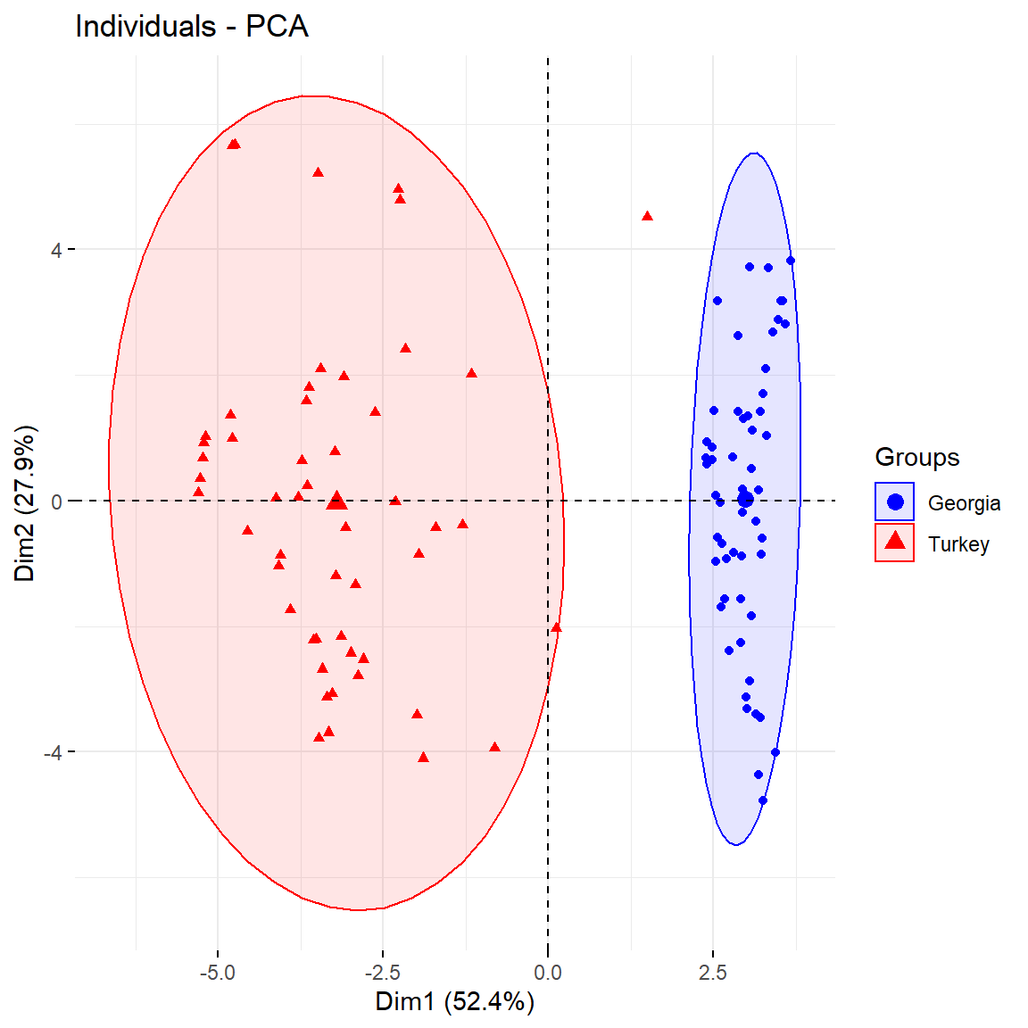

At k = 2, all sampling sites from Georgia were assigned to one cluster, and all Turkish sites to the second cluster (but except one site near Samsun in Turkey that was assigned to the Georgian cluster):

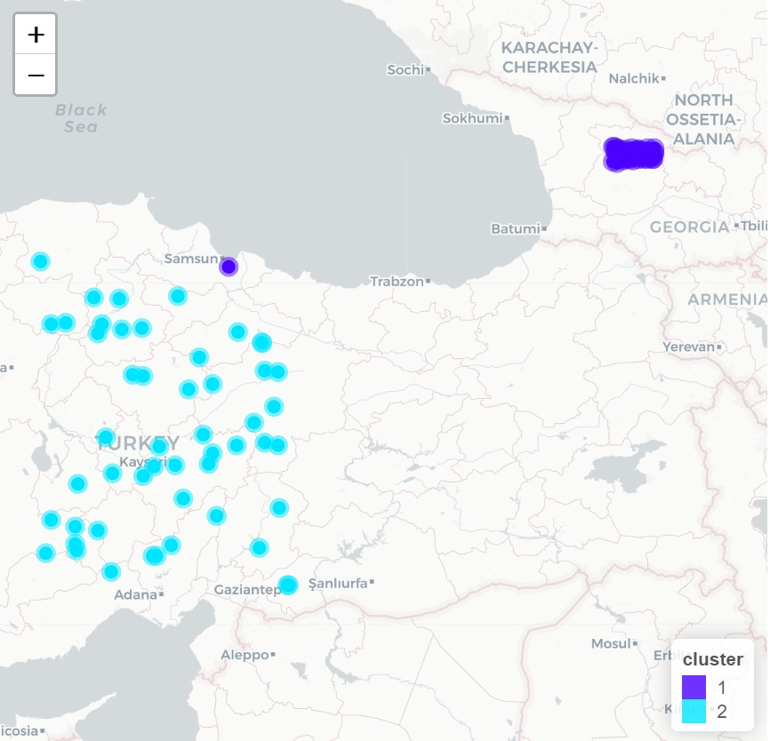

Conclusion:
Based on bioclimatic variables and our simulation of regional agro-ecological variation, we predict that T. timopheevii s.str. is maladapted to the climate outside Western Georgia.

References
Fick S E and Hijmans R (2017). WorldClim 2: new 1-km spatial resolution climate surfaces for global land areas (pp.1-14). International journal of climatology, 00, Wiley Online. doi: http://dx.doi.org/10.1002/joc.5086.
R Core Team (2016) R: A Language and Environment for Statistical Computing. R Foundation for Statistical Computing, Vienna, Austria. https://www.R-project.org/

