A unique lithospheric origin for a diamond from the Rio Sorriso area, Brazil
Antonio Angellotti¹, Giulia Marras¹, Marta Morana², Stella Chariton³, Veronica Stopponi⁴, Laura Medeghini¹, Claudia Romano⁵, Alessandra Correale⁶, Luca Bindi², Felix V. Kaminsky⁷, Vincenzo Stagno^{1,6*}

¹Department of Earth Sciences, Sapienza University of Rome, p. le A. Moro 5, 00185 Roma, Italy;
²Department of Earth Sciences, University of Florence, via G. La Pira 4, I-50121 Firenze, Italy;
³Center for Advanced Radiation Sources, The University of Chicago, USA;
⁴CNR-IOM, Basovizza, Trieste, Italy;
⁵Department of Science, University of Roma Tre, Rome, Italy;
⁶Istituto Nazionale di Geofisica e Vulcanologia, Palermo, Italy;
⁷Vernadsky Institute of Geochemistry and Analytical Chemistry, Russian Academy of Science, Moscow, Russia.
Correspondence to: Vincenzo Stagno (vincenzo.stagno@uniroma1.it)
Supplementary materials

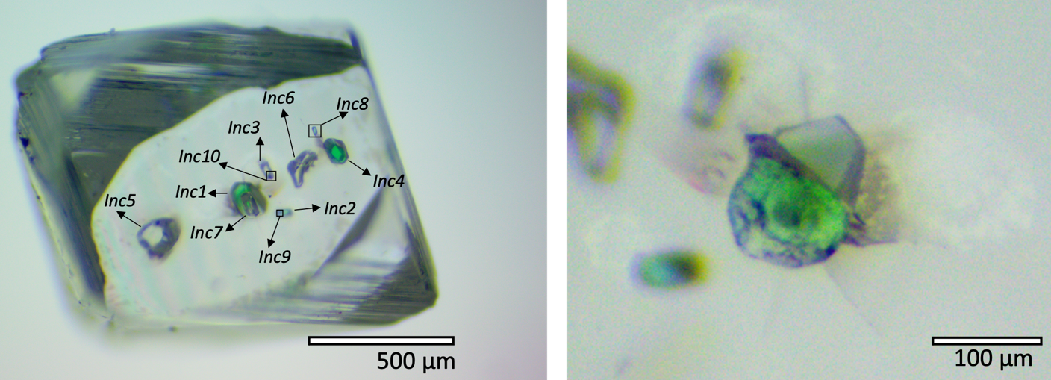
a.
b.

Supplementary Figure 1. a) Optical image of COMSK3 diamond and the ten visible inclusions. b) Detail of the Inc1 showing the slightly inclined orientation underneath the diamond surface.

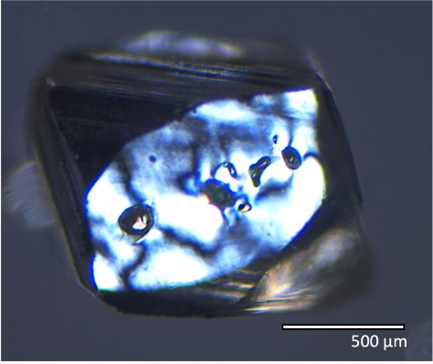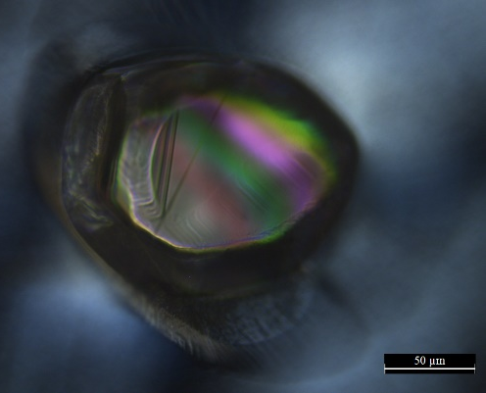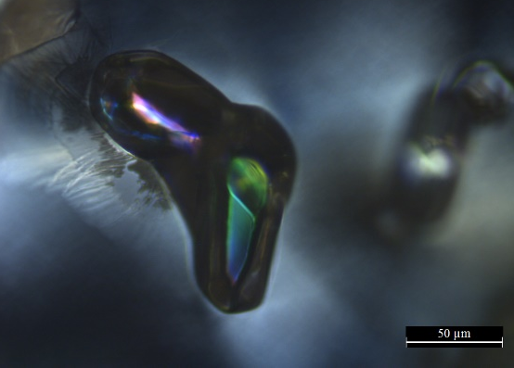
c.

a.
b.
Supplementary Figure 2. a) Optical image taken on the diamond using polarized transmitted light microscopy under crossed Nicols. b) Inc5 shows both slip plan and fringes plus a dark halo. c) Inc6 is made of two tiny, elongated inclusions here after Inc6a (pink) and Inc6b (green bluish) with dark rim on the upper left part.
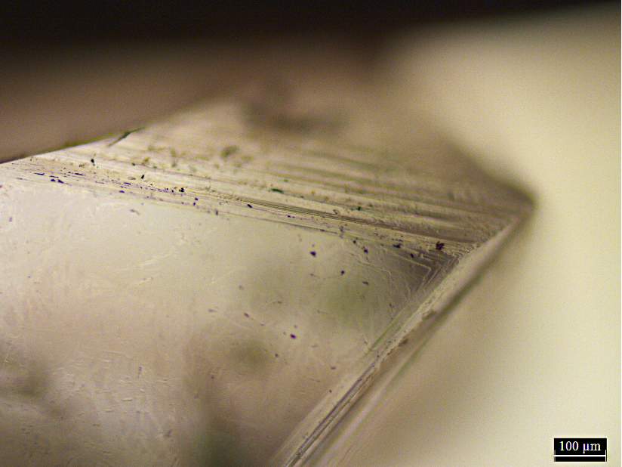
Supplementary Figure 3. Detail of the diamond COMSK3 showing the presence of striations.

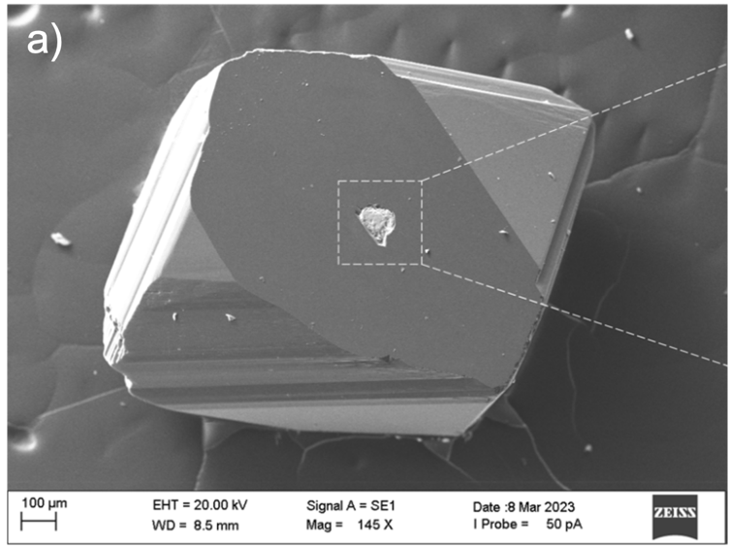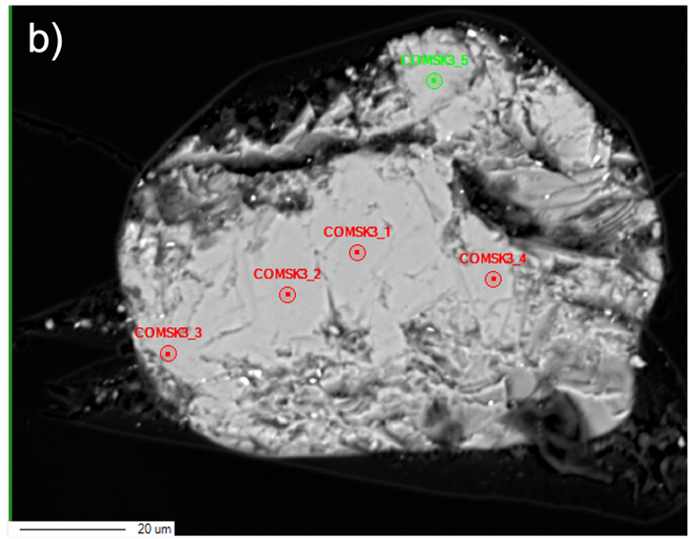
Supplementary Figure 4. a) Secondary electron SEM image of the polished Inc1, and b) the corresponding backscattered electron image taken by EPMA with labels for the analyzed spots.
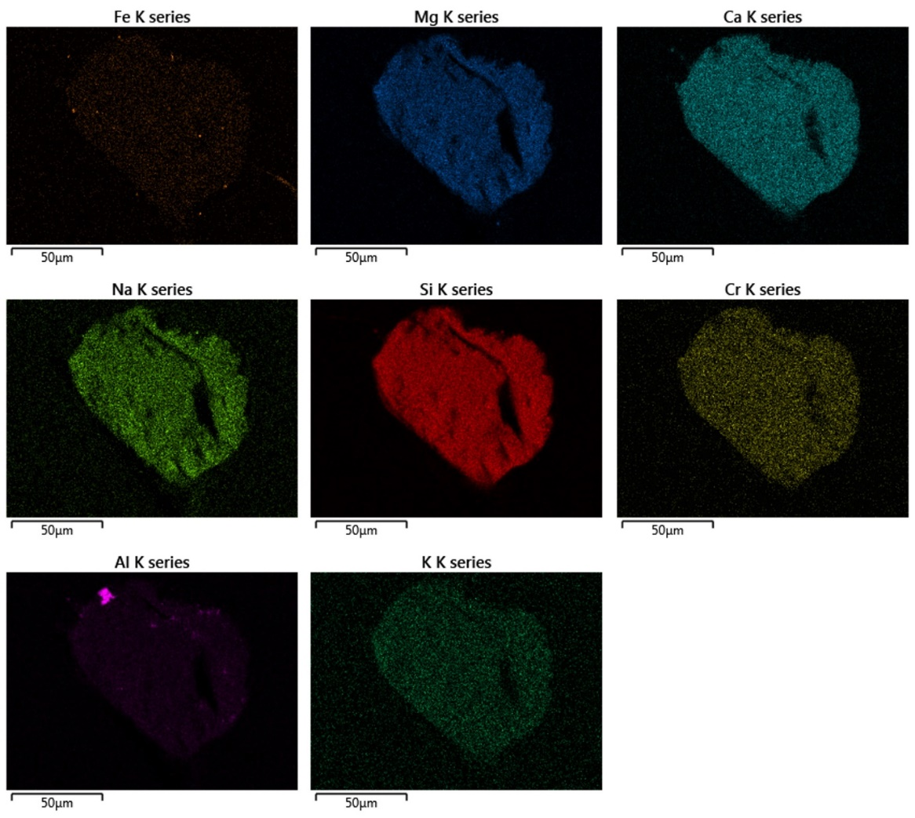
Supplementary Figure 5. EDS images showing the chemical map of the polished Inc1.

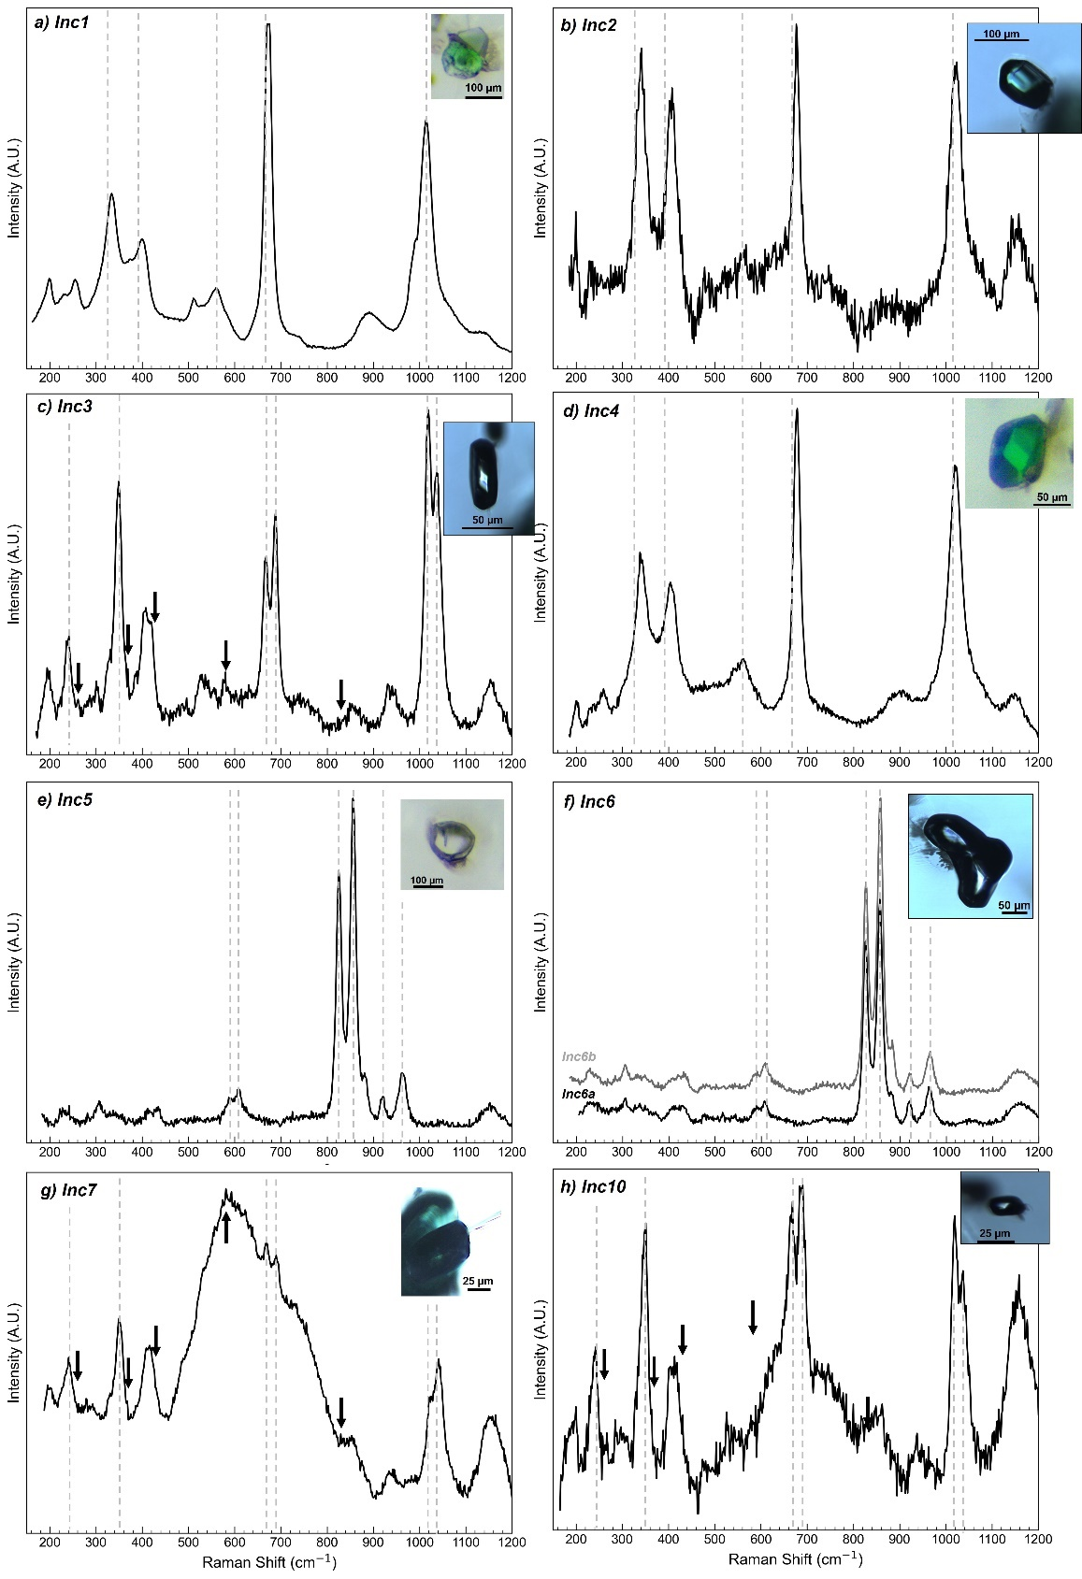
Supplementary Figure 6 (a) Inc1, (b) Inc2 and (d) Inc4 are all identified as cpx. (e) Inc5 and (f) Inc6a (top rounded crystal) and Inc6b (bottom elongated crystal) are assigned to ol. (c-h) Inc3, Inc7 and Inc10 might be representative of Cen on the basis of a shoulder at 367-368 cm^{-11,2}. Dashed grey lines are taken as reference for the band position³.

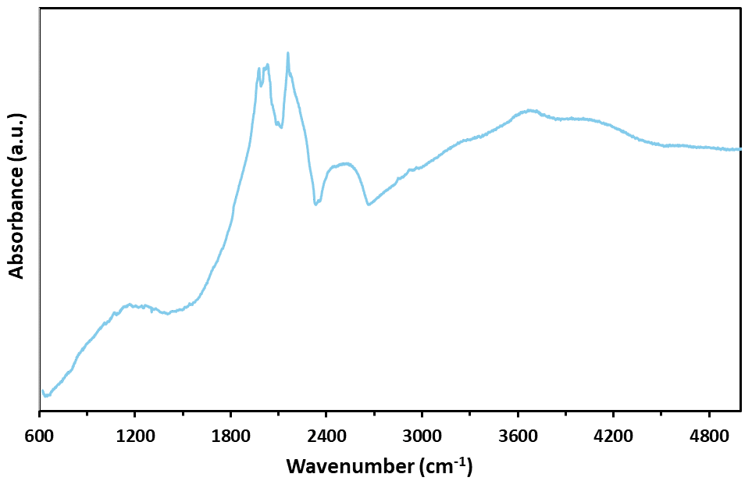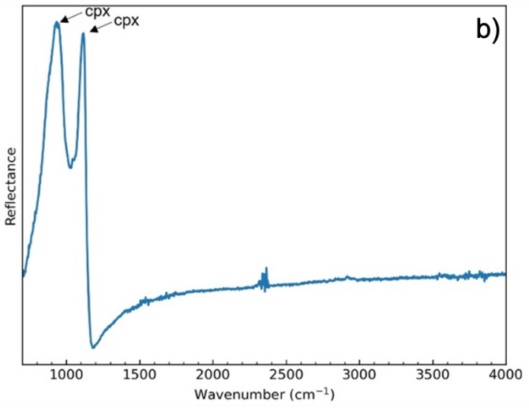
a)
Supplementary Figure 7 (a) µ-T-FTIR spectrum of COMSK3 diamond using synchrotron IR spectroscopy at SISSI beamline of Elettra facility. (b) µ-R-FTIR spectrum of exposed Inc1.

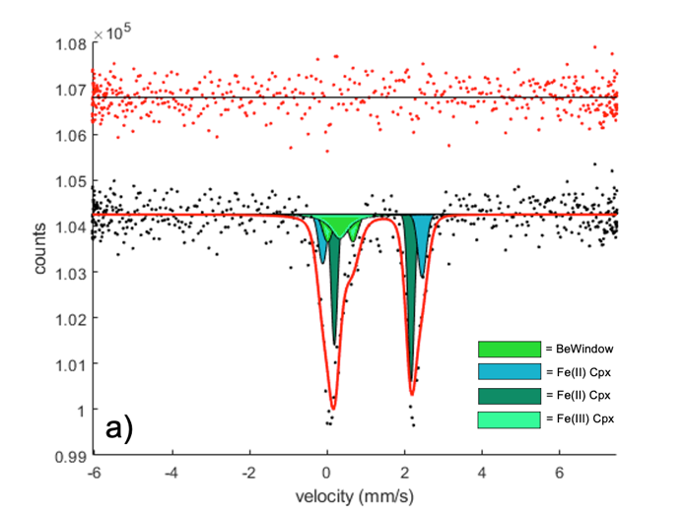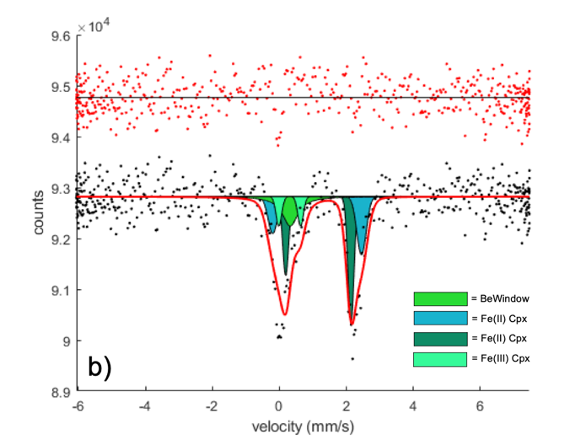

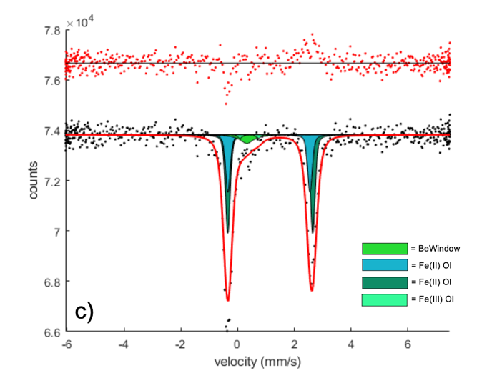
Supplementary Figure 8 Mössbauer spectra collected on a) polished Inc1, and b) entrapped Inc2 (cpx), and c) Inc5 (ol), fitted with two doublets for Fe²⁺ and one doublet for Fe³⁺. The singlet related to the Be window is also reported.

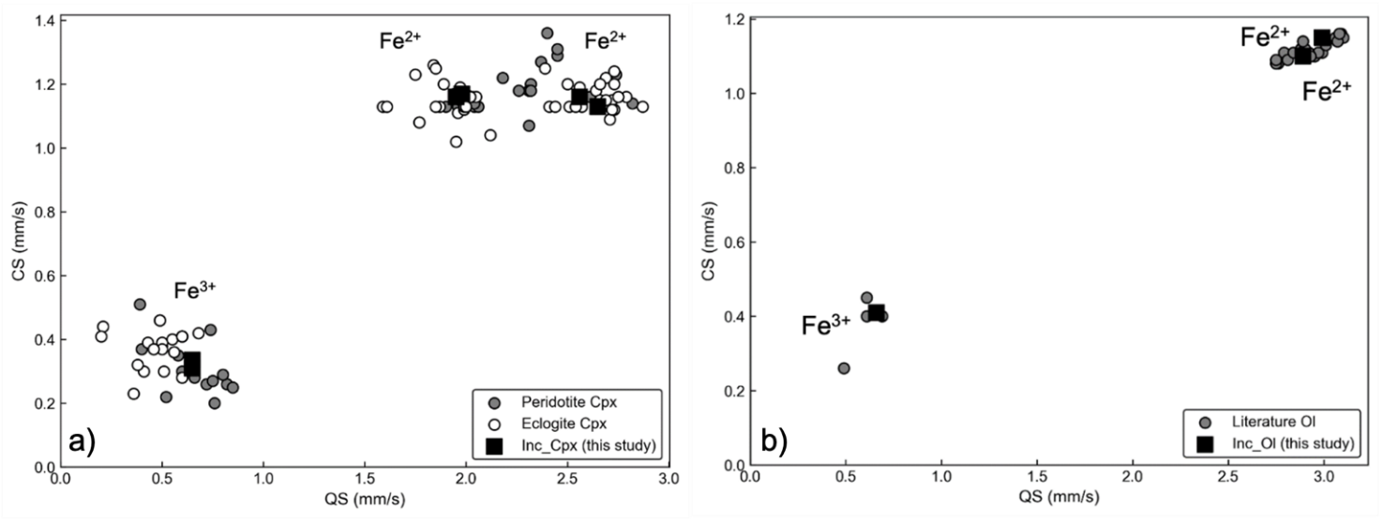
Supplementary Figure 9 (a) Center shift (CS) plotted against the quadrupole splitting (QS) for the cpx (Inc1 and Inc2) of this study along with literature data for peridotite cpx⁴ and for natural⁵⁻⁸ and synthetic⁹ eclogitic cpx. (b) Center shift (CS) plotted against the quadrupole splitting (QS) for olivine (Inc5) from this and previous studies^{4,10-11}.

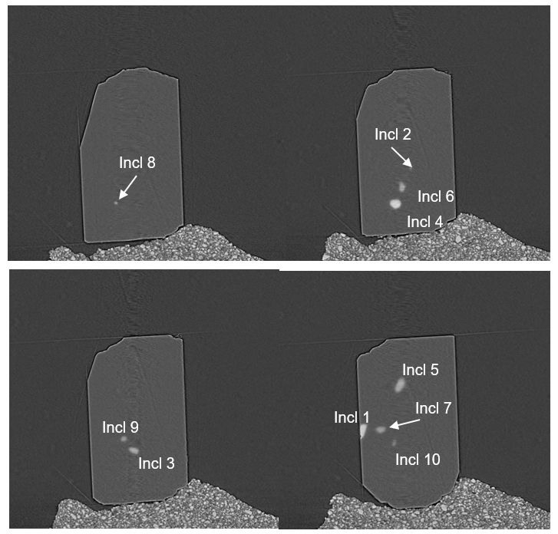
Supplementary Figure 10 Cross-sectional tomographic slices along the Y axis showing all inclusions as reported in Supplementary Figure 1.

- Chopelas, A. Thermal properties of β‐Mg2SiO4 at mantle pressures derived from vibrational spectroscopy: Implications for the mantle at 400 km depth. Journ. Geophys. Res.: Solid Earth 96.B7 11817-11829, https://doi.org/10.1029/91JB00898 (1991).
- Ulmer, P., and Stalder, R. The Mg(Fe)SiO₃ orthoenstatite-clinoenstatite transitions at high pressures and temperatures determined by Raman-spectroscopy on quenched samples. Am. Min., 86(10), 1267-1274. https://doi.org/10.2138/am-2001-1014 (2001).
- Smith, E. M., Krebs, M. Y., Genzel, P. T., and Brenker, F. E. Raman identification of inclusions in diamond. Rev. Min. Geochem., 88(1), 451-473, https://doi.org/10.2138/rmg.2022.88.08 (2022).
- Canil, D., and O'Neill H. Distribution of ferric iron in some upper-mantle assemblages. Journ. Petro. 37.3: 609-635, https://doi.org/10.1093/petrology/37.3.609 (1996).
- McCammon, C. A., Tennant, W. C., and Miletich, R. A new method for single crystal measurements: application to Mössbauer spectra of mineral inclusions in diamond. Hyperfine Interactions, 126(1-4), 241-245, https://doi.org/10.1023/A:1012650124159 (2000).
- Li, Y. L., Zheng, Y. F., and Fu, B. Mössbauer spectroscopy of omphacite and garnet pairs from eclogites: Application to geothermobarometry. Am. Min., 90(1), 90-100, https://doi.org/10.2138/am.2005.1400 (2005).
- Kopylova, M. G., Beausoleil, Y., Goncharov, A., Burgess, J., and Strand, P. Spatial distribution of eclogite in the Slave cratonic mantle: the role of subduction. Tectonophysics, 672, 87-103, https://doi.org/10.1016/j.tecto.2016.01.034 (2016).
- Mikhailenko, D. S., Stagno, V., Korsakov, A. V., Andreozzi, G. B., Marras, G., Cerantola, V., and Malygina, E. V. Redox state determination of eclogite xenoliths from Udachnaya kimberlite pipe (Siberian craton), with some implications for the graphite/diamond formation. Con. Min. and Petro., 175, 1-17. https://doi.org/10.1007/s00410-020-01748-3 (2020).
- Stagno, V., Frost, D.J., McCammon, C.A. et al. The oxygen fugacity at which graphite or diamond forms from carbonate-bearing melts in eclogitic rocks. Con. Min. Petro. 169, 16, https://doi.org/10.1007/s00410-015-1111-1 (2015).
- Ejima, T., Osanai, Y., Akasaka, M., Adachi, T., Nakano, N., Kon, Y., ...and Sereenen, J. Oxidation states of Fe in constituent minerals of a spinel lherzolite xenolith from the Tariat Depression, Mongolia: the significance of Fe³⁺ in olivine. Minerals, 8(5), 204, https://doi.org/10.3390/min8050204 (2018).
- Marras, G., Carnevale, G., Caracausi, A., Rotolo, S. G., and Stagno, V. First measurements of the Fe oxidation state of spinel inclusions in olivine single crystals from Vulture (Italy) with the in situ synchrotron micro-Mössbauer technique. Euro. Journ. Min., 35(4), 665-678. https://doi.org/10.5194/ejm-35-665-2023 (2023a).

