Radiomics Features
We evaluated a total number of 744 CT imaging features, which are divided in eight categories as follows: Gradient Orient Histogram (GOH), Gray-Level Co-occurrence Matrix (GLCM), Gray-Level Run Length Matrix (GLRLM), Intensity Direct (ID), Intensity Histogram (IH), Intensity Histogram Gauss Fit (IHGF), Neighbor Intensity Difference (NID), Shape-based features.
Group 1. Gradient Orient Histogram (GOH)
Implementation of Histogram of gradient orientations.
Group 2. Gray-Level Co-occurrence Matrix (GLCM)
This method is to compute gray-level co-occurrence matrix from image inside the binary mask separated by a certain distance (=1, 4 or 7 pixels) in a certain direction (= 0°, 45°, 90°, 135° or a random degree).
Let:
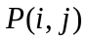 is the co-occurrence matrix by the and ,
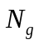 is the number of discrete intensity levels in the image,
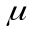 is the mean of ,
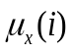 is the mean of 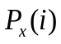,
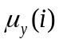 is the mean of 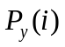,
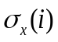 is the standard deviation of ,
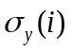 is the standard deviation of ,
,
,
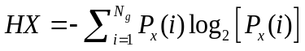 is the entropy of 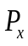,
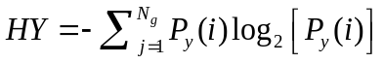 is the entropy of 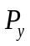,
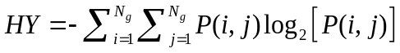 is the entropy of ,
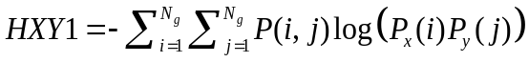,
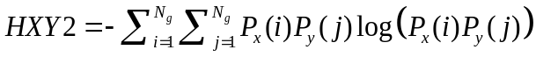.
1) Autocorrelation
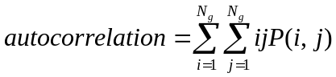
2) Cluster Prominence
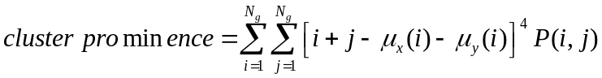
3) Cluster Shade
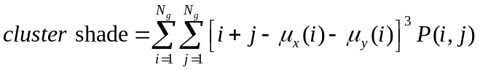
4) Cluster Tendency
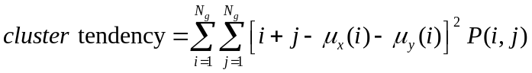
5) Contrast
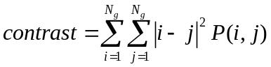
6) Correlation
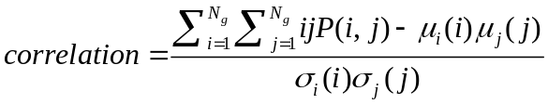
7) Difference Entropy
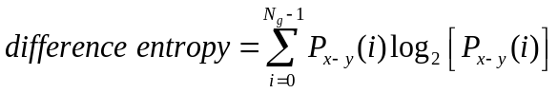
8) Dissimilarity
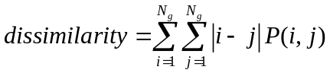
9) Energy
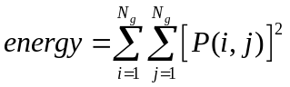
10) Entropy
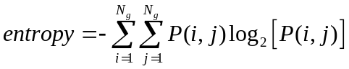
11) Homogeneity
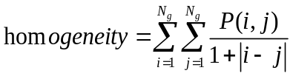
12) Homogeneity2
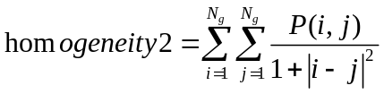
13) Informational Measure of Correlation 1 (IMC1)
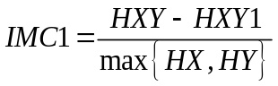
14) Informational Measure of Correlation 2 (IMC2)
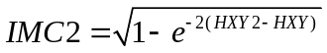
15) Inverse Difference Moment Normalized (IDMN)
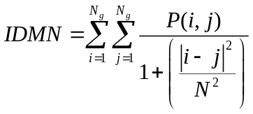
16) Inverse Difference Normalized (IDN)
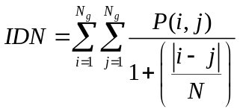
17) Inverse Variance
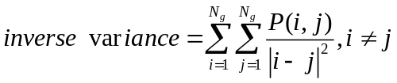
18) Maximum Probability
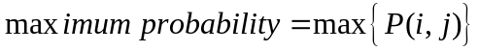
19) Sum Average
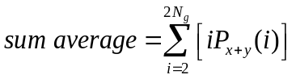
20) Sum Entropy
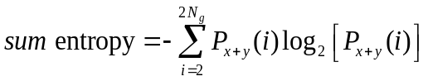
21) Sum Variance
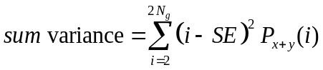
22) Variance
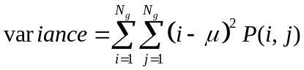
Group 3. Gray-Level Run Length Matrix (GLRLM)
This method is to compute gray-level run length matrix from image inside the binary mask in a certain direction (= 0°, 90° or a random degree). Group 3 and 4, second-order statistical texture feature, could provide information regarding the relative position of the various gray levels over the image.
Let:
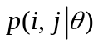 is the 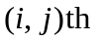entry in the given run-length matrix 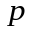for a direction ,
the number of discrete intensity values in the image,
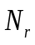 the number of different run lengths,
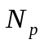 the number of voxels in the image.
1) Gray Level Non-Uniformity (GLN)
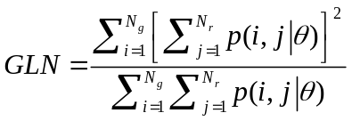
2) High Gray Level Run Emphasis (HGLRE)
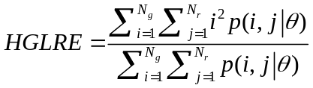
3) Long Run Emphasis (LRE)
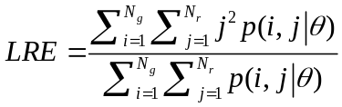
4) Long Run High Gray Level Emphasis (LRHGLE)
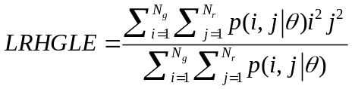
5) Long Run Low Gray Level Emphasis (LRLGLE)
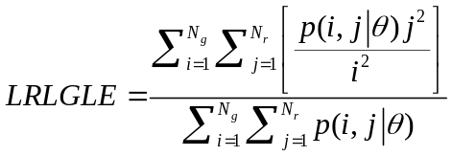
6) Low Gray Level Run Emphasis (LGLRE)
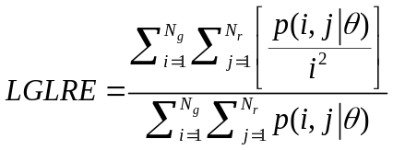
7) Run Length Non-Uniformity (RLN)
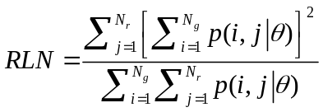
8) Run Percentage (RP)
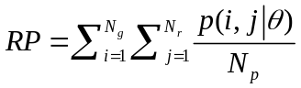
9) Short Run Emphasis (SRE)
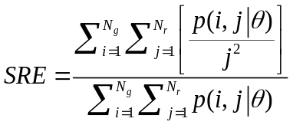
10) Short Run High Gray Level Emphasis (SRHGLE)
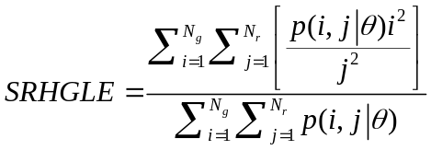
11) Short Run Low Gray Level Emphasis (SRLGLE)
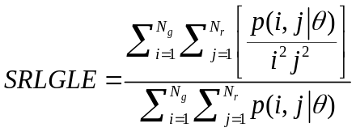
Group 4. Intensity Direct (ID), illustrating the histogram of intensity values. N is the number of pixel intensities within the ROI. 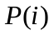represents the probability of pixel intensity across the ROI and is computed by dividing the number of the pixel intensity 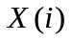 by the total pixel number within the ROI.
1) Energy
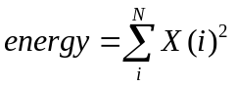
2) Energy Normalized
3) Entropy
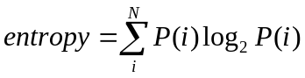
4) Global Max /Mean/Median/Min /Std
The intensity maximum/ mean/ median/ minimum/ standard deviation among all the voxels
5) Uniformity
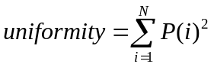
6) Range/InterOuartile Range
The range/ interquartile range of the intensity values among all the voxels.
7) Kurtosis
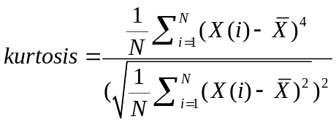
8) Local Entropy Max /Mean/Median/Min /Std
First, at each voxel, compute entropy in its neighborhood region. Then, compute the maximum/ mean/ median/ minimum/ standard deviation among all the voxel's entropy calculated from step 1.
9) Standard deviation (Std)
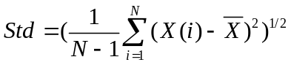
10) Mean/Median Absolute Deviation
The mean/median of the absolute deviations of the intensity values around the mean.
11) Percentile
Percentiles of the intensity values among all the voxels.
12)Quantile
Quantiles of the intensity values among all the voxels
13) Root Mean Square (RMS)
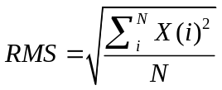
14) Skewness
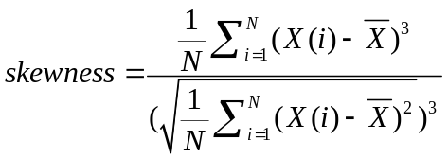
15) Variance
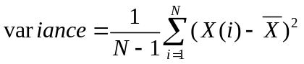
The Std, variance and mean/median absolute deviation are measures of the histogram dispersion. The skewness is a measure of the histogram asymmetry around the mean, and kurtosis measures the degree of the histogram sharpness. The uniformity and entropy may reflect the overall randomness of the image histogram. Laplacian of Gaussian (LoG) filter is a commonly used image preprocessing method in order to reduce the image photon noise and further highlight the heterogeneous characteristics of pixel enhancement [1].
Group 5. Intensity Histogram (IH) [2]
1) Inter-Quartile Range
The interquartile range of the occurrence probability values in the histogram.
2) Kurtosis
Measure the peakedness of the occurrence probability values in the histogram.
3) Mean Absolute Deviation
The mean absolute deviation of the occurrence probability values in the histogram.
4) Median Absolute Deviation
The median absolute deviation of the occurrence probability values in the histogram.
5) Percentile
Percentiles of the occurrence probability values in the histogram.
6) Percentile Area
Percentiles of values in the accumulative histogram.
7) Quantile
Quantiles of the occurrence probability values in the histogram.
8) Range
Measures the range (Max Value-Min Value) of the occurrence probability values in the histogram.
9) Skewness
Measure the asymmetry of the occurrence probability values in the histogram.
Group 6. Intensity Histogram Gauss Fit (IHGF)
This method is to fit histogram with Gaussian curves.
Group 7. Neighbor Intensity Difference (NID)
This method is to compute neighborhood intensity difference matrix from image inside the binary mask and intensity difference is computed in two-dimensional neighborhoods.
Group 8. Shape-based features
This group of radiomics features describes the size and shape of the tumour region. The maximum diameter, surface area and volume provide information on the size of the lesion, which are calculated automatically by software rather than manual measurement. In fact, the size is most widely used among various radiomics features. Measures of compactness, spherical disproportion, sphericity and surface area density describe how spherical, rounded, or elongated the shape of the tumour is.
References
- Shen, Q, Shan, Y, Hu, Z, et al. Quantitative parameters of CT texture analysis as potential markersfor early prediction of spontaneous intracranial hemorrhage enlargement. Eur Radiol, 2018 28: 4389- 4396.
- None. Investigation of radiomic signatures for local recurrence using primary tumor texture analysis in oropharyngeal head and neck cancer patients [J]. Scientific Reports, 2018, 8(1):1524

Supplementary Table 1 Radiomics features and abbreviations
GOH  (n = 46) | GLCM  (n=532) | GLRLM  (n=33) | ID  (n=56) | IH  (n=49) | IHGF  (n=6) | NIDM  (n=5) | Shape-based  (n=17)
IQR | Auto Correlation | GLN | Energy | IQR | Gauss Amplitude | Busyness | Compactness1
Kurtosis | Cluster Prominence | HGLRE | EnergyNorm | Kurtosis | Gauss Area | Coarseness | Compactness2
Mean AD | Cluster Shade | LRE | Global Entropy | Mean AD | Gauss Mean | Complexity | Convex
Median AD | Cluster Tendency | LRHGLE | Global Max/Mean/Median/Std | Median AD | Gauss Std | Contrast | Convex Hull Volume
Percentile | Contrast | LRLGLE | Global Uniformity | Percentile | Hist Area | Texture Strength | Mass
Percentile Area | Correlation | LGLRE | IQR | Percentile Area | Number Of Gauss |  | Max Diameter
Quantile | Difference Entropy | RLN | Kurtosis | Quantile |  |  | Mean Breadth
Range | Dissimilarity | RP | Local Entropy Max/Mean/Median/Std | Range |  |  | Number Of Objects
Skewness | Energy | SRE | Local Range Max/Mean/Median/Std | Skewness |  |  | Number Of Voxel
 | Entropy | SRHGLE | Local Std Max/Mean/Median/Std |  |  |  | Orientation
 | Homogeneity | SRLGLE | Mean Absolute Deviation |  |  |  | Roundness
 | Homogeneity2 |  | Median Absolute Deviation |  |  |  | Spherical Disproportion
 | IMC1 |  | Percentile |  |  |  | Sphericity
 | IMC2 |  | Quantile |  |  |  | Surface Area
 | IDMN |  | Range |  |  |  | Surface Area Density
 | IDN |  | Root Mean Square |  |  |  | Volume
 | Inverse Variance |  | Skewness |  |  |  | Voxel Size
 | Max Probability |  | Variance
 | Sum Average
 | Sum Entropy
 | Sum Variance
 | Variance
GOH, Gradient Orient Histogram; GLCM, Gray-Level Co-occurrence Matrix from image inside the binary mask separated by a certain interpixel distance (1, 4 or 7 pixels) in a certain or random direction (0°, 45°, 90°, 135° or a random degree respectively); GLRLM, Gray-Level Run Length Matrix from image inside the binary mask in a certain or random direction (0°, 90°or a random degree respectively); ID, Intensity Direct; IH, Intensity Histogram; IHGF, Intensity Histogram Gauss Fit; NIDM, Neighbor Intensity Difference Matrix from image inside the binary mask; IQR, InterQuartile Range; AD, Absolute Deviation; IMC1, Informational measure of correlation 1; IMC2, Informational measure of correlation 2; IDMN, Inverse Difference Moment Norm; IDN, Inverse Different Norm; GLN, Gray Level Nonuniformity; HGLRE, High Gray Level Run Emphasis; LRE, Long Run Emphasis; LRHGLE, Long Run High Gray Level Emphasis; LRLGLE, Long Run Low Gray Level Emphasis; LGLRE, Low Gray Level Run Emphasis; RLN, Run Length Nonuniformity; RP, Run Percentage; SRE, Short Run Emphasis; SRHGLE, Short Run High Gray Level Emphasis; SRLGLE, Short Run Low Gray Level Emphasis; Std, standard deviation.
.

