Supplementary material for the article “Adsorption of organic solvent vapours on pristine and doped few-layer graphene nanoflakes” by S.Yu. Kupreenko*, D.N. Stolbov, S.A. Chernyak, K.I. Maslakov, N.E. Strokova, M.M. Levin, E.A. Arkhipova, A.S. Ivanov, S.V. Savilov
S1 Parameters of used organic solvents
Table S1. Constants of modified Antoine equation for organic solvents [S1].
Organic solvent | A | B | C | D | E
Hexane | 104.65 | -6995.5 | -12.702 | 1.2381∙10⁻⁵ | 2
Toluene | 80.877 | -6902.4 | -8.7761 | 5.8034∙10⁻⁶ | 2
Ethanol | 74.465 | -7164.3 | -7.327 | 3.134∙10⁻⁶ | 2
Acetonitrile | 58.302 | -5385.6 | -5.4954 | 5.3634∙10⁻⁶ | 2

[S1] R.H. Perry, D.W. Green, J.O. Maloney, “Perry’s Chemical Engineers Handbook”, 7th edition, McGraw Hill, New York, 1999.

S2 XPS data
GNF
The survey XPS spectrum of GNF is shown in Fig. S1. The spectrum contains lines of oxygen, carbon and a weak line of chlorine. The high-resolution XPS spectra were fitted with several components attributed to different species. The fitting results are shown in Table S2 and Fig. S2-S3.
Table S2. Total elemental concentrations, binding energies of component, their attribution to different species and their content determined from high-resolution XPS spectra of GNF.
Spectrum | Concentration, at. % | Binding energy, eV | Content, at. % | Species
O1s | 2.19 | 530.2 | 0.10 | O⁻
O1s | 2.19 | 531.9 | 0.81 | O=C−O (aromatic)
O1s | 2.19 | 532.7 | 0.27 | O=C−O (aliphatic),  O−C (hydroxy, epoxy)
O1s | 2.19 | 533.4 | 0.85 | O=C−O, O−C (ethers)
O1s | 2.19 | 534.5 | 0.16 | *
C1s | 97.81 | 284.4 | 95.01 | C−C (sp²)
C1s | 97.81 | 285.2 | 1.46 | C−C (sp³)
C1s | 97.81 | 286.3 | 0.58 | C−O
C1s | 97.81 | 287.5 | 0.00 | C=O, O−C−C
C1s | 97.81 | 289.0 | 0.76 | O−C=O
* Oxygen from charged non-conductive particles.
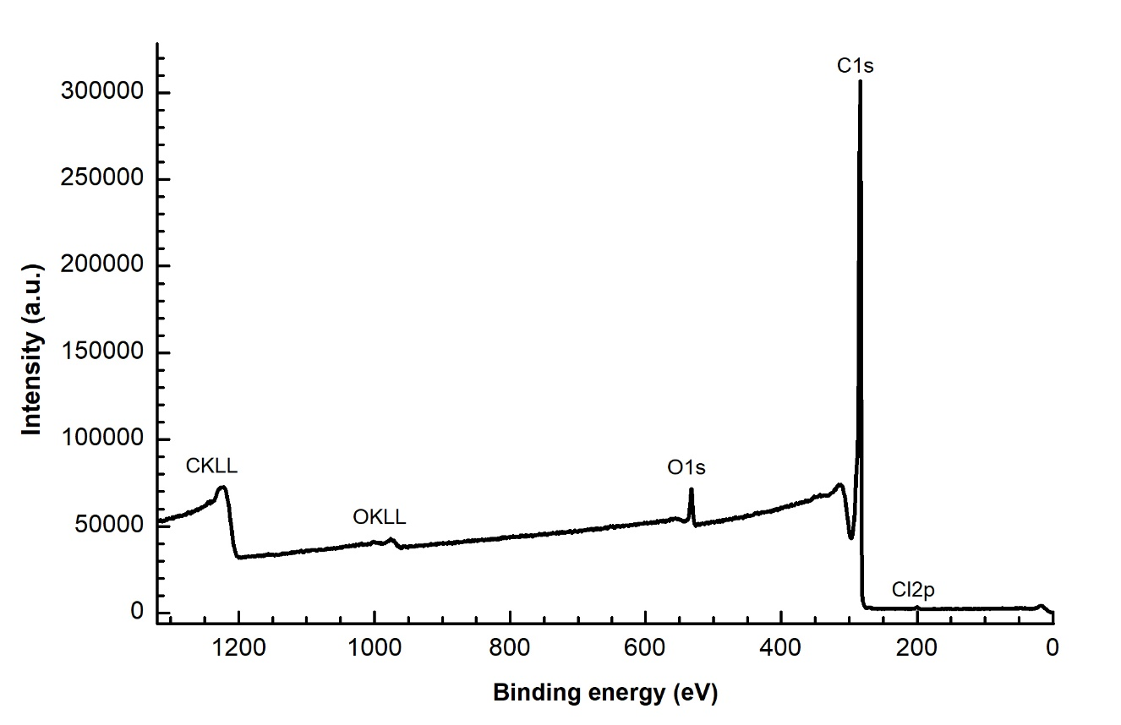
Fig. S1. Survey XPS spectrum of GNF.
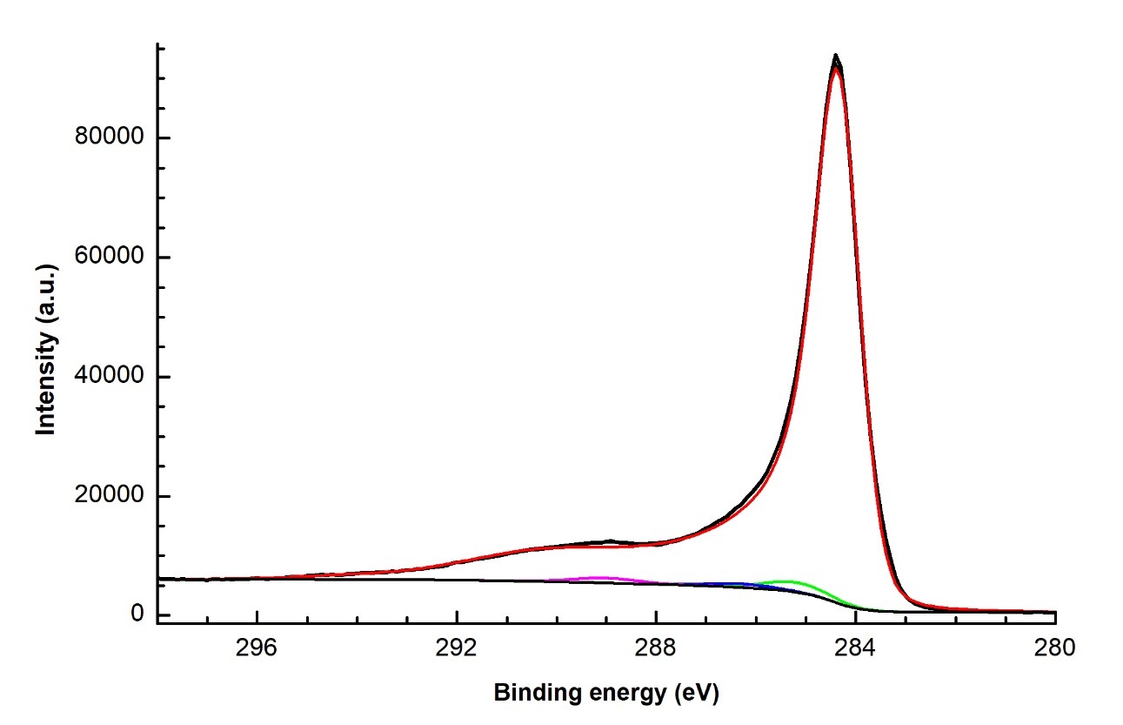
Fig. S2. C1s XPS spectrum of GNF.

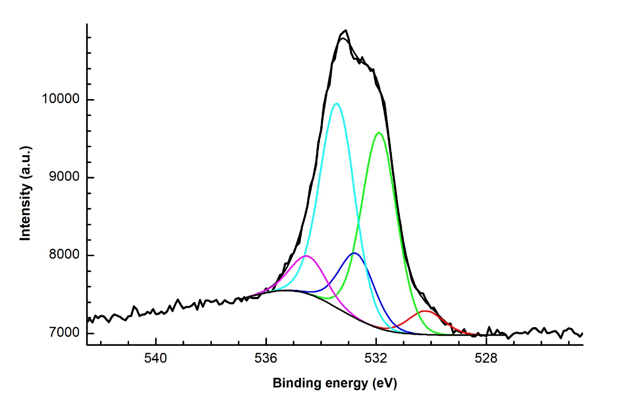
Fig S3. O1s XPS spectrum of GNF.
GNFox
The survey XPS spectrum of the GNFox is shown in Fig. S4. The spectrum contains lines of oxygen, carbon and nitrogen. The high-resolution XPS spectra were fitted with several components attributed to different species. The fitting results are shown in Table S3 and Fig. S5-S7.

Table S3. Total elemental concentrations, binding energies of component, their attribution to different species and their content determined from high-resolution XPS spectra of GNFox.
Spectrum | Concentration, at. % | Binding energy, eV | Content, at. % | Species
O1s | 9.20 | 530.3 | 0.12 | O⁻
O1s | 9.20 | 531.5 | 2.80 | O=C−O (aromatic)
O1s | 9.20 | 532.6 | 3.08 | O=C−O (aliphatic), NO_{X},  O−C (hydroxy, epoxy)
O1s | 9.20 | 533.5 | 3.20 | O=C−O, O−C (ethers)
N1s | 0.53 | 399.5 | 0.03 | NR₃
N1s | 0.53 | 401.3 | 0.05 | NR₄⁺
N1s | 0.53 | 405.7 | 0.40 | –NO₂
N1s | 0.53 | 407.3 | 0.05 | –NO₃
C1s | 90.27 | 284.4 | 72.90 | C−C (sp²)
C1s | 90.27 | 285.0 | 10.08 | C−C (sp³)
C1s | 90.27 | 286.3 | 3.74 | C−O, С−N
C1s | 90.27 | 287.7 | 0.40 | C=O, O−C−C
C1s | 90.27 | 288.8 | 3.15 | O−C=O

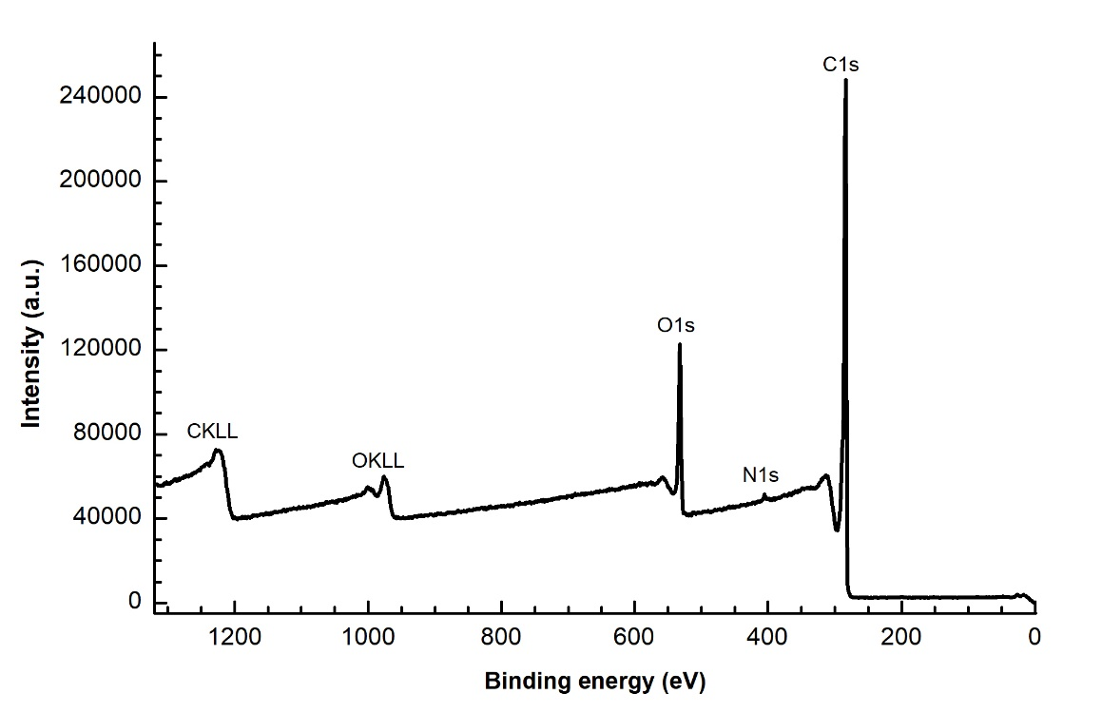
Fig. S4. Survey XPS spectrum of GNFox.
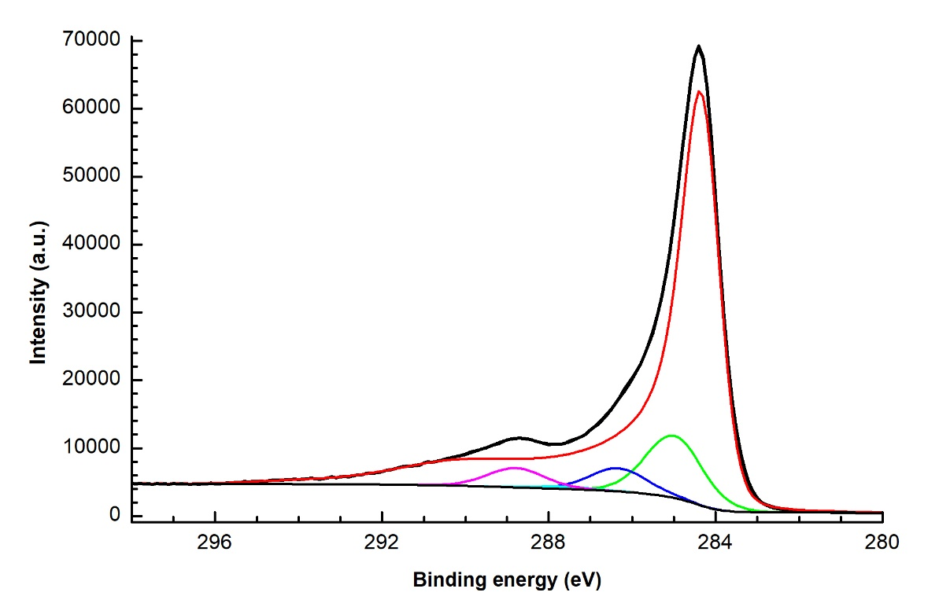
Fig. S5. C1s XPS spectrum of GNFox.
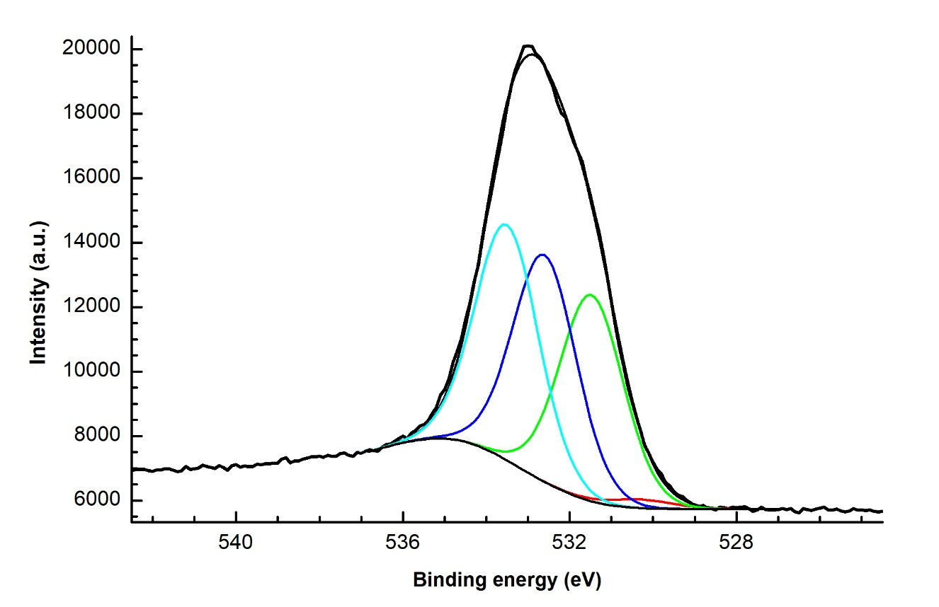
Fig S6. O1s XPS spectrum of GNFox.
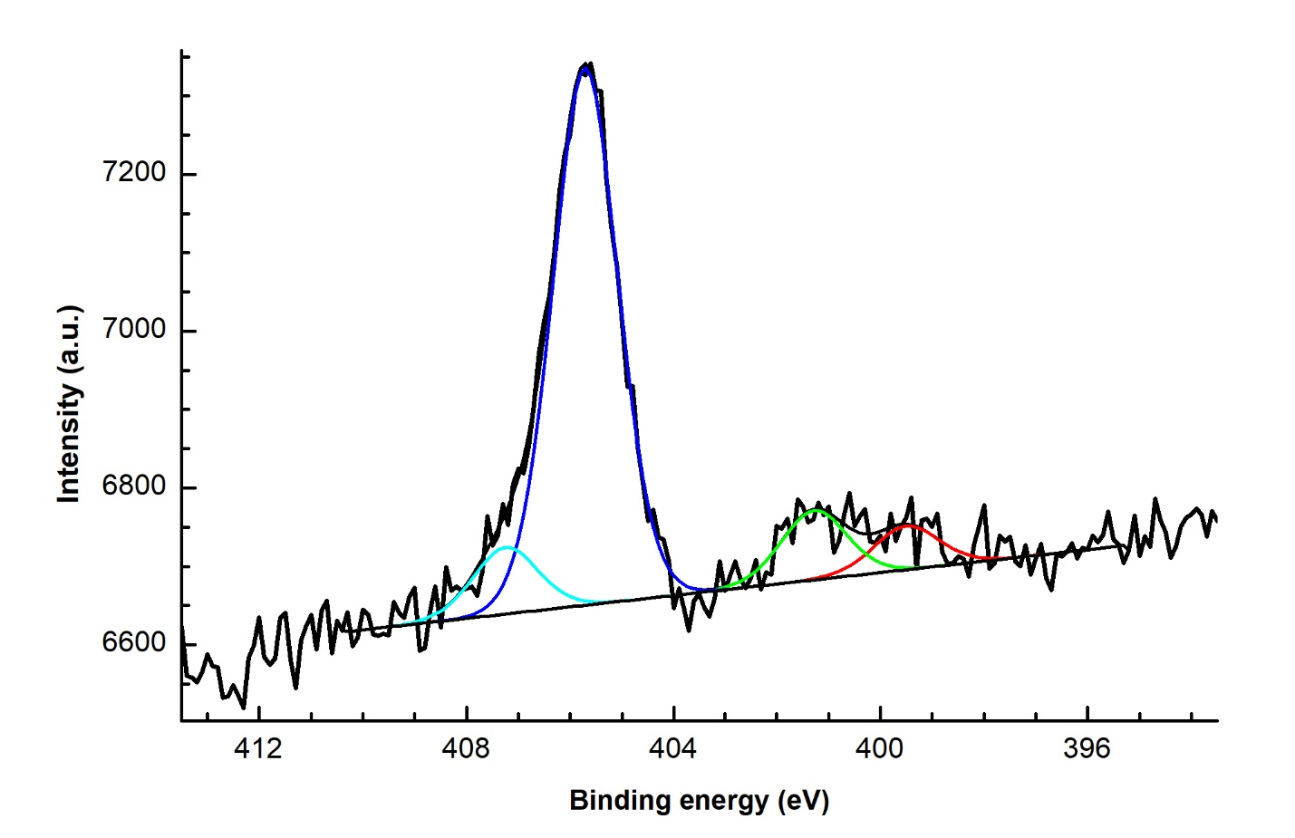
Fig S7. N1s XPS spectrum of GNFox.
N-GNF
The survey XPS spectrum of the N-GNF is shown in Fig. S8. The spectrum contains lines of oxygen, carbon, nitrogen and chlorine. The high-resolution spectra were fitted with several components attributed to different species. The fitting results are shown in Table S4 and Fig. S9-S11. The tail of N1s spectrum contains the contribution from several oxidized forms of nitrogen, that are difficult to identify.

Table S4. Total elemental concentrations, binding energies of component, their attribution to different species and their content determined from high-resolution XPS spectra of N-GNF.
Spectrum | Concentration, at. % | Binding energy, eV | Content, at. % | Species
O1s | 4.09 | 530.6 | 1.16 | O⁻
O1s | 4.09 | 531.7 | 0.91 | O=C−O (aromatic)
O1s | 4.09 | 532.6 | 1.04 | O=C−O (aliphatic), NO_{X},  O−C (hydroxy, epoxy)
O1s | 4.09 | 533.7 | 0.98 | O=C−O, O−C (ethers)
N1s | 9.56 | 398.2 | 2.56 | С=N−C
N1s | 9.56 | 399.6 | 2.31 | NR₃
N1s | 9.56 | 401.0 | 3.19 | graphitic
N1s | 9.56 | 402.5 | 0.77 | NR₄⁺
N1s | 9.56 | 404.1 | 0.39 | N−O
N1s | 9.56 | 405.6 | 0.24 | –NO₂
N1s | 9.56 | 407.2 | 0.10 | –NO₃
C1s | 86.35 | 284.4 | 41.81 | C−C (sp²)
C1s | 86.35 | 285.1 | 28.47 | C−C (sp³)
C1s | 86.35 | 286.3 | 9.69 | C−O, С−N
C1s | 86.35 | 287.7 | 3.97 | C=O, O−C−C
C1s | 86.35 | 289.1 | 2.41 | O−C=O

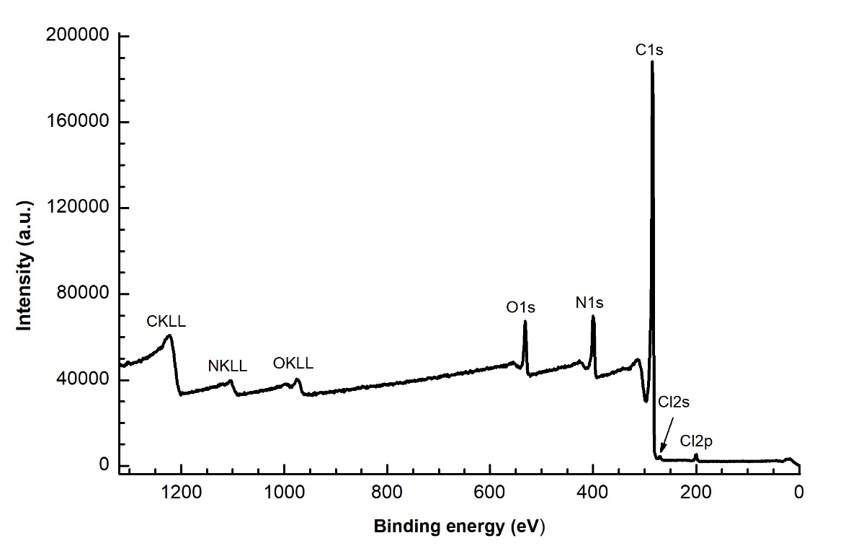
Fig. S8. Survey XPS spectrum of N-GNF.
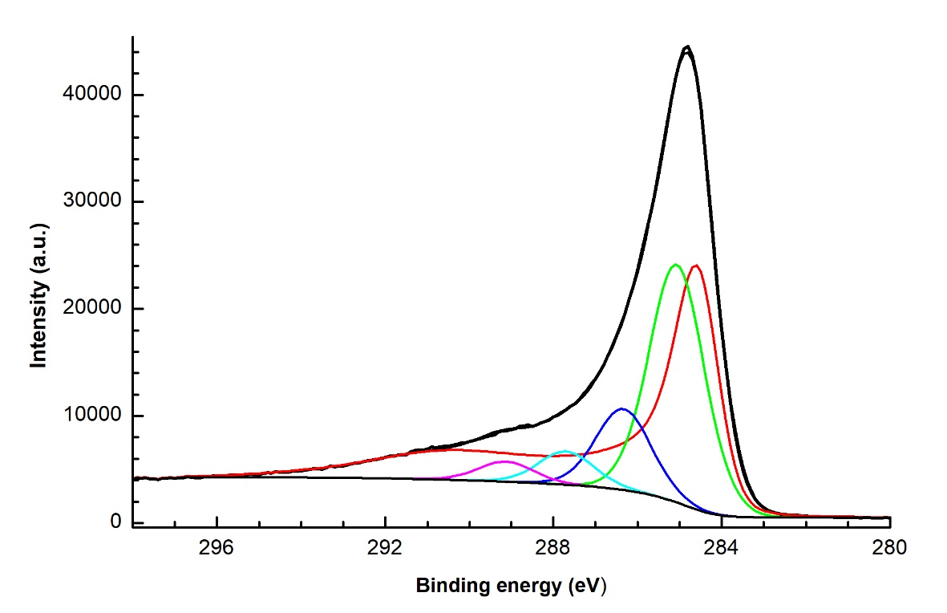
Fig. S9. C1s XPS spectrum of N-GNF.
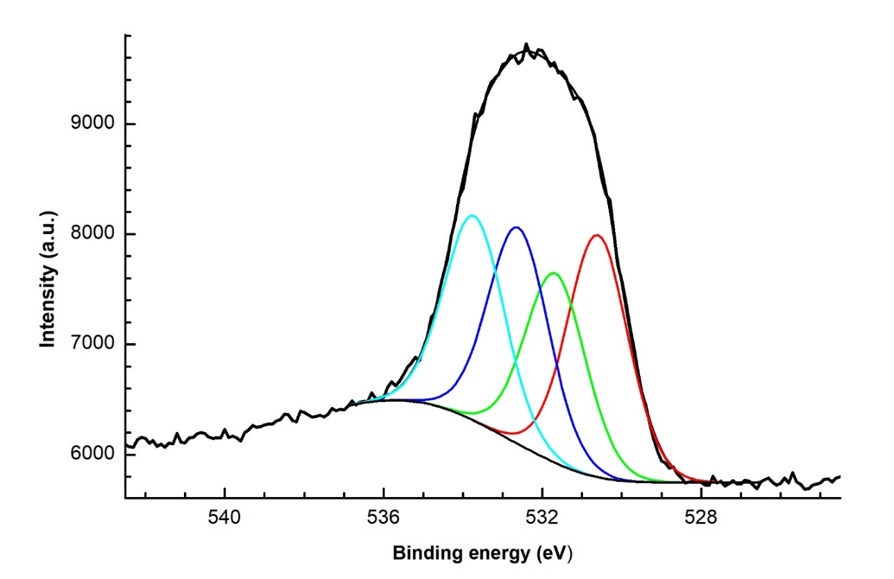
Fig. S10. O1s XPS spectrum of N-GNF.
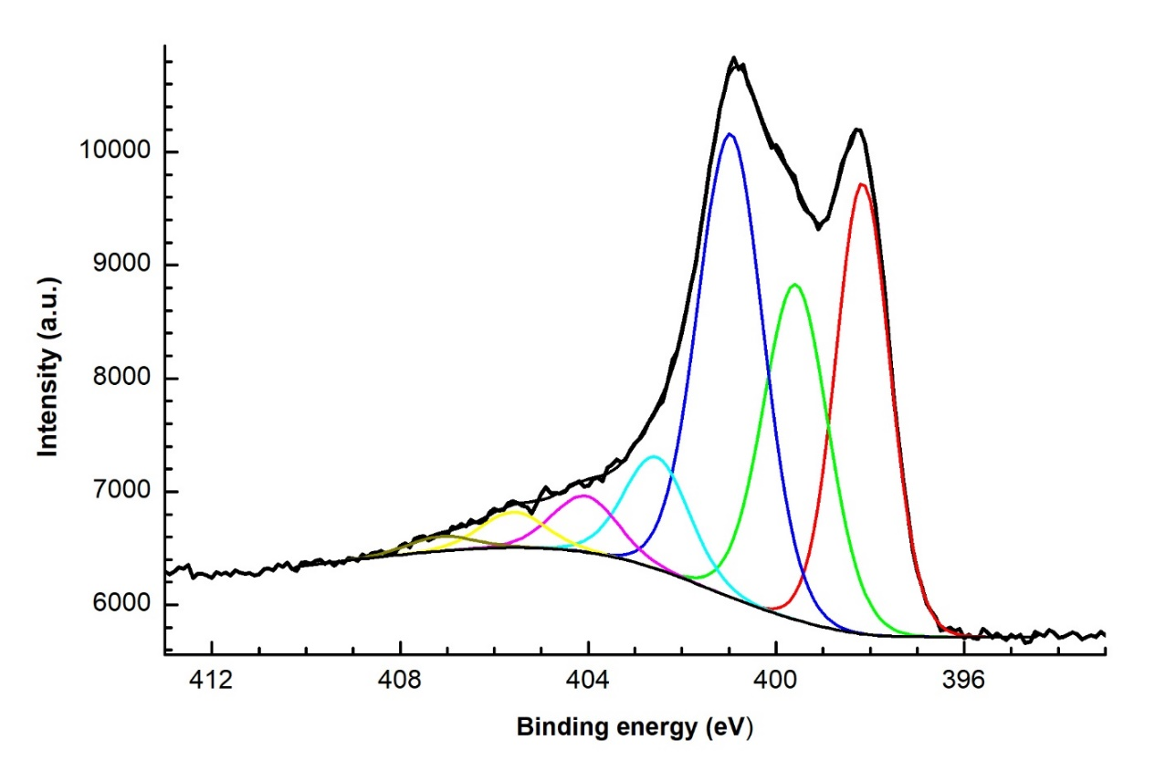
Fig. S11. N1s XPS spectrum of N-GNF.
S-GNF
The survey XPS spectrum of the S-GNF is shown in Fig. S12. The spectrum contains lines of oxygen, carbon and sulfur. The high-resolution spectra were fitted with several components corresponding to different species. The fitting results are shown in Table S5 and Fig. S13-S15. The oxygen spectrum is the most difficult to interpret (Fig. S14), because the observed components cannot be unambiguously attributed to certain species. Unoxidized C-S-C species are mainly observed in the S2p spectrum.
Table S5. Total elemental concentrations, binding energies of component, their attribution to different species and their content determined from high-resolution XPS spectra of S-GNF.
Spectrum | Concentration, at. % | Binding energy, eV | Content, at. % | Species
O1s | 4.66 | 530.8 | 0.76 | Quinones
O1s | 4.66 | 531.7 | 1.22 | C=O, SO_{x}
O1s | 4.66 | 533.1 | 1.78 | C–O−C, O−(C=O)−O
O1s | 4.66 | 534.6 | 0.90 | O−(C=O)−O
C1s | 91.37 | 284.4 | 78.13 | C−C (sp²)
C1s | 91.37 | 284.8 | 6.72 | C−C (sp³)
C1s | 91.37 | 286.3 | 4.15 | C−O
C1s | 91.37 | 287.7 | 0.96 | C=O, O−C−C
C1s | 91.37 | 289.7 | 1.41 | С–O−C=O
S2p_{3/2} | 3.97 | 163.7 | 3.03 | C−S−C
S2p_{3/2} | 3.97 | 165.0 | 0.42 | S_{n}
S2p_{3/2} | 3.97 | 167.2 | 0.22 | C−(O=S=O)−C
S2p_{3/2} | 3.97 | 168.4 | 0.30 | Sulphates, Sulphonates

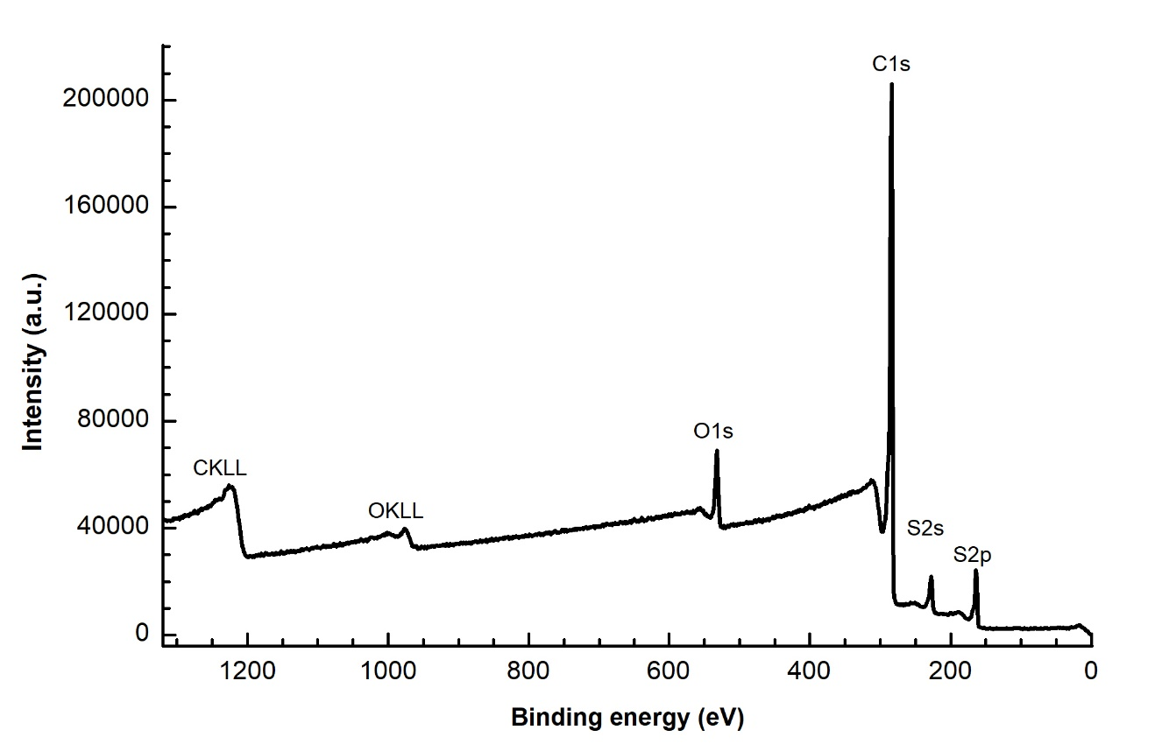
Fig. S12. Survey XPS spectrum of S-GNF.
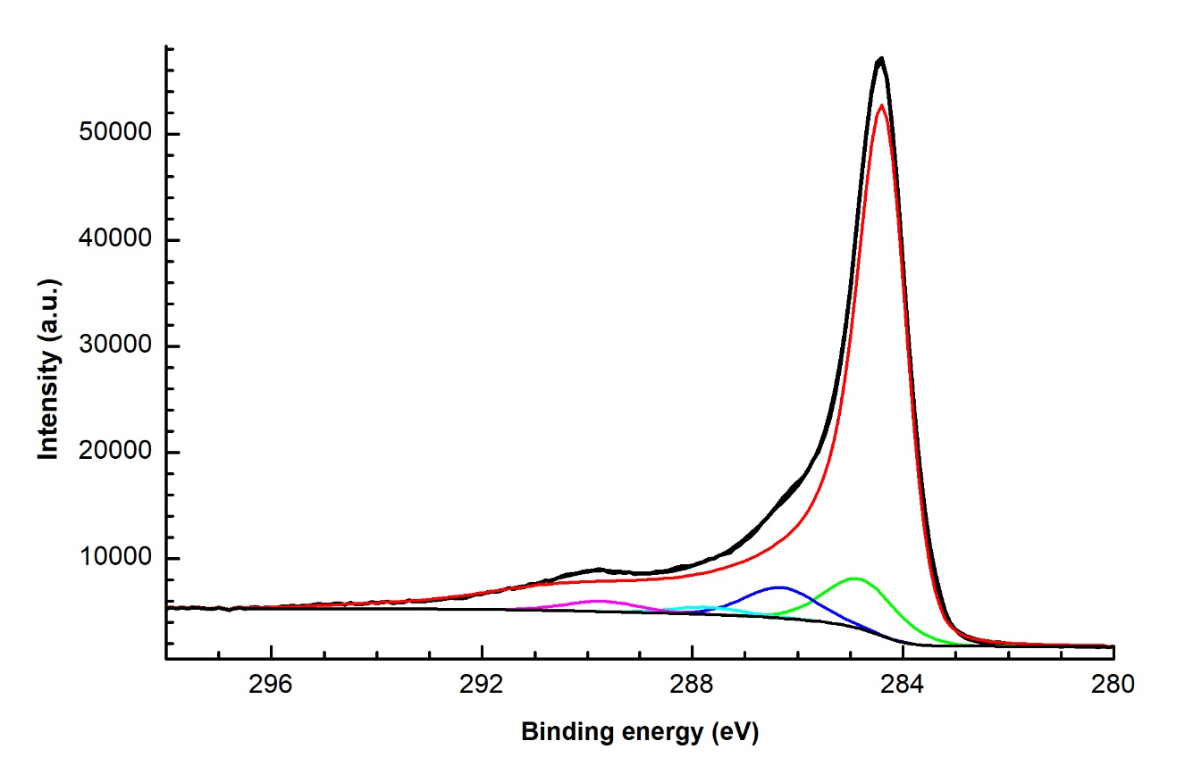
Fig. S13. C1s XPS spectrum of S-GNF.
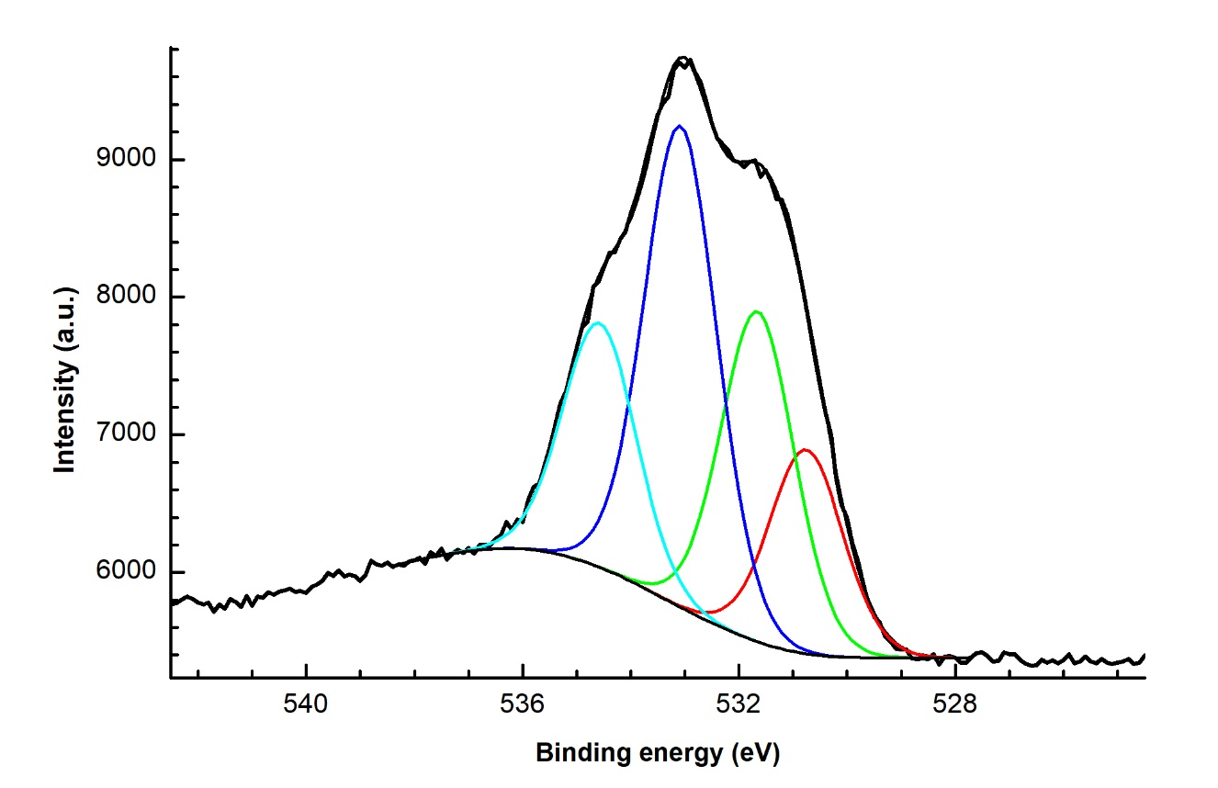
Fig. S14. O1s XPS spectrum of S-GNF.
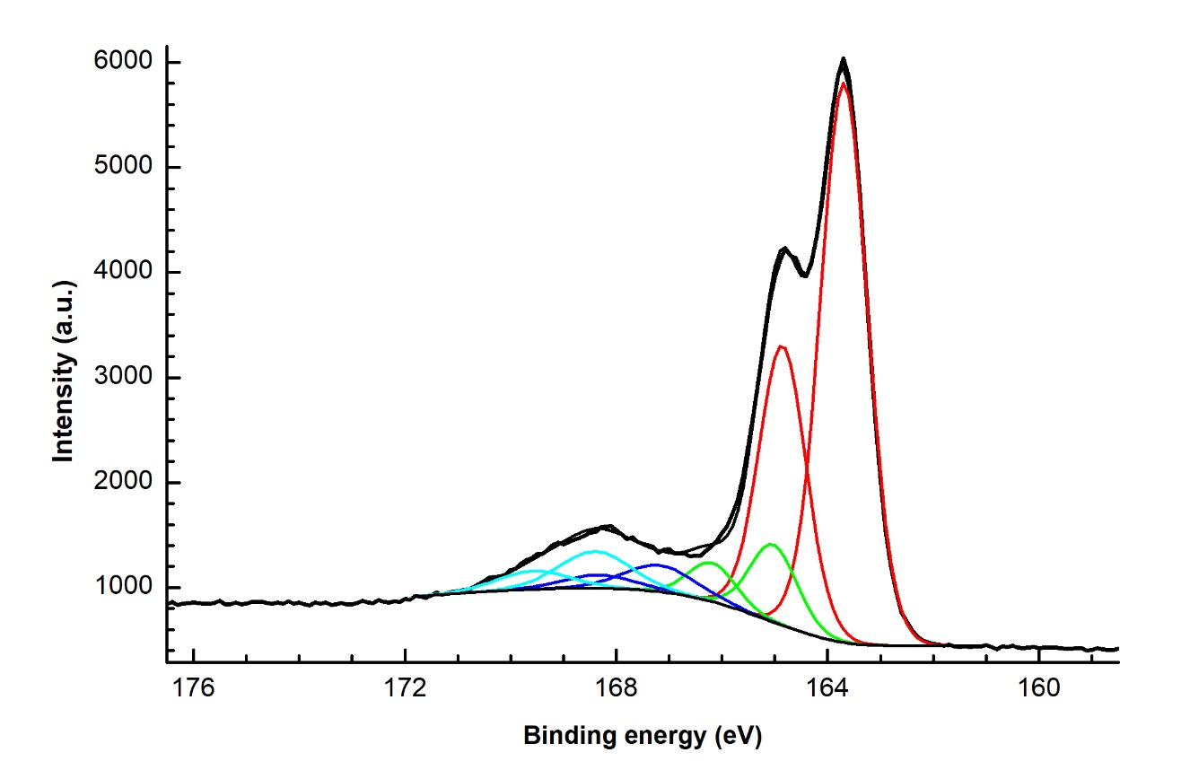
Fig. S15. S2p XPS spectrum of S-GNF.
Si-GNF
The survey XPS spectrum of the Si-GNF is shown in Fig. S16. The spectrum contains lines of oxygen, carbon and silicon. The high-resolution spectra were fitted with several components corresponding to different species. The fitting results are shown in Table S6 and Fig. S17-S19.
Table S6. Total elemental concentrations, binding energies of component, their attribution to different species and their content determined from high-resolution XPS spectra of Si-GNF.
Spectrum | Concentration, at. % | Binding energy, eV | Content, at. % | Species
O1s | 6.24 | 530.3 | 0.29 | O⁻
O1s | 6.24 | 531.7 | 2.07 | O=C−O (aromatic)
O1s | 6.24 | 532.5 | 2.76 | O=C−O (aliphatic),  O−C (hydroxy, epoxy), O−Si
O1s | 6.24 | 533.6 | 1.12 | O=C−O, O−C (ethers)
C1s | 91.39 | 283.6 | 4.94 | C−Si
C1s | 91.39 | 284.3 | 82.53 | C−C (sp²)
C1s | 91.39 | 284.8 | 2.09 | C−C (sp³)
C1s | 91.39 | 286.2 | 0.69 | C−O
C1s | 91.39 | 287.3 | 0.21 | C=O, O−C−O
C1s | 91.39 | 288.9 | 0.93 | O=C−O
Si2p | 2.37 | 100.3 | 1.15 | Si–C
Si2p | 2.37 | 101.6 | 0.93 | SiC_{x}O_{y}
Si2p | 2.37 | 103.1 | 0.29 | SiO₂

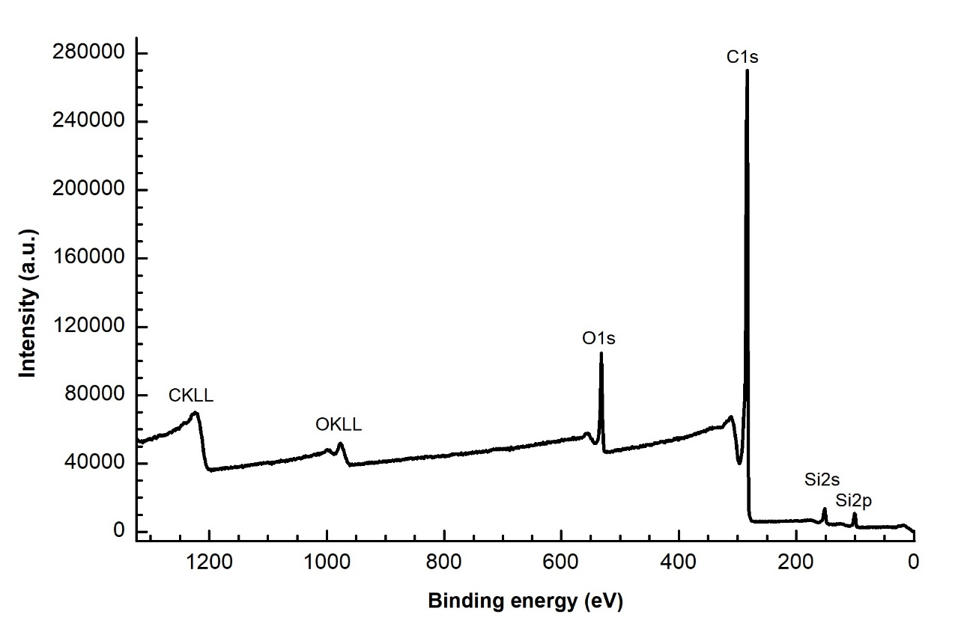
Fig. S16. Survey XPS spectrum of Si-GNF.
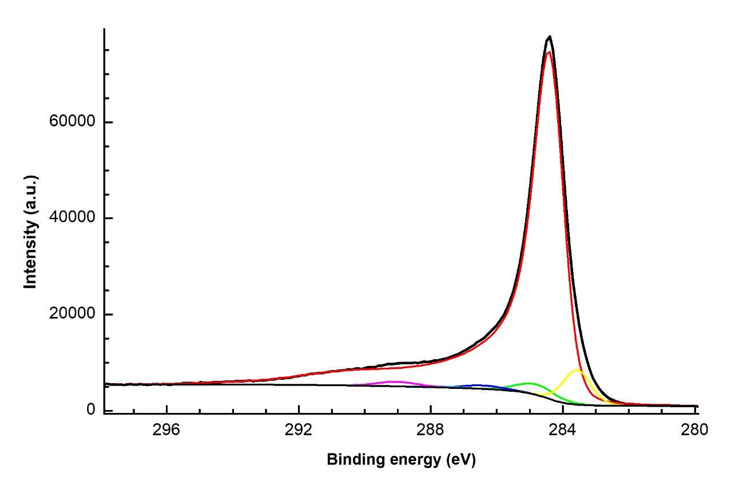
Fig. S17. C1s XPS spectrum of Si-GNF.
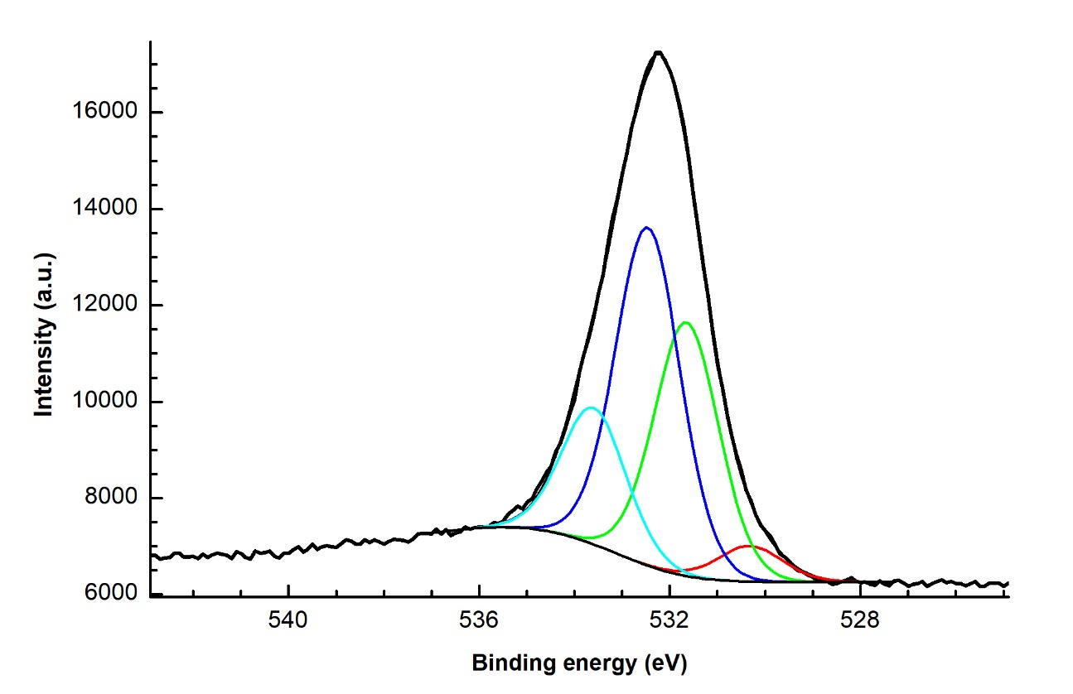
Fig. S18. O1s XPS spectrum of Si-GNF.
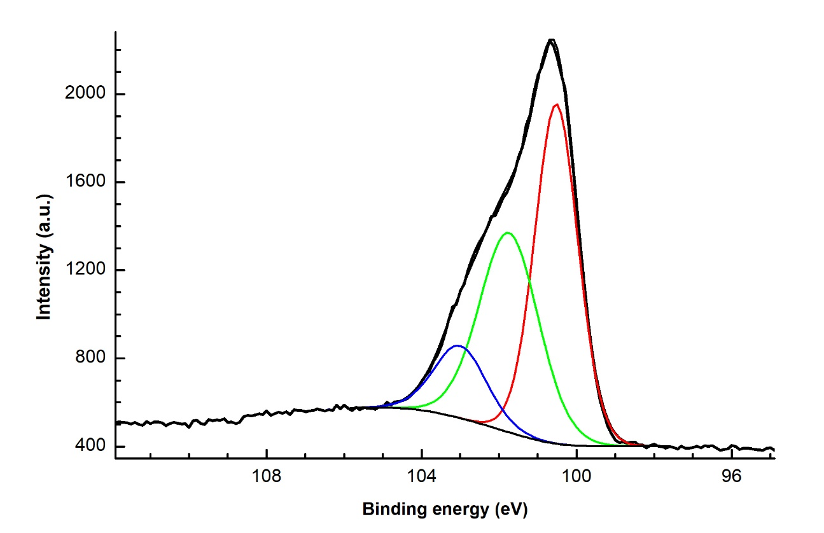
Fig. S19. Si2p XPS spectrum of Si-GNF.
S3 Raman spectroscopy data
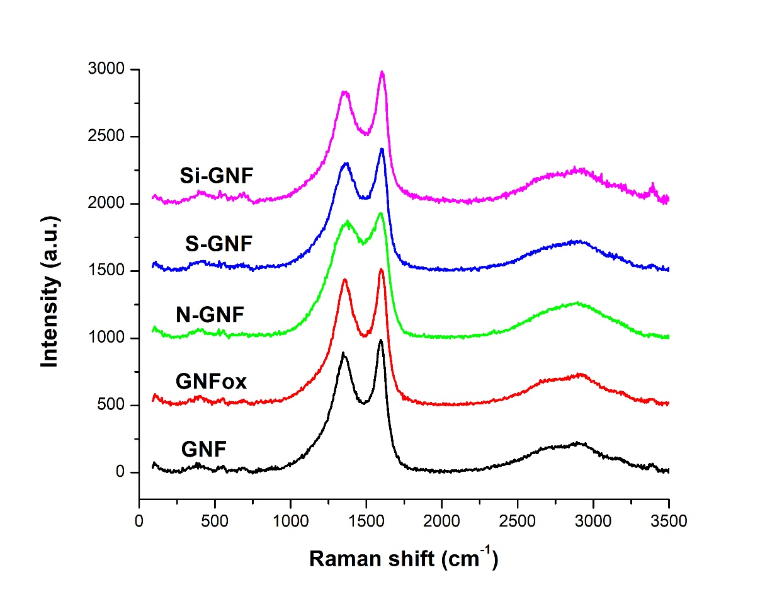
Fig. S20. Raman spectra of CNMs.
Table S7. Parameters of bands in Raman spectra of CNMs (S, I, W are, respectively, the area, intensity and FWHM of Raman bands).
Parameter | GNF | GNFox | N-GNF | S-GNF | Si-GNF
S_{D1}/S_{G} | 1.15 ± 0.06 | 1.17 ± 0.04 | 1.70 ± 0.25 | 1.41 ± 0.14 | 1.28 ± 0.15
S_{D3}/S_{G} | 0.36 ± 0.09 | 0.33 ± 0.05 | 0.34 ± 0.11 | 0.75 ± 0.23 | 0.49 ± 0.13
S_{D4}/S_{G} | 0.43 ± 0.06 | 0.39 ± 0.04 | 0.37 ± 0.13 | 0.48 ± 0.14 | 0.41 ± 0.12
I_{G´}/I_{G} | 0.224 ± 0.027 | 0.24 ± 0.04 | 0.294 ± 0.016 | 0.28 ± 0.04 | 0.30 ± 0.08
W(D1), cm⁻¹ | 159 ± 5 | 153 ± 4 | 223 ± 24 | 170 ± 10 | 165 ± 14
W(G), cm⁻¹ | 88 ± 5 | 87.6 ± 2.7 | 110.9 ± 1.7 | 92 ± 7 | 91 ± 13
S(G), % | 34.1 ± 1.7 | 34.6 ± 0.8 | 29.4 ± 0.8 | 28 ± 3 | 31.6 ± 1.6

S4 Isotherms of organic solvents vapour adsorption/desorption
Acetonitrile sorption
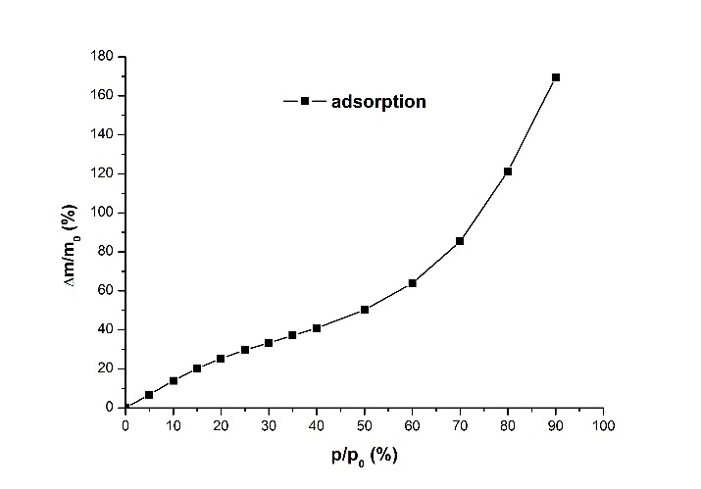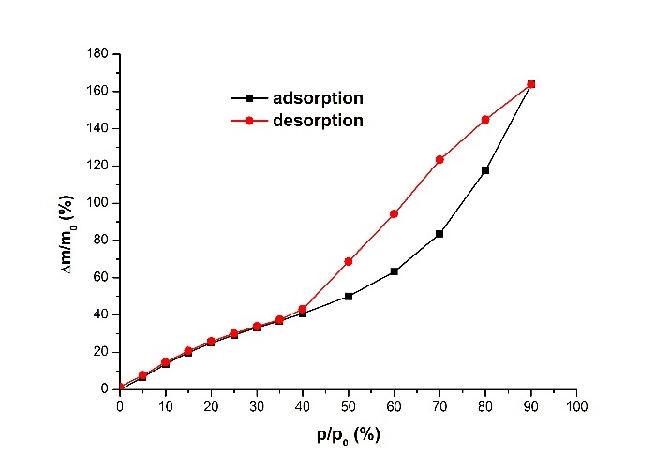
Fig. S21. Acetonitrile (a) adsorption isotherm at 20°C for GNF and (b) adsorption/desorption isotherm at 30°C.
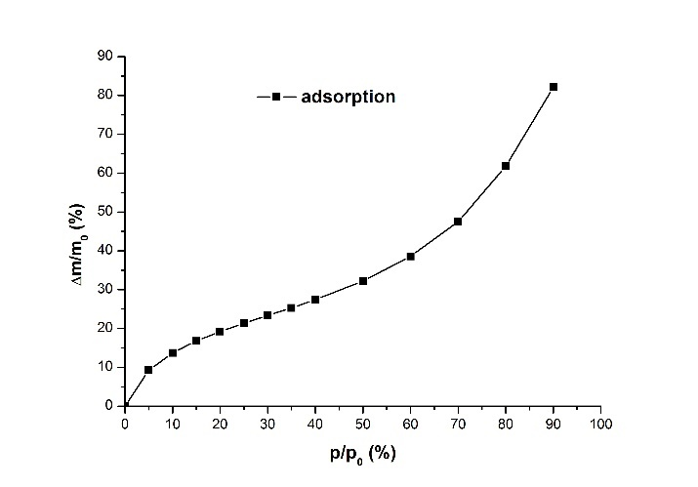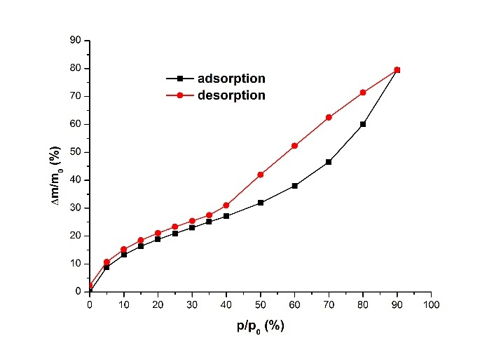
Fig. S22. Acetonitrile (a) adsorption isotherm at 20°C for GNFox and (b) adsorption/desorption isotherm at 30°C.
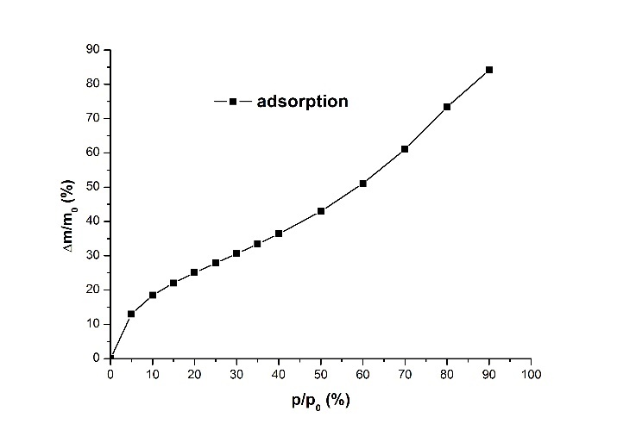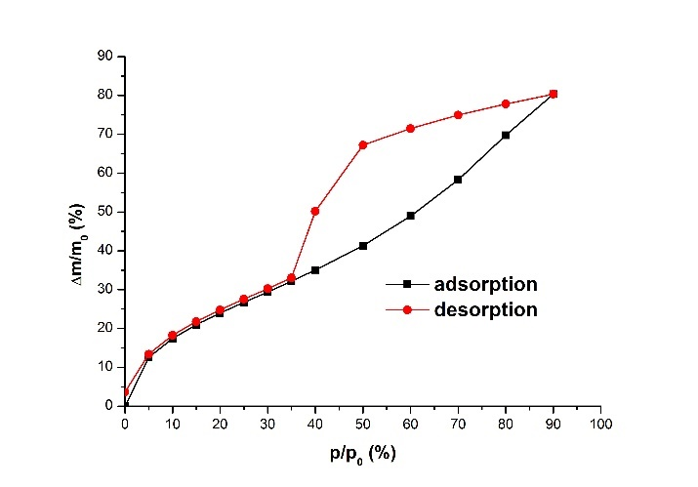
Fig. S23. Acetonitrile (a) adsorption isotherm at 20°C for N-GNF and (b) adsorption/desorption isotherm at 30°C.
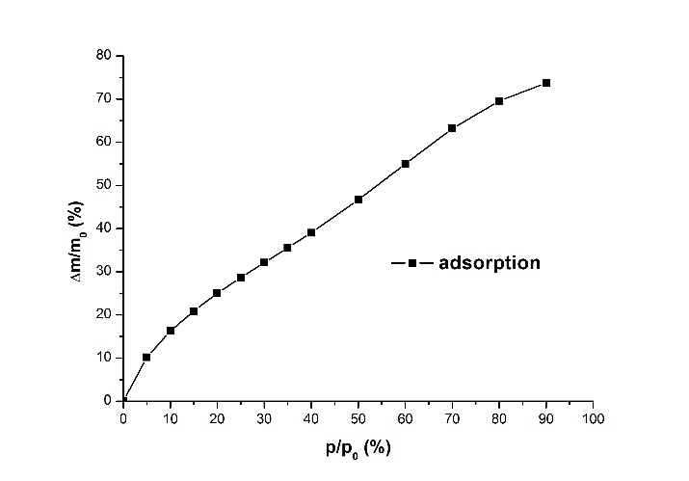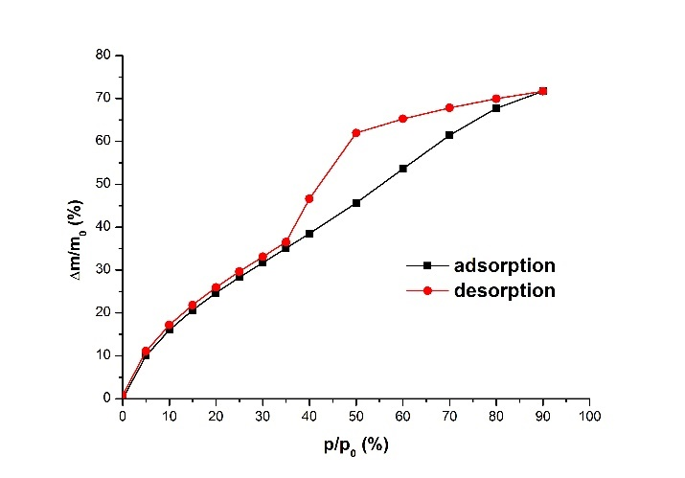
Fig. S24. Acetonitrile (a) adsorption isotherm at 20°C for S-GNF and (b) adsorption/desorption isotherm at 30°C.
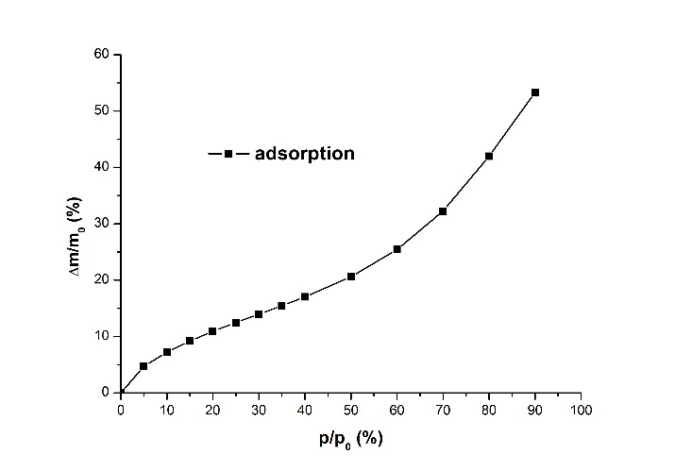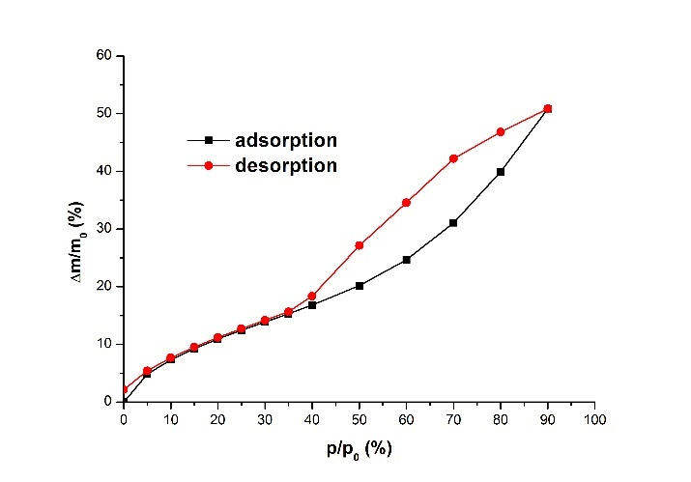
Fig. S25. Acetonitrile (a) adsorption isotherm at 20°C for Si-GNF and (b) adsorption/desorption isotherm at 30°C.
Ethanol sorption
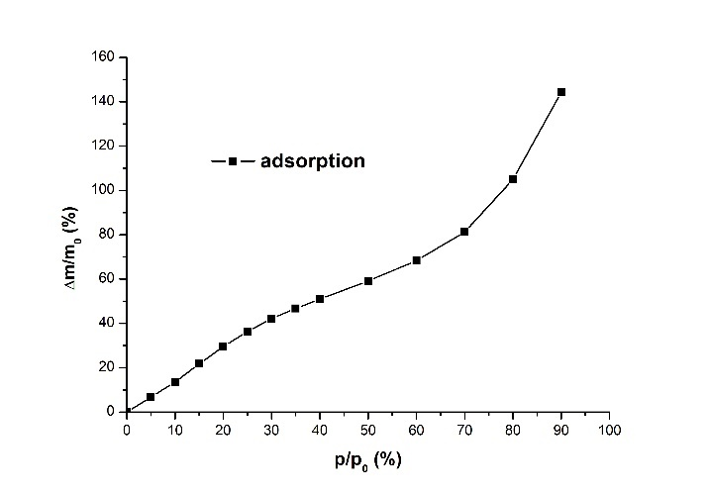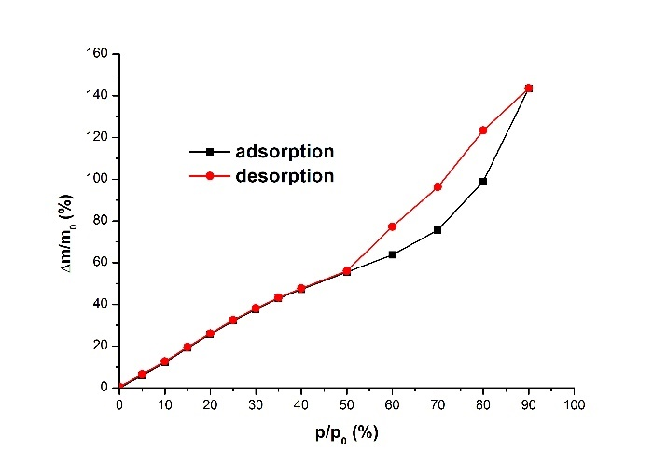
Fig. S26. Ethanol (a) adsorption isotherm at 20°C for GNF and (b) adsorption/desorption isotherm at 30°C.
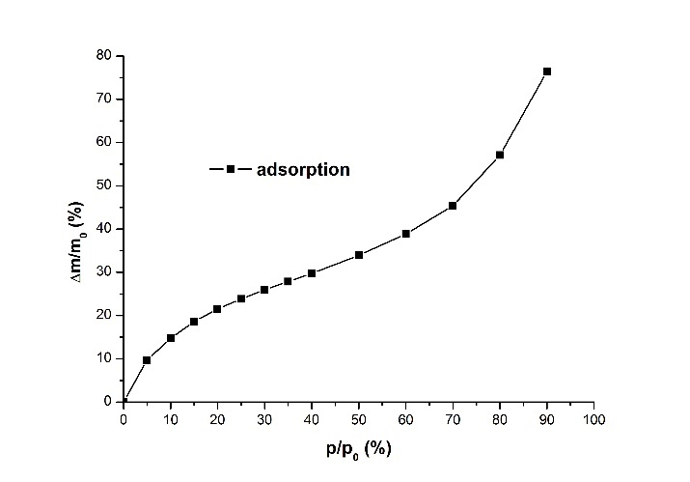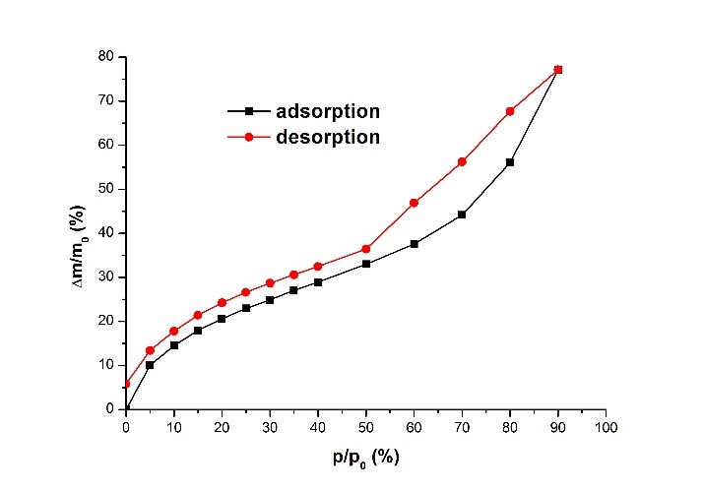
Fig. S27. Ethanol (a) adsorption isotherm at 20°C for GNFox and (b) adsorption/desorption isotherm at 30°C.
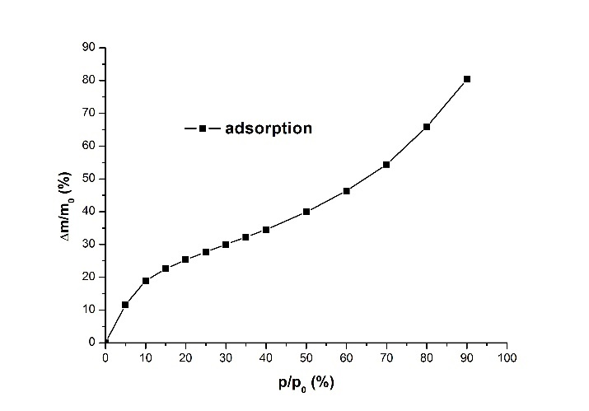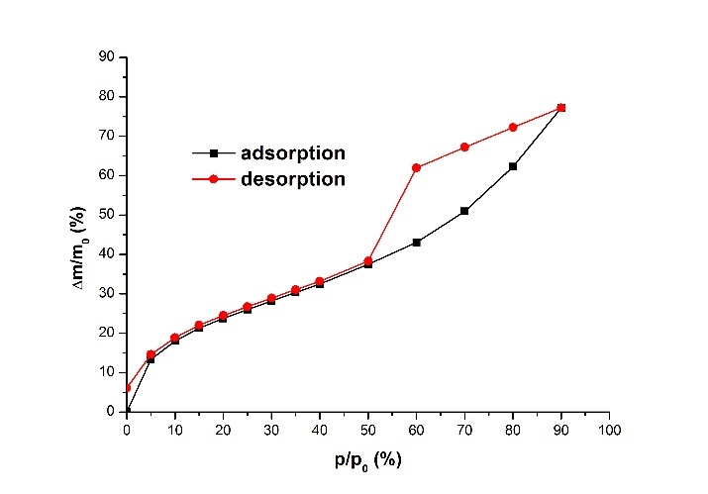
Fig. S28. Ethanol (a) adsorption isotherm at 20°C for N-GNF and (b) adsorption/desorption isotherm at 30°C.
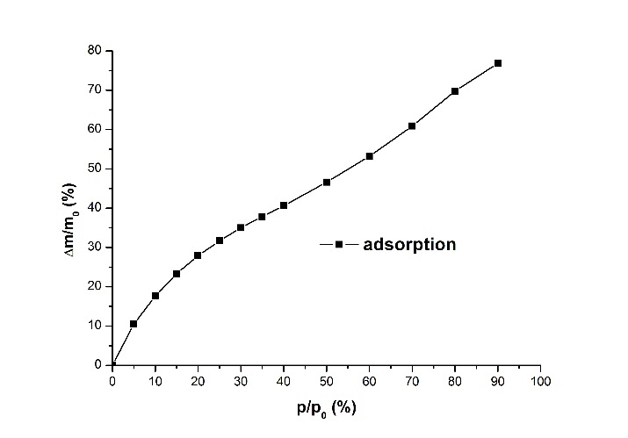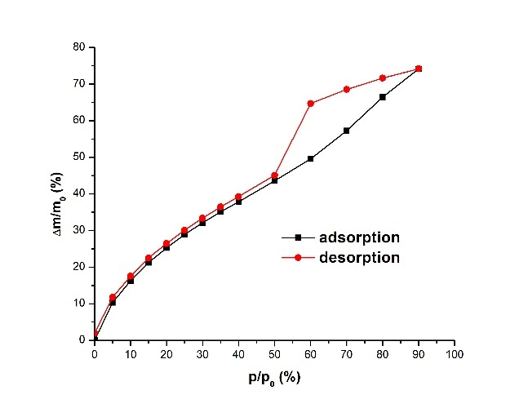
Fig. S29. Ethanol (a) adsorption isotherm at 20°C for S-GNF and (b) adsorption/desorption isotherm at 30°C.
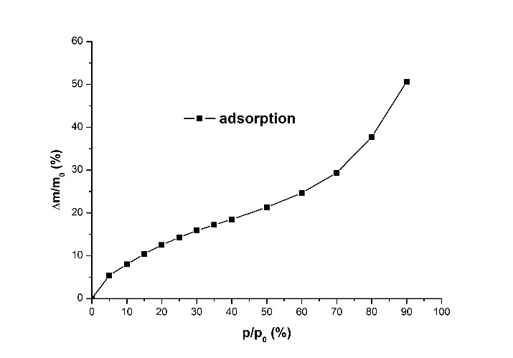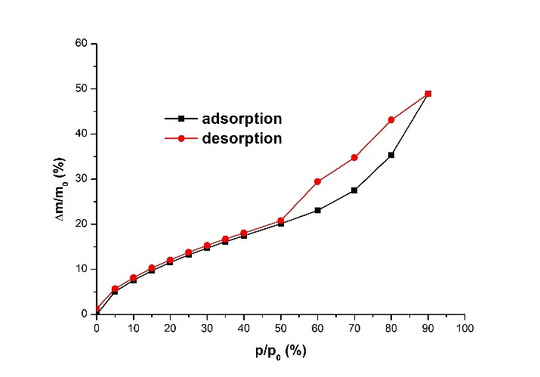
Fig. S30. Ethanol (a) adsorption isotherm at 20°C for Si-GNF and (b) adsorption/desorption isotherm at 30°C.

Toluene sorption
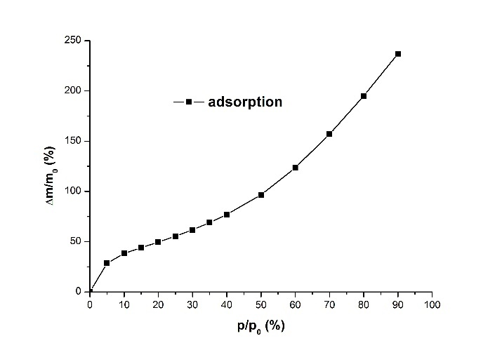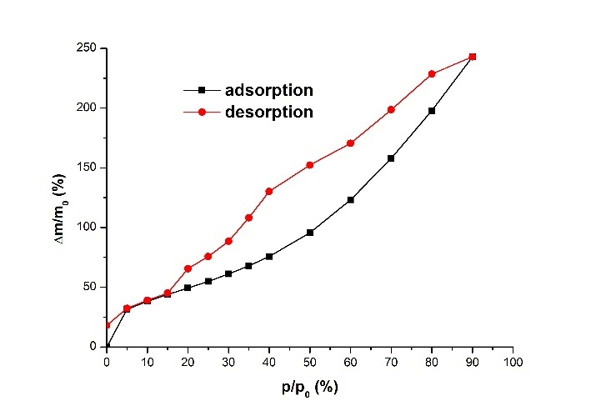
Fig. S31. Toluene (a) adsorption isotherm at 20°C for GNF and (b) adsorption/desorption isotherm at 30°C.
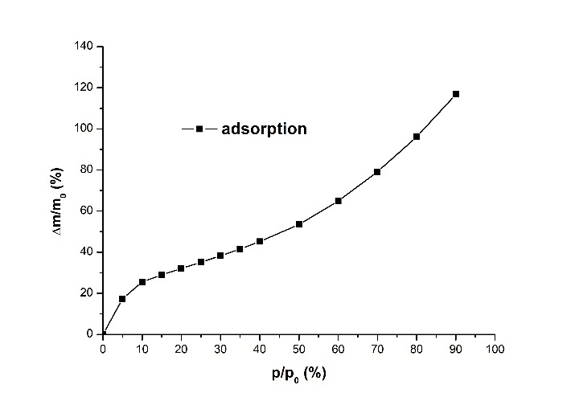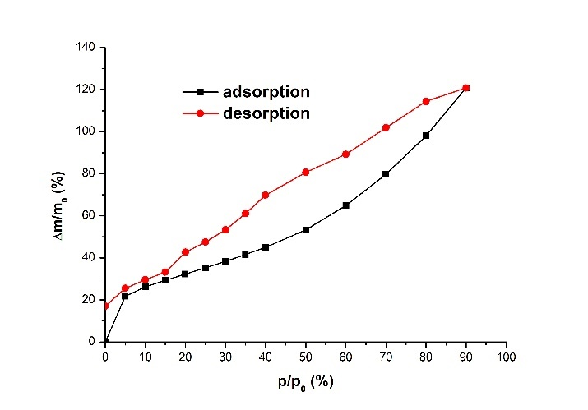
Fig. S32. Toluene (a) adsorption isotherm at 20°C for GNFox and (b) adsorption/desorption isotherm at 30°C.
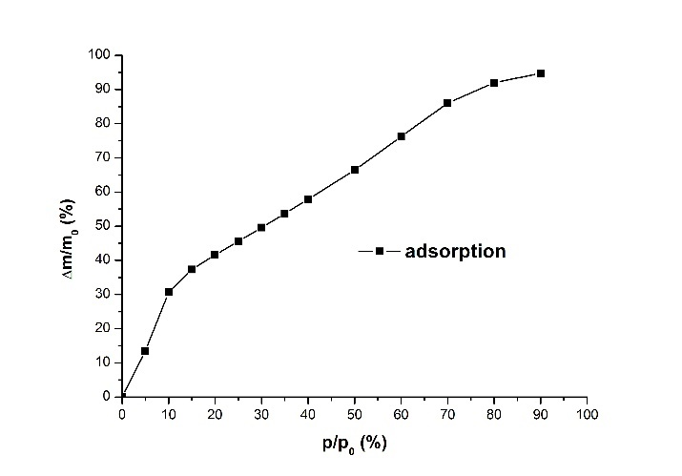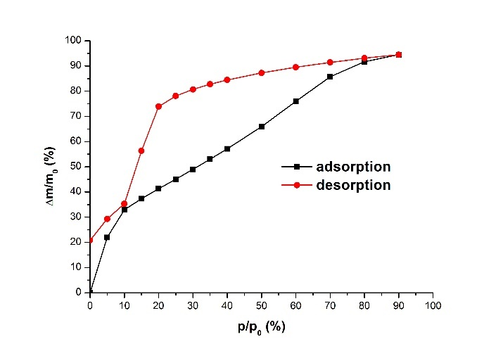
Fig. S33. Toluene (a) adsorption isotherm at 20°C for N-GNF and (b) adsorption/desorption isotherm at 30°C.
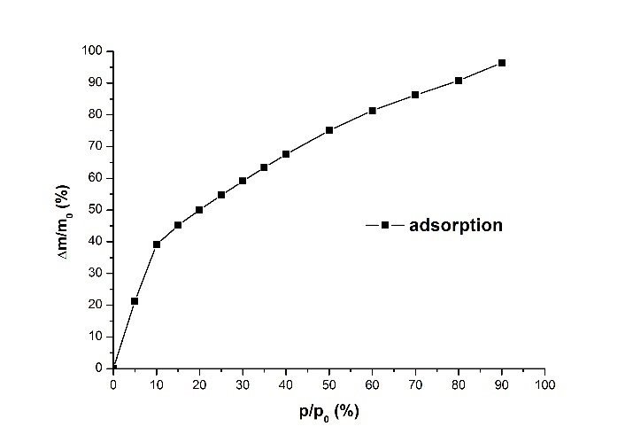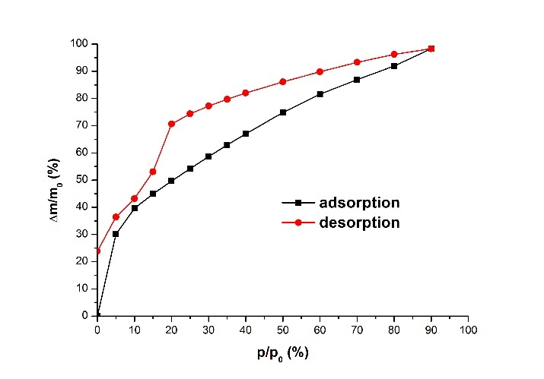
Fig. S34. Toluene (a) adsorption isotherm at 20°C for S-GNF and (b) adsorption/desorption isotherm at 30°C.
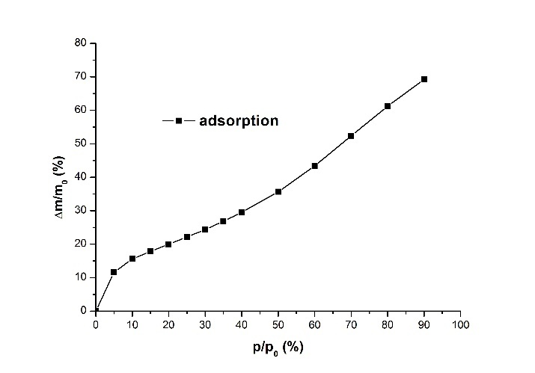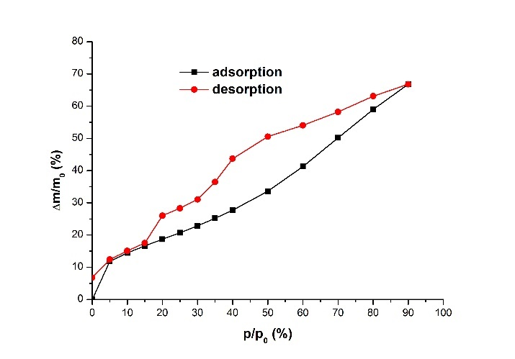
Fig. S35. Toluene (a) adsorption isotherm at 20°C for Si-GNF and (b) adsorption/desorption isotherm at 30°C.
Hexane sorption
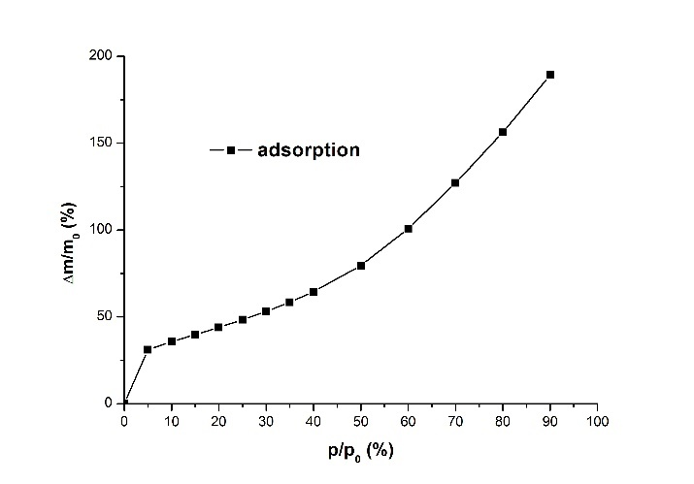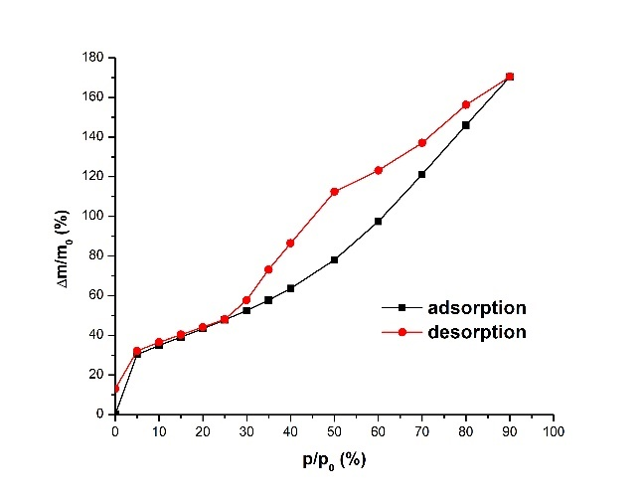
Fig. S36. Hexane (a) adsorption isotherm at 20°C for GNF and (b) adsorption/desorption isotherm at 30°C.
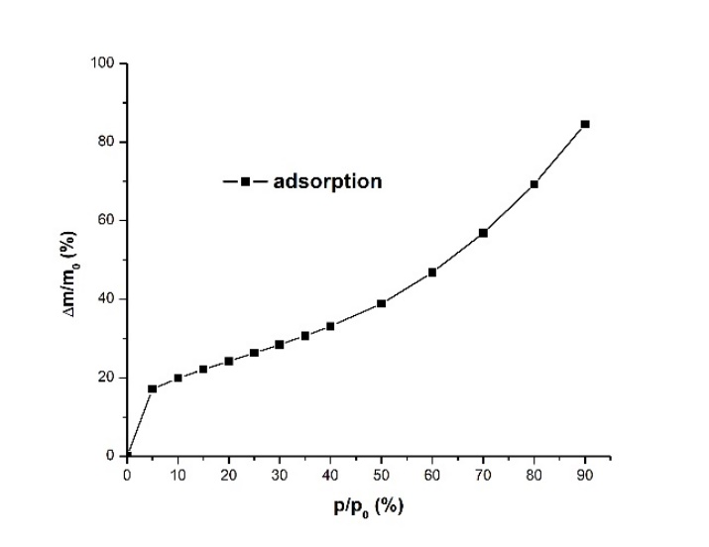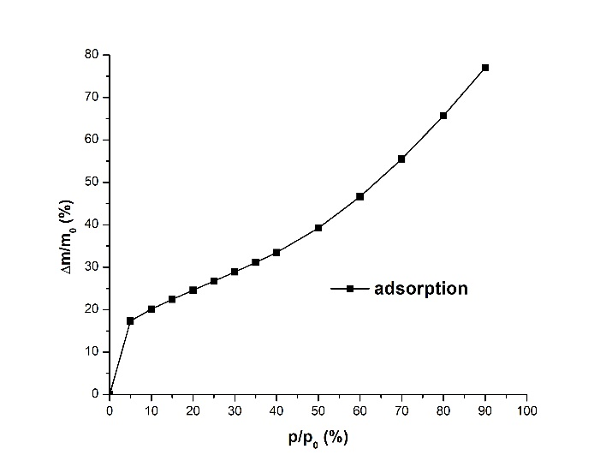
Fig. S37. Hexane (a) adsorption isotherm at 20°C for GNFox and (b) adsorption/desorption isotherm at 30°C.
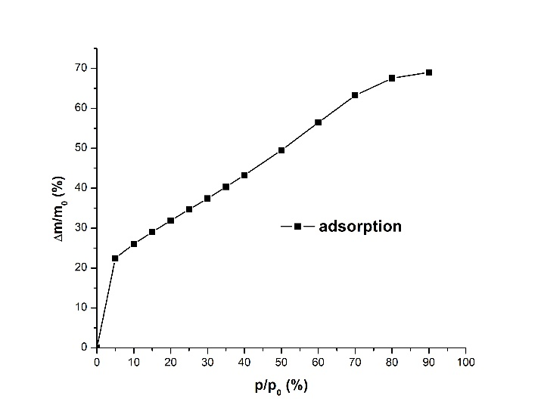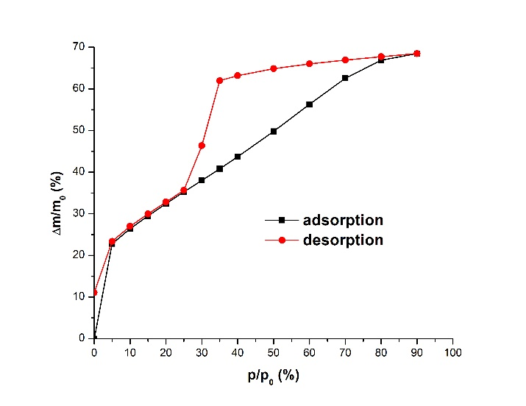
Fig. S38. Hexane (a) adsorption isotherm at 20°C for N-GNF and (b) adsorption/desorption isotherm at 30°C.
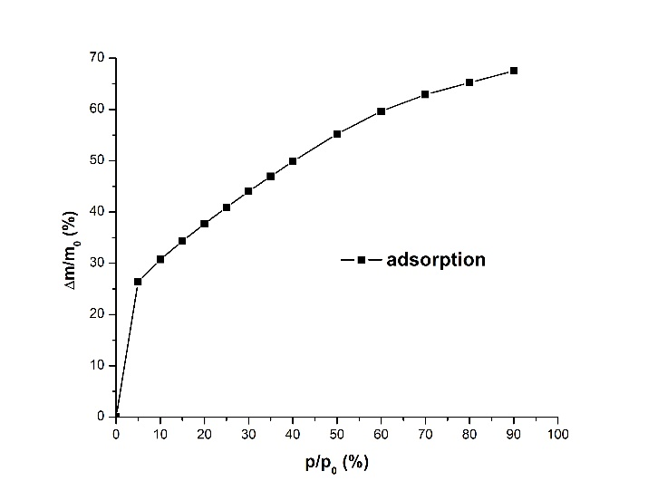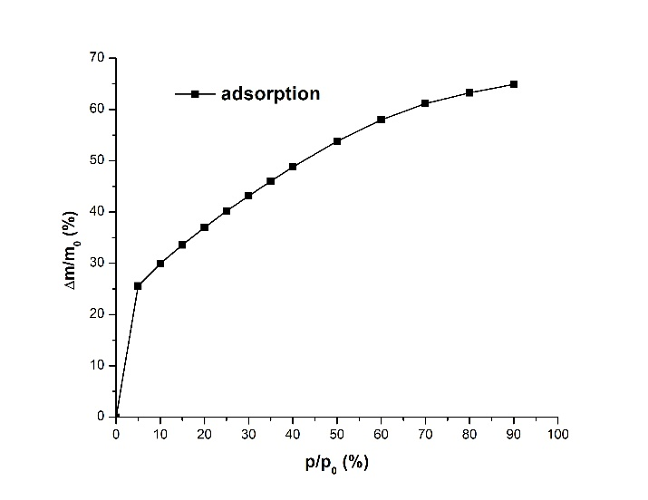
Fig. S39. Hexane (a) adsorption isotherm at 20°C for S-GNF and (b) adsorption/desorption isotherm at 30°C.
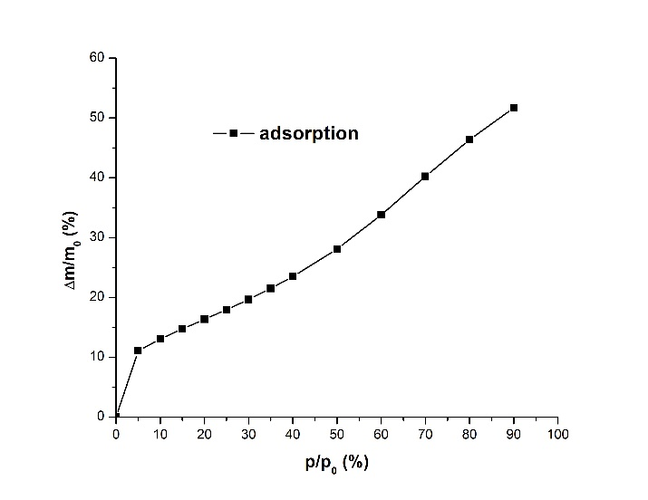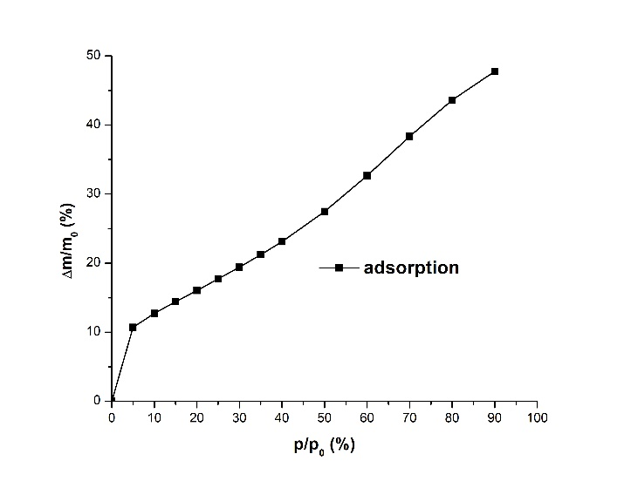
Fig. S40. Hexane (a) adsorption isotherm at 20°C for Si-GNF and (b) adsorption/desorption isotherm at 30°C.

S5 BET parameters for vapour sorption
Table S8. BET parameters for vapour sorption on CNMs (parameters were averaged for measurements at 20 and 30°C).
Adsorptive | Parameter | Adsorbent
Adsorptive | Parameter | GNF | GNFox | N-GNF | S-GNF | Si-GNF
Hexane | S, m²/g | 1386 ± 17 | 751 ± 19 | 990 ± 24 | 1146 ± 9 | 518 ± 6
Hexane | V_{m}, cm³/g | 100.2 ± 1.2 | 54.2 ± 1.3 | 71.5 ± 1.7 | 82.8 ± 0.6 | 37.4 ± 0.4
Hexane | c | 46.7 ± 1.5 | 62.92 ± 0.28 | 61.04 ± 0.18 | 61.0 ± 1.6 | 40.9 ± 1.8
Toluene | S, m²/g | 1026.5 ± 1.0 | 636.5 ± 1.5 | 839 ± 7 | 978 ± 12 | 394 ± 9
Toluene | V_{m}, cm³/g | 112.35 ± 0.15 | 69.67 ± 0.17 | 91.9 ± 0.8 | 107.1 ± 1.3 | 43.2 ± 1.0
Toluene | c | 27.2 ± 2.8 | 39 ± 10 | 27.4 ± 1.3 | 37.4 ± 0.6 | 29.3 ± 1.6
Ethanol | S, m²/g | -* | 952 ± 15 | 1050 ± 40 | 1360 ± 50 | 600 ± 16
Ethanol | V_{m}, cm³/g | -* | 100.4 ± 1.6 | 111 ± 4 | 144 ± 6 | 63.3 ± 1.7
Ethanol | c | -* | 16.5 ± 1.2 | 24 ± 4 | 9.9 ± 0.4 | 11.25 ± 0.23
Acetonitrile | S, m²/g | 921 ± 17** | 587 ± 8 | 739.8 ± 1.6 | 871 ± 10 | 368.9 ± 2.6
Acetonitrile | V_{m}, cm³/g | 160 ± 3** | 101.8 ± 1.4 | 128.4 ± 0.3 | 151.1 ± 1.8 | 64.0 ± 0.5
Acetonitrile | c | 8.60 ± 0.21** | 17.0 ± 0.6 | 20.2 ± 0.3 | 10.09 ± 0.05 | 11.7 ± 0.5
* The BET equation is inapplicable for ethanol adsorption isotherms on GNF, ** The BET equation is applicable for acetonitrile adsorption isotherms on GNF for p/p₀ = 0.15 - 0.30.

S6 Adsorption capacities
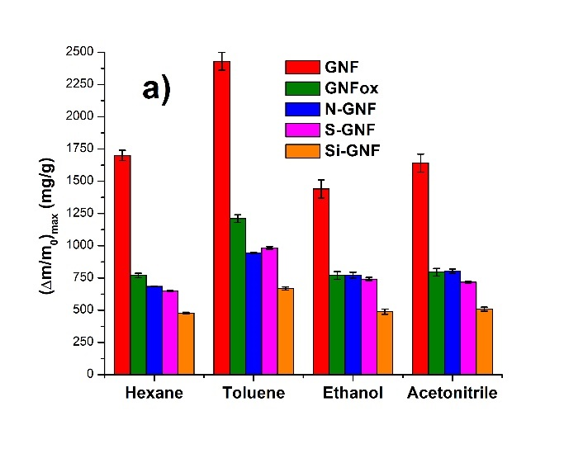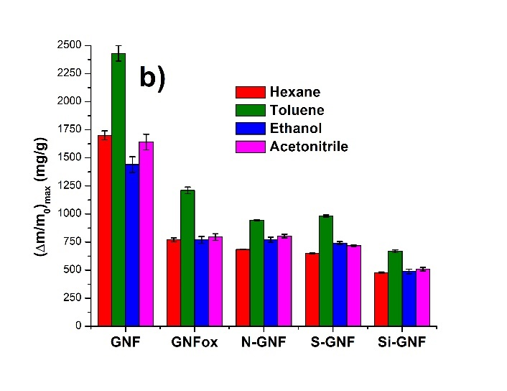
Fig. S41. Maximum adsorption capacities of CNMs at 30°C.
S7 Average isosteric heat of adsorption
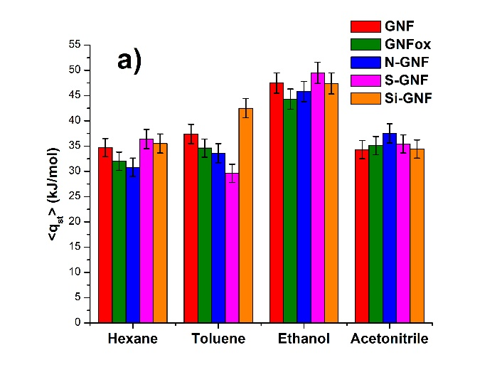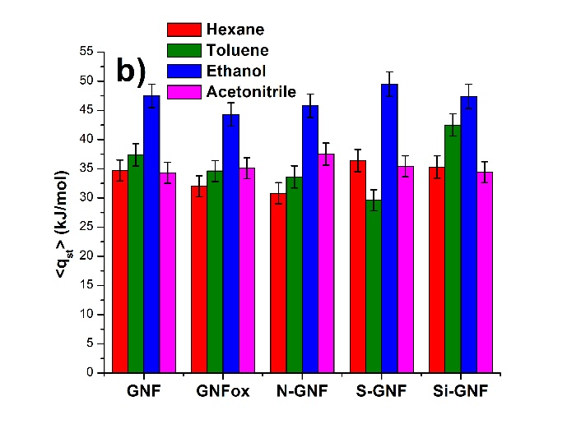Fig. S42. Average isosteric heat of adsorption $\overline{q_{st}}$ for all degrees of surface coverage for various adsorbent-adsorbate pairs.

