Supplementary Materials
Supplemental Figure
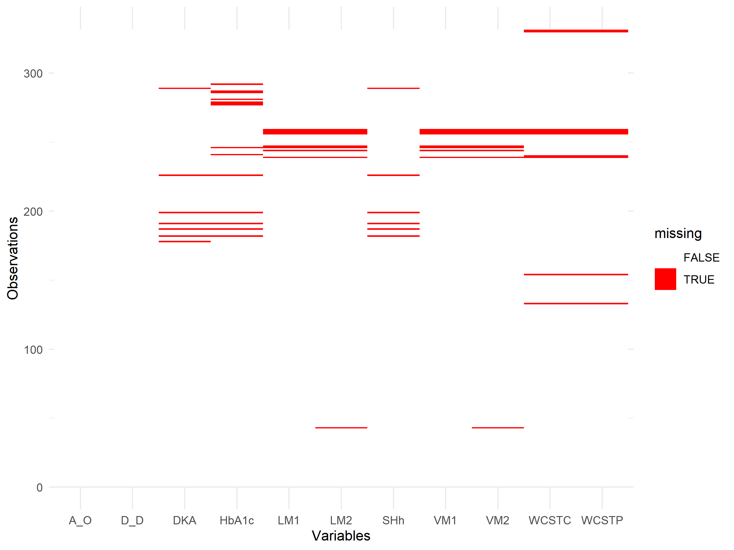

Figure S1. Visualization of missing values across the entire data set.

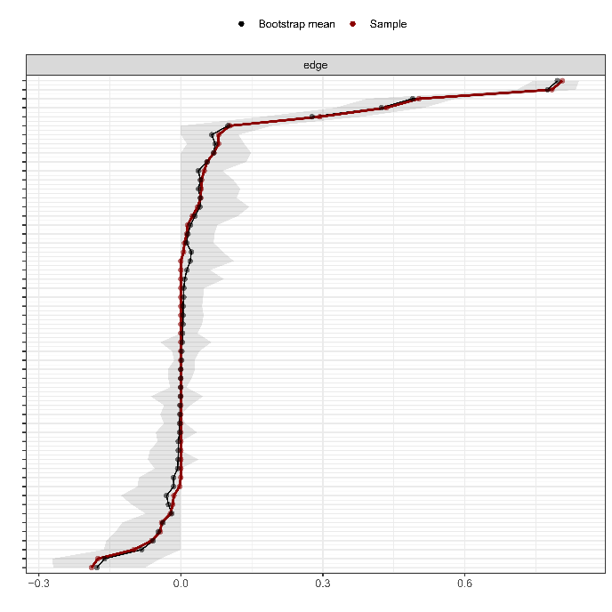
Figure S2. Edge-weight accuracy of the cognitive functions and clinical-glycemic characteristics network (N = 331).
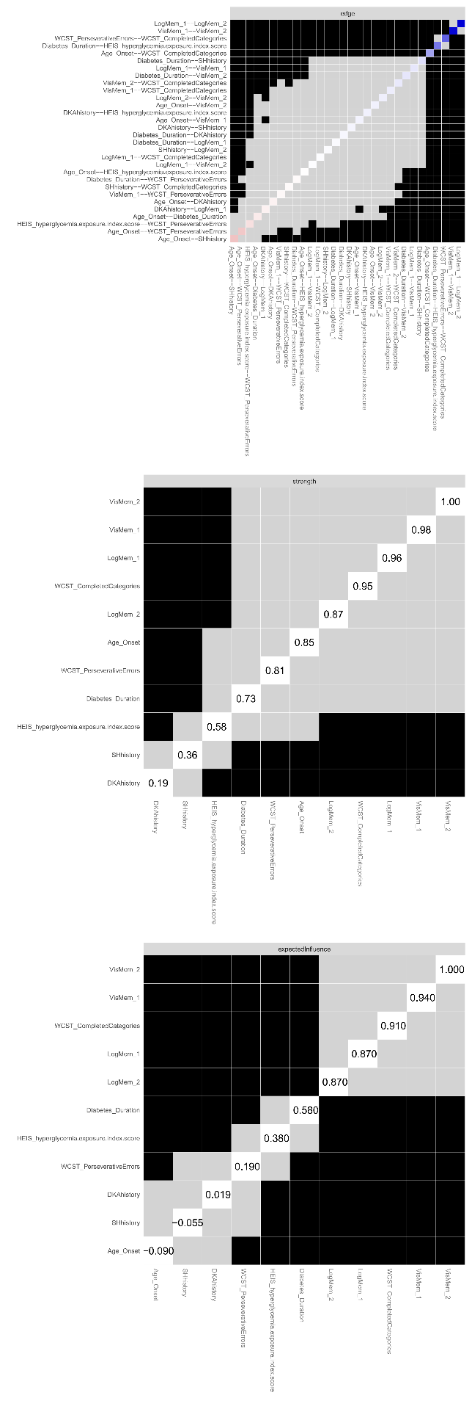
Figure S3. Differences in edge-weights and centralities of the cognitive functions and clinical-glycemic characteristics network. Gray boxes indicate nodes or edges that do not differ significantly and black boxes represent nodes or edges that differ significantly.
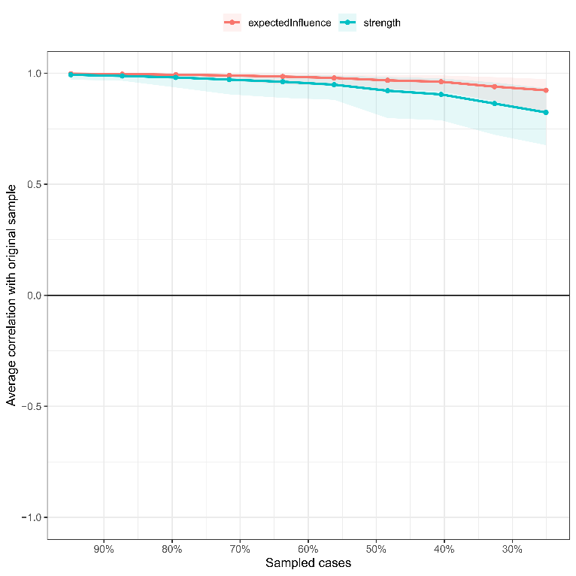
Figure S4. Centrality stability of the cognitive functions and clinical-glycemic characteristics network if portions of the participants are excluded.

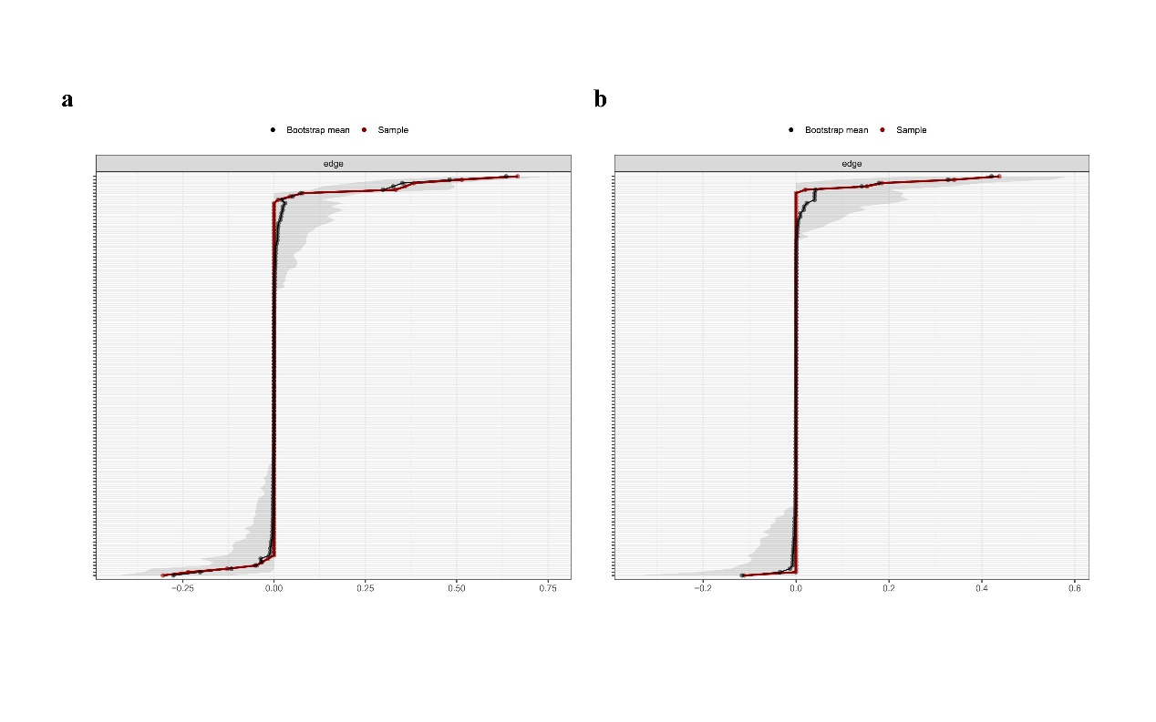
Figure S5. Edge-weight accuracy of the cognitive functions and clinical-glycemic characteristics networks for childhood-onset adult patients (n = 78, a) and adult-onset adult patients (n = 72, b).

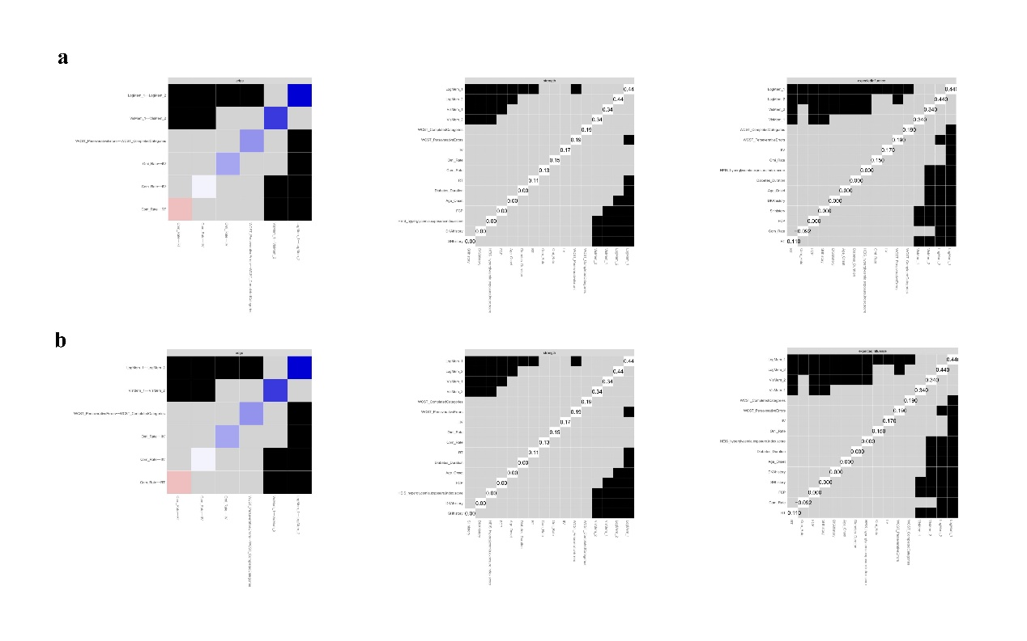
Figure S6. Differences in edge-weights and centralities of the cognitive functions and clinical-glycemic characteristics networks for childhood-onset adult patients (a) and adult-onset adult patients (b). Gray boxes indicate nodes or edges that do not differ significantly and black boxes represent nodes or edges that differ significantly.

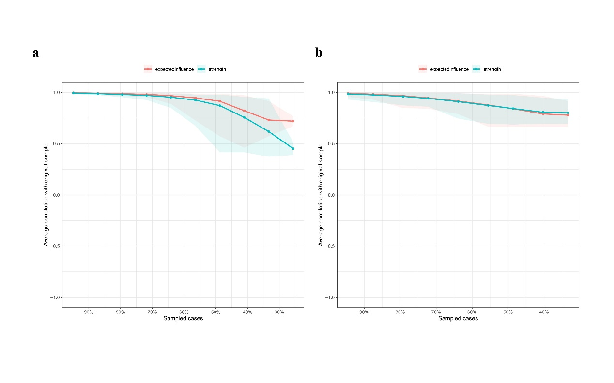
Figure S7. Centrality stability of the cognitive functions and clinical-glycemic characteristics networks if portion of the participants are excluded. a is for childhood-onset adult patients, and b is for adult-onset adult patients.

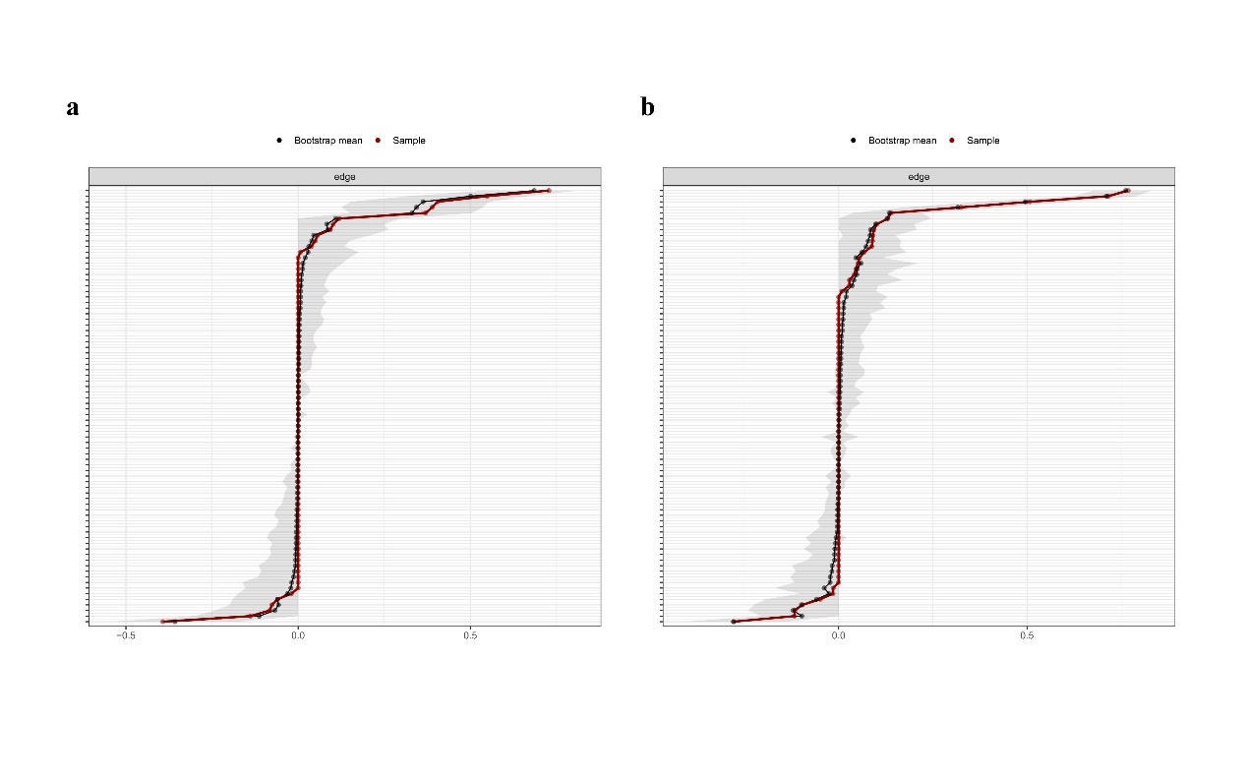
Figure S8. Edge-weight accuracy of the cognitive functions and clinical-glycemic characteristics networks of childhood-onset type 1 diabetes for child group (n = 181, a) and adult group (n = 78, b).

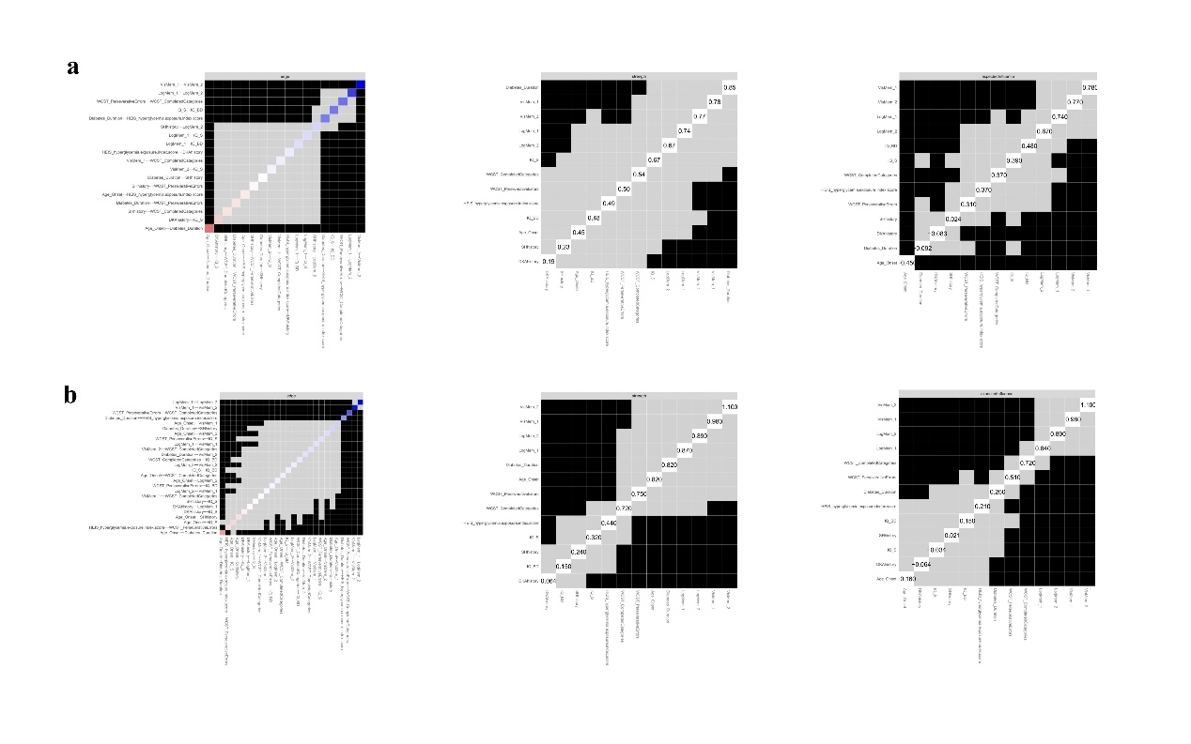
Figure S9. Differences of edge-weights and centralities of the cognitive functions and clinical-glycemic characteristics networks of childhood-onset type 1 diabetes for child group (a) and adult group (b). Gray boxes indicate nodes or edges that do not differ significantly and black boxes represent nodes or edges that differ significantly.

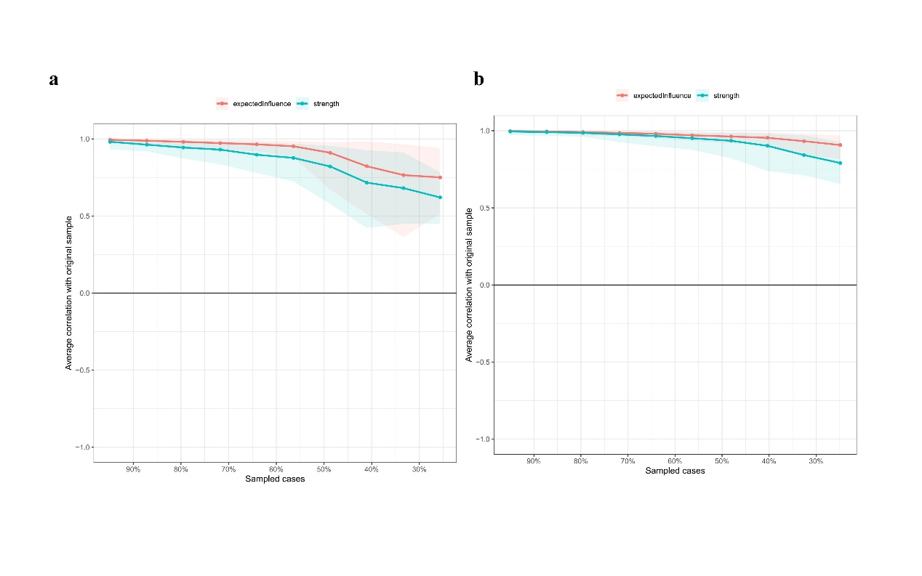
Figure S10. Centrality stability of the cognitive functions and clinical-glycemic characteristics networks of childhood-onset type 1 diabetes if portion of the participants are excluded. a is for child group, and b is for adult group.

Supplemental Table
Table S1. Details on cognitive testing used
Cognitive testing | Description
General Intellectual Ability | We measured general intellectual ability using the Wechsler Intelligence Scale for Children—Chinese Revision for participants under 16 years and the Wechsler Adult Intelligence Scale—Chinese Revision for those 16 years or older. Despite some differences, these scales are highly correlated (>0.9), indicating they measure similar structures.  Subtest scores were combined to calculate IQ using standard methods. The scales were revised into a Chinese version by Gong Yaoxian and others in 1981. In this study, we used five subtests—information, digit span, similarities, picture completion, and block design—to assess IQ. According to the Wechsler Abbreviated Scale of Intelligence, the full-scale IQ score was computed by summing age-scaled subtest scores.
The Similarity subtest of the Wechsler Intelligence Scale | The Similarity subtest of the Wechsler Intelligence Scale requires the test taker to choose the option most like a given item, which could be geometric shapes, symbols, or other abstract forms. The test involves scanning items quickly within a time limit and selecting the most similar one. This assesses visual reasoning and abstract thinking abilities. Evaluators use this test to understand how well the test taker processes abstract information and solves problems. Scores are compared to a standardized reference group to determine the level of similarity reasoning ability, with higher scores indicating stronger visual reasoning and abstract thinking skills.
The Block Design subtest of the Wechsler Intelligence Scale | The Block Design subtest of the Wechsler Intelligence Scale requires the test taker to recreate a target pattern using blocks. The blocks vary in shape, size, and color. The task involves observing pictures of block arrangements and matching them within a time limit, requiring three-dimensional spatial visualization, pattern recognition, and problem-solving. This subtest assesses spatial perception and processing abilities. Evaluators use the results to understand how well the test taker processes and solves spatial problems. Scores are compared to a standardized reference group, with higher scores indicating stronger spatial visualization and problem-solving skills.
Wechsler Memory Scale, WMS | Two tests were selected from the WMS: logical memory and visual memory. For logical memory, the experimenter reads a short story to participants, who must immediately recall it and then recall it again after 30 minutes. The score is the total number of words recalled correctly. For visual memory, participants view two pictures for 10 seconds each and then draw them from memory immediately and after 30 minutes. The score is the total number of pictures recalled correctly.
Modified Wisconsin Card Sorting Test, M-WSCT | This test measures cognitive flexibility using 4 stimulus cards and 48 test cards. The stimulus cards display different shapes, colors, and quantities (e.g., a red triangle, two yellow stars). The test cards are random combinations of these features. Participants categorize the test cards by matching them to the stimulus cards. The experimenter provides feedback on accuracy but does not reveal the classification rule. After six correct matches, the rule changes (color, shape, number) and participants continue. Measures include the total number of categories completed and perseverative errors (repeating the same mistake after feedback).
Sustained Attention to Response Task, SART | The SART included 225 trials, each displaying a single digit (1–9) for 250 milliseconds, followed by a 900-millisecond mask (a ring with a cross, 2.5 cm diameter) in black bold font on a white background. Participants responded to “Go” targets by pressing the left mouse button quickly, except for the number 3 (“No-go” target, 25 of 225 trials). Each digit appeared in five random font sizes (19, 26, 36, 66, 80 points), repeated five times. A practice session of eight trials with two “No-go” targets (digit “3”) ensured task comprehension.  After the task, the following were calculated: omission errors (failures to respond to “Go” targets), commission errors (failures to withhold response to “No-go” targets), mean reaction time (RT) before a correct response, and intraindividual variability (IIV; RT standard deviation/mean RT).

Table S2. Zero-order correlation matrix for all the participants (N = 331. Note: * p<0.05 (2-tailed); ** p<0.01 (2-tailed).
 | A_O | D_D | DKA | SHh | HEI | LM_1 | LM_2 | VM_1 | VM_2 | WCST_P | WCST_C
A_O | 1
D_D | -0.152 | 1
DKA | -0.146 | 0.139 | 1
SHh | -0.261 | 0.058 | 0.046 | 1
HEI | -0.095 | 0.660 | 0.114 | -0.009 | 1
LM_1 | 0.039 | 0.096 | -0.139 | -0.008 | -0.005 | 1
LM_2 | -0.025 | 0.081 | -0.052 | 0.018 | 0.038 | 0.872 | 1
VM_1 | 0.169 | 0.160 | -0.049 | -0.076 | 0.077 | 0.384 | 0.380 | 1
VM_2 | 0.162 | 0.205 | -0.042 | -0.076 | 0.086 | 0.369 | 0.371 | 0.896 | 1
WCST_P | -0.120 | -0.159 | -0.041 | 0.041 | -0.193 | 0.085 | 0.052 | -0.015 | -0.004 | 1
WCST_C | 0.271 | -0.002 | -0.068 | -0.109 | -0.065 | 0.158 | 0.084 | 0.269 | 0.264 | 0.508 | 1

Table S3. Zero-order correlation matrix for childhood-onset adult patients (N = 78. Note: * p<0.05 (2-tailed); ** p<0.01 (2-tailed).
 | A_O | D_D | HEI | DKA |  | SHh | FCP | LM_1 | LM_2 | VM_1 | VM_2 | WCST_P | WCST_C | Omi_R | Com_R | RT | IIV
A_O | 1
D_D | -0.646 | 1
HEI | -0.489 | 0.733 | 1
DKA | -0.119 | 0.196 | 0.242 | 1
SHh | -0.161 | 0.160 | 0.070 | 0.049 |  | 1
FCP | 0.246 | -0.417 | -0.134 | -0.239 |  | -0.154 | 1
LM_1 | -0.040 | -0.102 | -0.147 | -0.154 |  | 0.161 | -0.030 | 1
LM_2 | -0.028 | -0.117 | -0.124 | -0.137 |  | 0.305 | -0.051 | 0.862 | 1
VM_1 | -0.027 | 0.056 | 0.000 | -0.074 |  | 0.092 | -0.040 | 0.110 | 0.133 | 1
VM_2 | -0.057 | 0.074 | 0.023 | -0.103 |  | 0.153 | -0.021 | 0.080 | 0.145 | 0.949 | 1
WCST_P | 0.135 | -0.299 | -0.213 | 0.012 |  | -0.269 | 0.218 | -0.009 | -0.037 | -0.036 | -0.098 | 1
WCST_C | 0.105 | -0.112 | -0.065 | -0.049 |  | -0.300 | 0.169 | -0.029 | -0.042 | 0.169 | 0.106 | 0.635 | 1
Omi_R | 0.239 | -0.030 | 0.011 | 0.117 |  | 0.282 | -0.005 | -0.089 | -0.049 | 0.188 | 0.212 | -0.029 | -0.016 | 1
Com_R | -0.018 | -0.009 | 0.013 | 0.092 |  | 0.250 | 0.005 | -0.066 | 0.056 | 0.077 | 0.097 | -0.001 | -0.061 | 0.448 | 1
RT | 0.007 | -0.013 | 0.065 | -0.044 |  | 0.103 | 0.104 | 0.014 | -0.020 | -0.105 | -0.060 | -0.118 | -0.032 | 0.280 | -0.316 | 1
IIV | 0.026 | 0.038 | 0.133 | -0.117 |  | 0.028 | 0.050 | -0.158 | -0.143 | -0.022 | -0.045 | -0.099 | -0.044 | 0.275 | 0.118 | 0.206 | 1

Table S4. Zero-order correlation matrix for adult-onset adult patients (N = 72. Note: * p<0.05 (2-tailed); ** p<0.01 (2-tailed).
 | A_O | D_D | HEI | DKA | SHh | FCP | LM_1 | LM_2 | VM_1 | VM_2 | WCST_P | WCST_C | Omi_R | Com_R | RT | IIV
A_O | 1
D_D | -0.042 | 1
HEI | 0.064 | 0.431 | 1
DKA | -0.115 | 0.377 | 0.232 | 1
SHh | -0.017 | 0.111 | -0.032 | 0.148 | 1
FCP | 0.219 | -0.308 | -0.255 | -0.082 | -0.202 | 1
LM_1 | -0.271 | -0.003 | -0.169 | -0.155 | 0.107 | -0.024 | 1
LM_2 | -0.272 | -0.072 | -0.065 | -0.086 | 0.027 | -0.046 | 0.859 | 1
VM_1 | -0.283 | -0.060 | -0.144 | -0.019 | -0.071 | 0.037 | 0.203 | 0.166 | 1
VM_2 | -0.195 | -0.006 | -0.187 | -0.055 | -0.121 | 0.047 | 0.289 | 0.253 | 0.770 | 1
WCST_P | -0.097 | 0.214 | 0.137 | 0.089 | 0.048 | -0.275 | 0.193 | 0.137 | 0.032 | 0.122 | 1
WCST_C | -0.123 | 0.059 | -0.017 | 0.029 | -0.006 | -0.163 | 0.294 | 0.228 | 0.351 | 0.296 | 0.660 | 1
Omi_R | -0.040 | 0.115 | 0.097 | 0.172 | 0.311 | -0.085 | -0.221 | -0.180 | -0.072 | -0.038 | -0.133 | -0.297 | 1
Com_R | -0.134 | -0.018 | -0.110 | -0.051 | 0.092 | 0.150 | -0.063 | -0.055 | -0.017 | -0.006 | 0.069 | -0.172 | 0.678 | 1
RT | 0.296 | 0.109 | 0.074 | 0.048 | 0.060 | 0.028 | -0.083 | -0.068 | -0.291 | -0.208 | -0.211 | -0.226 | -0.015 | -0.223 | 1
IIV | 0.059 | -0.051 | -0.159 | -0.094 | -0.069 | 0.102 | -0.106 | -0.097 | -0.304 | -0.206 | -0.084 | -0.221 | 0.115 | 0.162 | 0.061 | 1

Table S5. Zero-order correlation matrix for childhood-onset child patients (N = 181. Note: * p<0.05 (2-tailed); ** p<0.01 (2-tailed).
 | A_O | D_D | HEI | DKA | SHh | LM_1 | LM_2 | VM_1 | VM_2 | WCST_P | WCST_C | IQ_S | IQ_B
A_O | 1
D_D | -0.495 | 1
HEI | -0.200 | 0.619 | 1
DKA | -0.028 | 0.154 | 0.087 | 1
SHh | -0.239 | 0.198 | 0.080 | -0.003 | 1
LM_1 | 0.269 | 0.081 | 0.007 | -0.131 | -0.018 | 1
LM_2 | 0.270 | 0.129 | 0.076 | -0.038 | -0.022 | 0.884 | 1
VM_1 | 0.447 | 0.085 | 0.036 | -0.030 | -0.048 | 0.485 | 0.502 | 1
VM_2 | 0.417 | 0.088 | 0.019 | -0.012 | -0.046 | 0.440 | 0.462 | 0.893 | 1
WCST_P | -0.008 | -0.125 | -0.246 | -0.093 | 0.031 | 0.110 | 0.069 | 0.030 | 0.064 | 1
WCST_C | 0.198 | -0.107 | -0.185 | -0.046 | -0.006 | 0.148 | 0.096 | 0.231 | 0.262 | 0.595 | 1
IQ_S | -0.240 | -0.006 | -0.078 | -0.120 | -0.077 | 0.064 | 0.049 | -0.137 | -0.136 | 0.161 | 0.059 | 1
IQ_B | -0.078 | -0.008 | -0.120 | 0.043 | -0.017 | 0.024 | 0.035 | 0.055 | 0.045 | 0.217 | 0.204 | 0.128 | 1

Table S6. Zero-order correlation matrix for childhood-onset adult patients (N = 78. Note: * p<0.05 (2-tailed); ** p<0.01 (2-tailed). (in second networks comparison)
 | A_O | D_D | HEI | DKA | SHh | LM_1 | LM_2 | VM_1 | VM_2 | WCST_P | WCST_C | IQ_S | IQ_B
A_O | 1
D_D | -0.646 | 1
HEI | -0.445 | 0.657 | 1
DKA | -0.101 | 0.203 | 0.234 | 1
SHh | -0.175 | 0.171 | 0.060 | 0.052 | 1
LM_1 | -0.005 | -0.101 | -0.147 | -0.137 | 0.120 | 1
LM_2 | -0.013 | -0.124 | -0.138 | -0.153 | 0.297 | 0.858 | 1
VM_1 | -0.012 | 0.068 | 0.005 | -0.065 | 0.061 | 0.088 | 0.115 | 1
VM_2 | -0.045 | 0.089 | 0.031 | -0.105 | 0.128 | 0.056 | 0.127 | 0.948 | 1
WCST_P | 0.129 | -0.283 | -0.175 | 0.015 | -0.277 | -0.021 | -0.045 | -0.040 | -0.105 | 1
WCST_C | 0.108 | -0.100 | -0.057 | -0.013 | -0.307 | -0.052 | -0.064 | 0.160 | 0.098 | 0.637 | 1
IQ_S | 0.016 | -0.163 | -0.136 | -0.337 | -0.259 | 0.437 | 0.296 | 0.173 | 0.180 | 0.063 | 0.067 | 1
IQ_B | 0.081 | -0.058 | -0.152 | -0.065 | -0.244 | 0.283 | 0.084 | 0.051 | 0.047 | 0.043 | 0.139 | 0.677 | 1

Table S7. Edge weights matrix of the cognitive functions and clinical-glycemic characteristics network for all the participants (N = 331).
 | A_O | D_D | DKA | SHh | HEI | LM_1 | LM_2 | VM_1 | VM_2 | WCST_P | WCST_C
A_O | 0 | -0.112 | -0.089 | -0.204 | 0 | 0 | -0.027 | 0.028 | 0.026 | -0.229 | 0.280
D_D | -0.112 | 0 | 0.065 | 0 | 0.604 | 0.007 | 0 | 0 | 0.076 | -0.055 | 0.020
DKA | -0.089 | 0.065 | 0 | 0 | 0.018 | -0.059 | 0 | 0 | 0 | 0 | 0
SHh | -0.204 | 0 | 0 | 0 | 0 | 0 | 0 | 0 | -0.004 | 0 | -0.016
HEI | 0 | 0.604 | 0.018 | 0 | 0 | 0 | 0 | 0 | 0 | -0.088 | 0
LM_1 | 0 | 0.007 | -0.059 | 0 | 0 | 0 | 0.811 | 0.057 | 0.004 | 0.012 | 0.018
LM_2 | -0.027 | 0.000 | 0 | 0 | 0 | 0.811 | 0 | 0.021 | 0.044 | 0 | 0
VM_1 | 0.028 | 0 | 0 | 0 | 0 | 0.057 | 0.021 | 0 | 0.827 | -0.037 | 0.071
VM_2 | 0.026 | 0.076 | 0 | -0.004 | 0 | 0.004 | 0.044 | 0.827 | 0 | 0 | 0.045
WCST_P | -0.229 | -0.055 | 0 | 0 | -0.088 | 0.012 | 0 | -0.037 | 0 | 0 | 0.507
WCST_C | 0.280 | 0.020 | 0 | -0.016 | 0 | 0.018 | 0 | 0.071 | 0.045 | 0.507 | 0

Table S8. Overview of the edges between specific cognitive functions domains and clinical-glycemic characteristics in the network for all the participants (N =331). The total strength in the table is the absolute value.
 | Total edges | Positive edges | Negative edges | Total strength | Positive strength | Negative strength
All edges | 31 | 20 | 11 | 4.460 | 3.539.56 | -0.921
Between cognitive functions nodes | 12 | 11 | 1 | 2.453 | 2.416 | -0.037
Between clinical-glycemic nodes | 6 | 3 | 3 | 1.092 | 0.687 | -0.405
Interaction between cognitive functions and clinical-glycemic characteristics | 13 | 6 | 7 | 0.915 | 0.437 | -0.478

Table S9. Edge weights matrix of the cognitive functions and clinical-glycemic network for childhood-onset adult patients (N = 78).
 | A_O | D_D | HEI | DKA | SHh | FCP | LM_1 | LM_2 | VM_1 | VM_2 | WCST_P | WCST_C | Omi_R | Com_R | RT | IIV
A_O | 0 | -0.369 | -0.070 | 0 | 0 | 0 | 0 | 0 | 0 | 0 | 0 | 0 | 0.058 | 0 | 0 | 0
D_D | -0.369 | 0 | 0.481 | 0 | 0 | -0.188 | 0 | 0 | 0 | 0 | -0.084 | 0 | 0 | 0 | 0 | 0
HEI | -0.070 | 0.481 | 0 | 0.053 | 0 | 0 | 0 | 0 | 0 | 0 | 0 | 0 | 0 | 0 | 0 | 0
DKA | 0 | 0 | 0.053 | 0 | 0 | -0.058 | 0 | 0 | 0 | 0 | 0 | 0 | 0 | 0 | 0 | 0
SHh | 0 | 0 | 0 | 0 | 0 | 0 | 0 | 0.096 | 0 | 0 | -0.043 | -0.094 | 0.091 | 0.050 | 0 | 0
FCP | 0 | -0.188 | 0 | -0.058 | 0 | 0 | 0 | 0 | 0 | 0 | 0.015 | 0 | 0 | 0 | 0 | 0
LM_1 | 0 | 0 | 0 | 0 | 0 | 0 | 0 | 0.689 | 0 | 0 | 0 | 0 | 0 | 0 | 0 | 0
LM_2 | 0 | 0 | 0 | 0 | 0.096 | 0 | 0.689 | 0 | 0 | 0 | 0 | 0 | 0 | 0 | 0 | 0
VM_1 | 0 | 0 | 0 | 0 | 0 | 0 | 0 | 0 | 0 | 0.779 | 0 | 0 | 0 | 0 | 0 | 0
VM_2 | 0 | 0 | 0 | 0 | 0 | 0 | 0 | 0 | 0.779 | 0 | 0 | 0 | 0.025 | 0 | 0 | 0
WCST_P | 0 | -0.084 | 0 | 0 | -0.043 | 0.015 | 0 | 0 | 0 | 0 | 0 | 0.455 | 0 | 0 | 0 | 0
WCST_C | 0 | 0 | 0 | 0 | -0.094 | 0 | 0 | 0 | 0 | 0 | 0.455 | 0 | 0 | 0 | 0 | 0
Omi_R | 0.058 | 0 | 0 | 0 | 0.091 | 0 | 0 | 0 | 0 | 0.025 | 0 | 0 | 0 | 0.291 | 0.155 | 0.097
Com_R | 0 | 0 | 0 | 0 | 0.050 | 0 | 0 | 0 | 0 | 0 | 0 | 0 | 0.291 | 0 | -0.185 | 0
RT | 0 | 0 | 0 | 0 | 0 | 0 | 0 | 0 | 0 | 0 | 0 | 0 | 0.155 | -0.185 | 0 | 0.024
IIV | 0 | 0 | 0 | 0 | 0 | 0 | 0 | 0 | 0 | 0 | 0 | 0 | 0.097 | 0 | 0.024 | 0

Table S10. Overview of the edges between specific cognitive functions domains and clinical-glycemic characteristics in the network for childhood-onset adult patients (N =78). The total strength in the table is the absolute value.
 | Total edges | Positive edges | Negative edges | Total strength | Positive strength | Negative strength
All edges | 23 | 15 | 8 | 4.450 | 3.359 | -1.091
Between cognitive functions nodes | 9 | 8 | 1 | 2.700 | 2.515 | -0.185
Between clinical-glycemic nodes | 6 | 2 | 4 | 1.219 | 0.534 | -0.685
Interaction between cognitive functions and clinical-glycemic characteristics | 8 | 5 | 3 | 0.530 | 0.309 | -0.221

Table S11. Edge weights matrix of the cognitive functions and clinical-glycemic network for adult-onset adult patients (N = 72).
 | A_O | D_D | HEI | DKA | SHh | FCP | LM_1 | LM_2 | VM_1 | VM_2 | WCST_P | WCST_C | Omi_R | Com_R | RT | IIV
A_O | 0 | 0 | 0 | 0 | 0 | 0 | 0 | 0 | 0 | 0 | 0 | 0 | 0 | 0 | 0 | 0
D_D | 0 | 0 | 0.107 | 0.053 | 0 | 0 | 0 | 0 | 0 | 0 | 0 | 0 | 0 | 0 | 0 | 0
HEI | 0 | 0.107 | 0 | 0 | 0 | 0 | 0 | 0 | 0 | 0 | 0 | 0 | 0 | 0 | 0 | 0
DKA | 0 | 0.053 | 0 | 0 | 0 | 0 | 0 | 0 | 0 | 0 | 0 | 0 | 0 | 0 | 0 | 0
SHh | 0 | 0 | 0 | 0 | 0 | 0 | 0 | 0 | 0 | 0 | 0 | 0 | 0 | 0 | 0 | 0
FCP | 0 | 0 | 0 | 0 | 0 | 0 | 0 | 0 | 0 | 0 | 0 | 0 | 0 | 0 | 0 | 0
LM_1 | 0 | 0 | 0 | 0 | 0 | 0 | 0 | 0.536 | 0 | 0 | 0 | 0 | 0 | 0 | 0 | 0
LM_2 | 0 | 0 | 0 | 0 | 0 | 0 | 0.536 | 0 | 0 | 0 | 0 | 0 | 0 | 0 | 0 | 0
VM_1 | 0 | 0 | 0 | 0 | 0 | 0 | 0 | 0 | 0 | 0.446 | 0 | 0.023 | 0 | 0 | 0 | 0
VM_2 | 0 | 0 | 0 | 0 | 0 | 0 | 0 | 0 | 0.446 | 0 | 0 | 0 | 0 | 0 | 0 | 0
WCST_P | 0 | 0 | 0 | 0 | 0 | 0 | 0 | 0 | 0 | 0 | 0 | 0.336 | 0 | 0 | 0 | 0
WCST_C | 0 | 0 | 0 | 0 | 0 | 0 | 0 | 0 | 0.023 | 0 | 0.336 | 0 | 0 | 0 | 0 | 0
Omi_R | 0 | 0 | 0 | 0 | 0 | 0 | 0 | 0 | 0 | 0 | 0 | 0 | 0 | 0.355 | 0 | 0
Com_R | 0 | 0 | 0 | 0 | 0 | 0 | 0 | 0 | 0 | 0 | 0 | 0 | 0.355 | 0 | 0 | 0
RT | 0 | 0 | 0 | 0 | 0 | 0 | 0 | 0 | 0 | 0 | 0 | 0 | 0 | 0 | 0 | 0
IIV | 0 | 0 | 0 | 0 | 0 | 0 | 0 | 0 | 0 | 0 | 0 | 0 | 0 | 0 | 0 | 0

Table S12. Overview of the edges between specific cognitive functions domains and clinical-glycemic characteristics in the network for adult-onset adult patients (N =72). The total strength in the table is the absolute value.
 | Total edges | Positive edges | Negative edges | Total strength | Positive strength | Negative strength
All edges | 7 | 7 | 0 | 1.856 | 1.856 | 0
Between cognitive functions nodes | 5 | 5 | 0 | 1.696 | 1.696 | 0
Between clinical-glycemic nodes | 2 | 2 | 0 | 0.160 | 0.160 | 0
Interaction between cognitive functions and clinical-glycemic characteristics | 0 | 0 | 0 | 0 | 0 | 0

Table S13. Edge weights matrix of the cognitive functions and clinical-glycemic network for childhood-onset child patients (N = 181).
 | A_O | D_D | HEI | DKA | SHh | LM_1 | LM_2 | VM_1 | VM_2 | WCST_P | WCST_C | IQ_S | IQ_B
A_O | 0 | -0.416 | 0 | 0 | -0.128 | 0.026 | 0.038 | 0.173 | 0.071 | -0.046 | 0.065 | -0.168 | -0.034
D_D | -0.416 | 0 | 0.502 | 0.078 | 0.056 | 0 | 0.059 | 0.069 | 0.046 | 0 | 0 | 0 | 0
HEI | 0 | 0.502 | 0 | 0 | 0 | 0 | 0 | 0 | 0 | -0.128 | -0.012 | -0.038 | -0.036
DKA | 0 | 0.078 | 0 | 0 | 0 | -0.045 | 0 | 0 | 0 | -0.014 | 0 | -0.066 | 0
SHh | -0.128 | 0.056 | 0 | 0 | 0 | 0 | 0 | 0 | 0 | 0 | 0 | -0.055 | 0
LM_1 | 0.026 | 0 | 0 | -0.045 | 0 | 0 | 0.785 | 0.065 | 0 | 0.011 | 0 | 0.034 | 0
LM_2 | 0.038 | 0.059 | 0 | 0 | 0 | 0.785 | 0 | 0.067 | 0.036 | 0 | 0 | 0 | 0
VM_1 | 0.173 | 0.069 | 0 | 0 | 0 | 0.065 | 0.067 | 0 | 0.767 | 0 | 0 | -0.005 | 0
VM_2 | 0.071 | 0.046 | 0 | 0 | 0 | 0 | 0.036 | 0.767 | 0 | 0 | 0.089 | -0.019 | 0
WCST_P | -0.046 | 0 | -0.128 | -0.014 | 0 | 0.011 | 0 | 0 | 0 | 0 | 0.514 | 0.082 | 0.084
WCST_C | 0.065 | 0 | -0.012 | 0 | 0 | 0 | 0 | 0 | 0.089 | 0.514 | 0 | 0 | 0.078
IQ_S | -0.168 | 0 | -0.038 | -0.066 | -0.055 | 0.034 | 0 | -0.005 | -0.019 | 0.082 | 0 | 0 | 0.050
IQ_B | -0.034 | 0 | -0.036 | 0 | 0 | 0 | 0 | 0 | 0 | 0.084 | 0.078 | 0.050 | 0

Table S14. Overview of the edges between specific cognitive functions domains and clinical-glycemic characteristics in the network for childhood-onset child patients (N =181. The total strength in the table is the absolute value.
 | Total edges | Positive edges | Negative edges | Total strength | Positive strength | Negative strength
All edges | 39 | 24 | 15 | 5.053 | 3.845 | -1.209
Between cognitive functions nodes | 15 | 13 | 2 | 2.686 | 2.662 | -0.024
Between clinical-glycemic nodes | 5 | 3 | 2 | 1.184 | 0.636 | -0.544
Interaction between cognitive functions and clinical-glycemic characteristics | 19 | 8 | 11 | 1.872 | 0.547 | -0.641

Table S15. Edge weights matrix of the cognitive functions and clinical-glycemic network for childhood-onset adult patients (N = 78)（NCT2）.
 | A_O | D_D | HEI | DKA | SHh | LM_1 | LM_2 | VM_1 | VM_2 | WCST_P | WCST_C | IQ_S | IQ_B
A_O | 0 | -0.395 | -0.055 | 0 | 0 | 0 | 0 | 0 | 0 | 0 | 0 | 0 | 0
D_D | -0.395 | 0 | 0.408 | 0 | 0 | 0 | 0 | 0 | 0 | -0.070 | 0 | 0 | 0
HEI | -0.055 | 0.408 | 0 | 0.042 | 0 | 0 | 0 | 0 | 0 | 0 | 0 | 0 | 0
DKA | 0 | 0 | 0.042 | 0 | 0 | 0 | 0 | 0 | 0 | 0 | 0 | -0.128 | 0
SHh | 0 | 0 | 0 | 0 | 0 | 0 | 0.093 | 0 | 0 | -0.040 | -0.089 | -0.067 | -0.025
LM_1 | 0 | 0 | 0 | 0 | 0 | 0 | 0.658 | 0 | 0 | 0 | 0 | 0.169 | 0
LM_2 | 0 | 0 | 0 | 0 | 0.093 | 0.658 | 0 | 0 | 0 | 0 | 0 | 0 | 0
VM_1 | 0 | 0 | 0 | 0 | 0 | 0 | 0 | 0 | 0.762 | 0 | 0 | 0 | 0
VM_2 | 0 | 0 | 0 | 0 | 0 | 0 | 0 | 0.762 | 0 | 0 | 0 | 0 | 0
WCST_P | 0 | -0.070 | 0 | 0 | -0.040 | 0 | 0 | 0 | 0 | 0 | 0.443 | 0 | 0
WCST_C | 0 | 0 | 0 | 0 | -0.089 | 0 | 0 | 0 | 0 | 0.443 | 0 | 0 | 0
IQ_S | 0 | 0 | 0 | -0.128 | -0.067 | 0.169 | 0 | 0 | 0 | 0 | 0 | 0 | 0.472
IQ_B | 0 | 0 | 0 | 0 | -0.025 | 0 | 0 | 0 | 0 | 0 | 0 | 0.472 | 0

Table S16. Overview of the edges between specific cognitive functions domains and clinical-glycemic characteristics in the network for childhood-onset adult patients (N =181. The total strength in the table is the absolute value.
 | Total edges | Positive edges | Negative edges | Total strength | Positive strength | Negative strength
All edges | 16 | 8 | 8 | 3.916 | 3.047 | -0.869
Between cognitive functions nodes | 5 | 5 | 0 | 1.696 | 1.696 | 0
Between clinical-glycemic nodes | 4 | 2 | 2 | 0.900 | 0.450 | -0.450
Interaction between cognitive functions and clinical-glycemic characteristics | 7 | 1 | 6 | 0.513 | 0.093 | -0.420

