The ecological niche and population history shape mosquito population genetics: a case study from Caribbean islands

Pepijn Helleman, Maarten Schrama, Krijn B. Trimbos, Marieta A.H. Braks, Francis Schaffner, Arjan Stroo, Roel M. Wouters, Jordy G. van der Beek*

*Correspondence: jordy.vanderbeek@naturalis.nl

Table S1 Preliminary list of mosquito species collected on Aruba, Curaçao and Bonaire, during the 2022 expedition.
Species | Aruba | Curaçao | Bonaire
Aedes (Ochlerotatus) taeniorhynchus (Wiedemann, 1821) | X | X | X
Aedes (Ochlerotatus) scapularis (Rondani, 1848) |  | X | X
Aedes (Stegomyia) aegypti (Linnaeus, 1762) | X | X | X
Anopheles (Nyssorhynchus) aquasalis Curry, 1932 |  | X | X
Culex (Culex) nigripalpus Theobald, 1901 | X | X | X
Culex (Culex) quinquefasciatus Say, 1823 | X | X | X
Culex (Culex) saltanensis Dyar, 1928 | X | X | X
Culex (Melanoconion) conspirator Dyar & Knab, 1906 |  | X
Culex (Melanoconion) erraticus (Dyar & Knab, 1906) | X | X | X
Culex (Melanoconion) unicornis (Root, 1928) |  | X | X
Deinocerites sp. 1 | X | X | X
Deinocerites sp. 2 | X | X
Haemagogus (Haemagogus) chrysochlorus Arnell, 1973 | X | X | X
Psorophora (Grabhamia) confinnis s.l. (Lynch Arribálzaga, 1891) | X | X | X
Uranotaenia (Uranotaenia) lowii Theobald, 1901 | X | X | X
Wyeomyia (Wyeomyia) celaenocephala Dyar & Knab, 1906 |  | X

Fig. S1 (next page) Total haplotype network of all 258 COII sequences included in this study using TCS inference. Species are indicated with coloured frames (green: Haemagogus chrysochlorus; purple: Deinocerites sp.; blue: Aedes taeniorhynchus; red: Aedes aegypti; orange: Culex nigripalpus; yellow: Culex quinquefasciatus). Pie charts represent unique haplotypes found in this study (haplotype name given in bold), with pie chart size representing the number of sequences with the same haplotype and pie chart colours corresponding to the island of origin of the sequences (pink: Aruba; yellow: Curaçao; blue: Bonaire). Hatch marks on the edges represent the number of genetic differences between closely related sequences. Edges representing four or more mutational steps are annotated with the exact number of steps between parentheses.
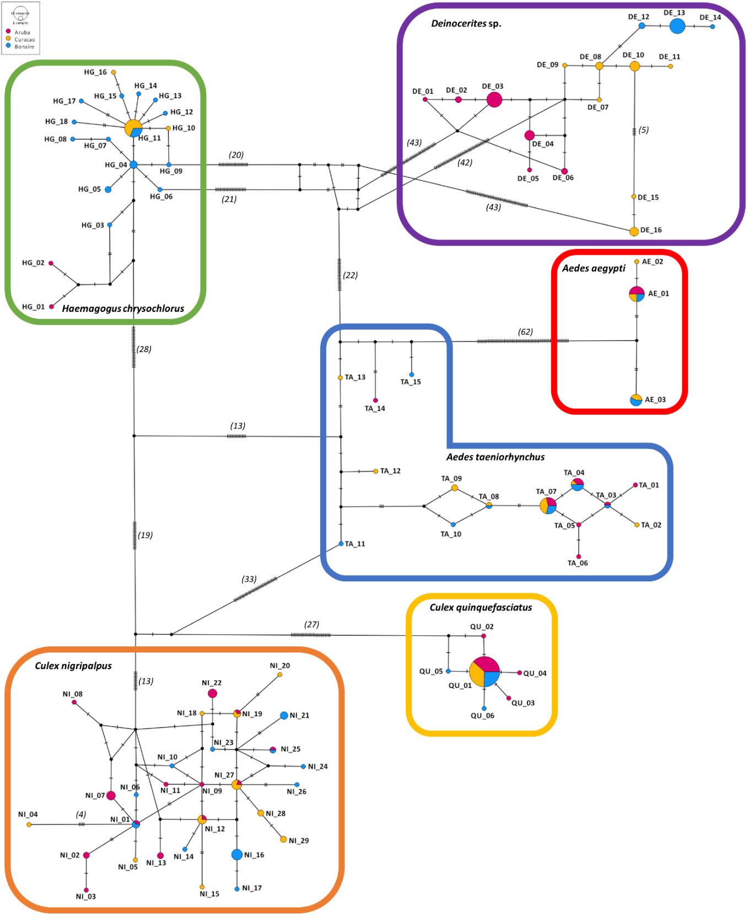

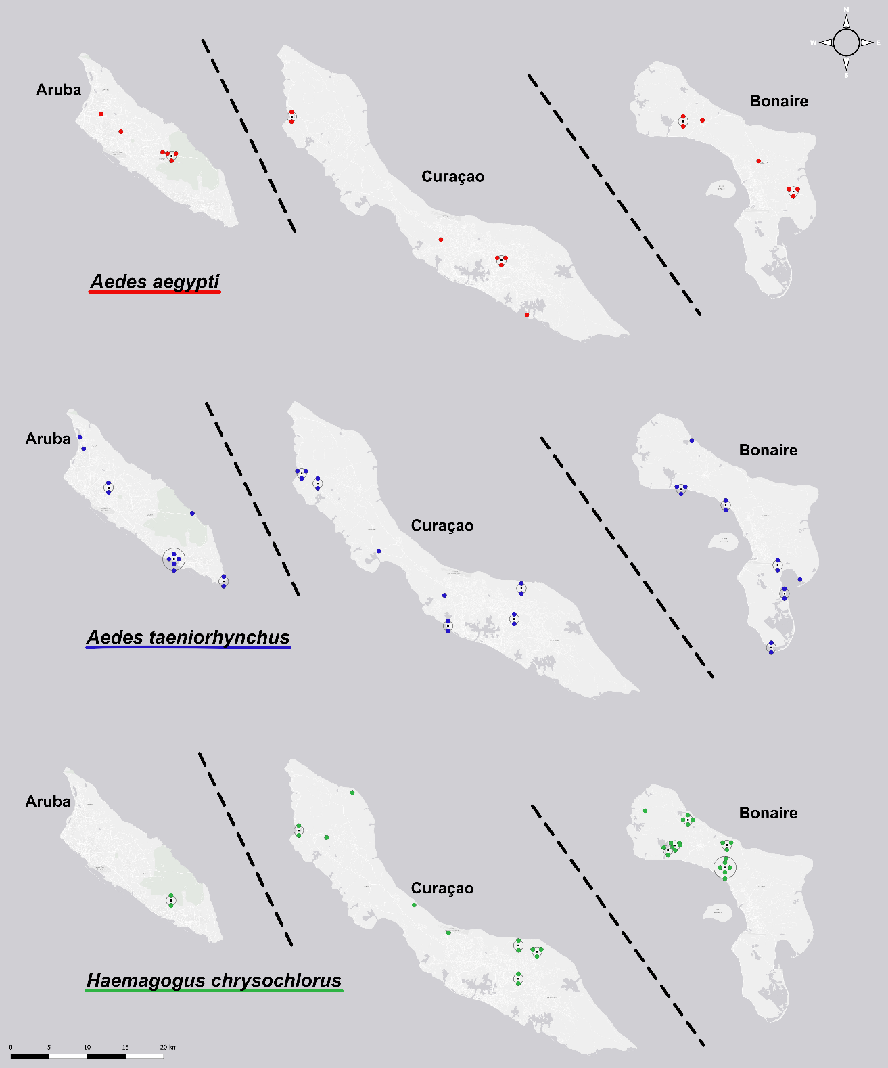
Fig. S2 All collection localities of specimens included in this study for Aedes aegypti, Aedes taeniorhynchus, and Haemagogus chrysochlorus (top to bottom). Colour corresponds with species. Sample locations in close proximity are presented in concentric circles. Dashed lines indicate that the distance between islands is not to scale.

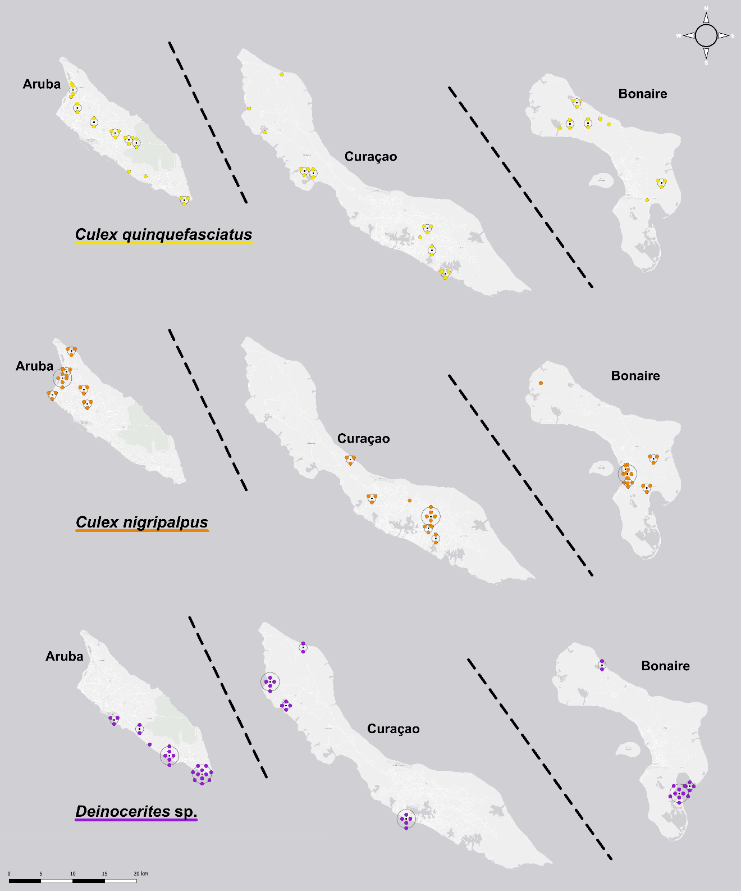
Fig. S3 All collection localities of specimens included in this study for Culex quinquefasciatus, Culex nigripalpus, and Deinocerites sp. (top to bottom). Colour corresponds with species. Sample locations in close proximity are presented in concentric circles. Dashed lines indicate that the distance between islands is not to scale.

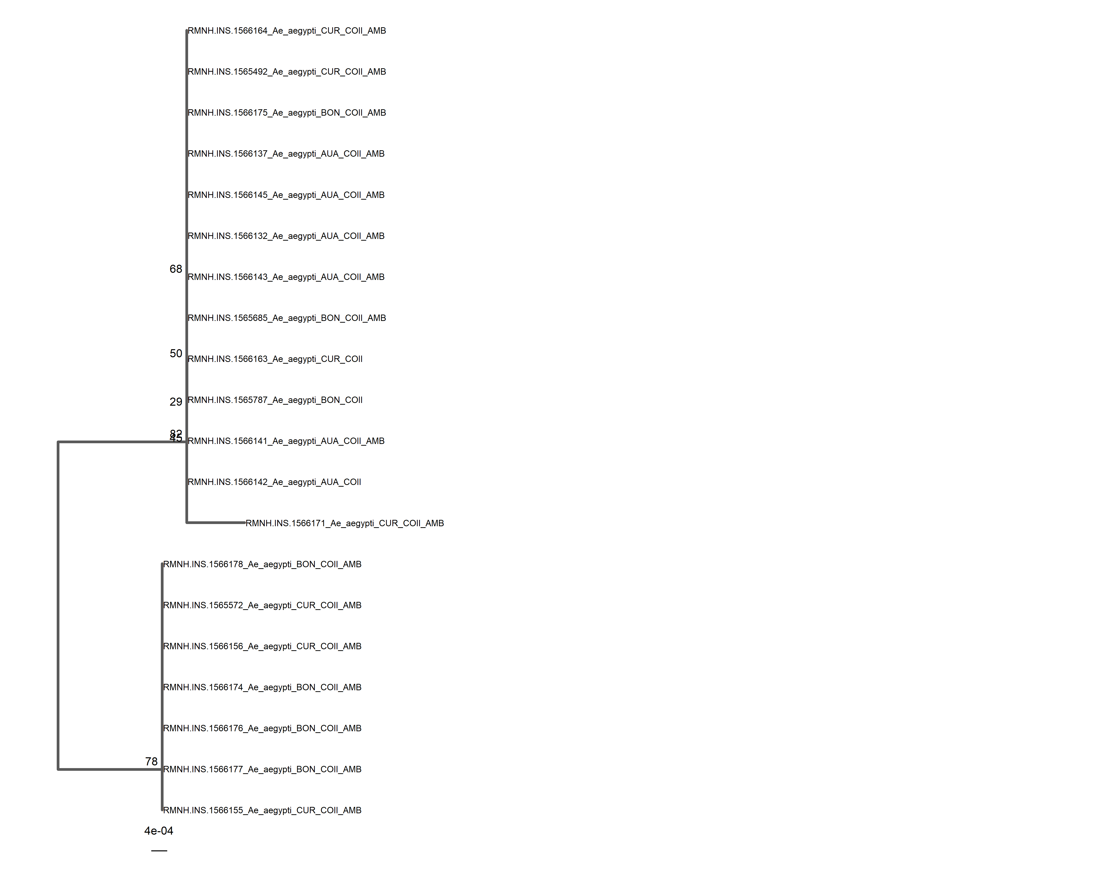
Fig. S4 Maximum Likelihood tree of the 20 included Aedes aegypti sequences (684 bp) in this study, showing internal branching and branch lengths of the collapsed clade from Fig. 2. Tip label names included the corresponding RMNH-collection number and the island of origin of the sequence. Branch length corresponds with the genetic distance between sequences. Support values represent 1000 Ultrafast bootstraps (%). Tree was rooted using a sequence of Chironomus plumosus, not shown in the figure.

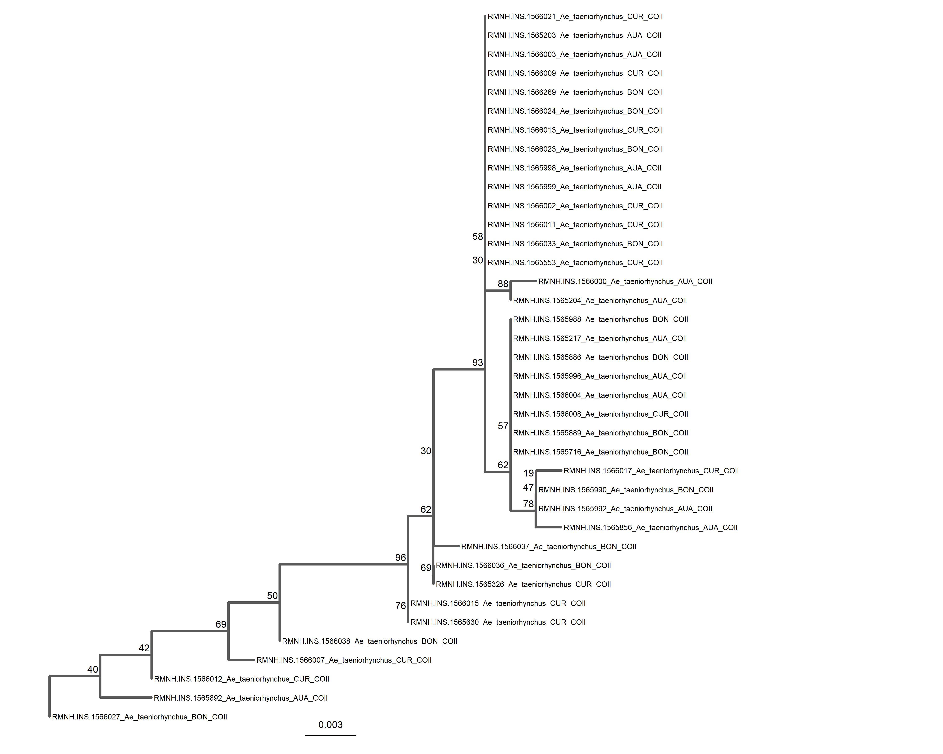
Fig. S5 Maximum Likelihood tree of the 38 included Aedes taeniorhynchus sequences (684 bp) in this study, showing internal branching and branch lengths of the collapsed clade from Fig. 2. Tip label names included the corresponding RMNH-collection number and the island of origin of the sequence. Branch length corresponds with the genetic distance between sequences. Support values represent 1000 Ultrafast bootstraps (%). Tree was rooted using a sequence of Chironomus plumosus, not shown in the figure.

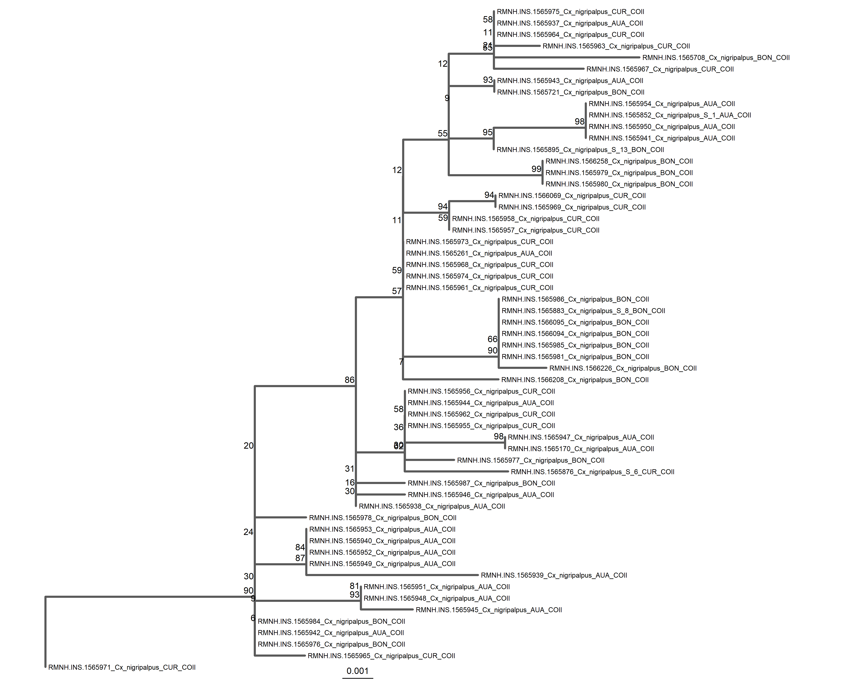
Fig. S6 Maximum Likelihood tree of the 58 included Culex nigripalpus sequences (684 bp) in this study, showing internal branching and branch lengths of the collapsed clade from Fig. 2. Tip label names included the corresponding RMNH-collection number and the island of origin of the sequence. Branch length corresponds with the genetic distance between sequences. Support values represent 1000 Ultrafast bootstraps (%). Tree was rooted using a sequence of Chironomus plumosus, not shown in the figure.

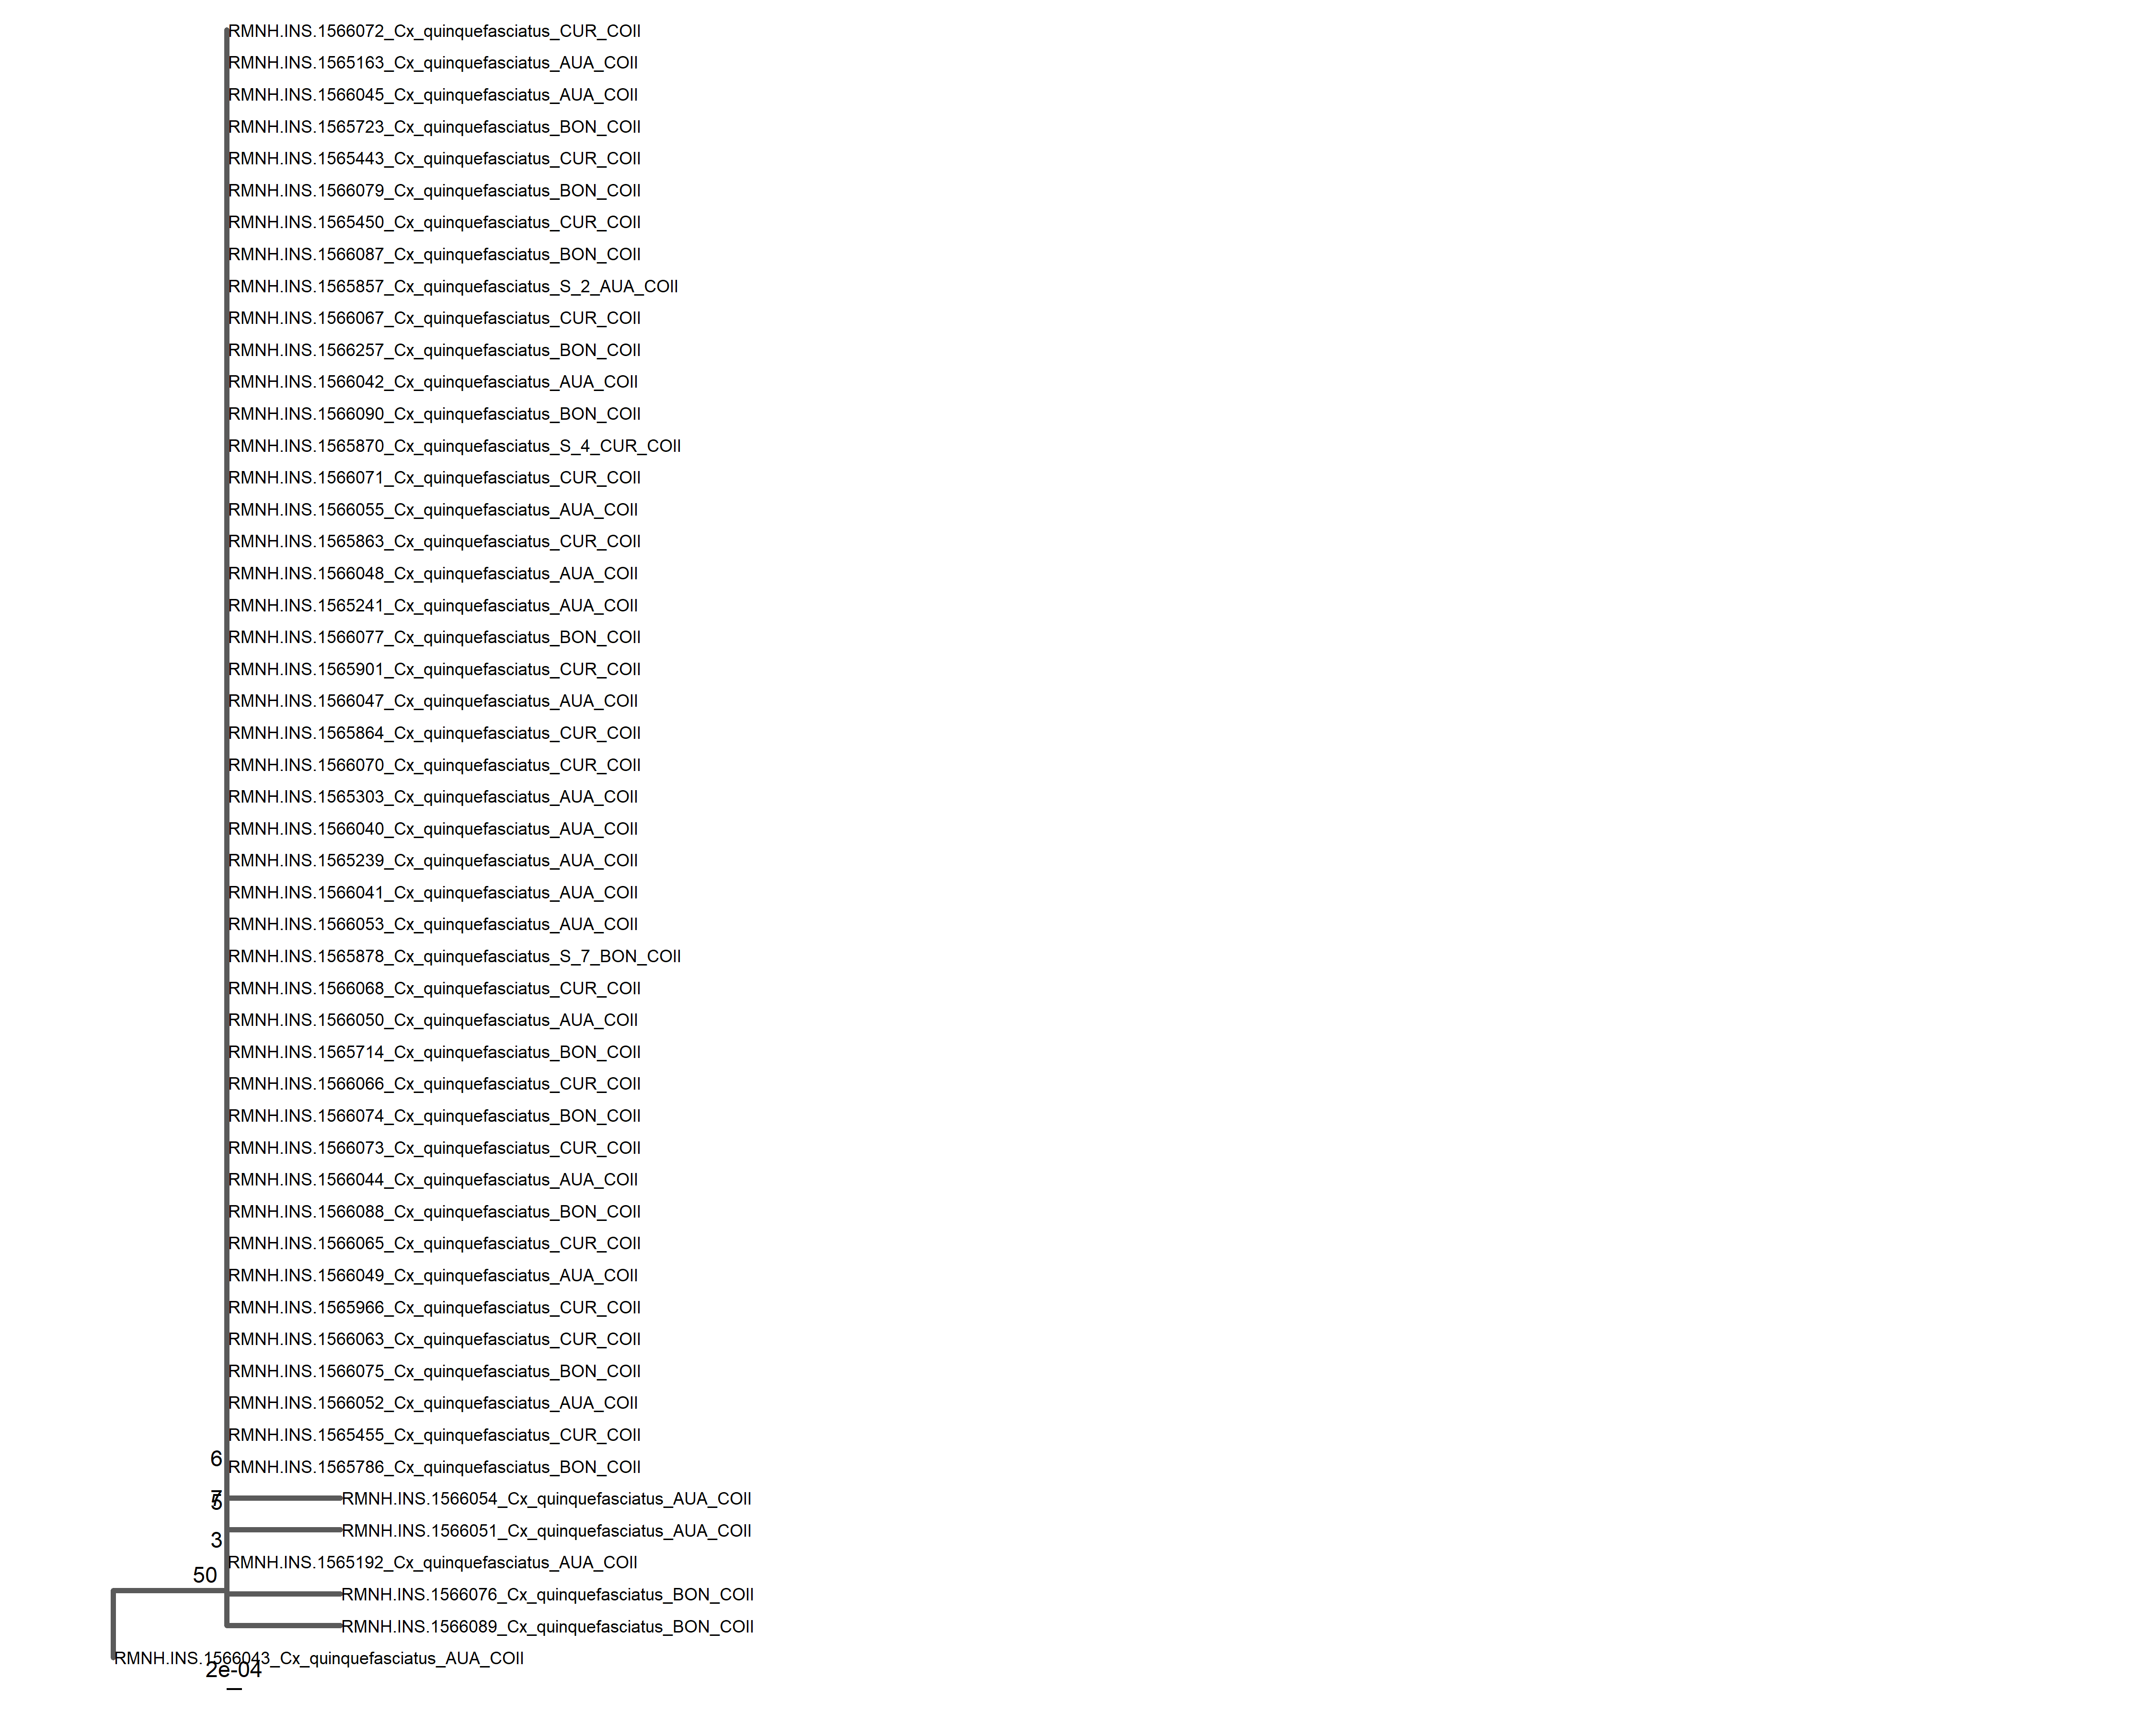
Fig. S7 Maximum Likelihood tree of the 52 included Culex quinquefasciatus sequences (684 bp) in this study, showing internal branching and branch lengths of the collapsed clade from Fig. 2. Tip label names included the corresponding RMNH-collection number and the island of origin of the sequence. Branch length corresponds with the genetic distance between sequences. Support values represent 1000 Ultrafast bootstraps (%). Tree was rooted using a sequence of Chironomus plumosus, not shown in the figure.

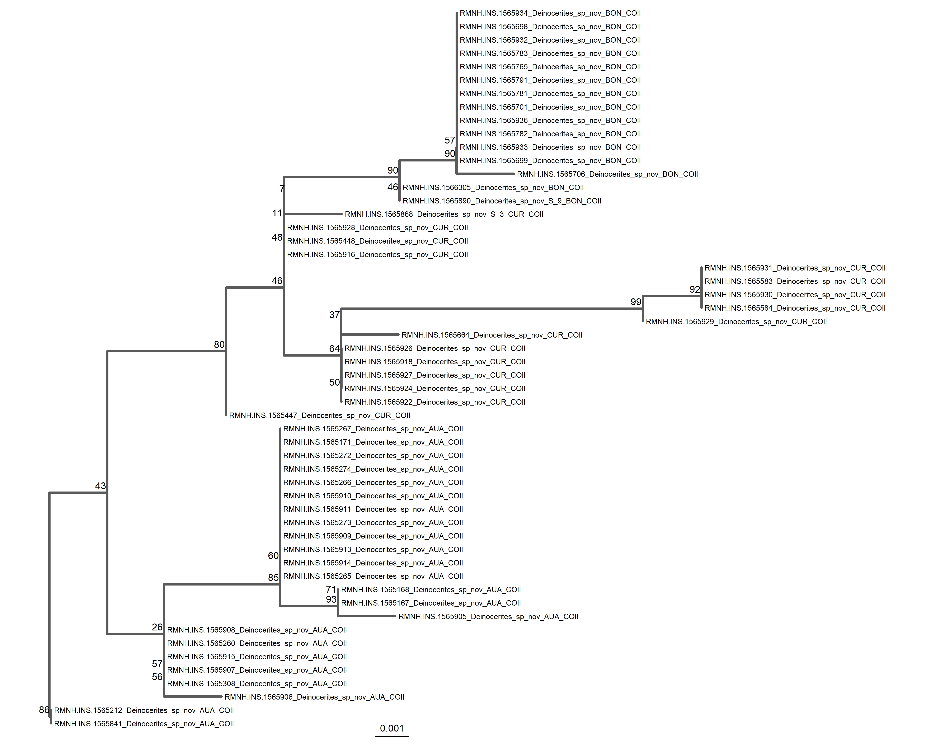
Fig. S8 Maximum Likelihood tree of the 54 included Deinocerites sp. sequences (684 bp) in this study, showing internal branching and branch lengths of the collapsed clade from Fig. 2. Tip label names included the corresponding RMNH-collection number and the island of origin of the sequence. Branch length corresponds with the genetic distance between sequences. Support values represent 1000 Ultrafast bootstraps (%). Tree was rooted using a sequence of Chironomus plumosus, not shown in the figure.

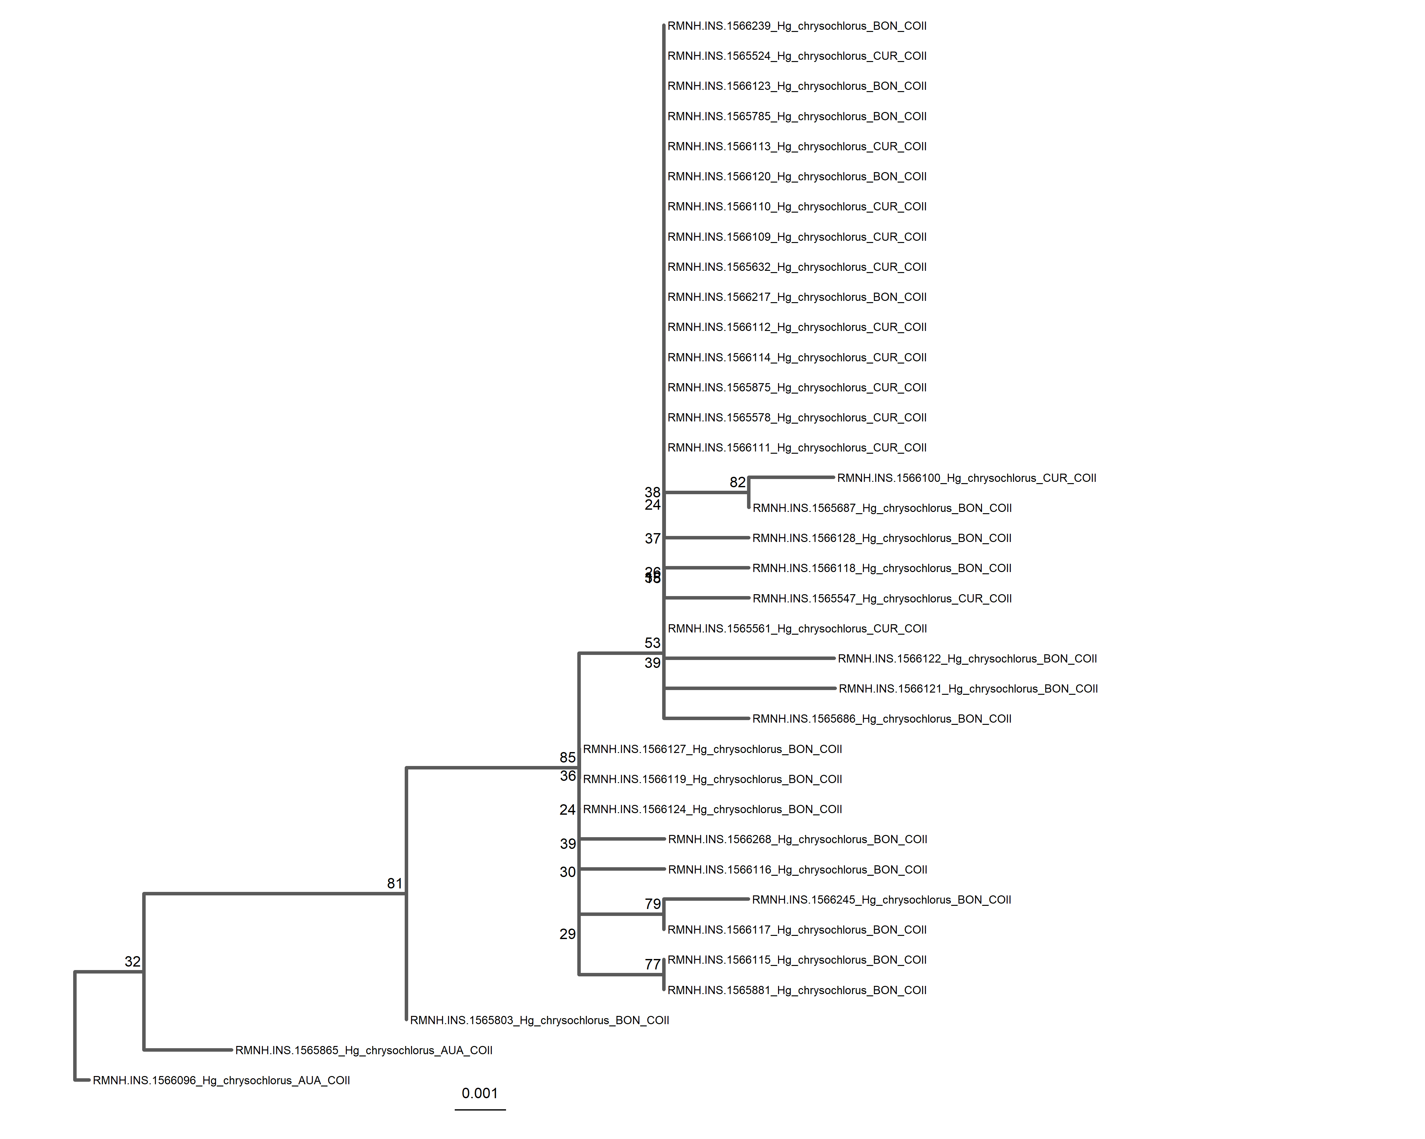
Fig. S9 Maximum Likelihood tree of the 36 included Haemagogus chrysochlorus sequences (684 bp) in this study, showing internal branching and branch lengths of the collapsed clade from Fig. 2. Tip label names included the corresponding RMNH-collection number and the island of origin of the sequence. Branch length corresponds with the genetic distance between sequences. Support values represent 1000 Ultrafast bootstraps (%). Tree was rooted using a sequence of Chironomus plumosus, not shown in the figure.

