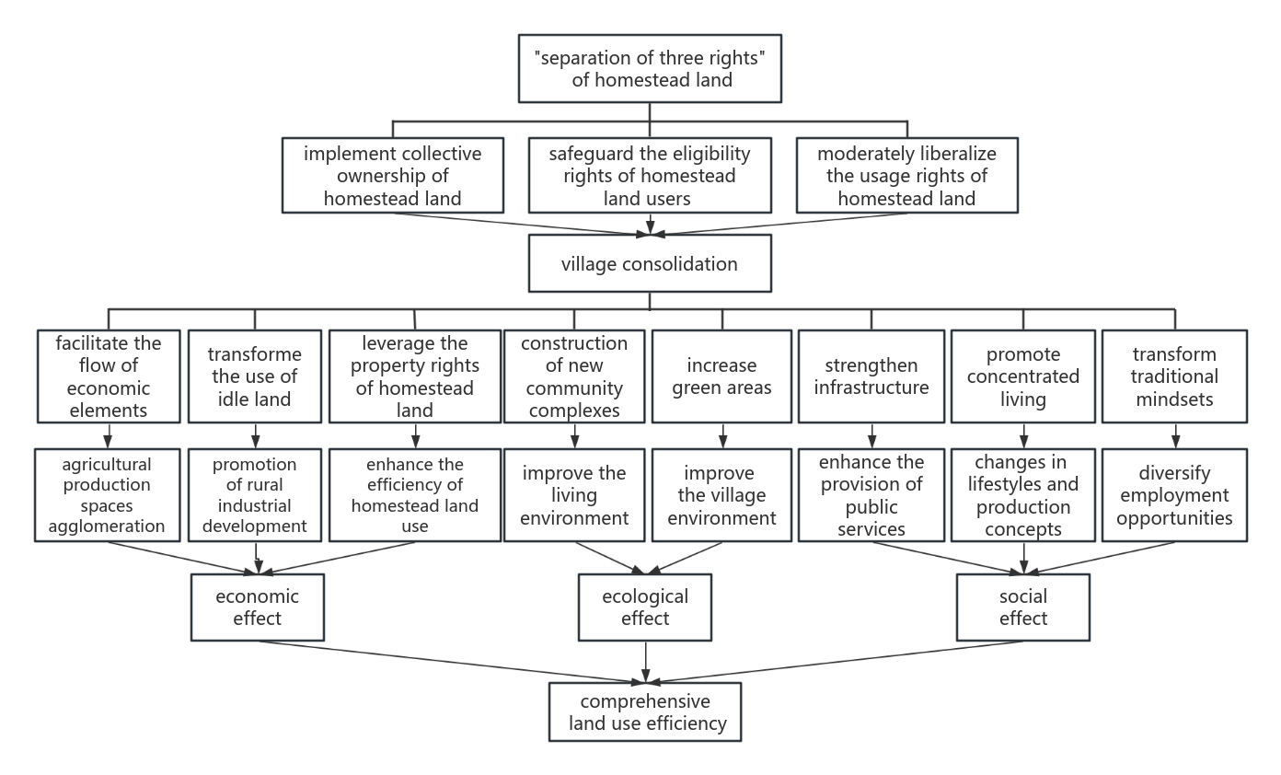
Figure 1. The influence mechanism of village consolidation on comprehensive land utilization

