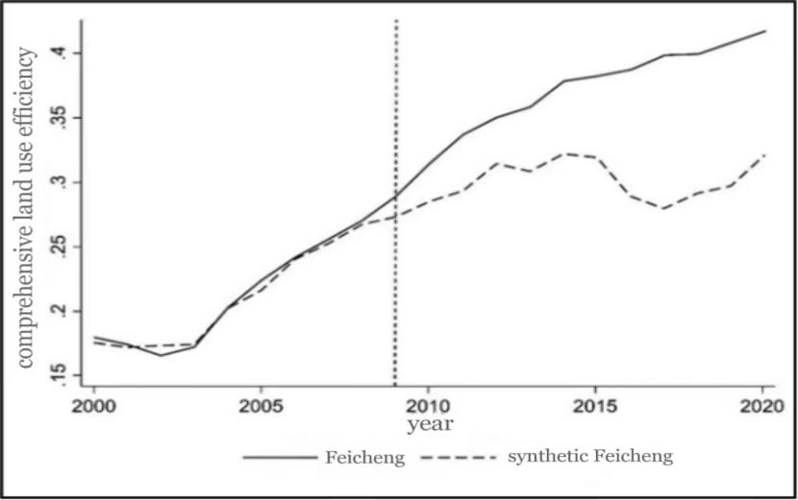
Figure 3. Comparison between actual synthetic value of comprehensive land use efficiency in Feicheng city

