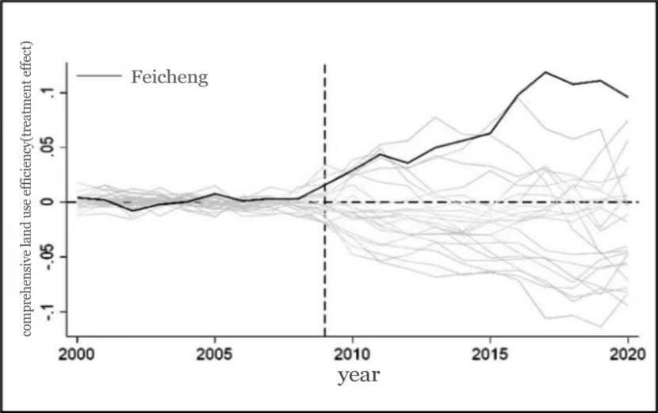
Figure 5. The placebo test after excluding regions with MSPE greater than five times that of Feicheng

