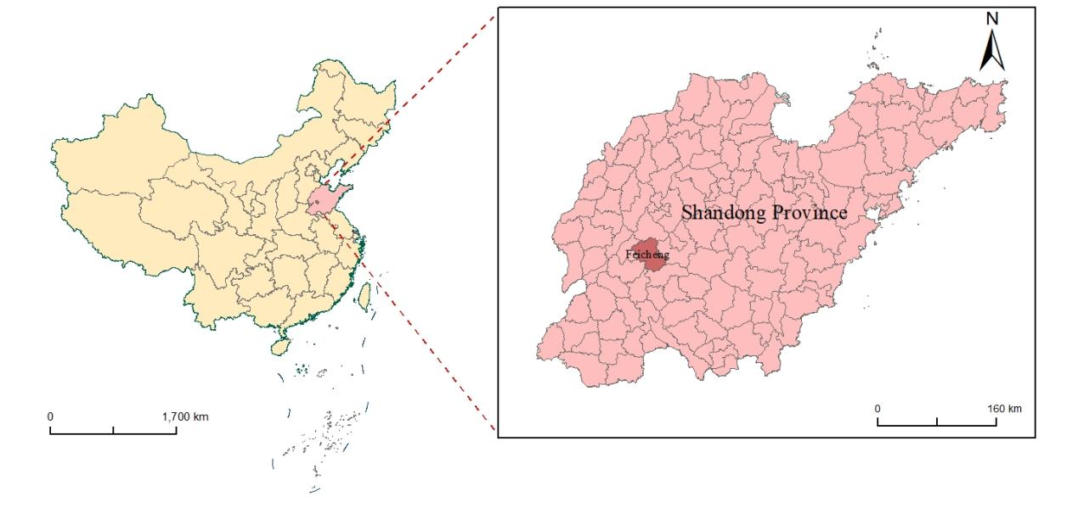
Figure 2. Feicheng's geographical location map

