Supplementary Information
Kosmotropic anion for improving cycling stability of aqueous lithium-ion batteries in salt-in-water electrolytes

Hyunjeong Oh^{1, 2,†}, Seung-Jae Shin^{1, †}, Hirona Yamagishi³, Toshiaki Ohta³, Naoaki Yabuuchi⁴, Hyungjun Kim^{1,*}, and Hye Ryung Byon^{1, 2,} *

¹Department of Chemistry, Korea Advanced Institute of Science and Technology (KAIST), 291 Daehak-ro, Yuseong-gu, Daejeon 34141, Republic of Korea
²Advanced Battery Center, KAIST Institute for NanoCentury, Daejeon 34141, Republic of Korea
³Sychrotron Radiation (SR) Center, Ritsumeikan University, Kusatsu, Shiga 525-8577, Japan
⁴Department of Chemistry and Life Science, Yokohama National University, 79-5 Tokiwadai, Hodogaya-ku. Yokohama, Kanagawa 240-8501, Japan

† Contributed equally to this work
*E-mail: hrbyon@kaist.ac.kr, linus16@kaist.ac.kr
Method
Chemicals
For electrolyte, LiN(SO₂CF₃)₂ (lithium bis(trifluoromethanesulfonyl) imide, LiTFSI, >99.7%, Kanto), Li₂SO₄ (99.7% Alfa aesar), LiNO₃ (reagent plus, Sigma aldrich), LiCH₃COO (98%, Wako), LiClO₄, (99.99 %, Sigma aldrich) and LiOH (>98%, Sigma aldrich) were used as received without any purification. For electrodes, LiCoO₂ (99.8%), N-methylpyrrolidine (NMP), and H₂O₂ (30% in H₂O) were purchased from Sigma aldrich, and NH₄OH was purchased from Fluka (5.0 M).

Electrode preparation
LiCoO₂ (LCO) powders were mixed with Super P carbon (Timcal) and polyvinyldene fluoride (PVDF, Kynar) binder with 8/1/1 wt%, respectively, using NMP using planetary mixer (Thinky, ARE-310). This slurry was cast on the titanium (Ti) foil (Wellcos, 99.5% thickness (t) = 20 μm) or carbon paper (TGP-H-120, Toray) using doctor blade method, followed by drying at 80 ºC overnight in the thermal oven (As one, AVO-310NB). Weight of active material was 2.5~5 mg cm⁻². The Ti foil was pre-treated using the piranha solution (7/3 v/v of NH₄OH/H₂O₂, respectively) to enhance adhesion.
A Li-excess Mo based cation-disordered rock salt oxide, Li_{9/7-x}Nb_{2/7}Mo_{3/7}O₂ (LNMO) was prepared according to the previous report.¹ The LNMO was cast on carbon paper with 4~8 mg cm⁻² of mass loading. This negative electrode was completed by soaking in H₂O with stirring for 2 h for extraction of the Li⁺.

Electrochemical measurements
All electrochemical tests were conducted in an argon (Ar)-filled glove box. Half-cell tests were examined through cyclic voltammetry (CV) and galvanostatic cycles. The three-electrode cells were composed of the working electrode (WE) of LCO on the Ti foil (diameter (d) = 6 mm), the counter electrode of a platinum (Pt) coil, and the reference electrode of Ag/AgCl (3 M NaCl). All tests were conducted using electrochemical tester (VMP-3, Biologic) in an argon (Ar)-filled glove box (MOTEK). De-gassing process was conducted for all aqueous electrolyte solutions by Ar-gas bubbling.²
Full cells were prepared using the 2032-type coin cells and galvanostatic electrochemical examinations were examined using battery cycler (PNE, PESC05-0.1). The LCO electrode on the carbon paper (d = 12 mm) was assembled with the delithiated LNMO (d = 14 mm) on the carbon and a piece of GF/C separator (d = 19 mm, Whatman®) in an Ar-filled glove box. The weight ratio of active materials for LNMO/LCO was 2 ~ 2.5.
Electrochemical impedance spectroscopy (EIS) tests were conducted with an amplitude of 10 mA and a frequency range of 100 kHz~100 mHz by using an electrochemical tester (VMP-3, Biologic). The EIS for the LCO electrode in the half cell was measured during the galvanostatic test and after holding a programmed potential for 10 min. To measure the electrochemical double-layer capacitance, staircase-potential EIS was conducted for a potential range of 0.3 V ~ –0.3 V vs. Ag/AgCl.^{3,4} Every potential step of –25 mV was moved, and EIS was measured after holding a programmed potential for 30 min.

Characterizations
LCO electrodes were washed with de-gassed distilled (DI) water and dried under vacuum at 60 ºC overnight. X-ray diffraction (XRD, Cu K-α, Rigaku) was used to analyze long-range order of crystal structure. Soft X-ray absorption near-edge structure (s-XANES) was measured in the BL11, Synchrotron Radiation (SR) center at Ritsumeikan University. The LCO electrodes were not exposed to air and directly transferred to s-XANES chamber using a hermetic vessel. X-ray photoelectron spectroscopy (XPS, Al K-α, Thermo VG Scientific) was used for surface analysis. All spectra were calibrated to C 1s sp² hybridization signal at 248.5 eV. Transmission electron microscopy (TEM, FEI Tecnai GE F30 S-Twin (300 kV)) images were attained to observe the surface layer. The OH stretching vibrations of aqueous electrolyte solutions were attained from attenuated total reflection-infrared (ATR-IR) spectroscopy in the range of 400~4000 cm⁻¹ (iS50, diamond window, Thermo Scientific). Confocal Raman spectroscopy (Ramanforce, Nanophoton) was used with a laser of 532 nm wavelength.

Mean-field QM/MM Simulations
Mean-field QM/MM simulations were performed using the DFT-CES (density functional theory in classical Explicit Solvents)⁵ method. DFT-CES is implemented by combining the Quantum ESPRESSO⁶ DFT module and Large-scale Atomic/Molecular Massively Parallel Simulator (LAMMPS) molecular dynamics (MD) module.⁷ Detailed simulation procedure of the DFT-CES can be found from our previous publications^{5,8-10}.
The LCO electrode was modeled as the (003) LiCoO₂ surface of R$\overline{3}$m space group at a QM level. Half of the outermost CoO₂ layer was terminated with hydrogen to block overestimating surface property¹¹, resulting in a stoichiometry of Li_{0.66}CoO₂H_{0.33}. Projector-augmented-wave (PAW)¹² method was used with the kinetic energy cutoff of 60 Ry and the exchange correlation using the Perdew-Burke-Ernzerhof functional under the generalized gradient approximation (GGA) scheme.¹³ The strongly localized 3d orbital of Co was simulated using GGA+U method with U_{eff} value to be 4.91 eV.¹⁴ Gaussian smearing was used with a value of 0.02 Ry. The dipole correction along the z-direction was applied to block the unphysical interaction between the images of the cells. The Brillouin zone was sampled by Γￚcentered kpoints of 5Ⅹ5Ⅹ1.
The electrolyte phases of 0.5 m Li₂SO₄ and 1 m LiTFSI, LiNO₃, and LiClO₄ were modeled using classical force-fields (FF). 800 numbers of TIP3P¹⁵ water molecules were included along with 8 pairs of Li₂SO₄ or 16 pairs of LiTFSI, LiNO₃, and LiClO₄ pairs, respectively. Ions were described using the previously developed FFs¹⁶⁻²⁰, and the van der Waals (vdW) parameter of the LCO were described using the universal FF²¹. Off-diagonal vdW interactions were modeled using the Lorentz-Bertelot mixing rule. We performed canonical ensemble MD simulations at 300 K using the Nosé-Hoover thermostat.^{22,23}
To negatively charge the electrode-electrolyte interface, electrons were inserted to the LCO electrode using DFT, while Li⁺ were inserted in the electrolyte phase with keeping the total charge of the DFT-CES cell to be zero.

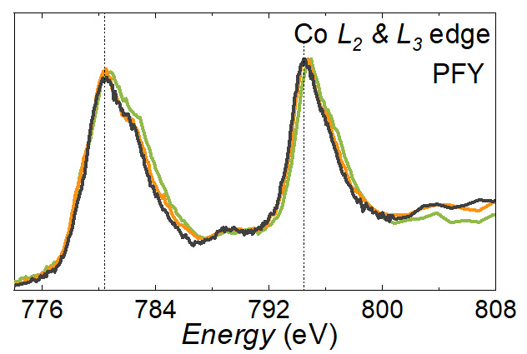
Figure S1. XAFS analyses of 30th cycled LCO electrodes with 0.5 m Li₂SO₄ (orange) and 1 m LiTFSI (green) and pristine LCO (black) in Co L-edge PFY mode. Comparing to the spectra for the pristine and the 0.5 m Li₂SO₄, the main Co³⁺ peaks with 1 m LiTFSI are shifted to ~0.3 eV for Co L₃ edge and 0.2~0.3 eV for Co L₂ edge.

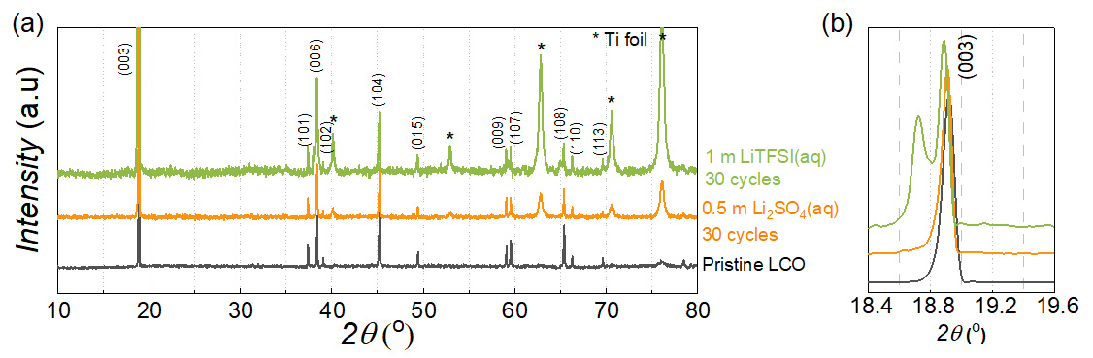
Figure S2. XRD spectra of LCO electrodes. The black, orange, and green spectra are the pristine LCO, the LCO electrode with 0.5 m Li₂SO₄ after 30th cycle, and the LCO electrode with 1 m LITFSI after 30th cycle, respectively. The asterisk mark indicates Ti foil as the substrate. (b) is the high-magnification curves of (a) at 003 reflection.

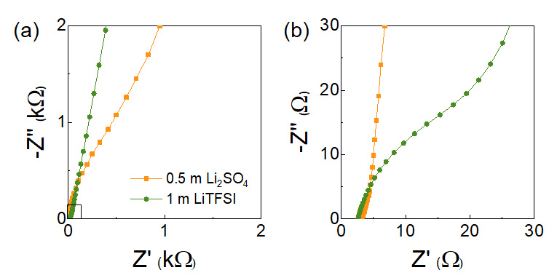
Figure S3. Nyquist plots at open circuit potential (OCP) with 0.5 m Li₂SO₄ (orange, ~0 V) and 1 m LiTFSI (green, ~0.1 V) before galvanostatic cycle. (b) is a high-magnification curves in the square region of (a).
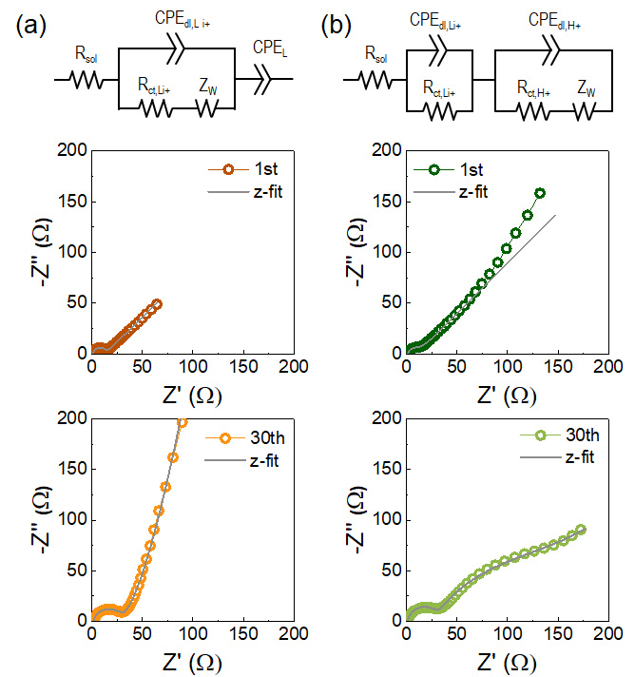
Figure S4. Equivalent circuits (top) and Nyquist plots of LCO half-cells with (a) 0.5 m Li₂SO₄ (orange), and (b) 1 m LiTFSI (green) after 1st cycle (middle) and 30 cycles (bottom). Unlike Figure 2 where EIS was measured at different charging and discharging states for initial 3 cycles, EIS in Figure S4 was measured after continuous 30 cycles, followed by rest for 30 min. The solid lines are the fitting curves using corresponding equivalent circuits.^{24,25} R_{sol}, R_{ct,Li+}, R_{ct,H+}, and Z_{w} indicate the resistance of bulk electrolyte solution resistance, the charge-transfer (ct) resistance for Li⁺ intercalation/extraction, the ct for H⁺ (de)intercalation, and the Warburg impedance, respectively. The CPE_{dl,Li+}, CPE_{dl,H+}, CPE_{L} indicate the constant phase elements (CPE) of double-layer capacitances for Li⁺ and H⁺ (de)intercalation, and limited capacitance at the electrode surface, respectively. The R_{ct,H+} term was enlarged with 1 m LiTFSI after 30 cycle in contrast to negligible R_{ct,H+} with 0.5 m Li₂SO₄.
Table S1. Summary of R_{sol}, R_{ct,Li+}, and R_{ct,H+} values acquired from EIS fitting based on the equivalent circuits in Figure S4.
 | 0.5 m Li₂SO₄ |  | 1 m LiTFSI
Unit: Ω | 1st cycle | 30th cycle | 1st cycle | 30th cycle
R_{sol} | 1.09 | 1.75 | 1.38 | 1.33
R_{ct,Li+} | 1.75 | 27.8 | 1.28 | 27.6
R_{ct,H+} | - | - | 11.2 | 147.3

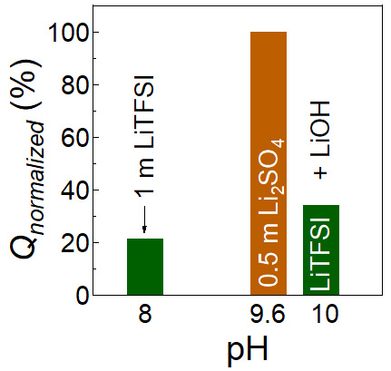

Figure S5. Correlation between pH of electrolyte solution and normalized capacity (Q_{normalized}) at 30th cycle. 1 m LiTFSI showing pH ~8 (green) provided 21.4% of Q_{normalized} for LCO. 0.5 m Li₂SO₄ having pH ~9.6 (brown) showed ~100% of Q_{normalized} for LCO. pH ~10 of 1 m LiTFSI made by adjusting LiOH showed 34.2% of Q_{normalized}. Obviously, the capacity is not entirely determined from pH.

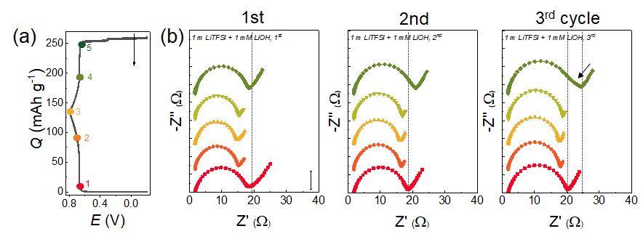
Figure S6. Galvanostatic profiles and corresponding EIS analysis of LCO cells for 3 cycles with 1 m LiTFSI at pH of 10, prepared by addition of 1 mM LiOH. (a) Galvanostatic profiles for consecutive 3 cycles. The arrows indicate galvanostatic profiles from the 1st to the 3rd cycle. (b) Nyquist plots after potential holding for 10 min for charging process at the potential 1 (red, 0.66 V), 2, (orange, 0.7 V), and 3 (yellow, 0.8 V), and subsequent discharging process at 4 (light green, 0.7 V), and 5 (green, 0.66 V) in (a). The panels in (b) correspond from the 1st (left) to the 3rd cycle (right). The y-axis scales indicate 5 $Ω$.

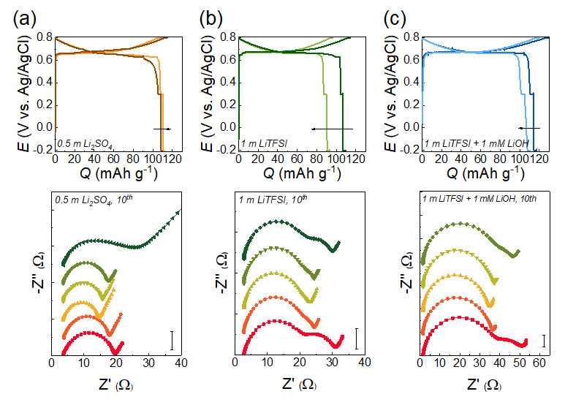
Figure S7. Comparative galvanostatic profiles (top panels) and corresponding EIS (bottom panels) of LCO cells for the 10th cycle. Electrolyte solutions are (a) 0.5 m Li₂SO₄, (b) pH ~8 of 1 m LiTFSI, and (c) pH ~10 of 1 m LiTFSI. The arrows in the galvanostatic profiles indicate from 1st and 10th cycles. Nyquist plots were acquired after potential holding for 10 min for charging process at the potential of 0.66 V (red), 0.7 V (orange), and 0.8 V (yellow), and subsequent discharging process at 0.7 V (light green), 0.66 V (green), 0.7 V), and 0.63 V (dark green, Li₂SO₄ only). The y-axis scales indicate 5 $Ω$.
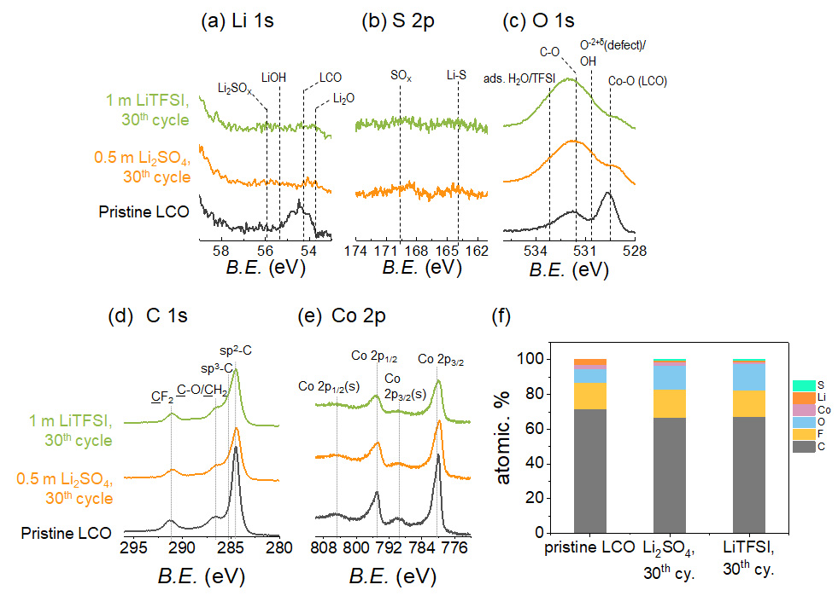
Figure S8. XPS results of pristine LCO (black), 30th cycled LCO with 0.5 m Li₂SO₄ (orange), and 1 m LiTFSI (green). (a) Li 1s, (b) S 2p, (c) O 1s, (d) C 1s, (e) Co 2p, and (f) atomic % of C, F, O, Co, Li, and S. The Co-O lattice of the LCO (529.7 eV), oxide defect/hydroxide peak (530.8 eV), C-O (531.8eV) arising from carbonaceous particles appeared after 30 cycles.^{26,27} The intense peaks of sp²-C (284.5 eV), sp³-C (285.2 eV), and C-O (286.6 eV) emerged from the Super P carbon, while CH₂ (286.7 eV) and CF₂ signal (291 eV) arose from the PVdF binder in the C 1s BE region.²⁸⁻³¹ In the Co 2p BE region, Co 2p_{3/2} (780 eV), Co 2p_{1/2} (795 eV) and their satellite (s) peaks (790 eV and 805 eV, respectively) arising from Co³⁺ appeared for all samples. It is noted the satellite signal of Co²⁺ (786 eV) is not visible, indicating the absence of Co²⁺ on the LCO surface after cycling.²⁸⁻³¹

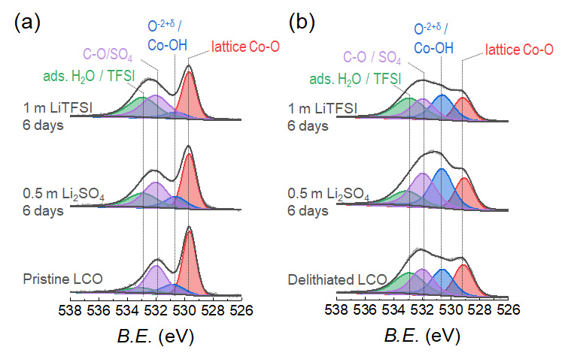
Figure S9. XPS O 1s BE regions of (a) pristine LCO and (b) as-prepared delithiated LCO electrodes in the bottom panel. These samples were immersed in 0.5 m Li₂SO₄ (middle) and 1 m LiTFSI for 6 days (top panel). The delithiation of LCO was carried out with 0.5 m Li₂SO₄ at 0.8 V, and a current rate of 0.5C. It appears to the enhanced O^{-2+δ} and Co-OH signals and the relatively reduced lattice Co-O only after the delithiation.

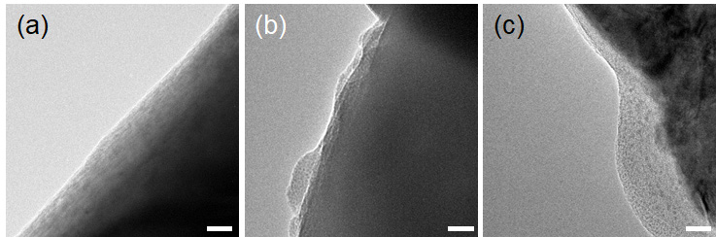
Figure S10. TEM images of (a) pristine LCO surface, and (b-c) 30th cycled LCO surfaces with (b) 0.5 m Li₂SO₄ and (c) 1 m LiTFSI. All scale bars indicate 20 nm.

Table S2. Measured molar (mol L⁻¹) concentrations.
 | m (mol kg⁻¹) | M (mol L⁻¹)
Li₂SO₄ | 0.5 | 0.49
LiNO₃ | 1 | 0.98
LiClO₄ | 1 | 0.95
LiTFSI | 1 | 0.88

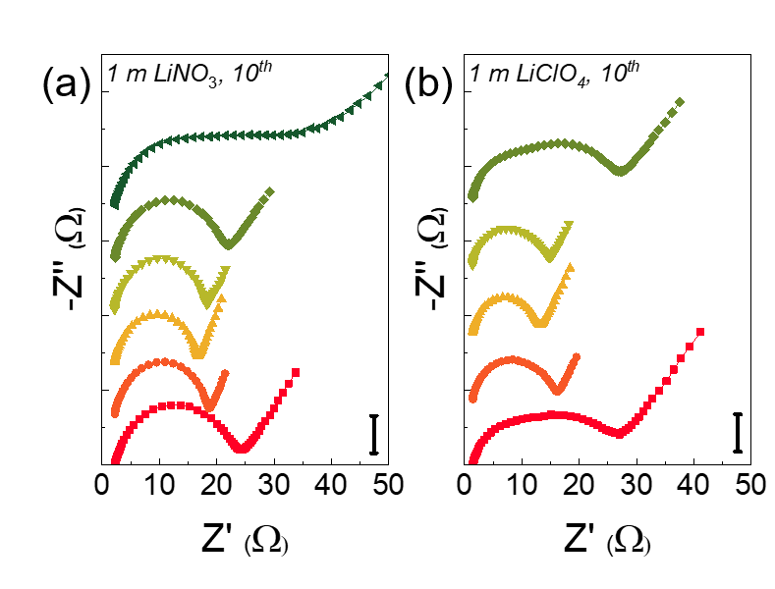
Figure S11. EIS of LCO cells for the 10th cycle during galvanostatic cycle. Electrolyte solutions are (a) 1 m LiNO₃ (b) 1 m LiClO₄. Nyquist plots were acquired after potential holding for 10 min for charging process at the potential of 0.66 V (red), 0.7 V (orange), and 0.8 V (yellow), and subsequent discharging process at 0.7 V (light green), 0.66 V (green), 0.7 V), and 0.63 V (dark green, LiNO₃ only). The y-axis scales indicate 5 $Ω$.
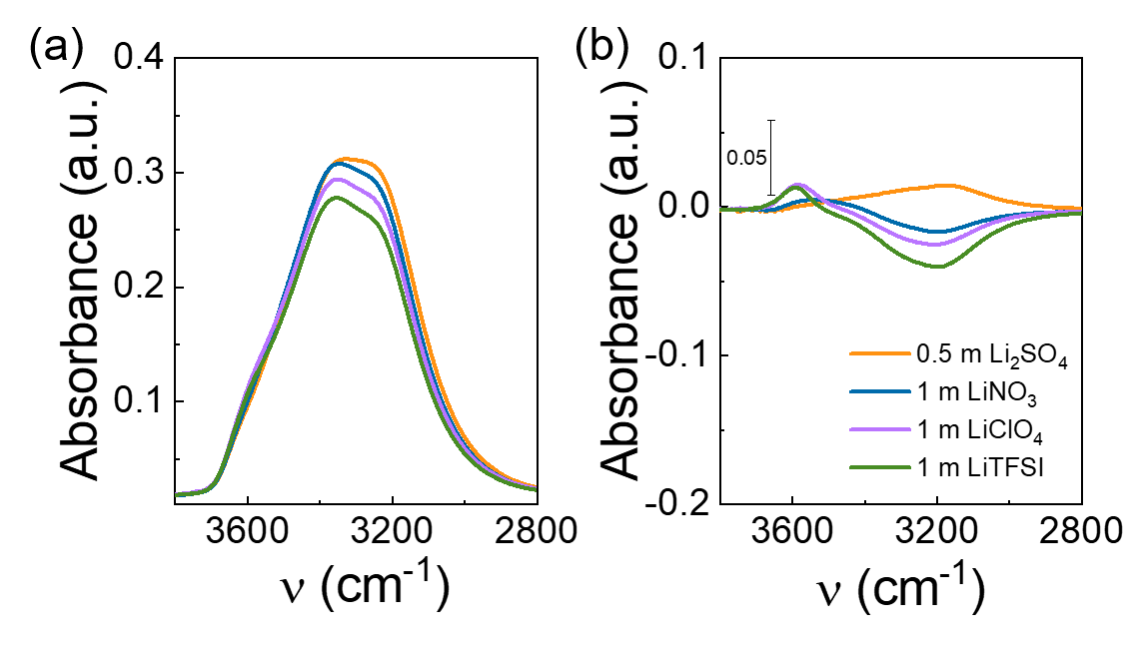
Figure S12. Comparative ATR-IR spectra of 0.5 m Li₂SO₄ (orange), 1 m LiNO₃ (blue), 1 m LiClO₄ (purple), and 1 m LiTFSI (green). (a) ATR-IR spectra at O-H stretching region. (b) Corresponding differential O-H vibration signals from pure water.
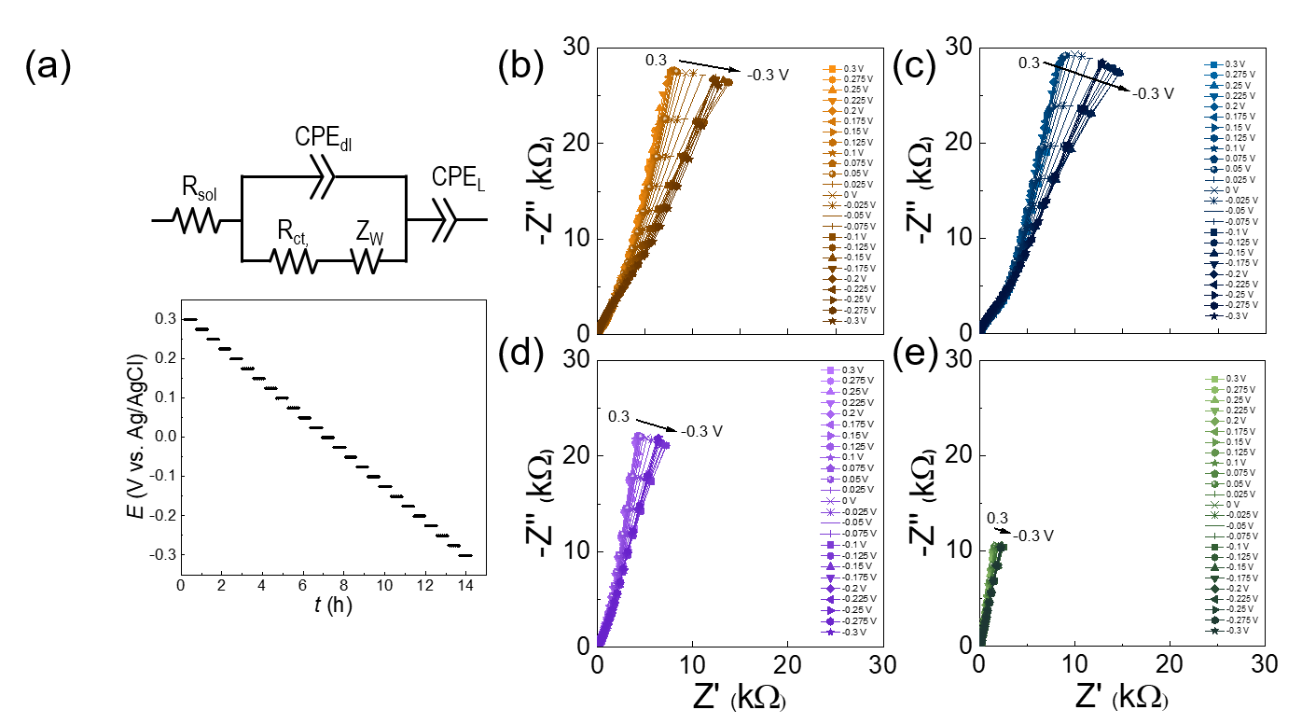
Figure S13. Nyquist plots and Bode plots of the LCO electrode and equivalent circuit with various electrolyte solutions. The staircase-potential EIS was conducted for every potential step of –25 mV and following 30 min rest in a potential range of 0.3 V ~ –0.3 V vs. Ag/AgCl. (a) An equivalent circuit model and representative staircase-potential curve. (b-f) Nyquest plots with (b) 0.5 m Li₂SO₄, (c) 1 m LiNO₃, (d) 1 m LiClO₄, and (e) 1 m LiTFSI.

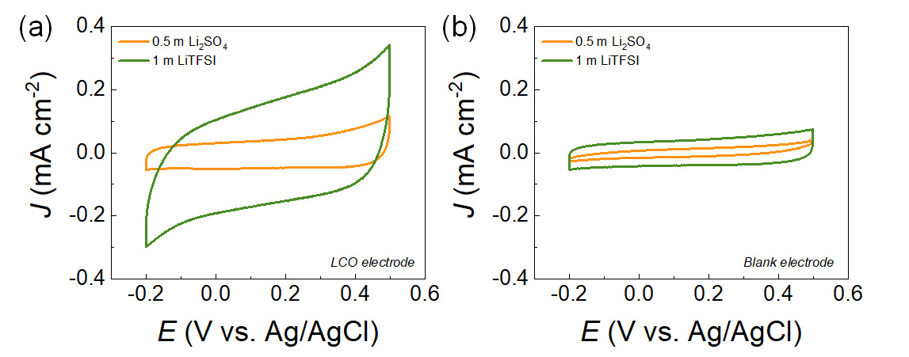
Figure S14. CV curves of LCO electrodes in the non-faradaic potential region (–0.2 ~ 0.5 V) at a scan rate of 50 mV s⁻¹. (a) CV profiles of the LCO electrode, and (b) CV curves of the blank electrode (LCO-free carbon + binder electrode). The orange and green curves indicate 0.5 m Li₂SO₄ and 1 m LiTFSI, respectively. These results indicate superior adsorption property of TFSI– on both the LCO and the additive carbon in the EDL range relative to that of SO₄^{2–}.
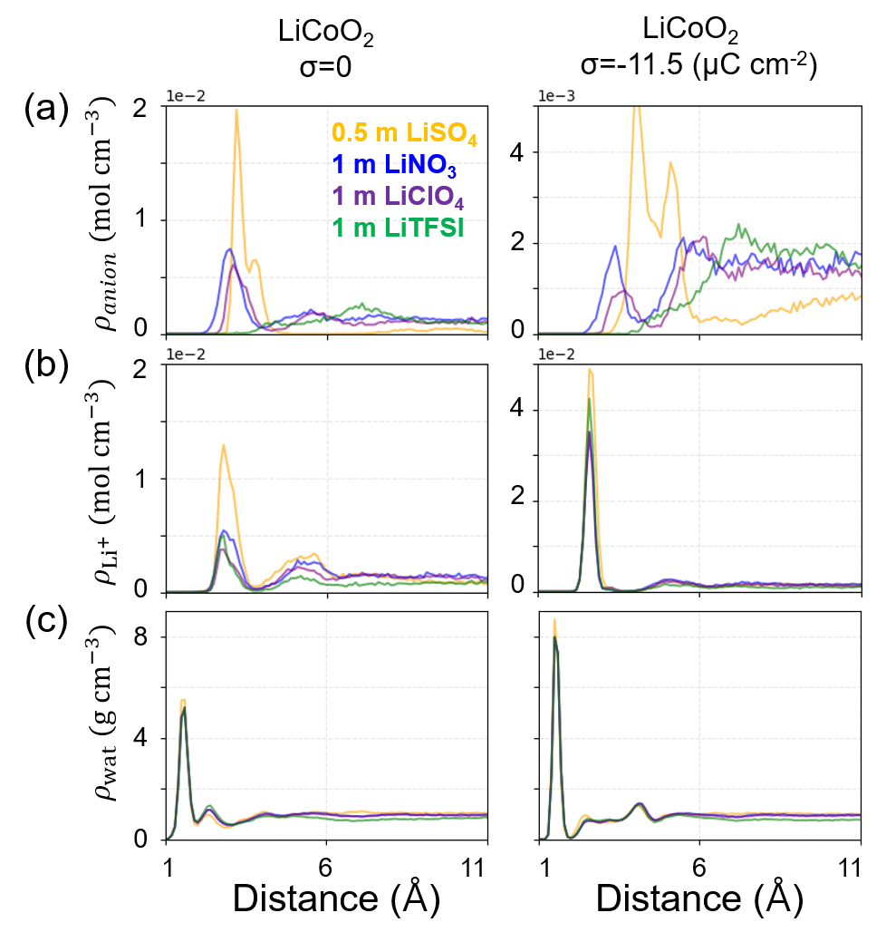
Figure S15. Local concentrations of (a) anion ($ρ_{anion}$), (b) Li⁺ ($ρ_{{Li}^{+}}$), and (c) density of water ($ρ_{wat}$) along the surface normal direction. The distance is referred to the top-most atoms of the electrode. Left panels are the uncharged LiCoO₂, and the right panels are for the cathodically (negatively) charged LiCoO₂ by σ = -11.5 μC cm⁻².

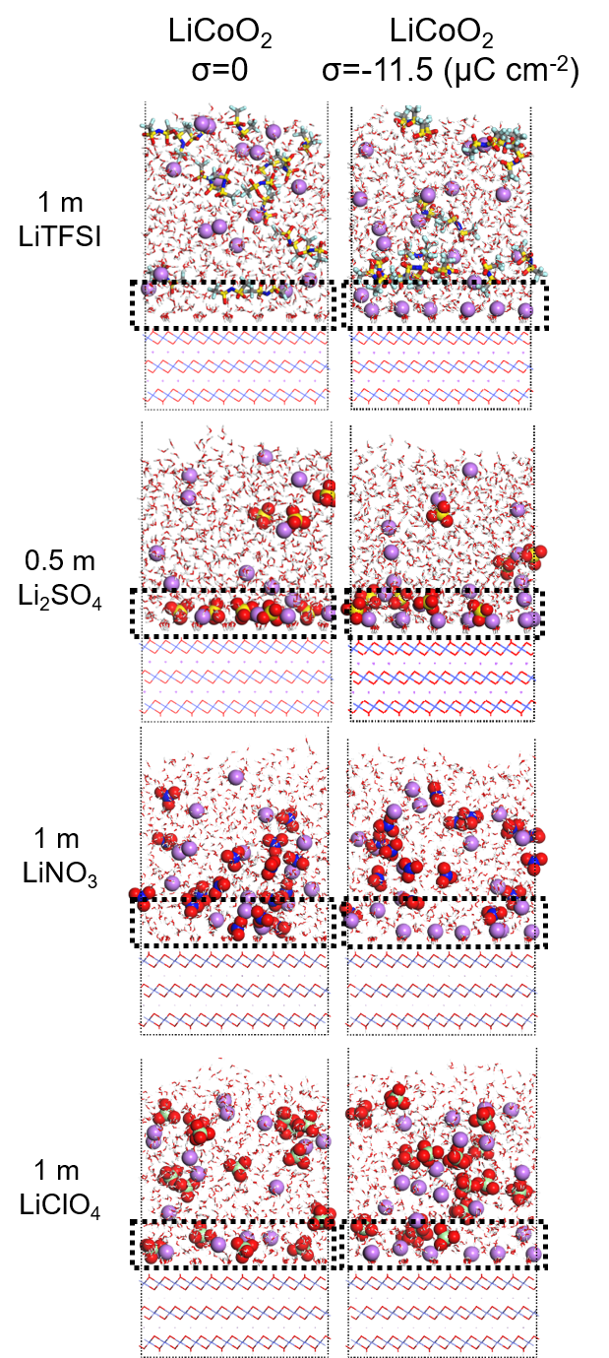
Figure S16. Representative double-layer structures for different double-layer charging states (σ) with varying salts, which are obtained from mean-field QM/MM simulations. Color codes are; purple for Li⁺, red for O, yellow for S, grey for C, and cyan for F, blue for N, and light green for Cl. Ionic species are displayed using spheres while water and LCO are displayed using sticks. The regions for analyzing ion quantities or free water density are shown with a dashed line.

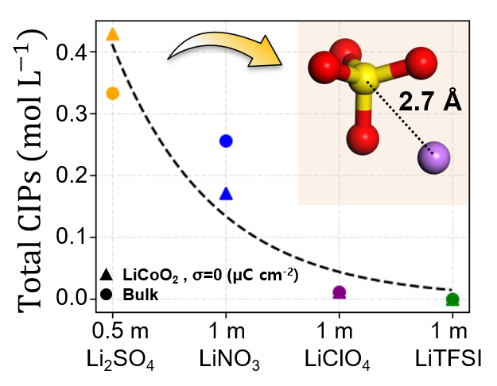
Figure S17. Number of contact ion pairs (CIPs). SO₄²⁻-Li⁺ CIP structure is shown in the inset.

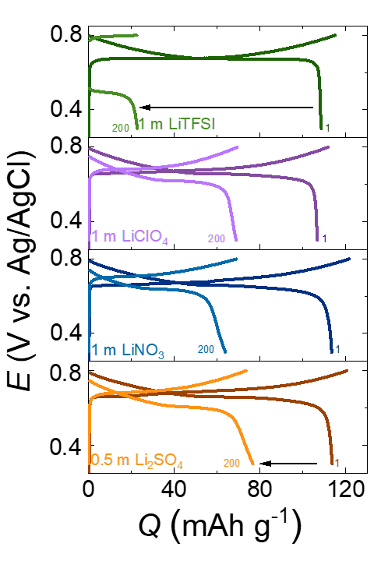
Figure S18. Galvanostatic cycling performances at 1st and 200th cycles with various electrolyte solutions, 0.5 m Li₂SO₄, 1 m LiNO₃, 1 m LiClO₄, and 1 m LiTFSI (from bottom to top). The current rates were 0.5 C, and the potential ranges were 0.3 ~ 0.8 V vs. Ag/AgCl. Comparative capacity retention and Coulombic efficiency (CE) for 200 cycles.
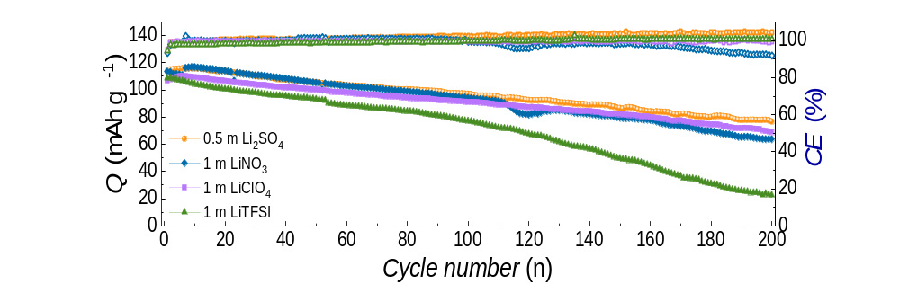
Figure S19. Comparative capacity retention and Coulombic efficiency (CE) for 200 cycles at 0.5C.

Table S3. Capacity retention ratios (a) after 100 cycles in the potential range of -0.2 ~ 0.8 V (Figure 2b), (b) after 100 cycles and (c) after 200 cycles in the potential range of 0.3 ~ 0.8 V (Figures S18-19).
 | Capacity retention (Q_{normalized} %)
 | -0.2 ~ 0.8 V | 0.3 ~ 0.8 V
 | 100 cycles | 100 cycles | 200 cycles
0.5 m Li₂SO₄ | 72.5 | 85.4 | 67.4
1 m LiNO₃ | 33.0 | 82.8 | 56.1
1 m LiClO₄ | 13.3 | 85.4 | 64.6
1 m LiTFSI |  | 71.0 | 20.7

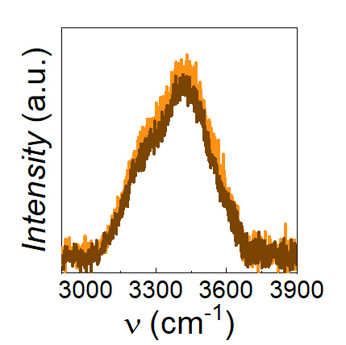
Figure S20. Raman spectra of 0.5 m (light orange) and 3 m (dark brown) Li₂SO₄ at (O-H stretching region. The negligible vibration change indicates no appearance of the water-in-salt characteristics by 3 m.

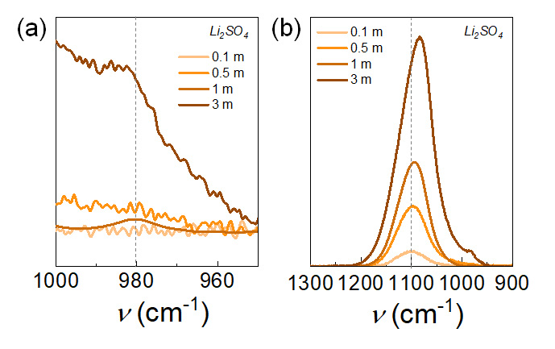
Figure S21. ATR-IR spectra from 0.1 m to 3 m Li₂SO₄ at (a) IR-inactive symmetric stretching band ($ν_{1}$(SO₄²⁻)) at ~981 cm⁻¹ and (b) IR-active anti-symmetric stretching band ($ν_{3}$(SO₄²⁻)) at ~1101 cm⁻¹. With increasing concentration, the $ν_{1}$(SO₄²⁻) signal is apparent, and $ν_{3}$(SO₄²⁻) shifts to low wavenumber, which are in good agreement with the previous report.³² Emerging $ν_{1}$(SO₄²⁻) is understood to the symmetry decrease of the SO₄²⁻ stretch by forming the ion pairs. A marginal band splitting of the $ν_{3}$(SO₄²⁻) suggests the formation of the solvent-separated ion pairs (SIP).

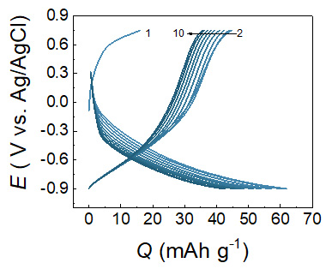.
Figure S22. Galvanostatic profiles of Li_{9/7-x}Nb_{2/7}Mo_{3/7}O₂ (LNMO) for 10 cycles with 1 m LiTFSI. The current rates were 0.5C, and the potential ranges were -0.9 ~ 0.75 V vs. Ag/AgCl.

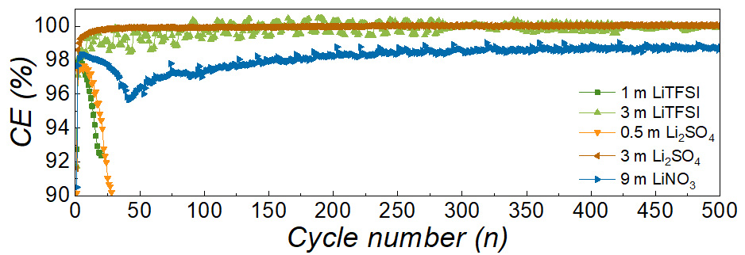
Figure S23. Coulombic efficiency (CE) of full cells consisting of (+)LiCoO₂ and (–)Li_{9/7-x}Nb_{2/7}Mo_{3/7}O₂ electrodes with 1 m LiTFSI (green), 3 m LiTFSI (light green), 0.5 m Li₂SO₄ (orange), 3 m Li₂SO₄ (brown), and 9 m LiNO₃ (blue) electrolyte solution. Among the various electrolyte solutions, 3 m Li₂SO₄ only maintained stable CE close to 100% of CE 500 cycles.

Table S4. Summary of CE of full cells at 20th, 50th, and 500th cycles (Figure S23).
 | CE (%)
 | 20th cycle | 50th cycle | 500th cycle
0.5 m Li₂SO₄ | 94.44 | 98.46
1 m LiTFSI | 92.38 | 96.77
3 m Li₂SO₄ | 99.80 | 99.92 | 100.09
3 m LiTFSI | 98.90 | 99.27 | 99.92
9 m LiNO₃ | 97.97 | 96.38 | 98.79

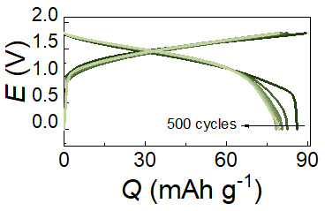
Figure S24. Voltage profiles of a full cell with 21 m LiTFSI for 500 cycles. The negative electrode was LNMO, and the current rate was 0.5C. Capacity retention was estimated to ~92%.

References
1 Hoshino, S. et al. Reversible three-electron redox reaction of Mo³⁺/Mo⁶⁺ for rechargeable lithium batteries. ACS Energy Lett. 2, 733-738, (2017).
2 Luo, J. Y., Cui, W. J., He, P. & Xia, Y. Y. Raising the cycling stability of aqueous lithium-ion batteries by eliminating oxygen in the electrolyte. Nat. Chem. 2, 760-765, (2010).
3 Lukomska, A. & Sobkowski, J. Potential of zero charge of monocrystalline copper electrodes in perchlorate solutions. J. Electroanal. Chem. 567, 95-102, (2004).
4 Finke, C. E. et al. Enhancing the activity of oxygen-evolution and chlorine-evolution electrocatalysts by atomic layer deposition of TiO₂. Energy Environ. Sci. 12, 358-365, (2019).
5 Lim, H. K., Lee, H. & Kim, H. A Seamless Grid-Based Interface for Mean-Field QM/MM Coupled with Efficient Solvation Free Energy Calculations. J. Chem. Theory Comput. 12, 5088-5099, (2016).
6 Giannozzi, P. et al. QUANTUM ESPRESSO: a modular and open-source software project for quantum simulations of materials. J. Phys.-Condes. Matter 21, 395502, (2009).
7 Plimpton, S. Fast parallel algorithms for short-range molecular-dynamics. J. Comput. Phys. 117, 1-19, (1995).
8 Gim, S., Lim, H. K. & Kim, H. Multiscale Simulation Method for Quantitative Prediction of Surface Wettability at the Atomistic Level. J. Phys. Chem. Lett. 9, 1750-1758, (2018).
9 Gim, S., Cho, K. J., Lim, H. K. & Kim, H. Structure, Dynamics, and Wettability of Water at Metal Interfaces. Sci Rep 9, 14805, (2019).
10 Cho, K. J., Gim, S., Lim, H. K., Kim, C. & Kim, H. Water Slippage on Graphitic and Metallic Surfaces: Impact of the Surface Packing Structure and Electron Density Tail. J. Phys. Chem. C 124, 11392-11400, (2020).
11 Abbaspour-Tamijani, A. et al. DFT and thermodynamics calculations of surface cation release in LiCoO₂. Appl. Surf. Sci. 515, 145865, (2020).
12 Blochl, P. E. Projector augmented-wave method Phys. Rev. B 50, 17953-17979, (1994).
13 Perdew, J. P., Burke, K. & Ernzerhof, M. Generalized gradient approximation made simple. Phys. Rev. Lett. 77, 3865-3868, (1996).
14 Zhou, F., Cococcioni, M., Marianetti, C. A., Morgan, D. & Ceder, G. First-principles prediction of redox potentials in transition-metal compounds with LDA + U. Phys. Rev. B 70, 235121, (2004).
15 Price, D. J. & Brooks, C. L. A modified TIP3P water potential for simulation with Ewald summation. J. Chem. Phys. 121, 10096-10103, (2004).
16 Jeon, J. et al. The Role of Confined Water in Ionic Liquid Electrolytes for Dye-Sensitized Solar Cells. J. Phys. Chem. Lett. 3, 556-559, (2012).
17 Pegado, L., Marsalek, O., Jungwirth, P. & Wernersson, E. Solvation and ion-pairing properties of the aqueous sulfate anion: explicit versus effective electronic polarization. Phys. Chem. Chem. Phys. 14, 10248-10257, (2012).
18 Joung, I. S. & Cheatham, T. E. Determination of alkali and halide monovalent ion parameters for use in explicitly solvated biomolecular simulations. J. Phys. Chem. B 112, 9020-9041, (2008).
19 Liu, X. M. et al. New force field for molecular simulation of guanidinium-based ionic liquids. J. Phys. Chem. B 110, 12062-12071, (2006).
20 Thogersen, J. et al. Hydration Dynamics of Aqueous Nitrate. J. Phys. Chem. B 117, 3376-3388, (2013).
21 Rappe, A. K., Casewit, C. J., Colwell, K. S., Goddard, W. A. & Skiff, W. M. UFF, a full periodic table force field for molecular mechanics and molecular dynamics simulations. J. Am. Chem. Soc. 114, 10024-10035, (1992).
22 Nose, S. A unified formulation of the constant temperature molecular-dynamics method. J. Chem. Phys. 81, 511-519, (1984).
23 Hoover, W. G. Canonical dynamics: Equilibrium phase-space distributions. Phys. Rev. A 31, 1695-1697, (1985).
24 Wang, Y. G., Lou, J. Y., Wu, W., Wang, C. X. & Xia, Y. Y. Hybrid aqueous energy storage cells using activated carbon and lithium-ion intercalated compounds - III. Capacity fading mechanism of LiCo_{1/3}Ni_{1/3}Mn_{1/3}O₂ at different pH electrolyte solutions. J. Electrochem. Soc. 154, A228-A234, (2007).
25 Wang, Y. G., Luo, J. Y., Wang, C. X. & Xia, Y. Y. Hybrid aqueous energy storage cells using activated carbon and lithium-ion intercalated compounds II. Comparison of LiMn₂O₄, LiCo_{1/3}Ni_{1/3}Mn_{1/3}O₂, and LiCoO₂ positive electrodes. J. Electrochem. Soc. 153, A1425-A1431, (2006).
26 Yang, J., Liu, H. W., Martens, W. N. & Frost, R. L. Synthesis and Characterization of Cobalt Hydroxide, Cobalt Oxyhydroxide, and Cobalt Oxide Nanodiscs. J. Phys. Chem. C 114, 111-119, (2010).
27 Cherkashinin, G. & Jaegermann, W. Dissociative adsorption of H₂O on LiCoO₂ (00l) surfaces: Co reduction induced by electron transfer from intrinsic defects. J. Chem. Phys. 144, 184706, (2016).
28 Schulz, N., Hausbrand, R., Dimesso, L. & Jaegermann, W. XPS-Surface Analysis of SEI Layers on Li-Ion Cathodes: Part I. Investigation of Initial Surface Chemistry. J. Electrochem. Soc. 165, A819-A832, (2018).
29 Schulz, N., Hausbrand, R., Wittich, C., Dimesso, L. & Jaegermann, W. XPS-Surface Analysis of SEI Layers on Li-Ion Cathodes: Part II. SEI-Composition and Formation inside Composite Electrodes. J. Electrochem. Soc. 165, A833-A846, (2018).
30 Motzko, M., Solano, M. A. C., Jaegermann, W. & Hausbrand, R. Photoemission Study on the Interaction Between LiCoO₂ Thin Films and Adsorbed Water. J. Phys. Chem. C 119, 23407-23412, (2015).
31 Daheron, L. et al. Electron transfer mechanisms upon lithium deintercalation from LiCoO₂ to CoO₂ investigated by XPS. Chem. Mat. 20, 583-590, (2008).
32 Wei, Z. F., Zhang, Y. H., Zhao, L. J., Liu, J. H. & Li, X. H. Observation of the first hydration layer of isolated cations and anions through the FTIR-ATR difference spectra. J. Phys. Chem. A 109, 1337-1342, (2005).

