Document S2
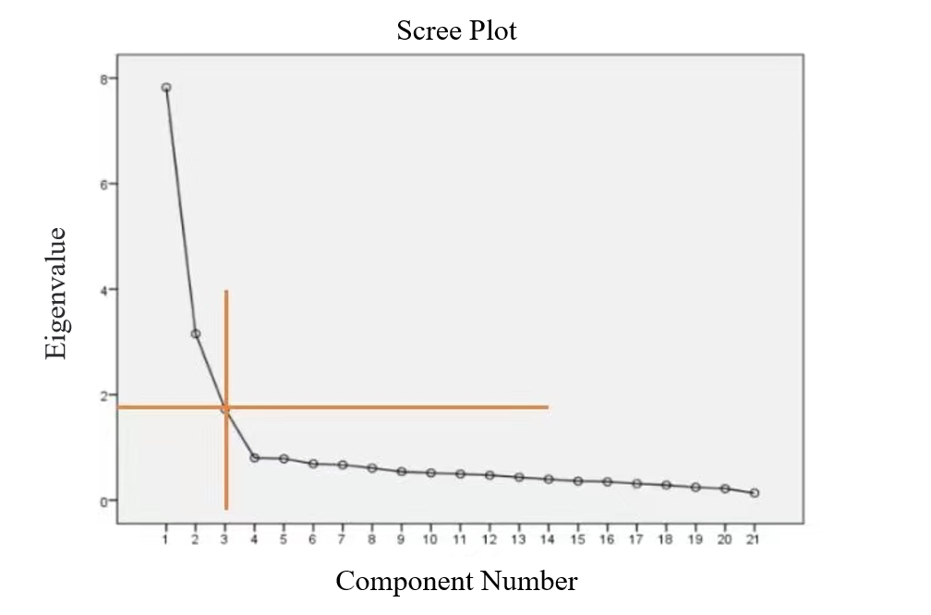
SFig.1 Scree Plot

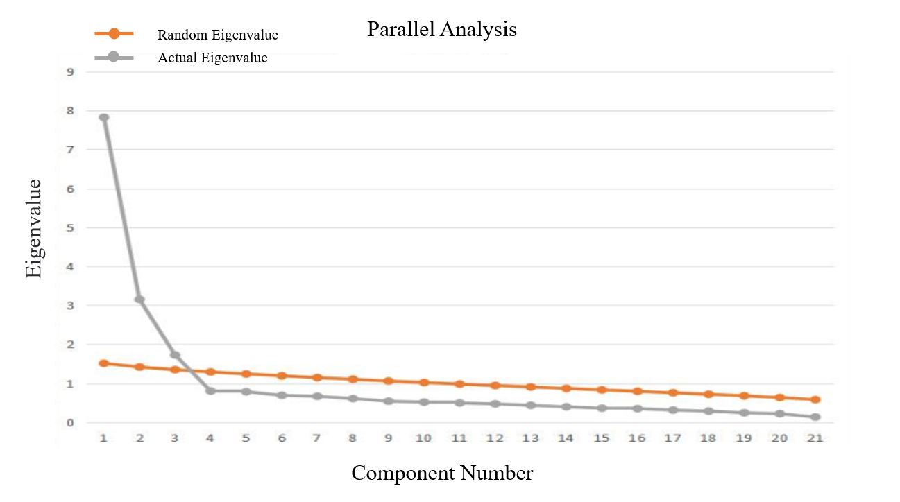 SFig.2 Parallel Analysis

