Document S3
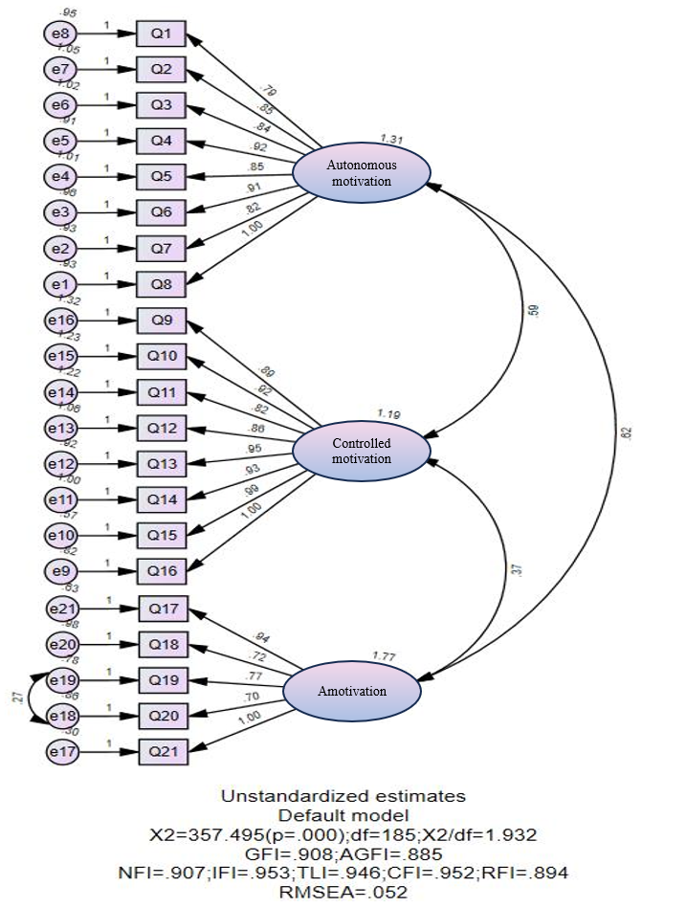
SFig.3 Modified CFA unstandardized estimates default model diagram

