Table of Contents
Supplemental Information 2
Table S1: Patients’ Distribution of intervention step across time by treatment arm 2
Table S2: Comparisons of Included (i.e. paired) versus Excluded Caregivers 3
Table S3: Model Fit Summaries For Patients and Caregivers from CFA 4
Table S4: Mental Health Outcomes Factor Loadings from CFA 4
Table S5: Patient outcomes across different study conditions 5
Table S6: Caregiver outcomes across different study conditions 6
Figure S1: Scree Plot 7
Figure S2: Exploratory Factor Analysis (EFA) Diagram 8
Figure S3: Plot of estimated mean of Patient Mental Health Outcomes (top) and Caregiver Mental Health Outcomes (bottom) at baseline (week 0), week 6, week 12, and week 24 in the control and intervention conditions. 9
CFA Analysis in R 10
Joint Model Equation 11

Supplemental Information

Table S1: Patients’ Distribution of intervention step across time by treatment arm
 | Control | Intervention | Total | p-value¹
Total | 88 (47%) | 98 (53%) | 186 (100%)
Step at baseline |  |  |  | >0.9
*missing | 0 (0%) | 1 (0.5%) | 1 (0.5%)
Step 1 | 37 (20%) | 43 (23%) | 80 (43%)
Step 2 | 31 (17%) | 31 (17%) | 62 (33%)
Step 3 | 18 (9.7%) | 22 (12%) | 40 (22%)
Step 4 | 2 (1.1%) | 1 (0.5%) | 3 (1.6%)
Step at 6 weeks |  |  |  | 0.4
*missing | 13 (7.0%) | 25 (13%) | 38 (20%)
Step 1 | 28 (15%) | 32 (17%) | 60 (32%)
Step 2 | 28 (15%) | 24 (13%) | 52 (28%)
Step 3 | 18 (9.7%) | 16 (8.6%) | 34 (18%)
Step 4 | 1 (0.5%) | 1 (0.5%) | 2 (1.1%)
Step at 12 weeks |  |  |  | 0.028
*missing | 14 (7.5%) | 34 (18%) | 48 (26%)
Step 1 | 28 (15%) | 29 (16%) | 57 (31%)
Step 2 | 29 (16%) | 20 (11%) | 49 (26%)
Step 3 | 16 (8.6%) | 13 (7.0%) | 29 (16%)
Step 4 | 1 (0.5%) | 2 (1.1%) | 3 (1.6%)
Total | 88 (47%) | 98 (53%) | 186 (100%)
Step at 24 weeks |  |  |  | 0.14
*missing | 22 (12%) | 38 (20%) | 60 (32%)
Step 1 | 21 (11%) | 27 (15%) | 48 (26%)
Step 2 | 26 (14%) | 19 (10%) | 45 (24%)
Step 3 | 18 (9.7%) | 13 (7.0%) | 31 (17%)
Step 4 | 1 (0.5%) | 1 (0.5%) | 2 (1.1%)
¹ Fisher's exact test

Table S2: Comparisons of Included (i.e. paired) versus Excluded Caregivers
Characteristic | Excluded N = 36¹ | Paired N = 31¹ | p-value²
Language |  |  | 0.7
Both | 0 (0%) | 1 (3.3%)
English | 31 (89%) | 25 (83%)
Spanish | 4 (11%) | 4 (13%)
Unknown | 1 | 1
Gender |  |  | 0.4
Female | 9 (25%) | 5 (16%)
Male | 27 (75%) | 26 (84%)
Age | 44 (35, 56) | 58 (40, 66) | 0.022
Race |  |  | 0.5
Other | 11 (31%) | 7 (23%)
White | 25 (69%) | 24 (77%)
Education |  |  | 0.8
College or graduate school | 21 (58%) | 19 (61%)
High school or lower | 15 (42%) | 12 (39%)
Treatment assignment |  |  | 0.7
Intervention | 19 (53%) | 18 (58%)
Usual Care | 17 (47%) | 13 (42%)
¹n (%); Median (Q1, Q3)
²Fisher's exact test; Pearson's Chi-squared test; Wilcoxon rank sum test

Table S3: Model Fit Summaries For Patients and Caregivers from CFA
Model | $$x^{2}$$ | df | TLI | CFI | SRMR | RMSEA
Patient Model | 169.457 | 44 | 0.944 | 0.939 | 0.055 | 0.141
Caregiver Model | 102.046 | 44 | 0.974 | 0.971 | 0.051 | 0.096
*These models were evaluated with the following indices of model fit. Tucker–Lewis index (TLI), comparative fit index (CFI), standardized root mean square residual (SRMR), and root mean square error of approximation (RMSEA).

Table S4: Mental Health Outcomes Factor Loadings from CFA
 | Estimates | Standard Errors
Patient mental health outcomes
Perceived Stress Score | 1.000
Quality of life | -2.338 | 0.105
Anxiety | 0.966 | 0.036
Depression | 0.905 | 0.033
Coping Self-Efficacy | -6.139 | 0.316
Caregiver mental health outcomes
Perceived Stress Score | 1.000
Caregiver’s Burden | 0.857 | 0.045
Anxiety | 1.015 | 0.032
Depression | 0.896 | 0.029
Coping Self-Efficacy | -5.455 | 0.288
*The estimates are the factors loadings applied to every timepoint.

Table S5: Patient outcomes across different study conditions
Time | 0 |  | 6 |  | 12 |  | 24
 | Usual Care  (N=88) | Intervention  (N=98) | Usual Care  (N=76) | Intervention  (N=72) | Usual Care  (N=75) | Intervention  (N=65) | Usual Care  (N=68) | Intervention  (N=60)
Depression
Mean (SD) | 12.9 (5.80) | 13.1 (5.77) | 14.4 (6.34) | 13.8 (5.89) | 14.9 (6.32) | 13.7 (7.04) | 15.2 (6.81) | 13.1 (5.79)
Median [Min, Max] | 11.0 [8.00, 30.0] | 10.5 [8.00, 30.0] | 12.0 [8.00, 34.0] | 12.0 [8.00, 29.0] | 14.0 [8.00, 31.0] | 11.0 [8.00, 40.0] | 13.5 [8.00, 31.0] | 11.5 [8.00, 27.0]
Missing | 1 (1.1%) | 0 (0%) | 1 (1.3%) | 0 (0%) | 1 (1.3%) | 1 (1.5%) | 0 (0%) | 0 (0%)
Anxiety
Mean (SD) | 14.7 (6.58) | 14.9 (6.70) | 15.5 (6.56) | 14.5 (6.89) | 14.9 (6.63) | 14.2 (7.34) | 15.9 (6.59) | 14.4 (7.04)
Median [Min, Max] | 13.0 [8.00, 35.0] | 13.0 [8.00, 32.0] | 13.0 [8.00, 31.0] | 12.0 [8.00, 35.0] | 13.0 [8.00, 33.0] | 11.0 [8.00, 40.0] | 16.0 [8.00, 33.0] | 11.0 [8.00, 32.0]
Missing | 1 (1.1%) | 1 (1.0%) | 1 (1.3%) | 0 (0%) | 0 (0%) | 1 (1.5%) | 0 (0%) | 0 (0%)
Coping Self-Efficacy
Mean (SD) | 205 (59.1) | 206 (54.8) | 199 (53.7) | 209 (51.5) | 200 (51.1) | 214 (48.1) | 191 (55.8) | 205 (55.7)
Median [Min, Max] | 224 [10.0, 260] | 225 [46.8, 260] | 215 [40.0, 260] | 220 [75.0, 260] | 210 [70.0, 260] | 233 [110, 260] | 203 [60.0, 260] | 220 [60.0, 260]
Missing | 0 (0%) | 0 (0%) | 1 (1.3%) | 1 (1.4%) | 0 (0%) | 1 (1.5%) | 0 (0%) | 0 (0%)
Quality of Life
Mean (SD) | 75.8 (17.8) | 73.4 (17.2) | 75.1 (18.6) | 74.3 (18.9) | 73.5 (18.4) | 75.2 (21.1) | 73.1 (19.1) | 79.0 (19.6)
Median [Min, Max] | 77.0 [38.0, 107] | 75.7 [30.0, 108] | 76.2 [27.0, 107] | 74.8 [33.0, 108] | 71.0 [34.0, 108] | 76.5 [29.5, 108] | 70.1 [36.0, 107] | 83.1 [30.0, 108]
Missing | 1 (1.1%) | 1 (1.0%) | 2 (2.6%) | 2 (2.8%) | 0 (0%) | 1 (1.5%) | 0 (0%) | 0 (0%)
Perceived Stress
Mean (SD) | 12.8 (6.73) | 13.2 (7.31) | 13.4 (7.00) | 11.8 (7.53) | 12.3 (7.89) | 11.9 (7.80) | 13.5 (7.38) | 13.2 (7.51)
Median [Min, Max] | 12.0 [0, 30.0] | 13.0 [0, 31.0] | 13.0 [0, 31.0] | 11.0 [0, 34.0] | 13.0 [0, 32.0] | 12.5 [0, 26.0] | 14.0 [0, 29.0] | 15.0 [0, 28.0]
Missing | 4 (4.5%) | 2 (2.0%) | 5 (6.6%) | 3 (4.2%) | 2 (2.7%) | 3 (4.6%) | 0 (0%) | 1 (1.7%)
*Categorical variables are presented as N(%) and continuous variables are presented as Mean (SD) and Median (IQR).

Table S6: Caregiver outcomes across different study conditions
Time | 0 |  | 6 |  | 12 |  | 24
 | Usual Care  (N=88) | Intervention  (N=98) | Usual Care  (N=76) | Intervention  (N=65) | Usual Care  (N=74) | Intervention  (N=62) | Usual Care  (N=73) | Intervention  (N=58)
Depression
Mean (SD) | 13.0 (6.13) | 12.4 (5.29) | 15.8 (6.71) | 13.5 (5.83) | 15.2 (6.96) | 14.3 (6.31) | 14.9 (7.21) | 13.1 (5.72)
Median [Min, Max] | 11.0 [8.00, 34.0] | 10.0 [8.00, 27.0] | 16.0 [8.00, 35.0] | 11.0 [8.00, 30.0] | 14.0 [8.00, 34.0] | 11.0 [8.00, 29.0] | 13.0 [8.00, 33.0] | 11.0 [8.00, 31.0]
Missing | 0 (0%) | 1 (1.0%) | 1 (1.3%) | 0 (0%) | 0 (0%) | 0 (0%) | 0 (0%) | 0 (0%)
Anxiety
Mean (SD) | 15.5 (7.62) | 14.3 (6.21) | 17.7 (7.23) | 15.6 (6.97) | 16.6 (7.33) | 16.0 (7.23) | 17.4 (7.13) | 13.9 (6.75)
Median [Min, Max] | 14.0 [8.00, 39.0] | 12.5 [8.00, 35.0] | 17.0 [8.00, 32.0] | 14.0 [8.00, 34.0] | 15.0 [8.00, 35.0] | 16.0 [8.00, 33.0] | 16.0 [8.00, 34.0] | 11.0 [8.00, 32.0]
Missing | 0 (0%) | 0 (0%) | 1 (1.3%) | 0 (0%) | 1 (1.4%) | 0 (0%) | 0 (0%) | 0 (0%)
Coping Self-Efficacy
Mean (SD) | 200 (50.9) | 209 (46.3) | 195 (50.6) | 196 (54.6) | 194 (53.3) | 202 (52.5) | 193 (52.4) | 208 (51.1)
Median [Min, Max] | 213 [0, 260] | 215 [80.0, 260] | 200 [75.0, 260] | 205 [5.00, 260] | 200 [75.0, 260] | 220 [75.0, 260] | 205 [55.0, 260] | 220 [0, 260]
Missing | 0 (0%) | 0 (0%) | 1 (1.3%) | 0 (0%) | 1 (1.4%) | 0 (0%) | 0 (0%) | 0 (0%)
Caregiver Burden
Mean (SD) | 9.87 (7.58) | 8.52 (6.26) | 13.0 (8.83) | 9.84 (7.17) | 12.6 (8.86) | 9.69 (7.91) | 12.5 (8.83) | 9.17 (8.19)
Median [Min, Max] | 8.00 [0, 29.0] | 7.00 [0, 27.0] | 11.0 [0, 33.0] | 10.0 [0, 30.0] | 10.0 [0, 43.0] | 8.00 [0, 31.0] | 12.0 [0, 36.0] | 7.00 [0, 33.0]
Missing | 0 (0%) | 0 (0%) | 1 (1.3%) | 0 (0%) | 0 (0%) | 0 (0%) | 0 (0%) | 0 (0%)
Perceived Stress
Mean (SD) | 13.2 (6.99) | 12.7 (6.25) | 14.6 (7.70) | 13.4 (8.11) | 13.5 (7.75) | 13.2 (6.72) | 14.6 (7.36) | 11.3 (7.17)
Median [Min, Max] | 12.0 [0, 31.0] | 12.0 [1.00, 28.0] | 15.5 [0, 28.0] | 13.0 [0, 29.0] | 13.0 [0, 34.0] | 14.0 [0, 26.0] | 14.0 [0, 30.0] | 11.0 [0, 29.0]
Missing | 7 (8.0%) | 5 (5.1%) | 2 (2.6%) | 1 (1.5%) | 0 (0%) | 3 (4.8%) | 0 (0%) | 0 (0%)
*Categorical variables are presented as N(%) and continuous variables are presented as Mean (SD) and Median (IQR).

Figure S1: Scree Plot
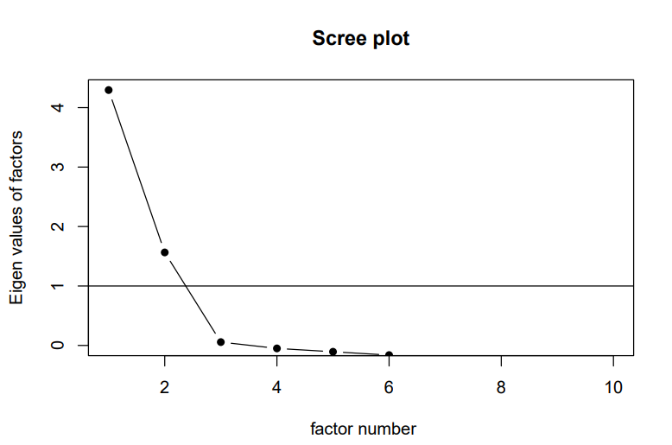

Figure S2: Exploratory Factor Analysis (EFA) Diagram
Caregiver’s Depression

Caregiver’s Perceived Stress

0.9
0.87
0.86
Caregiver’s Anxiety
Factor 1

0.66
Caregiver’s Burden

-0.66
Caregiver’s Coping Self-Efficacy

Patient’s Depression

0.9

Patient’s Anxiety
0.89
Factor 2
Patient’s Perceived Stress

0.77

-0.72
Patient’s Quality of Life

-0.63
Patient’s Coping Self-Efficacy

*Blue arrows are the positive loadings and dashed orange arrows represent the negative loadings.

Figure S3: Plot of estimated mean of Patient Mental Health Outcomes (top) and Caregiver Mental Health Outcomes (bottom) at baseline (week 0), week 6, week 12, and week 24 in the control and intervention conditions.

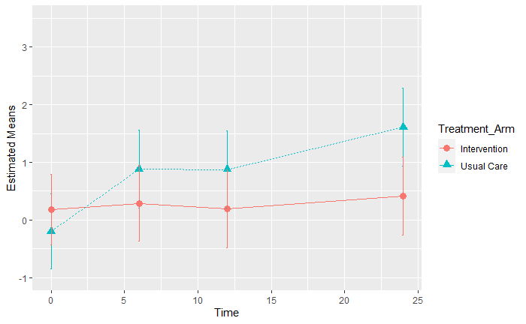
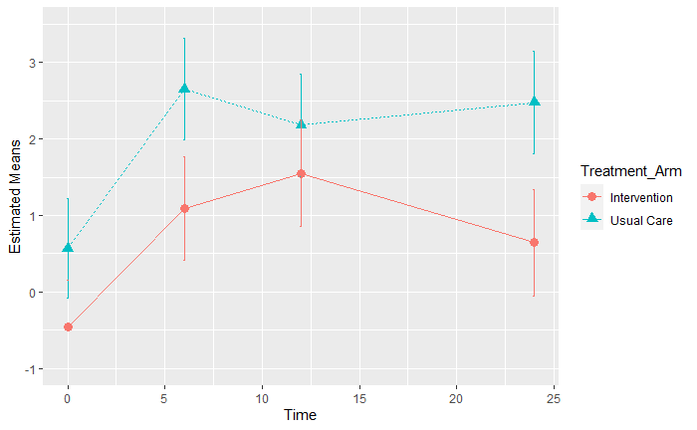

CFA Analysis in R
First, a model describing the hypothesized factor structure was established above using our observations from EFA of the baseline data. This model was estimated using the cfa function from the lavaan package (Rosseel,2012) by specifying group = “time” to estimate the same CFA model for our four timepoints separately and group.equal = c(“loadings”,“intercepts”). We chose the default scaling of the latent variable which fixes the loading of the first outcome for a certain latent variable to the value of 1.
The scalar invariance assumption ensures that the items (outcomes) loadings are constrained to be equal at each of the four timepoints (Widaman & Olivera-Aguilar, 2023, pp. 367-384). Scalar invariance also constrains the intercepts of the observed outcomes to be the same across timepoints. This scalar invariance assumption allows the latent variable to capture the changes over time given the other parameters are assumed fixed.
In our analysis, factor score extraction in lavaan is using the default method (the regression method) developed by Thurstone (Estabrook & Neale, 2013). This method used a least squares regression approach to predict factor score(s) that takes into account not only the correlation between the factors and between factors and observed variables (via item loadings), but also the correlation among observed variables. The independent variables in the regression equation are the standardized observed values of the items(outcomes) in the estimated factors. These predictor variables are weighted by regression coefficients, which are obtained by multiplying the inverse of the observed variable correlation matrix by the matrix of factor loadings (DiStefano et al.,2009 ).
The patient and caregiver CFA models are described as follows:
Patient’s Latent Variable =~ Perceived Stress Score + Quality of Life + Anxiety + Depression + Coping Self-Efficacy. This latent variable summarizes patient mental health outcomes which is a weighted average of the measures.
Similarly, a model is fitted for the caregiver’s dataset, with the following latent variable definitions:
Caregiver’s Latent Variable =~ Perceived Stress Score + Caregiver’s Burden + Anxiety + Depression + Coping Self-Efficacy. This latent variable summarizes caregiver mental health outcomes which is a weighted average of the measures.

Joint Model Equation
Let Y_{ij} and Z_{ij} denote the latent outcomes summarizing mental health outcomes for the patient and caregiver members of dyad, i, respectively.
The bivariate random intercept model is as follows (Fitzmaurice, 2009,pp. 327-345):
Y_{ij}=β₀ + β₁*Treatment_{ij} +β₂*T_{6i}+ β₃* T_{12i} + β₄* T_{24i} + β₅*Treatment_{ij} * T_{6i} + β₆*Treatment_{ij} * T_{12i} + β₇*Treatment_{ij} * T_{24i} + b_{io}+ϵ_{ij},

Z_{ij}=α₀ + α₁*Treatment_{ij} + α₂* T_{6i} + α₃* T_{12i} + α₄* T_{24i} + α₅*Treatment_{ij} * T_{6i} + α₆*Treatment_{ij} * T_{12i} + α₇*Treatment_{ij} *24 weeks T_{24i} + a_{io}+θ_{ij.}
Where:
- i=1,……,n with n being the number of dyads.
- j=0,…..,n_{i} with n_{i} being the number of observations/repeated measures on subject i with j indexing the observation. j=(0,6,12,24) with 6,12 and 24 denoting the time from baseline (6 weeks,12 weeks and 24 weeks) respectively with time =0 as the reference group.
- T_{ij}=is an indicator variable for the timepoint 6,12, or 24 weeks.
- β and α are the regression coefficients/ fixed effect estimates of the covariates with beta for the patients and alpha for caregivers.
- ϵ_{ij} and θ_{ij} are error terms, and b_{io} and a_{io} are correlated subject-specific random intercepts assumed to be normally distributed with mean zero and variance-covariance matrix:
Var$\left(\begin{matrix}b_{io} \\ a_{io}\end{matrix}\right)$=$\left[\begin{matrix}σ_{b}^{2} & σ_{a,b} \\ σ_{a,b} & σ_{a}^{2}\end{matrix}\right]$ where $σ_{b}^{2}$ is variance of the random intercept b_{io}, $σ_{a}^{2}$ is variance of the random intercept a_{io} and $σ_{a,b}$ is the covariance between the random intercept for patients, b_{io} , and caregivers a_{io.}

