Gold Nanoclusters Decorated Hollow ZIF-8 Encapsulating Iron-catecholates as Oxidase Mimetics for Ratiometric Colorimetric Detection of Nitrite

Cunhui Wu, Mengzhen Dai, Xinguang Qin, Gang Liu, Haizhi Zhang*

College of Food Science and Engineering, Wuhan Polytechnic University, Wuhan430023, China

*Correspondence to: Haizhi Zhang
Full postal address: Xuefu South Road No.68, Changqing Garden, Wuhan City, Hubei Province, 430023, China
- mail: hzzhang@iccas.ac.cn (H.Z.Z.)

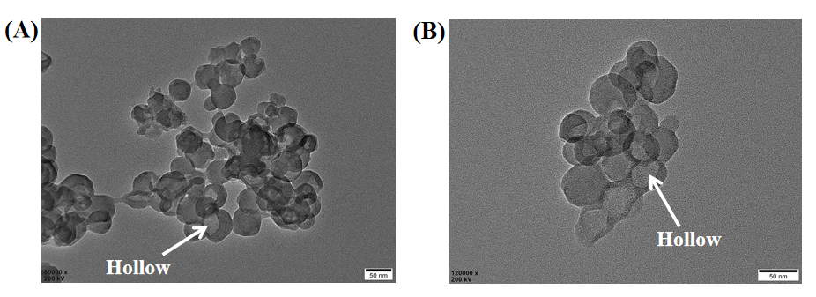

Figure S1 (A-B) TEM image of Fe-HHTP@HZIF-8@AuNCs

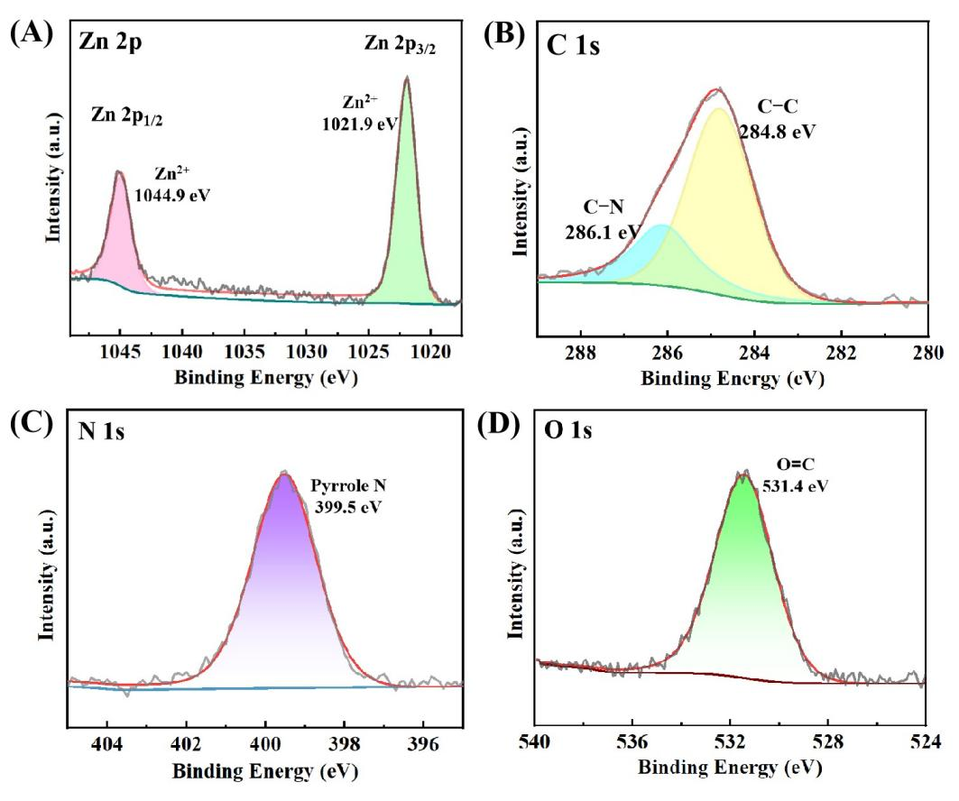

Figure S2 High-resolution XPS spectra of Zn 2p, C1s, N1s, O1s in Fe-HHTP@HZIF-8@AuNCs

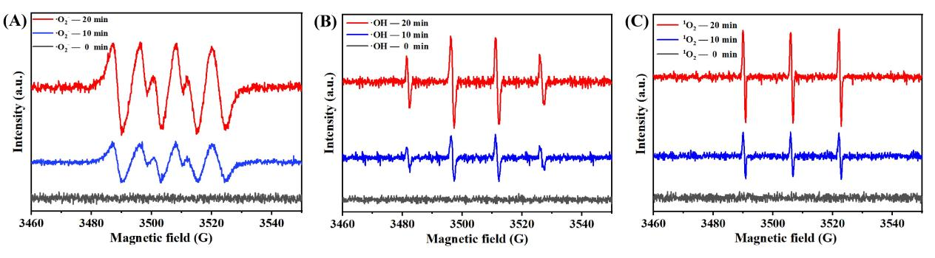

Figure S3 EPR spectrum of Fe-HHTP@HZIF-8@AuNCs

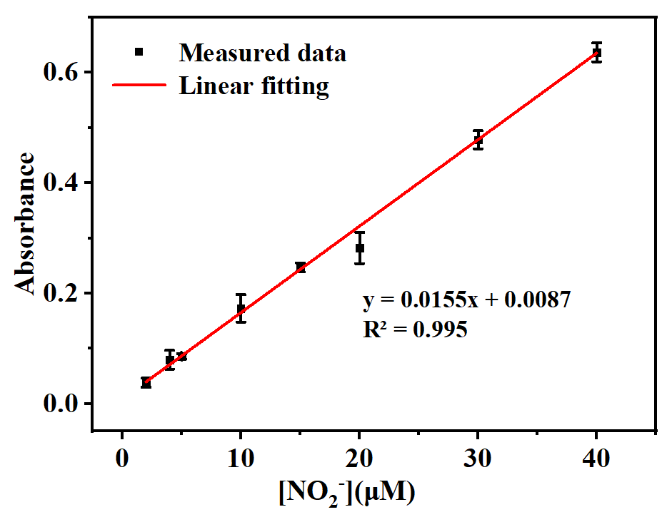
Figure S4 Linear relationship between UV absorbance (540 nm) and different nitrite concentration obtained by using commercial kit.

Table S1 Comparison of steady-state kinetic parameters for Fe-HHTP@HZIF-8@AuNCs and other reported oxidase-like nanomaterials.
Catalyst | K_{m}(mM) | V_{max}(10⁻⁶ M·s⁻¹) | Reference
Catalyst | TMB | TMB | Reference
Fe-HHTP@HZIF-8@AuNCs | 0.21 | 1.74  0.56  0.39  0.83  0.09  0.07 | This work
Pd/MMR  OV-Mn₃O₄ NFs  Ag₃PO₄  RuNPs  CeO₂ | 0.77  1.66  0.25  54.92  1.50 | 1.74  0.56  0.39  0.83  0.09  0.07 | [1]  [2]  [3]  [4]  [5]

[1] Wang G, Feng N, Zhao S, Song L, Zhang Y, Tong J, Liu Y, Kang X, Hu T, Khan IA, Lu K, Wu H, Xie J (2024) Synthesis and DFT calculation of microbe-supported Pd nanocomposites with oxidase-like activity for sensitive detection of nitrite. Food Chem 434: 137422. https://doi.org/10.1016/j.foodchem.2023.137422.
[2] Lu W, Chen J, Kong, L, Zhu F, Feng Z, & Zhan J (2021) Oxygen vacancies modulation Mn₃O₄ nanozyme with enhanced oxidase-mimicking performance for l-cysteine detection. Sensor Actuat B-chem 333: 129560. https://doi.org/10.1016/j.snb.2021.129560.
[3] Liu P, Li X, Xu X, Niu X, Wang M, Zhu H, Pan J (2021) Analyte-triggered oxidase-mimetic activity loss of Ag₃PO₄/UiO-66 enables colorimetric detection of malathion completely free from bioenzymes. Sensor Actuat B-chem 338: 129866. https://doi.org/10.1016/j.snb.2021.129866.
[4] Cao GJ, Jiang X, Zhang H, Croley TR, Yin JJ (2017) Mimicking horseradish peroxidase and oxidase using ruthenium nanomaterials. RSC Adv 7(82): 52210-52217. https://doi.org/10.1039/c7ra10370k.
[5] Liu B, Huang Z, Liu J (2016) Boosting the oxidase mimicking activity of nanoceria by fluoride capping: rivaling protein enzymes and ultrasensitive F- detection. Nanoscale 8(28): 13562-13567. https://doi.org/10.1039/c6nr02730j.

Table S2 Comparison of the proposed sensing system with other reported methods for nitrite detection
Type of biosensor | Dynamic range | LOD | Reference
Colorimetric biosensor | 0-700 μM | 0.12 μM | This work
Colorimetric biosensor | 8.3-16700 μM | 0.72 μM | [6]
Colorimetric biosensor | 0-233.3 μM | 0.20 μM | [7]
Colorimetric biosensor | 0.5-50 μM | 0.20 μM | [8]
Electrochemical biosensor | 0-2000 μM | 9.10 μM | [9]
Electrochemical biosensor | 5-5000 μM | 1.00 μM | [10]
Electrochemical biosensor | 100-500 μM | 0.56 μM | [11]
Fluorometric biosensor | 0-2000 μM | 1.00 μM | [12]
Fluorometric biosensor | 5-30 μM | 0.70 μM | [13]

[6] Tai YT, Cheng CY, Chen YS, Ko FH (2022) A hydrogel-based chemosensor applied in conjunction with a Griess assay for real-time colorimetric detection of nitrite in the environment. Sensor Actuat B-chem 369: 132298. https://doi.org/10.1016/j.snb.2022.132298.
[7] Wang M, Liu P, Zhu H, Liu B, Niu X (2021) Ratiometric colorimetric detection of nitrite realized by stringing nanozyme catalysis and diazotization together. Biosensors 11(8): 280. https://doi.org/10.3390/bios11080280.
[8] Mako TL, Levenson AM, Levine M (2020) Ultrasensitive detection of nitrite through implementation of N-(1-naphthyl) ethylenediamine-grafted cellulose into a paper-based device. ACS Sens 5(4): 1207-1215. https://doi.org/10.1021/acssensors.0c00291.
[9] Wang YC, Chen YC, Chuang WS, Li JH, Wang YS, Chuang CH, Chen CY, Kung CW (2020) Pore-confined silver nanoparticles in a porphyrinic metal-organic framework for electrochemical nitrite detection. ACS Appl Nano Mater 3(9): 9440-9448. https://doi.org/10.1021/acsanm.0c02052.
[10] Han Y, Zhang R, Dong C, Cheng F, Guo Y (2019) Sensitive electrochemical sensor for nitrite ions based on rose-like AuNPs/MoS₂/graphene composite. Biosens 142: 111529. https://doi.org/10.1016/j.bios.2019.111529.
[11] Gao B, Zhao X, Liang Z, Wu Z, Wang W, Han D, Niu L (2020) CdS/TiO₂ nanocomposite-based photoelectrochemical sensor for a sensitive determination of nitrite in principle of etching reaction. Anal Chem 93(2): 820-827. https://doi.org/10.1021/acs.analchem.0c03315.
[12] Zhang H, Kang S, Wang G, Zhang Y, Zhao H (2016) Fluorescence determination of nitrite in water using prawn-shell derived nitrogen-doped carbon nanodots as fluorophores. ACS Sens 1(7): 875-881. https://doi.org/10.1021/acssensors.6b00269.
[13] Deng HH, Huang KY, Zhang MJ, Zou ZY, Xu YY, Peng HP, Chen W, Hong GL (2020) Sensitive and selective nitrite assay based on fluorescent gold nanoclusters and Fe²⁺/Fe³⁺ redox reaction. Food Chem 317: 126456. https://doi.org/10.1016/j.foodchem.2020.126456.

