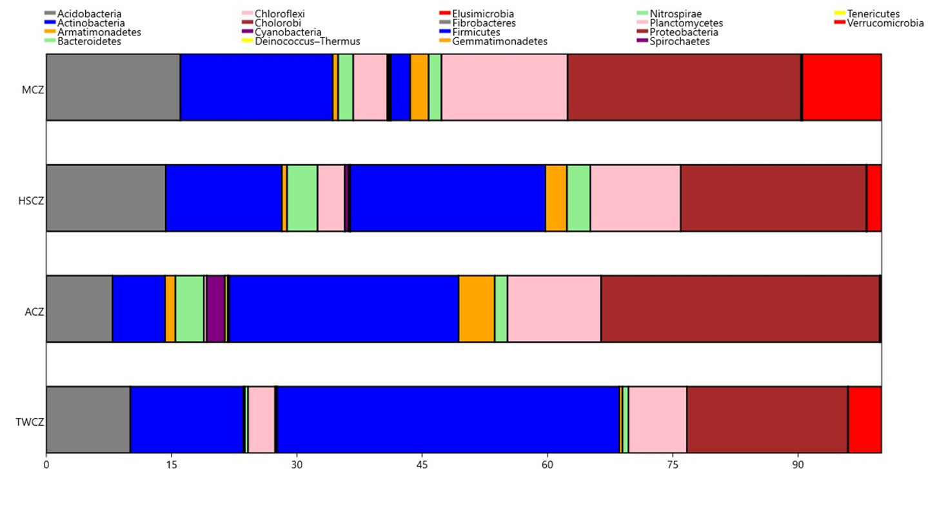
Additional file 5. Abundance pattern of known bacterial phyla obtained from the four contrasting climatic zones. TWCZ (tropical wet climatic zone); ACZ (Arid climatic zone); HSCZ (humid subtropical climatic zone); MCZ (Mountain climatic zone).

