Supplementary figures and legends
The following are the Supplementary figures and legends to this article:
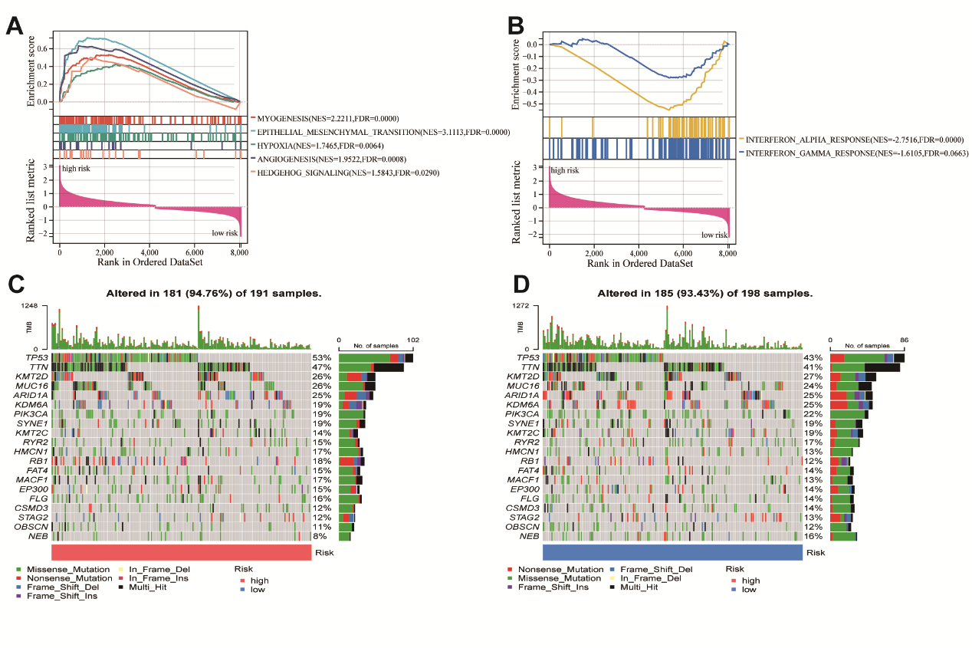
Supplement Figure. 1. Gene set enrichment analysis and mutational landscapes between high and low-risk groups.
(A) GSEA revealing enriched gene sets in the high-risk group (nominal p < 0.05). (B) GSEA revealing enriched gene sets in the low-risk group (nominal p < 0.05). (C-D) Genomic profiling of the top 20 most frequently altered genes in the high-risk group (C) and low-risk group (D).
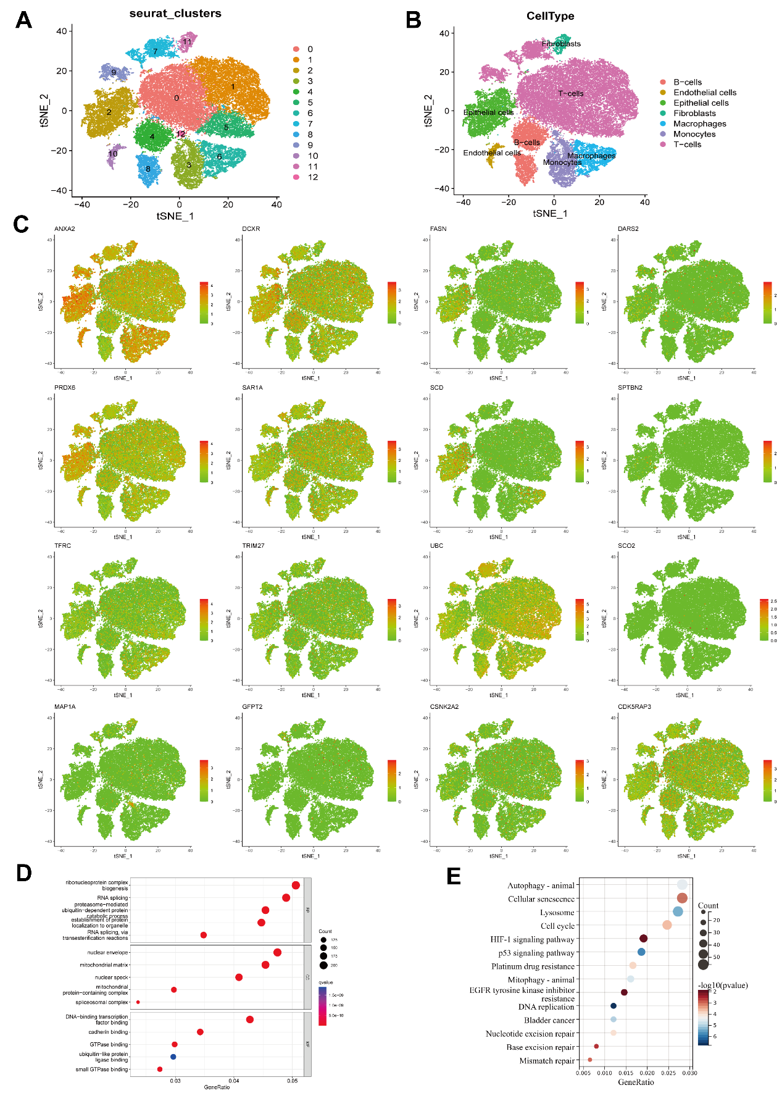
Supplement Figure. 2. Expression and functions of MRGs model.
(A-B) Visualization of all cell clusters using t-SNE plots. The Seurat algorithm was used to annotate the different clusters. (C) Proportional projection of model gene expression in various cell clusters. (D-E) GO and KEGG pathway analysis of model genes in bladder cancer.

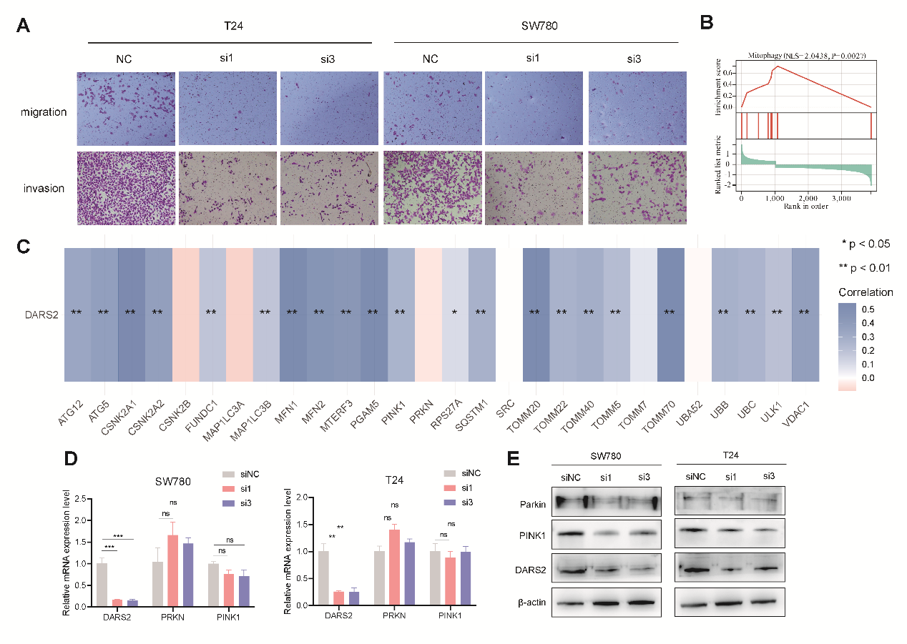
Supplementary Figure. 3. DARS2 is related to mitophagy.
(A) Transwell assay showing the migration as well as invasion abilities of BCa cells after DARS2 knockdown. (B) GSEA enrichment analysis of DARS2-related genes in the GSE13507 dataset. (C) Correlation analysis between DARS2 and mitophagy-related genes. (D-E) Analysis of PINK1 and PRKN mRNA (D) and protein levels (E) following DARS2 knockdown.
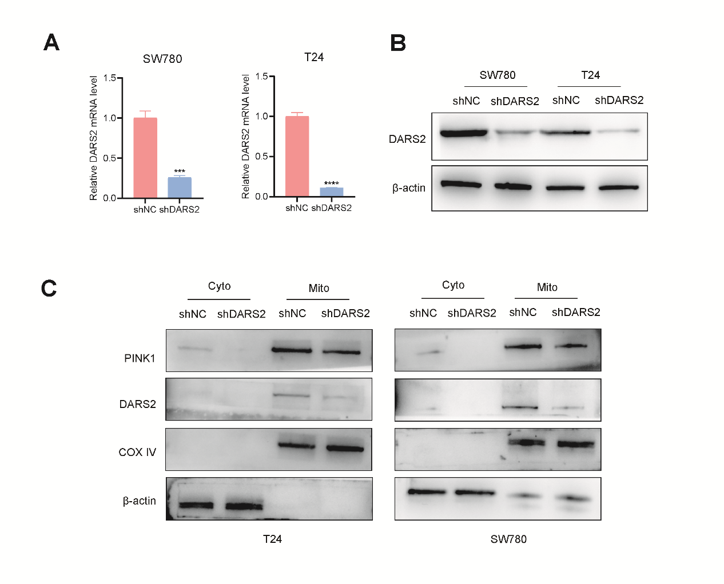
Supplementary Figure. 4. DARS2 promotes PINK1 mitochondrial synthesis.
(A-B) qRT-PCR (A) and Western blot (B) confirming stable DARS2 knockdown efficiency. (C) Western blot analysis of PINK1 protein levels in mitochondrial and cytoplasmic fractions following DARS2 knockdown. β-actin was used as the loading control for cytoplasmic proteins, and COX IV as the control for mitochondrial proteins.
v

