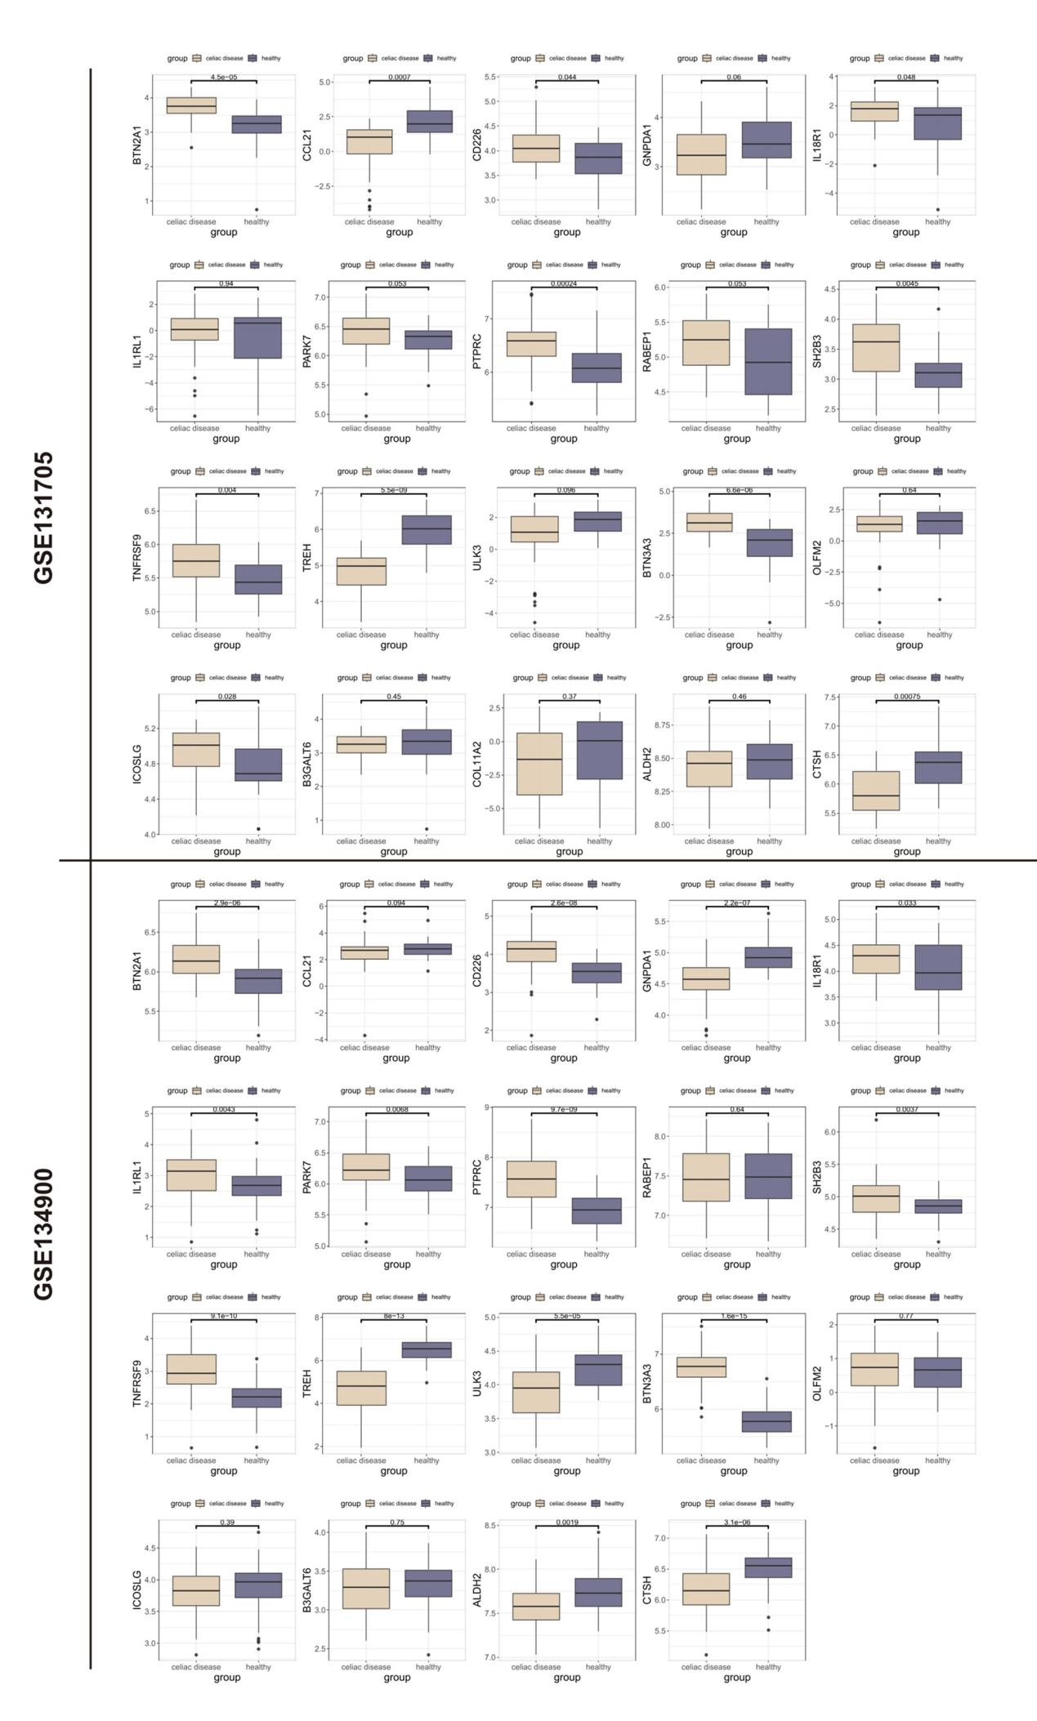
Figure S1 The differential expression analysis of 22 candidate target coding genes in both RNAseq cohorts including CeD samples and healthy samples.

