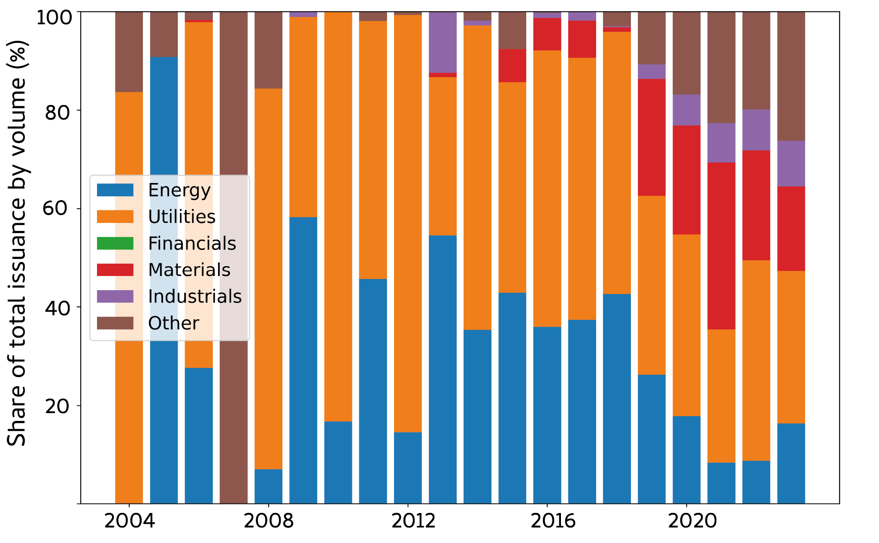
Supplementary Figure 1. Corporate bonds and loans labeled green, social, sustainable or sustainability-linked disaggregated by industry. Stacked bar charts show the share of bond and loan volumes issued annually by industry. Data source: Bloomberg.

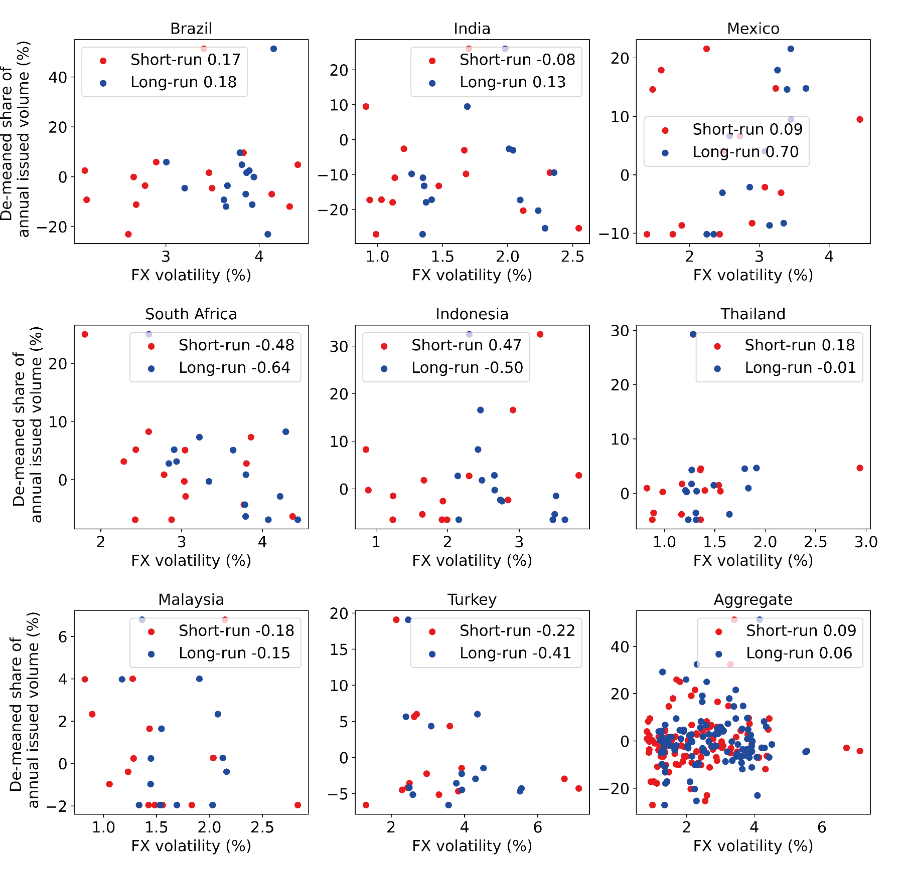
Supplementary Figure 2. Regression analysis of foreign exchange volatility and annual issued volumes. Scatter plots show average yearly FX volatility (short-run and long-run) against de-meaned yearly share of annual issued volumes by country and on aggregate. Legends show Pearson’s correlation coefficient for short-run and long-run FX volatility.

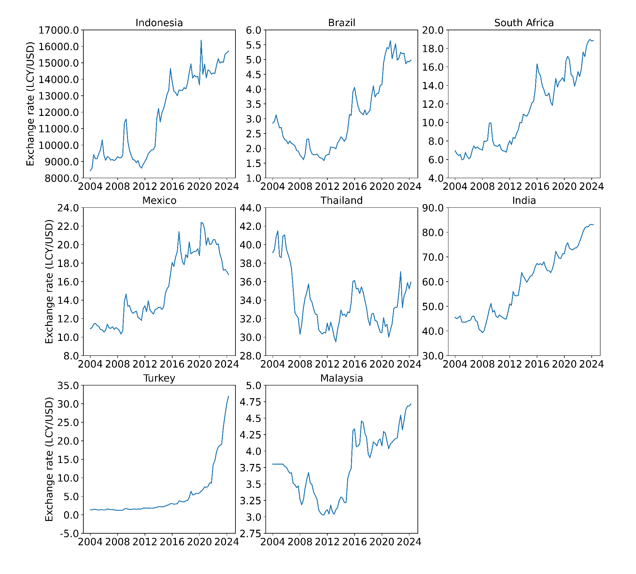
Supplementary Figure 3. Quarterly spot exchange rates. Data source: the St Louis Federal Reserve Bank’s economic database.

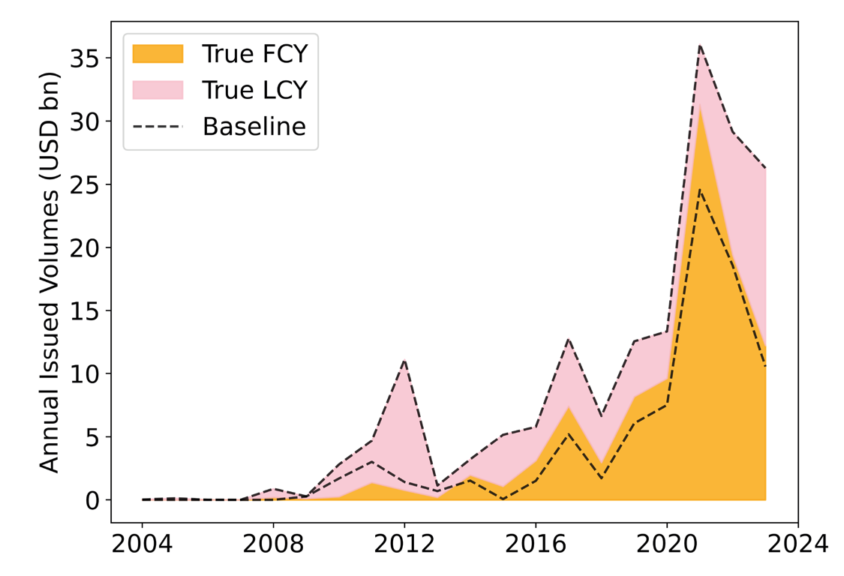

Supplementary Figure 4. Comparison of foreign and local currency debt issuance forecast by the baseline model compared to the empirical data. Stacked line graph shows true local currency (LCY) and foreign currency (FCY) debt issuance in pink and orange respectively. Forecast of baseline model is shown by dashed lines.

 | Mean | SD | Median | Min | Max
FCY | 0.29 | 0.45 | 0 | 0 | 1
FX_RISK_SHORT | 0.02184973 | 0.01162583 | 0.01723979 | 0.00389522 | 0.07151711
FX_RISK_LONG | 0.02554301 | 0.01006602 | 0.02514522 | 0.00575053 | 0.0421431
SOV_RISK_FC | 11.2176259 | 1.47384473 | 11 | 9 | 14
POL_RISK | -0.6354737 | 0.28890513 | -0.6883609 | -1.4427884 | 0.16366422
VIX | 18.7879676 | 6.46364035 | 17.26 | 9.89 | 35.54
GDP_GROWTH | 3.2192446 | 3.79180842 | 3 | -8.6 | 9.7
AMOUNT | 0.16063507 | 0.24778173 | 0.065 | 0.0001 | 2
TENOR | 10.7972874 | 6.29232093 | 10 | 1 | 40
Observations | 1112 | 1112 | 1112 | 1112 | 1112
Supplementary Table 1. Descriptive statistics for key variables in baseline model. The dependent variable FCY takes the value 1 if a bond or loan is issued in foreign currency and 0 if the bond/loan is issued in local currency. FX_RISK is a backward-looking measure of short-run (1-year) foreign exchange (FX) volatility (see methods); SOV_RISK is Moody’s foreign currency sovereign credit rating; POL_RISK is a political risk proxy from the World Bank Governance Indicators; VIX proxies market uncertainty and is a volatility index of the S&P 500; AMOUNT is the size of the bond/loan; DOMESTIC is a dummy variable equal to 1 if the firm is domiciled in the country that the bond/loan was issued; GDP_GROWTH is a proxy for macroeconomic strength and is the annual percentage change in GDP from the World Bank; TENOR is the maturity of the bond/loan. Standard deviation (SD).

 | Reg 1 | Reg 2
FX_RISK | 74.69***(11.26) | 102.28***(10.55)
SOV_RISK | 0.38***(0.07)
POL_RISK | -0.03 (0.38) | 0.01 (0.36)
VIX | 0.04**(0.01) | 0.05***(0.01)
AMOUNT | 0.68***(0.07) | 0.66***(0.07)
DOMESTIC | -5.62***(0.66) | -4.00***(0.42)
BOND | -2.07***(0.24) | -1.77***(0.22)
GDP_GROWTH | 0.03 (0.03) | 0.05 (0.03)
TENOR | -0.09***(0.02) | -0.05***(0.01)
Observations | 1534 | 1534
R² | 0.51 | 0.49
Accuracy | 89.3 | 87.8
Supplementary Table 2. Alternative model specification including Malaysia and Turkey. Maximum likelihood estimation results are shown with standard errors in brackets. FX_RISK is a backward-looking measure of short-run (1-year) foreign exchange (FX) volatility (see methods); SOV_RISK is Moody’s foreign currency sovereign credit rating; POL_RISK is a political risk proxy from the World Bank Governance Indicators; VIX proxies market uncertainty and is a volatility index of the S&P 500; AMOUNT is the size of the bond/loan; DOMESTIC is a dummy variable equal to 1 if the firm is domiciled in the country that the bond/loan was issued; GDP_GROWTH is a proxy for macroeconomic strength and is the annual percentage change in GDP from the World Bank; TENOR is the maturity of the bond/loan; McFadden’s pseudo-R² and accuracy scores indicate model goodness-of-fit (see methods).***Significant at p < 0.005; **significant at p < 0.01; *significant at p < 0.05.

 | Reg 1 | Reg 2 | Reg 3 | Reg 4
FX_RISK | 110.86***(10.37)
SOV_RISK |  | 0.59***(0.06)
POL_RISK |  |  | -1.34***(0.35)
VIX |  |  |  | 0.09***(0.01)
Controls
Amount | 0.67***(0.07) | 0.64***(0.07) | 0.53***(0.06) | 0.53***(0.06)
Domestic | -3.36***(0.38) | -4.57***(0.52) | -1.71***(0.28) | -2.46***(0.31)
Bond | -1.46***(0.22) | -1.84***(0.24) | -0.59***(0.17) | -1.08***(0.20)
GDP Growth | 0.04 (0.03) | -0.01 (0.02) | 0.01 (0.02) | 0.04 (0.02)
Tenor | -0.05***(0.02) | -0.10***(0.02) | -0.00 (0.01) | -0.02 (0.01)
Observations | 1112 | 1112 | 1112 | 1112
R² | 0.38 | 0.37 | 0.26 | 0.31
Log-likelihood Ratio | 511.51 | 491.93 | 353.04 | 410.8
Accuracy | 84.2 | 86.9 | 80.1 | 81.5
Supplementary Table 3. Alternative model specifications assessing the significance of key variables. Maximum likelihood estimation results are shown with standard errors in brackets. The four alternative models include the control variables and country fixed effects plus one of the four key variables (FX_RISK, SOV_RISK, POL_RISK, VIX). The log-likelihood ratio expresses the ratio between a model specification including each key variable against a regression including only control variables and country fixed effects. FX_RISK is a backward-looking measure of short-run (1-year) foreign exchange (FX) volatility (see methods); SOV_RISK is Moody’s foreign currency sovereign credit rating; POL_RISK is a political risk proxy from the World Bank Governance Indicators; VIX proxies market uncertainty and is a volatility index of the S&P 500; AMOUNT is the size of the bond/loan; DOMESTIC is a dummy variable equal to 1 if the firm is domiciled in the country that the bond/loan was issued; GDP_GROWTH is a proxy for macroeconomic strength and is the annual percentage change in GDP from the World Bank; TENOR is the maturity of the bond/loan; McFadden’s pseudo-R² and accuracy scores indicate model goodness-of-fit (see methods). *Significant at p < 0.01.***Significant at p < 0.005; **significant at p < 0.01.

 | Regression 1 | Regression 2 | Regression 3 | Regression 4
FX_RISK_SHORT | 78.69***(12.54) | 77.40***(12.08)
FX_RISK_LONG |  |  | 20.70 (22.44) | 34.29 (21.77)
SOV_RISK | 0.33***(0.08) | 0.32***(0.08) | 0.48***(0.08) | 0.45***(0.08)
POL_RISK | 0.14 (0.41) | -0.03 (0.41) | -0.28 (0.44) | -0.35 (0.44)
VIX | 0.04***(0.01) |  | 0.04***(0.01)
WUI |  | 0.04 (0.02) |  | 0.03 (0.02)
AMOUNT | 0.69***(0.07) | 0.69***(0.07) | 0.64***(0.07) | 0.64***(0.07)
DOMESTIC | -5.47***(0.69) | -5.30***(0.67) | -5.13***(0.63) | -5.14***(0.63)
BOND | -1.93***(0.25) | -1.99***(0.26) | -1.97***(0.25) | -2.05***(0.26)
GDP_GROWTH | 0.03 (0.03) | 0.03 (0.03) | -0.00 (0.03) | -0.01 (0.03)
TENOR | -0.09***(0.02) | -0.09***(0.02) | -0.10***(0.02) | -0.10***(0.02)
Observations | 1112 | 1112 | 1112 | 1112
R² | 0.41 | 0.41 | 0.38 | 0.37
Accuracy | 84.7 | 85.6 | 86.1 | 86.6
Supplementary Table 4. Alternative model specifications assessing variable alternatives. Maximum likelihood estimation results are shown with standard errors in brackets. The baseline model (Regression 1) is compared to regression substituting short-run FX volatility (FX_RISK_SHORT) with long-run FX volatility (FX_RISK_LONG) and substituting VIX (S&P 500 volatility index) with the WUI (World Uncertainty Index). SOV_RISK is Moody’s foreign currency sovereign credit rating; POL_RISK is a political risk proxy from the World Bank Governance Indicators; VIX proxies market uncertainty and is a volatility index of the S&P 500; AMOUNT is the size of the bond/loan; DOMESTIC is a dummy variable equal to 1 if the firm is domiciled in the country that the bond/loan was issued; GDP_GROWTH is a proxy for macroeconomic strength and is the annual percentage change in GDP from the World Bank; TENOR is the maturity of the bond/loan; McFadden’s pseudo-R² and accuracy scores indicate model goodness-of-fit (see methods). *Significant at p < 0.01.***Significant at p < 0.005; **significant at p < 0.01.***Significant at p < 0.005; **significant at p < 0.01.

 | Reg 1 | Reg 2
FX_RISK | 76.50***(12.72) | 75.75***(13.09)
SOV_RISK | 0.40***(0.11) | 0.41***(0.11)
POL_RISK | 0.17 (0.41) | -0.00 (0.42)
VIX | 0.05***(0.01) | 0.05***(0.01)
TENOR | -0.09***(0.02)
AMOUNT | 0.69***(0.07) | 0.66***(0.08)
DOMESTIC | -5.30***(0.69) | -5.16***(0.68)
BOND | -1.87***(0.26) | -1.91***(0.26)
GDP_GROWTH | 0.04 (0.03) | 0.04 (0.03)
Observations | 1112 | 1112
R² | 0.42 | 0.43
Accuracy | 85.3 | 85.3
Supplementary Table 5. Alternative model specifications assessing tenor fixed effects. Maximum likelihood estimation results are shown with standard errors in brackets. The baseline model with country fixed effects (Regression 1) is compared to results including fixed effects for country and tenor (Regression 2). FX_RISK is a backward-looking measure of short-run (1-year) foreign exchange (FX) volatility (see methods); SOV_RISK is Moody’s foreign currency sovereign credit rating; POL_RISK is a political risk proxy from the World Bank Governance Indicators; VIX proxies market uncertainty and is a volatility index of the S&P 500; AMOUNT is the size of the bond/loan; DOMESTIC is a dummy variable equal to 1 if the firm is domiciled in the country that the bond/loan was issued; GDP_GROWTH is a proxy for macroeconomic strength and is the annual percentage change in GDP from the World Bank; TENOR is the maturity of the bond/loan; McFadden’s pseudo-R² and accuracy scores indicate model goodness-of-fit (see methods). ***Significant at p < 0.005; **significant at p < 0.01; *significant at p < 0.05.

