Supplementary data:

Presence and strength of binding of IgM, IgG and IgA antibodies against SARS-CoV-2 during CoViD-19 infection

Richard B.M. Schasfoort^{1,2}, Jos van Weperen³, Margot van Amsterdam², Judicaël Parisot⁴ Jan Hendriks⁵, Michelle Koerselman⁵, Marcel Karperien⁵, Anouk Mentink¹, Martin Bennink⁶, Hans Krabbe^{7,8}, Leon WMM Terstappen¹, A.H. Leontine Mulder^{7,9}.

As indicated in the manuscript a combined measurement of the anti-RBD IgM, IgG and IgA specific levels of CoViD-19 patients is possible in a single experiment using Surface Plasmon Resonance imaging (SPRi). In contrast, an ELISA immune assay need three separate tests for obtaining the values of CoViD-19 patients and strength of binding nor affinity can be tested easily. The strength of binding of the anti-SARS-CoV-2 antibodies can be extracted from the SPRi data, while the levels of the antibodies are measured in high throughput for ultimate 384 patients simultaneously. In this supplementary part, additional figures will clarify this new method.

Figures to support the main article.
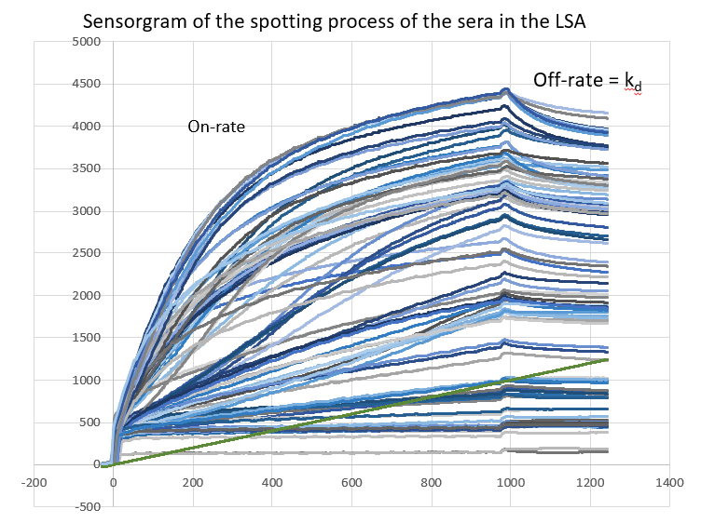

Supplementary figure 1. Raw non-referenced sensorgrams of the binding process of the CoViD-19 sera to the RBD coupled sensor surface using the LSA SPR imager. Because of mixed compositions of IgM, IgG and IgA and unknown concentrations the association rate is does not give a reliable value. For the off-rate determination it is necessary to obtain the value of the SPR response in RU during the association phase (on-rate) and this is measured in the LSA (and not in the MX96).

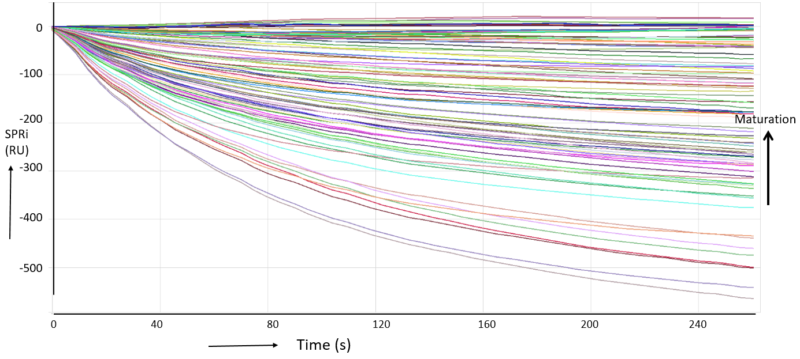

Supplementary figure 2 The slopes are shown of immunoglobulins dissociating from the RBD coupled sensor surface by injecting free RBD protein to prevent rebinding (see Figure 5). In this graph, the end of the association phase is zeroed and aligned for calculating the slopes. As explained in the previous supplementary figure 1, the off-rate determination needs for each curve the response level RU. The apparent off rate constant can be calculated accurately by the slope (RU/s) divided by the response (RU). In this way the kd (s-1) value for each curve can be calculated for all spotted sera. During the maturation of the immune response the dissociation rate will decrease and the patients will generate better quality antibodies (see arrow on the right).

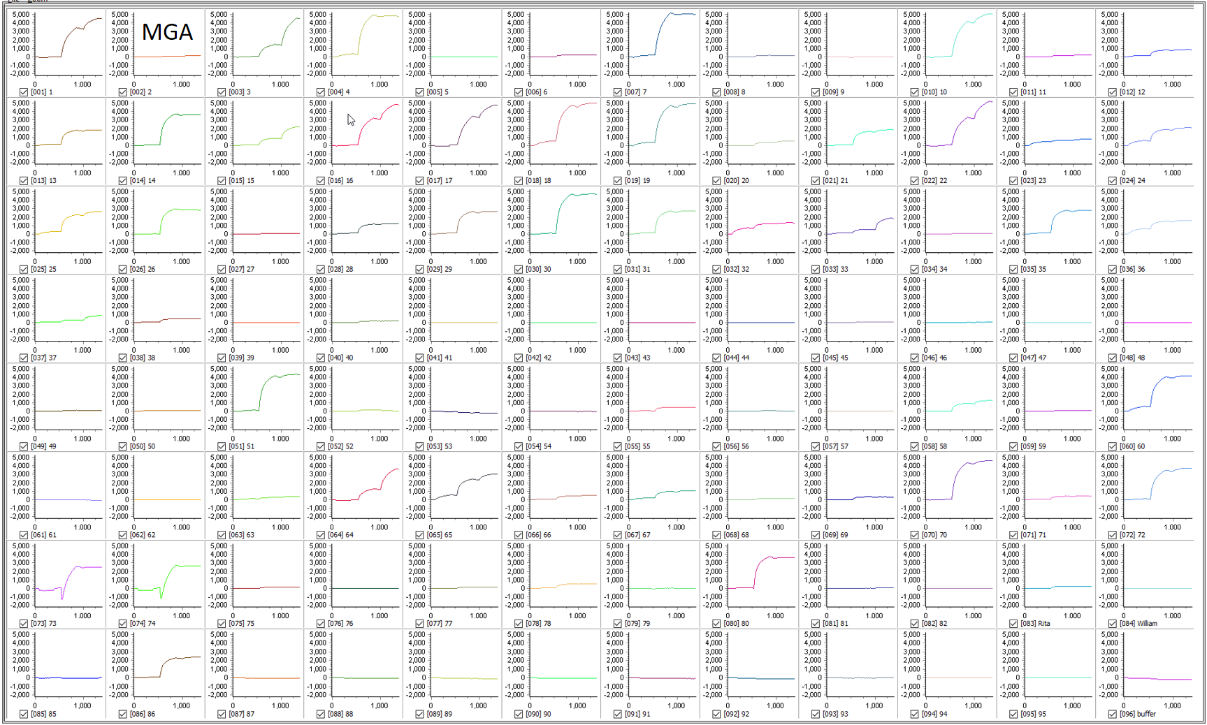

Supplementary figure 3. Tile view of interactions of anti-IgM, anti-IgG and anti-IgA sequence of injections on 96 serum spots. All spots are exposed to the same composition of analyte but will respond differently because of patient dependent variation in presence of IgM IgG and IgA antibodies.
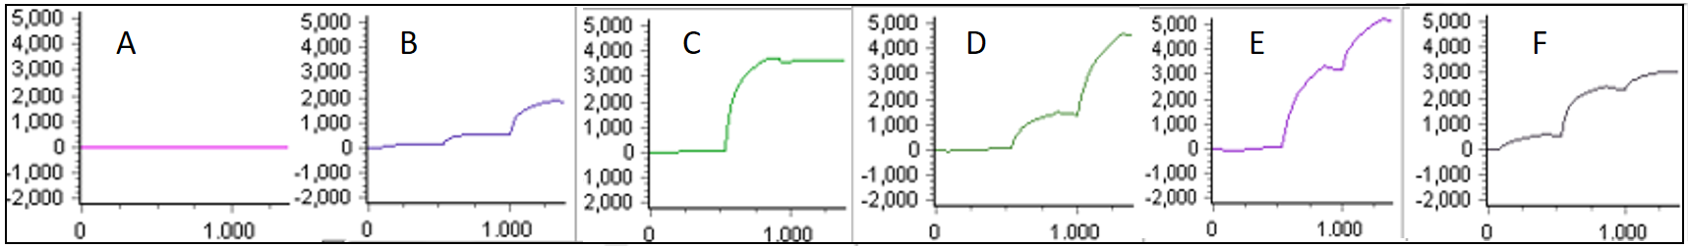

Supplementary figure 4. Six typical SPRi sensorgrams of anti-SARS-CoV-2 IgG, IgA and IgM in serum of CoViD-19 patients. Panel A: patient without detectable immune globulins. B: patient with mild symptoms. C: patient with only an IgG response. D: patient with undetectable IgM a moderate IgG and a high IgA. Panel E and F show various levels of IgM, IgG and IgA. In figure 1 of the manuscript three typical explanatory examples are illustrated.

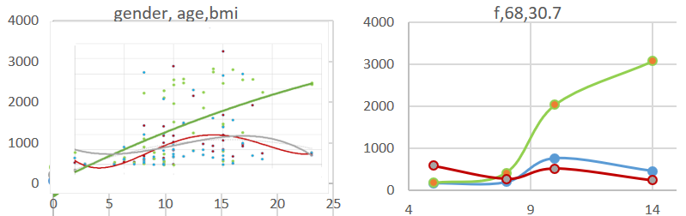

Supplementary figure 5. The levels of IgM (magenta), IgG (green) and IgA (blue) as a function of days of symptoms onset for the patients. A wide variety of levels of the antibodies was measured. In the right panel a typical course of the disease is shown for a woman of age 68 with a BMI of 30.7.

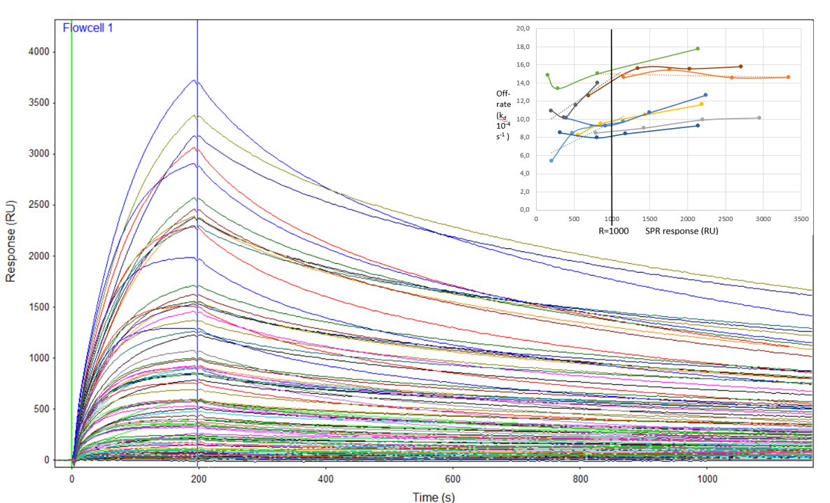
Supplementary figure 6. Sensorgram of a Fab anti human IgG injection and the response of all 96 spots. In the dissociation phase of the sensorgram one can observe differences due to stronger or weaker binding of the anti-RBD antibodies to the spots. The off-rate is however also dependent on the ligand density. Therefore, we decided that the anti-RBD antibodies from the same patient should be spotted in 4 densities. Panel insert: The off-rate as a function of the Fab response. The value of the off-rate was determined at R=1000 RU by interpolating the values obtained in the ligand density gradient.

Sensor surface preparation
Initially a selection was made for which protein of SARS-CoV-2 the SPR imaging test should be set up. Among the various immunogenic proteins, we observed a better specific response on RBD with respect to S1 or S1+S2 or nucleocapsid proteins of SARS-CoV-2. The molecular weight of RBD with 192 amino acids [16] is smaller than the S domains and immobilization resulted in a higher functional ligand density. Based on these first results we decided to choose for the recombinant RBD-Spike protein and not to optimize the system for the various antigens. As confirmed in the literature, the RBD-Spike protein generates more potent antibodies for neutralizing the infection than the other immunogenic proteins of the virus [17,18]. In ELISA a discrimination between the isotypes is not possible in a single test, while in SPRi, the binding of anti-IgM (M), anti-IgG (G) and anti-IgA (A) can be followed in real-time after the injection of the specific antisera. For the sequence of the isotypes M, G and A, six permutations do exist: MGA, MAG, GMA, GAM, AMG and AGM. One can expect that there will be steric hindrance, which will influence the R_{max} value. Because the M showed the highest variation, we decided that M should be injected first. Because G is relevant for humoral immunity and is always tested in competing immunoassays G will be in the second injection so A was the third. All additional tests were carried out with the MGA sequence. Additionally the MGA sequence resulted in the lowest non-specific binding and/or false-positives.
During the process of developing the method, the blocking buffer is crucial for reducing non-specific binding. False-positives are due to a non-optimized blocking buffer. Although we definitely think that the blocking buffer can be improved, we choose for PBS-Tween 20 - 0.1%, BSA - 0.5% and casein - 0.5% in both the spotter and SPRimager.
The surface chemistry in terms of hydrogel quality was studied. Among various surface chemistries the HC30M surface turned out to be the best in terms of signal quality, signal homogeneity and signal reproducibility. This surface with a 30 nm open hydrogel was applied in both SPR-imagers.

Supplementary explanation regarding the strength of binding measurement of anti-SARS-CoV-2 Spike RBD IgG, IgA and IgM.
During the development of the method, we tried first an indirect route to reveal the strength of binding as shown in supplementary figure 5. Because the association rate could not be followed in the MX96 SPR imager during the spotting process, the off-rate can be accurately measured when the SPR response is known. The Fab anti human IgG injection (instead of the dimer anti-human IgG) is needed to determine the human IgG density on the spot and the Fab will not cross-link the human IgGs on the spot. The disadvantage of this indirect approach is that we cannot determine the fraction of the IgM and IgA off-rate. As supplementary figure 5 shows, we observed various off-rates of the anti-RBD antibodies but do not know the overall off-rate or strength of binding.
As explained in the paper of Schasfoort et al. [19], the off-rate is a function of the ligand density due to rebinding of the protein to the spots. When spots possess exactly the same ligand density then a comparison can be made for the apparent affinity equilibrium constant (K_{D}) and/or the off-rate (k_{d}) [20] . The four dilutions are needed to measure the off-rate by interpolating to R=1000 RU. In this way, the interpolated spot density at 1000 RU can be compared to each other for the sera and its serial dilutions. The absolute value of the off-rate depends on the quality of the Fab but it will be a constant for all spots if the antibodies will not dissociate from the surface. The quantitative value for all spots depends on the off-rates of the polyclonal human anti-RBD IgG and the samples can be compared/ranked to each other. This was the initial set-up to measure differences in off-rate.
Fortunately, in the LSA SPR imager, we can measure the binding of anti-RBD antibodies of all isotypes together of the patient sera in real time (see supplementary figure 1), so a Fab injection that shows an indirect off-rate is not necessary. This facilitates the assay enormously because a separate indirect test is not necessary. After the binding of the sera, we injected free RBD to prevent rebinding to the sensor and we could follow the dissociation process of the total anti-RBD antibodies much more accurate not only as a mixed total antibody dissociation. So, the value we calculate, is a measure of the strength of the complex bound to RBD. As can be observed in supplementary figure 2, the anti-RBD molecules will dissociate from the spots and definitely, this will affect the initial values of IgM, IgG and IgA. Now the remaining immunoglobulins are measured. We found that the difference between initial and remaining immunoglobulins was within the general error of the assay. Ultimately, the procedure was used to calculate the apparent off-rate (k_{d}) of the anti-RBD antibodies accurately as is given in the main figure 5.
In a single automated experiment, the strength of binding can be measured plus the concentration of IgM, IgG and IgA in the serum of CoViD-19 patients and this can be considered as the first break-through of the high-throughput method. The second break-through is that we observed that during the course of the disease the strength of binding of the anti RBD antibodies of CoViD-19 patients increases independently from the isotype ratios which changed too. Hence, a well-known maturation effect of the affinity of antibodies can be ranked and quantified precisely. It is clear that the new method enables to follow the strength of binding and concentration of anti-RBD antibodies not only of CoViD-19 patients but also of healthy people who will be vaccinated to SARS-CoV-2 in clinical trials that are foreseen for the autumn of 2020.

References
- Zhu X, Liu Q, Du L, Lu L, Jiang S. Receptor-binding domain as a target for developing SARS vaccines. J Thorac Dis. 2013; 5 Suppl 2(Suppl 2):S142-S148. doi:10.3978/j.issn.2072-1439.2013.06.06
- Meyer B, Drosten C, Muller MA. Serological assays for emerging coronaviruses: challenges and pitfalls. Virus research. 2014 194:175-83
- Lan J. et al. Structure of the SARS-CoV-2 spike receptor-binding domain bound to the ACE2 receptor. Nature 581, 215–220 (2020). https://doi.org/10.1038/s41586-020-2180-5
- Schasfoort et al. Method for estimating the single molecular affinity, Anal. Biochem. 421 (2012) 794-796.
- Schasfoort R.B.M. et al. Interpolation method for accurate affinity ranking of arrayed ligand–analyte interactions Analytical Biochemistry 500, Pages 21-23

