TOC Figures:

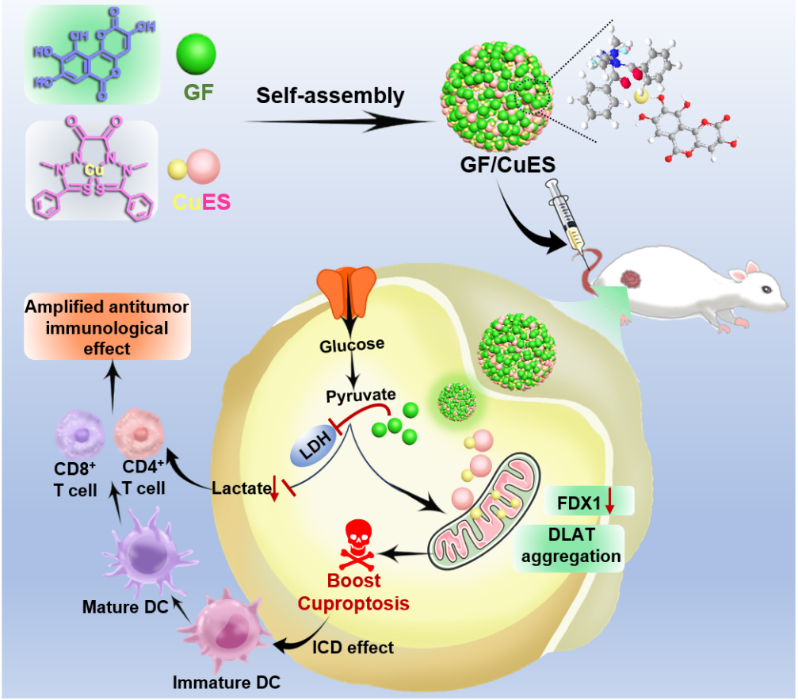
The lactate dehydrogenase inhibitor galloflavin self-assembles with the copper ionophore elesclomol, synergistically targeting mitochondria and anaerobic glycolysis to boost cuproptosis-immunotherapy.

