Supporting Information for
Mitochondria- and Anaerobic Glycolysis- Targeted Self-Assembled Copper Complex Nanoparticles for Boosting Cuproptosis-Immunotherapy

Hanyu Zhang, ^{1, #} Jing Xia, ^{2, #} Lingling Xie,³ Meng Hao,^{4,}* Sizhang Wang, ^{2, 5} Xiao Dong,⁶ Yongxin Li, ^{1,}* Qiang Mu ^{2,} *

¹ State Key Laboratory of Bio-fibers and Eco-textiles, Institute of Biochemical Engineering, College of Materials Science and Engineering, Qingdao University, Qingdao 266071, China.
² The First Department of Breast Surgery, Qingdao Central Hospital, University of Health and Rehabilitation Sciences, Qingdao, 266042 China.
³ Brain Science Center Ward, Qingdao Eighth People's Hospital, Qingdao, 266041, China,
⁴ Spine Surgery Department, Qingdao Municipal Hospital, Qingdao 266000, China
⁵ Medical College of Qingdao University, Qingdao University, Qingdao 266071, China.
⁶ Department of Oncology, Shanghai General Hospital, Shanghai 201620, China
# These two authors contributed equally.
*Corresponding author, E-mail:
hm1984@163.com (M. Hao), liyx@qdu.edu.cn (Y. Li), muqiang@qdu.edu.cn (Q. Mu).

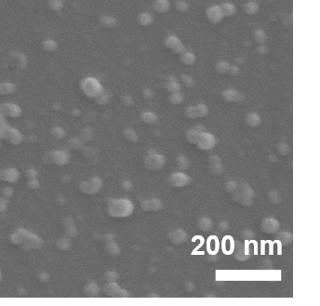

Fig. S1 The SEM image of GF/CuES.

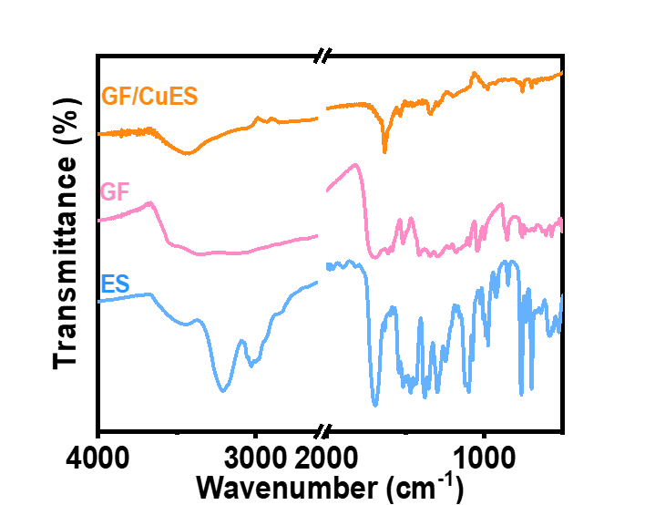

Fig. S2 The FTIR spectra of GF/CuES, GF and ES.

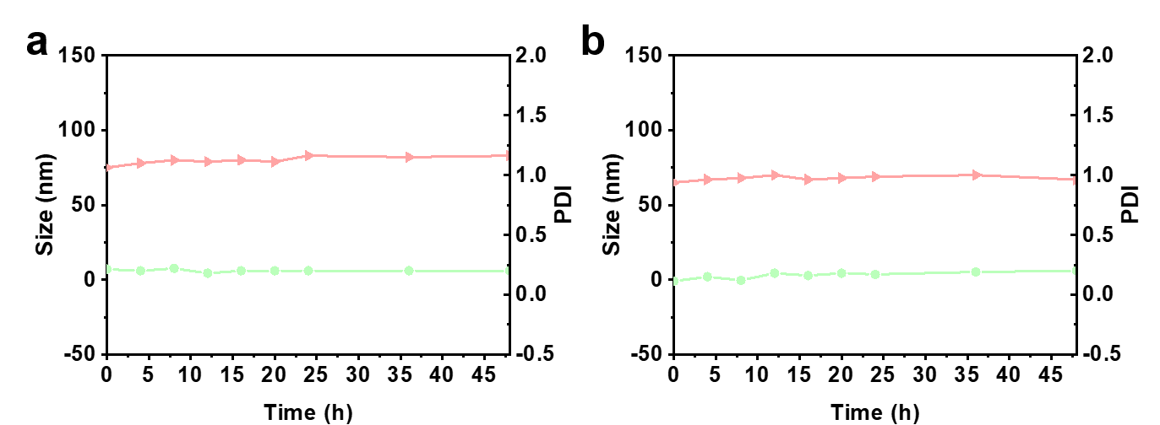
Fig. S3 Change in hydrodynamic diameter () and PDI () of GF/CuES (a) in DMEM with 10% FBS and (b) in PBS over a period of 48 h.

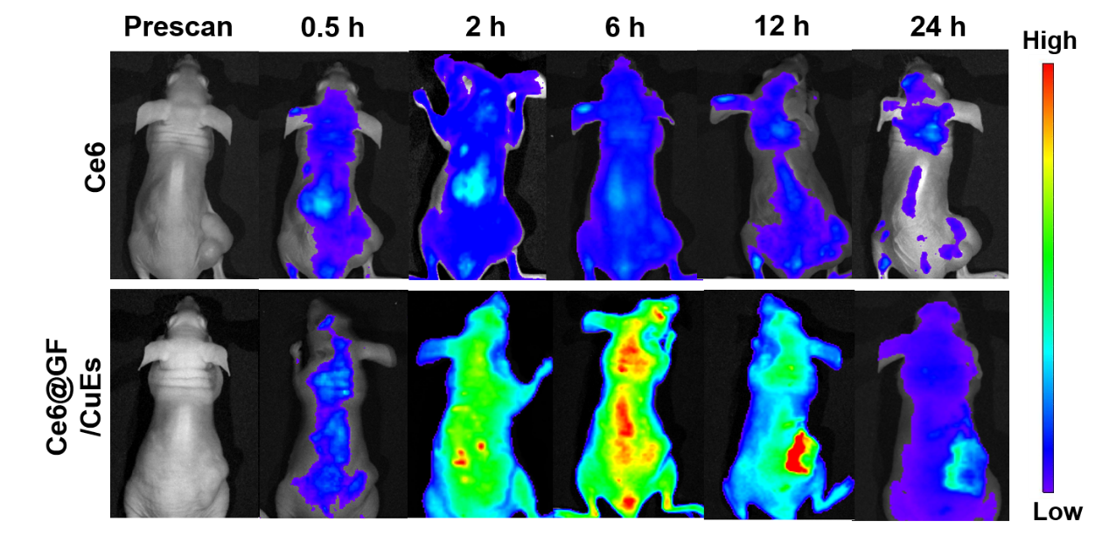
Fig. S4 Real-time fluorescence images captured in MCF-7 tumor-bearing mice following intravenous injection of Ce6 labeled GF/CuES and free Ce6.

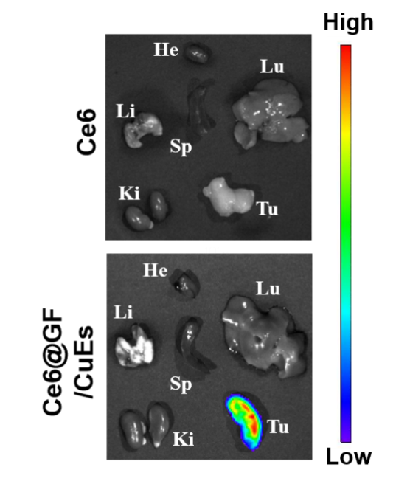
Fig. S5 Ex vivo fluorescence images of major organs and tumors at 24 h post-injection.

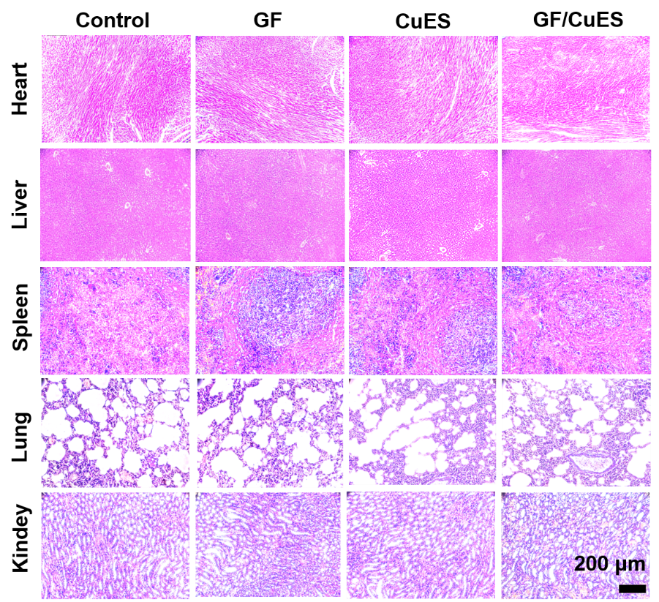
Fig. S6 H&E staining of major organs from various groups after 14-days therapy.

