Ultrathin Ni-fumarate MOFs decorated with PVP-Au NPs for simultaneous dopamine and paracetamol sensor and DFT investigations
Feng Zhou¹, Limei Gai^{2*}, Hua Liu¹, Danfeng Qin³, Tushagu Abudouwufu⁴, Yi Liu^{5*}
¹School of Engineering, Guangzhou College of Technology and Business, Guangzhou 510880, Guangdong, P.R. China
²National-Local Joint Engineering Laboratory of Harbour Oil & Gas Storage and Transportation Technology/Zhejiang Key Laboratory of Petrochemical Environmental Pollution Control, School of Petrochemical Engineering & Environment, Zhejiang Ocean University, Zhoushan 316022, P.R. China
³School of Medicine Guangxi University of Science and Technology, Liuzhou 545006, Guangxi, P.R. China
⁴School of Pharmacy and Food Science, Zhuhai College of Science and Technology, No. 8 Anji East Road, Jinwan District, Zhuhai 519041, P.R. China
⁵State Key Laboratory of Functional Materials and Devices for Special Environments Conditions, Xinjiang Technical Institute of Physics & Chemistry of CAS, 40-1 South Beijing Road, Urumqi, 830011, China
*Email address: liu_yi@ms.xjb.ac.cn, gailimei@zjou.edu.cn

Table S1- Parameters of the porous structures determined from the N adsorption values.
Samples | Ni-MOF (Ni(CH₃CO₂)₂) | Au@Ni-MOF (Ni(CH₃CO₂)₂)
S_{BET} (m²g⁻¹) | 12.7379 | 10.0816
V_{BJH} (cm³g⁻¹) | 0.0301 | 0.0188
Pore size | 9.4555 | 7.4406

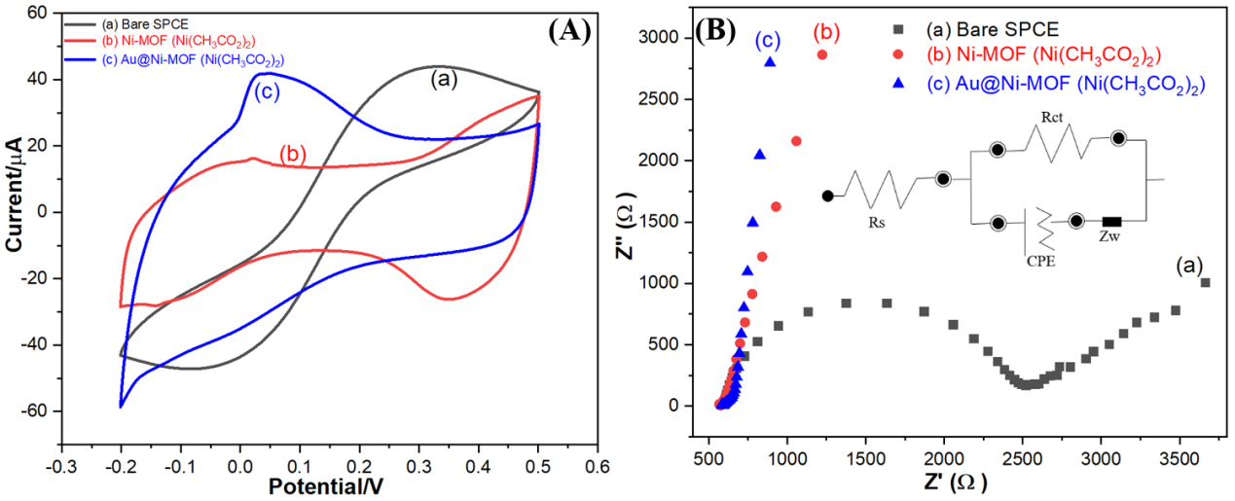 Fig. S1 (A) CVs obtained for (a) bare SPCE, (b) Ni-MOF (Ni(CH₃CO₂)₂)/SPCE, and (c) Au@Ni-MOF (Ni(CH₃CO₂)₂)/SPCE in 5.0 mmol L⁻¹ K₃[Fe(CN)₆] as redox probe in 0.1 mol L⁻¹ KCl at a scan rate of 50 mV s⁻¹ and (B) EIS got for (a) bare SPCE, (b) Ni-MOF (Ni(CH₃CO₂)₂)/SPCE, and (c) Au@Ni-MOF (Ni(CH₃CO₂)₂)/SPCE in 5.0 mmol L⁻¹ [Fe(CN)₆]^{3-/4-} as redox probe in 0.1 mol L⁻¹ KCl at a scan rate of 50 mV s⁻¹.

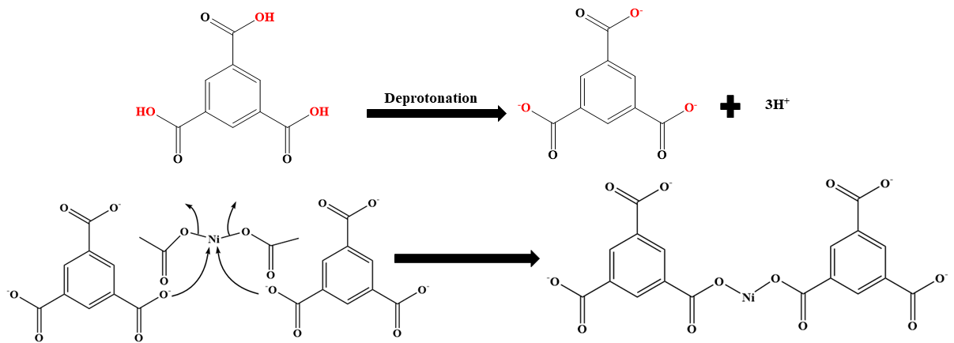 Fig. S2 The possible reaction mechanism for the reaction of the nickel acetate with H₃BTC.

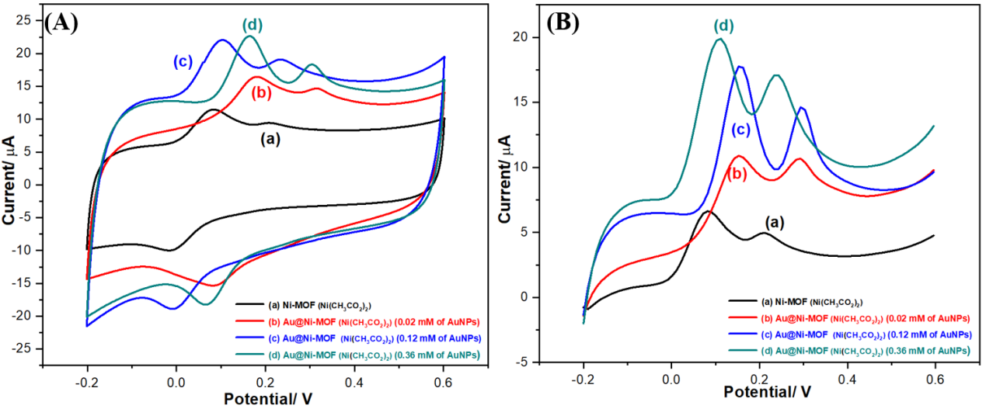 Fig. S3 (A) CV and (B) DPV of (a) Ni-MOF (Ni(CH₃CO₂)₂)/SPCE, (b) Au@Ni-MOF (Ni(CH₃CO₂)₂) (0.02 mM of AuNPs)/SPCE, (c) Au@Ni-MOF (Ni(CH₃CO₂)₂) (0.12 mM of AuNPs)/SPCE, and (d) Au@Ni-MOF (Ni(CH₃CO₂)₂) (0.36 mM of AuNPs)/SPCE in PBS (pH=6) electrolyte at scan rate of 50 mV s⁻¹. (50μM of DAand UA were added).

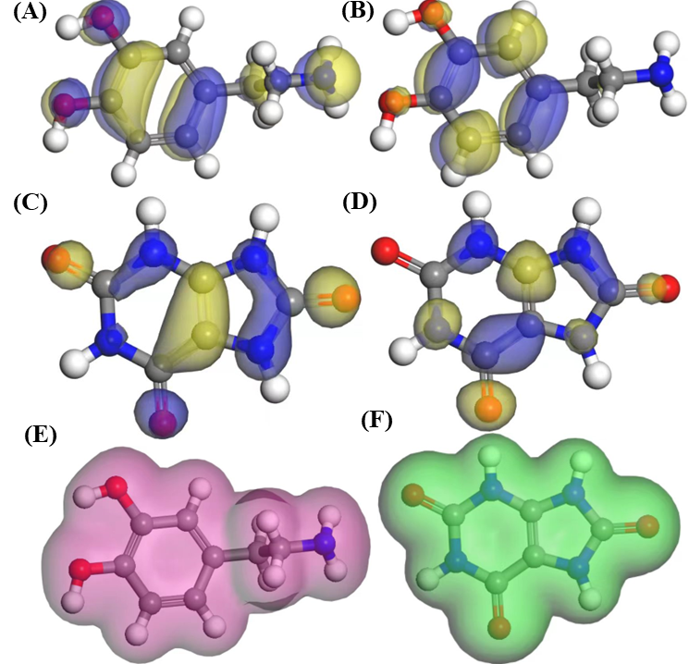
Fig. S4 (A) The plots of the conjugate orbital along with the HOMO and LUMO distributions for DA (A, B) and UA (C, D), respectively; The plots of the electron density for DA (E) and UA (F).

Table S2 Energy gap (Eg) analysis for DA and UA.
Analyte | HOMO  (eV) | LUMO  (eV) | Eg  (eV) | Eg  (kJ/mol) | η (kJ/mol) | σ (kJ/mol) | χ (kJ/mol)
DA | -0.175964 | -0.025313 | 0.150651 | 14.54 | 7.27 | 0.138 | 9.71
UA | -0.194448 | -0.068916 | 0.125532 | 12.11 | 6.06 | 0.165 | 12.71

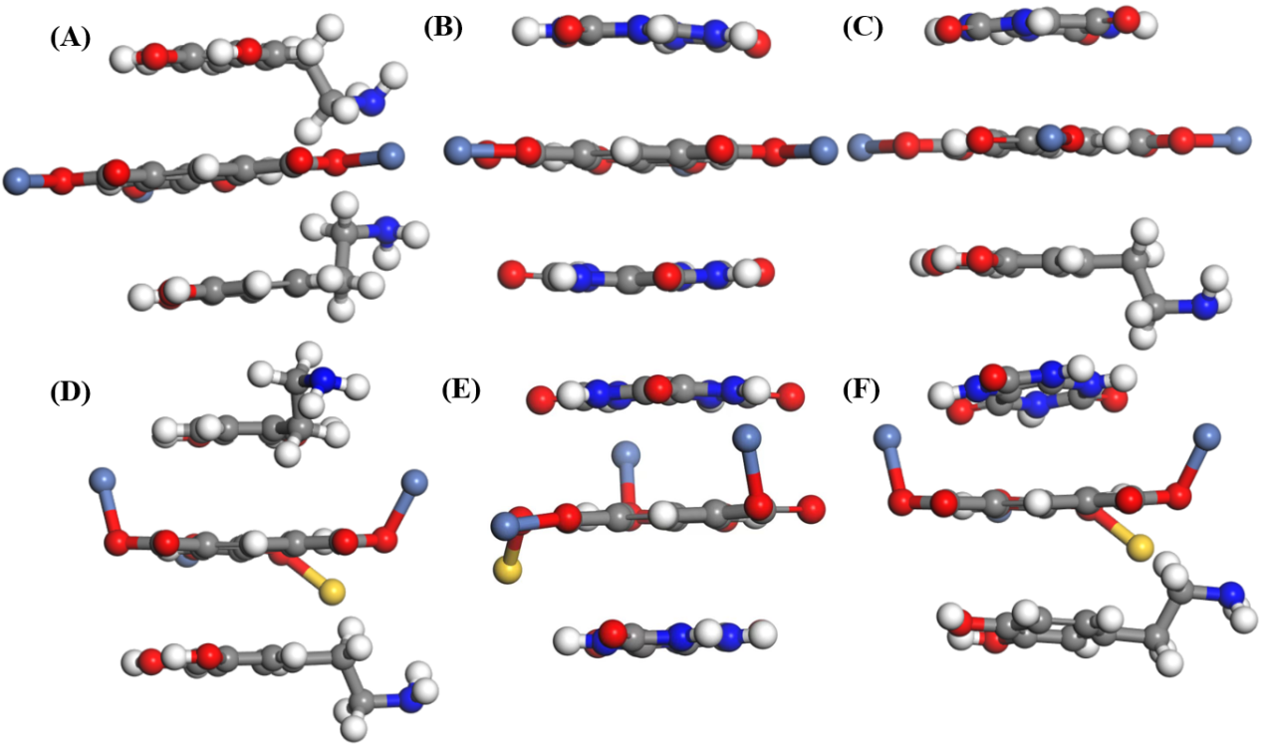 Fig. S5 The adsorption formation of 2DA (A), 2UA (B), and DA/UA (C) on the surface of Ni-MOF (Ni(CH₃CO₂)₂), the adsorption formation of 2DA (D), 2UA (E), and DA/UA (F) on the surface of Au@Ni-MOF (Ni(CH₃CO₂)₂). Carbon, oxygen, nitrogen, hydrogen, and gold atoms are depicted in gray, red, blue, white, and yellow, respectively.

Table S3 Adsorption energy (Eads) analysis for DA and UA on the surface of Ni-MOF (Ni(CH₃CO₂)₂) and Au@Ni-MOF (Ni(CH₃CO₂)₂).
Energy | E_{Substrate}  (eV) |  | E_{Adsorbate}  (eV) | E_{Complex}  (eV) | E_{ads}  (eV) | E_{ads} (kJ/mol)
Ni-MOF (Ni(CH₃CO₂)₂)-2DA | -5186.17764 |  | -8224.64425 | -13411.8712 | -1.0493 | -101.24
Ni-MOF (Ni(CH₃CO₂)₂)-2UA | -6553.79262 |  | -8224.64425 | -14779.5172 | -1.0803 | -104.24
Ni-MOF (Ni(CH₃CO₂)₂)-DA/UA | -5869.98513 |  | -8224.64425 | -14096.4742 | -1.8448 | -178.00
Au@Ni-MOF (Ni(CH₃CO₂)₂)-2DA | -5186.17764 |  | -22348.4175 | -27540.1569 | -5.5618 | -536.63
Au@Ni-MOF (Ni(CH₃CO₂)₂)-2UA | -6553.79262 |  | -22348.4175 | -28906.4071 | -4.1970 | -404.95
Au@Ni-MOF (Ni(CH₃CO₂)₂)-DA/UA | -5869.98513 | -22348.4175 |  | -28222.9084 | -4.5058 | -434.74

